**PROCEDURE: GRAM STAINS**

# PRINCIPLE

Gram-negative and Gram-positive bacteria differ in their cell wall composition. Gram-positive microorganisms have a higher peptidoglycan and lower lipid content than Gram-negative bacteria. During Gram staining, cell walls are stained by the crystal violet. Iodine is added as a mordant to form the crystal violet-iodine complex so the dye cannot be easily removed. The decolorization step using a mixed solvent of ethanol and acetone dissolves the lipid layer from the Gram-negative cells. The removal of the lipid layer enhances the leaching of the primary stain from the cells. In contrast, the solvent dehydrates the thicker Gram-positive cell walls closing the pores as the cell wall shrinks during dehydration. As a result, the diffusion of the violet-iodine complex is blocked, and the bacteria remain stained a purple color. Finally, a counterstain of basic fuchsin is applied to the smear to give decolorized Gram-negative bacteria a pink color.

# AVAILABILITY

Gram stains are performed in the microbiology laboratory on all shifts.

# TEST CODE

GRAMO

# SPECIMEN PREPARATION AND PROCESSING

* 1. All slides should be pre-cleaned immediately before use by dipping the glass slide into Coplin jars filled with 70% ethanol.
  2. All alcohol from the cleaning process must be dried away before the Gram stain smear is prepared.
  3. Once the glass slides are cleaned, they are to be inoculated first (before the media).
  4. All tissue specimens need to be ground using the one-time use disposable tissue grinding kit and sterile saline. A Gram stain should be made by pipetting a drop or two from the ground specimen onto an alcohol cleaned glass slide.
  5. A normally sterile site is defined as, but not limited to: blood, cerebrospinal fluid (CSF or shunt), pleural fluid (chest/ empyema or thoracentesis), peritoneal fluid (abdominal or ascites), pericardial fluid, bone (bone marrow, tissue or disk space), joint fluid (synovial, bursa, knee, ankle, elbow, hip or wrist aspirated from joint site), tissue specimen obtained from surgery or sterile aspirate procedure (lymph node, brain, heart, liver, spleen, vitreous fluid, kidney, pancreas, ovary or vascular tissue).
  6. All specimens received on swabs for Gram stain and culture should be immersed in specimen material found in the bottom sponge of the Copan swab container before preparing the Gram stain smear or inoculating media.
  7. All specimens received on swabs should be rolled, not rubbed onto the alcohol cleaned glass slide.
  8. Each specimen should be examined before the Gram stain smear is prepared. Purulent material should be used for all sputum and respiratory specimens. Portions of the specimen that resemble saliva should be avoided.
  9. Direct cytospin slides should be made for all cerebral spinal fluids, vitreous fluids, shunt fluids, clear sterile body fluids and BAL specimens.
     1. Place an alcohol cleaned, dry cytospin slide in the metal slide holder apparatus.
     2. Attach the funnel and place the clip of the metal apparatus in the locked position.
     3. Stand the holder upright and place 1-3 drops of the fluid into the funnel using a sterile transfer pipet.
     4. Cap the funnel.
     5. The funnel apparatus is now placed in the cytospin holder bowl and into the centrifuge to be spun at 1500 RPM for 5 minutes.
  10. Viscous or Bloody sterile body fluids can be diluted. If the specimen requires dilution, a 1:20 dilution is made by using a sterile transfer pipet to deliver 19 drops of sterile saline and one drop of a thoroughly mixed specimen to a sterile glass tube. This diluted specimen is then vortexed to ensure complete mixing.
      1. Place an alcohol cleaned, dry cytospin slide in the metal slide holder apparatus.
      2. Attach the funnel and place the clip of the metal apparatus in the locked position.
      3. Stand the holder upright and place 1-3 drops of the diluted fluid into the funnel using a sterile transfer pipet.
      4. Cap the funnel.
      5. The funnel apparatus is now placed in the cytospin holder bowl and into the centrifuge to be spun at 1500 RPM for 5 minutes.

# REAGENTS

* 1. Crystal Violet
  2. Grams Iodine
  3. Grams Decolorizer
  4. Safranin
  5. Basic Fuchsin

# STORAGE AND HANDLING

* 1. Aseptic technique should always be used.
  2. Reagents should be stored at 15 – 30°C.
  3. Ethanol filled Coplin jars need to be emptied and changed with each shift.

# QUALITY CONTROL

# Positive control organism is *Staphylococus aureus.*

* 1. Negative control organism is *Escherichia coli.*
  2. Positive and Negative control slides are available at the Gram stain bench.
  3. Controls are run routinely on a weekly basis, for each new lot, and each shipment of reagent
  4. Alcohol in Coplin jar for Gram staining is to be changed at the beginning of every shift.

# PROCEDURE

* 1. Manual Gram staining procedure:
     1. After specimen preparation, allow smear to dry on the heat block.
     2. Remove slide from heat block and allow slide to cool.
     3. Flood slide with methanol to fix specimen to the slide (60 sec.)
     4. Flood smear with Crystal Violet (60 sec).
     5. Wash with tap water (5-10 sec).
     6. Flood smear with Grams Iodine (60 sec).
     7. Wash with tap water (5-10 sec).
     8. Decolorize with Gram Decolorizer solution until no further violet washes away.
     9. Wash with tap water (5-10 sec).
     10. Counterstain with Basic Fuchsin (30-60 sec).
     11. Air dry and examine.

# INTERPRETATION

* 1. Evaluation
     1. Evaluate the general nature of the smear under low power (10x).
     2. Determine if the smear was properly stained. The background should appear clear or Gram negative. If WBCs are present, they should appear completely Gram negative. The nuclei of the Polys should not be Gram positive.
     3. Determine if the smear thickness is appropriate. For proper interpretation, areas must be no more than one cell thick with no overlapping of cells. Background should appear clear or Gram negative.
     4. Inappropriately prepared/ poorly stained smears are to be remade.
     5. A review or second opinion should be requested if the result of the Gram stain is questionable. If a tech specialist is working, it is more beneficial to have the blood cultures and questionable smears reviewed in “real-time.” If assistance is needed on second and third shifts and on the weekends the Pathology Resident on call should be paged. On the rare occasion when a proper interpretation cannot be made (quantity not sufficient for repeat smear), the GRAM or GRAMO portion of the test must be resulted as such, and the patient credited. (Refer to section X. REPORTING)
     6. All organism morphologies are reported in all specimen types, except for sputum and genital wounds.
     7. Unless obtained in the OR/IR, specimens submitted for Anaerobic Culture that have squamous epithelial cells seen in the gram stain are considered inappropriate for anaerobic culture and must be cancelled and reordered as a wound culture.
     8. For Sputum specimens, a ‘Q Score’ will be given to the culture based on the following criteria (refer to Q Score chart below). If the sputum Q Score=0, the sputum is unsatisfactory for culture. The unsatisfactory specimen must then be cancelled. **Bronchial washes, BALs, and Cystic Sputum are NEVER cancelled. These cultures are processed regardless of Q Score.** (Refer to section X. REPORTING)

|  |  |  |  |  |  |
| --- | --- | --- | --- | --- | --- |
| **Q SCORE CHART** | | **Squamous Epithelial cells** | | | |
| NO SQUAMS | FEW SQUAMS | MOD SQUAMS | MANY SQUAMS |
| **POLYS** | **NO** POLYS | 3 | 0 | 0 | 0 |
| **FEW** POLYS | 3 | 0 | 0 | 0 |
| **MOD** POLYS | 3 | 1 | 0 | 0 |
| MANY POLYS | 3 | 2 | 1 | 0 |

* 1. Morphology
     1. Polymorphonuclear leukocytes (Polys) (Appendix A; Example A)
        1. Should appear Gram negative (pink)
        2. Should be intact
        3. Multi-lobed nucleus
     2. Squamous epithelial cells (Squams) (Appendix A; Example B)
        1. Should appear Gram negative (pink)
        2. Should have a small nucleus compared to cell’s size
     3. Gram positive cocci suggestive of Staphylococci (Appendix A; Example C)
        1. Should appear Gram postive (purple)
        2. Should be arranged in clusters or singles
        3. These organisms should not form chains
     4. Gram positive cocci suggestive of Streptococci (Appendix A; Example D)
        1. Should appear Gram positive (purple)
        2. Should be arranged in singles, pairs or chains of four or more organisms
        3. The chains of cocci can sometimes fold over and simulate clusters
     5. Gram positive diplococci suggestive of Pneumococci (Appendix A; Example E)
        1. Should appear Gram positive (purple)
        2. Should be arranged in pairs/lancet shapes
        3. Usually see a clearing where capsule surrounds bacteria
     6. Gram positive rods (Appendix A; Example F)
        1. Should appear Gram positive (purple)
        2. Should be longer than they are wide (may be short or long; boxcar shaped; pleomorphic; beaded; branching)
     7. Gram negative rods (Appendix A; Example G)
        1. Should appear Gram negative (pink)
        2. Should be longer than they are wide (may be short or long or pointed)
     8. Gram negative coccobacilli suggestive of *Haemophilus* (Appendix A; Example H)
        1. Should appear Gram negative (pink)
        2. Typically look like very tiny Gram-negative rods with rounded ends.
     9. Gram negative diplococci (Appendix A; Example I)
        1. Should appear Gram negative
        2. Should have a paired “kidney bean” appearance
        3. Should not be confused with over-decolorized staph or strep
     10. Yeast (Appendix A; Example J)
         1. Should appear Gram positive – but decolorize very easily
         2. Should see budding or pinched pseudohyphae
         3. Should be easily seen when smear is examined under low power.
     11. Fungal elements (Appendix A; Example K)
         1. Should appear Gram positive – but decolorize very easily
         2. Should see septate hyphae and branching
         3. Should be easily seen when smear is examined under low power
  2. Quantitation
     1. When reading Gram stains, make enumerations using the following criteria after scanning 20-40 fields.
     2. Squamous epithelial cells (Squams) and polymorphonuclear leukocytes (Polys) will be enumerated per low power field (LPF 10x objective). Cells are quantitated the same for all specimen types.
     3. Organisms are quantitated per high power field (HPF 100x Oil objective). See below for special organism considerations and quantitation by specimen source/site.

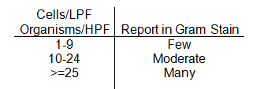

* + - 1. **Quantitation of organisms in respiratory specimens-Expectorated, Induced, Tracheal aspirates, Bronchial washes, Cystic sputum**
         1. Organisms in respiratory specimens are quantitated and reported as follows:

GNR, GNCB: Report organisms when ≥10/OIF, if <10 report Mixed Resp Flora

GPCPNE: Report organisms when ≥25/OIF, if <25 report Mixed Resp Flora

GNDC: Report organisms when ≥25/OIF, if <25 report Mixed Resp Flora

GPCSTA: Report organisms when ≥50/OIF, if <50 report Mixed Resp Flora

GPCSTREP (not consistent with *Streptococcus pneumoniae*), GPR, and YEAST in any amount report as Mixed Resp Flora

FUNGAL ELEMENTS (not yeast/pseudohyphae): report any amount present.

* + - * 1. MIXR can be quantitated and reported for cytospin BAL specimens if there is not a predominant organism.
        2. Predominant organisms should be reported in cytospin BALs using same criteria as respiratory specimens.
      1. **Quantitation of organisms in urine specimens**
         1. Quantitate and report cells.
         2. Organisms are reported if present in a quantity of at least 1 organism per HPF for at least 10 fields.

≥1 / OIF/10 fields = Quantitate as POSITIVE FOR followed by the Gram morphology that is observed.

<1 / OIF/10 fields = NO ORGANISMS SEEN

# REPORTING

* 1. Enter Gram stain results using test comment keypad
  2. Every Gram stain report should include
     1. Quantitation of Polys
     2. Quantitation of squams
     3. Quantitation and morphology of organisms
  3. Report all Gram stains as final reports
  4. For any positive Gram stains on cultures or those that fall into the “Red” category on the Critical Call Policy: Set SIGNIFICANT FLAG  so results are flagged as ABNORMAL in EPIC.

**NOTE:** Per the Critical Results Policy, all positive Gram stains from sterile sites (IE: CSF, Tissue, & Body Fluids) are to be called.

* 1. Bacteria found from any OR specimen, tissue or sterile body site is to be called according to the laboratory procedure: *Notification Scheme for Test Results of Clinical Significance*
     1. All questionable stains on sterile body fluids or tissues on second shift and on the weekends are to be called to the Pathology Resident on call. In addition, all questionable Gram stains for positive blood cultures on second and third shifts and on the weekends are to be called to the Pathology Resident on call. The Pathology Resident is to be notified **prior** to calling results to the floor according to the critical call procedure. This is done for support of the Microbiology personnel and as a safeguard for patient care.

NOTE: If the Pathology Resident does NOT return the page within 15 minutes, proceed on to calling the result according to the laboratory’s critical call procedure. Inform the Microbiology Lab Director via email or follow-up log so that this can be discussed with the Pathology Resident/Resident Director.

* + 1. A Gram stain review should be performed on all positive blood cultures from second and third shift unless otherwise directed by the manager/ technical specialist or laboratory director.
  1. For cytospin slides, use the test comment keypad enter the SOFT statement “**Cytospin of Gram stain shows:”**
  2. Partial Acid-fast smears are only to be added and performed on specimens whose Gram stains show Gram positive beaded rods which are suggestive of *Nocardia*. (Appendix A; Example L)
  3. Gram positive rods suggestive of *Mycobacterium* should have a Kinyoun stain ordered. (Appendix A; Example M)
  4. For CSF Gram stains positive for yeast, add a SAB if enough specimen is available. (Appendix A; Example N)
  5. Correcting Gram Stain in SOFT
     1. Insert the canned message } PREC above the **incorrect** Gram stain.
     2. Place the **correct** Gram stain above the “PREVIOUSLY REPORTED AS:” statement.

Example of a corrected final Gram stain report:

**THIS IS A CORRECTED REPORT

**Many Polys

**No Squamous Epithelials

**Moderate Gram Positive Cocci suggestive of Staph

**Called to and read back by: Dr. Smith 12/14/2015 at 1300

PREVIOUSLY REPORTED AS:

Many Polys

No Squamous Epithelials

No Organisms seen

* 1. Canceling unsatisfactory sputum samples (Q Score=0). **Bronchial washes, BALs, and Cystic Sputum are NEVER cancelled. Cultures are processed regardless of Q Score**
     + - 1. Quantitate and report polys and squams
         2. Add comments }SPUT and }CALL
         3. Notify unit/provider of specimen quality and cancellation
         4. Finalize Gram stain report
         5. Report sputum culture as “No further Workup”.
         6. Finalize culture report
         7. Go to Order Entry, right click on the CXSPT order, click on Bill-No Charge, then save.
         8. Type in comment box “Poor Quality”
         9. Discard plates and save original specimen
  2. Canceling unacceptable anaerobic cultures (NOT FROM OR/IR) and reordering as CXWND:
     1. Result and final gram stain of CXANA with the canned message }ANA :
     2. Final anaerobic culture as “No Further Workup”.

“Specimen inappropriate for deep anaerobic culture due to the presence of squamous epithelial cells on the gram stain. Routine culture will be performed.”

* + 1. Go to Order Entry, right on CXANA and GRAM orders, click on Bill-No Charge, then save.
    2. Use Add Next Order key  to reorder specimen as CXWND.
    3. Enter same date and time of collection as associated anaerobic culture and save.
    4. Relabel aerobic media plates and discard anaerobic media.
    5. Result gram stain of specimen in new CXWND order.
  1. Report for Gram stains that cannot be interpreted
     1. Result the Gram stain as either:

If it was improperly stained and quantity not sufficient for repeat testing: “**Unable to perform Gram stain due to Laboratory error**”

If it was a specimen that was unable to be interpreted because it was unable to be properly stained: “**Unable to perform Gram stain due to poor staining quality of the specimen**”

* + 1. On second and third shift, notify the Pathology Resident **prior** to calling this result to the floor.
    2. On first shift, notify the technical specialist, manager, or laboratory director prior to calling this result to the floor.
    3. Notify unit/provider of specimen quality and cancellation
    4. Finalize Gram stain report
    5. Go to Order Entry, right click on the GRAM order, click on Bill-No Charge, then save.
    6. Type in comment box “Poor Quality”
    7. Save all Gram stain slides that were made for further evaluation.

# LIMITATIONS

* 1. The sensitivity of the Gram stain is dependent upon: cytocentrifugation, quality and type of specimen collected, and portion of the specimen selected for preparation.
  2. The results of the Gram stain should be used by the physician in correlation with other clinical and laboratory findings.
  3. Use additional stains and selective media if necessary to confirm findings suggested by the Gram-stained smear.
  4. Careful adherence to the procedure is required for accurate results. Accuracy is highly dependent on the training and skill of the technologists performing the interpretation.
  5. Gram stain positive, culture negative specimens may be the result of contaminated reagents or supplies. It is especially important that the correct sterile device is used for collecting and transporting the specimen.
  6. False negative Gram stain results may be related to inadequately collected specimen, delay in transit or improper interpretation of the slide.

# NOTES

1. An organism whose average quantitation over 20-40 fields is less than 1 per high power field should not be reported. If a second smear can be made to verify the organism, it should be prepared and interpreted. A note in the worksheet should be made.
2. Smears should not be left on the slide heat block for an excessive amount of time. When the prepared slide is dried, it is time to remove it from the heat block and stain. Leaving them for an extended amount of time may distort the morphology of structures on the slide.
3. **REFERENCES**
   1. www.microbelibrary.org
   2. www.uphs.upenn.edu
   3. http:matcmadison.edu
   4. www.health.state.mn.us/index.html
   5. Garcia. Lynne S, Clinical Microbiology Procedures Handbook Third Edition; Volume 1, 2007
   6. [www.cdc.gov](http://www.cdc.gov)
4. **REVISIONS**
   1. March 1, 2022
      1. Removed GRAMPRO1 instructions
      2. Removed India Ink for use on CSF

**GS examples, High Power (100x)**

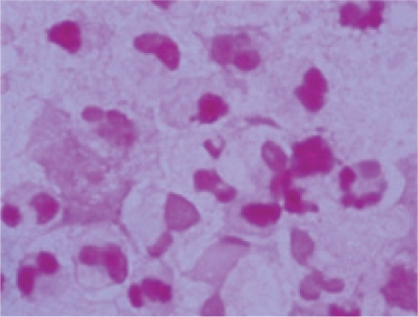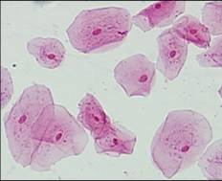

Example A – Polymorphonuclear leukocytes

Example B – Squamous epithelial cells

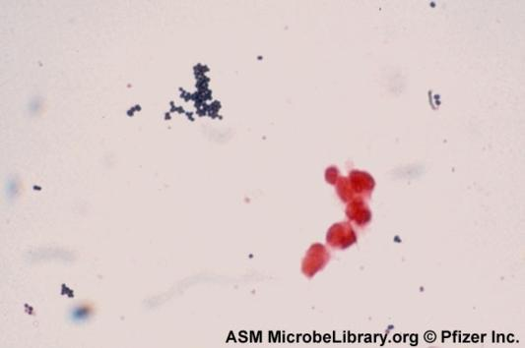

Example C – Gram positive cocci suggestive of staphylococci

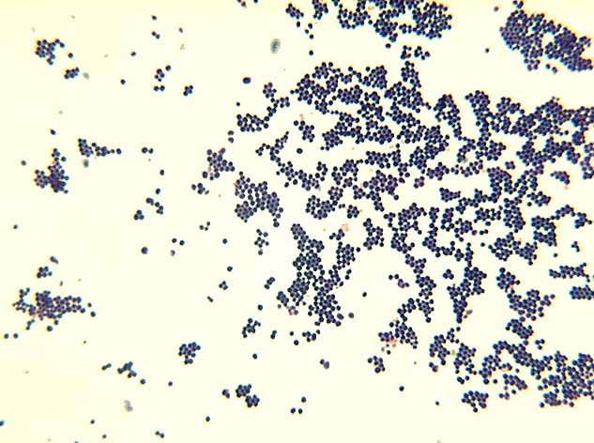

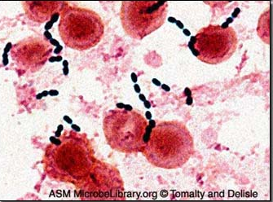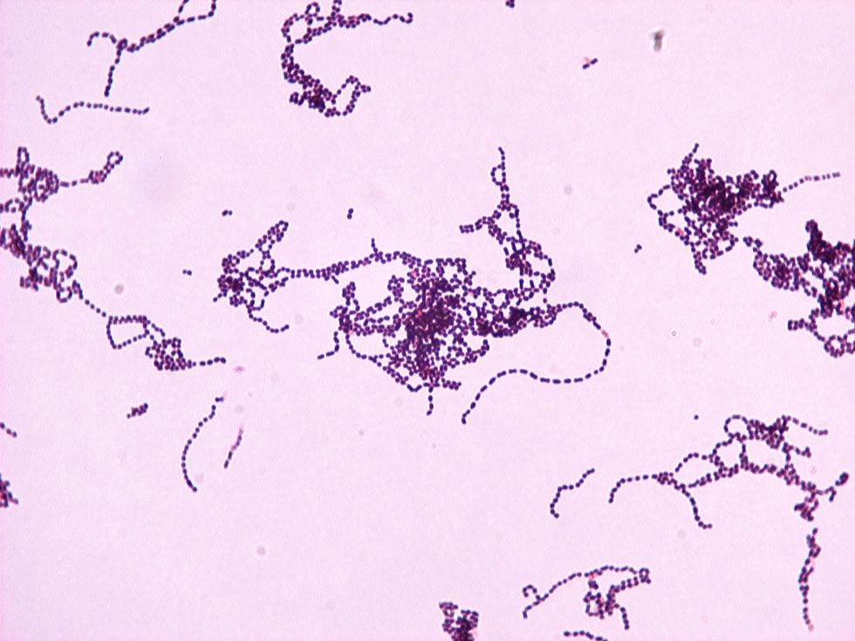

Example D – Gram positive cocci suggestive of streptococci

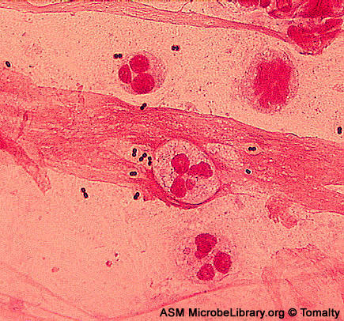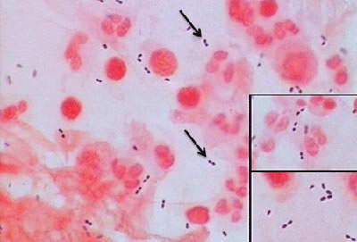

Example E – Gram positive diplococci suggestive of pneumococci

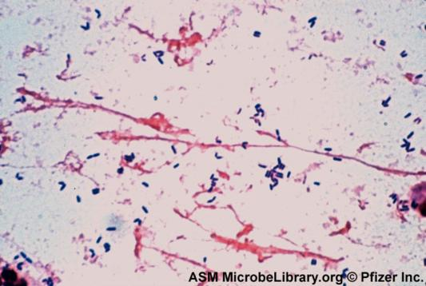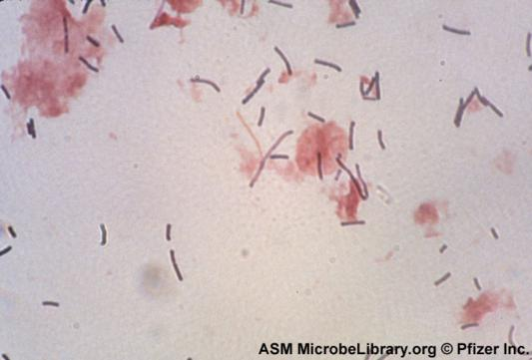

Example F – Gram positive rods

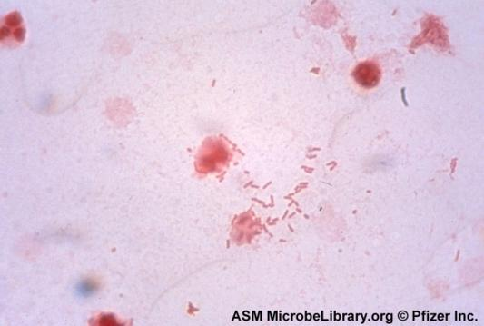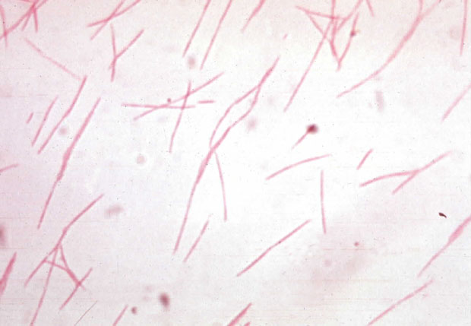

Example G – Gram negative rods

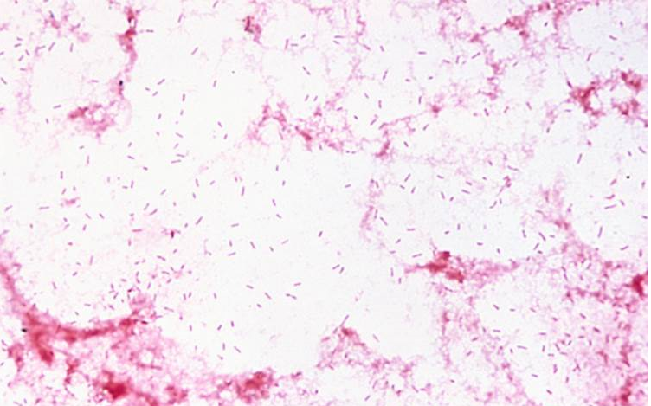 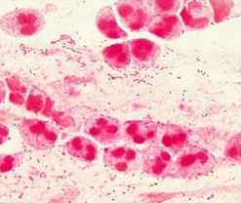

Example H – Gram negative coccobacilli suggestive of *Haemophilus*

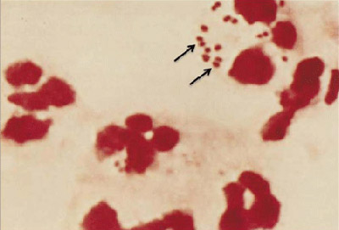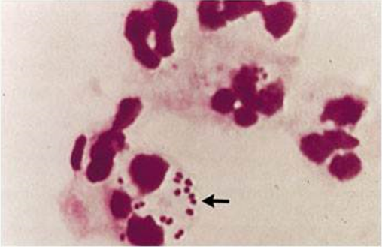

Example I – Gram negative diplococci

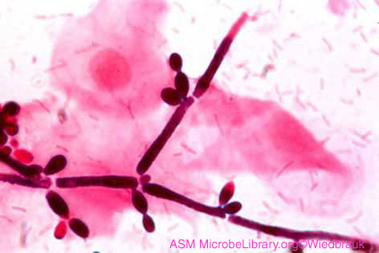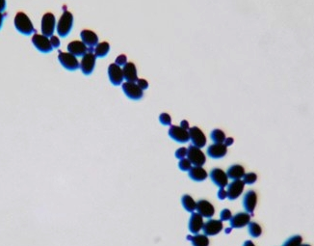

Example J – Yeast

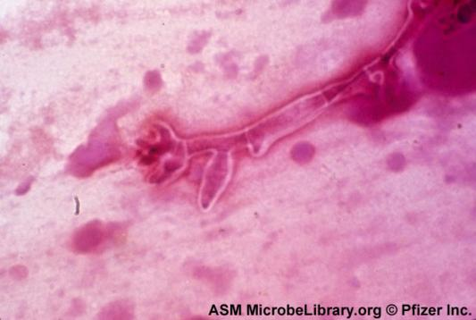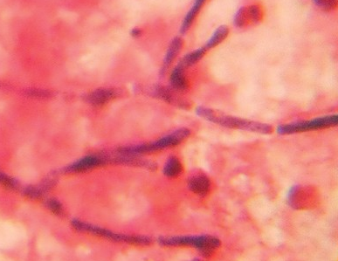

Example K – Fungal elements

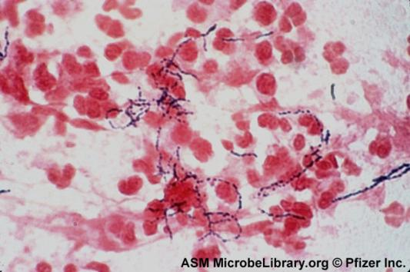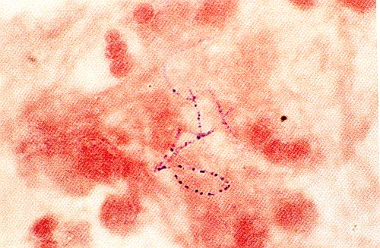

Example L – Gram positive beaded rods suggestive of *Nocardia*

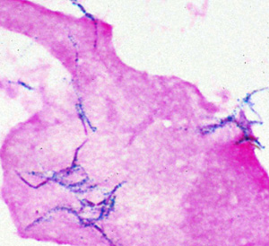

Example M – Gram positive rods suggestive of *Mycobacterium*

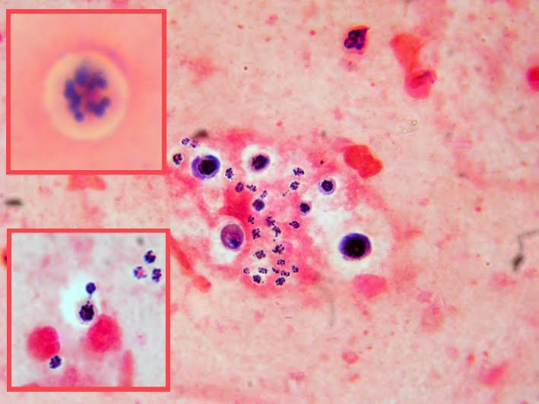

Example N – Encapsulated yeast suggestive of *Cryptococcus* in CSF specimen

[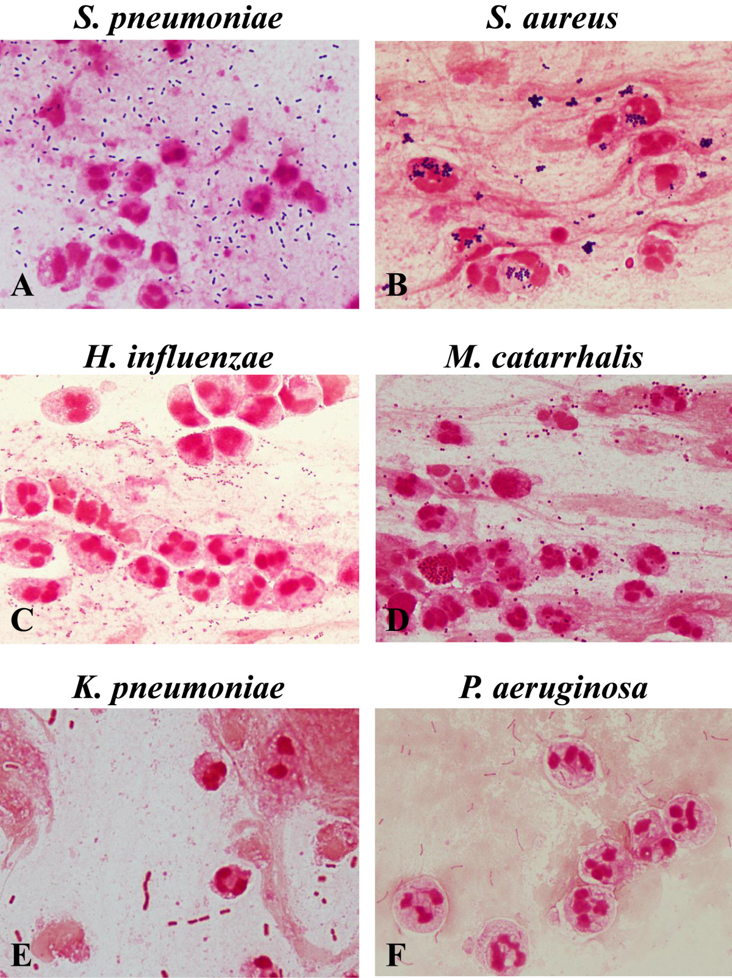](http://www.biomedcentral.com/1471-2334/14/534/figure/F1)

**Bacterial morphotypes in sputum Gram stain (×100, oil immersion field).** Gram positive diplococci (lancet-shaped or football-shaped) are suggestive of *Streptococcus pneumoniae***(A)**. Cluster of Gram-positive cocci are suggestive of *Staphylococcus aureus***(B)**. Tiny Gram-negative coccobacilli are suggestive of *Haemophilus influenzae***(C)**. Gram-negative diplococci (kidney bean-shaped) are suggestive of *Moraxella catarrhalis***(D)**. Plump Gram-negative rods are suggestive of *Klebsiella pneumoniae***(E)**. Thin Gram-negative rods are suggestive of *Pseudomonas aeruginosa***(F)**.

Fukuyama *et al.* *BMC Infectious Diseases* 2014 **14**:534   doi:10.1186/1471-2334-14-534