**Blood Gases on GEM5000**

Prepared by: D. Napert

|  |  |  |
| --- | --- | --- |
| **Date** | **Adopted / Reviewed / Revision** | **Authorized Signature** |
|  | Reviewed – Dr. Grisson or Dr. Latif |  |
|  |  |  |
|  |  |  |
|  |  |  |
|  |  |  |
|  |  |  |
|  |  |  |
|  |  |  |
|  |  |  |
|  |  |  |
|  |  |  |

|  |
| --- |
| **Supersedes: 5/4/2020** |

|  |  |  |
| --- | --- | --- |
|  |  |  |
|  |  |  |

Lifespan AMC-Department of Pathology

The Miriam Hospital ___ ___ Rhode Island Hospital

164 Summit Avenue 593 Eddy Street

Providence, Rhode Island 02906 Providence, Rhode Island 02903

# This policy covers measuring pH, Blood Gases, Electrolytes, Glucose, Lactate, Hematocrit, and CO-Oximetry parameters in Arterial, Mixed Venous, or Venous Blood using the Instrumentation Laboratory GEM® Premier 5000 Analyzer. Note: Lifespan will not utilize the Gem5000 platform for testing of TBili or capillary samples.

# Intended Use

The GEM Premier 5000 is a portable critical care system for use by health care professionals to rapidly analyze heparinized whole blood samples at the point of health care delivery in a clinical setting and in a central laboratory. The instrument provides quantitative measurements of pH, *p*CO2, *p*O2, sodium, potassium, chloride, ionized calcium, glucose, lactate, hematocrit, total bilirubin and CO-Oximetry (tHb, O2Hb, COHb, MetHb, HHb, sO2*) parameters from arterial or venous heparinized whole blood. These parameters, along with derived parameters, aid in the diagnosis of a patient’s acid/base status, electrolyte and metabolite balance and oxygen delivery capacity.

*sO2 = ratio between the concentration of oxyhemoglobin and oxyhemoglobin plus deoxyhemoglobin.

* pH, *p*CO2, and *p*O2 measurements in whole blood are used in the diagnosis and treatment of life-threatening acid-base disturbances.
* Electrolytes in the human body have multiple roles. Nearly all metabolic processes depend on or vary with electrolytes: Sodium (Na+) measurements are used in the diagnosis and treatment of aldosteronism, diabetes insipidus, adrenal hypertension, Addison’s disease, dehydration, inappropriate antidiuretic secretion, or other diseases involving electrolyte imbalance.
* Potassium (K+) measurements are used to monitor electrolyte balance in the diagnosis and treatment of disease conditions characterized by low or high blood potassium levels.
* Ionized calcium (Ca++) measurements are used in the diagnosis and treatment of parathyroid disease, a variety of bone diseases, chronic renal disease and tetany.
* Chloride (Cl-) measurements are used in the diagnosis and treatment of electrolyte and metabolic disorders, such as cystic fibrosis and diabetic acidosis.
* Hematocrit (Hct) measurements in whole blood of the packed red cell volume of a blood sample are used to distinguish normal from abnormal states, such as anemia and erythrocytosis (an increase in the number of red cells).
* Glucose (Glu) measurement is used in the diagnosis, monitoring and treatment of carbohydrate metabolism disturbances including diabetes mellitus, neonatal hypoglycemia, idiopathic hypoglycemia, and pancreatic islet cell carcinoma.
* Lactate (Lac) measurement is used: to evaluate the acid-base status of patients suspected of having lactic acidosis; to monitor tissue hypoxia and strenuous physical exertion; in the diagnosis of hyperlactatemia.
* CO-Oximetry (tHb, COHb, MetHb, O2Hb, HHb, and sO2) evaluates the ability of the blood to carry oxygen by measuring total hemoglobin and determining the percentage of functional and dysfunctional hemoglobin species. Total Hemoglobin (tHb): Total hemoglobin measurements are used to measure the hemoglobin content of whole blood for the detection of anemia.
* COHb: Carboxyhemoglobin measurements are used to determine the carboxyhemoglobin content of human blood as an aid in the diagnosis of carbon monoxide poisoning.
* MetHb: Methemoglobin measurements are used to determine different conditions of methemoglobinemia.
* HHb: Deoxyhemoglobin, as a fraction of total hemoglobin, is used in combination with oxyhemoglobin to measure oxygen status.
* O2Hb: Oxyhemoglobin, as a fraction of total hemoglobin, is used in combination with deoxyhemoglobin to measure oxygen status.
* sO2: Oxygen saturation, more specifically the ratio between the concentration of oxyhemoglobin and oxyhemoglobin plus deoxyhemoglobin, is used to measure oxygen status.

# Equipment and Supplies

## Instrument and Consumables

|  |  |
| --- | --- |
| **Description** | **Part Number** |
| GEM Premier 5000 Analyzer | 00024019255 |
| Printer Paper, 5 rolls per Box | 00025000500 |
| Replacement Fuse, 5 per Pack | 00025002107 |

## GEM PAK

Instrumentation Laboratory has a variety of GEM PAK analyte menus and test volumes available to meet the testing needs of all departments. Please refer to the chart of GEM PAK options.

|  |  |  |  |
| --- | --- | --- | --- |
| **GEM PAK Analyte Menu** | **Number of Tests** | **Onboard Stability** | **Part Number** |
| pH, *p*CO2, *p*O2, Na+, K+, Ca++, Cl-, Glu, Lac, Hct, tHb, O2Hb, COHb, HHb, MetHb, sO2 | 75 | 31 days | 00055407510 |
| 150 | 31 days | 00055415010 |
| 300 | 31 days | 00055430010 |
| 450 | 31 days | 00055445010 |
| 600 | 21 days | 00055360010 |

### GEM PAK Storage

Room temperature: 15 to 25°C (59 to 77°F).

### GEM PAK Preparation

None.

### GEM PAK Expiration

Shelf-Life Expiration: Expires on the date indicated on the label of each GEM PAK. A GEM PAK may be inserted up to and including the date of expiration. If a GEM PAK is inserted past its indicated expiration date it will be rejected by the system. GEM PAK should be stored in foil pack prior to use.

On-board Expiration: The GEM Premier 5000 PAK must be replaced when the maximum number of tests are run, or when cartridge use-life is reached, whichever comes first. See “5.5 GEM PAK Removal.” The operator is notified when the GEM PAK must be replaced.

## GEM PAK Validation-

Only Auto PAK Validation (APV) can be used to complete the validation process following cartridge warm up. APV is run automatically upon installation of each new GEM PAK. APV uses two completely independent, NIST and CLSI traceable solutions (PCS D and E) to validate the performance of the analytical system and the other Process Control Solutions. APV must be acceptable prior to the GEM Premier 5000 system accepting patient samples.

Once the GEM PAK start-up and APV is completed, iQM2 continuously monitors performance of the GEM PAK, reagents, CO-Ox module and sensors throughout the cartridge use-life by five specific quality checks:

* System
* Sensor/CO-Ox
* IntraSpect
* Pattern Recognition (PR)
* PCS Stability

### Quality Control for GEM PAKs

Once the GEM PAK is validated with APV, the quality control process becomes an automatic part of iQM2 operation. iQM2 is used as the quality control and assessment system for the GEM Premier 5000 system. iQM2 is an active quality process control program designed to provide continuous monitoring of the analytical process before, during, and after sample measurement with real-time, automatic error detection, automatic correction of the system and automatic documentation of all corrective actions, replacing the use of traditional external quality controls (QC). Facilities should follow local, state and federal regulatory guidelines to ensure that a total quality management system is followed.

# Specimen Type, Collection, and Handling Criteria

Please refer to Pathology Sample Collection Policy and Respiratory Care Blood Gas Collection Policy(TMH) or Blood Sampling for Acid Base Balance (RIH). Sample types, collection and handling requirements will vary depending on the blood gas orders. For full details of requirments refer to *Appendix ABG-2.*

## Sampling Site

The Arterial Blood Sampling policy (Respiratory Care Dept) should be used for sample site identification.

## Sample Volumes

The syringe or capillary that is used should be filled nearly to capacity to prevent excessive heparin concentration in the sample. Use only Lithium Heparin (Li+) anticoagulant.

Minimum sample requirements for the cartridge in use are as follows:

|  |  |
| --- | --- |
| **Sample Volume:** | **Menu:** |
| 150 µL | pH, *p*CO2, *p*O2, Na+, K+, Cl-, Ca++, Glu, Lac, Hct, tHb, O2Hb, COHb, MetHb, HHb, sO2, tBili or any combination of Electrochemical* analytes and CO-Oximetry** and/or tBili |
| 100 µL | tHb, O2Hb, COHb, MetHb, HHb, sO2, tBili |
| 65 µL (Capillary Only) | pH, pCO2, pO2, Na+, K+, Cl-, Ca++, Glu, Lac, Hct,  (Capillary Device Only) |

## Anticoagulants

The GEM Premier 5000 system requires the use of properly heparinized syringes. Blood samples that have not been mixed correctly or without anticoagulant will result in clots and fluidic errors. Lyophilized lithium heparin is the anticoagulant of choice for analyzing whole blood specimens on the GEM Premier 5000 system. In addition, the type of anticoagulant used must have little to no effect on all the analytes measured. A final heparin concentration of no more than 20 IU/mL of blood is the recommendation made by CLSI guidelines.

Lyophilized anticoagulants eliminate the dilution issue associated with aqueous heparin preparations. However, dried heparin preparations may not dissolve adequately or quickly if the sample is not thoroughly mixed immediately after sample collection. Therefore, IL recommends that specimens obtained in syringes containing lyophilized lithium heparin be thoroughly mixed for >30 seconds by repeatedly inverting the device immediately following collection.

**Note:** Vigorous shaking can cause falsely elevated K+ results.

**Note:** Key for a thorough mixing is the quick and fast inversion of the syringe.

**Note**: Samples should be mixed for >30 seconds prior to sample analysis. Insufficient mixing can cause erroneous Hct/tHb/tBili results.

**CAUTION: The use of Citrate, EDTA, oxalate or sodium fluoride anticoagulant may adversely affect sensor performance.**

## Sample Devices

Patient samples can be collected in two types of containers:

* + - Arterial and Venous syringe samples
    - Venous vacutainer tubes

Unacceptable: Capillary samples are not acceptable at RIH/TMH laboratory.

See further instructions in 3.6 Sample Handling section

### Arterial and Venous Syringe Samples

In most instances, the ideal collection device for arterial blood sampling is a 1-3 mL self-filling plastic, disposable syringe, pre-filled with an appropriate concentration and type of heparin salt.

Any air in the syringe should be removed immediately after collection. Syringe samples must be mixed thoroughly immediately after sample collection. The syringe should be inverted at least 3 times and rolled between outstretched palms at least 5 times.

### Mixed Venous Blood

Mixed venous blood is obtained from the pulmonary artery via a pulmonary artery catheter and is used to measure and evaluate oxygen uptake and cardiac output. It may also be used to assess the degree of intrapulmonary shunting. Mixing strategy recommended for arterial samples should be applied to mixed venous samples.

### Venous Vacutainer Samples

Vacutainer tubes (Lithium Heparin no gel) are the specimen of choice for routine ionized calcium, carboxy hemoglobin, and met hemoglobin. Specimens with gel should be rejected.

## Sample Labeling

All blood samples should be accurately labeled with the appropriate SoftLab barcode label. The individual collecting the sample should document that they have followed the Patient ID policy by initialling the label with their first and last initial.

## Sample Handling

1. Specimen should be received within 30 minutes if not on ice. Specimen must be transported on ice if received >30 and up to 60 mins. If time exceeds limits, it may be appropriate to call unit to verify actual collection time if it is not written on label.
2. All specimens with attached needles will be rejected, regardless of the ordering location and a safety net entered.
3. All specimens with air in the the barrel of the syringe will be rejected.
4. Samples should be analyzed within 1 hour of collection.
5. Any sample with an order for potassium should have an aliquot centrifuged to review for potential hemolysis. If present at low level, add @HEM1 to results in SoftLab and verify. If present at high level, result as Hemolyzed and call to the unit.

## Patient Sample Analysis

### Preparation Prior to Analysis

# Prior to analysis, it is essential that the sample be thoroughly mixed. Hematocrit, total hemoglobin, hemoglobin derivatives, and oxygen are particularly affected when samples are not well mixed. A uniform distribution of red blood cells and plasma prior to sample aspiration is mandatory for reliable results. The sample should be inverted at least 3 times and rolled between outstretched palms at least 5 times if drawn within 5 minutes of sampling. The syringe should be gently rotated for a minimum of 2 minutes immediately prior to analysis if more than 5 minutes have elapsed from sample collection. This can be accomplished manually or by using a mechanical device that produces a motion that rotates the specimen through two axes.

# In summary, immediately prior to sample analysis follow the preparation procedure outline below.

#### For syringe samples:

* + Visually check specimen to ensure there is no air in the sample syringe
  + Mix the sample thoroughly
  + Invert at least 3 times, and roll between outstretched palms at least 5 times.
  + Push out a few drops of the sample onto a gauze pad to ensure there is no clot in the syringe tip.

**Note:** Custom sample sources can be defined in Configuration.

Types of sampling devices accepted include:

* syringe
* opened ampoules
* uncapped collection tubes using the syringe or ampoule sampling position

Pre-defined non patient sample sources accepted include:

* Proficiency
* GEM System Evaluator (GSE)

**Note:** GEM System Evaluator are products that are available from IL to GEM Premier customers, to meet individual local, state or country requirements. However, these products are not required by Instrumentation Laboratory to be analyzed on the GEM Premier 5000 system.

## Limitations and Interferences

### Limitations

|  |  |
| --- | --- |
| **Condition** | **Result** |
| Room Air Contamination | Samples having a very low or high *p*O2 content or high HHb levels are especially sensitive to room air contamination. Similarly, *p*CO2 may be affected and subsequently pH and Ca++ results as well. |
| Metabolic Changes Due to a Delay in Sampling | Errors can occur due to metabolic changes if there is a delay in the measurement of the samples. |
| Elevated White Blood Cells or Reticulocyte Counts | Samples will deteriorate more rapidly, even when kept in ice water. |
| Improper Mixing | Errors will be introduced for measurement of hematocrit, total bilirubin and CO-Ox parameters if the sample is not properly mixed prior to measurement. |
| Not following Manufacturer’s Instructions or Method Verification Protocols | Results obtained may be compromised. |
| Improper Installation | The instrument must be installed per the manufacturer’s instructions. Failure to do so invalidates any warranty, explicit or implied. |
| Under-Heparinized Sample Due to Using Non-Heparinized Sampling Devices or Inadequate Mixing with Heparinized Devices | Blood clot can form in the sensor chamber causing various sensor failures if sample is not properly heparinized. |
| Hemolysis | Hemolyzed samples may result in falsely elevated potassium levels. |
| Over-Heparinized Sample Due to under filling Heparinized Sampling Device or Transferring Heparinized Sample to a Second Heparinized Sampling Device | Over Heparinization can cause bias in Na+, iCa and Hct results. |
| Drug/Chemicals | Drugs/Chemicals may change analyte concentration, e.g. Citrate. |
| Vacutainer tubes with Gel separator | Gel separator can significantly elevate COHb levels. |

### Interference Testing Results

All Interference testing followed CLSI EP-7A2, “Interference Testing in Clinical Chemistry, Approved Guideline”.

**Table 1, Substances for which no interference was observed on EC or CO-Oximetry analytes**

The substances listed in the Table 1 did not show noticeable interference with gases, electrolytes and metabolites measured using electrochemical methods or total hemoglobin, hemoglobin derivatives or tBili measured using CO-Oximetry on the GEM Premier 5000 system when tested at the concentrations listed as per CLSI. Interference was tested on three different lots of GEM Premier 5000 GEM PAKs on 3 GEM Premier 5000 instruments.

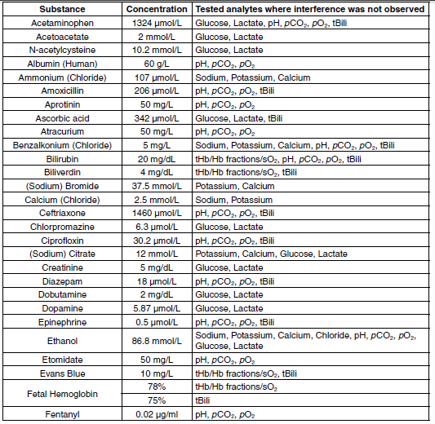

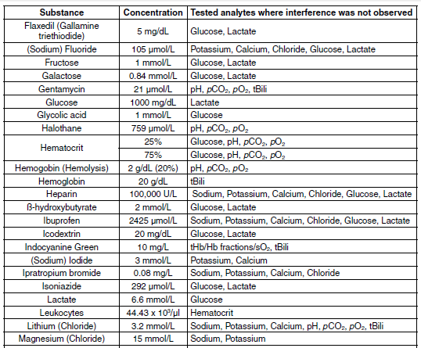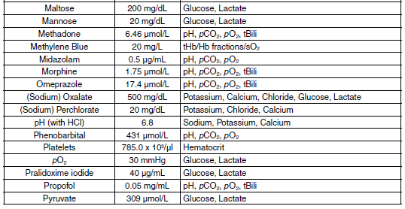

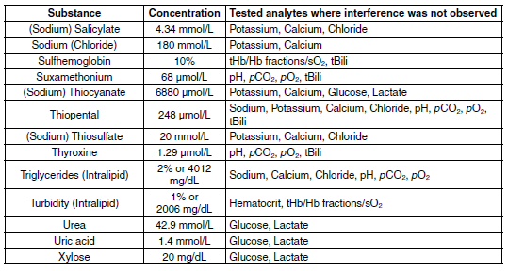

**Table 2, Interferences observed on gases, electrolytes, metabolites, Hct and tBili**

The substances listed in Table 2 showed an interference with electrolyte analytes gases, electrolytes, Hct, and metabolites measured using electrochemical methods and tBili using CO-Oximetry causing a clinically significant error (> TEa). Interference was tested on three different lots of GEM Premier 5000 GEM PAKs on 3 GEM Premier 5000 instruments.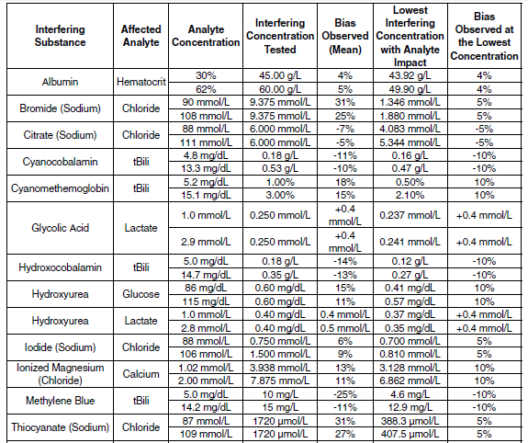

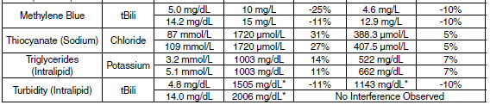

* 1% Intralipid is equal to 2006 mg/dL of triglyerides. **Note:** The GEM Premier 5000 system with iQM2 employs failure pattern recognition checks. These checks include detecting the presence of positively charged lipophilic compounds (e.g., benzalkonium) and negatively lipophilic compounds (e.g., thiopental). The GEM Premier 5000 system offers the facility the ability to enable flagging of patient results if interference patterns for these compounds are detected by iQM2 at the time of result reporting. Even if the flagging option is not enabled, following the post analysis check, the operator is informed of the event. The operator must acknowledge the message before it will be removed from the screen.

**Table 3, Interferences observed on CO-Oximetry**

The substances listed in Table 4 showed an interference with CO-Oximetry/tBili analytes causing a clinically significant error (> TEa). Interference was tested on three different lots of GEM Premier 5000 GEM PAKs on 3 GEM Premier 5000 instruments.

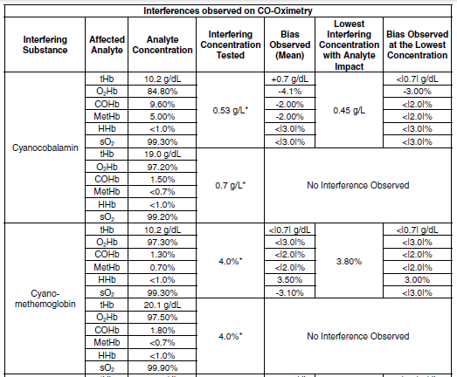

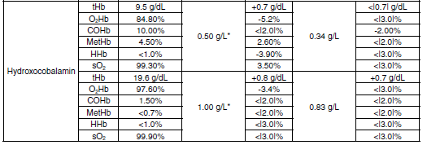

*Results are flagged by iQM2 at the concentrations noted. **Note:** For CO-Oximetry fractions, all biases are expressed in absolute % (i.e. measured units, not CV%)

# Procedures

### Analyzing a Sample

Note: Refer to *Gem5000 Analyzer SOP* for complete details on operation of Gem5000.

The GEM Premier 5000 with iQM2 features three home screens for analyzing patient samples:

• Quick Start

• Manual Selection

• Orders

The default home screen presented on the analyzer is Quick Start. The Quick Start screen streamlines the sample analysis process by enabling the configuration of unique test panel buttons customizable to the needs of a given location in the hospital. Quick Start buttons are configured with unique test panel names, parameter selections, sample source and test volumes.

The Manual Selection screen allows users to choose parameters, sample source and test volume for samples in a simple 3-4 step workflow that do not fit within a pre-defined Quick Start panel.

The Orders screen provides the ability to execute a test order downloaded from an HIS/LIS. This feature is only available on systems running as a client analyzer on a GEMweb Plus network that is configured to accept orders from a HIS/LIS.

The availability of all three screens maximizes flexibility and enables customization to the unique needs of the testing location.

***Analyzing samples from the Quick Start screen***

1. Select the desired Quick Start Button. The Quick Start Button outlines customized panel name, sample device, and sample volume. **Note:** Quick Start buttons are configurable to meet the requirements of your facilities (see “Configuration Set-Up” in Operator’s Manual).
2. The sampler will emerge from its home position. Syringe or ampoule sampling – The sampler will extend from the luer and move approximately 30 degrees from its home position.
   1. **Vacutainer samples for iCa –** The sample should be run using the same process for collection tubes that are full enough for the probe to aspirate the blood. For those that there is not sufficient volume, the sample can be poured off into an aliquot tube or nesting cup and presented for analysis.
   2. If a **whole blood potassium** is ordered on the sample (including the whole blood chem panel), an aliquot of the specimen should be poured off into a capped cone and spun to check for hemolysis. The cone should be labelled with the last four digits of the order number and the initials of the tech processing the sample. If gross hemolysis is present, the test should be cancelled and called to the unit. If slight hemolysis is present, the @HEM1 comment may be added to the results prior to release. Aliquots will be discarded after result review is completed.
3. Present the syringe or ampoule by placing it over the end of the sampler. The sampler should be inserted far enough into the container to allow aspiration but not so far that the sampler touches the bottom of the device.
4. The system will aspirate the sample and provide audio and visual prompts when aspiration is complete.
5. Remove the container promptly. The sampler will retract into the system.
6. Dispose of the remaining sample as medical waste.

***Analyzing samples from the Orders screen***

**Note:** Receiving and processing Orders generated by the HIS/LIS is available only on a

GEM Premier 5000 running as a client analyzer on a GEMweb Plus network. The Order

Processing feature must be enabled during the Configuration of the GEMweb Plus server.

* 1. If Order Processing is enabled, an action button labeled Orders will be presented on the home screen of the analyzer. The button will appear directly to the right of the Ampoules toggle button along the top of the screen. The Orders button will show the number of pending orders received from the HIS/LIS. Orders are downloaded from the HIS/LIS into an orders database that can be selected when samples are available. The number displayed next to Orders will increment as new orders are received and decrement as orders are fulfilled.
  2. There are two ways to search for a test order. All search methods will match the search criteria to the following fields, in order of priority: Order Number, Patient ID, Account Number, Sample Number, Sample ID and Patient Last Name. To search, the following methods can be used:

1. From the Pending Orders screen, scan the barcode label on the sample
2. From the Pending Orders screen, select Enter Order and enter the search criteria
3. Finally, a test order can be initiated from the Pending Orders screen by selecting an order from the list.
   1. Once a sample is matched to an order by any method above, the Order Details screen will be presented. This screen provides details of the order as sent by the HIS/LIS. The order will define what analytes are to be reported for the sample and may also specify the sample type and volume. If the sample type and volume are not available in the test order, they must be selected from an additional pop-up screen prior to running the order.
   2. Once the operator is satisfied the sample matches the order, press Start Aspiration to initiate sample processing.
   3. Patient samples that have no corresponding Orders can be processed on the analyzer using Quick Start or Manual Selection screens.

***Entering patient information during sample analysis***

Whether you are using Quick Start, Manual Selection or Orders sample processing, the analyzer will provide the user with the Required and Optional Information screen where data related to the patient, operator, order and other customized information fields can be scanned, manually entered, or downloaded from a HIS/LIS.- *Scanning is strongly recommended to minimize patient identification errors.*

1. The system will perform analysis while you enter patient information using the alphanumeric keypad (the keypad becomes accessible when you press a button requiring data entry), barcode gun, or via pre-populated fields imported from the HIS or LIS. Required fields are indicated with an asterisk (*) and conveniently located in the left column marked “Required”. **Note:** When required fields are configured, View Results cannot be accessed until all required fields are completed.
2. Comments may be entered on the Enter Information screen. Comments may be freetext entries or selected from pre-defined entries. This is optional information if desired.
3. After all required information is completed, user can move to result screen by selecting View Results Button. If required information is completed, the analyzer will migrate to result screen automatically.

User-Entered Parameters(Optional) -Temperature and Barometric Pressure

The temperature corrected results will be manually entered in SOFT with the comment @TEMP which expands to state: “PH, PCO@, PO2 CORRECTED FOR A BODY TEMPERATURE OF ( ) DEGREES CELSIUS.

The default temperature is 37°C. This temperature will be used to calculate pH, pCO2,

pO2, unless a different entry is made by the operator. The measured and corrected

temperatures, if applicable, are displayed on the View Results screen and on the printout.

The default Barometric Pressure (BP) is 760 mmHg. This BP will be used unless a

different entry is made by the operator. Barometric Pressure is used in various calculated

parameter equations, alveolar oxygen partial pressure (pAO2) for example. Therefore, if

a BP other than 760 mmHg is desired for use in the calculated parameter equations the

operator must enter it when the Enter Information tab is presented. The entered value will

be displayed on the screen and shown on the printed report.

The analyzer provides space for entering the following parameters, which operators must measure, calculate, or obtain elsewhere:

|  |  |  |
| --- | --- | --- |
| Entered Parameter | Unit of Measure | Allowable Range Entry |
| Temperature (Temp) | °C | 15.0 to 45.0 |
| Temperature (Temp) | °F | 59.0 to 113.0 |
| Barometric Pressure (BP) | mmHg | 500 to 999 (default 760) |
| Barometric Pressure (BP) | kPa | 66.7 to 133.2 (default 101.3) |

### Entering comments (Optional)

Comments may be entered on the Enter Information screen. Comments may be free-text entries or selected from pre-defined entries. Comments cannot be edited or deleted after the sample has been accepted. However, operators with permission to do so may add comments after the sample has been accepted. An amended report will automatically be generated if additional comments are included.

### View sample results

After all required patient and sample information have been entered, patient results may be viewed. If required field entries are completed, and Autoverification is not enabled, the View Results tab will display automatically following a short period of inactivity.

When Autoverification is enabled (current setting at RIH/TMH), the operator must select the View Results tab to view patient results. The reason for this is that if Autoverification is enabled, once the View Results tab is displayed, entries on the Enter Information tab cannot be changed except by an operator with a permission level capable of editing patient and sample demographic information.

* **Measured values** – pH, blood gas, electrolyte, and metabolite analyte levels measured during patient sample analysis
* **Temperature corrected values** – displayed only if a patient temperature has been entered in the Required and Optional Information screen
* **CO-Oximetry values** – displayed only if one or more CO-Oximetry analytes are selected for measurement
* **Derived values** – calculated using equations applied to one or more measured analytes only if enabled

If patient reference ranges and critical value limits have been configured, results within the reference range are displayed in green text on a white background. A result outside the reference range, but not above or below a critical limit is displayed in black text on a yellow background. If a result is at, above or below a critical limit it is displayed in white text on a red background. Results in white text on a gray background indicate that no reference range or critical limits have been configured for that analyte.

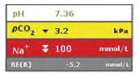

The following exceptions or flags may be displayed along with the sample results.

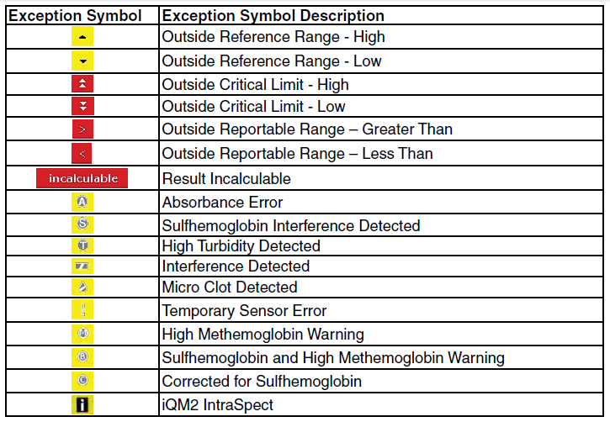

A flagged analyte result should be interpreted with caution and operator should assess sample quality when:

* The result is flagged with an exception symbol when the Flag Results for Interference and Micro Clots is enabled, or
* The result is immediately followed by a message to the operator indicating that any condition exists, which is referenced in the Exception Table above.

#### Flag Results for Interference and Micro Clots *(Not enabled at RIH/TMH)*

When this option is enabled in Configuration, reporting of patient results will be displayed after the post-sample sensor check is completed. The GEM Premier 5000 system will flag analytes if an interference or micro clot is detected through the IntraSpect or Sensor Checks, utilizing the Pattern Recognition Check to determine error cause. When this option is disabled, patient results will be displayed immediately after completion of measurement, and results will not display flags unless an error is detected by IntraSpect check during sample analysis. However, the operator will be presented with a pop-up dialogue message when an interference or clot is detected in the previous sample by the post-sample sensor and pattern recognition checks. The dialogue pop-up message will be displayed until dismissed by the operator.

### Intelligent Quality Management 2 (iQM2) with IntraSpect

Intelligent Quality Management 2 (iQM2) is used as the quality control and assessment system for the GEM Premier 5000 system. iQM2 is an active quality process control program designed to provide continuous monitoring of the analytical process before, *during* and after sample measurement with real-time, automatic error detection, automatic correction of the system and automatic documentation of all corrective actions, replacing the use of traditional external quality controls (QC). Facilities should follow local, state and federal regulatory guidelines to ensure that a total quality management system is followed.

iQM2 is a statistical process control system with well-defined performance characteristics that maximizes probability of error detection, minimizes time to error detection while minimizing probability of false rejection.

iQM2 performs 5 types of continuous, quality checks to monitor the performance of the GEM PAK, sensors, CO-Ox, and reagents. These checks include System, Sensor, the NEW IntraSpect, Pattern Recognition and Stability Checks to ensure the delivery of quality patient results every time. iQM2 utilizes the various checks along with pattern recognition software to identify errors, initiate corrective actions, and document all steps in the corrective action process to assure regulatory compliance, while significantly reducing the time and cost required for performing traditional quality control.

iQM2 performs continuous 5 specific types of quality checks (Figure below) to continuously monitor performance of the GEM PAKs, reagents, CO-Oximetry and sensors throughout the cartridge use-life.

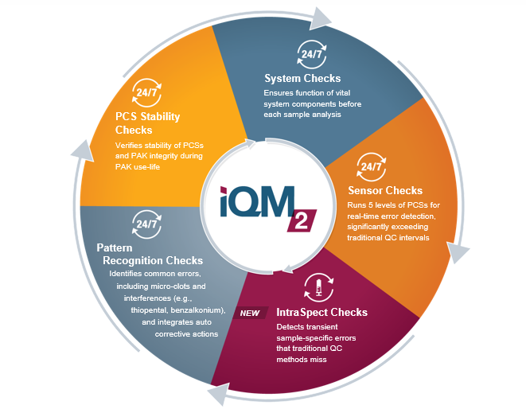

#### iQM2

Upon manufacture at IL and before sensor cards are assembled into GEM PAKs, every

electrochemical sensor is functionally tested using solutions that are NIST-traceable or

traceable to other standards. Sensors test results are documented by sensor card serial

number and sensors that do not meet specifications are discarded. The unique and

proprietary design of the sensor architecture allows for multiple hydration and drying

stages without effecting sensor performance. This ensures that the quality of all sensors

has been confirmed with NIST-traceable solutions prior to PAK manufacturing and clinical

use.

Every lot of PCS is tested and analyte values assigned, using NIST-traceable standards or

other standards prior to assembly into GEM PAKs. PCS values are encoded electronically

through an EEPROM chip on each PAK. Upon PAK insertion, the GEM Premier 5000

system reads and records all factory-assigned information, including lot number, expiration

date, test menu, sample capacity and PCS assigned values and acceptable ranges.

With the iQM2 process, the PCSs are exposed to the sensor and CO-Ox along the same

fluidic pathway as patient samples, including the full extent of the sampler. iQM2 is thus

able to detect any obstructions or malfunctions originating from the sampler through the

entire analytical pathway. After insertion of the GEM PAK into the analyzer, the instrument

performs an automated PAK start-up during which the sensors are hydrated and a variety

of checks occur, all of which take about 40 minutes. PC Solutions are tested and the slope

and intercept of the sensors are compared to factory-assigned values on the EEPROM.

After performing PC Solutions checks, the APV (Auto PAK Validation) process is

automatically completed: two completely independent solutions traceable to NIST

standards, CLSI procedures or internal standards, containing two levels of concentration

for each analyte (PC Solution D and E), APV is run by the analyzer to validate the integrity

of the PCSs and the overall performance of the analytical system (GEM PAK). APV must

be acceptable prior to the GEM Premier 5000 system accepting patient samples.

Once the GEM PAK start-up and APV is completed, iQM2 continuously monitors

performance of the GEM PAK, reagents, CO-Ox module and sensors throughout the

cartridge use-life by five specific quality checks:

• System

• Sensor/CO-Ox

• IntraSpect

• Pattern Recognition (PR)

• PCS Stability

#### IntraSpect

During the sample measurement period, iQM2 software collects 15 sample mV readings in 15 seconds and evaluates sensor performance by abnormal sensor response pattern through slope shape and coefficient values. IntraSpect Checks provide continuous sample integrity quality checks throughout the entire measurement process to ensure accuracy of patient results.

**Note:** iQM2 with IntraSpect technology provides complete quality assurance of results throughout the entire sample measurement process.

IntraSpect can detect abnormal sensor response slope or absorbance residual error during the measurement process.

The following events may cause abnormal sensor response or residual absorbance errors during the measurement process:

* Microclots
* Microbubbles
* Interferences

After performing IntraSpect check in a sample, the affected analyte result becomes either incalculable or flagged for sample response errors.

#### Measured Analyte Reported Ranges

|  |  |  |  |  |  |
| --- | --- | --- | --- | --- | --- |
|  |  | GEM 5000 "REPORTABLE RANGE" | | **Lifespan** Reportable Ranges (Gem5000) | |
|  | ANLYTE | LOWER | UPPER | Lower | Upper |
|  | PH | 6.80 (7.00) | 7.92 | 6.81 | 7.9 |
| mm/hg | PCO2 | 6 | 125 | 16 | 125 |
| mm/hg | PO2 | 6 | 690 | 29 | 630 |
| mmol/l | NA | 100 | 180 | 100 | 180 |
| mmol/l | K | 1.0 | 19.0 | 1.0 | 11.1 |
| mmol/l | CL | 40 | 158 | 63 | 158 |
| mg/dl | CA++ | 0.44 | 17.00 | 0.90 | 14.60 |
| mg/dl | GLU | 4 | 685 | 14 | 685 |
| mmol/l | LAC | 0.3 | 17.0 | 0.3 | 17.0 |
| g/dl | THB | 3.0 | 23.0 | 6.2 | 21.7 |

* The Measuring Range for a parameter is the range where analyte performance claims are verified and validated.

** The Reportable Range for a parameter is the range where software default limits have been configured.

Notes: Analytes with measured values outside the Reportable Range are reported with a > or < symbol. Incalculable will be displayed for results that are outside the measuring capability of the analyzer.

### Derived (Calculated) Parameters

|  |  |  |
| --- | --- | --- |
| Derived Parameter | Unit of Measure | Resoution |
| TCO2 | mmol/L | 0.1 |
| BE(B) (In vitro) | mmol/L | 0.1 |
| sO2(c) | % | 0.1 |
| HCO3- (c) | mmol/L | 0.1 |

### Patient History-

To view patient result trending, press the Patient History button located at the lower right part of the screen when current patient result is being displayed. The analyzer will display the most recent five test results of the same sample type for the current patient. Samples older than one month will not be shown. The delta (Δ) value represents the difference between the current sample and the one prior to it. Patient history is only available if bidirectional interface.

### Reference Ranges

|  |  |  |
| --- | --- | --- |
| **Parameter** | **Lifespan Reference Range** | **Unit** |
| pH Arterial | 7.35 to 7.45 | pH |
| pH Venous | 7.32 to 7.42 | pH |
| *p*CO2 Arterial | 35 to 45 | mmHg |
| *pCO2* Venous | 42 to 50 | mmHg |
| *p*O2 Arterial | 80 to 105 | mmHg |
| *p*O2 Venous | 30 to 50 | mmHg |
| Na+ | >15 years 135 to 145 | mEq/L |
| K+ | >12 years 3.6 to 5.1 | mEq/L |
| Glu | >12 years 67 to 99 | mg/dL |
| Lac | 0.2 to 1.9 | mEq/L |
| Cl- | >15 years 98 to 110 | mEq/L |
| HCO3- Arterial | 22 to 26 | mEq/L |
| HCO3- Venous | 22 to 28 | mEq/L |
| Ca++ Art & Ven | 4.2 to 5.2 | mg/dL |
| O2Hb Arterial (O2Sat) | 95 to 98 | % |
| O2Hb Venous (O2Sat) | 70 to 80 | % |
| TCO2 1+2 ** | 23 to 27 | mmol/L |
| TC02 Venous | 24 to 29 |  |

|  |  |  |
| --- | --- | --- |
| **Parameter** | **Recommended Reference Range** | **Units** |
| Na+ 1+ 2 Art and Ven | <1 month 131 to 143 | mEq/L |
| Na+ | 1 month to 1 year 131 to 145 | mEq/L |
| Na+ | 1 year to 5 year 132 to 143 | mEq/L |
| Na+ | 5 years to 10 years 135 to 143 | mEq/L |
| Na+ | 10 to 15 years 133 to 143 | mEq/L |
| K+ 1 | < 1 month 3.7 to 5.9 | mEq/L |
| K+ | 1 month to 1year 4.1 to 5.3 | mEq/L |
| K+ | 1 year to 12 years 3.4 to 4.7 | mEq/L |
| Cl- 1+ 2 | < 1 month 99 to 116 | mEq/L |
| Cl- | 1 month to 1 year 98 to 118 | mEq/L |
| Cl- | 1 year to 5 years 98 to 116 | mEq/L |
| Cl- | 5 years to 10 years 99 to 114 | mEq/L |
| Cl- | 10 years to 15 years 98 to 115 | mEq/L |
| Hct | Not Applicable | % |
| Glu | < 1 month 50 to 80 | mg/dL |
| Glu | 1 month to 12 years 60 to 100 | mg/dL |
| tHb | Not applicable | g/dL |
| COHb | Non – Smokers < 1.5  Smokers 1.5 to 5.0  Heavy Smokers 5.0 to 9.0 | % |
| MetHb | 0 to 1.8 | % |
| HHb | Not Applicable | % |
| sO2  * | Not Applicable | % |
| BE* | -2.0 to 3.0 | mmol/L |

1 Plasma

2 Serum

*sO2 is a derived parameter calculated from measured CO-Oximetry results

**TCO2 and BE (Base Excess) are derived parameters

**Reference Range References:**

*General Normal Ranges*:

1. Burtis, Carl and David Bruns, Tietz Textbook of Clinical Chemistry and Molecular Diagnostics, Elsevier Saunders, 7th edition, 2015, pp 952-982

*CO-Oximetry Normal Ranges:*

1. Burtis, Carl and David Bruns, Tietz Textbook of Clinical Chemistry and Molecular Diagnostics, 7th edition, 2015, pp 952-982
2. Hampson, NB, et al. Practice Recommendations in the Diagnosis, Management and Prevention of Carbon Monoxide Poisoning, Am J Respir Crit Care Med, 2012:186:1095-1101
3. Piantadosi, C.A, Carbon Monoxide Poisoning, New England Journal of Medicine (2002), 347 (14): 1054-1055
4. Radford, EP, Blood Carbon Monoxide Levels in Person 3-74 Years of Age: United States, 1976-1980. National Center for Health Statistics, 1982.
5. Wu, A., Tietz Clinical Guide to Laboratory Tests, W.B. Saunders Co., St. Louis MO, 4th Edition, 2006: 951-982
6. Haymond, S., Oxygen Saturation, A Guide to Laboratory Assessment, Clinical Laboratory News, February 2006, pages 10-12.
7. American Environmental Laboratory: The Laboratory Assessment of Oxygenation. Robert F. Morgan, 1993, 5(4), p. 147-153.

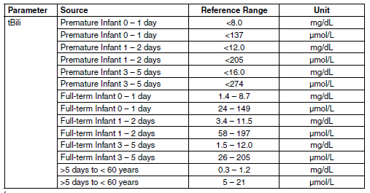

Reference:

Wu, A., Tietz Clinical Guide to Laboratory Tests, W.B. Saunders Co., St. Louis MO, 4th Edition, 2006

### Critical Values

|  |  |  |  |  |
| --- | --- | --- | --- | --- |
| **Parameter** | **Lower Limit** | **Upper Limit** | **Unit** | **Notification Frequency** |
| COHgb | n/a | >20.0 | % | Every time |
| WB Glu | <40 | >450 | mg/dL | Every time |
| WB NA | <120 | >160 | MEQ/L | Every time |
| WB K | <3.0 | >6.0 | MEQ/L | Every time |
| WB CL | <85 | >120 | MEQ/L | Every time |
| WB Lac | N/A | >3.9 | MEQ/L | Every time |
| Art pO2 | < or = 40 | N/A | mmhg | Every 4 hrs |
| Art pCO2 | <20 | >70 | mmhg | Every 4 hrs |
| Art pH | <7.2 | >7.6 | mmhg | Every 4 hrs |
| Ven pCO2 | <20 | >70 | mmhg | Every 4 hrs |
| Ven pH | <7.2 | >7.6 | mmhg | Every 4 hrs |

1 Serum

Critical values will be called to the ordering location following the Pathology Department Critical value policy.

Verified/accepted results on the Gem5000 will cross over to instrument menu in Soft where the technologist can evaluate and verify results.

# References

1. Tietz, N.W., Fundamentals of Clinical Chemistry, W.B. Saunders Co., Philadelphia, 5th Edition, 2001.
2. Shapiro, B.A., Clinical Application of Blood Gases, Mosby, Inc., 5th Edition, 1994.
3. CLSI document C46-A, Blood Gas and pH Analysis and Related Measurements; Approved Guideline, Volume 21 Number 14, page 10, section 4.2.1
4. Dellinger R. P. et al, “Surviving Sepsis Campaign: International Guidelines for Management of Severe Sepsis and Septic Shock: 2012”, Critical Care Medicine, 41 (2): 580-637, 2013
5. Levraut J, Ichai C, Petit I, Ciebiera JP, Perus O, Grimaud D. “Low Exogenous Lactate Clearance As An Early Predictor of Mortality in Normolactatemic Critically Ill Septic Patients”, Critical Care Medicine 2003; 31 (3): 705-710.