**GEM 5000 Standard Operating Procedure (SOP)**

Measuring pH, Blood Gases, Electrolytes, Glucose,

Lactate, Hematocrit, and CO-Oximetry parameters

in Arterial, Mixed Venous, or Venous Blood

using the Instrumentation Laboratory GEM® Premier 5000 Analyzer

Prepared by: D. Napert

|  |  |  |
| --- | --- | --- |
| **Date** | **Adopted / Reviewed / Revision** | **Authorized Signature** |
|  |  |  |
|  |  |  |
|  |  |  |
|  |  |  |
|  |  |  |
|  |  |  |
|  |  |  |
|  |  |  |

|  |
| --- |
| **Supersedes:** |

|  |  |  |
| --- | --- | --- |
|  |  |  |
|  |  |  |

Lifespan AMC-Department of Pathology

The Miriam Hospital ___ ___ Rhode Island Hospital

164 Summit Avenue 593 Eddy Street

Providence, Rhode Island 02906 Providence, Rhode Island 02903

# Document Purpose

This document provides instructions on the use of the GEM Premier 5000 analyzer. This procedure document includes pre-analytical considerations, analyzer preparation, sampling, result review and routine procedures.

# Intended Use

The GEM Premier 5000 is a portable critical care system for use by health care professionals to rapidly analyze heparinized whole blood samples at the point of health care delivery in a clinical setting and in a central laboratory. The instrument provides quantitative measurements of pH, *p*CO2, *p*O2, sodium, potassium, chloride, ionized calcium, glucose, lactate, hematocrit, and CO-Oximetry (tHb, O2Hb, COHb, MetHb, HHb, sO2*) parameters from arterial or venous heparinized whole blood. These parameters, along with derived parameters, aid in the diagnosis of a patient’s acid/base status, electrolyte and metabolite balance and oxygen delivery capacity. Note: Tbili not performed on Gem5000 at Lifespan.

*sO2 = ratio between the concentration of oxyhemoglobin and oxyhemoglobin plus deoxyhemoglobin.

* pH, *p*CO2, and *p*O2 measurements in whole blood are used in the diagnosis and treatment of life-threatening acid-base disturbances.
* Electrolytes in the human body have multiple roles. Nearly all metabolic processes depend on or vary with electrolytes: Sodium (Na+) measurements are used in the diagnosis and treatment of aldosteronism, diabetes insipidus, adrenal hypertension, Addison’s disease, dehydration, inappropriate antidiuretic secretion, or other diseases involving electrolyte imbalance.
* Potassium (K+) measurements are used to monitor electrolyte balance in the diagnosis and treatment of disease conditions characterized by low or high blood potassium levels.
* Ionized calcium (Ca++) measurements are used in the diagnosis and treatment of parathyroid disease, a variety of bone diseases, chronic renal disease and tetany.
* Chloride (Cl-) measurements are used in the diagnosis and treatment of electrolyte and metabolic disorders, such as cystic fibrosis and diabetic acidosis.
* Hematocrit (Hct) measurements in whole blood of the packed red cell volume of a blood sample are used to distinguish normal from abnormal states, such as anemia and erythrocytosis (an increase in the number of red cells).
* Glucose (Glu) measurement is used in the diagnosis, monitoring and treatment of carbohydrate metabolism disturbances including diabetes mellitus, neonatal hypoglycemia, idiopathic hypoglycemia, and pancreatic islet cell carcinoma.
* Lactate (Lac) measurement is used: to evaluate the acid-base status of patients suspected of having lactic acidosis; to monitor tissue hypoxia and strenuous physical exertion; in the diagnosis of hyperlactatemia.
* CO-Oximetry (tHb, COHb, MetHb, O2Hb, HHb, and sO2) evaluates the ability of the blood to carry oxygen by measuring total hemoglobin and determining the percentage of functional and dysfunctional hemoglobin species. Total Hemoglobin (tHb): Total hemoglobin measurements are used to measure the hemoglobin content of whole blood for the detection of anemia.
* COHb: Carboxyhemoglobin measurements are used to determine the carboxyhemoglobin content of human blood as an aid in the diagnosis of carbon monoxide poisoning.
* MetHb: Methemoglobin measurements are used to determine different conditions of methemoglobinemia.
* HHb: Deoxyhemoglobin, as a fraction of total hemoglobin, is used in combination with oxyhemoglobin to measure oxygen status.
* O2Hb: Oxyhemoglobin, as a fraction of total hemoglobin, is used in combination with deoxyhemoglobin to measure oxygen status.
* sO2: Oxygen saturation, more specifically the ratio between the concentration of oxyhemoglobin and oxyhemoglobin plus deoxyhemoglobin, is used to measure oxygen status.

# Equipment and Supplies

## Instrument and Consumables

|  |  |
| --- | --- |
| **Description** | **Part Number** |
| GEM Premier 5000 Analyzer | 00024019255 |
| Printer Paper, 5 rolls per Box | 00025000500 |
| Replacement Fuse, 5 per Pack | 00025002107 |

## GEM PAK

Instrumentation Laboratory has a variety of GEM PAK analyte menus and test volumes available to meet the testing needs of all departments. Please refer to the chart of GEM PAK options.

|  |  |  |  |
| --- | --- | --- | --- |
| **GEM PAK Analyte Menu** | **Number of Tests** | **Onboard Stability** | **Part Number** |
| pH, *p*CO2, *p*O2, Na+, K+, Ca++, Cl-, Glu, Lac, Hct, tHb, O2Hb, COHb, HHb, MetHb, sO2 | 75 | 31 days | 00055407510 |
| 150 | 31 days | 00055415010 |
| 300 | 31 days | 00055430010 |
| 450 | 31 days | 00055445010 |
| 600 | 21 days | 00055360010 |

### GEM PAK Storage

Room temperature: 15 to 25°C (59 to 77°F).

### GEM PAK Preparation

None.

### GEM PAK Expiration

Shelf-Life Expiration: Expires on the date indicated on the label of each GEM PAK. A GEM PAK may be inserted up to and including the date of expiration. If a GEM PAK is inserted past its indicated expiration date it will be rejected by the system. GEM PAK should be stored in foil pack prior to use.

On-board Expiration: The GEM Premier 5000 PAK must be replaced when the maximum number of tests are run, or when cartridge use-life is reached, whichever comes first. See “5.5 GEM PAK Removal.” The operator is notified when the GEM PAK must be replaced.

## GEM PAK Validation-

Only Auto PAK Validation (APV) and GEM CVP 5 can be used to complete the validation process following cartridge warm up. APV is run automatically upon installation of each new GEM PAK. APV uses two completely independent, NIST and CLSI traceable solutions (PCS D and E) to validate the performance of the analytical system and the other Process Control Solutions. APV must be acceptable prior to the GEM Premier 5000 system accepting patient samples.

Once the GEM PAK start-up and APV is completed, iQM2 continuously monitors performance of the GEM PAK, reagents, CO-Ox module and sensors throughout the cartridge use-life by five specific quality checks:

* System
* Sensor/CO-Ox
* IntraSpect
* Pattern Recognition (PR)
* PCS Stability

### Quality Control for GEM PAKs

Once the GEM PAK is validated with APV, the quality control process becomes an automatic part of iQM2 operation. iQM2 is used as the quality control and assessment system for the GEM Premier 5000 system. iQM2 is an active quality process control program designed to provide continuous monitoring of the analytical process before, during, and after sample measurement with real-time, automatic error detection, automatic correction of the system and automatic documentation of all corrective actions, replacing the use of traditional external quality controls (QC). Facilities should follow local, state and federal regulatory guidelines to ensure that a total quality management system is followed.

# Specimen Type, Collection, and Handling Criteria

Please refer to Pathology Sample Collection Policy and Respiratory Care Blood Gas Collection Policy. Sample types, collection and handling requirements will vary depending on the blood gas orders. For full details of requirments refer to Appendix ABG-2.

## Patient Status

A steady state of ventilation should be achieved before obtaining arterial blood samples. Twenty to thirty minutes of stable ventilatory status are desired for spontaneously breathing patients. Other patients may require more than 30 minutes to equilibrate following ventilatory changes. Less time may elapse for specific applications, such as obtaining confirmation that a change in ventilator settings is having the desired effect, without waiting for complete equilibration.

## Sampling Site

The Arterial Blood Sampling policy (Respiratory Care Dept) should be used for sample site identification.

## Sample Volumes

The syringe or capillary that is used must be filled nearly to capacity to prevent excessive heparin concentration in the sample. Use only Lithium Heparin (Li+) anticoagulant.

Minimum sample requirements for the cartridge in use are as follows:

|  |  |
| --- | --- |
| **Sample Volume:** | **Menu:** |
| 150 µL | pH, *p*CO2, *p*O2, Na+, K+, Cl-, Ca++, Glu, Lac, Hct, tHb, O2Hb, COHb, MetHb, HHb, sO2, or any combination of Electrochemical* analytes and CO-Oximetry** and/or |
| 100 µL | tHb, O2Hb, COHb, MetHb, HHb, sO2, |

## Anticoagulants

The GEM Premier 5000 system requires the use of properly heparinized syringes. Blood samples that have not been mixed correctly or without anticoagulant will result in clots and fluidic errors. Lyophilized lithium heparin is the anticoagulant of choice for analyzing whole blood specimens on the GEM Premier 5000 system. In addition, the type of anticoagulant used must have little to no effect on all the analytes measured. A final heparin concentration of no more than 20 IU/mL of blood is the recommendation made by CLSI guidelines.

Lyophilized anticoagulants eliminate the dilution issue associated with aqueous heparin preparations. However, dried heparin preparations may not dissolve adequately or quickly if the sample is not thoroughly mixed immediately after sample collection. Therefore, IL recommends that specimens obtained in syringes containing lyophilized lithium heparin be thoroughly mixed for >30 seconds by repeatedly inverting the device immediately following collection.

**Note:** Vigorous shaking can cause falsely elevated K+ results.

**Note:** Key for a thorough mixing is the quick and fast inversion of the syringe.

**Note**: Samples should be mixed for >30 seconds prior to sample analysis. Insufficient mixing can cause erroneous Hct/tHb results.

**CAUTION: The use of Citrate, EDTA, oxalate or sodium fluoride anticoagulant may adversely affect sensor performance.**

## Sample Devices

Patient samples can be collected in two types of containers:

* + - Arterial and Venous syringe samples
    - Venous vacutainer tubes

Unacceptable: Capillary samples are not acceptable at RIH/TMH laboratory.

See further instructions in 4.7 Sample Handling section.

### Arterial and Venous Syringe Samples

In most instances, the ideal collection device for arterial blood sampling is a 1-3 mL self-filling plastic, disposable syringe, pre-filled with an appropriate concentration and type of heparin salt.

Any air in the syringe should be removed immediately after collection. Syringe samples must be mixed thoroughly immediately after sample collection. The syringe should be inverted at least 3 times and rolled between outstretched palms at least 5 times.

### Mixed Venous Blood

Mixed venous blood is obtained from the pulmonary artery via a pulmonary artery catheter and is used to measure and evaluate oxygen uptake and cardiac output. It may also be used to assess the degree of intrapulmonary shunting. Mixing strategy recommended for arterial samples should be applied to mixed venous samples.

### Venous Vacutainer Samples

Vacutainer tubes (Lithium Heparin no gel) are the specimen of choice for routine ionized calcium, carboxy hemoglobin, and met hemoglobin. Specimens with gel should be rejected.

## Sample Labeling

All blood samples should be accurately labeled with the appropriate SoftLab barcode label. The individual collecting the sample should document that they have followed the Patient ID policy by initialling the label with their first and last initial.

## Sample Handling

1. Specimen should be received within 30 minutes if not on ice. Specimen must be transported on ice if received >30 and up to 60 mins. If time exceeds limits, it may be appropriate to call unit to verify actual collection time if it is not written on label.
2. All specimens with attached needles will be rejected, regardless of the ordering location and a safety net entered.
3. All specimens with air in the the barrel of the syringe will be rejected.
4. Samples should be analyzed within 1 hour of collection.
5. Any sample with an order for potassium should have an aliquot centrifuged to review for potential hemolysis. If present at low level, add @HEM1 to results in SoftLab and verify. If present at high level, result**s** as Hemolyzed and call to the unit.

## Sample Mixing

Refer to section 5.5 Patient Sample Analysis

## Limitations and Interferences

### Limitations

|  |  |
| --- | --- |
| **Condition** | **Result** |
| Room Air Contamination | Samples having a very low or high *p*O2 content or high HHb levels are especially sensitive to room air contamination. Similarly, *p*CO2 may be affected and subsequently pH and Ca++ results as well. |
| Metabolic Changes Due to a Delay in Sampling | Errors can occur due to metabolic changes if there is a delay in the measurement of the samples. |
| Elevated White Blood Cells or Reticulocyte Counts | Samples will deteriorate more rapidly, even when kept in ice water. |
| Improper Mixing | Errors will be introduced for measurement of hematocrit, and CO-Ox parameters if the sample is not properly mixed prior to measurement. |
| Not following Manufacturer’s Instructions or Method Verification Protocols | Results obtained may be compromised. |
| Improper Installation | The instrument must be installed per the manufacturer’s instructions. Failure to do so invalidates any warranty, explicit or implied. |
| Under-Heparinized Sample Due to Using Non-Heparinized Sampling Devices or Inadequate Mixing with Heparinized Devices | Blood clot can form in the sensor chamber causing various sensor failures if sample is not properly heparinized. |
| Hemolysis | Hemolyzed samples may result in falsely elevated potassium levels. |
| Over-Heparinized Sample Due to under filling Heparinized Sampling Device or Transferring Heparinized Sample to a Second Heparinized Sampling Device | Over Heparinization can cause bias in Na+, iCa and Hct results. |
| Drug/Chemicals | Drugs/Chemicals may change analyte concentration, e.g. Citrate. |
| Vacutainer tubes with Gel separator | Gel separator can significantly elevate COHb levels. |

### Interference Testing Results

All Interference testing followed CLSI EP-7A2, “Interference Testing in Clinical Chemistry, Approved Guideline”.

**Table 1, Substances for which no interference was observed on EC or CO-Oximetry analytes**

The substances listed in the Table 1 did not show noticeable interference with gases, electrolytes and metabolites measured using electrochemical methods or total hemoglobin, hemoglobin derivatives measured using CO-Oximetry on the GEM Premier 5000 system when tested at the concentrations listed as per CLSI. Interference was tested on three different lots of GEM Premier 5000 GEM PAKs on 3 GEM Premier 5000 instruments.

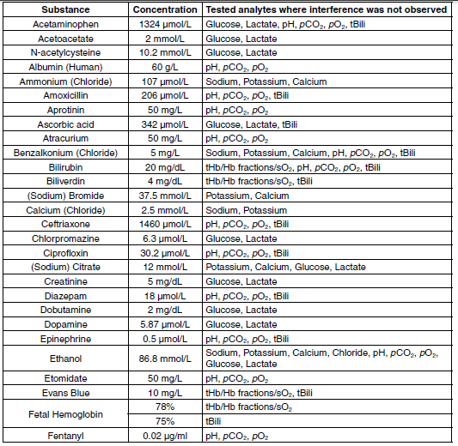

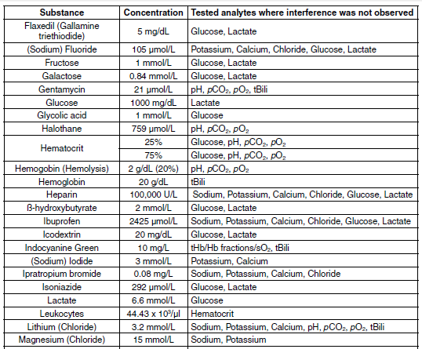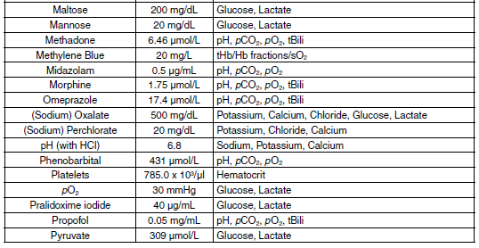

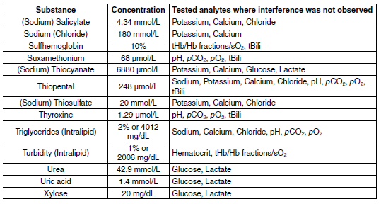

**Table 2, Interferences observed on gases, electrolytes, metabolites, Hct and tBili**

The substances listed in Table 2 showed an interference with electrolyte analytes gases, electrolytes, Hct, and metabolites measured using electrochemical methods and tBili using CO-Oximetry causing a clinically significant error (> TEa). Interference was tested on three different lots of GEM Premier 5000 GEM PAKs on 3 GEM Premier 5000 instruments.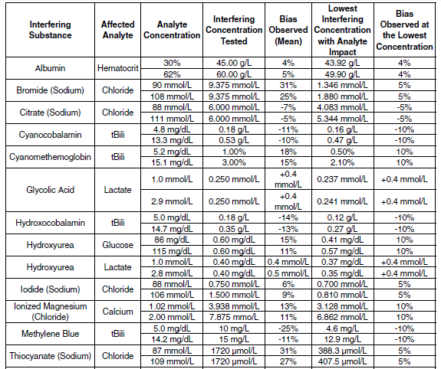

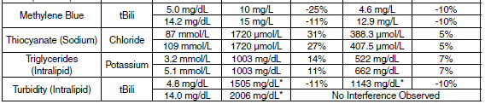

* 1% Intralipid is equal to 2006 mg/dL of triglyerides. **Note:** The GEM Premier 5000 system with iQM2 employs failure pattern recognition checks. These checks include detecting the presence of positively charged lipophilic compounds (e.g., benzalkonium) and negatively lipophilic compounds (e.g., thiopental). The GEM Premier 5000 system offers the facility the ability to enable flagging of patient results if interference patterns for these compounds are detected by iQM2 at the time of result reporting. Even if the flagging option is not enabled, following the post analysis check, the operator is informed of the event. The operator must acknowledge the message before it will be removed from the screen.

**Table 3, Interferences observed on CO-Oximetry**

The substances listed in Table 4 showed an interference with CO-Oximetry/tBili analytes causing a clinically significant error (> TEa). Interference was tested on three different lots of GEM Premier 5000 GEM PAKs on 3 GEM Premier 5000 instruments.

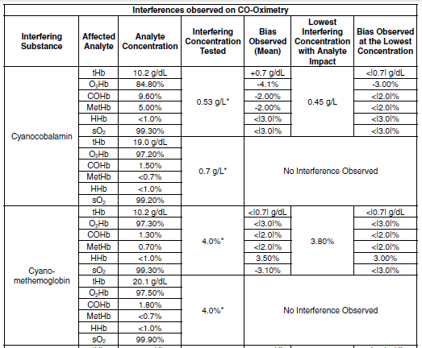

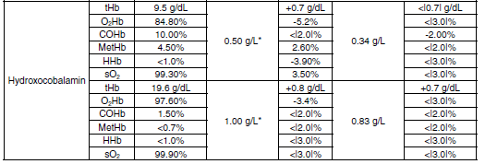

*Results are flagged by iQM2 at the concentrations noted. **Note:** For CO-Oximetry fractions, all biases are expressed in absolute % (i.e. measured units, not CV%)

# Procedures

## GEM PAK Insertion and Start-up

The GEM Premier 5000 system requires a GEM Premier 5000 PAK to perform analysis. Only GEM PAKs designed for use with the GEM Premier 5000 system and supplied by Werfen/Instrumentation Laboratory can be used with the analyzer.

1. Press Open Door on the touch screen. You will hear an audio prompt, and the door will release and open slightly. Then manually move the door all the way to the left.
2. Unpack the GEM PAK from its protective wrapper. Remove the clear plastic cover and desiccant pouch from the pump winding area.

**The GEM PAK must be stored at room temperature (15 to 25° C).**

**CAUTION:** Only IL supplied cartridges may be used with this analyzer. The use of non-IL supplied cartridges will invalidate the analyzer warranty and will release IL from any responsibility for analyzer performance.

1. Position the GEM PAK with the gray sampling area facing forward. Push the cartridge in until you feel resistance. Please note that approximately one inch of the GEM PAK will extend beyond the front of the analyzer.
2. Guide the analyzer door to the right to close it and move the GEM PAK into its final position.
3. In approximately 20 seconds, the analyzer will inform you that the GEM PAK is warming up. The clock will count down for the next 40 minutes as the GEM PAK starts up. During this time, the sensors will hydrate, and the analyzer will perform internal checks and processes.

## General Operating Information

The GEM Premier 5000 analyzer is designed for intuitive use, and provides clear direction when you are operating the system.

Changes in color signal different conditions:

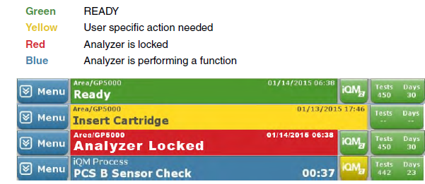

Operator messages provide clear directions to you for next steps. These instructions are generally in white boxes with black text.

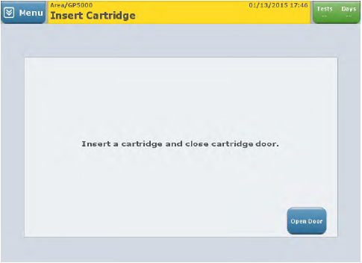

**Password protection** prevents unauthorized access to key activities. When prompted, enter your password, as provided by your supervisor or other managerial personnel.

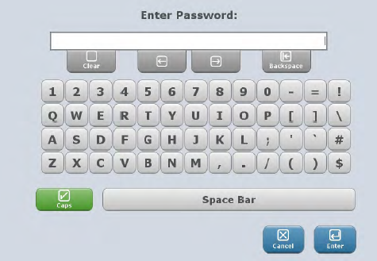

**Audio prompts** also aid use by providing programmed beeps or tones to indicate that an action has occurred.

## Main Sampling Screen (Start New Sample Tab)

Once you have completed installation (including Auto PAK Validation (APV) and CVP testing if testing for tBili), you will see the main sampling screen, which displays the Quick Start sampling screen. The information and capabilities available to the operator from this screen, beyond patient sampling, are described below.

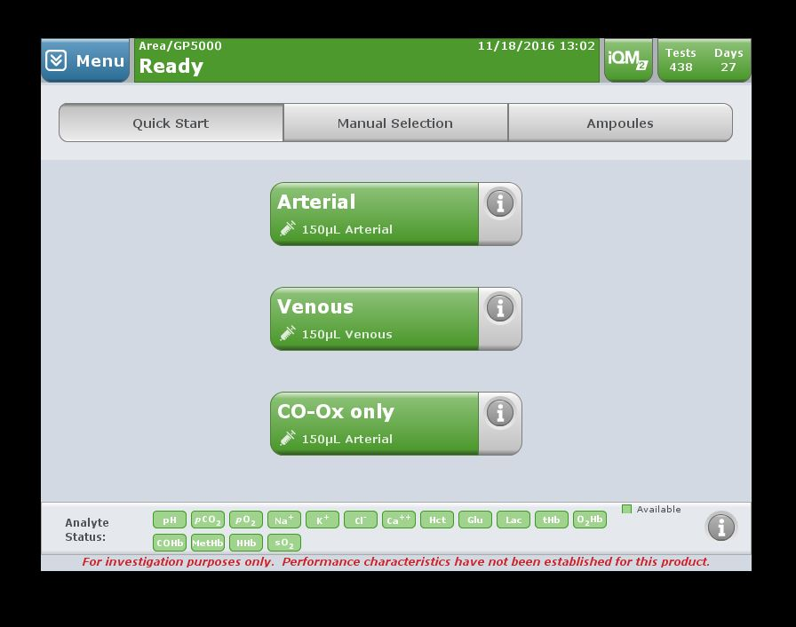

The Status Bar along the top provides quick access to critical information and capabilities.

* **Analyzer Status** – indicates overall readiness of analyzer for patient sampling. It will turn yellow if a specific action (i.e., CVP testing) is needed.
* **Date/Time** – system clock runs on 24 hour time.
* **iQM2 Button** – iQM2 is Instrumentation Laboratory’s patented Intelligent Quality Management 2 system, which ensures the integrity of the overall analysis system. When quality testing runs automatically in the background the iQM2 Button will turn yellow.

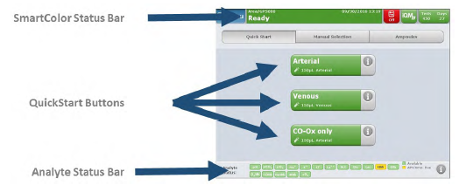

* **Network Status Button** – indicates whether the analyzer is connected to a network or LIS. Selecting this button provides more detailed information about the network connection. **This button will not be visible if the analyzer is operated as a stand-alone unit.**
* **Tests/Days Button** – these figures indicate how many days/tests remain before you must change the cartridge. Selecting this button will display the exact day/time the cartridge will expire. When either 1 day or 5 tests are remaining, the button background color will turn yellow.

**Note: 600 test GEM PAK have an on-board stability of 21 days.**

**Note: An expired GEM PAK cannot be used by the analyzer.**

* **Mail Button** – alerts you to incoming e-mail messages and system error messages. When a new message is received, the Mail Button will turn yellow and the number represents the total mail messages received that have not been acknowledged. **Note:** The email feature on the GEM Premier 5000 analyzer may not be available in all countries.
* **Menu Button** – allows access to additional functions beyond patient sampling.

Touching the blue **Menu** button in the upper left triggers a drop-down menu that provides fast access to other functionality beyond patient sampling.

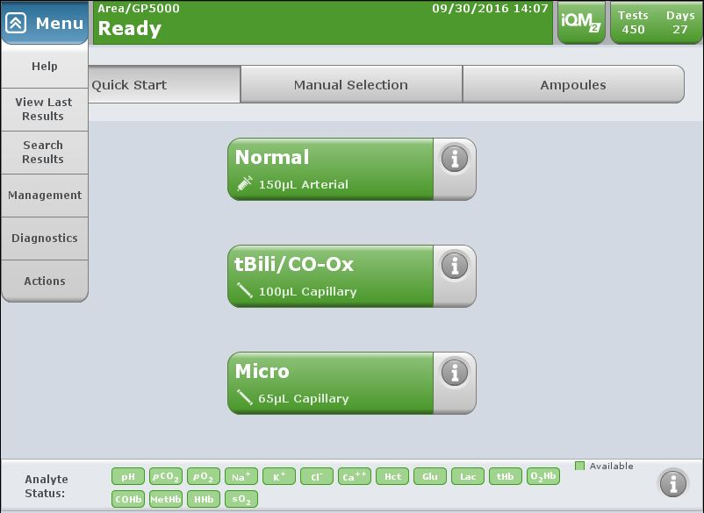

**NOTE:** Menu functions may be password protected.

* **Help** – will provide topic-based help on analyzer operation.
* **View Last Results**—enables you to search last 20 patient results.
* **Search Results** – enables you to search patient results from the database.
* **Management or GEMweb Plus** – not applicable to routine operators. This area gives managers access to key system tasks.
* **Diagnostics** – offers access to a range of tasks related to the status of the GEM Premier 5000 (see Section XIII: Diagnostics).
* **System Info**—provides system information to include SW version.
* **Run iQM2 Process**—allows users to manually initiate iQM2 process.
* **Print Last iQM2 Process**
* **Copy IL Data—**allows user to copy GEM PAK data onto a CD or USB for investigation purposes.
* **Action—**enables you to manually remove a GEM PAK, restart the analyzer, or shutdown the analyzer.
* **Remove GEM PAK** – enables you to manually remove a GEM PAK (see Section: Removing the GEM PAK).
* **Shut Down** – allows you to shut down the analyzer correctly.

**NOTE:** This is the only method that should be used to power down the analyzer.

## Patient Sample Analysis

### Preparation Prior to Analysis

# Prior to analysis, it is essential that the sample be thoroughly mixed. Hematocrit, total hemoglobin, hemoglobin derivatives, and oxygen are particularly affected when samples are not well mixed. A uniform distribution of red blood cells and plasma prior to sample aspiration is mandatory for reliable results. The sample should be inverted at least 3 times and rolled between outstretched palms at least 5 times if drawn within 5 minutes of sampling. The syringe should be gently rotated for a minimum of 2 minutes immediately prior to analysis if more than 5 minutes have elapsed from sample collection. This can be accomplished manually or by using a mechanical device that produces a motion that rotates the specimen through two axes.

# In summary, immediately prior to sample analysis follow the preparation procedure outline below.

#### For syringe samples:

* + Visually check specimen to ensure there is no air in the sample syringe.
  + Mix the sample thoroughly
  + Invert at least 3 times, and roll between outstretched palms at least 5 times.
  + Push out a few drops of the sample onto a gauze pad to ensure there is no clot in the syringe tip.

**Note:** Custom sample sources can be defined in Configuration.

Types of sampling devices accepted include:

* syringe
* opened ampoules
* uncapped collection tubes using the syringe or ampoule sampling position

Pre-defined non patient sample sources accepted include:

* Proficiency
* GEM System Evaluator (GSE)

**Note:** GEM System Evaluator are products that are available from IL to GEM Premier customers, in order to meet individual local, state or country requirements. However, these products are not required by Instrumentation Laboratory to be analyzed on the GEM Premier 5000 system.

### Analyzing a Sample

The GEM Premier 5000 with iQM2 features three home screens for analyzing patient samples:

• Quick Start

• Manual Selection

• Orders

The default home screen presented on the analyzer is Quick Start. The Quick Start screen streamlines the sample analysis process by enabling the configuration of unique test panel buttons customizable to the needs of a given location in the hospital. Quick Start buttons are configured with unique test panel names, parameter selections, sample source and test volumes.

The Manual Selection screen allows users to choose parameters, sample source and test volume for samples in a simple 3-4 step workflow that do not fit within a pre-defined Quick Start panel.

The Orders screen provides the ability to execute a test order downloaded from an HIS/LIS. This feature is only available on systems running as a client analyzer on a GEMweb Plus network that is configured to accept orders from a HIS/LIS.

The availability of all three screens maximizes flexibility and enables customization to the unique needs of the testing location.



***Analyzing samples from the Quick Start screen***

1. Select the desired Quick Start Button. The Quick Start Button outlines customized panel name, sample device, and sample volume. **Note:** Quick Start buttons are configurable to meet the requirements of your facilities (see “Configuration Set-Up” in Operator’s Manual).
2. The sampler will emerge from its home position. Syringe or ampoule sampling – The sampler will extend from the luer and move approximately 30 degrees from its home position.
   1. **Vacutainer samples for iCa –** The sample should be run using the same process for collection tubes that are full enough for the probe to aspirate the blood. For those that there is not sufficient volume, the sample can be poured off into an aliquot tube or nesting cup and presented for analysis.
   2. If a **whole blood potassium** is ordered on the sample (including the whole blood chem panel), an aliquot of the specimen should be poured off into a capped cone and spun to check for hemolysis. The cone should be labelled with the last four digits of the order number and the initials of the tech processing the sample. If gross hemolysis is present, the test should be cancelled and called to the unit. If slight hemolysis is present, the @HEM1 comment may be added to the results prior to release. Aliquots will be discarded after result review is completed.
3. Present the syringe or ampoule by placing it over the end of the sampler. The sampler should be inserted far enough into the container to allow aspiration but not so far that the sampler touches the bottom of the device.
4. The system will aspirate the sample and provide audio and visual prompts when aspiration is complete.

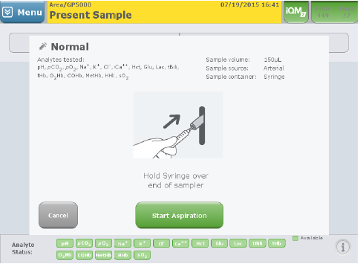

1. Remove the container promptly. The sampler will retract into the system.
2. Dispose of the remaining sample as you would medical waste.

***Analyzing samples from the Manual Selection screen***

1. Select the desired sample panel by selecting the radio button on the left. 150 μL mode offers full menu testing for syringe, and tube devices. 100 μL mode offers CO-Ox only.
2. Select or deselect available analytes by pressing the green analyte buttons. A check indicates that the analyte will be included in the test. **Note:** Analytes that are not available for testing will be identified with a grey, red or yellow flag.
3. Select the sample type/ container if it is not already selected.
4. Press Run Test
5. The sampler will emerge from its home position. When ready, press Start Analysis. Syringe or ampoule sampling – The sampler will extend from the luer and move approximately 30 degrees from its home position.
6. Present the syringe or ampoule by placing it over the end of the sampler. The sampler should be inserted far enough into the container to allow aspiration but not so far that the sampler touches the bottom of the device.
7. The system will aspirate the sample and provide audio and visual prompts when aspiration is complete.
8. Remove the container promptly. The sampler will retract into the system.
9. Dispose of the remaining sample as you would medical waste.

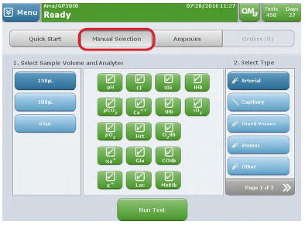

**Note:** Your analyzer may be configured to have a “Sample Removal Confirmation”. If this is enabled, the user must press OK to confirm removal of the device. The sampler will still automatically retract if OK is not selected within 15 seconds of completing aspiration. A count down timer will be displayed.

***Analyzing samples from the Orders screen***

**Note:** Receiving and processing Orders generated by the HIS/LIS is available only on a

GEM Premier 5000 running as a client analyzer on a GEMweb Plus network. The Order

Processing feature must be enabled during the Configuration of the GEMweb Plus server.

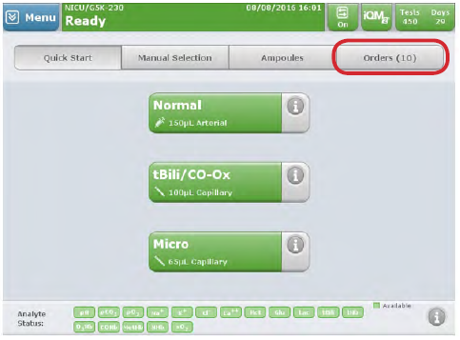

* 1. If Order Processing is enabled, an action button labeled Orders will be presented on the home screen of the analyzer. The button will appear directly to the right of the Ampoules toggle button along the top of the screen. The Orders button will show the number of pending orders received from the HIS/LIS. Orders are downloaded from the HIS/LIS into an orders database that can be selected when samples are available. The number displayed next to Orders will increment as new orders are received and decrement as orders are fulfilled.
  2. There are two ways to search for a test order. All search methods will match the search criteria to the following fields, in order of priority: Order Number, Patient ID, Account Number, Sample Number, Sample ID and Patient Last Name. To search, the following methods can be used:

1. From the Pending Orders screen, scan the barcode label on the sample
2. From the Pending Orders screen, select Enter Order and enter the search criteria.
3. Finally, a test order can be initiated from the Pending Orders screen by selecting an order from the list.
   1. Once a sample is matched to an order by any method above, the Order Details screen will be presented. This screen provides details of the order as sent by the HIS/LIS. The order will define what analytes are to be reported for the sample and may also specify the sample type and volume. If the sample type and volume are not available in the test order, they must be selected from an additional pop-up screen prior to running the order.
   2. Once the operator is satisfied the sample matches the order, press Start Aspiration to initiate sample processing.
   3. Patient samples that have no corresponding Orders can be processed on the analyzer using Quick Start or Manual Selection screens.

***Entering patient information during sample analysis***

Whether you are using Quick Start, Manual Selection or Orders sample processing, the analyzer will provide the user with the Required and Optional Information screen where data related to the patient, operator, order and other customized information fields can be scanned, manually entered, or downloaded from a HIS/LIS.- *Scanning is strongly recommended to minimize patient identification errors.*

1. The system will perform analysis while you enter patient information using the alphanumeric keypad (the keypad becomes accessible when you press a button requiring data entry), barcode gun, or via pre-populated fields imported from the HIS or LIS. Required fields are indicated with an asterisk (*) and conveniently located in the left column marked “Required”. **Note:** When required fields are configured, View Results cannot be accessed until all required fields are completed.
2. Comments may be entered on the Enter Information screen. Comments may be freetext entries or selected from pre-defined entries. (Optional function)
3. After all required information is completed, user can move to result screen by selecting View Results Button. If required information is completed, the analyzer will migrate to result screen automatically.

User-Entered Parameters(Optional)-Temperature and Barometric Pressure

The temperature corrected results will be manually entered in SOFT with the comment @TEMP which expands to state: “PH, PCO@, PO2 CORRECTED FOR A BODY TEMPERATURE OF ( ) DEGREES CELSIUS.

The default temperature is 37°C. This temperature will be used to calculate pH, pCO2,

pO2, unless a different entry is made by the operator. The measured and corrected

temperatures, if applicable, are displayed on the View Results screen and on the printout.

The default Barometric Pressure (BP) is 760 mmHg. This BP will be used unless a

different entry is made by the operator. Barometric Pressure is used in various calculated

parameter equations, alveolar oxygen partial pressure (pAO2) for example. Therefore, if

a BP other than 760 mmHg is desired for use in the calculated parameter equations the

operator must enter it when the Enter Information tab is presented. The entered value will

be displayed on the screen and shown on the printed report.

The analyzer provides space for entering the following parameters, which operators must measure, calculate, or obtain elsewhere:

|  |  |  |
| --- | --- | --- |
| Entered Parameter | Unit of Measure | Allowable Range Entry |
| Temperature (Temp) | °C | 15.0 to 45.0 |
| Temperature (Temp) | °F | 59.0 to 113.0 |
| Barometric Pressure (BP) | mmHg | 500 to 999 (default 760) |
| Barometric Pressure (BP) | kPa | 66.7 to 133.2 (default 101.3) |

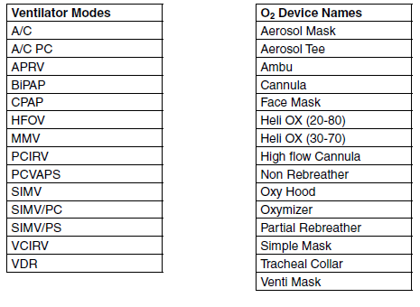

Input Parameters 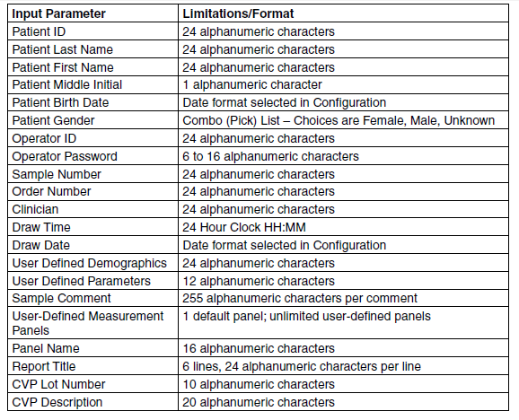

**Entered O2 and Vent Entries**

| **Parameter** | **Description** | **Unit of Measure** | **Resolution or Format** | **Entry Range** |
| --- | --- | --- | --- | --- |
| Mode #1 | Pull-down list is provided at analysis time with the configured and enabled ventilator modes, plus <Key Entry> to allow typing in of a different ventilator mode. | Not Applicable | Alphanumeric | Not Applicable |
| Mode #2 | Pull-down list is provided at analysis time with the configured and enabled ventilator modes, plus <Key Entry> to allow typing in of a different ventilator mode. | Not Applicable | Alphanumeric | Not Applicable |
| O2 Device #1 | Pull-down list is provided at analysis time with the configured and enabled O2 device names, plus <Key Entry> to allow typing in of a different device name. | Not Applicable | Alphanumeric | Not Applicable |
| O2 Device #2 | Pull-down list is provided at analysis time with the configured and enabled O2 device names, plus <Key Entry> to allow typing in of a different device name. | Not Applicable | Alphanumeric | Not Applicable |
| O2 | Oxygen flow | LPM | 0.1 | 0.0 – 99.0 |
| FIO2 | Percent Inspired Oxygen | % | 0.1 | 10.0 - 100.0 |
| Mech VT | Mechanical Tidal Volume | mL | 1 | 0 - 4000 |
| Spont VT | Spontaneous Tidal Volume | mL | 1 | 0 - 4000 |
| Set Minute Vol | Set Minute Volume | L | 0.1 | 0.0 – 99.9 |
| Total Minute Vol | Totak Minute Volume | L | 0.1 | 0.0 – 200.00 |
| Mech Rate(bpm) | Mechanical Rate in bpm | bpm | 1 | 0 – 999 |
| Mech Rate(Hz) | Mechanical Rate in Hz | Hz | 1 | 0 – 999 |
| Spont Rate(bpm) | Spontaneous Rate in bpm | bpm | 1 | 0 – 999 |
| PIP | Peak Inspiratory Pressure | cm H2O | 0.1 | 0.0 – 100.0 |
| MAP | Mean Airway Pressure | cm H2O | 1 | 0 – 999 |
| Itime (sec) | Inspiratory time | sec | 1 | 0 – 10 |
| Itime (%) | Inspiratory time | % | 1 | 0 – 99 |
| PEEP | Positive End Expiratory Pressure | cm H2O | 1 | 0 – 99 |
| CPAP | Continuous Positive Airway Pressure | cm H2O | 1 | 0 – 99 |
| BIPAP(I) | Bi-level Positive Airway Pressure (Inspiratory) | cm H2O | 1 | 0 – 99 |
| BIPAP(E) | Bi-level Positive Airway Pressure (Expiratory) | cm H2O | 1 | 0 – 99 |
| PS | Pressure Support | cm H2O | 1 | 0 – 99 |
| PC | Pressure Control | cm H2O | 1 | 0 – 99 |
| Pulse Ox | Pulse Oximeter | % | 1 | 0 – 100 |
| Flow | Flow | LPM | 1 | 0 – 999 |
| Amplitude | Amplitude | cm H2O | 1 | 0 - 100 |
| Delta P | Delta P | cm H2O | 1 | 0 - 100 |
| High PEEP | High Positive End Expiratory Pressure | cm H2O | 1 | 0 - 99 |
| Low PEEP | Low Positive End Expiratory Pressure | cm H2O | 1 | 0 - 99 |
| IPAP | Inspiratory Positive Airway Pressure | cm H2O | 1 | 0 - 99 |
| EPAP | Expiratory Positive Airway Pressure | cm H2O | 1 | 0 - 99 |
| ASV | Adaptive Support Ventilation | % Support | 1 | 0 - 99 |
| PAV | Proportional Assist Ventilation | % Support | 1 | 0 - 99 |
| Nitric Oxide | Nitric Oxide | ppm | 1 | 0 - 80 |

### Entering comments (Optional)

Comments may be entered on the Enter Information screen. Comments may be free-text entries or selected from pre-defined entries. Comments cannot be edited or deleted after the sample has been accepted. However, operators with permission to do so may add comments after the sample has been accepted. An amended report will automatically be generated if additional comments are included.

### View sample results

After all required patient and sample information have been entered, patient results may be viewed. If required field entries are completed, and Autoverification is not enabled, the View Results tab will display automatically following a short period of inactivity.

When Autoverification is enabled (current setting at RIH/TMH), the operator must select the View Results tab to view patient results. The reason for this is that if Autoverification is enabled, once the View Results tab is displayed, entries on the Enter Information tab cannot be changed except by an operator with a permission level capable of editing patient and sample demographic information.

* **Measured values** – pH, blood gas, electrolyte, and metabolite analyte levels measured during patient sample analysis
* **Temperature corrected values** – displayed only if a patient temperature has been entered in the Required and Optional Information screen
* **CO-Oximetry values** – displayed only if one or more CO-Oximetry analytes are selected for measurement
* **Derived values** – calculated using equations applied to one or more measured analytes only if enabled

If patient reference ranges and critical value limits have been configured, results within the reference range are displayed in green text on a white background. A result outside the reference range, but not above or below a critical limit is displayed in black text on a yellow background. If a result is at, above or below a critical limit it is displayed in white text on a red background. Results in white text on a gray background indicate that no reference range or critical limits have been configured for that analyte.

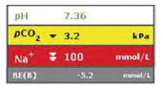

The following exceptions or flags may be displayed along with the sample results.

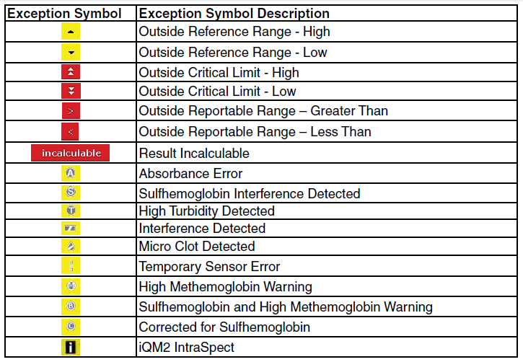

A flagged analyte result should be interpreted with caution, and should be repeated when:

* The result is flagged with an exception symbol when the Flag Results for Interference and Micro Clots is enabled, or
* The result is immediately followed by a message to the operator indicating that any condition exists, which is referenced in the Exception Table above.

#### Flag Results for Interference and Micro Clots *(Not enabled at RIH/TMH)*

When this option is enabled in Configuration, reporting of patient results will be displayed after the post-sample sensor check is completed. The GEM Premier 5000 system will flag analytes if an interference or micro clot is detected through the IntraSpect or Sensor Checks, utilizing the Pattern Recognition Check to determine error cause. When this option is disabled, patient results will be displayed immediately after completion of measurement, and results will not display flags unless an error is detected by IntraSpect check during sample analysis. However, the operator will be presented with a pop-up dialogue message when an interference or clot is detected in the previous sample by the post-sample sensor and pattern recognition checks. The dialogue pop-up message will be displayed until dismissed by the operator.

### Intelligent Quality Management 2 (iQM2) with IntraSpect

Intelligent Quality Management 2 (iQM2) is used as the quality control and assessment system for the GEM Premier 5000 system. iQM2 is an active quality process control program designed to provide continuous monitoring of the analytical process before, *during* and after sample measurement with real-time, automatic error detection, automatic correction of the system and automatic documentation of all corrective actions, replacing the use of traditional external quality controls (QC). Facilities should follow local, state and federal regulatory guidelines to ensure that a total quality management system is followed.

iQM2 is a statistical process control system with well-defined performance characteristics that maximizes probability of error detection, minimizes time to error detection while minimizing probability of false rejection.

iQM2 performs 5 types of continuous, quality checks to monitor the performance of the GEM PAK, sensors, CO-Ox, and reagents. These checks include System, Sensor, the NEW IntraSpect, Pattern Recognition and Stability Checks to ensure the delivery of quality patient results every time. iQM2 utilizes the various checks along with pattern recognition software to identify errors, initiate corrective actions, and document all steps in the corrective action process to assure regulatory compliance, while significantly reducing the time and cost required for performing traditional quality control.

iQM2 performs continuous 5 specific types of quality checks (Figure below) to continuously monitor performance of the GEM PAKs, reagents, CO-Oximetry and sensors throughout the cartridge use-life.

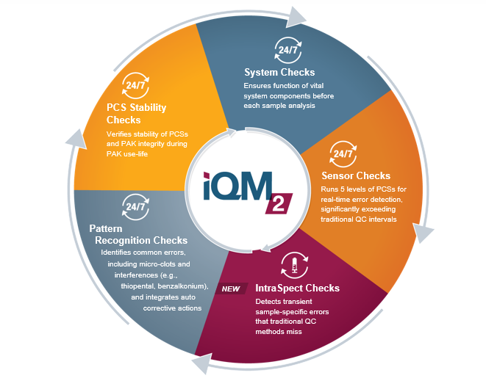

#### iQM2

Upon manufacture at IL and before sensor cards are assembled into GEM PAKs, every

electrochemical sensor is functionally tested using solutions that are NIST-traceable or

traceable to other standards. Sensors test results are documented by sensor card serial

number and sensors that do not meet specifications are discarded. The unique and

proprietary design of the sensor architecture allows for multiple hydration and drying

stages without effecting sensor performance. This ensures that the quality of all sensors

has been confirmed with NIST-traceable solutions prior to PAK manufacturing and clinical

use.

Every lot of PCS is tested and analyte values assigned, using NIST-traceable standards or

other standards prior to assembly into GEM PAKs. PCS values are encoded electronically

through an EEPROM chip on each PAK. Upon PAK insertion, the GEM Premier 5000

system reads and records all factory-assigned information, including lot number, expiration

date, test menu, sample capacity and PCS assigned values and acceptable ranges.

With the iQM2 process, the PCSs are exposed to the sensor and CO-Ox along the same

fluidic pathway as patient samples, including the full extent of the sampler. iQM2 is thus

able to detect any obstructions or malfunctions originating from the sampler through the

entire analytical pathway. After insertion of the GEM PAK into the analyzer, the instrument

performs an automated PAK start-up during which the sensors are hydrated and a variety

of checks occur, all of which take about 40 minutes. PC Solutions are tested and the slope

and intercept of the sensors are compared to factory-assigned values on the EEPROM.

After performing PC Solutions checks, the APV (Auto PAK Validation) process is

automatically completed: two completely independent solutions traceable to NIST

standards, CLSI procedures or internal standards, containing two levels of concentration

for each analyte (PC Solution D and E), APV is run by the analyzer to validate the integrity

of the PCSs and the overall performance of the analytical system (GEM PAK). APV must

be acceptable prior to the GEM Premier 5000 system accepting patient samples.

Once the GEM PAK start-up and APV is completed, iQM2 continuously monitors

performance of the GEM PAK, reagents, CO-Ox module and sensors throughout the

cartridge use-life by five specific quality checks:

• System

• Sensor/CO-Ox

• IntraSpect

• Pattern Recognition (PR)

• PCS Stability

#### IntraSpect

During the sample measurement period, iQM2 software collects 15 sample mV readings in 15 seconds and evaluates sensor performance by abnormal sensor response pattern through slope shape and coefficient values. IntraSpect Checks provide continuous sample integrity quality checks throughout the entire measurement process to ensure accuracy of patient results.

**Note:** iQM2 with IntraSpect technology provides complete quality assurance of results throughout the entire sample measurement process.

IntraSpect can detect abnormal sensor response slope or absorbance residual error during the measurement process.

The following events may cause abnormal sensor response or residual absorbance errors during the measurement process:

* Microclots
* Microbubbles
* Interferences

After performing IntraSpect check in a sample, the affected analyte result becomes either incalculable or flagged for sample response errors.

#### Measured Analyte Reported Ranges

|  |  |  |  |  |  |
| --- | --- | --- | --- | --- | --- |
|  |  | GEM 5000 "REPORTABLE RANGE" | | **Lifespan** Reportable Ranges (Gem5000) | |
|  | ANLYTE | LOWER | UPPER | Lower | Upper |
|  | PH | 6.80 (7.00) | 7.92 | 6.81 | 7.9 |
| mm/hg | PCO2 | 6 | 125 | 16 | 125 |
| mm/hg | PO2 | 6 | 690 | 29 | 630 |
| mmol/l | NA | 100 | 180 | 100 | 180 |
| mmol/l | K | 1.0 | 19.0 | 1.0 | 11.1 |
| mmol/l | CL | 40 | 158 | 63 | 158 |
| mg/dl | CA++ | 0.44 | 17.00 | 0.90 | 14.60 |
| mg/dl | GLU | 4 | 685 | 14 | 685 |
| mmol/l | LAC | 0.3 | 17.0 | 0.3 | 17.0 |
| g/dl | THB | 3.0 | 23.0 | 6.2 | 21.7 |

* The Measuring Range for a parameter is the range where analyte performance claims are verified and validated.

** The Reportable Range for a parameter is the range where software default limits have been configured.

Notes: Analytes with measured values outside the Reportable Range are reported with a > or < symbol. Incalculable will be displayed for results that are outside the measuring capability of the analyzer.

### Derived (Calculated) Parameters

|  |  |  |
| --- | --- | --- |
| Derived Parameter | Unit of Measure | Resoution |
| TCO2 | mmol/L | 0.1 |
| BE(B) (In vitro) | mmol/L | 0.1 |
| sO2(c) | % | 0.1 |
| HCO3- (c) | mmol/L | 0.1 |

### Patient History-

To view patient result trending, press the Patient History button located at the lower right part of the screen when current patient result is being displayed. The analyzer will display the most recent five test results of the same sample type for the current patient. Samples older than one month will not be shown. The delta (Δ) value represents the difference between the current sample and the one prior to it. Patient history is only available with bidirectional interface.

### Reference Ranges

|  |  |  |
| --- | --- | --- |
| **Parameter** | **Lifespan Reference Range** | **Unit** |
| pH Arterial | 7.35 to 7.45 | pH |
| pH Venous | 7.32 to 7.42 | pH |
| *p*CO2 Arterial | 35 to 45 | mmHg |
| *pCO2* Venous | 42 to 50 | mmHg |
| *p*O2 Arterial | 80 to 105 | mmHg |
| *p*O2 Venous | 30 to 50 | mmHg |
| Na+ | >15 years 135 to 145 | mEq/L |
| K+ | >12 years 3.6 to 5.1 | mEq/L |
| Glu | >12 years 67 to 99 | mg/dL |
| Lac | 0.2 to 1.9 | mEq/L |
| Cl- | >15 years 98 to 110 | mEq/L |
| HCO3- Arterial | 22 to 26 | mEq/L |
| HCO3- Venous | 22 to 28 | mEq/L |
| Ca++ Art & Ven | 4.2 to 5.2 | mg/dL |
| O2Hb Arterial (O2Sat) | 95 to 98 | % |
| O2Hb Venous (O2Sat) | 70 to 80 | % |
| TCO2 1+2 ** | 23 to 27 | mmol/L |
| TC02 Venous | 24 to 29 |  |

|  |  |  |
| --- | --- | --- |
| **Parameter** | **Recommended Reference Range** | **Units** |
| Na+ 1+ 2 Art and Ven | <1 month 131 to 143 | mEq/L |
| Na+ | 1 month to 1 year 131 to 145 | mEq/L |
| Na+ | 1 year to 5 year 132 to 143 | mEq/L |
| Na+ | 5 years to 10 years 135 to 143 | mEq/L |
| Na+ | 10 to 15 years 133 to 143 | mEq/L |
| K+ 1 | < 1 month 3.7 to 5.9 | mEq/L |
| K+ | 1 month to 1year 4.1 to 5.3 | mEq/L |
| K+ | 1 year to 12 years 3.4 to 4.7 | mEq/L |
| Cl- 1+ 2 | < 1 month 99 to 116 | mEq/L |
| Cl- | 1 month to 1 year 98 to 118 | mEq/L |
| Cl- | 1 year to 5 years 98 to 116 | mEq/L |
| Cl- | 5 years to 10 years 99 to 114 | mEq/L |
| Cl- | 10 years to 15 years 98 to 115 | mEq/L |
| Hct | Not Applicable | % |
| Glu | < 1 month 50 to 80 | mg/dL |
| Glu | 1 month to 12 years 60 to 100 | mg/dL |
| tHb | Not applicable | g/dL |
| COHb | Non – Smokers < 1.5  Smokers 1.5 to 5.0  Heavy Smokers 5.0 to 9.0 | % |
| MetHb | 0 to 1.8 | % |
| HHb | Not Applicable | % |
| sO2  * | Not Applicable | % |
| BE* | -2.0 to 3.0 | mmol/L |

1 Plasma

2 Serum

*sO2 is a derived parameter calculated from measured CO-Oximetry results

**TCO2 and BE (Base Excess) are derived parameters

*General Normal Ranges*:

1. Burtis, Carl and David Bruns, Tietz Textbook of Clinical Chemistry and Molecular Diagnostics, Elsevier Saunders, 7th edition, 2015, pp 952-982

*CO-Oximetry Normal Ranges:*

1. Burtis, Carl and David Bruns, Tietz Textbook of Clinical Chemistry and Molecular Diagnostics, 7th edition, 2015, pp 952-982
2. Hampson, NB, et al. Practice Recommendations in the Diagnosis, Management and Prevention of Carbon Monoxide Poisoning, Am J Respir Crit Care Med, 2012:186:1095-1101
3. Piantadosi, C.A, Carbon Monoxide Poisoning, New England Journal of Medicine (2002), 347 (14): 1054-1055
4. Radford, EP, Blood Carbon Monoxide Levels in Person 3-74 Years of Age: United States, 1976-1980. National Center for Health Statistics, 1982.
5. Wu, A., Tietz Clinical Guide to Laboratory Tests, W.B. Saunders Co., St. Louis MO, 4th Edition, 2006: 951-982
6. Haymond, S., Oxygen Saturation, A Guide to Laboratory Assessment, Clinical Laboratory News, February 2006, pages 10-12.
7. American Environmental Laboratory: The Laboratory Assessment of Oxygenation. Robert F. Morgan, 1993, 5(4), p. 147-153.

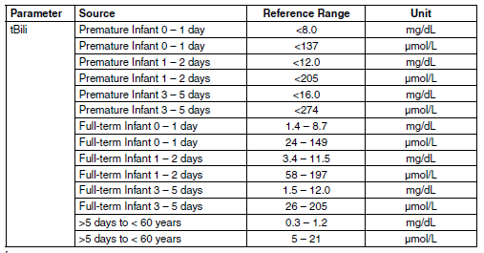

Reference:

Wu, A., Tietz Clinical Guide to Laboratory Tests, W.B. Saunders Co., St. Louis MO, 4th Edition, 2006

### Critical Values

|  |  |  |  |  |
| --- | --- | --- | --- | --- |
| **Parameter** | **Lower Limit** | **Upper Limit** | **Unit** | **Frequency** |
| COHgb | n/a | >20.0 | % | Every time |
| WB Glu | <40 | >450 | mg/dL | Every time |
| WB NA | <120 | >160 | MEQ/L | Every time |
| WB K | <3.0 | >6.0 | MEQ/L | Every time |
| WB CL | <85 | >120 | MEQ/L | Every time |
| WB Lac | N/A | >3.9 | MEQ/L | Every time |
| Art pO2 | < or = 40 | N/A | mmhg | Every 4 hrs |
| Art pCO2 | <20 | >70 | mmhg | Every 4 hrs |
| Art pH | <7.2 | >7.6 | mmhg | Every 4 hrs |
| Ven pCO2 | <20 | >70 | mmhg | Every 4 hrs |
| Ven pH | <7.2 | >7.6 | mmhg | Every 4 hrs |

1 Serum

Critical values will be called to the ordering location following the Pathology Department Critical value policy.

Verified/accepted results on the GEM5000 will cross over to instrument menu in Soft where the technologist can evaluate and verify results.

References:

1. Tietz, N.W., Fundamentals of Clinical Chemistry, W.B. Saunders Co., Philadelphia, 5th Edition, 2001.
2. Shapiro, B.A., Clinical Application of Blood Gases, Mosby, Inc., 5th Edition, 1994.
3. Dellinger R. P. et al, “Surviving Sepsis Campaign: International Guidelines for Management of Severe Sepsis and Septic Shock: 2012”, Critical Care Medicine, 41 (2): 580-637, 2013
4. Levraut J, Ichai C, Petit I, Ciebiera JP, Perus O, Grimaud D. “Low Exogenous Lactate Clearance As An Early Predictor of Mortality in Normolactatemic Critically Ill Septic Patients”, Critical Care Medicine 2003; 31 (3): 705-710.

## Process Control Solution (PCS) Schedules

PC Solutions are performed continuously each day with each PC Solution frequency designated at a scheduled time throughout each day. In addition, PC Solution B will remain over the sensors with readings performed every 30 seconds when samples are not performed, thus providing hundreds of PC Solution quality checks performed each day to ensure sensor and PAK performance throughout the GEM PAK use-life.

**Note:** If an error persists in four consecutive PC Solution C, D or E measurements or in seven consecutive PC Solution A measurements, or in 30 consecutive PC Solution B measurements, then the affected parameter will be permanently disabled.

Only after the above steps are successfully completed will iQM2 adjust any drifts to zero, correcting for normal sensor electronic drift.

iQM2 records all PC Solution sensor readings. This allows IL to use the information for enhanced understanding of patterns, leading to continuous product improvement.

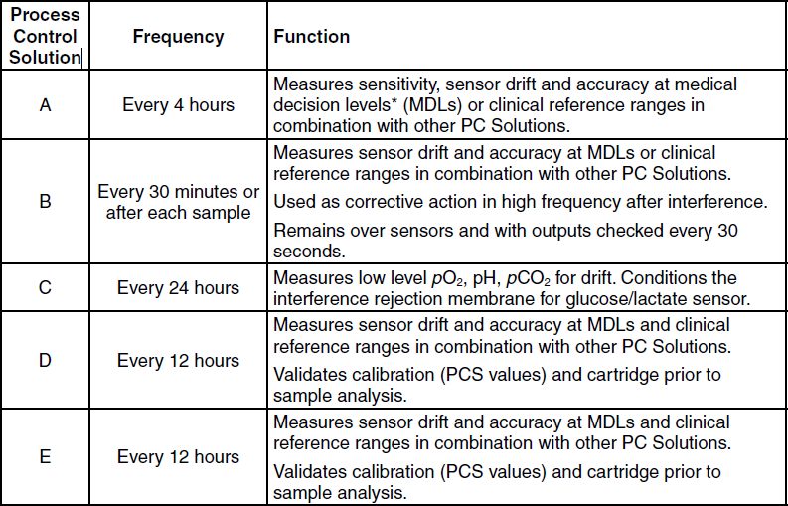

## GEM PAK Removal

Removing the GEM PAK is generally a task that should be performed only when the cartridge is completely used and the analyzer indicates that it needs to be replaced. A supervisor may decide to manually remove a GEM PAK when there are a few tests left for convenience (for example, in the operating room when a cartridge change in the middle of a case is not practical). Once removed from an analyzer, GEM Premier 5000 PAKs cannot be reinserted. Be sure to consult your supervisor before performing this task.

If a GEM PAK has reached its maximum onboard use-life or test capacity, the GEM PAK door will automatically open and display a message to the operator to remove the cartridge.

To remove a cartridge prior to its maximum onboard use-life or test capacity, follow the instructions provided below. Removing the cartridge is a simple operation but requires careful consideration to avoid underutilizing a cartridge.

1. Press the blue **Menu** button in the upper left corner of the screen. Select **Remove**   
   **Cartridge**. If requested, enter your password.

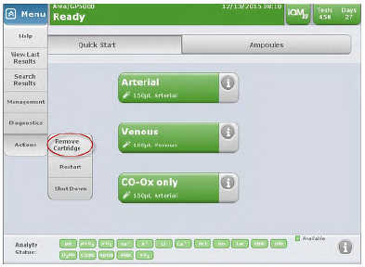

1. As a precaution, the system will ask you whether you want to continue. Press **No** to stop the process and return to the QuickStart tab. Press **Yes** to continue.
2. Once you press **Yes**, the door will click open slightly. Move the door to the left, grasp the GEM PAK, and pull it gently toward you. Dispose of cartridge in an appropriate biohazard container. The system will now be inactive until you reinsert a new PAK (See Cartridge Insertion section).

**NOTE:** Cartridges cannot be reused once they have been removed.

**CAUTION:** The cartridge contains a waste bag that contains blood, a potential biohazard. Use universal precautions as designated by your facility when handling a used cartridge. Dispose of it in an appropriate biohazard waste container.

### Diagnostics

In general, operators will not need to access the Diagnostics area of the analyzer, which includes a range of tasks relevant to the overall status of the GEM Premier 5000 analyzer. This section highlights the key diagnostics tasks available on the analyzer, which are of primary interest to technical personnel.

The Diagnostics function – available via the blue **Menu** button – provides an entry point to perform various diagnostic activities with the analyzer.

1. Press the blue **Menu** button in the upper left corner of the New Sample tab. Select **Diagnostics**. You will see the diagnostic tasks available to you. If prompted, enter your password.

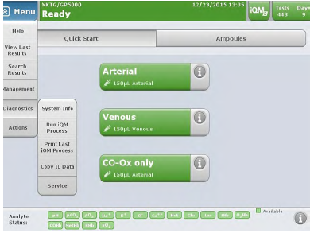

1. Select the area you would like to access:

* **System Info** – provides a snapshot of the system and its operation; it is used primarily by customer support personnel. The software version and analyzer serial number are located here.
* **Analytes** – lists the analyte concentrations in the reagent bags for the selected GEM PAK.
* **Run iQM2 Process.** – The GEM Premier 5000 system performs iQM2 processes automatically. If you receive a prompt to run an iQM2 process, do so through this menu. For example, if an analyte does not pass a CVP specified range, the operator is instructed to run an iQM2 process prior to analyzing a new vial.
* **Print Last iQM2 Process.** – prints the last complete iQM2 process.
* **Copy IL Data** – enables you to copy cartridge data onto a CD, DVD, or USB device. Select the GEM PAK to be copied. The default selection is the most recently inserted cartridge.

**NOTE:** Patient demographic information is removed from the data files when this function is used.

* **Service** – this password-protected area is reserved for authorized service personnel.

## Shutting Down the Analyzer

Shutting down the analyzer is an important step that requires careful consideration before completing. Once the analyzer is shut down you will need to replace the GEM PAK if power is not restored within 60 minutes. If, when power is restored the GEM PAK cannot be recovered, the analyzer will alert the operator to remove the GEM PAK.

1. Press **Menu>Actions>Shutdown** from the pull-down menu.
2. The analyzer will prompt you to consider your decision. Press No to return to the Start New Sample tab. Press Yes to continue to shut down. The analyzer will shut off on its own. The analyzer has now been correctly shut down.

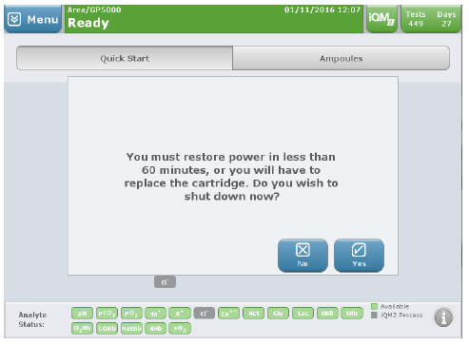

The GEM Premier 5000 system has a momentary power switch. To power the instrument off, it is necessary to utilize the Shut down command in the instrument software, which is accessed through the drop-down Menu. If the power switch is pressed and held for 5 seconds or longer, the instrument will shut down. However, this causes illegal software shut down, and, depending on the event terminated by the illegal shutdown, may shorten the restore power requirement to 20 minutes or reject the installed GEM PAK.

## Instrument Cleaning and Decontamination

### Routine Cleaning

The following paragraphs describe how to clean and disinfect the instrument as necessary. **Cleaning of the GEM Premier 5000 is only required when a blood spill or drops are visible.**

Recommended Supplies:

* Disposable latex or rubber gloves
* Laboratory coat or jacket
* Eye protection
* Soft cleaning cloths
* 10% chlorine bleach solution
* Biohazard waste bags
* Non-abrasive, mild cleaning solution

**The GEM Premier 5000 system processes patient samples that may be highly infectious. When cleaning the instrument use proper technique and care to avoid contaminating yourself or others.**

**Put on rubber or latex gloves, eye protection, and a laboratory coat or jacket before handling the instrument.**

#### Decontaminating the Touch Screen

***To decontaminate the touch screen:***

1. Remove the GEM PAK from the analyzer as described in the Removing the GEM PAK Section.
2. Discard the GEM PAK in a biohazard container.
3. Shut down the instrument as described in Shutting Down the Analyzer Section.
4. Disconnect the instrument from the AC power supply [AC outlet or uninterruptible power supply (UPS)].
5. Dampen a soft cleaning cloth with a mild cleaning solution.
6. Be sure that the cleaning cloth is only moist, not dripping wet.
7. Carefully wipe the face of the touch screen.

**Use only a soft cloth moistened with water or a mild cleaning solution. Do not use an abrasive cleaner or any bleach mixture to clean the touch screen, as this will damage the screen.**

**Make sure the cleaning cloth is only moist, not dripping wet. Avoid letting water or cleaning solution enter the unit enclosure.**

#### Cleaning the Instrument

***To disinfect the instrument:***

1. Disconnect the power cord from the analyzer and from the AC power source.
2. Using a clean, soft cloth moistened with a 10% chlorine bleach solution and wipe down the exterior of the instrument, except for the touch screen.
3. Wipe down the polyester laminate protective sheet on the bottom of the cartridge bay.
4. Wipe the AC power cord completely from end to end using a soft cloth moistened with cleaning solution.
5. Place any used cloth or paper towel in an appropriate biohazard waste bag. Seal the bag and dispose of it in accordance your institution’s procedures for disposing of materials contaminated with biohazard material.

### Decontamination Procedure

Decontamination of the GEM Premier 5000 is only required if the analyzer needs to be shipped, i.e, to a GEM Service Center.

Supplies:

* Disposable latex or rubber gloves
* Laboratory coat or jacket
* Eye protection
* Soft cleaning cloths
* 10% chlorine bleach solution
* Biohazard waste bags
* Non-abrasive, mild cleaning solution
* **CAUTION:** The GEM Premier 5000 analyzer processes patient samples that may be highly infectious. When cleaning the instrument use proper technique and care to avoid contaminating yourself or others.
* **CAUTION:** Put on gloves, eye protection, and a laboratory coat or jacket before handling the instrument.
* **CAUTION:** Prepare a biohazard waste bag for waste disposal.

#### Cleaning the Touch Screen:

**Cleaning the Touch Screen**

You do not need to disconnect the GEM Premier 5000 system from AC power when cleaning the touch screen. However, be careful to prevent water or cleaning solution from entering the unit enclosure.

To clean the touch screen:

1. Dampen a soft cleaning cloth with water or mild cleaning solution.
2. Be sure that the cleaning cloth is only moist, not dripping wet.
3. Carefully wipe the face of the touch screen free of fingerprints and other smudges.

**Use only a soft cloth moistened with water or a mild cleaning solution. Do not use an abrasive cleaner or any bleach mixture to clean the touch screen, as this will damage the screen.**

**Make sure the cleaning cloth is only moist, not dripping wet. Avoid letting water or cleaning solution enter the unit enclosure.**

#### Cleaning the Instrument:

1. Remove the GEM PAK from the analyzer. Discard the GEM PAK in a biohazard container. Once the GEM PAK has been removed, it cannot be reinserted.
2. Shut down the instrument.
3. Disconnect the instrument from AC power supply [AC outlet or uninterruptible power supply (UPS)].
4. Remove any blood or dust from the outer surface of the case using a clean, soft cloth moistened with the 10% chlorine bleach solution.
5. Inspect the GEM PAK bay area and clean the polyester laminate protective sheet on the bottom of the bay as needed.
6. (Optional) With the AC power cord unplugged from the power source, wipe the AC power cord completely from end to end using a soft cloth moistened with cleaning solution.
7. If necessary, remove the instrument from the work surface, and clean the work surface using a cloth or paper towel moistened with the 10% chlorine bleach solution.
8. Place any used cloth or paper towel in an appropriate biohazard waste bag. Seal the bag and dispose of it in accordance your institution’s procedures for disposing of materials contaminated with biohazard material.
9. Reconnect the power cord to a properly grounded and wired AC outlet (AC outlet or UPS). **Make sure the plug and cord are dry before engaging the plug.**
10. Turn on the analyzer by briefly pressing the power button on the left side of the back of the analyzer.
11. The GEM Premier 5000 system starts its power-up cycle and then displays the Insert Cartridge screen.
12. Insert a new GEM PAK.

### Disposing of the Optional Ampoule Breaker

The optional ampoule breaker is a disposable unit and when filled should be disposed of in a suitable biohazard container.

### Installing the Printer Paper

To install the thermal printer paper in the paper area on top of the system:

1. Press the tab at the top of the system to release the door.
2. Open the door and extend paper guide if desired.
3. Place the roll of paper in the compartment so the paper unfurls from the bottom.
4. Press the door firmly closed.

### Replacing the Fuse

There is one fuse that may be replaced by the operator. The fuse is located directly below the power connector and is behind a black cover. The fuse is a 3 Amp, 250 Volt, SLO-BLO fuse, and measures 5 mm x 20 mm. The fuse should be replaced only if, after the power cord is connected to the power source and the power switch is pressed, the analyzer does not respond.

To replace the fuse:

1. Disconnect the instrument from AC power [AC outlet or uninterruptible power supply (UPS)].
2. Remove the black cover using the tabs.
3. Remove the old fuse.
4. Dispose of the old fuse in a container suitable for glass.

**CAUTION:** Dispose of the fuse using a container that is approved for glass disposal.

1. Insert the new fuse.
2. Replace the cover.
3. Reconnect the power cord the instrument to a properly grounded and wired AC outlet (AC oulet or UPS).
4. Turn on the analyzer by briefly pressing the power button on the left side of the back of the analyzer.
5. The GEM Premier 5000 analyzer starts its power-up cycle and then displays the Insert Cartridge screen.
6. Insert a new GEM PAK.

# References

1. Tietz, N.W., Fundamentals of Clinical Chemistry, W.B. Saunders Co., Philadelphia, 5th Edition, 2001.
2. Shapiro, B.A., Clinical Application of Blood Gases, Mosby, Inc., 5th Edition, 1994.
3. CLSI document C46-A, Blood Gas and pH Analysis and Related Measurements; Approved Guideline, Volume 21 Number 14, page 10, section 4.2.1