**Soft Molecular Result Review, Sign-Out Entry and Utilities Procedure**

1. **PRINCIPLE:**
   1. Soft Molecular is a module within the SCC Laboratory Information System. This module automates workflow and manages data and analysis stemming from molecular testing methods in order to generate accurate interpretations and meaningful reports. The system supports the clinical application of Next Generation Sequencing (NGS) as well as other common molecular technologies.
2. **MY ORDERS BINS**:
   1. **General overview:**
      1. Soft Molecular allows samples and tasklists to pend to user group bins within My Orders. To access the bins, click on the **My Orders** tile on the dashboard or the icon on the bottom right of the dashboard window.
      2. Depending on the user’s role, they may have access to some or all bins, including “Molecular Pathologist”, “Director Review”, and “Bioinformatician”. Some users do not have access to any bins.
      3. When a tasklist or order is selected to open, a pop-up will ask the user if they want to assign the item to themselves. Users should not typically assign these items, as this will prevent other users from seeing the items in My Orders. If an item is assigned to a user, it will appear in the “My Pending Activities” section at the top of the window.
      4. **Director Review Bin:**The Director Review bin consists of two sections:
         1. **My Pending Activities:** Displays the tasklists and patient orders that are assigned to the specific user.
            1. Removing a tasklist or patient order that appears in the My Pending Activities tab:

Highlight the correct row using the pin icon. 

Click the **Reassign** button in the middle of the screen. 

The tasklist, or patient order will now appear in the pending list on the Director Review tab.

* + - 1. **Director Review tab:** Displays the tasklists and patient orders that are pending a Director Review action.
         1. Opening a tasklist or patient order:

Double click the correct row in the pending list.

Select **No** when asked to assign to yourself.

The tasklist or patient order record will now be displayed on the screen.

Click the **Back** button to return to the Director Review bin.

* 1. **Bioinformatics bin:**
     1. For samples that require rerun, please refer to the Molecular Genomic Pathology Laboratory *Soft Molecular Rerun Procedure.*
     2. The Bioinformatics bin consists of two sections:
        1. **My Pending Activities:** Displays the tasklists and patient orders that are assigned to the specific user.
           1. Removing a tasklist or patient order that appears in the My Pending Activities tab:

Highlight the correct row using the pin icon. 

Click the **Reassign** button in the middle of the screen. 

The tasklist or patient order will now appear in the pending list on the Bioinformatics tab.

* + - 1. **Bioinformatics tab:** Displays the tasklists that are pending a Bioinformatics action.
         1. Opening a tasklist or patient order:

Double click the correct row in the pending list.

Select **No** when asked to assign to yourself.

The tasklist or patient order record will now be displayed on the screen.

Click the **Back** button to return to the Bioinformatics bin.

* 1. **Molecular Pathologist Bin:**
     1. The Pathologist Bin consists of two sections:
        1. My Pending Activities: Displays the tasklists and patient orders that are assigned to the specific user.
           1. Removing a tasklist or patient order that appears in the My Pending Activities tab:

Highlight the correct row using the pin icon. 

Click the **Reassign** button in the middle of the screen. 

The tasklist or patient order will now appear in the pending list on the Director Review tab.

* + - 1. Molecular Pathologist tab: Displays the tasklists for review or patient orders that are pending for Sign-Out.
         1. Opening a tasklist or patient record:

Double click the correct row in the pending list.

Select **No** when asked to assign to yourself.

The tasklist or patient sample record will now be displayed on the screen.

Click the **Back** button to return to the Molecular Pathologist bin.

1. **RESULT REVIEW:**
   1. Depending on the workflow of the test, results may be reviewed in one or multiple ways in Soft Molecular, including worksheets, tasklists, and/or Test Review Entry.
   2. **Test Review Entry Overview:**
      1. The Test Review Entry window is used to review the interpretation of an order.
      2. Orders cannot be edited by multiple users at the same time. If an order is locked, or in use, it can be opened in Read Only mode and reviewed, but not edited.
      3. The Interpretation Review Entry window is comprised of five sections: Patient Info, Order Panel, Test Results, Other Info tabs, and Final Interpretation tab.
         1. **Patient Info:** These fields are read-only. Edits can only be made in Patient Maintenance. Includes information such as Patient Name, Medical Record Number, Age, Date of Birth, Gender, Billing Number, Clinic, and Attending Doctor.
         2. **Order Panel:** Displays information about the current order and tests for the patient including Soft Molecular Order#, Soft Lab Order#, and Order Status.
         3. **Test Results:** If multiple tests are ordered, multiple tabs will appear in the Test Results panel. The tabs contain the resulted test information and a field for the interpretation result, if required. Fields displaying the Worksheet and Reviewed By are included in this panel.
         4. **Other Info tabs:** Provides information that is found in Order Entry. The tabs include Tests, Specimen, Internal Notes, Scanned Doc/Images, Reports, and Test History.
         5. **Final Interpretation tab:** Displays the Final Interpretation.
   3. **Customizing the Test Review Entry window:**
      1. Right click in the area of the Test Review Entry window you wish to customize.
      2. In the dropdown menu that appears, select **Customize Patient Header** or **Customize Order Panel**.
      3. The selected Customization menu will appear. Click the desired field and drag it to the correct location in the window.
      4. Resize the fields by clicking and dragging the field to expand.
   4. **Samples for re-run:** For samples that require rerun, please refer to the Molecular Genomic Pathology Laboratory *Soft Molecular Rerun Procedure.*
2. **SIGNING OUT REPORTS:**
   1. **Sign Out Entry Overview:**
      1. The Sign Out Entry window is broken into four sections: Patient Demographics and Order Information, Test Result, Order Entry tabs, and Final Test Specific Interpretation tabs.
         1. **Patient Demographics and Order Information:** Displays patient demographic information and pertinent order information, including Patient Name, Medical Record number, Billing number, Clinic, Soft Molecular Order number, Requesting Doctor and Order Status.
         2. **Test Result:** Displays the results from each test on separate tabs. When a Test Result tab is selected, the system automatically selects the corresponding Final Test Specific Interpretation tab to ensure that interpreted results are not entered on the incorrect tab.
         3. **Order Entry tabs:** Displays information that can also be found in Order Entry. The tabs include Tests, Specimens, Internal Notes and Scanned Doc/Images.
         4. **Final Test Specific Interpretation tabs:** Displays the Result, Interpretation and Supplemental Comment if applicable.
   2. **Interpretation Result Entry Overview:**
      1. Some tests may use Interpretation Result Entry instead of Sign Out Entry for signing out results.
      2. The Interpretation Result Entry window is broken into four sections: Patient Demographics and Order Information, Test Result, Order Entry tabs, and Final Test Specific Interpretation tabs.
         1. **Patient Demographics and Order Information:** Displays patient demographic information and pertinent order information, including Patient Name, Medical Record number, Billing number, Clinic, Soft Molecular Order number, Requesting Doctor and Order Status.
         2. **Test Result:** Displays the results from each test on separate tabs. When a Test Result tab is selected, the system automatically selects the corresponding Final Test Specific Interpretation tab to ensure that interpreted results are not entered on the incorrect tab.
         3. **Order Entry tabs:** Displays information that can also be found in Order Entry. The tabs include Tests, Specimens, Internal Notes and Scanned Doc/Images.
         4. **Final Test Specific Interpretation tabs:** Displays the Result, Interpretation and Supplemental Comment if applicable.
   3. **Signing-out a case:**
      1. Edit the information in the various fields, as appropriate. For text formatting (bold, italics, etc.), buttons are available in the Home ribbon menu.
      2. Upon completion of review, click the **Completed** checkbox at the bottom of the Sign Out Entry or Interpretation Result Entry window. An electronic signature with date and time will populate in the corresponding fields.
      3. Click the **Sign Out** button found in the Home ribbon menu.
      4. In the Report Preview window that appears, verify the report populated correctly. If any data needs to be edited, some fields can be highlighted in the Report Preview and directly edited. Buttons for formatting are also available. However, if a particular field of interest cannot be edited, exit the preview window and edit the information in Sign Out Entry or Interpretation Result Entry, as appropriate for the test.
      5. In the Report Preview window, click the **Sign-Out** button. The Report Preview window will automatically close, and the case status will appear as Signed Out.
   4. For samples that require rerun, please refer to the Molecular Genomic Pathology Laboratory *Soft Molecular Rerun Procedure.*
   5. When testing is performed on a non-validated sample, a comment should be entered on the Final Report, such as:
      1. “This assay has not been validated for this specimen source; however, testing was performed with Laboratory Director approval. Results should be interpreted with caution and clinical correlation is recommended.”
   6. Fresh/Frozen tissue is currently not a sample type available in Lifespan’s Soft Molecular. When testing is performed on Fresh/Frozen tissue, the specimen can be accessioned as an FFPE Block. When the case is signed-out, a comment can be entered for clarification, such as:
      1. “The indication of FFPE tissue above is a limitation of the lab information system. Testing was performed on fresh/frozen tissue.”
   7. We have canned messages available for Colorectal cancer cases with loss of MLH1 by IHC.
      1. Change the drop-down to “All Resulting” and then search for “MLH1”
      2. There is a canned message for the Interpretation #2, depending on if the BRAF results is positive or negative (requires MLH1 hypermethylation sendout).

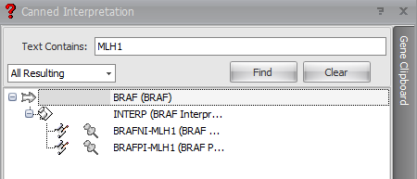

1. **UTILITY:**
   1. This menu can be used for a variety of functions, including: tracking changes in the system, managing locked records, and print administration.
   2. **Lock Info**:
      1. The Lock Info option is used to search for and unlock orders. If a patient sample is locked by another user, investigate and discuss with the Laboratory Manager, Director(s), or Pathologist prior to unlocking.
      2. Click the dropdown arrow on the Utility tab located on the Main Menu.
      3. Select the **Utilities** button, followed by the **Lock Info** button.
      4. Under the Order Locks tab, enter the patient sample Soft Molecular Order# in the Order# field and select **Find**.
      5. Highlight the applicable patient sample and click **Unlock**.
      6. Click the **Close** button to exit the window.
   3. **Connect a computer to RMOLG workstation:**
      1. On the left side of the Soft Molecular window, click **Setup**, followed by **Organization**.
      2. In the Organization window, double-click the **Workstation** tile.
      3. Verify the RMOLG workstation is highlighted. Then, click **OK**.
      4. In the Workstation window, select the **PC/Hosts** tab.
      5. In the empty field at the bottom of the list, enter the computer name. Then, click **Save**.
      6. Select **Back** to exit the Workstation window.
         1. **Note:** If a computer has both Soft Molecular LIVE7 and Soft Molecular TEST7, steps 1-6 must be repeated in both environments.
   4. **Basic Print Admin Functionality:** The Soft Molecular reports are currently set to fax to certain clients one time daily from Sunday – Thursday at 8PM in addition to any on demand faxes. The Fax Log should be checked once in the morning around 8AM for any failures from the previous evening and then once in the afternoon around 4PM for any failures from on demand faxing from that day. Any fax fails will need to be resent and then checked to confirm the resend was successful.
      1. Sign into Soft Molecular. 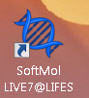
      2. In the main menu, select **Utility.** In the dropdown that appears, select **Utilities**.
      3. Double click the **Print Admin Utility** tile.

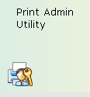

* + 1. In the Reports Distribution Administration Console window that displays, click on the **Fax Queue** tab.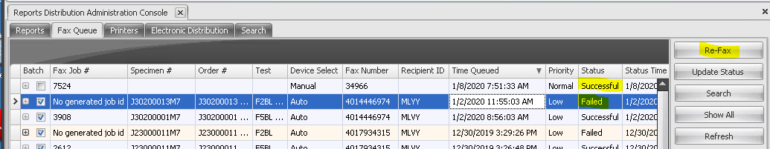
    2. In the Status column, search for Failed jobs in the last day or since the last time the Fax log was checked.
    3. Highlight the entry and click on the **Re-Fax** button to send the job to the original fax number.
    4. Click the **OK** button. 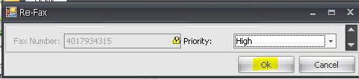
    5. To check on any resend, click on the plus sign to expand the line and column and confirm the status of the resend is successful. 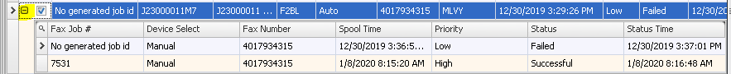
       1. **Note:** Documents with a status of Absorbed had two documents that were available to send before the scheduled job ran and the earlier document was absorbed into the later document. Therefore, this status can be ignored. If desired, there is a **Show/Hide Absorbed Reports** icon on the toolbar that can be used to filter out the entries in an Absorb status.
       2. There is a Search options available to help look up the fax status for a Soft order number.
          1. Click the **Search** button.
          2. In the Fax Search Dialog box, enter the Soft order number in the Order# field and click **OK**.
  1. **Resending Reports to the HIS from Soft Molecular.**
     1. The Resend Events function in SoftMol is used to resend test results for an order via the result reporting interface.
     2. In the main menu, select **Utility.** In the dropdown that appears, select **Utilities**.
     3. Double click the **Resend Events** tile. 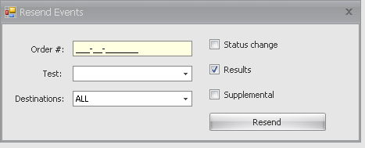
     4. Enter the order number of the result to be resent.
     5. Using the dropdown menu, select the test to be resent.
     6. The Destination field should display **ALL**.
     7. Verify the **Results** checkbox is marked.
     8. Click the **Resend** button. 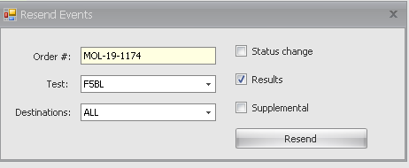
     9. A warning will appear, ‘Do you want to resend result only for indicated test?’. Click **Yes**.
     10. A message will appear, ‘Results sent successfully.’ Select **OK**.
  2. Additional functions in this menu are related to billing, audit trails, and administration functions for Soft Molecular. See Soft Molecular – Super User Manual for more details.

1. **PRINTING AND FAXING REPORTS FROM SOFT LAB**:
   1. **View, Print, and Fax Soft Molecular Results in Soft Lab Query:**
      1. Double click the Soft Lab icon to open the program. 
      2. Enter Login ID and Password and click **OK**.
      3. Click the **Lab Results Query** button.
      4. Enter patient demographic information in the Search window and click **Query**.
      5. Expand the encounter by selecting the **+** icon next to the patient Billing number.
      6. Highlight the desired order.
      7. Select the **Tools** button.
      8. In the dropdown menu that appears, select **Other Clinical Tests**.
      9. Select the tab with the correct test.
         1. Only tests that are Signed Out or Revised will be able to be printed.
         2. Each test must be printed or faxed separately.
         3. **NOTE: Do not provide results from the Interpretation View screen as they are not formatted correctly.**
      10. Click the **Show Report** hyperlink in the lower right-hand corner of the Other Clinical Tests window.
      11. **Print the Report:**
          1. Click the **Print** button in the Report Viewer window.
          2. In the Select Printer or Fax window, select the desired printer and click **Print**.
      12. **Fax the Report:**
          1. Click the **Fax** button in the Report Viewer window.
          2. Highlight desired clinic or doctor and select **Append**. The selection will move to the bottom of the screen.
             1. Doctors appear in the list by Soft ID code. To verify the correct Doctor was selected to receive the fax:

Select the dropdown arrow in the Choose specific Client field.

In the Doctor Profile window that appears, enter the provided Soft ID in the Doctor Code field and click **Find**.

Verify the Soft ID matches the name of the correct Doctor.

* + - 1. Select **Fax**.
    1. **Fax to Remote Printer:**
       1. Click the **Fax** button in the Report Viewer window.
       2. Select the **Remote Printers** tab.
       3. Highlight the desired remote printer and click **Fax**.

1. **TROUBLESHOOTING:**
   1. For troubleshooting, refer to the Soft Molecular – Super User Manual.
   2. For additional troubleshooting, refer to the Molecular Genomic Pathology *Soft Molecular Troubleshooting Procedure*.
2. **REFERENCES:**
   1. Soft Molecular: Diagnostic Genetics Laboratory Intuitive Workflow Solution – Super User Manual, MOL4.1.1 – SU 1st Ed. August 2016.
3. **REVISIONS:**
   1. 4/28/2021: Instructions were added on how to add a computer to the RMOLG workstation.
   2. 10/27/2022: Added instructions for non-validated sources, and canned messages for colorectal cases.