**NextSeq 500 Instrument Procedure**

1. **PRINCIPLE:**
   1. The NextSeq 500 platform is a Next Generation Sequencing (NGS) instrument that measures fluorescence signals of labeled nucleotides using instrument specific reagents and flow cells, imaging hardware, and data analysis software. Illumina’s NextSeq system utilizes Sequencing-By-Synthesis (SBS) technology, integrating cluster generation, sequencing, and data analysis on a single instrument.
   2. The NextSeq 500 platform (see Figure 1-3) combines the power of high-throughput sequencing, which enables the sequencing of exomes, whole genomes, and transcriptomes with the simplicity of a desktop sequencing instrument.
      1. Real-Time Analysis: Integrated analysis software performs on-instrument data analysis which includes image analysis and base calling.
      2. BaseSpace Integration: The Illumina genomics computing environment for data analysis, storage, and collaboration.
      3. In addition to BaseSpace, the integrated NextSeq Control Software (NCS) guides the user through all the steps to load consumables and start a run (see Figure 2).
   3. Cluster generation and sequencing are performed on-instrument. The run steps include:
      1. Cluster Generation: Single DNA molecules are bound to the surface of the flow cell, which is randomly coated with oligos that are complementary to Library Adapters and then amplified to form clusters.
      2. Sequencing: Clusters are imaged using 2-channel Sequencing-by-Synthesis chemistry and filter combinations specific to each of the fluorescently labeled chain terminators. After imaging of a tile on the flow cell is complete, the next tile is imaged. The process is repeated for each cycle of sequencing. Following image analysis, the software performs base calling, filtering, and quality scoring.
      3. Analysis: After the completion of sequencing, the data may be transferred automatically or manually to a specified output location for secondary analysis.
         1. **NOTE:** If the run is set-up to output files to a specified location: as the run progresses, the NextSeq Control Software automatically transfers base call files to the specified output location for secondary analysis.
         2. **NOTE:** The NextSeq 500 kits also include Accessory Box 2 (Not pictured), which is the Hybridization Buffer (HT1) used during Library Loading

**Figure 1: The NextSeq 500 Instrument**



**Figure 2: The NextSeq 500 Home Screen (NextSeq Control Software Guide)**

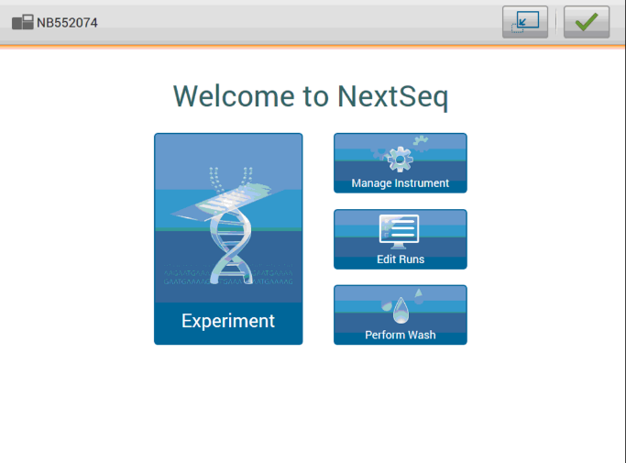

**Figure 3: The NextSeq 500 Kit Components (l-r: Flow Cell, Reagent Cartridge, and Buffer Cartridge)**

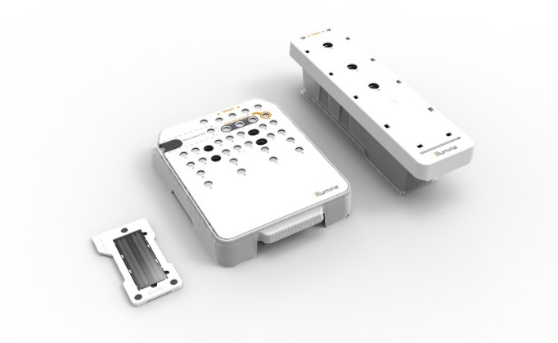

1. **PROCEDURE OF OPERATION:**
   1. **Starting the NextSeq 500:**
      1. For the best performance, leave the instrument on continuously with the exception of scheduled power-downs.
      2. A Power Cycle is performed once per week as part of instrument maintenance. Please refer to the Maintenance section for further instructions.
   2. **NextSeq 500 Workflow:**
      1. Prepare the Reagent Cartridge:
         1. Remove Reagent Cartridge from -20° C freezer to thaw.
         2. Option 1 (preferred): Thaw overnight at 2° to 8°C.

**NOTE**: The cartridge can be stored at 2° to 8°C for up to 1 week.

* + - 1. Option 2: Place Reagent Cartridge in a room temperature water bath for 60-90 minutes.

**NOTE**: Do not submerge above lower lid edge.

**NOTE**: If thawed in a room temperature deionized water bath for 60-90 minutes, place on ice or set aside at 2°C to 8°C and use as quickly as possible or within the same day.

* + - 1. Ensure all reagents are fully thawed.
      2. Manually invert cartridge 5 times to mix.
      3. Gently tap the cartridge on a hard surface to remove bubbles and dislodge water from cartridge base.
      4. Dry the base of the cartridge with clean paper towel.
      5. Inspect the Reagent Cartridge for any damage or leak and ensure that positions 29, 30, 31, and 32 are completely thawed.
    1. Prepare the Flow Cell:
       1. Remove a new Flow Cell from the refrigerator.
       2. Set the unwrapped Flow Cell package aside at room temperature for at least 30 minutes before use.
          1. **NOTE**: The Flow Cell can remain at room temperature for up to 12 hours; avoid repeated cooling and warming of the Flow Cell.
    2. Prepare the Buffer Cartridge:
       1. Manually invert cartridge 5 times to mix.
       2. Gently tap the cartridge on a hard surface to remove bubbles.
       3. Inspect the Buffer Cartridge to ensure there is no damage or leak.
    3. Loading Libraries into the Reagent Cartridge:
       1. Use a clean Kim wipe to clean the foil seal covering position #10 (the reservoir labeled **Load Library Here**).
       2. Using a clean 1mL pipette tip, pierce the foil seal and create a wide enough opening for Library loading.
       3. Load the Libraries into reservoir #10. Refer to the assay specific procedures to determine final loading volume.
       4. Pipette slowly and avoid creating air bubbles when loading Library.
  1. **Starting a run on the NextSeq 500:** 
     1. **NOTE:** Please refer to the appropriate assay specific procedure to program a run on the NextSeq 500. Refer to Figure 4 below for the NextSeq 500 run setup screens.
     2. Loading NextSeq 500 Consumables:
        1. Each consumable loaded onto the NextSeq contains a unique RFID, which is recognized by the NCS, allowing the software to automatically populate the barcode numbers of each consumable.
     3. Load the new flow cell:
        1. **NOTE**:
           1. Do not touch the surface of the flow cell.
           2. After the foil packaging has been opened, the flow cell must be used within the next 12 hours.
        2. Open the foil package and then remove the flow cell cartridge from the plastic clamshell casing.
        3. Visually inspect the flow cell for any damage/defect.
        4. Align the new flow cell over the alignment pins and place on the stage.
        5. When properly inserted, the software will recognize the RFID.
           1. See the Troubleshooting section for more information if an error occurs.
        6. Select **Load**.
           1. The door closes, the RFID appears on the screen, and the sensors are checked.
        7. Select **Next**.
     4. Load the Buffer Reagent:
        1. When prompted, open the Buffer compartment door, and remove the spent reagents container. Discard the contents in the appropriate waste container.
        2. Remove the used Buffer Cartridge from the previous run or the Wash Buffer container and discard the contents in the appropriate waste container.
        3. Slide the empty spent reagents container into the buffer compartment until it stops.
        4. Slide the new Buffer Cartridge into the buffer compartment until it stops.
           1. An audible click indicates that the cartridge is in position, the Buffer Cartridge RFID appears on the screen, and the sensor is checked.
        5. Close the buffer compartment door and select **Next**.
     5. Load the Reagent Cartridge:
        1. When prompted, open the Reagent Cartridge door, and remove the used Reagent Cartridge from the previous run or the Wash Reagent Cartridge container and discard the contents in the appropriate waste container.
        2. Slide the new loaded Reagent Cartridge into the Reagent Cartridge compartment until the cartridge stops.
        3. Close the compartment door.
        4. Select **Load**.
           1. The instrument moves the cartridge into position (~30 seconds), the Reagent Cartridge ID appears on the screen, and the sensors are checked.
        5. Select **Next**.
           1. A review screen with the Run Setup parameters will appear; confirm that the Run Setup entries are correct and edit if necessary.
        6. Select **Next** to move to the Pre-Run Systems Check.
     6. Automated System Check (see Figure 5): The software performs an automated check of the system. During the system check, the following indicators may appear on the screen:
        1. Gray  checkmark: System check has not been performed yet.
        2. Progress icon: System check is in progress.
        3. Green checkmark: System check passed.
        4. Red : System check failed.
           1. **NOTE**: For any item that does not pass, an action is required before you can proceed (Refer to the Troubleshooting section for more information).
           2. **NOTE**: To view the results of each individual check within a category, select the arrow down icon to expand the category.
     7. Start the Run: When the automated check is completed, the run will Start automatically.

**Figure 4A and B:** The NextSeq 500 Run Setup Screens

**Figure 5:** The NextSeq 500 Automated Pre-Run System Check Screen

* 1. **Monitor Run Progress:** 
     1. Run Progress shows the current step and number of cycles completed for each **Read**. (Figure 6, A)
        1. In addition, the user can also monitor the run quality by viewing several Quality Control (QC) metrics.
        2. QC metrics are displayed on the screen (after cycle 25) and by accessing the Sequencing Analysis Viewer software (SAV), which shows sequencing metrics generated during the run.
        3. These metrics include:
           1. **Quality score (Q-score)** (Figure 6, B):

The Q-score is a prediction of the probability of an error in base calling. The percentage of bases > Q30 is averaged across the entire run. A higher Q-score implies that a base call is higher quality and more likely to be correct.

Optimal %Q30 for a NextSeq® 500 sequencing run is 75% or greater. Refer to *Quality Scoring* on page 46 of the NextSeq® 500 System Guide for more information.

* + - * 1. **Intensity** (Figure 6, C):

Shows the value of cluster intensities of the 90th percentile for each tile.

Plot colors indicate each base:

Red = A

Green = C

Blue = G

Black = T.

* + - * 1. **Cluster Density (K/mm2)** (Figure 6, D):

Shows the number of clusters on the Flow Cell detected per run.

Optimal Cluster Density for a NextSeq® 500 sequencing run is 170-220 K/mm2.

* + - * 1. **Clusters Passing Filter (%PF)** (Figure 6, E):

Shows the percentage of clusters/reads that pass Illumina®’s internal quality filtering metric called “Chastity Filter”.

The Chastity Filter is defined as the ratio of the brightest base intensity, divided by the sum of the brightest and second brightest base intensities.

Clusters of reads pass the filter if no more than 1 base call has chasity value below 0.6 in the first 25 cycles.

This filtration process removes the least reliable clusters from the image analysis results.

Optimal %PF for a NextSeq® 500 sequencing run is 80% or greater. For additional information, refer to *Clusters Passing Filter* on page 46 the NextSeq® 500 System Guide.

**Figure 6:** The NextSeq® 500 Run Progress Screen

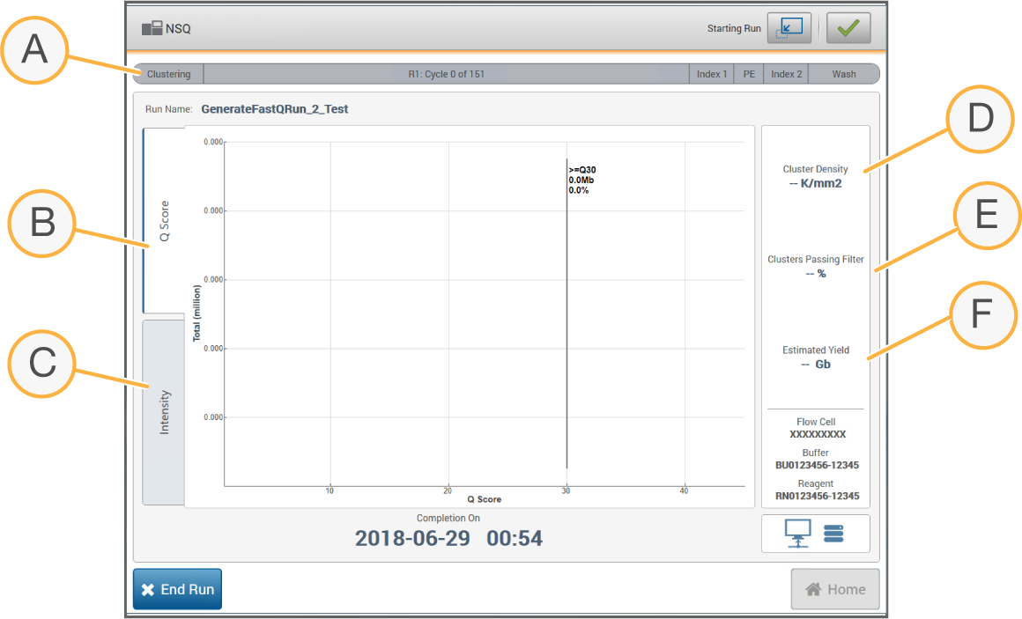

* 1. **Automated Post-Run Wash:** 
     1. When the sequencing run is finished, the software automatically initiates a post-run wash using the wash solution provided in the Buffer Cartridge and the NaOCl provided in the Reagent Cartridge.
     2. The post-run wash takes approximately 90 minutes.
     3. Following the wash, the sippers remain in the down position to prevent air from entering the system. Leave the cartridges in place until the next run.

1. **TRANSFERING NEXTSEQ DATA:**

Refer to the appropriate assay specific procedure for instructions on the manual transfer of data.

1. **MAINTENANCE:**
   1. **Weekly Maintenance:** 
      1. Power Cycle/Instrument Shut Down: This must be performed between each Sequencing run.
         1. On the Home Screen, select **Manage Instrument**.
         2. Select **Shutdown Options**.
         3. Select **Shutdown** andthen**, Yes**. The Shut Down command safely shuts down the software and turns off instrument power.
         4. Wait until the instrument completely powers off then, turn the power toggle switch in the back of the instrument to the OFF position.
         5. Wait for 3 minutes and turn the power toggle switch back to the ON position.
         6. Wait for 60 seconds and press the power button on the front of the instrument to turn the instrument on.
         7. Initiate the NextSeq® Control Software (NCS):
            1. After the instrument powers back on, depress the Ctrl, Alt, and Delete keys on the keyboard
            2. Select the **sbsuser** account and enter the password
         8. The NCS launches and the initialization process takes a few minutes to complete.
         9. If the instrument fails to initialize:
            1. Repeat the power cycle.
            2. If the problem persists, contact Illumina Technical Support.
      2. Clean the Exterior of the Instrument: required once a week.
         1. Lightly dampen some paper towel with water and wipe down the exterior of the NextSeq®, Servers, and Keyboard to get rid of dust and dirt.
         2. Clean the NextSeq® touch screen by gently wiping with a Glass/LCD anti-static wipe.
      3. Quick Wash: required once a week (must be performed before the next sequencing run).
         1. The weekly quick wash is performed with laboratory-grade deionized water.
            1. However, a tween solution can be made as needed.
            2. Combine the following volumes in a 50mL conical tube to result in a 0.05% Tween 20 wash solution:
            3. 20 µL of 100% Tween 20 and 40 mL of laboratory-grade water.
         2. Add the entire wash solution to the center reservoir of the buffer wash cartridge.
         3. On the Home Screen, select **Perform Wash**.
         4. Then, select **Quick Wash**.
         5. Load a used High Output Flow Cell onto the Flow Cell stage.
         6. Click **Load** then, select **Next**.
         7. Remove the spent reagents container and discard the contents in the appropriate waste container.
         8. Slide the empty spent reagents container into the buffer compartment until it stops.
         9. Remove the used Buffer Cartridge from the previous run.
         10. Load the buffer wash cartridge containing laboratory-grade deionized water.
         11. Remove the used Reagent Cartridge from the previous run.
         12. Load the reagent wash cartridge.
         13. Select **Next**. The prewash check begins automatically.
         14. Select **Start**. The wash takes 20 minutes.
         15. When the wash is complete, select Home.
             1. **NOTE:** After the wash, the sippers remain in the down position to prevent air from entering the system. Leave the cartridges in place until the next run.
   2. **As-needed Maintenance:** 
      1. **Delete NextSeq Output Data:**
         1. Upon completion of data analysis, the run folder can be deleted from the Output folder on the instrument.
      2. **Manual Post-Run Wash:** As needed (i.e., System failure or Run Aborted).
         1. Combine the following volumes in a microcentrifuge tube to result in 1 mL:
            1. 24 µL of 5% NaOCl and 976 µL of laboratory-grade water.
         2. Invert the tube to mix.
            1. Add 1 mL of 0.12% NaOCl to the reagent wash cartridge. The correct reservoir is equivalent to position #28 on the prefilled cartridge.
         3. Combine the following volumes to result in a 0.05% Tween 20 wash solution:
            1. 62 µL of 100% Tween and 125 mL of laboratory-grade water.
         4. Add the entire wash solution to the center reservoir of the buffer wash cartridge.
         5. On the Home Screen, select **Perform Wash**, and then select **Manual Post-Run Wash**.
         6. If a used Flow Cell is not present, load a **used** Flow Cell. Select **Load** and then select **Next**.
         7. Remove the spent reagents container and discard the contents in the appropriate waste container.
         8. Slide the empty spent reagents container back into the buffer compartment until it stops.
         9. Remove the used Buffer Cartridge from the previous or aborted run.
         10. Load the buffer wash cartridge containing the wash solution.
         11. Remove the used Reagent Cartridge from the previous or aborted run.
         12. Load the reagent wash cartridge onto the instrument.
         13. Select **Next**. The pre-wash check begins automatically.
         14. Select **Start**. The wash takes 90 minutes to complete.
         15. When the wash is complete, select **Home**.
             1. **NOTE:** After the wash, the sippers remain in the down position to prevent air from entering the system. Leave the cartridges in place until the next run.
   3. **Software Update:** Software updates can be installed automatically using an internet connection or manually from a network or USB location.
      1. **NOTE**: Updates should only be performed with Director approval, when the instrument is not in use, and at an appropriate time. Updates should be validated as per standard laboratory procedures.
      2. Automatic software updates – for instruments connected to a network with internet access:
         * 1. Select **Manage Instrument**.
           2. Select **Software Update**.
           3. Select **Install the update already downloaded from BaseSpace**.
           4. Select **Update** to begin the update. A dialog box opens to confirm the command.
           5. Follow the prompts in the installation wizard: accept the licensing agreement, review the release notes, and review the list of software included in the update.
           6. When the update is complete, the control software restarts automatically.
      3. Manual software updates – download the System Suite installer from the Illumina® website and save it to a network location. Alternatively, copy the software installation file to a portable USB drive:
         * 1. Select **Manage Instrument.**
           2. Select **Software Update**.
           3. Select **Manually install the update from the following location.**
           4. Select **Browse** to navigate to the location of the software installation file, and then select **Update.**
           5. Follow the prompts in the installation wizard: accept the licensing agreement, review the release notes, and review the list of software included in the update.
           6. When the update is complete, the control software restarts automatically.
2. **TROUBLESHOOTING:**
   1. For technical questions and support, visit the NextSeq 500 support pages on the Illumina website or contact Illumina Technical Support. See the **Contact Information** section for contact info.
      1. **NOTE**: Always fill out the NextSeq Instrument Problem Log for any troubleshooting issue
         1. Problem Log can be found with the NextSeq 500 Instrument Binder.
   2. Below is a list of errors that could occur during the automatic Pre-Run System Check. If a Pre-Run check fails, follow the recommended action to resolve the error.

|  |  |
| --- | --- |
| **System Checks** | **Recommended Action** |
| Doors Closed | Make sure that the compartment doors are closed. |
| Consumables Loaded | Consumable sensors do not register. Make sure that each consumable is properly loaded. On the Run Setup screens, select **Back** to return to the loading step, and repeat Run Setup. |
| Required Software | Critical components of the software are missing. Perform a manual software update to restore all software components. |
| Instrument Disk Space | The instrument hard drive does not have sufficient disk space to perform a run. It is possible that data from a previous run did not transfer. |
| Network Connection | The network connection has been interrupted. Check network status and the physical network connection. |
| Network Disk Space | Either the BaseSpace account is full or the network server is full. |
| Temperature | Contact Illumina® Technical Support. |
| Temperature Sensors | Contact Illumina® Technical Support. |
| Fans | Contact Illumina® Technical Support. |
| Imaging Limits | Contact Illumina® Technical Support. |
| Z Steps-and-Settle | Contact Illumina® Technical Support. |
| Bit Error Rate | Contact Illumina® Technical Support. |
| Flow Cell Registration | It is possible that the Flow Cell is not properly seated: On the Run Setup screens, select **Back** to return to the Flow Cell step. The imaging compartment door opens. Unload and reload the Flow Cell to make sure that it is seated properly. |
| Valve Response | Contact Illumina® Technical Support. |
| Pump | Contact Illumina® Technical Support. |
| Buffer Mechanism | Contact Illumina® Technical Support. |
| Spent Reagents Empty | Empty the spent reagents container and reload the empty container. |

* 1. **Troubleshooting Notes:**
     1. Consumables can be used for a subsequent run if the RFID is not locked (foil seals are intact). However, a consumable can no longer be used if the RFID becomes locked, which occurs when the foil seals are pierced.
     2. When necessary, an Illumina Technical Support representative might request copies of run-specific or scan-specific files to troubleshoot issues. Representative will guide you through the process of extracting and transferring the files.
     3. Discuss with Director before transferring copies of NextSeq files. Document when there is file transfer by filling out the Data Transfer Log found on the RICMBLAB network drive (G:\Problem log\DataManagement\DataTransferLog).
  2. **Additional Error Messages:**
     1. RAID Error Message:
        1. The NextSeq computer is equipped with 2 hard drives. If a hard drive begins to fail, the system generates a RAID error message and suggests that you contact Illumina Technical Support.
        2. A hard drive replacement may be required.
        3. You can proceed with the run setup steps and normal operation. The purpose of the message is for scheduling service in advance to avoid interruptions in normal instrument operation. To proceed, select **Acknowledge** and then **Close**.
     2. Power Supply Error:
        1. In the event that the instrument is turned off using the power switch in the back and is unable to be turned back on, remove all peripheral connections to the instrument including the keyboard and mouse.
        2. Wait a full five minutes and turn the instrument back on. Once the instrument is fully re-booted, you can plug back in any peripherals that were removed.
     3. For additional troubleshooting concerns, refer to Appendix A of the NextSeq 500 System Guide.
  3. **Performing a System Check:** Technical support may require a system check to proceed with troubleshooting.
     + 1. From the Manage Instrument Screen, select **System Check**. When prompted to close the control software, select **Yes**.
       2. Load the consumables:
          1. Load a High Output flow cell onto the instrument.
          2. Empty the spent reagents container in the appropriate waste container, then return it to the instrument.
          3. Load the buffer wash cartridge containing 120 mL laboratory-grade water in the center reservoir.
          4. Load the reagent wash cartridge. Make sure that the reagent wash cartridge is empty and clean.
       3. Select **Load**. The software moves the Flow Cell and reagent wash cartridge into position.
       4. Select **Next**. The system check begins.
       5. Select **Next**. The system check report opens.
       6. Select **Save** to save the report to a zipped file. Navigate to a network location to save the file.
       7. When finished, select **Exit**.

When prompted to close the service software and restart the control software, select **Yes**. The control software restarts automatically.

1. **DATA TRANSFER PROCESS (When applicable – e.g., when the run data is set to output to local NextSeq storage):** 
   1. After the completion of sequencing, the data must be transferred from the NextSeq to the Lifespan network shared drive.
      1. NOTE: Wait at least 2.5 hours after the run for certain files (such as RunCompletion.xml) to show up.
   2. On the NextSeq Instrument, click on the Windows start button on the bottom left of the screen.
      1. Select **Computer**.
      2. Select the drive called **Data**.
      3. Open the **Illumina** folder.
      4. Open the **Output** folder.
      5. There will be subfolders contained raw data for different runs. As an example, “200131_NB501196_0047_AHY3JYAFXY” represents the run performed on 01/31/2020.
      6. Open the run folder and look for a file named RunCompletionStatus.xml
      7. If this file is present, check the “Date Modified” column. If it has been at least 15 minutes past the time listed, proceed with copying the data. If not, wait and check back again at a later time.
      8. In Windows Explorer, click the **Back** button to return to the Output folder.
      9. Right-click on the appropriate run folder. Then, select **Copy**.
   3. On the NextSeq Instrument, click on the Windows start button on the bottom left of the screen.
      1. Select **Computer** to open a second window.
      2. Under the Networks heading, select the mapped drive called “nextseq”.
         * 1. A Pop-up may ask for the Network Password.
           2. Select **Use another account**.
           3. Enter User Name = “sbsuser” and then add the password.
           4. Press **OK**.
      3. Open the Runs subfolder and keep that window open.
      4. Right-click and then **Paste** the run data into this folder.
2. **CONTACT INFORMATION:**
   1. Illumina® Technical Support
      1. Phone: 1-800-809-4566
      2. Fax: 1-858-202-4766
      3. Email: [techsupport@Illumina®.com](mailto:techsupport@illumina.com)
      4. Website: www. Illumina®.com
3. **REFERENCES:**
   1. NextSeq® 500 System Guide Document #15046563 v06 (July 25, 2019).
   2. NextSeq® System Denature and Dilute Libraries.
   3. NextSeq® System Custom Primers Guide (July 25, 2019).
   4. Indexed Sequencing Overview Guide (April 2, 2019).
   5. Cluster Optimization Overview Guide (April 2, 2019).
   6. NextSeq® Series RNA-Seq Solution.
4. **REVISIONS:**
   1. 5/1/2020: Added a section on Data Transfer; updated the methods for thawing the Reagent Cartridge.
   2. 10/5/2020: Pictures and text updated to reflect changes from Windows 10 upgrade; practices for power operation updated per Illumina recommendation; and updated steps for transferring SAV results.
   3. 4/28/2021: Bioinformatics Analysis was updated
   4. 11/18/2022: Maintenance section updated to reflect changes in weekly maintenance. Bioinformatics analysis was moved to assay specific procedures.