**Soft Molecular Clonality Comparison Procedure**

1. **PRINCIPLE:**
   1. The MGP lab performs testing for the identification of B and T lymphocyte clonality by PCR, followed by gel electrophoresis. See Clonality-IGH, Clonality-TRB, and Clonality TRG procedures for more details.
   2. Occasionally, multiple specimens (concurrent or prior/historical specimens) are received in the lab for testing. Clinically, a question may arise as to whether the same clonal process is present in these specimens. The clonality assays can help in this situation by testing the samples in parallel.
   3. If the clonal bands identified in the specimens show a similar band size and pattern by gel electrophoresis, it would support the possibility of a common clonal origin; however, it should be noted that DNA sequencing would be required to establish a definitive clonal relationship based on immune receptor rearrangement.
   4. When the specimens are received concurrently, they should be independently accessioned, tested, and reported in Soft Molecular.
   5. However, for a comparison request using a specimen that was previously tested and reported, a workflow has been developed in Soft Molecular for attaching the additional specimen to the current order and making it available for testing. This Procedure describes the specific steps to perform when requesting comparison testing in Soft Molecular.
   6. **NOTE**: These steps are typically performed by the Director/Pathologist.
2. **LOCATE THE COMPARISON SPECIMEN IN THE LAB INFORMATION SYSTEM/DATABASE:**
   1. The first step in this process involves identifying the specimen for comparison testing so that the technologist can pull the DNA.
   2. First, search for a comparison specimen in the Soft Molecular Database:
      1. If necessary, log into Soft Molecular.
      2. Click on the Order Entry tile.
      3. Find the patient by searching for first name, last name, MRN, etc. Click **Find**.
         1. Multiple patients may be returned by the query.
      4. Once the correct patient is identified, expand the patient record.
         1. Find the current visit and expand the child-level to reveal the orders associated with this visit.
         2. Find the current order for the test associated to the materials being processed.
         3. Click **OK** when the order is found.
      5. Click on the **Patient** menu option at the top of the window.
         1. Then, click on the **Patient History** button. A new window will pop-up.
         2. Expand the Registration Date range. If appropriate, select the test code to match the test on the current order. Click **Find**.
         3. Search the list of orders to find the prior order to compare against.
         4. Select an order of interest. To check the results, click on the **Query Screen** button (at the bottom left of the window). This will open a new window that will show the results and interpretation comments for that sample. When the review is complete, click the **Back** button to return to the Patient History Window.
         5. Repeat until a comparison sample has been identified and make note of the sample’s Soft Molecular order and the tube # for the DNA.
            1. Example: MOL-20-100-A-03-00
         6. Click **OK** to close window and return to Order Entry.
      6. Exit Order Entry.
   3. If no comparison sample was identified in Soft Molecular, a specimen may have been tested prior to implementation.
      1. In this case, search the CMB Lab database, CoPath, SoftLab, or Epic to identify a prior sample.
      2. If a sample has been identified, determine and make note of the CMB #, as well as any other relevant identifiers (CoPath# or SoftLab#).
   4. Optional step: check with a technologist to see if there is sufficient DNA for testing. If not, select a different specimen.
   5. If there is insufficient DNA for testing, the gel images may be visually compared and reported as such.
3. **ADD THE COMPARISON SPECIMEN TO THE CURRENT ORDER IN SOFT MOLECULAR:**
   1. **NOTE:** the steps below will be the same whether the DNA for the comparison specimen has a Soft Molecular # or a CMB #.
   2. If necessary, log into Soft Molecular.
   3. Click on the Order Entry Tile.
   4. Click on the Test tab in the middle of the window.
      1. Select the **Add** button located on the right end of the window.
      2. In the ‘Test’ field, enter the comparison test code.
         1. Example: IGHCOMP, TCRBCOMP, TCRGCOMP
      3. Scroll to the right. In the ‘Reflexed Test’ field, select the reflex test (example: IGHT, TCRS).
         1. NOTE: Do not select the comparison test options for this (i.e., do not select IGHCOMP/TCRBCOMP/TCRGCOMP).
         2. NOTE: There are different test codes for different specimen types. For example, IGHT is the test code for IGH clonality on tissue specimens.
         3. NOTE: For TCR, use the group TCR code and not the individual TRB or TRG codes.
      4. Scroll to the right. In the 'Add Type' field, use the dropdown to select 'Reflex'.
      5. Select the row with the comparison test highlighted. Then, click on the **Test Info** button, which is located on the right end of the window. A pop-up box will appear.
         1. Mark the 'Report with Reflexed Test' checkbox located on the left end of the window.
         2. Click the **OK** button to close the window.
      6. If there are any additional comparison tests, repeat steps 1-5 above.
         1. NOTE: IGHCOMP, TCRBCOMP, and TCRGCOMP must be added as individual tests, according to what is desired.
   5. See below screenshots for an example of a specimen with original orders of IGHT and TCRT.
      1. Notice that the system has automatically added a reflexed QC Ladder test as per standard protocol. In addition, the user has manually added comparison tests for both TCRBCOMP and TCRGCOMP.
   6. Then, continue with the procedure on the following page.

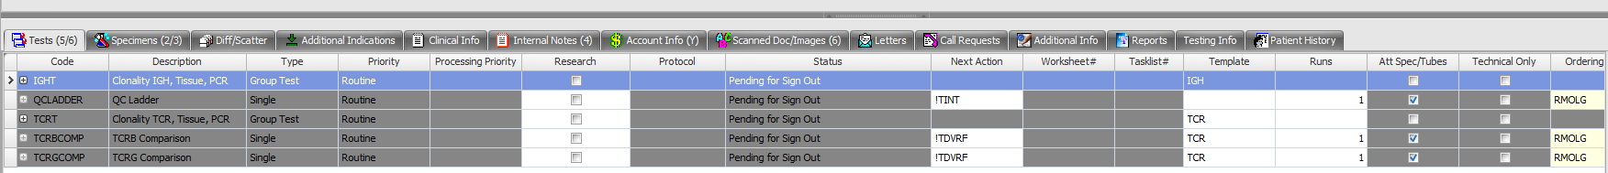





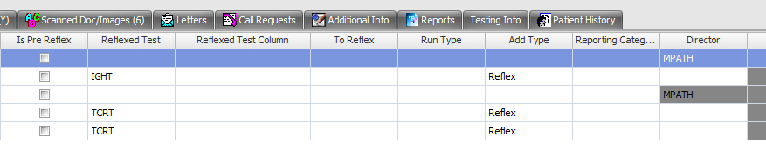

* 1. Click on the specimen tab in the middle of the window.
     1. Click on the **Add Spec** button located on the right end of the window.
     2. In the ‘Type’ Field, use the dropdown to select the specimen type for the original comparison sample type.
     3. Under the specimen line, check to make sure that the tube type is correct for the specimen type or adjust, as needed.
     4. Select the child-level row.
     5. In the ‘EXT#’ field, enter the lab identifying number of the comparison specimen tube (DNA aliquot).
        1. For Soft Molecular specimens, enter the Specimen ID according to the format: MOL-##-###-#-##-##.
           1. Example: MOL-20-100-A-03-00
        2. For pre-Soft Molecular samples, enter the CMB# of the DNA.
           1. Example: CMB# 12345
     6. In the ‘Initial Volume’ field, change the value to 5000 (the unit should be uL).
     7. Use the scrollbar at the child level to scroll to the right. In the ‘Att Tests’ field, attach the comparison test(s) to the tube. If there are multiple comparison tests, add any that are appropriate.
     8. Use the scrollbar at the child level to scroll to the right. In the ‘Protocol’ field, use the dropdown to select ATST.
     9. Use the scrollbar at the child level to scroll to the right. In the ‘Next Action’ field, use the dropdown to select !ATST.
     10. If there are any additional comparison specimens, repeat steps 1-9 above.
  2. See below screenshots for an example of a specimen with original orders of IGHT and TCRT and comparison tests for both TCRBCOMP and TCRGCOMP.
  3. Then, continue with the procedure on the following page.

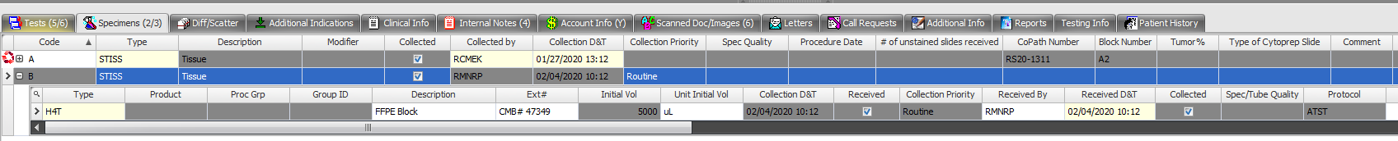





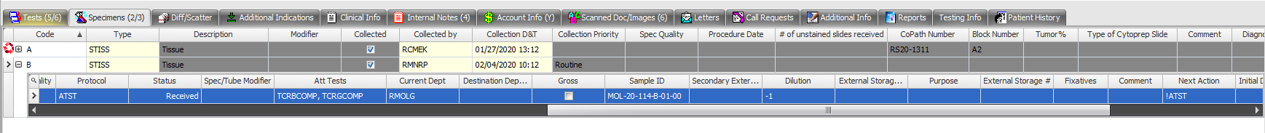

 

* 1. Click on the Internal Notes tab in the middle of the window.
     1. Add internal note to indicate the sample to test, the test to perform, and which reaction (master mix tube) should be performed.
     2. Click on the **Add** button.
        1. In the textbox, specify the CMB#/Molecular# of the comparison specimen and, if appropriate, also include the CoPath#.
        2. In the 'Type' field, select all except Employee specific.
        3. Mark the 'Request' checkbox to have a pop-up appear in Sign Out Entry.
     3. In the 'Test' field, use the dropdown to the select comparison test code.
        1. Note: Choose the comparison test (not the regular test).
     4. Select the **Home** menu, then select **Save**.
     5. Close the Order Entry window.
  2. See below screenshot for an example of a specimen with original orders of IGHT and TCRT and comparison tests for both TCRBCOMP and TCRGCOMP.

1. **REVISIONS**
   1. 1/16/2024: Clarification on the step to attach to comparison test.