**Critical Results Notification Procedure**

1. **PRINCIPLE:**
   1. Testing results that exceed a designated critical threshold, as defined by the Medical Director and consulted committee, must be communicated to the patient’s provider. This includes any clinically significant changes made to a previously resulted test report.
2. **PROCEDURE:**
   1. When communicating a critical result, the patient’s full name and date of birth are the demographics used to properly identify the patient.
   2. The entire communicated report, including the patient’s name and date of birth, must be correctly “read-back” by the person notified. This communication is documented in the patient record.
   3. Soft electronically stamps the identification of the responsible reporting laboratory individual when the documentation is saved in the system.
   4. Documentation of communicated test result must be linked to the critical result and must include:
      1. “Called to and readback by” statement
      2. DATE and TIME of phone call
      3. At least the first name and first initial of last name of the person notified is required.
3. **NOTIFICATION ALGORITHM:**
   1. The following information should be referenced when notifying health care providers.
   2. **Inpatients/Patients still in the ED at TMH, RIH and NH:**
      1. Call unit and ask to speak with the nurse in charge of that patient.
      2. NH ED – Mid-level provider, 5-1120.
   3. **Discharged Patients at RIH:**
      1. If the patient was discharged from the Adult ED, call the Chest Pain Unit and ask for the Midlevel Provider (NP or PA) on the unit at 4-9234.
      2. If the patient was discharged from the Hasbro ED, call 444-4900 and ask to speak with the charge nurse.
      3. If a patient was discharged from any other RIH location, using Order Entry in SOFT, find the name of the Attending physician. Compare that name to Appendices I (RIH Adult Hospitalists), II, (Adult Teaching Service), and III (Pediatric Hospitalists).
         1. If the attending is found in Appendix I, page 350-7541.
         2. If the attending is found in Appendix II, call the page operator and ask that the Medical Consult Resident be paged.
         3. If the attending is found in Appendix III, call the page operator and ask that the Pediatric Hospitalist on call be paged.
            1. Based on the patient’s last name, page either the blue team hospitalist (patient last name A-L) or the red team hospitalist (patient last name M-Z)
         4. If the attending is not listed on any of these Appendices, call the attending directly.
   4. **Discharged Patients at TMH:**
      1. If the patient was discharged from the ED:
         1. M-F 8AM to 4:30PM, call the QA Administrator, at 33921.
         2. Between the hours of 4:30PM to midnight, please call 793-4400 and ask for the Attending Physician in team 4.
         3. If the patient was discharged from any other TMH location, using Order Entry in SOFT, find the name of the Attending physician. Compare that name to the list of physicians listed in Appendix IV (TMH Hospitalists).
            1. If the physician is listed in Appendix IV, call the page operator and ask that the Hospitalist on duty or IMIS be paged.
            2. If the attending is not in this Appendix, call the attending directly.
   5. Discharged Patients from NH:
      1. Critical results on patients from the ED (either discharged or if they are still in the ED) are to be called to the ED, 5-1120, and ask to speak to a Mid-level provider.
      2. Critical results for patients that have been discharged:
         1. Go to Order Entry in Soft, find the name of the Attending Physician. Compare that name to Appendix V. If the attending is on the list, page the attending directly.
         2. If the doctor is not listed in the Appendix, the hospitalist service covers all other admissions. There is one admitting doctor on during the day and Nocturnist on at night. The beeper number is 350-9512.
   6. **Outreach Patients:**
      1. For non-critical results Monday - Friday 7:30am – 10:30pm: Call ext 3-4242 with results.
      2. For critical results:
         1. Call the ordering provider’s office directly within the specified amount of time based on call Category.
         2. The phone number to call is located in Order Entry:



* + - 1. **Open the Call Box:**

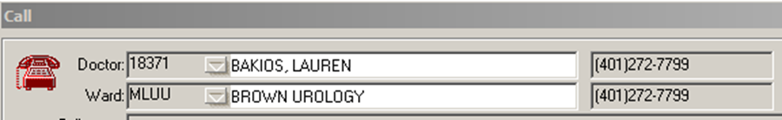

* + - 1. **There also might be a 2nd box with Clinic instructions that pops up:**

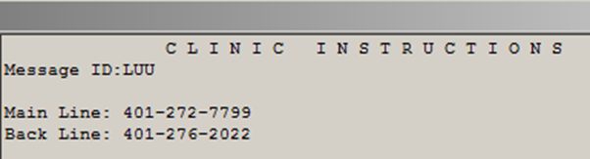

* 1. **Private MD (non-outreach) & Brown University:**
     1. Call MD office directly within the specified amount of time based on call Category. See Appendix VI for Brown University patients (MLBU).
  2. **Clinic Patients:**
     1. Refer to the Critical Result Reporting for Outpatient Areas, Appendix VII.
  3. **Bradley Patients:**
     1. Contact Bradley Laboratory Services via pager 350- 6192 (7:00AM - 3:00PM) or the Nursing Supervisor via hospital operator #21000 (3:00PM – 7:00AM and weekends).
  4. **Notification time limits:**
     1. **For ALL critical results called:**
        1. **For Microbiology, all positive results of Gonorrhea from the eye, Gonorrhea, Chlamydia, Trichomonas or Herpes on patients <14 years old are considered critical, as well as any positive CSF tests.**
        2. If unable to contact the healthcare provider within an hour, contact the Laboratory Director or Manager during work hours. If they are unavailable, contact the Pathology Resident on-call by calling the operator. If the resident has not called back within 15 minutes, call their cell phone. The number can be found on the intranet: <http://intra.lifespan.org/directory/list.php>

1. **REVISIONS:**
   1. 3/6/2018: Updated to include the addition of the last name of the person notified, the removal of viral assays and Red Category references.
   2. 1/13/2020: Updated to include reference to Soft Molecular and updated footer to reflect new laboratory name.
   3. 1/16/2024: Updated with new phone numbers.