**Cobas p480 v2 Instrument Procedure**

1. **INTENDED USE**
   1. The cobas p 480 instrument is a stand-alone general purpose laboratory instrument to minimize repetitive manual tasks associated with specimen handling.
   2. This instrument is intended to perform pre-analytical processing, such as uncapping and recapping, pipette, and spin-mixing specimens, and aliquoting specimens to secondary vials, of common sample types including but not limited to PreservCyt® containers (PC), SurePath™ (SP), and cobas® PCR Media tube.
2. **HARDWARE OVERVIEW**

* 1. Instrument Deck
     1. The instrument deck holds the following items:
        1. Removable carriers for samples, secondary tubes, caps, reagents, and tips.
        2. Two decapper/recapper modules for uncapping and recapping of PC/SP containers and tubes.
     2. Layout
        1. The instrument deck is divided into 43 equal tracks. The tracks are numbered so that the location where a carrier must be loaded can be identified. The track positions are stamped on the surface of the autoload tray.
        2. A corresponding LED on the LED bar above the autoload tray indicates the loading status of each track.
     3. Autoload Unit
        1. The autoload unit consists of the autoload tray – the platform where the carriers are placed - and the autoloader. The autoloader detects waiting carriers with their tubes and containers and scans the barcode labels.
        2. The autoload unit is used to load carriers onto the instrument automatically. The operator inserts the carriers into their designated position on the autoload tray. The LED bar above the autoload tray indicates the correct loading position by a blinking LED.
        3. After correct placement, the carriers are loaded automatically onto the instrument deck by the autoloader. During loading, the barcode reader on the autoloader scans the carrier barcode and the barcode labels of the supplies on the carrier (samples, reagents, and consumables).
     4. Pipetting Arm
        1. The instrument is equipped with a pipetting arm containing 4 pipetting channels. During operation, the pipetting arm moves horizontally, picks up the required number of disposable pipette tips, aspirates, dispenses, and mixes the liquids. Then the pipetting arm ejects the used tips into the solid waste bag.
        2. Each air-displacement pipetting channel can move forward and back and up and down during the pipetting operation. Each pipetting channel picks up a disposable pipette tip at the beginning of a pipetting cycle. The pipette tip is ejected into the solid waste bag at the completion of pipetting for that cycle.
     5. Grippers
        1. The gripper arm holds 4 grippers. They pick up PC containers and tubes and move them to different positions on the instrument deck.
        2. The gripper also handles the caps when the containers and tubes are uncapped and recapped. Furthermore, the grippers rotate the containers and tubes for correct barcode label alignment and spin-mixing of the containers and tubes.
     6. Decapper/Recapper Modules
        1. The decapper/recapper modules are used for recapping and uncapping PC containers and tubes.
        2. There is one module for PC containers and another one for CPM tubes or secondary containers.
        3. Each decapper/recapper module contains 4 independent stations with which the instrument uncaps or recaps multiple containers and tubes simultaneously. Inside each station, a lower ring holds the container or tube while an upper ring grips and rotates the cap.
        4. A camera system above the decapper/recapper module aligns containers with inserts for correct pipetting.
     7. Solid Waste Station
        1. If the instrument is installed on a trolley, a plastic waste chute can be used in place of the solid waste bag. The cap and tip waste is directed into a solid waste container on the trolley that holds a large solid waste bag.
        2. The waste chute and solid waste container cannot be reused and must be replaced when they are full.
        3. When you replace the solid waste container, also replace the waste chute.
     8. LED Bar
        1. The LED bar above the autoload tray indicates the loading status on the instrument deck. The status LEDs inform you where to place the carriers on the autoload tray and which tracks on the instrument deck have a carrier on them.
           1. No light: No carrier loaded.
           2. Green light steady: Carrier loaded on this track.
           3. Green light blinking: Carrier can be loaded on this track.

1. **CARRIERS**
   1. PC carrier: Thin Prep PreservCyt tube

* 1. 24 position sample carrier: Secondary (aliquot) tube

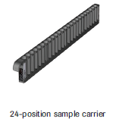

* 1. MPA rack carrier: MPA racks with secondary tubes

* 1. PC cap carrier: Thin Prep PreservCyt caps

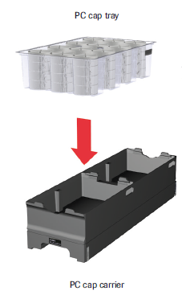

* 1. CPM cap carrier: Secondary tube caps

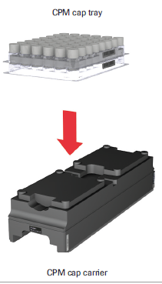

* 1. Tip Rack carrier: Pipette tips

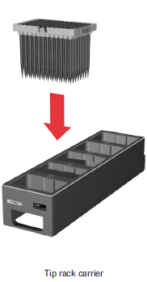

1. **SPECIMEN LABELS**
   1. Dimensions of barcode labels on the primary containers and tubes:

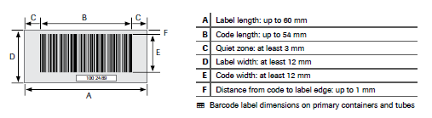

* 1. Position of barcode labels on containers and tubes:
     1. The barcode labels must fit within a specific range from the bottom of the containers and tubes.

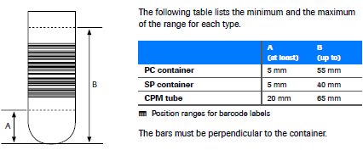

1. **USER INTERFACE**
   1. Screen Design

* 1. Status area
     1. Displays the processing status, the currently logged on user, the date, and time.
  2. Tab Navigation bar
     1. In the first row, main tabs:
        1. Overview
        2. Workplace (displayed only if a run is active)
        3. Run Report
        4. Messages
        5. Utilities
     2. In the second row: subtabs for the opened work area.
  3. Work area
     1. Displays all related information and software functions in one place in the user interface.
  4. Alarm area
     1. Displays the most recent alarm of a run.
  5. Global action bar
     1. Contains buttons used for general software functions.
  6. Colors in the user interface
     1. Green: Normal condition, status is ok
     2. Yellow: Warning condition, status is not OK, but immediate intervention is not required.
     3. Red: Alarm condition, Immediate intervention is required. Operation has stopped.
     4. Blue: The item is selected or active.
  7. Sample, container, or tube status
     1. The status is indicated by icons.
     2. To display a callout with additional information, move the cursor over a status icon.
     3. To display a callout with general information about a status, move the cursor over a status icon or text in the legend:

* + 1. To display a callout with specific information about a container, move the cursor over a container icon in the different views displaying container icons.
    2. For aliquot runs, the callouts include the location of the corresponding container.

* 1. Runs in the user interface:

* + 1. Run name: Displays the name that you have defined when initiating a new run.
    2. Instructional area: Displays status information about the progress of a step or instructions for operator tasks.
    3. Step time line: Displays all steps for a run, including operator tasks, instrument activities, and software activities.
       1. The colors of the step boxes indicate the progress:
          1. Green: The step is finalized.
          2. Blue: The step is in progress.
          3. Gray: The step has not been started yet.
       2. The next step can only be started if the current step has been successfully finished. It is not possible to go back to a previous step in a run.
       3. When a run is started, the expected end time is displayed. The end time is calculated form the 10 last successful runs of the same type.

1. **OPERATING**
   1. Starting up the system:
      1. To switch on the instrument, press the power strip on the bottom left of the front of the instrument.
      2. To start the software, double click on the Roche icon on the desktop and log in with your username and password.
      3. Perform any maintenance actions that the Overview work area display as being due.
      4. Make sure the safety guards on both sides of the autoload tray are extended.
   2. Performing Maintenance:
      1. If both daily and weekly maintenance are due, initiate weekly maintenance. It includes daily maintenance.
      2. If preventative maintenance is due, you must contact a Roche Service representative.
   3. Initiating a new run
      1. Choose the New run button.
      2. Define the workflow:
         1. Select a workflow.
         2. Optionally, edit the default run name, which is displayed in the Run name field.
         3. Choose the OK button.
   4. Preparing CAP carriers
      1. Cap carriers are only used during capping runs.
      2. CPM caps are delivered in trays.
      3. Place a cap tray package on a CPM cap carrier.
      4. Lift the upper cap tray and place it on the cap carrier in from to the lower cap tray.
      5. Remove the cover from the front cap tray.
      6. Make sure the barcode label of each cap tray is visible at the right side of the cap carrier.
      7. The surface of the cap trays must be on the same level as the surface of the cap carrier.
   5. Preparing Tip rack carriers
      1. Place up to 5 tip racks on a tip rack carrier.
      2. The racks are barcoded. The barcode labels of the tip racks must face to the right of the carrier when they are loaded on the carrier.
   6. Preparing PC Container carriers
      1. 12-position PC carriers can be loaded with only 6 containers when they are capped. Always keep an empty position between capped PC containers.
      2. 10-position PC carriers can be fully loaded with capped containers.
      3. It is recommended to align the PC container barcode labels to the right so that the autoloader can read the barcodes when loading.
   7. Preparing secondary tube carriers (aliquot tube)
      1. Place the uncapped tubes in the 24-position sample carrier rack.
      2. The secondary tube must always have the same barcode information as the corresponding primary container.
      3. It is recommended to align the secondary tube barcode labels to the right to so the autoloader can read the barcodes when loading.
   8. Loading the autoload tray

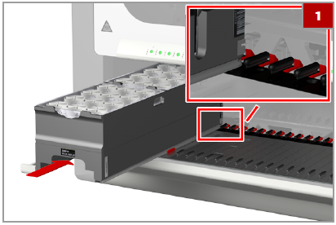

* + 1. Insert the carrier horizontally on the autoload tray until it touches the stop hook.
    2. Make sure to insert the carrier on the correct tracks.
    3. The slide blocks must engage the guiding rails of the carrier.
    4. Do not insert the carrier beyond the stop hook on the far side of the autoload tray.

1. **WORKFLOWS**
   1. Aliquot
      1. The aliquot run prepares an aliquot from each loaded primary PC container into a secondary tube.
      2. Choose New Run button and select the Aliquot run type.
      3. Optionally, enter a new run name.
      4. Choose the OK button.
      5. Load supplies onto the autoload tray according to the on-screen wizard.
         1. Tip rack carrier
         2. 24 position secondary tube sample carrier (uncapped)
         3. PC carrier (10 position carrier capped)
         4. Error carriers
      6. To start the run, choose the Load button.
      7. A bar with the start and end time shows the progress of the run.
      8. When completed, choose the Unload button.
      9. When processing is complete, the run report is displayed.
      10. Remove all carriers from the autoload tray.
   2. Recap
      1. Once the HPV samples are processed, the MPA rack can be unloaded from the Roche 6800 instrument and placed in a MPA carrier rack for recapping.
      2. Choose New Run button and select the Recapping-MPA rack run type.
      3. Optionally, enter a new run name.
      4. Choose the OK button.
      5. Load supplies onto the autoload tray according to the on-screen wizard.
         1. Cap carrier
         2. Processed tubes on MPA rack carriers (uncapped)
         3. Error carrier
      6. To start the run, choose the Load button.
      7. A bar with the start and end time shows the progress of the run.
      8. When completed, choose the Unload button.
      9. When processing is complete, the run report is displayed.
      10. Remove all carriers form the autoload tray.
2. **ERROR HANDLING**
   1. Loading Errors
      1. The current loading status on the instrument deck is displayed on the Workplace tab using colored icons.
         1. White: No carrier loaded
         2. Green: Carrier successfully loaded
         3. Ren: Carrier with loading error.
      2. If there is a loading error, a detailed dialog box can be opened.
      3. When a loading error occurs, a message is displayed.
      4. To confirm the message, choose the OK button.
      5. If there are problems with the primary or secondary tubes on the carrier (example bar code errors), choose the Details button.
      6. In the Carrier layout dialog box, locate the tube error on the carrier.
         1. Use the legend to determine the cause of each of the errors.
         2. If necessary, choose the View List button to get a load list with further details such as container barcodes.
      7. To unload erroneous carriers, choose one of the following:
         1. To unload all carriers, choose the Select all check box.
         2. To unload only the erroneous racks, select the check boxes of the affected racks.
      8. Choose the Unload button.
      9. Fix the problem and load the carriers again.
   2. Unprocessed Samples
      1. At the end of a run, the run report is displayed. Unprocessed samples are in the original carrier positions or placed in error carriers.
      2. Check the details of unprocessed samples before processing them on another instrument.
      3. If there are unprocessed samples on error carriers, a message is displayed on the wizard when the error carriers are unloaded.
      4. Choose the Details button.
      5. In the Carrier Layout dialog box, locate the tube error on the carrier.
         1. To see details about an error, move the cursor over the sample.
      6. If necessary, choose the View List button to get a list with further details.
      7. After the run is finished, the Run report tab is displayed.
      8. In the Rune Report table, choose the workflow for which you want to display the report.
         1. Choose the Show report button.
         2. Check the run report for errors before processing the samples on the sample preparation instrument.
   3. Clean up procedure for aborted runs:
      1. Refer to p 480 Instrument User Guide for instructions.
3. **SHUTTING DOWN**
   1. When you do not plan to use the system, for example, overnight, Roche recommends shutting it down.
   2. Make sure all supplies are unloaded.
   3. Shut down the software first by choosing the Exit button.
   4. Second, shut down the control unit, using the Windows functionality.
   5. Then, switch off the instrument by pressing the power button on the front of the instrument.
4. **MAINTENANCE**
   1. Daily
      1. In the instrument area for daily maintenance, choose the Perform Daily Maintenance button.
      2. The processing status should be idle. If not, you may need to initiate weekly maintenance action in the Overview work area first.
      3. Replace the waste chute: As needed.
         1. Open the solid waste door.
         2. Pull the waste chute from the support frame.
         3. Remove the waste chute and dispose it accordingly.
         4. Place the bottom portion of a new waste chute inside the support frame.
         5. Fold the top of the new waste chute over the support frame.
         6. Close the solid waste door.
      4. Replace the solid waste container: As needed.
         1. Remove the solid waste container from the trolly.
         2. Dispose of the large solid waste bag accordingly.
         3. Insert a new large solid waste bag int a new solid waste container.
         4. Place the solid waste container on the trolly.
         5. Put the end of the new waste chute into the large solid waste bag.
      5. Cleaning the tip eject plate:
         1. Remove the tip eject plate.
         2. Clean the tip eject plate with disinfectant solution.
         3. Put the clean tip eject plate fits horizontally on the initialization/waste block.
         4. If the tip eject plate is not stationed properly, moving parts could crash into it and cause an instrument malfunction.
      6. Confirm maintenance has been completed by choosing the OK button in the dialog box that lists all maintenance actions.
   2. Weekly
      1. In addition to the daily tasks, you will clean the instrument with weekly maintenance.
      2. In the instrument area for daily maintenance, choose the Perform Weekly Maintenance button.
      3. If a spill of regents occurs the instrument should be cleaned with deionized water followed with a 70% ethanol solution.
      4. If a specimen, a positive control or other biohazardous material spills on the instrument or instrument carriers, clean it with a disinfectant solution followed by deionized water and then 70% ethanol.
      5. The processing status should be idle.
      6. Cleaning instrument surface:
         1. Clean the front and side covers using a lint-free cloth moistened with disinfectant solution. Wipe dry.
         2. Clean the safety guards using a lint-free cloth moistened with disinfectant solution. Wipe dry without exerting pressure.
         3. Open the front cover.
         4. Clean the instrument deck and autoload tray using a lint-free cloth moistened with disinfectant solution and wipe dry.
            1. Check the slide blocks for cleanliness.
            2. Wipe the surface of the decapper/recapper modules.
         5. Check the laser scanner window of the barcode reader on the autoloader. Clean it with a lint-free cloth or with cotton swabs lightly soaked in 70% ethanol.
         6. Clean the autoload protection ribbon with a lint-free cloth moistened with disinfectant solution. Wipe dry without exerting pressure.
      7. Cleaning a carrier:
         1. Clean the carrier with a lint-free cloth moistened with disinfectant solution. Wipe dry.
         2. Leave the carrier to dry completely before you place it on the autoload tray again.
      8. Confirm maintenance has been completed by choosing the OK button in the dialog box that lists all maintenance actions.
5. **TROUBLESHOOTING**
   1. Refer to p 480 Instrument User Guide for Troubleshooting instructions.
6. **REFERENCES**
   1. Cobas p 480 v2 Instrument User Guide v1.0