**Idylla™ *BRAF* Mutation Assay Procedure**

1. **PRINCIPLE:**
   1. *BRAF* is part of the RAS/RAF signaling pathway in cells. Disruption of this pathway occurs in a number of different cancers, for example, by gain-of-function mutations in genes that cause kinase activation. RAS family mutations occur in about 15-30% of all cancers and RAF family mutations in about 7% of all cancers. For each of these genes, mutations tend to occur in certain hotspot positions. The RAS/RAF/MEK/ERK signaling pathway is a therapeutic target and mutations can predict tumor responsiveness to certain types of therapeutic agents. In addition, for some tumors, the presence or absence of *BRAF* mutations can aid in making a diagnosis.
   2. The Biocartis Idylla™ System covers the entire process from sample to result with fully integrated sample preparation followed by real-time PCR amplification and detection of the targeted sequences. The Idylla™ System consists of the Idylla™ Console connected to one or more Idylla™ Instruments. Idylla™ Cartridges, designed for specific applications, can be processed by the Idylla™ System using BRAF specific software (Test Type Package, BRAF TTP).
   3. The Idylla™ BRAF Mutation Assay detects V600E/D and V600K/R/M mutations in codon 600 of the *BRAF* gene. The Assay consists of three allele-specific duplex PCR reactions, designed to specifically amplify either the *BRAF* Wild Type, V600E, V600D, V600K, V600R and V600M mutations, each combined with an endogenous control gene that serves as a Sample Processing Control (SPC). This control checks for adequate execution of the complete process from sample to result.
2. **SAMPLE TYPES:**
   1. DNA extracted from formalin-fixed, paraffin embedded (FFPE) tissue sections and cytology cell blocks. stored at -20 ˚C and -80 ˚C indefinitely.
   2. DNA extracted from EDTA whole blood, stored at -20 ˚C and -80 ˚C indefinitely.
   3. DNA extracted from EDTA bone marrow aspirate, stored at -20 ˚C and -80 ˚C indefinitely.
   4. FFPE unstained slides, FFPE tissue block, and FFPE cell blocks stored at room temperature.
   5. Acceptability Criteria based on sample type:
      1. Extracted DNA:
         1. Tumor percentage ≥ 10%.
         2. DNA concentration ≥ 7.5 ng/uL.
         3. Specimens with DNA concentration <7.5 ng/uL should be discussed with faculty and may be tested using a higher input volume.
      2. Tissue Samples:
         1. Tumor percentage ≥ 50%. Macrodissection is required for samples <50% neoplastic cells.
         2. Tissue area of 50-600mm2 from 5 µm sections.
         3. Specimens that do not meet the acceptability criteria should be discussed with faculty.
3. **REAGENTS AND STORAGE:**
   1. Idylla™ BRAF Mutation Assay Cartridge, Cat# A0011/6. Store at room temperature.
   2. Molecular grade nuclease-free water. Store at room temperature.
   3. Glass microscope slides
   4. Whatman 10mm circle filter paper
   5. Tweezers
   6. Microtome
   7. Microtome blade or scalpel
   8. Idylla tissue measurement tool
4. **MAJOR EQUIPMENT:**
   1. Idylla™ Console
   2. Idylla™ Instrument Module
   3. Idylla™ Explore Web Application v4.1.1
5. **CONTROLS:**
   1. Sample Processing Control:
      1. Sample processing control (SPC) targets the RPP30 (RNase P) gene that is amplified from the patient sample.
         1. The SPC verifies the effectiveness of on-board sample processing from sample to result.
         2. The SPC control is amplified in chambers A, B, and C.
      2. The *BRAF* Wild Type is amplified in chamber A and is used for the calculation of delta Cq’s.
   2. External Control: Run every 30 days and with new lot verification
      1. Positive Control: *BRAF* V600E gDNA 50% VAF (Horizon cat#HD238), diluted to 15ng/ul with dH2O and mixed with tonsil DNA at 15ng/ul to obtain a 30% VAF. The Tonsil to *BRAF* ratio to achieve 30% VAF is 2:3.
      2. Negative Control-placenta DNA (Fisher cat#D1234200, diluted to 15ng/ul with dH2O.
      3. Idylla Environmental Control
         1. Expected Result: Invalid
         2. Refer to the *Idylla Instrument Procedure* for additional information.
6. **QUALITY CONTROL PROCEDURE:**
   1. QC controls will be run on each new lot and every 30 days, according to the IQCP plan. To set up a QC run:
      1. Log into Soft Lab LIVE7.
      2. Open **Order Entry** tile.
      3. Input TEST in the Last Name field, and MOLECULAR in the First Name field.
      4. Select the **Next** button in the Search Window.
      5. Select the **Finish** button in the Search Window.
      6. Input a collection time in the required field.
      7. Place the cursor in the ID field. In the Keypad window, select the 9 Molec tab.
      8. Click the **Tissue** folder and select “BRAF Codon 600 Mutation, Tissue, PCR”
      9. Click the Specimen tab on the left side of the screen.
      10. Click on the order, then **Coll/Rec** and OK the verify popup.
      11. Click the save icon in the menu bar at the top of the screen.
      12. Verify the correct label printer is selected and click **Print** in the Print Label popup.
   2. Receive the test patient in Soft Molecular.
      1. Log into Soft Molecular LIVE7.
      2. Open the **Specimen Receiving Worklist** by selecting the tile on the dashboard.
      3. Place the cursor in the Barcode# field. Scan the Soft Lab specimen label.
      4. Mark the Received checkbox and click **Save**.
      5. Open **Order Entry** using the tile on the dashboard.
      6. Input the appropriate MOL# then click Find.
      7. Click the Specimens tab, then open the child level using the + sign in the Code field.
      8. Make sure the **Protocol** field is set to **ATST** and **Att Tests** is set to **BRFT.**
      9. Select the Internal Notes tab.
      10. Click the Add button.
      11. Input ‘No patients pending for BRAF, test patient ordered for control run only.’
      12. In the dropdown menu in the Type column, mark Select All and uncheck Employee Specific.
      13. Mark the Request checkbox.
      14. Select BRFT in the Test dropdown menu, then click the Save button in the Order Entry Home menu.
   3. Worksheet Builder:
      1. Log into Soft Molecular.
      2. Open BRAF2 PCR-Test Worksheet Builder using the tile on the dashboard.
      3. Click the Find button.
      4. Highlight the Test patient and click the **Add** button
      5. Add BRAF positive and BRAF negative controls to the worksheet by selecting the control from the dropdown menu and clicking the **Add Control** button.
      6. Verify the control lot numbers by clicking on the Sample ID field. If a lot number needs to be changed, click the dropdown arrow, and select the correct lot number.
      7. Mark the Completed checkbox and click **Save**.
         1. **NOTE:** Q numbers will generate for the control upon saving.
      8. Click the **printer** icon in the print preview window that appears. Verify the correct printer is selected and click **Print.**
      9. Close the Print Preview window.
      10. Select **Back** in the BRAF Idylla–Test Worksheet Builder window.
7. **TEST PROCEDURE:**
   1. Create a worksheet: BRAF2 PCR-Test Worksheet Builder.
      1. Log into Soft Molecular.
      2. Open BRAF Idylla-Test Worksheet Builder using the tile on the dashboard.
      3. Select **Find**.
      4. In the Found Activities tab, click **OK** or double click any row.
         1. **Note:** All Test Codes are attached to the BRAF worksheet.
      5. Highlight the Barcode# field. Scan the Soft Mol label associated with the sample to be added to the worksheet. Press Enter.
      6. Mark the Completed checkbox and click **Save**.
         1. **NOTE:** Q numbers will generate for the controls upon saving.
      7. Click the **Print Worksheet** button to open the worksheet preview window.
      8. Select the **printer** icon; verify the correct printer is selected, and **Print**.
      9. Close the Print Preview window.
      10. Select **Back** in the BRAF2 PCR–Test Worksheet Builder window.
   2. **Prepare the sample and load the cartridge:**
      1. Obtain a new Idylla™ BRAF cartridge for each specimen and control to be run.
      2. Open the pouch and remove the cartridge.
         1. **NOTE:** Once removed from sealed packaging, the cartridge must be used within 5 days away from the light.
         2. Once the cartridge has been opened and the sample has been loaded, the cartridge must be used within 2 hours.
      3. Using a marker, label the cartridge in the designated space with the patient’s Soft Molecular number.

* + 1. If you use DNA, skip to step 11 below.
    2. If using tissue, refer to the steps below for sample preparation.
       1. FFPE tissue block and FFPE cell block:
          1. Measure the size of the tissue section using the Idylla™ tissue measurement tool.
          2. For tissue sections that are 50-100mm² and ≥50% tumor: cut 2 scrolls.
          3. For tissue sections that are <50mm2 and/or <50% tumor: cut the adequate number of scrolls to achievetissue input requirement.
          4. Cut the appropriate number of scrolls for each specimen using a microtome set at 5 microns.

Please refer to the *FFPE Tissue Preparation for Molecular Testing* procedure for additional information.

* + - 1. FFPE tissue on unstained slides:
         1. Measure the size of the tissue section or circled tumor for macrodissection using the Idylla™ tissue measurement tool.
         2. For tissue sections that are ≥50mm2 and ≥50% tumor: scrape 2 unstained slides.
         3. For tissue sections that are <50mm2 and/or <50% tumor: scrape the appropriate number of slides to meet the 50mm2 tissue input requirement.

Please refer to the *FFPE Tissue Preparation for Molecular Testing* procedure for additional information.

* + 1. Using the appropriate tweezers, place two filter papers on a glass slide.
    2. Wet each filter paper with one or two drops of nuclease-free water using a sterile transfer pipette.
    3. Place the prepared tissue section(s) onto one of the wet filter papers.
    4. Use the tweezers to place the second prepared filter paper on top of the tissue.
    5. Pull out the access door to open the cartridge. Remove and discard the black tab.
       1. **NOTE:** Once the black locking tab has been removed, **DO NOT** close the access door until the sample has been added to the lysis pad. Once the access door is closed, it cannot be opened again.
    6. If the sample is extracted DNA, pipette 10ul of the sample onto the center of the cartridge sample well.
       1. If the sample is less than 7.5ng/ul, consult with the Medical Director.
    7. If the sample is tissue, place the prepared tissue sample onto the center of the lysis pad at the bottom of the cartridge sample well.
       1. **NOTE:** Be careful to avoid touching the lysis pad with the tweezers.

* + 1. Close the cartridge by pushing the access door until it is tightly shut. The cartridge is now ready for processing.
       1. Once the sample is loaded, avoid tilting the cartridge.
       2. **NOTE:** The cartridge must be used within 2 hours of opening the pouch and loading the sample.
  1. **Starting a run on the Idylla console:**
     1. If appropriate, turn on the Idylla instrument and console. If necessary, refer to the *Idylla System Procedure* for more information.
     2. Log on to the console using your username and password.
     3. Click **New Test**.
     4. Highlight the **Sample ID** test field and scan the Soft Molecular specimen label.
     5. Scan the barcode located on the top of the cartridge using the console barcode scanner.
        1. Upon scanning, the BRAF Mutation Assay TTP information will autofill and confirm the cartridge is not expired.
        2. The Sample Type field will display FFPE for all specimens.
     6. Highlight the Comments textbox and enter the patient’s first and last name; and Copath case number. (Ex. John Doe [enter] RS25-1234-A1).
        1. Keep in mind, this will appear in the final report and cannot be changed once saved. Check your spelling and case number for accuracy.
     7. Press **Confirm** to confirm the test request.
     8. A white light around the instrument tray will blink to indicate it is ready for use.
     9. Press the **open/close** button on the tray to open the instrument.
     10. Place the cartridge in the tray with the access door facing forward.
     11. Press the **open/close** button on the tray to close the instrument. Once closed, the test will begin automatically.
         1. **NOTE:** Test run time is approximately 145 minutes. Remaining time is displayed in the progress bar on the Status Overview screen.
  2. **Process the worksheet: Load Idylla**
     1. Log into Soft Molecular.
     2. Open BRAF PCR–Test Worksheet Processing by using the tile on the dashboard.
     3. Scan the barcode of the Idylla BRAF worksheet into the Worksheet# field and select **Find**.
     4. If tissue was used directly in the cartridge, enter the size of the tissue used, in the Tissue input mm² field on the patient line.
     5. In the General Settings tab, confirm the lot number for the BRAF cartridge in use. Make applicable changes if necessary.
     6. Mark the Completed checkbox for the Load Idylla action and select **Save**.
     7. Select **Back** in the Idylla BRAF – Test Worksheet Processing window.
     8. Exit Soft Molecular.
  3. **Viewing Test Results and Generating Reports:**
     1. When the test is complete, press the **open/close** button on the tray and dispose of the used cartridge in the red biohazard trash.
     2. Log in to the Idylla using your username and password.
     3. Insert a USB drive into the rear of the Idylla console.
     4. Export the PDF report and Assay logs:
        1. Press **View PDF**, then press **Export PDF**. Save to the USB drive.
        2. Press **Export assay logs**. Save to the USB drive.
        3. Export is now complete. Remove the USB drive.
     5. Log into a network computer and insert the USB drive.
     6. Create a run folder within G:\CMB_Tests. Name it by scanning the worksheet barcode. (Ex. 09.24.24-BRAFIDYLLA-1)
     7. Transfer the PDF report and assay log from the USB drive to the run folder.
  4. **Tasklist Processing: Upload Tasklist Documents:**
     1. Log into Soft Molecular.
     2. Open the BRAF2-Idylla Tasklist by using the icon on the dashboard.
     3. Change the date range to one month.
     4. Scan the barcode of the BRAF worksheet into the Worksheet# field and select **Find**.
     5. If this is a control run, open the QC Data tab.
        1. Click 2 times on the first control.
        2. Navigate to the Documents tab.
        3. Select the Add File tab, then click the add file (folder) icon.
        4. Locate and highlight the file to be added in Windows Explorer. Select **Open**.
        5. Select the Instrument Documents Template TQC in the Template dropdown.
        6. Select the green check icon to add the file(s).
        7. Open the Results tab.
        8. Using the dropdown in the Result column, select the appropriate result for the control.
        9. Click **Save** in the TQC window. When asked to verify results, click **No**.
        10. Click **OK** in the QC Components window that appears.
        11. Repeat as necessary for all controls.
     6. Click on the Assigned Tests tab.
     7. Highlight the first order for the first patient sample (parent level).
     8. Verify the Test Results window populates with the correct patient information.
     9. Open the Analysis Images tab.
     10. Select the Add File tab, then select the add file (folder) icon.
     11. Locate and highlight the file to be added in Windows Explorer. Select **Open**.
     12. Choose Instrument Documents from the Template dropdown.
     13. Select the green check icon to add file(s).
     14. If a patient sample required rerun on the Idylla instrument and multiple PDF documents were generated:
         1. Attach all PDFs to the first order for each patient sample. Rerun documents should be labeled with the suffix RERUN#.
     15. Click the dual view icon in the menu bar to view the PDF report.

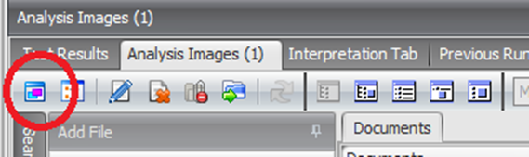

* + 1. Ensure the correct PDF report has been uploaded, and the information is accurate.
    2. Click the Test Results tab.
    3. Using the dropdown in the Results column, select the appropriate result for the test. Leave the BRAF2 interpretation field blank.
    4. Repeat as necessary for all patient samples on the list.
    5. Press the **Select All** button (if there is more than one patient).
    6. Complete the Upload Tasklist Documents action by marking the Completed checkbox, found on the parent row for each patient sample, and select **Save**.
    7. Close the tasklist window and exit Soft Molecular.
    8. Inform the director that BRAF testing is ready for result review.

1. **INTERPRETATION:**
   1. The Idylla™ System automatically interprets the Test Results and makes them available for viewing on the Console.
   2. Additional information regarding the reported results may be observed by using Idylla™ Explore to view the generated curves.
   3. The Idylla™ BRAF Mutation Assay can report three types of results:
      1. MUTATION DETECTED IN BRAF CODON 600
      2. NO MUTATION DETECTED IN BRAF CODON 600
      3. INVALID
   4. BRAF assay detects two types of mutation groups:
      1. V600E/D
      2. V600K/R/M
   5. When a mutation is detected, more information on the mutation type is provided and is displayed on the console screen with the following details:
      1. Protein change: indicates the mutation according to the Human Genome Variation Society (HGVS) nomenclature.
      2. Nucleotide change: indicates the nucleotide change and its position in the *BRAF* gene.
      3. Cq value of the detected mutation.
      4. ΔCq value of the detected mutation.
      5. For a MUTATION DETECTED or NO MUTATION DETECTED result, the following additional information will be displayed:
         1. Cq of the BRAF Wild Type control.
         2. Quality Status.

i. The Quality Status is also displayed for INVALID results.

* 1. Results for Valid Cartridges:
     1. **MUTATION DETECTED** **IN BRAF CODON 600**

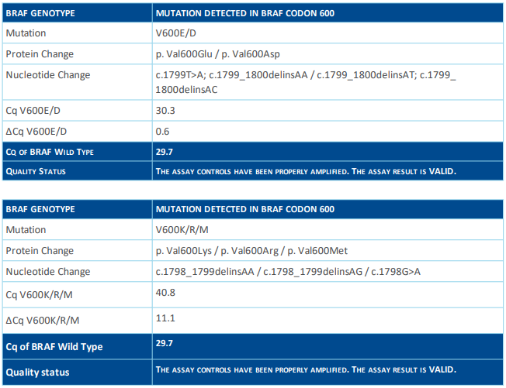

Note: It is possible to have a valid mutation call when there is no valid Cq value available for the BRAF Wild Type Control. Although the BRAF Wild Type control generated an invalid signal, the Sample Processing Controls generated a valid result and the overall test is valid based on the call from the mutant PCR.

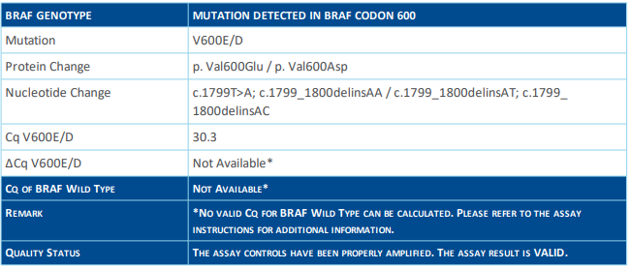

* + 1. **NO MUTATION DETECTED IN CODON 600**

The Console shows a NO MUTATION DETECTED IN BRAF CODON 600 result, if only the Wild Type PCR has generated a valid curve and no V600E/D or V600K/R/M mutation have been detected.

* + - 1. When the Console shows a NO MUTATION DETECTED IN BRAF CODON 600 result, in certain conditions, the presence of a mutation in BRAF CODON 600 cannot be excluded since the result is dependent on:
         1. The quality of the tissue or DNA sample.
         2. The presence of sufficient amplifiable DNA.
         3. The percentage of tumor present in the specimen.
         4. The absence of inhibiting substances.
      2. If the Cq of the *BRAF* Wild Type control is between 32 and 36, the report will additionally display a remark to indicate that a low amount of amplifiable DNA was present in the sample. In these cases, V600K/R/M mutations <5% VAF may not be detected. See example below.

* + 1. **INVALID**



An INVALID result may be presented for any of the following reasons:

* + - 1. Presence of inhibitors in the sample.
      2. Severe DNA fragmentation potentially caused by over-fixation.
      3. Incorrect placement of a sample in a Cartridge.
      4. No sample added.
      5. Sample volume or concentration out of range.
      6. Cartridges that are damaged, stored improperly, or have exceeded their in-use period after removal from the pouch.
      7. Cartridge malfunction.

1. **RESULT REVIEW IN IDYLLA EXPLORE:**

Idylla™ Explore is a web application tool that allows assessment of data by providing visualization of PCR curves from test results and Cq and ∆Cq values, and direct access to console result reports.

To access Idylla™ Explore, login with your username and password at <https://us.idyllaexplore.biocartis.com/>

* 1. The homepage gives an overview of all the Runs performed on the Console. You can filter the Runs in the **Filter** pane (A) and review information about one or more test runs by browsing the **Runs** table (B). Click the dropdown arrow to the right of the desired run to view the amplification curves.

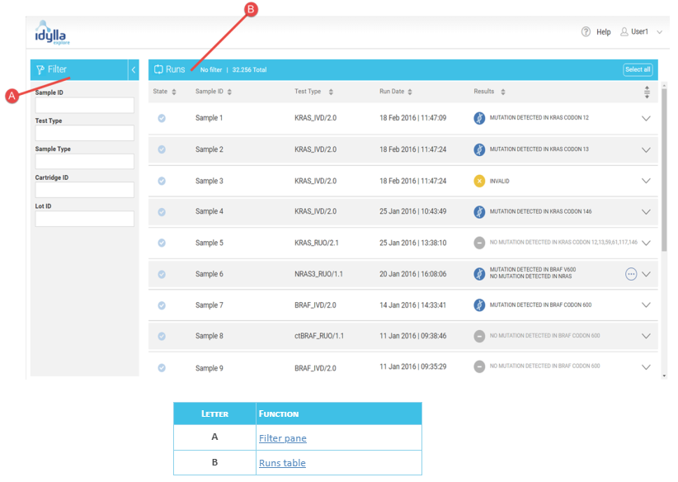

* 1. Target Result tab displays:
     1. Targets detected for the sample.
     2. The corresponding chamber where the target reaction occurred.
     3. The cycle of quantitation (Cq) score for the target reaction.
     4. The ΔCq for targets where a mutation was detected.
  2. Test Results tab displays:
     1. All genotype calls for the *BRAF* assay and the mutation status.
     2. The protein and nucleotide changes of the genotype calls for positive mutations.
     3. The Cq and ΔCq for the positive mutations.
     4. The median Cq for each of the *BRAF* total reactions.
     5. The quality status of the run.
  3. Curve Reports and Console reports can be downloaded/printed using the respective buttons at the bottom right of the results pane.

1. **DIRECTOR RESULTS REVIEW:**
   1. Open My Orders by using the icon on the dashboard.
   2. Click on the Director Review tab.
   3. Click two times on tasklist number.
   4. Click **No** in the window that appears.
   5. Open the QC Data tab on the left side of the screen.
      1. Click two times on a control.
      2. Navigate to the Document tabs.
      3. Click the Dual View icon to view the PDF report.
      4. Select the Results tab.
      5. Compare the result in the Result column with that on the PDF. Make changes if necessary.
      6. Click **Verify All**.
      7. Click **Save.**
      8. Click **OK** to close the QC Components popup window.
      9. Click **Yes** when asked to save changes.
      10. Repeat as necessary for additional controls.
   6. Open the Assigned Tests tab.
      1. Highlight the order for the first patient sample (parent level).
      2. Open the Analysis Images tab.
         1. Click the Dual View icon to view the PDF report.
         2. Open the test results tab.
         3. Compare the result in the Result column with that on the PDF. Make changes if necessary.
         4. Complete the Result Review action by marking the Completed checkbox.
         5. Click **Save**.

Close the Tasklist Entry window.

1. **SIGN-OUT ENTRY:**
   1. Open My Orders by using the icon on the dashboard.
   2. Click the Molecular Pathologist tab.
   3. Click two times on the appropriate order.
   4. Click **No** in the “assign it to you” window that appears.
   5. Verify RBS rules triggered correctly for the Result, Interpretation, Methodology and Disclaimer sections. Double click the Final Test Interpretation tab to view in full screen.
   6. Mark the Completed checkbox.
   7. Click the **Sign Out** button in the menu bar at the top of the window.
   8. Click **Sign Out** in the popup that appears.
   9. The final report will now open. Click Complete Sign Out at the bottom left of the screen to complete the case.

Close the Sign Out Entry tab.

1. **REPEAT TESTING:**
   1. During the testing process, testing for some samples must be repeated for a variety of technical or analytical reasons.

Samples will be rerun if failures occur, and both PDF reports will be uploaded into Soft Molecular.

1. **LIMITATIONS:**
   1. The Idylla™ BRAF mutation assay is a qualitative assay not to be used for quantitative measurement of allele frequencies.
   2. False positive or negative results may occur if there is low tumor content or genetic heterogeneity in the tumor.
   3. The results do not exclude the possibility of other *BRAF* variants that are not targeted by this assay.
   4. When using samples that do not meet the specified criteria, it is possible that the results are not reliable or valid.
   5. Interlesion heterogeneity should be considered.
   6. Insufficient sample input can lead to a No Mutation Detected or Invalid result.
   7. Improper specimen collection, processing and handling can result in degraded or deaminated DNA and may affect the result obtained with the assay.
   8. Using samples embedded in paraffin with a melting temperature above 60°C could generate invalid and/or incorrect results.
   9. Using stained samples could generate invalid and/or incorrect results.
   10. The presence of PCR inhibitors, although tested up to a certain level, may cause a false negative result or an invalid result. When melanin inhibition is suspected, repeat testing on a smaller FFPE tissue section, keeping the minimum specimen requirements into account.
2. **REFERENCES:**
   1. Biocartis Idylla™ Laboratory Integration Guide, First Version (Released 01/2019).
   2. Biocartis Idylla™ Operator Manual, CSW/4.3 (Released 02/2019).
   3. Biocartis Idylla™ EGFR Mutation Assay Instructions, A0061/6 (Released 07/2017)
   4. Tan LY, Walker SM, Lonergan T, Lima NE, Todd AV, Mokany E (2017) Superior Multiplexing Capacity of PlexPrimers Enables Sensitive and Specific Detection of SNPs and Clustered Mutations in qPCR. PLoS ONE 12(1): e0170087. doi: 10.1371/journal.pone.0170087
   5. Huiya Huang, Stephanie Springborn, Kiefer Haug, Kaitlyn Bartow, Hasan Samra, Smitha Menon, and Alexander C. Mackinnon. Evaluation, Validation, and Implementation of the Idylla™ system as Rapid Molecular Testing for Precision Medicine. The Journal of Molecular Diagnostics, 2019 September, 862-872.