PROCEDURE: NEWPORT GRAM STAINS

PRINCIPLE
Gram-negative and Gram-positive bacteria differ in their cell wall composition. Gram-positive microorganisms have a higher peptidoglycan and lower lipid content than Gram-negative bacteria. During Gram staining, cell walls are stained by the crystal violet. Iodine is added as a mordant to form the crystal violet-iodine complex so the dye cannot be easily removed. The decolorization step using a mixed solvent of ethanol and acetone dissolves the lipid layer from the Gram-negative cells. The removal of the lipid layer enhances the leaching of the primary stain from the cells. In contrast, the solvent dehydrates the thicker Gram-positive cell walls closing the pores as the cell wall shrinks during dehydration. As a result, the diffusion of the violet-iodine complex is blocked, and the bacteria remain stained a purple color. Finally, a counterstain of basic fuschin is applied to the smear to give decolorized Gram-negative bacteria a pink color.

AVAILABILITY
Gram stains are performed on ALL specimens from the OR, ALL cerebral spinal fluid, and sterile body fluids from the ED. Gram stains are performed in the microbiology laboratory on all shifts. They are shipped daily to RIH for review and correction if necessary.

TEST CODE
GRAM

SPECIMEN PREPARATION AND PROCESSING
  - All slides should be pre-cleaned immediately before use by wiping with an alcohol pad.
  - All alcohol from the cleaning process must be dried away before the Gram stain smear is prepared.
  - Once the glass slides are cleaned, they are to be inoculated first (before the media).
  - Each specimen should be examined before the Gram stain smear is prepared.
  - All tissue specimens need to be ground using the one-time use disposable tissue grinding kit and sterile saline. A Gram stain should be made by pipetting a drop or two from the ground specimen onto an alcohol cleaned glass slide.
  - A normally sterile site is defined as, but not limited to: blood, cerebrospinal fluid (CSF or shunt), pleural fluid (chest/ empyema or thorocentesis), peritoneal fluid (abdominal or ascites), pericardial fluid, bone (bone marrow, tissue or disk space), joint fluid (synovial, bursa, knee, ankle, elbow, hip or wrist aspirated from joint site), tissue specimen obtained from surgery or sterile aspirate procedure (lymph node, brain, heart, liver, spleen, vitreous fluid, kidney, pancreas, ovary, or vascular tissue).
  - All specimens received on swabs, including E-swabs, should be rolled, not rubbed onto the alcohol cleaned glass slide. Sterile body fluids collected on E-swabs should be cytospun.
  - Direct cytospin slides should be made for all cerebral spinal fluids, vitreous fluids, shunt fluids, and clear sterile body fluids.
    - Place an alcohol cleaned, dry cytospin slide in the metal slide holder apparatus.
    - Attach the funnel and place the clip of the metal apparatus in the locked position.
    - Stand the holder upright and place 1-3 drops of the fluid into the funnel using a sterile transfer pipet.
    - Cap the funnel.
    - The funnel apparatus is now placed in the cytospin holder bowl and into the centrifuge to be spun at 1500 RPM for 5 minutes.
  - Viscous or Bloody sterile body fluids can be diluted. If the specimen requires dilution, a 1:20 dilution is made by using a sterile transfer pipet to deliver 19 drops of sterile saline and one drop of a thoroughly mixed specimen to a sterile glass tube. This diluted specimen is then vortexed to ensure complete mixing.
    - Place an alcohol cleaned, dry cytospin slide in the metal slide holder apparatus.
    - Attach the funnel and place the clip of the metal apparatus in the locked position.
    - Stand the holder upright and place 1-3 drops of the diluted fluid into the funnel using a sterile transfer pipet.
    - Cap the funnel.
    - The funnel apparatus is now placed in the cytospin holder bowl and into the centrifuge to be spun at 1500 RPM for 5 minutes.

REAGENTS for Manual Staining
  - Crystal Violet
  - Grams Iodine
  - Grams Decolorizer
  - Basic Fuschin

STORAGE AND HANDLING
  - Aseptic technique should always be used.
  - Reagents should be stored at 15 – 30°C.

QUALITY CONTROL

Positive control organism is Staphylococus aureus.
  - Negative control organism is Escherichia coli.
  - Positive and Negative control slides are available at the Gram stain counter.
  - Controls are run routinely on a weekly basis, for each new lot, and each shipment of reagents.
  - When reagents are first put into use that were received from another facility, if the QC fails, any gram stains will be reviewed for accuracy from the date the reagents were put in use to the date of failure.
  - For Technologists that do not perform Gram stains at least once per week, a QC Slide is to be stained and read each day of testing.

PROCEDURE
  - After specimen preparation, allow smear to dry can use heat block (40ºC). Methanol fix all slides before staining.
  - Flood smear with Crystal Violet (60 sec).
  - Wash with tap water (5-10 sec).
  - Flood smear with Grams Iodine (60 sec).
  - Wash with tap water (5-10 sec).
  - Decolorize with Gram Decolorizer solution until no further violet washes away.
  - Wash with tap water (5-10 sec).
  - Counterstain with Basic Fuschin (30-60 sec).
  - Air dry and examine.

INTERPRETATION
  - Evaluation
    - Evaluate the general nature of the smear under low power (10x).
    - Determine if the smear was properly stained. The background should appear clear or Gram negative (pink). If WBCs are present, they should appear completely Gram negative. The nuclei of the Polys should not be Gram positive (purple).
    - Determine if the smear thickness is appropriate. For proper interpretation, areas must be no more than one cell thick with no overlapping of cells. Background should appear clear or Gram negative.
    - Inappropriately prepared/ poorly stained smears are to be remade.
    - A review or second opinion should be requested if the result of the Gram stain is questionable. Refer to Teams Procedure for Virtual Viewing. If assistance is needed on 2nd shift, 3rd shift or weekends for gram stain assistance, the Pathology Resident on call should be paged, Beeper # 350-2945. On the rare occasion when a proper interpretation cannot be made (quantity not sufficient for repeat smear), the GRAM or GRAMO portion of the test must be
resulted as such and the patient credited.
    - All organism morphologies are reported in all specimen types.
  - Morphology
    - Polymorphonuclear leukocytes (Polys) (Appendix A; Example A)
- Should appear Gram negative (pink)
- Should be intact
- Multi-lobed nucleus
    - Squamous epithelial cells (Squams) (Appendix A; Example B)
- Should appear Gram negative (pink)
- Should have a small nucleus compared to cell’s size
    - Gram positive cocci suggestive of Staphylococci (Appendix A; Example C)
          - Should appear Gram postive (purple)
          - Should be arranged in clusters or singles
          - These organisms should not form chains
    - Gram positive cocci suggestive of Streptococci (Appendix A; Example D)
- Should appear Gram positive (purple)
- Should be arranged in singles, pairs or chains of four or more organisms
- The chains of cocci can sometimes fold over and simulate clusters
    - Gram positive diplococci suggestive of Pneumococci (Appendix A; Example E)
- Should appear Gram positive (purple)
- Should be arranged in pairs/lancet shapes
- Usually see a clearing where capsule surrounds bacteria
    - Gram positive rods (Appendix A; Example F)
- Should appear Gram positive (purple)
- Should be longer than they are wide (may be short or long; box-car shaped; pleomorphic; beaded; branching)
    - Gram negative rods (Appendix A; Example G)
- Should appear Gram negative (pink)
- Should be longer than they are wide (may be short or long or pointed)
    - Gram negative coccobacilli suggestive of Haemophilus (Appendix A; Example H)
- Should appear Gram negative (pink)
- Typically look like very tiny Gram-negative rods with rounded ends.
    - Gram negative diplococci (Appendix A; Example I)
- Should appear Gram negative
- Should have a paired “kidney bean” appearance
- Should not be confused with over-decolorized staph or strep
    - Yeast (Appendix A; Example J)
- Should appear Gram positive – but decolorize very easily
- Should see budding or pinched pseudohyphae
- Should be easily seen when smear is examined under low power.
    - Fungal elements (Appendix A; Example K)
- Should appear Gram positive – but decolorize very easily
- Should see septate hyphae and branching
- Should be easily seen when smear is examined under low power
  - Quantitation
      - When reading Gram stains, make enumerations using the following criteria after scanning 20-40 fields.
      - Squamous epithelial cells (Squams) and polymorphonuclear leukocytes (Polys) will be enumerated per low power field (LPF 10x objective). Cells are quantitated the same for all specimen types.
      - Organisms are quantitated per high power field (HPF 100x Oil objective). See below for special organism considerations and quantitation by specimen source/site.
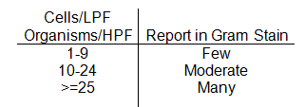

  - Enter Gram stain results using test comment keypad
  - Every Gram stain report should include
    - Quantitation of Polys
    - Quantitation of squams
    - Quantitation and morphology of organisms
  - Report all Gram stains as final reports
  - For any positive Gram stains on cultures or those that fall into the “Red” category on the Critical Call Policy: Set SIGNIFICANT FLAG so results are flagged as ABNORMAL in EPIC.
  - Bacteria found from any OR specimen, tissue or sterile body site is to be called according to the critical call policy.
  - For cytospin slides, use the test comment keypad enter the SOFT statement “Cytospin of Gram stain shows:”
  - Correcting Gram Stain in SOFT
    - Insert the canned message }PREC above the incorrect Gram stain.
    - Place the correct Gram stain above the “PREVIOUSLY REPORTED AS:” statement.

Example of a corrected final Gram stain report:

**THIS IS A CORRECTED REPORT
**Many Polys
**No Squamous Epithelials
**Moderate Gram Positive Cocci suggestive of Staph
**Called to and read back by: Dr. Smith 12/14/2015 at 1300
PREVIOUSLY REPORTED AS:
Many Polys
No Squamous Epithelials
No Organisms seen

  - Report for Gram stains that cannot be interpreted.
    - Result the Gram stain as either:
          - If it was improperly stained and quantity not sufficient for repeat testing: “Unable to perform Gram stain due to Laboratory error”
          - If it was a specimen that was unable to be interpreted because it was unable to be properly stained: “Unable to perform Gram stain due to poor staining quality of the specimen.”
    - On first shift, notify the technical specialist, manager or laboratory director prior to calling this result to the floor.
    - Notify unit/provider of specimen quality and cancellation.
    - Finalize Gram stain report.
    - Go to Order Entry, right click on the GRAM order, click on Bill-No Charge, then save.
    - Type in comment box “Poor Quality”
    - Save all Gram stain slides that were made for further evaluation.
  - TEAMS Procedure for Virtual Viewing: Newport Hospital Microbiology may request a virtual review or second opinion on a questionable Gram stain.
    - NH Tech:
      - Contact the person assigned to Gram stains at RIH Microbiology to request GS review
        - Using teams, call tech assigned to RIH Gram stains and share screen
      - Using the Hematology microscope, pull the pin out on the right side to engage virtual viewing.
      - Click on CellSens
      - Click line on right side under camera control.
      - Review GS slide with RIH tech while on call
      - Document any applicable information and name of RIH GS tech involved in review in worksheet.
    - RIH Tech:
      - NH will contact tech assigned to Gram stains at RIH when a GS review is needed
      - Accept conference call via Teams and review questionable GS with NH tech

LIMITATIONS
  - The sensitivity of the Gram stain is dependent upon: cytocentrifugation, quality and type of specimen collected, and portion of the specimen selected for preparation.
  - The results of the Gram stain should be used by the physician in correlation with other clinical and laboratory findings.
  - Careful adherence to the procedure is required for accurate results. Accuracy is highly dependent on the training and skill of the technologists performing the interpretation.
  - Gram stain-positive, culture negative specimens may be the result of contaminated reagents or supplies. It is especially important that the correct sterile device is used for collecting and transporting the specimen.
  - False negative Gram stain results may be related to inadequately collected specimen, delay in transit or improper interpretation of the slide.

NOTES
- An organism whose average quantitation over 20-40 fields is less than 1 per high power field should not be reported. If a second smear can be made to verify the organism, it should be prepared and interpreted. A note in the worksheet should be made.
- Smears should not be left on the slide heat block for an excessive amount of time. When the prepared slide is dried, it is time to remove it from the heat block and stained. Leaving them for an extended amount of time may distort the morphology of structures on the slide.

- REFERENCES
  - www.microbelibrary.org
  - www.uphs.upenn.edu
  - http:matcmadison.edu
  - www.health.state.mn.us/index.html
  - Garcia. Lynne S, Clinical Microbiology Procedures Handbook Third Edition; Volume 1, 2007
  - www.cdc.gov

Appendix A – GS examples, High Power (100x)

Example A – Polymorphonuclear leukocytes
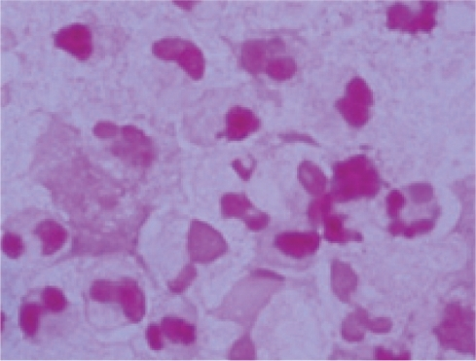
Example B – Squamous epithelial cells

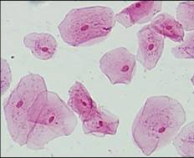

Example C – Gram positive cocci suggestive of staphylococci
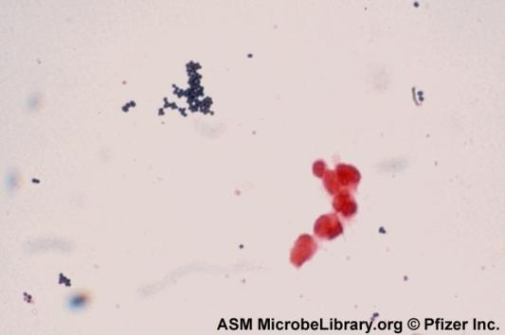
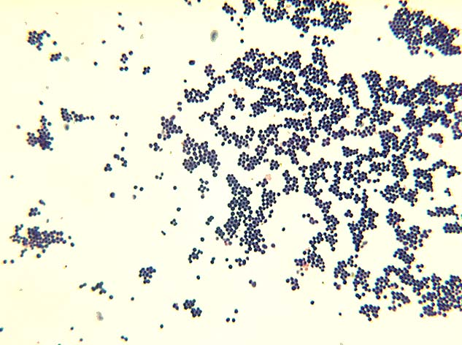
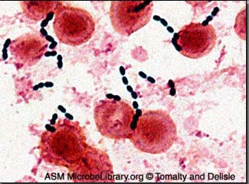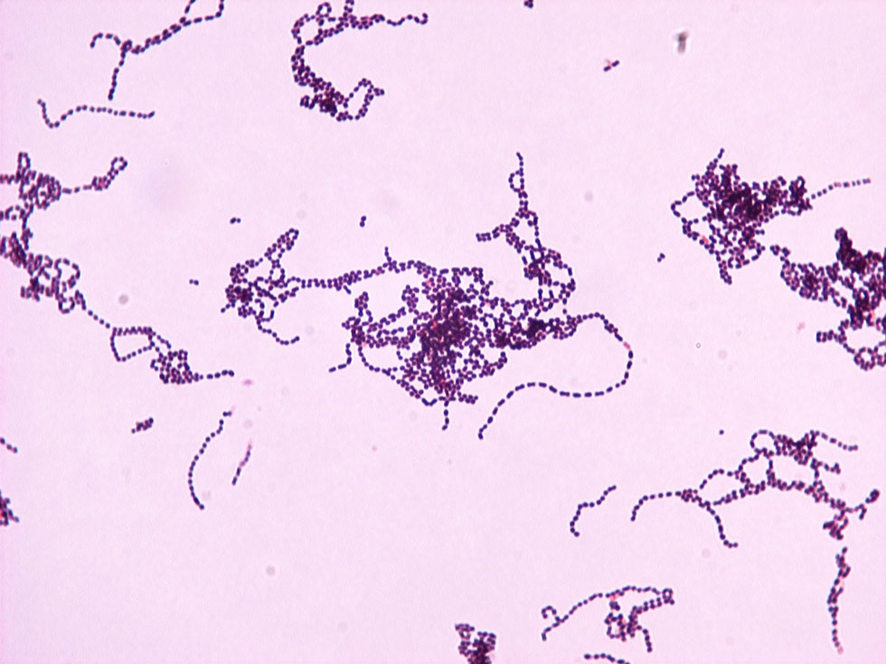
Example D – Gram positive cocci suggestive of streptococci
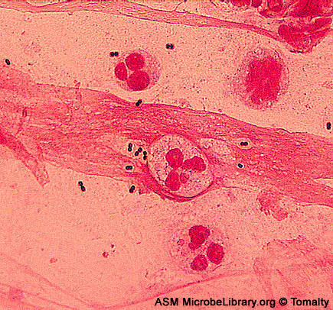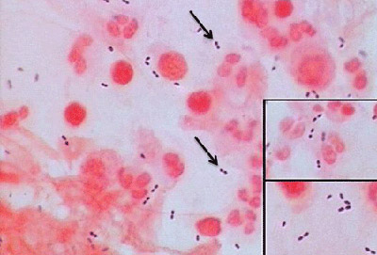
Example E – Gram positive diplococci suggestive of pneumococci

Example F – Gram positive rods
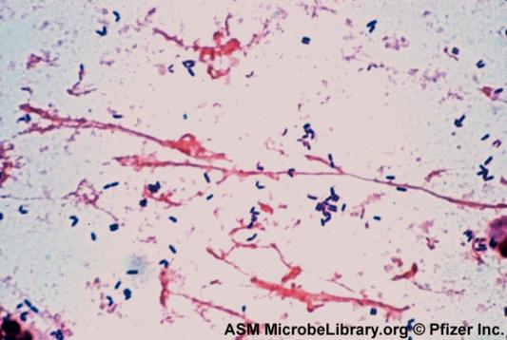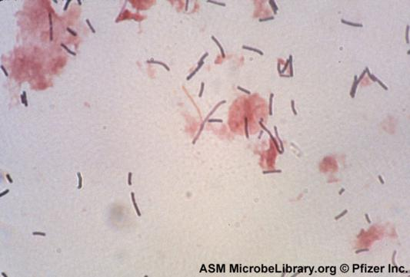

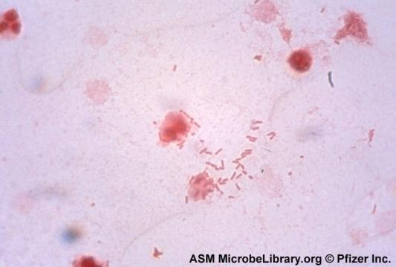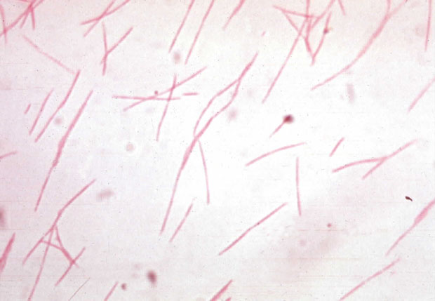
Example G – Gram negative rods
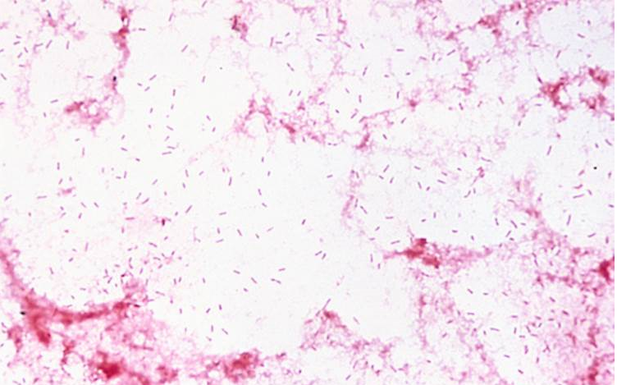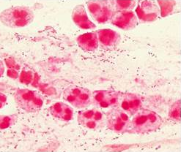
Example H – Gram negative coccobacilli suggestive of Haemophilus
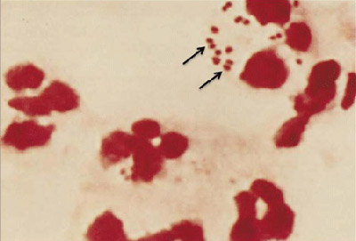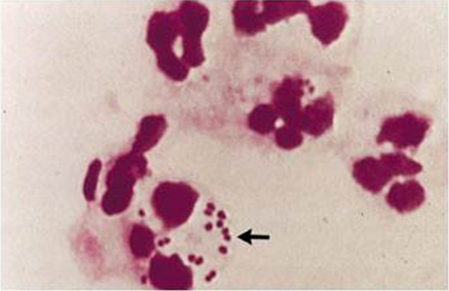
Example I – Gram negative diplococci

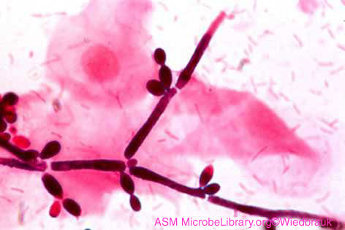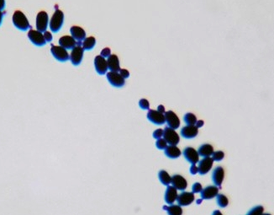
Example J – Yeast
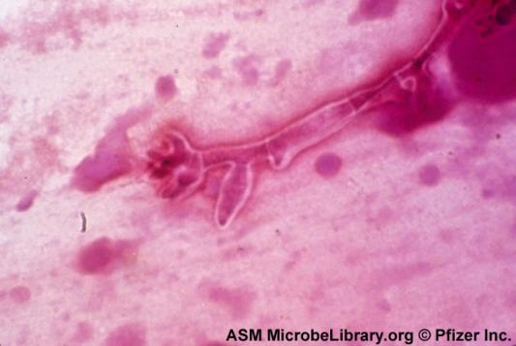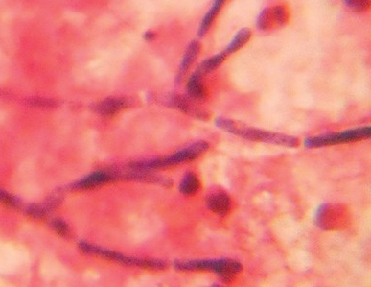
Example K – Fungal elements

Example L – Gram positive beaded rods suggestive of Nocardia
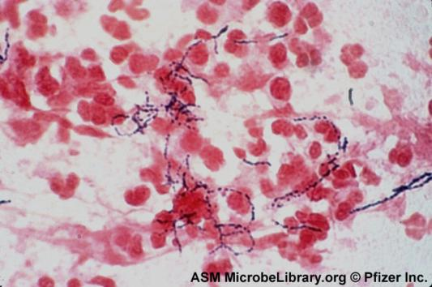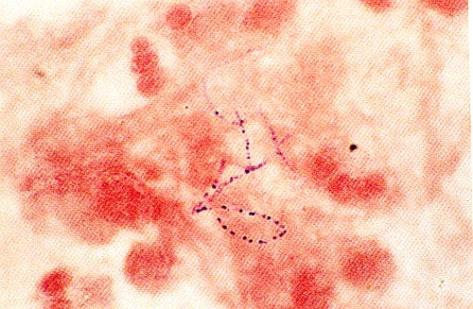

Example M – Gram positive rods suggestive of Mycobacterium
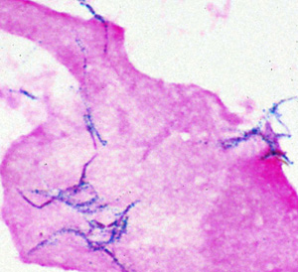
Example N – Encapsulated yeast suggestive of Cryptococcus in CSF specimen
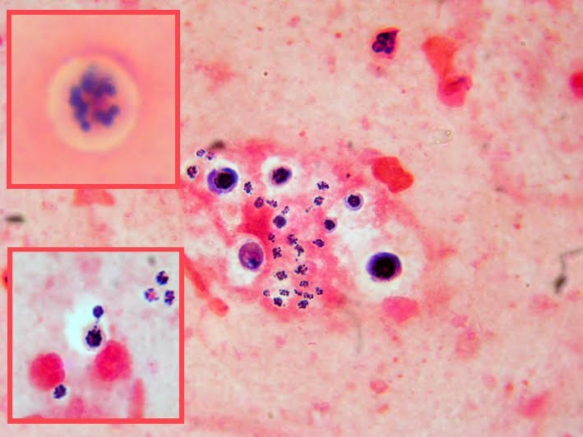

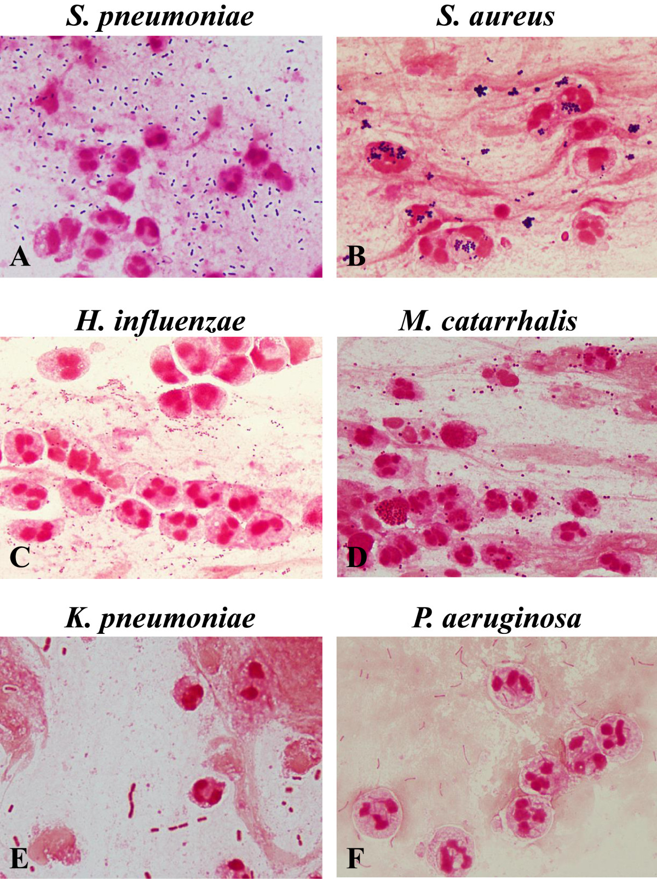
Bacterial morphotypes in sputum Gram stain (×100, oil immersion field). Gram positive diplococci (lancet-shaped or football-shaped) are suggestive of Streptococcus pneumoniae(A). Cluster of Gram positive cocci are suggestive of Staphylococcus aureus(B). Tiny Gram negative coccobacilli are suggestive of Haemophilus influenzae(C). Gram negative diplococci (kidney bean-shaped) are suggestive of Moraxella catarrhalis(D). Plump Gram negative rods are suggestive of Klebsiella pneumoniae(E). Thin Gram negative rods are suggestive of Pseudomonas aeruginosa(F).
Fukuyama et al. BMC Infectious Diseases 2014 14:534 doi:10.1186/1471-2334-14-534

