Actionable Mutation Panel 2 (AMP2) Procedure
- PRINCIPLE:
  - The identification of molecular biomarkers in cancer has contributed to the rise of precision medicine and targeted therapeutics. Somatic alterations, such as single nucleotide variants, insertions, and deletions, can provide diagnostic, prognostic, or therapeutic guidance. However, in the clinical laboratory, the detection of these alterations can be difficult, due to the heterogeneous nature of most tumor tissue and the limited amount of clinical sample available for testing. As a result, sensitive methodologies, such as next-generation sequencing (NGS), are required for the detection of variants at a low allele fraction within a sample.
  - The Pillar ONCO/Reveal Solid Tumor Panel v2 is a robust 48-gene assay that simultaneously tests for key mutations present in solid tumors, including NSCLC, colorectal, pancreatic, gastrointestinal stromal tumor (GIST), thyroid cancer, melanomas, and gliomas. Additionally, genes with potential importance in immuno-oncology such as POLD1 and POLE are analyzed. The panel uses proprietary Stem-Loop Inhibition-Mediated amplification (SLIMamp®) technology, a tiled amplicon-based library prep chemistry for efficient single-tube target enrichment.
  - The kit supports multiplex NGS analysis with an Illumina® MiSeq® Instrument using v2 chemistry. Also included is the Pillar analysis software (PiVAT), which analyzes MiSeq® data files for the identification of base substitution mutations and small insertions/deletions using a locally integrated bioinformatics pipeline and companion data visualization tools. In addition, custom bioinformatics and pathology informatics tools have been implemented and clinically validated.
  - The MiSeqDx Platform is an NGS instrument that measures fluorescence signals of labeled nucleotides using instrument specific reagents and flow cells, imaging hardware, and data analysis software. Illumina MiSeq® systems utilize sequencing by synthesis (SBS) technology, integrating cluster generation, sequencing, and data analysis on a single instrument.
    - In contrast to standard MiSeq instruments, the MiSeqDx Platform has two modes of operation: Diagnostic Mode, which can be used with FDA-approved/cleared assays; and RUO/Research Mode, which can be used with laboratory-developed tests and research assays.
    - This assay is performed using RUO/Research Mode. For the purposes of this Procedure, “MiSeqDx” and “MiSeq” shall be used interchangeably.
    - This assay is performed using MiSeq Reagent Kits with V2 chemistry.
    - The following Illumina software is used for this assay:
      - MiSeq Suite Version: 4.1.0.480
      - MiSeq Software Version: 4.1.0.656
      - IP Address 169.254.1.2 (Subnet Mask 255.255.255.0)
      - RTA Version: 1.18.54.4
      - Universal Copy Service: 2.7.4.5117
      - Local Run Manager: 4.1.0.471
      - Sequencing Analysis Viewer (SAV) V3.0.0
  - The Actionable Mutation Panel 2 consists of five broad parts:
    - ONCO/Reveal Solid Tumor Panel v2 by Pillar
    - Illumina MiSeq Sequencing Kit v2
    - Pillar Biosciences PiVAT Bioinformatics Pipeline – version 2022.1.3
    - Lifespan Actionable Mutation Reporter 2 Bioinformatics Pipeline – version 2.0
    - Lifespan Variant Review Tool – LVRT version 1.1
  - Figures 1 and 2 below summarize the steps and subcomponents of the assay.
    - After DNA extraction from the specimen (see appropriate DNA Extraction Procedure), the wet-bench procedure is performed.
    - Then, two bioinformatics pipelines are performed in parallel, and results are cross-correlated for internal QC.
      - The first pipeline is a custom pipeline developed according to guidelines from the National Cancer Institute. In addition, additional software has been added to optimize sensitivity and specificity of the assay.
      - The second pipeline has been provided by the vendor of the reagents and has additional features, such as QC data and annotation of the variants (e.g., benign, likely benign, pathogenic, variant of unknown significance).
    - Data from each pipeline are analyzed and cross-correlated.
      - Analysis of the PiVAT program results is performed within the LVRT application – a custom software tool written in Python for variant filtration and data review.
    - If applicable, results are confirmed by alternative testing methods and then reported through the Laboratory Information System (LIS).
      - The decision for whether confirmation testing should be performed is made at the discretion of the Pathologist/Lab Director.
    - Table 1 below lists the 48 genes targeted by the AMP2 Pillar ONCO/Reveal Panel v2.

Figure 1: Summary of AMP2 Pillar ONCO/Reveal Panel v2 Procedure

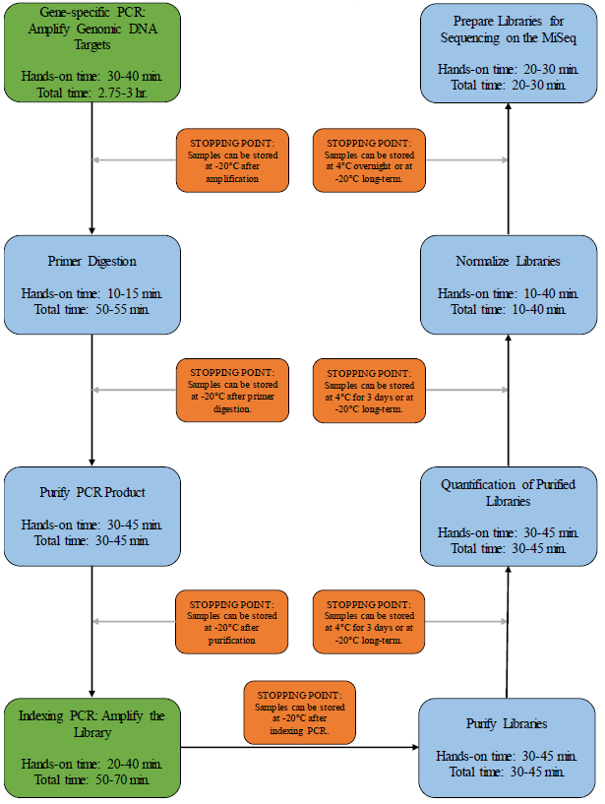

Figure 2: Summary of AMP2 Pillar ONCO/Reveal Panel v2 Library Preparation
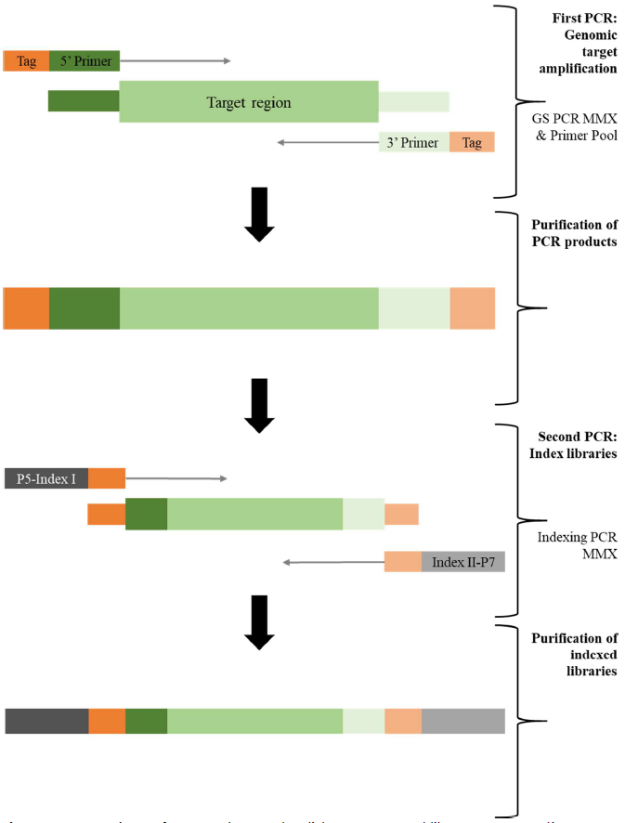

Table 1: Genes Covered by the AMP2 Pillar ONCO/Reveal Solid Tumor v2 Panel
  - The assay is designed to target genes associated with clinical actionability in a variety of tumor types. Inclusion of these targets is based on the NCCN guidelines for targets that should be tested in these tumor types.
  - The Pillar ONCO/Reveal Solid Tumor Panel v2 kit includes reagents for DNA assessment, target enrichment, and index codes. This assay is optimized to assess for mutations in a variety of clinical samples, including low-quality and low-quantity DNA samples isolated from FFPE (Formalin-Fixed, Paraffin-Embedded) or FNA (Fine Needle Aspiration) and other cytology tumor samples. Each kit component serves an essential role in the library prep workflow:
    - Gene Specific PCR Reagents
      - 2X Gene Specific PCR Master Mix
      - CH222 Oligo Pool
      - GC Rescue G
        - PCR primers and PCR reagents that support single-well multiplex PCR enrichment, across hotspot regions.
    - Gene Specific Primer Digestion Reagent
      - Exonuclease I
        - Exonuclease I facilitates excess primer digestion.
    - Indexing PCR Reagents
      - 2X Indexing PCR Master Mix
      - Pillar Custom Indexing Primers Kit D
        - PCR primers that add index adaptors, P5 and P7 sequences to each library for sample tracking and sequencing on Illumina v2 flow cells.
    - The positive control is purchased separately from Horizon Discovery.
      - Quantitative Multiplex Reference Standard (gDNA), Cat# HD701.
        - The expected control variants are included in Table 2 below.
Table 2: HD701 Expected Variants with %VAF
Chromosome | Gene | Variant | Expected Allelic Frequency %
7q34 | BRAF | V600E | 10.5
4q11-q12 | KIT | D816V | 10.0
7p12 | EGFR | ΔE746-A750 | 2.00
7p12 | EGFR | L858R | 3.00
7p12 | EGFR | T790M | 1.00
7p12 | EGFR | G719S | 24.50
12p12.1 | KRAS | G13D | 15.00
12p12.1 | KRAS | G12D | 6.00
1p13.2 | NRAS | Q61K | 12.50
3q26.3 | PIK3CA | H1047R | 17.50
3q26.3 | PIK3CA | E545K | 9.00

  - This assay is designed to target mutations associated with a variety of tumors (such as: non-small-cell lung cancer, colorectal adenocarcinoma, thyroid carcinoma, melanoma, and other tumors).
    - Therefore, the assay can be performed on a variety of specimen types (see below for full list).
    - Of note, various cytology preparations have been evaluated as a specimen type and require specific processing steps (see the TNA, Cytology Manual Extraction Procedure and QC/Evaluation documentation for more details).
    - In addition, this assay is designed to target mutations in melanoma samples and melanin is a known inhibitor of PCR. Specimens with melanin pigmentation, hemoglobin, and other inhibitors may require specific processing steps (see the PCR Interfering Substances: BSA Method Procedure and QC/Evaluation documentation for more details).
      - Refer to the AMP2 Pillar ONCO/Reveal Solid Tumor Panel Validation Summary for additional details.

- SPECIMENS:
  - Sample types: FFPE unstained slides, FFPE scrolls, cytology cell block, cytology preparation (such as smear and liquid-based cytology slides), blood, and bone marrow aspirate.
  - Before proceeding with the assay, determine the DNA concentration in each specimen using the Qubit 3.0 (see Qubit 3.0 Fluorometer Instrument Procedure).
    - Optimal DNA Input is ≥50ng.
      - Any sample with a concentration ≥ 8ng/uL will achieve optimal DNA input.
    - Minimum DNA input is ≥2ng.
      - Any sample with a concentration ≥0.32ng/uL will achieve the minimum DNA input requirement.
    - Samples with concentrations <0.32 ng/uL should be discussed with the Laboratory Director and/or Pathologist prior to assay setup.
      - Note: Such specimens may be added to the NGS Exception Log (see below).
  - Specimen acceptability criteria:
    - FFPE and cytology samples should have a tumor content of at least 10% within the material for extraction (i.e., entire tissue for scrolls or encircled area for macro-dissected slides). In a diploid genome, this corresponds to the limit of detection for heterozygous variants (variant allele fraction of 5%).
    - Samples with tumor content less than 10% should be discussed with the Laboratory Director and/or Pathologist prior to assay setup.
      - Note: Such specimens may be added to the NGS Exception Log (see below).

- MATERIALS AND EQUIPMENT:
  - REAGENTS:
    - 70% Ethanol (Pharmco, or equivalent Molecular Grade Ethanol). Store at room temperature in flammable cabinet.
    - Agencourt AMPure XP Beads, Cat# A63880. Store at 2-8°C.
    - Nuclease-free water, Cat# 15230196. Store at room temperature.
    - Qubit dsDNA High Sensitivity Kit, Cat# Q33230. Store at 4-8°C.
    - 1N Sodium Hydroxide. Store at room temperature.
      - 1N NaOH is aliquoted into a 15mL conical tube and stored at room temperature for 6 months.
      - If run quality looks poor (e.g., poor SAV metrics), check the pH of the 1N NaOH aliquot (should be 12), and document prior to using the 1N NaOH on the subsequent run.
    - PhiX Control v3, Cat# FC-110-3001. Store at -20°C.
    - MiSeq Reagent Kit v2 Components:
      - Box 1: Store at -20°C
        - MiSeq v2 Cartridge
        - HYB1 Buffer
      - Box 2: Store at 4°C
        - MiSeq v2 Flow Cell
        - Incorporation Buffer
    - The ONCO/Reveal Solid Tumor Panel v2 Kit components including any additional storage and handling information are listed in Table 3 below.
      - Pillar provides several index kit options depending on throughput needs, but the Pillar Custom Indexing Primers Kit D is used in this laboratory.

Table 3: Components of the ONCO/Reveal Solid Tumor Panel v2 and Storage Conditions
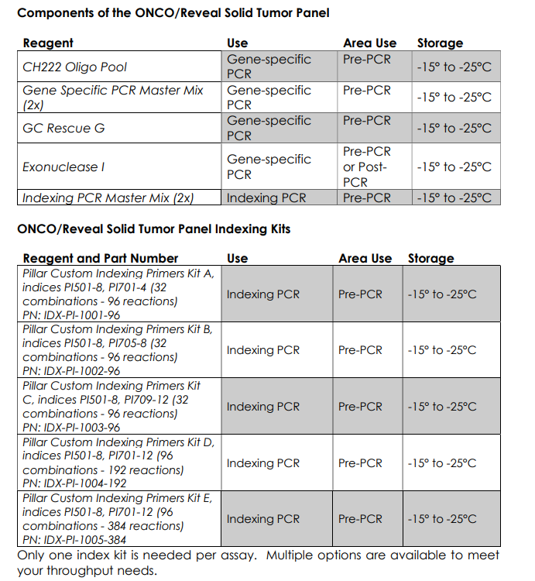
  - CONTROLS:
    - Positive Control
      - Quantitative Multiplex Reference Standard (gDNA), Cat# HD701.
        - Upon receipt, determine the concentration of HD701 using the Qubit dsDNA High Sensitivity kit.
        - Dilute HD701 to 4 ng/uL with nuclease-free water
          - Refer to Table 2 above for expected variants and % VAF.
    - Negative Control
      - No Template Control (Nuclease-free water), Cat# 15230196.
  - MAJOR EQUIPMENT:
    - Illumina MiSeqDx
    - Applied Biosystems (Thermo Fisher) Veriti Thermal Cycler
    - Standard Brown Health Desktop Computer
    - Dell Server with Red Hat Enterprise Linux 8.10
    - PiVAT Software

- QUALITY CONTROL:
  - The following information provides general guidelines for the performance of the ONCO/Reveal Solid Tumor Panel v2.
    - The total number of sequenced reads obtained is a function of the cluster density and the read quality passing filter. Generally, as the cluster density increases, the passing filter decreases.
    - Optimal SAV metric ranges:
      - Percent Q30: >80% (percent of bases with at least Q30)
      - Percent Cluster Passing Filter: >80%
      - Aligned Percent: 1.0% +/- 1.
      - Cluster Density: 950-1,200K/mm2
      - Mapping Rate (%): ≥ 95%
      - On Target Rate (%): ≥ 97%
        - Optimal SAV ranges are established, however, completed runs with SAV metrics outside the optimal range may be accepted at the discretion of the Laboratory Director and/or Molecular Pathologist.

- PROCEDURE:
  - NOTE: If a patient sample requires Sanger Sequencing confirmation:
    - Faculty will send an email to the NGS team.
    - AMP2 technologist:
      - Write a note on the whiteboard in PRE-PCR.
      - Assign the confirmation to an available technologist signed off on Sanger Sequencing.
      - Reply to the email including the technologist assigned to Sanger Sequencing, so the faculty are aware testing is in progress.
  - Note: The following steps are performed by a Molecular Laboratory Scientist, unless otherwise indicated.
  - Preliminary processing:
    - DNA extraction of each sample should be performed according to the appropriate procedure for the specimen type.
    - If the sample contains potential PCR inhibitors or interfering substances (such as melanin or hemoglobin), discuss with the Director or Molecular Pathologist, and perform the following steps:
      - If appropriate, the sample may be tested as per usual protocol and then discussed with a Director or Molecular Pathologist for further processing.
      - Alternatively, the specimen may be diluted with water or BSA after extraction.
        - Refer to the PCR Interfering Substances: BSA Method Procedure for more information.
  - All samples will be pending DNA Qubit Quantitation action in Extractions prior to assay setup. Please refer to the Qubit 3.0 Fluorometer Instrument Procedure for instructions to quantitate all pending samples using the dsDNA High Sensitivity Kit. Soft Molecular steps are included below.
  - DNA Qubit Quantitation
    - Log into Soft Molecular.
    - Open Extractions by using the Extraction tile on the dashboard.
    - Highlight the DNA Qubit Quantitation branch on the action tree.
    - Select Tools tab followed by Import to import Qubit results.
    - Select QUDNAINIT from the dropdown in the Template field.
    - Select the appropriate file using the ‘…’ button next to the File Name field and confirm by clicking Open.
    - Select Import.
    - In the Import Finished window, select OK.
    - Close the Import from Excel window using the ‘X’.
    - If a dilution is not required, highlight the Barcode# field, scan the product label, and select Enter on the keyboard. Repeat this step for all applicable specimens. Select Save.
    - If a dilution is required, mark the Dilute(?) checkbox, then highlight the Barcode# field, scan the product label and select Enter on the keyboard. Repeat this for all applicable specimens. Select Save.
    - Select Back in the Extractions window.
  - DNA Qubit Dilute and Repeat Quantitation
    - Highlight the DNA Qubit Dilute and Repeat Quantitation branch on the action tree.
    - Select Tools tab followed by Import to import Qubit results.
    - Select QUDNAFINAL from the dropdown in the Template field.
    - Choose the appropriate file using the ‘…’ button next to the File Name field and confirm by clicking Open.
    - Select Import.
    - In the Import Finished window, select OK.
    - Close the Import from Excel window using the ‘X’.
    - Highlight the Barcode# field, scan the product label, and select Enter on the keyboard. Repeat this step for all applicable specimens. Select Save.
    - Select Back in the Extractions window.
  - Create the AMP2 Worksheet: AMP2LIBPRP – Test Worksheet Builder
    - Open AMP2LIBPRP – Test Worksheet Builder using the tile on the dashboard.
    - Select Find.
    - If applicable, on the Found Activities tab, click OK or double click on any row.
      - Note: All test codes are pointed at the same worksheet.
    - If applicable, select New in the Pending Worksheet window.
    - Click the Barcode# field. Scan the sample product label and click Enter on the keyboard to add a sample to the worksheet. Repeat for all applicable samples.
    - Check internal notes for each sample being run.
      - Highlight the appropriate patient sample.
      - Select Tools. Then, click Internal Notes.
    - If any sample requires modification, make note in the Comment field of the AMP2LIBPRP worksheet.
    - Select indices for patients and controls based on what was recorded in the Index Code Log, using the dropdown menu in the P5 and P7 columns.
      - Note: If a sample is repeated to Library Preparation, be careful to update the AMP2 P5 and P7 index codes with the new codes. Soft Molecular will default the codes from the previous run.
    - Verify control lot numbers by clicking on the Sample ID field.
      - If the control needs to be changed, click the dropdown arrow and in the window that appears, select the appropriate lot number.
    - Verify the Test Code for the controls matches the sample test code.
      - Note: If multiple different test types are included on the run, the control test code only needs to match the test from one sample,
      - Note: The controls must only have one Test Code. Verify the controls only have one Test Code when the worksheet prints.
    - Verify the reagent lot numbers by clicking on the vertical Settings tab on the left side of the screen.
      - If the reagent lot needs to be changed, click on the dropdown arrow in the Stock# field and select the correct lot in the window that appears.
    - Enter control concentrations for POSCTAMP2 and NTCAMP2 in the AMP2 Control Qubit Concentration field.
    - Mark the Completed checkbox and select Save. The Worksheet Print Preview window will open automatically.
      - Note: Control Q numbers will not generate until the Tasklist is built.
    - In the Worksheet Print Preview window, click the Printer icon, verify the appropriate printer is selected, then click Print.
    - Click on the Settings button to open the Select Printer window. Verify the appropriate printer is selected in the dropdown field. Select Print.
      - Note: Select View in the Select Printer window to preview the Section Settings.
    - Close the preview window.
    - Select Back in the AMP2LIBPRP – Test Worksheet Builder screen.
    - Exit Soft Molecular application.
  - Generate a Pillar Sample Sheet:
    - Navigate to the AMP2_MasterFiles folder within the PCR_Worksheets_Current folder on the RICMBLAB$ shared drive.
    - Open the Pillar-ILMN SampleSheet Generator.
    - Click File, followed by Save As.
    - Name the file by scanning the Library Preparation worksheet, then save in the appropriate run folder.
    - Navigate to the MiSeq-SampleSheet tab in the saved copy of the Sample Sheet Generator.
    - Enter the appropriate initials in the Investigator Name field.
    - Highlight the Experiment Name field, then scan the Library Preparation worksheet.
    - In the Sample_ID field, name each sample and control on the run using the Order# field on the AMP2LIBPRP worksheet.
      - Information entered in the Sample_ID field, automatically copies into the Sample_Name field.
    - Enter the i7 and i5 index codes in the appropriate columns according to the Library Preparation worksheet. Once the i7 and i5 codes have been entered, the Check_index_uniqueness column should change from red to green.
      - NOTE: If a Sample ID is duplicated, the check sample ID calculation will change from green to red.
      - NOTE: If an index code combination is duplicated, the check index uniqueness calculation will change from green to red.
    - Once the i7 and i5 index codes have been entered, verify all assignments match the Library Preparation worksheet and all Sample ID and Index calculations are green.
    - Click the Export button.
    - In the window that appears, navigate to the appropriate run folder, then click Save.
  - Gene-Specific PCR: Amplify Genomic DNA Targets
    - Prepare an ice bucket, then remove the Pillar ONCO/Reveal Solid Tumor Panel v2 kit and Index code kit from the freezer.
    - Place 2X Gene Specific PCR Master Mix, CH222 Oligo Pool, Exonuclease I, and Index PCR Master Mix in the ice bucket the thaw.
    - The remaining reagents, including GC Rescue G, and index codes thaw at room temperature.
    - Obtain 4 microcentrifuge tubes in the appropriate volumes.
    - Label the tubes GS PCR, Exo. Dil., Index PCR and DH2O.
    - Obtain an aliquot of nuclease-free water.
    - Once the reagents have thawed, vortex, then pulse spin ONLY the reagents included below.
      - 2X Gene Specific PCR Master Mix
      - CH222 Oligo Pool
      - GC Rescue G
      - 2X Index PCR Master Mix
    - Prepare the GS PCR, Exonuclease and Index PCR master mixes in the previously labelled microcentrifuge tubes according to the Library Preparation Section Settings worksheet.
      - NOTE: The Gene Specific PCR Master Mix is viscous. Ensure the mix is fully homogenized before adding additional reaction components. Vortexing is recommended and will not adversely affect enzyme activity.
    - Place the prepared master mixes on ice.
    - Obtain the appropriate number of 0.2mL strip-tubes. Detach any extra tubes with clean scissors or razor blade.
      - NOTE: The maximum number of samples per run is 15, including the positive and NTC controls.
    - Label the 0.2mL strip tube with the corresponding reaction tube numbers.
    - Label the side of the first tube GS PCR, the side of the second tube with the date, and if necessary, the side of the third tube with 1 of 2, or 2 of 2.
    - Place the labelled 0.2mL strip tube in a rack.
    - For each sample, perform the 6.25uL dilution in the labeled 0.2mL strip tubes by combining the appropriate volumes of nuclease-free water and purified DNA according to the Library Preparation worksheet.
    - NOTE: For samples or controls with DNA concentration ≤8.0 ng/uL, no dilution is required. Pipette 6.25uL of sample or nuclease-free water (NTC Control) directly into the corresponding Reaction Tube.
    - Briefly vortex and spin down the diluted samples.
    - Using a single-channel pipette, add 18.75uL of previously prepared GS PCR Master mix to each tube.
    - Close the reaction tubes, vortex for 10-15 seconds, then briefly spin to collect contents.
    - Transfer the GS PCR reactions to a Veriti thermal cycler, select the Pillar GS PCR no UDG program, then click Start. This program will run for approximately 2 hours and 10 minutes.

Pillar GS PCR no UDG (with Heated Lid)
Temperature (˚C) | Time | Number of Cycles
95 | 15 minutes | 1
98 | 1 minutes | 5
58 | 2 minutes | 5
60 | 4 minutes | 5
64 | 1 minutes | 5
72 | 1 minutes | 5
95 | 30 seconds | 18
66 | 3 minutes | 18
8 | Hold | ∞

    - Return to the PCR room and obtain a clean 0.2mL strip tube.
    - Label the new 0.2mL strip tube with the corresponding reaction tube numbers.
    - Label the side of the first tube Pillar Index, the side of the second tube with the date, and if necessary, the side of the third tube with 1 of 2, or 2 of 2.
    - Place the labelled 0.2mL strip tube in a rack.
    - Aliquot 4uL of the appropriate P5 index code into each tube according to the Library Preparation worksheet.
    - Briefly spin the tubes to collect contents, then verify a P5 index code was added to each well. The P5 index codes are clear.
    - Aliquot 4uL of the appropriate P7 index code into each tube according to the Library Preparation worksheet.
    - Briefly spin the tubes to collect contents, then verify a P7 index code has been added to each well. The P7 index codes are green.
    - Once the index codes are aliquoted, place the Exonuclease dilution, Index PCR master mix, and Index PCR strip-tube in the -20˚C freezer in POST-PCR for storage.
    - If stopping the workflow, observe the Safe Stopping Point.
    - SAFE STOPPING POINT: After the Pillar GS PCR program ends, briefly spin down and place the products in the -20˚C freezer in POST-PCR. Resume the workflow the next day.
      - Please note, the reactions cannot be left on the Veriti Thermal Cycler at 8˚C overnight.
  - Process Worksheet: AMP2 Gene Specific PCR
    - Log into Soft Molecular.
    - Open AMP2LIBPRP – Test Worksheet Processing by using the tile on the dashboard.
    - Scan the barcode of the AMP2LIBPRP worksheet in the Worksheet# field or select Find.
    - Open the dropdown in the Used Instrument field, then select the appropriate Veriti Thermal Cycler.
    - Complete the AMP2 Gene Specific PCR action by marking the Completed checkbox and selecting Save.
    - Select Back in the AMP2LIBPRP – Test Worksheet Processing screen.
    - Exit Soft Molecular application.
  - Gene-Specific Primer Digestion
    - Prepare an ice bucket, then remove the Exonuclease dilution from the -20˚C freezer in POST-PCR. Place on ice.
    - If the GS PCR products were stored at -20˚C overnight, remove from the freezer and allow them to completely thaw at room temperature before proceeding with the primer digestion.
    - Briefly spin the reaction tubes to remove any droplets from the side walls.
    - Add 5uL of the diluted exonuclease to each sample.
    - Close the reaction tubes, vortex for 10-15 seconds, then briefly spin to collect contents.
    - Transfer the GS PCR strip-tube to a Veriti thermal cycler, select the Pillar GS Primer Digestion program, then click Start. This program will run for approximately 33 minutes.

Pillar GS Primer Digestion (with Heated Lid)
Temperature (˚C) | Time | Number of Cycles
37 | 20 Minutes | 1
80 | 10 minutes | 1
8 | Hold | ∞

    - If proceeding directly to Gene Specific Product Purification, remove the AMPure XP beads from the refrigerator and allow to incubate at room temperature for at least 30 minutes prior to use.
      - NOTE: It is critical the AMPure XP beads reach room temperature before performing the purification process because the temperature of the beads can impact the purification process.
    - If stopping the workflow, observe the Safe Stopping Point.
    - SAFE STOPPING POINT: After the Pillar GS Primer Digestion program ends, briefly spin down and place the products in the -20˚C freezer in POST-PCR. Resume the workflow the next day.
      - Please note, the reactions cannot be left on the Veriti Thermal Cycler at 8˚C overnight.
  - Process Worksheet: AMP2 GS Primer Digestion
    - Log into Soft Molecular.
    - Open AMP2LIBPRP – Test Worksheet Processing by using the tile on the dashboard.
    - Scan the barcode of the AMP2LIBPRP worksheet in the Worksheet# field or select Find.
    - Verify the Veriti Thermal Cycler selected in the Used Instrument field is correct. Otherwise, open the dropdown and change the selected Veriti Thermal Cycler to the instrument in use.
    - Complete the AMP2 Gene Specific Primer Digestion action by marking the Completed checkbox and selecting Save.
    - Select Back in the AMP2LIBPRP – Test Worksheet Processing screen.
    - Exit Soft Molecular application.
  - Gene-Specific PCR Product Purification
    - If necessary, remove the AMPure XP beads from the refrigerator and allow to incubate at room temperature for at least 30 minutes prior to use.
      - NOTE: It is critical the AMPure XP beads reach room temperature before performing the purification process because the temperature of the beads can impact the purification process.
    - If the Digested GS PCR products were stored at -20˚C overnight, remove from the freezer and allow them to completely thaw at room temperature before proceeding with the primer digestion.
    - Prepare a clean 0.2mL strip-tube for the purified GS PCR products.
    - Label the 0.2mL strip tube with the corresponding reaction tube numbers.
    - Label the side of the first tube Purified GS, the side of the second tube with the date, and if necessary, the side of the third tube with 1 of 2, or 2 of 2.
    - Place the labelled 0.2mL strip tube in a rack.
    - Briefly spin the Digested GS PCR products to remove any droplets from the side walls, then add 20uL of nuclease-free water to each tube to achieve a final volume of 50uL.
    - Completely resuspend the AMPure beads by vortexing vigorously for 10 seconds.
    - Add 60uL of beads to each tube, then vortex for 8 seconds to mix. Visually inspect the color of the tubes to ensure a homogenous mixture.
    - Incubate the Reaction Mixtures for 5 minutes at room temperature.
    - Briefly spin down the Reaction Mixtures, then place on the magnet for 5 minutes to fully pellet the beads against the tube walls.
    - Without disturbing the bead pellet, use a pipette set to 150uL to remove and discard the supernatant.
      - NOTE: If the pellet becomes dislodged from the magnet or a portion is drawn into the pipette tip, return the contents back to the tube and repeat the 5-minute magnet incubation.
    - With the supernatant removed and the tubes still on the magnet, add 150uL of 70% ethanol to each pellet.
    - Incubate for 30 seconds to allow the bead to fully pellet against the side of the tubes.
    - Without disturbing the bead pellet, use a pipette set to 150uL to remove and discard the supernatant.
    - Repeat wash steps for a total of two washes in 70% ethanol.
    - After the final wash, use a 10uL multi-channel pipette to completely remove visible supernatant residue, then place the strip tube in a rack.
    - Elute the DNA by resuspending the beads in 32uL of nuclease-free water.
    - Vortex briefly and spin down.
    - Incubate the elution products at room temperature for 5 minutes.
    - Place the tubes on the magnet for 2 minutes.
    - After 2 minutes, transfer 30uL of the purified products into the corresponding Purified GS product tubes.
    - Please note, if proceeding to the Index PCR purification, the AMPure XP beads can remain at room temperature.
    - If stopping the workflow, place the AMPure XP beads in the refrigerator and observe the Safe Stopping Point.
    - SAFE STOPPING POINT: After the GS PCR products are purified, briefly spin down and place the products in the -20˚C freezer in POST-PCR. Resume the workflow the next day.
  - Process Worksheet: AMP2 Library Cleanup
    - Log into Soft Molecular.
    - Open AMP2LIBPRP – Test Worksheet Processing by using the tile on the dashboard.
    - Scan the barcode of the AMP2LIBPRP worksheet in the Worksheet# field or select Find.
    - Complete the AMP2 Library Cleanup action by marking the Completed checkbox and selecting Save.
    - Select Back in the AMP2LIBPRP – Test Worksheet Processing screen.
    - Exit Soft Molecular application.
  - Indexing PCR: Amplify the Libraries
    - Prepare an ice bucket, then remove the Index PCR master mix, and aliquoted index codes from the -20˚C freezer in POST-PCR. Place on ice.
    - If the Purified GS products were stored at -20˚C overnight, remove from the freezer and allow them to completely thaw at room temperature before proceeding with the Index PCR.
    - Briefly spin the Purified GS and aliquoted index code strip tubes to remove any droplets from the side walls.
    - Add 36uL of the Index PCR master mix to each index code strip tube.
    - Using a 10uL multi-channel pipette, transfer 6uL of the purified GS PCR products to the corresponding index code strip tubes. Briefly vortex and spin to collect contents.
    - Transfer the Index PCR strip tube to a Veriti thermal cycler, select the Pillar Index PCR program, then click Start. This program will run for approximately 23 minutes.

Pillar Index PCR (with Heated Lid)
Temperature (˚C) | Time | Number of Cycles
95 | 2 minutes | 1
95 | 30 seconds | 6
66 | 30 seconds | 6
72 | 60 seconds | 6
72 | 5 minutes | 1
8 | Hold | ∞

    - If necessary, remove the AMPure XP beads from the refrigerator and allow to incubate at room temperature for at least 30 minutes.
      - NOTE: It is critical the AMPure XP beads reach room temperature before performing the purification process because the temperature of the beads can impact the purification process.
    - If stopping the workflow, observe the Safe Stopping Point.
    - SAFE STOPPING POINT: After the Pillar Index PCR program ends, briefly spin down and place the products in the -20˚C freezer in POST-PCR. Resume the workflow the next day.
      - Please note, the reactions cannot be left on the Veriti Thermal Cycler at 8˚C overnight.

  - Process Worksheet: AMP2 Index PCR
    - Log into Soft Molecular.
    - Open AMP2LIBPRP – Test Worksheet Processing by using the tile on the dashboard.
    - Scan the barcode of the AMP2LIBPRP worksheet in the Worksheet# field or select Find.
    - Verify the Veriti Thermal Cycler selected in the Used Instrument field is correct. Otherwise, open the dropdown and change the selected Veriti Thermal Cycler to the instrument in use.
    - Complete the AMP2 Index PCR action by marking the Completed checkbox and selecting Save.
    - Select Back in the AMP2LIBPRP – Test Worksheet Processing screen.
    - Exit Soft Molecular application.
  - Index PCR Product Purification
    - If necessary, remove the AMPure XP beads from the refrigerator and allow to incubate at room temperature for at least 30 minutes prior to use.
      - NOTE: It is critical the AMPure XP beads reach room temperature before performing the purification process because the temperature of the beads can impact the purification process.
    - If the Index PCR products were stored at -20˚C overnight, remove from the freezer and allow them to completely thaw at room temperature before proceeding with the primer digestion.
    - Prepare a clean 0.2mL strip-tube for the purified Index PCR products.
    - Label the 0.2mL strip tube with the corresponding reaction tube numbers.
    - Label the side of the first tube Purified Libraries, the side of the second tube with the date, and if necessary, the side of the third tube with 1 of 2, or 2 of 2.
    - Place the labelled 0.2mL strip tube in a rack.
    - Briefly spin the Index PCR products to remove any droplets from the side walls.
    - Completely resuspend the AMPure beads by vortexing vigorously for 10 seconds.
    - Add 50uL of beads to each tube, then vortex for 8 seconds to mix. Visually inspect the color of the tubes to ensure a homogenous mixture.
    - Incubate the Reaction Mixtures for 5 minutes at room temperature.
    - Briefly spin the Reaction Mixtures, then place on the magnet for 5 minutes to fully pellet the beads against the tube walls.
    - Without disturbing the bead pellet, use a pipette set to 150uL to remove and discard the supernatant.
      - NOTE: If the pellet becomes dislodged from the magnet or a portion is drawn into the pipette tip, return the contents back to the tube and repeat the 5-minute magnet incubation.
    - With the supernatant removed and the tubes still on the magnet, add 150uL of 70% ethanol to each pellet.
    - Incubate for 30 seconds to allow the bead to fully pellet against the side of the tubes.
    - Without disturbing the bead pellet, use a pipette set to 150uL to remove and discard the supernatant.
    - Repeat wash steps for a total of two washes in 70% ethanol.
    - After the final wash, use a 10uL multi-channel pipette to completely remove visible supernatant residue.
    - Allow the bead pellets to dry on the magnet for 5 minutes at room temperature with the tube lids open. Dry time may need to be adjusted to accommodate humidity in the laboratory.
      - NOTE: Take care not to over-dry the beads as this will significantly decrease overall recovery (yield) of nucleic acid.
    - Observe the appearance of the beads: a “glossy” appearance indicates that the bead is not properly dry. A “cracked” appearance indicates over-drying.
    - Once dry, remove from magnet and elute the DNA by resuspending the beads in 32uL of nuclease-free water.
    - Vortex briefly and spin down.
    - Verify the beads are homogenous in the nuclease-free water.
    - Incubate the elution products at room temperature for 5 minutes.
    - Place the tubes on the magnet for 2 minutes.
    - After 2 minutes on the magnet, transfer 30uL of the purified Index PCR products into the corresponding Purified Libraries product tubes.
    - If stopping the workflow, observe the Safe Stopping Point.
    - SAFE STOPPING POINT: After the Index PCR products are purified, briefly spin down and place the products in the -20˚C freezer in POST-PCR. Resume the workflow the next day.
  - Process Worksheet: AMP2 Library Cleanup 2
    - Log into Soft Molecular.
    - Open AMP2LIBPRP – Test Worksheet Processing by using the tile on the dashboard.
    - Scan the barcode of the AMP2LIBPRP worksheet in the Worksheet# field or select Find.
    - Complete the AMP2 Library Cleanup 2 action by marking the Completed checkbox, then click Build Next Worksheet.
    - Verify Select All tests and Transfer Control checkboxes are marked.
    - Mark the AMP2NORMLD To build checkbox, then click OK.
    - The system will ask the user if they want to open the new worksheet. Click No.
    - Select Back in the AMP2LIBPRP – Test Worksheet Processing screen.
    - Exit Soft Molecular application.
  - Qubit Quantitation of Purified Libraries
    - If the Purified Index PCR products were stored at -20˚C overnight, remove from the freezer and allow them to completely thaw at room temperature before proceeding with Qubit Quantitation.
    - Prepare the Qubit dsDNA High Sensitivity master mix according to the chart below:
Number of Reactions (Sample and/or Standards) | Volume of Qubit® Buffer (µL) | Volume of Qubit® Reagent (µL)
1 | 398 | 2
2 | 597 | 3
3 | 796 | 4
4 | 995 | 5
5 | 1194 | 6
6 | 1393 | 7
7 | 1592 | 8
8 | 1791 | 9
9 | 1990 | 10
10 | 2189 | 11
11 | 2388 | 12
12 | 2587 | 13
13 | 2786 | 14
14 | 2985 | 15
15 | 3184 | 16
16 | 3383 | 17

    - Label a Qubit tube for each sample and control on the run.
    - Transfer 198uL of the Qubit dsDNA HS master mix into each Qubit tube.
    - Add 2uL of each purified PCR sample to the appropriate Qubit tube.
    - Briefly vortex and spin each tube, to mix and collect contents.
    - Incubate the tubes at room temperature, away from the light, for 2 minutes.
    - To prevent inaccurate readings due to residue on the tube, use a clean Kim Wipe to wipe each tube before inserting into the Sample Chamber.
    - On the Qubit home screen, click dsDNA, then select the appropriate Qubit quantitation kit.
    - Click Run Samples, then verify the input volume is set to 2uL.
    - Insert the assay tube into the sample chamber, close the lid, and then touch Read Tube. The reading takes approximately 3 seconds.
    - The concentration values are displayed as:
      - The top value (in large font) is the concentration of the original sample.
      - The bottom value is the dilution concentration (the concentration of the sample in the tube inserted into the Qubit® Fluorometer).
    - Please refer to the Qubit 3.0 Fluorometer Instrument Procedure for additional information regarding readings outside the Qubit dsDNA High Sensitivity range.
    - To quantitate the next sample, remove the current tube and insert the next tube. Touch Read Tube. Repeat this for all applicable samples and controls.
    - Before exporting the data, check the Qubit drive appears in the file finder on the appropriate Brown Healthnetworked computer. If the Qubit drive is not available, remove and re-insert the Qubit USB plug into the networked computer.
    - To export the data, return to the Qubit Home screen using the house icon, click Data, then select Export.
    - In the Export Data Screen, mark the selection box to the left of the appropriate data set.
    - Click Export.
    - Once the file has been exported, return to the Brown Health networked computer, and navigate to the Qubit 4 drive.
    - Open the Internal Storage folder, then the Qubit 4 folder.
      - Note: In the Qubit 4 folder, data is organized into separate folders according to date.
    - Open the appropriate data folder, then open the Excel .csv file.
    - Log into Soft Molecular and navigate to Normalization Worksheet Processing using the tile on the dashboard.
    - Return to the .csv Excel file and in the Test Name column, rename each sample and control using the Sample ID column in Normalization Worksheet Processing.
    - Highlight and delete the Qubit tube conc and corresponding unit columns from the document. The Original sample conc and corresponding Units column (ng/uL) are the only concentration fields that should remain.
    - Click File, then Save As and name the file using the format: [YYYYMMDD_NucleicAcid_Qubit_Readings]
        - Ex. 20230123_DNA_Qubit_Readings
    - Change the output folder to the MGP_Qubit Import files folder on the RICMBLAB$ shared drive.
    - Change the file type to Excel Workbook (*.xlsx).
    - Select Save.
    - Return to the Qubit 4 folder, right click on the appropriate folder and in the dropdown that appears click Delete. This removes the folder and .csv file from the Qubit Export folder.
  - Process Worksheet: AMP2 Library Normalization
    - Return to the AMP2NORMLD Test Worksheet Processing window in Soft Molecular.
    - Click the ‘…’ button to the right of the Import button.
    - Select the Excel radial button, then click the ‘…’ button next to the File Name field.
    - In the File Finder, navigate to the previously saved final Qubit Quantitation file, then click Import.
    - The final quantity of each sample will appear in the AMP2 Final Qubit Concentration field. The normalization dilutions will be calculated automatically upon import.
    - Click the Print Worksheet button.
    - In the Print Preview window, select the printer icon, verify the correct printer is highlighted, then click Print.
    - Select Back in the AMP2 Library Normalization – Test Worksheet Processing window.
    - Exit Soft Molecular application.
  - Library Normalization: After quantification, each library is normalized to a concentration of 5nM.
    - Obtain a 0.2mL strip-tube with the appropriate number of tubes. If the number of samples including the positive and NTC controls exceeds 8, obtain an additional strip-tube. Detach any extra tubes with clean scissors or razor blade.
    - Label the 0.2mL strip tube with the corresponding reaction tube numbers.
    - Label the side of the first tube 5nM Dilution, the side of the second tube with the date, and if necessary, the side of the third tube with 1 of 2 or 2 of 2.
    - Place the labelled strip tube in a rack.
    - Perform the 5nM dilution by combining 4 µL of final library with the corresponding volume of nuclease-free water into the appropriate tube (see the Normalization Worksheet).
    - For any sample or control with a final concentration less than 5nM, add 5uL of final library to the corresponding tube.
    - Once the dilutions are complete, place the final libraries on ice.
    - Vortex and briefly centrifuge the 5nM diluted libraries.
    - Label a clean 1.5 mL microcentrifuge tube 5nM Pool with the date.
    - Create the 5nM pool by pipetting 5 µL of each 5nM diluted library into this tube.
    - Vortex and briefly centrifuge, then place the 5nM Big Pool Library on ice.
    - Discard the individual 5nM diluted libraries.
      - NOTE: The 5nM Pool is available for repeats. In rare cases, if necessary, the individual 5nM libraries can be remade from the final libraries.
    - After normalization, proceed to Sequencing Setup and Loading.
  - Sequencing Setup and Loading
    - Remove MiSeq v2 Cartridge from freezer.
    - Thaw the reagent cartridge.
      - Option 1 (preferred): Thaw overnight at 2° to 8°C.
        - NOTE: store at 2° to 8°C for up to 1 week.
      - Option 2:
        - Place in dH2O water bath for 1 hour to thaw.
        - The water bath should contain enough room temperature deionized water to submerge the base of the reagent cartridge.
        - Do not allow the water to exceed the maximum water line printed on the reagent cartridge.
        - When completed, remove from the water bath.
    - Remove HYB buffer from the MiSeq v2 cartridge kit and place in the refrigerator or on ice.
    - Remove the 10nM PhiX Control from the freezer and place on ice.
      - NOTE: The PhiX Control is derived from the bacteriophage genome (PhiX) and is provided as a ready-to-use library at a concentration of 10nM. The PhiX Control is used to monitor the quality of sequencing runs on Illumina platforms.
    - Once the HYB buffer is thawed, denature, and dilute the 5nM Library Pool and PhiX Control as follows:
      - Obtain six clean 1.5 mL microcentrifuge tubes. Label according to the list below.
        - 0.2N NaOH
        - Library Denature and Dilute
        - 10pM Library
        - PhiX Denature and Dilute
        - 12.5pM PhiX
        - Final Loading Pool
      - Make a fresh aliquot of 0.2N NaOH by combining 200uL of 1N NaOH with 800uL of laboratory PCR-grade water.
      - Pipette 5uL of the previously made 5nM Pool into the Library Denature and Dilute tube and set aside at room temperature.
      - Return the remainder of the 5nM Pool to ice.
      - Finger flick and briefly spin down the thawed PhiX Control.
      - Pipette 2uL of the 10nM PhiX Control and 3uL of nuclease-free water into the PhiX Denature and Dilute tube.
        - The result is a 5uL PhiX Control at a 4nM concentration.
      - Denature the 5uL Library Denature and Dilute tube and the 5uL PhiX Control by adding 5uL of 0.2N NaOH to each tube.
      - Briefly vortex to mix and centrifuge to collect contents.
      - Incubate the tubes at room temperature for 5 minutes.
      - After 5 minutes, stop the denaturation by adding 990uL of ice-cold HYB buffer to each tube.
      - Briefly vortex to mix and centrifuge to collect contents.
        - The result is a denatured 20pM PhiX and 25pM library pool.
      - Dilute the denatured library to 10pM by combining 240uL of the 25pM library and 360uL of ice-cold HYB buffer in the 10pM Library tube.
      - Dilute the denatured PhiX to 12.5pM by combining 375uL 20pM PhiX and 225uL of ice-cold HYB buffer in the 12.5pM PhiX tube.
      - Vortex both tubes to mix, spin down, and place on ice.
      - Pipette the following into the Final Loading Pool tube:
        - 594uL of the 10pM denatured and diluted library.
        - 6uL of the 12.5pM denatured and diluted PhiX Control.
          - This results in a 600uL Final Loading Pool at a concentration of 10pM with 1% PhiX.
      - Place the Final Loading Pool on ice until ready to use.
    - SAFE STOPPING POINT: Briefly spin down the remaining purified products, then place in the -20˚C freezer in POST-PCR. The remaining purified products can be used for rerunning if necessary.
      - If rerun is required and there is enough volume left in the 5nM pool, complete the setup beginning at Sequencing Setup and Loading.
      - If rerun is required and there is not enough volume left in the 5nM pool, complete the setup beginning at Normalization using the remaining purified libraries.
  - Loading and set-up of the MiSeqDx (MiSeq) Instrument:
    - Save the Pillar Sample Sheet on the MiSeq Shared Drive
      - To map the MiSeq Shared Data folder, login to the NGS Brown Health networked computer.
      - A command prompt window will open, disregard this and close the window. Open Windows File Explorer by clicking the folder icon in the taskbar at the bottom of the screen.
      - On the left side of the screen click “This PC”.
      - In the menu bar click “Map network drive”.
      - In the window that opens, type the address in the Folder textbox as follows: \\169.254.1.2\SharedData. Check Reconnect at sign-in and click Finish.
      - The SharedData drive will now be mapped under “This PC”.
      - Once the MiSeq Shared Drive has been mapped, navigate to the appropriate run folder in the CMB_Tests folder on the RICMBLAB$ shared drive.
      - Highlight the .csv copy of the run Sample Sheet, then right click and in the dropdown that appears, click Copy.
        - NOTE: The Sample Sheet .csv file name format is MiSeq-SampleSheetYYYY_MM_DD_HOUR_MIN.
      - Navigate to the Shared Data folder on the MiSeq drive, right click and in the dropdown that appears, click Paste.
        - A copy of the Sample Sheet should now be saved to the MiSeq drive.
    - Load the MiSeq Cartridge:
      - Thaw the reagent cartridge as described above.
        - Once the cartridge is completely thawed, gently invert 10 times. If the cartridge was defrosted in the water bath, gently tap it on the bench to dislodge water from the base of the cartridge, then dry the base of the cartridge.
        - The cartridge is now ready to be loaded.
      - Pierce foil for position 17.
      - Add 600ul of tube “Final Loading Pool” (pooled, diluted, and denatured library) to position 17.
    - Load the MiSeqDx Instrument:
      - From the home screen of the Illumina MiSeq Control Software, select the blue Sequence button.
      - Choose the option to create a run from a sample sheet.
      - You will be prompted to enter the password for Local Run Manager (LRM) under username admin. The password is located inside the access door of the MiSeq.
      - The next screen will ask if you want to use BaseSpace. Leave this box unchecked. Click next.
      - Browse to the SharedData folder and select your sample sheet. This will auto populate the run information such as: Experiment Name, FastQ Workflow, Read Lengths, and Amplicon Chemistry. Review this information for accuracy.
      - Follow the on-screen prompts to load the consumables.
      - Clean the flow cell:
        - Lightly rinse with laboratory-grade water until both the glass and plastic cartridge are free of excess salts.
        - Thoroughly dry the flow cell with a Kimwipe, followed by lint-free lens cleansing tissue.
        - Make sure that the glass is free of streaks, fingerprints, and lint or tissue fibers.
      - Load the flow cell:
        - Raise the flow cell compartment door, and then press the release button to the right of the flow cell latch. The flow cell latch will open.
        - The stage should have the used flow cell from the previous run/wash. Remove the used flow cell and store/discard appropriately (see MiSeqDx Instrument Procedure).
        - Verify the flow cell stage is free of lint. If there is any lint or debris, clean the stage using a Kimwipe damp with laboratory-grade water.
        - Holding the flow cell by the edges, place it on the flow cell stage so it is aligned with the alignment pins.
        - Gently press down the flow cell latch to close it over the flow cell.
          - An audible click indicates that the flow cell latch is secure.
        - If the software does not identify the flow cell RFID, see the troubleshooting section of the MiSeqDx Instrument Procedure for instructions.
        - Close the flow cell compartment door.
        - Select Next.
      - Load the reagents:
        - Invert the bottle of PR2 to mix, then remove the lid.
        - Open the reagent compartment door.
        - Raise the sipper handle until it locks into place.
        - Remove the wash bottle and load the PR2 bottle.
        - Dispose of the wash bottle contents appropriately.
        - Empty the contents of the waste bottle into the appropriate waste container and return to the MiSeq compartment.
        - Slowly lower the sipper handle.
        - If the software does not identify the RFID of the PR2 bottle, see the troubleshooting section of the MiSeqDx Instrument Procedure for instructions.
        - Select Next.
      - Load the reagent cartridge:
        - Open the reagent chiller door.
        - Remove the wash cartridge and dispose of the contents into the appropriate waste container.
        - Hold the reagent cartridge on the end with the Illumina label and slide it into the reagent chiller until the cartridge stops.
        - Close the reagent chiller door.
        - If the software does not identify the RFID of the reagent cartridge, see the troubleshooting section for instructions.
        - Select Next.
        - The system will then perform a check of all run components, disk space, and network connections.
          - If any items do not pass the pre-run check, a message will appear on the screen with instructions on how to correct the error.
          - When all items successfully pass the pre-run check, select Start Run.

  - Process Worksheet – AMP2 Library Normalization and Loading
    - Log into Soft Molecular.
    - Open AMP2NORMLD – Test Worksheet Processing by using the tile on the dashboard.
    - Scan the barcode of the AMP2NORMLD worksheet in the Worksheet# field or select Find.
    - Complete the Normalization and Loading action by marking the Completed checkbox and selecting Save.
    - Select Back in the AMP2NORMLD – Test Worksheet Processing screen.
    - Exit Soft Molecular application.
  - Bioinformatics Processing- Transferring files from the MiSeqDx to the desktop computer:
    - Prepare files on the MiSeqDx:
      - Select the shortcut on the desktop for the SharedData folder.
      - Alternatively, on the MiSeqDx instrument, open Windows File Explorer by clicking the folder icon found on the bottom of the screen.
        - Select This PC.
        - Under the Network locations heading, select The SharedData drive
      - Within the SharedData folder, create a new folder for your run. Name the folder by scanning the AMP2NORMLD worksheet.
        - In the subfolder, create a folder labeled using the format FASTQ-[Worksheet Name].
      - Transfer FASTQ files:
        - FASTQ files are located on the Data (D:) drive.
        - Select the Illumina folder.
        - Select the MiSeq Output folder.
        - Select the run (i.e., based on the date – example: 20230403).
        - Select the Alignment_1 folder.
        - Select the FASTQ Date and Time Generation folder (i.e., based on the date – example: 20240713_110222) folder.
        - Select the Fastq folder.
        - All FASTQ files will be in the GZ file type. Copy and paste all FASTQ files into the newly created FASTQ-[Worksheet Name] folder. NOTE: You do not need to transfer ‘Undetermined Files’.
        - NOTE: IF ANY DISCREPANCIES ARE SEEN IN FASTQ FILES OR THERE IS A PROBLEM WITH FASTQ FILE TRANSFER, CONTACT THE DIRECTOR OF CLINICAL BIOINFORMATICS.
      - Transfer the archived (*.zip) SAV file:
        - Select the Illumina Sequencing Analysis Viewer icon located on the desktop of the MiSeqDx instrument.
        - Select Browse on the top left.
        - Select Computer.
        - Select the Data (D:) drive.
        - Select the Illumina folder.
        - Select the MiSeq Output folder.
        - Select the run (i.e., based on the date – example: 20230403).
        - Select OK.
        - Click on the Summary tab.
        - Select the Zip my Run button on the bottom of the screen.
        - Save the folder in the previously created run folder.
  - Generate MD5Checksum for the FASTQ Files
    - Open the md5check.txt document on the MiSeq RUO desktop.
    - Open the Shared Data folder.
    - Navigate to the new run using the following file path as shown in Figure 3: D:\Illumina\MiSeq Output\(Current AMP run)\Alignment_1\(FASTQ Date and Time Generation)\Fastq

Figure 3. Navigation for md5check run path
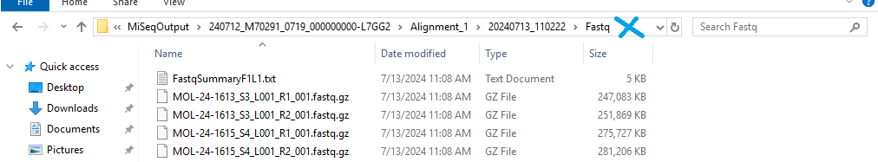

    - Right click the file address bar. This is depicted in the image above marked with the blue X.
    - Select “Copy address to text”.
    - Paste the copied file path into the md5check.txt file to replace the file path from the previous run.
      - The file path to be replaced is depicted in the image below, highlighted blue shown in figure 4.
Figure 4. Placement of copied address
    - While still in the notepad window, copy the entire command beginning with “FOR”.
    - Click the Windows start button on the bottom left of the screen.
    - Select the Command Prompt in the menu.
    - Right click to paste the command into Command prompt after C:\Users\sbsUser>_.
    - Press Enter on the keyboard and run the script.
    - When the script is completed, you should see C:\Users\sbsUser>_ in the command prompt.
    - Navigate to C:\Users\sbsuser\MD5checksums_sequencer.txt.
    - Right click the MD5checksums_sequencer.txt document and click Cut.
    - Navigate to the Shared Drive folder created for the run and paste the text file.
  - Document SAV metrics in the AMP2 Index Code log.
    - Navigate to the log following the file path: RICMBLAB$\PCR_Worksheets_Current\AMP_MasterFiles\IndexCodeLog_AMP2.
    - On the Illumina Sequencing Analysis Viewer, open the Summary tab for the run.
    - In the IndexCodeLog_AMP2 excel file, enter values for all SAV parameters for the current run.
      - There are 6 metrics to be documented from the Sequencing Analysis Viewer Summary tab:
        - Under Run Summary:
          - % > Q30 – from Total
          - Aligned % (R1) – from Read 1
        - Under Read 1:
          - Cluster Density (Density (K/mm2))
          - Cluster PF (%)
          - Reads (M)
          - Reads PF (M)
    - Save the IndexCodeLog_AMP2 excel file
  - Document SAV metrics in the Soft Molecular AMP Tasklist:
    - On the Illumina Sequencing Analysis Viewer, open the Summary tab for the run.
    - Using a Brown Health computer, navigate to the desktop application SoftMol.
    - Launch SoftMol, and log in using your Brown Health credentials.
    - Select RIH from the Select Site page when prompted
    - select OK
    - Navigate to AMP2 Normalization -Test Worksheet Processing tile.
      - Double click the tile to enter the Worksheet Processing application
      - In the Pending Worksheets Search tab, click Find in the upper right corner of the page
      - This will pull up any recently built task lists, double check the samples in the Found Worksheet tab match the samples on the AMP2NORMLD worksheet.
      - Click Select all
      - Click OK at the bottom right corner of the page, this will pull all the samples into the AMP2 Tasklist.
    - Complete AMP2 data transfer to Tasklist:
      - Find the Activity field in the top left corner of the screen, and complete steps 7.b. and 7.c. until the Activity reads Data Transfer and the complete check box can no longer be clicked.
      - Click Complete
      - Click the Save button above the Tasklist header
      - Find the tile labeled Tasklist on the top left side of the screen
        - Select Tasklist, this will pull all the selected samples to the next stage.
    - In Soft Molecular, enter values for all SAV parameters in steps 3 a(i-ii) into the fields on the Tasklist header.
      - Note: Alternatively, the SAV metric values may be copied and pasted from the AMP2 Index Code Log file provided it has been filled out for the current run.
    - After SAV parameters have been entered, look for the buttons on the bottom of task list that says Select All and collapse/expand (Coll/Exp).
      - Click Select All, then Coll/Exp. button.
    - Complete SAV Parameters action by marking the Completed checkbox next to one of the MOL samples, this should populate checked boxes for all the samples and push the current action to “AMP Bioinformatics”
    - Select Save in the top left corner.
    - Select Back in the Tasklist Entry window.
    - Exit Soft Molecular.
  - Transfer files from the MiSeqDx to the Brown Health desktop computer:
    - To map the MiSeq Shared Data folder, login to the Brown Health computer next to MiSeq.
    - Open Windows File Explorer, click This PC, and open the SharedData folder. You may be prompted to enter the password, which is located inside the access door of the MiSeq.
    - Once connected to the SharedData folder, navigate to the appropriate run folder in the CMB_Tests folder on the RICMBLAB$ shared drive.
    - Go to the SharedData folder.
      - Locate the run folder you created.
        - This folder contains the FASTQ files, SAV zipped file (should remain zipped) and the md5checksum.txt document created in the steps above.
      - Move this folder into the appropriate run folder on the RICMBLAB$ drive.
      - Once the file transfer is completed, delete the files from the SharedData drive.
      - NOTE: IF ANY DISCREPANCIES ARE SEEN IN FASTQ FILES OR THERE IS A PROBLEM WITH FASTQ FILE TRANSFER CONTACT THE DIRECTOR OF CLINICAL BIOINFORMATICS OR BIOINFORMATICS ANALYST.
  - After each run, the raw sequencing is transferred from the Miseq to the MGPGenomicData$ drive:
    - Navigate to the current run file in (D:\Illumina\MiSeqAnalysis) on the Miseq
    - Cut and paste the entire run folder into the Shared Data folder.
    - Transfer the entire run folder from the Shared Data folder to the MiSeq_Files directory for the current year in the MGPGenomicData$ shared drive using file explorer.
  - Pillar PiVAT Program is a vendor provided program to detect SNV and indels from targeted sequencing data. It is run on lsmplinux3.
    - The FASTQ files are analyzed using PiVAT program and custom-made bioinformatics pipeline.
    - Data Processing:
      - To launch PiVAT, open the web browser Google Chrome and type http://lsmplinux3.
      - Type in the username and password, click login.
        - This will open the program dashboard.
      - Select Tools on top.
      - On the left panel, select Data Management.
      - Select Create Project on the top right.
      - Enter the name of the run in the following format: [YYYYMMDD]_[Tasklist#]
        - i.e: 120925-amp2libprp-1
      - FASTQ files can be uploaded onto the program in two ways.
        - First option is using the Graphical User Interface (GUI) of the program:
          - Click on the run name and click on Upload File.
          - Locate the FASTQ files under the run directory and select all FASTQ files to be imported.
          - Click on Open
          - While the FASTQ files are being uploaded, ‘Files are in queue waiting to be uploaded’ should be displayed.
        - Second option is to transfer the FASTQ file directly to lsmplinux3 (10.37.28.238) server:
          - Log in to lsmplinux3 (10.37.28.238) using WinSCP.
          - Navigate to /molpath/pillar/data/output/pivat/sbsuser/user/upload on the right side of WinSCP.
          - Navigate to G:\CMB_Tests\[YYYY]tests\[MM-YYYY]\[MM.DD.YY]-amp2libprp-1\[MM.DD.YY]-amp2normld-1 on the left side of WinSCP
          - Locate folder named FASTQ-[MM.DD.YY]-amp2normld-1 in G:\CMB_Tests\[YYYY]tests\[MM-YYYY]\[MM.DD.YY]-amp2libprp-1\[MM.DD.YY]-amp2normld-1.
          - Drag FASTQ-[MM.DD.YY]-amp2normld-1 folder into /molpath/pillar/data/output/pivat/sbsuser/user/upload in WinSCP.
      - After the FASTQ files are uploaded on PiVAT program, click on Start Upload.
      - Once the upload is done, select Analysis on top.
      - On the left panel, click on Start Analysis.
      - Click on Select Panel, choose oncoReveal Solid Tumor V2 Panel (P-ST-02).
      - From Select Samples, click on user
      - Select upload
      - Select the folder FASTQ-[MM.DD.YY]-amp2normld-1.
      - Select all FASTQ files you want to analyze and click on Next.
      - In Analysis Name, enter the run name in the following format: [YYYYMMDD]-[Tasklist#].
        - i.e: 120925-amp2libprp-1
      - The QC Type for all samples should be “Sample”.
        - Change QC Type from “Sample” to “PosCtrl” for the positive control.
        - Change QC Type from “Sample” to “NTC” for the NTC.
      - Select Next.
      - Double check the information presented in Summary.
      - Select Launch Analysis.
      - Select Dashboard on top to check the analysis status.
        - Recent Task Activity provides analysis status.
        - When the Analysis is completed, both SA Status and Stage will display “completed”.
      - When the analysis is completed, download the analysis results.
        - This can be done in two ways.
          - First option is to use the GUI of the program:
            - Select the run name and navigate to the Analysis Task.
            - Select Download Results Zip Files to download the “Customer Results” excel file, and compressed BAM files.
            - Transfer the results to the run directory under the RICMBLAB$ shared drive.
          - Second option is to transfer directly from the lsmplinux3 (10.37.28.238) server:
            - Log in to lsmplinux3 (10.37.28.238) using WinSCP.
            - On the right side of WinSCP, Navigate to /molpath/pillar/data/output/pivat/sbsuser/user/output/RUO/P-ST-02/[run_name]
            - On the left side of WinSCP, Navigate to G:\CMB_Tests\[YYYY] tests\[MM-YYYY]\[MM.DD.YY]-amp2normld-1 \PiVAT_Files
              - Transfer the “CUSTOMER_RESULTS” excel file and all sample folders to the PiVAT_Files directory in the RICMBLAB$ shared drive.
            - Copy the .bam and .bam.bai files for all samples and controls from corresponding folders (i.e. /molpath/pillar/data/output/pivat/sbsuser/user/output/RUO/P-ST-02/[run_name]/POSCT) into the PiVAT_Files/BAM_Files location in the RICMBLAB$ shared drive
    - Take screenshots on Integrative Genomic Viewer (IGV)
      - Open IGV on a Brown Health desktop
      - Change reference to human GRCh37/hg19 using the dropdown menu on top left side of the IGV menu.

      - Click File in the top left corner
      - Select load from file from the dropdown menu
      - Navigate to G:\Validations\PIllar ONCO Solid Tumor Panel (AMP2) v2, select the p-st-02_ROI.bed.
      - Click open
        - This will open the bed file for covered regions.
      - Upload four or fewer BAM files from G:\CMB_Tests\[Year] tests\[Month]- [Year]\[Month].[Day].[Year]-amp2libprp-1\PiVAT_Files\BAM_Files:
        - Click File in the top left corner of IGV
        - Select load from file from the dropdown menu
        - Navigate to G:\CMB_Tests\[Year] tests\[Month]- [Year] \[Month].[Day]. [Year] -amp2libprp-1\PiVAT_Files\BAM_Files in the IGV file explorer
        - NOTE: If there are more than 4 samples, split the samples into groups of up to 4 and complete steps g-s for each group.
        - Select up to 4 sample .bam files
        - Click open
      - Type KIT in Search
      - Navigate to Exon (Ex) 9
      - On the right side, click the plus on the bar to Zoom in until either individual bases are shown, or exon fills up screen completely
      - Right click on the sample and select Color alignment by
      - Select read strand as shown in figure 5.
        - This will change the color for reads based on forward/reverse strand
Figure 5. Color alignment by read strand
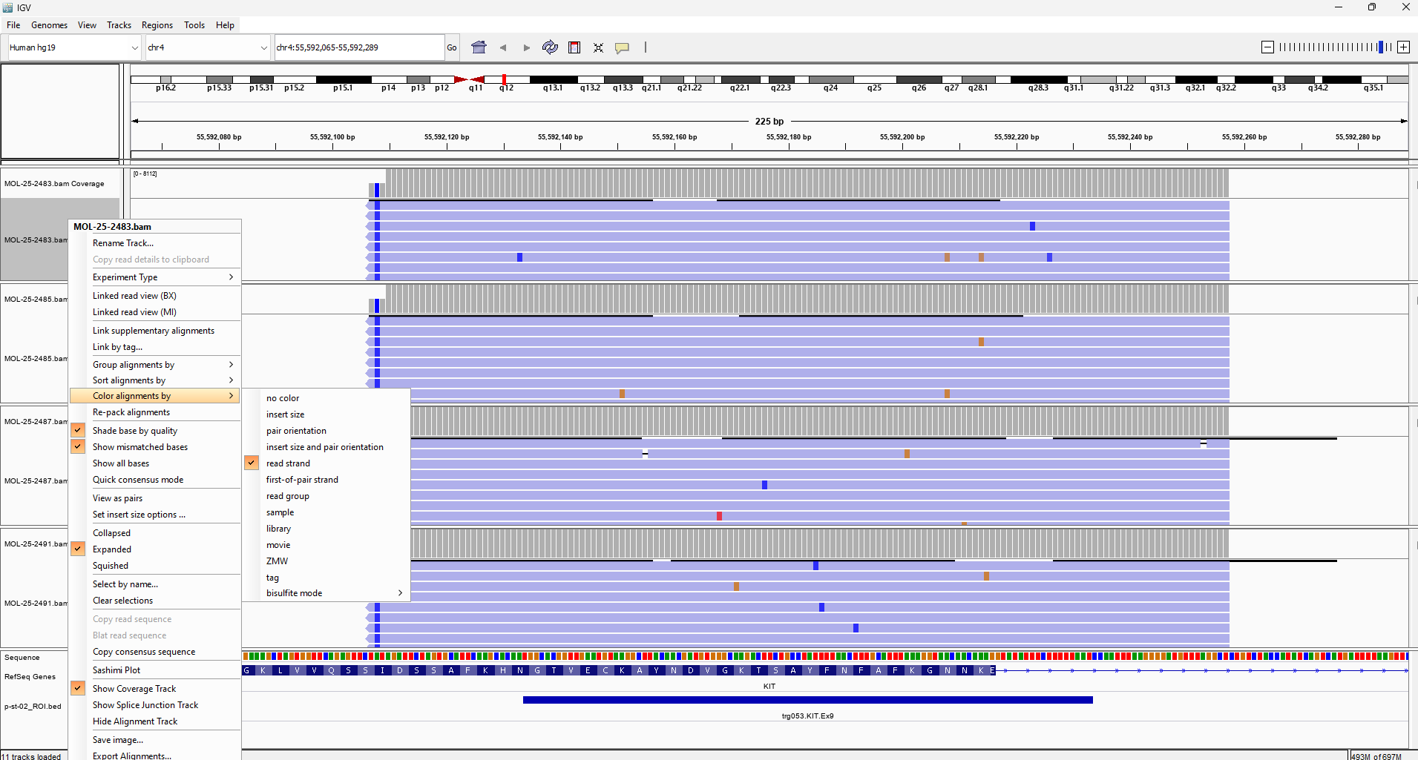
      - Right click the sample name and hover over Sort alignments by
      - Select Base as shown in Figure 6.
Figure 6. Sort alignments by base
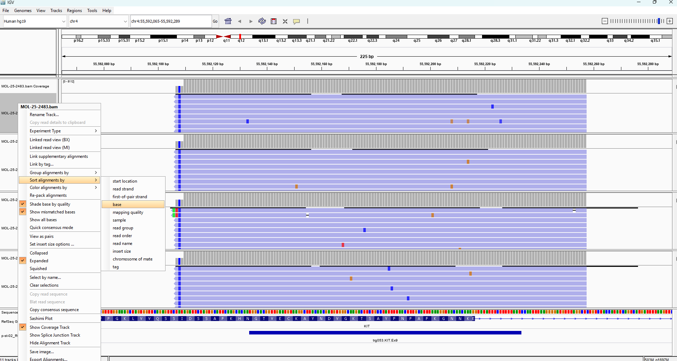
      - NOTE: If Soft clipped reads should be visible, if they are missing, follow the steps below:
        - go to view tab on the top left
        - click preferences
        - Navigate to the alignment tab
        - scroll down until you see the Show softclipped bases check box as shown in figure 7.
        - Make sure the check box is checked off

Figure 7. Show soft-clipped bases check box
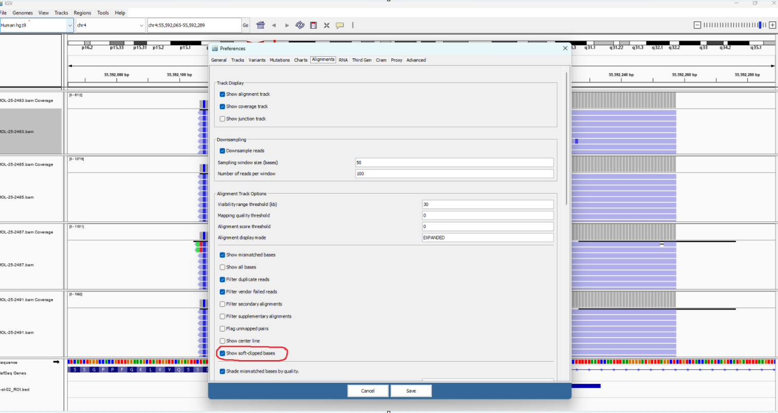
      - Click the File tab in the top left corner
      - Scroll down and select Save PNG image.
      - label file as: KIT_ex9.png save to G:\CMB_Tests\[Year] tests\[Month]-[Year]\[Date]-amp2libprp-1\Screenshots
        - If processing screenshots for more than one group of samples per region name the screenshot files as KIT_ex9_1, KIT_ex9_2, etc.
      - Repeat steps h though r for KIT exons 10, 11 and 13 and ERBB2 exon 20.

Cclick “open”
This will open the bed file for covered regions.
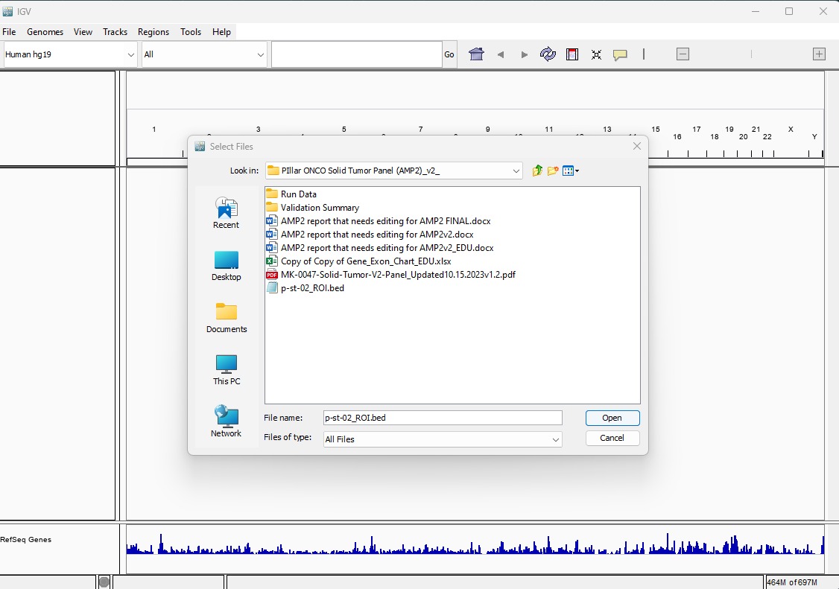:of IGVin the IGV file explorerUpload or fewer
all BAM indexed BAM (BAM), split the samples into groups of up to 4 and complete steps f-o for each group.and steps f-o
Select up to 4 sample .bam files
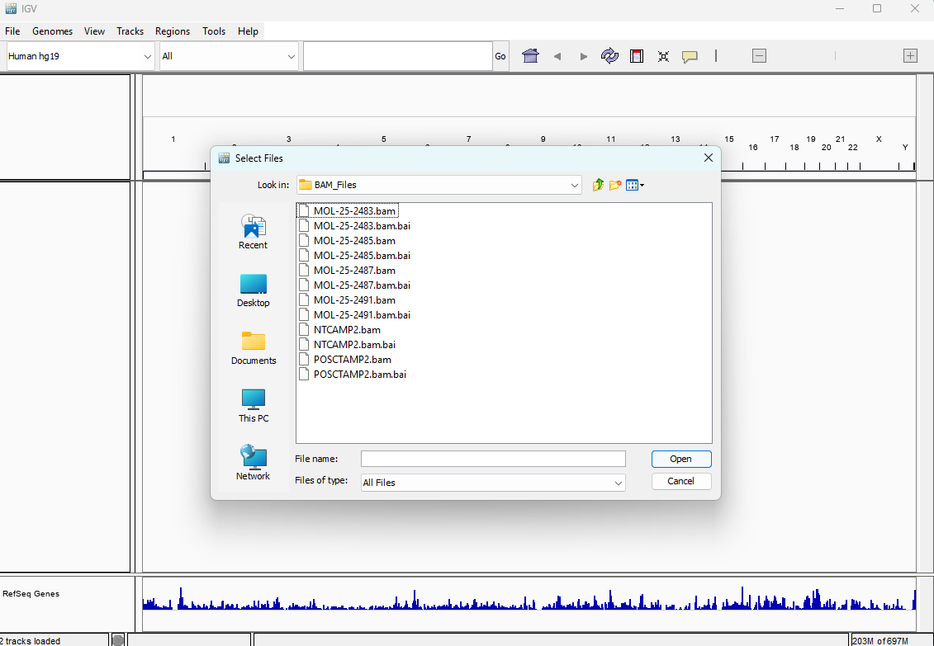select “C”
Select“”
This will change the color for two read strands
Repeat this for all samples

the sample name and hover over “Sort alignments by”
Select “Base”
Do this for all samplesBAM
should beif they are missing, follow the steps below:
“”
“”
Navigate to the “then”until you see the “Show softclipped bases” check box
Make sure the check box is checked off
NavigateMove to
Zoom in until either individual bases are shown, or exon fills up screen completely
Click the “File” tab in the top LH corner
Scroll down and select “Save PNG image”
.pngf one screenshots for more than one group of samples per regionname the filesas .Repeat step (i) for KIT exons 10, 112 and 13 and ERBB2 exon 20.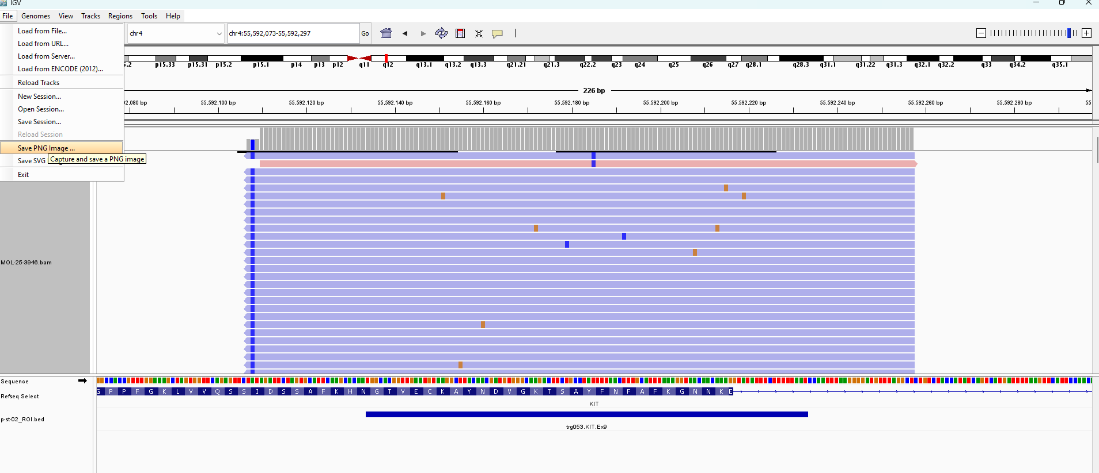

- LIFESPAN AMP REPORTER 2 (LAR2):
  - Principle:
    - Lifespan AMP Reporter 2 (LAR2) is a bioinformatics pipeline which combines multiple open-source programs to analyze NGS data produced by the MiSeqDx instrument. The pipeline has been optimized to detect Single Nucleotide Variants (SNVs), as well as insertions and deletions (indels) in clinical samples.
    - LAR2 includes 7 open-source programs: FastQC, Burrows-Wheeler Aligner (BWA), Samtools, Picard, VarScan2, INDELfindR and Annovar. In addition to these programs, the pipeline includes custom Perl scripts that create shell scripts to run the programs and perform upstream analysis. Please see Figure 8 below for the pipeline flowchart.
      - The Pipeline is performed on a desktop server running Red Hat Enterprise Linux 8.10 using Perl v5.26.3.
      - FastQC is a program designed to perform quality control checks on raw sequencing data. It provides average quality scores for every base in each read. In addition, there are graphs indicating run metrics, including a tile graph that showing quality of the reads in the results. FASTQ files produced by the MiSeqDx are used as input.
        - LAR2 includes FastQC version 0.11.9.
      - BWA is a program which maps raw sequencing reads in FASTQ format produced by the MiSeqDx against human reference genome. BWA consists of three algorithms: BWA-trackback, BWA-SW and BWA-MEM. The first algorithm is for Illumina reads up to 100bp and the other two are for reads between 70bp to 1Mbp. In LAR, BWA-MEM is used since it is the largest and the read length in the libraries produced by the Actionable Mutation Panel 2 is 150bp. BWA produces a BAM file with mapped reads.
        - LAR2 includes BWA version 0.7.17 and human_g1k_v37.fasta as the human reference file.
      - Picard is a set of command line tools used to format SAM/BAM or VCF files. In LAR2, Picard is used to sort and format BAM files.
        - LAR2 includes Picard version 2.6.0.
      - Samtools is a program used to format SAM files produced by BWA-MEM. In LAR2, Samtools is used to convert SAM files to BAM files.
        - LAR2 includes Samtools version 1.15.1.
      - VarScan2 is a program that detects SNVs and indels. VarScan2 has two separate modules to call SNV and indels independently. LAR2 uses the mpileup2snp and mpileup2indel modules.
        - LAR2 includes VarScan version 2.3.9.
      - INDELfindR is a custom-made program to detect indels in targeted sequencing data.
        - LAR2 includes INDELfindR v1.0.
      - Annovar is a program used to functionally annotate variants.
        - LAR2 includes Annovar version 2015-12-14 as well as hg19_refGene, hg19_clinvar_20161128 and hg19_cosmic70 as Annovar databases.
    - LAR2 includes custom Perl and shell scripts to automatically run the pipeline. There are three main scripts in the pipeline:
      - Perl script “ListDetect_Pillar_IndelFindR.pl” creates shell scripts for each sample to run BWA, Picard, Samtools, VarScan2, INDELFindR and Annovar.
      - Shell script “start_code.sh” is a combination of sub-scripts to perform several tasks:
        - It creates sub-folders for FastQC, BAM, VCF, annotated Annovar and INDELfindR files as well as a main, Run_Files folder.
        - It creates shell scripts for each sample to automatically run the pipeline.
      - Shell script “final_code.sh” is a combination of sub-scripts to perform several tasks:
        - It moves FastQC, BAM, VCF and annotated Annovar sub-folders to the Run_Files folder.
        - It removes the Meta_Files folder which includes the copies of the BAM files (they are saved under BAM_Files).
      - Please refer to Appendix A for more details, including the source code for the pipeline.
Figure 8: Lifespan AMP Reporter 2 (LAR2) pipeline flowchart
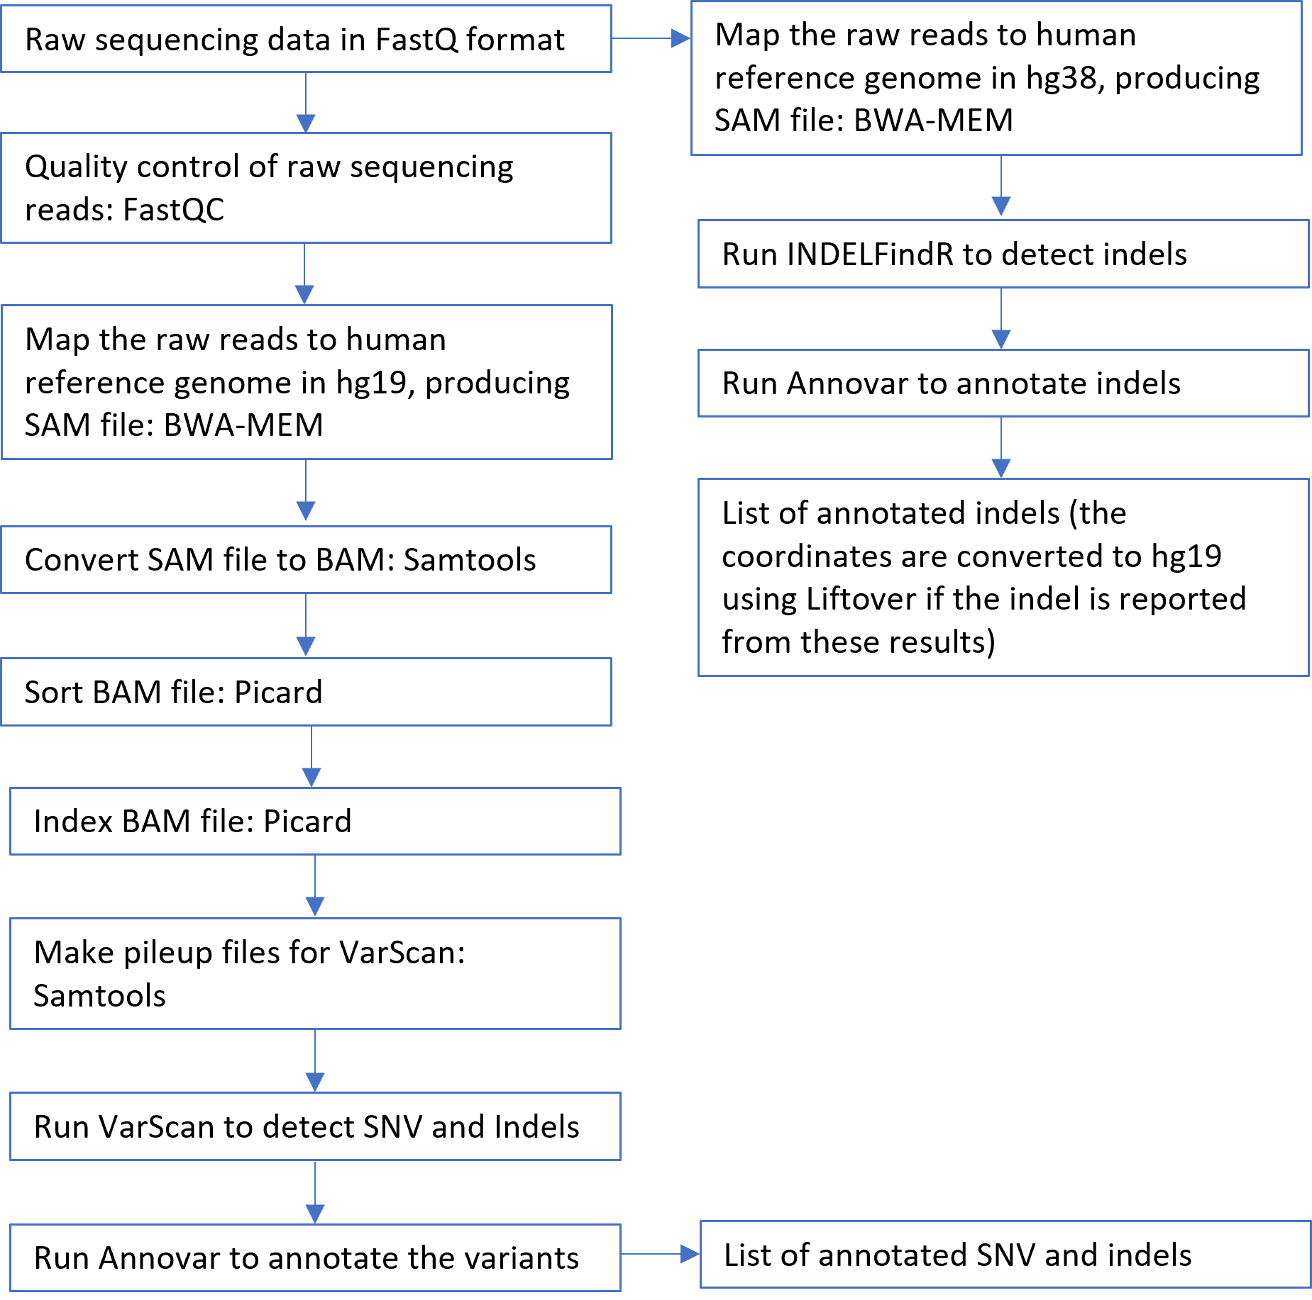

  - Data Analysis:
    - NOTE: These steps are performed by the Director of Clinical Bioinformatics or Bioinformatics Analyst.
    - Open the RICMBLAB$ shared drive AMP Run folder. Open [Run_ID]-amp2normld-1 subfolder and navigate to the FASTQ files.
    - Transfer FASTQ files to /nextseq/Analysis_Directory/Fastq_Files on Linux server using WinSCP, or similar secure method.
      - NOTE: Do not unzip these files, as they must be zipped to be run in LAR2.
    - MD5 Check:
      - To verify the integrity of the FASTQ files, an MD5 checksum is generated on the sequencer, desktop, and lsmplinux3 systems. The resulting checksums are compared to confirm that file integrity is preserved throughout the transfer process.
      - NOTE: MD5 check on the Linux server must be completed before LAR2 pipeline is started.
      - PowerShell MD5 Checksum Generation on Desktop
        - To complete the MD5 Checksum on the G: Drive search for PowerShell in the search bar on the bottom left of your screen.
        - Launch Powershell as shown in Figure 9.

Figure 9: Powershell window
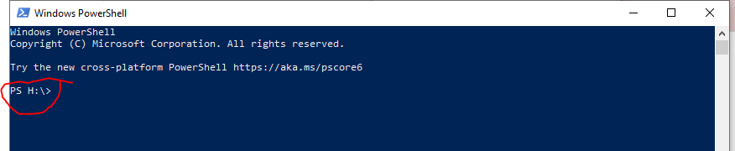
Note the default directory. Your files will be output here unless you change the directory.
        - Paste the following command and press enter, updating the path for the current run:
dir "(Path to FASTQ folder under the G Drive run directory)" -Recurse | Get-FileHash -ea 0 -Algorithm MD5 > MD5checksum_Gdrive_amp.txt
          - Example:
dir "G:\CMB_Tests\2025 tests\12-2025\12.15.25-amp2libprp-1\12.15.25-amp2normld-1\FASTQ-12.15.25-amp2normld-1" -Recurse | Get-FileHash -ea 0 -Algorithm MD5 > MD5checksum_Gdrive_amp.txt
        - Once complete, copy the MD5checksum_Gdrive_amp.txt file from C:/users/[username] into the [Run Date]-amp2normld-1 folder under the run directory

      - Lsmplinux3 (10.37.28.238) MD5 Checksum Generation
        - To complete the MD5 checksum on lsmplinux3 (10.37.28.238) launch Putty on a Brown Health Windows-based computer to open a Terminal.
        - Type the IP address for lsmplinux3 (10.37.28.238) , on the Host Name (or IP address) window.
          - Note: When Putty is used for the first time, the IP address can be saved under Saved Sessions.
        - If the IP address has been previously saved, click on the IP address under Saved Sessions window and press Load.
        - Press Open.
        - Enter your username/password.
        - In the Terminal window:
          - Type “cd /nextseq”
          - Type “sh md5gen.sh ./Analysis_Directory/Fastq_Files/”
Note: FASTQ files should be transferred to nextseq/Analysis_Directory/Fastq_Files/ before this script is run.
        - Once completed, use WinSCP to transfer the MD5checksums_server.txt file from /nextseq in lsmplinux3 (10.37.28.238) to the [Run Date]-amp2normld-1 folder under the run directory
    - Using file explorer, copy the MD5checksum_amp.xlsx file from G:\Bioinformatics\MD5CheckSum Folder and place in the [Run Date]-amp2normld-1 folder
      - This file contains separate tabs to paste data from each of the three MD5 check text files located in the [Run Date]-amp2normld-1 folder.
    - Open MD5checksum_Gdrive_amp.txt file in NotePad.
    - Select and copy all the data in the text file.
    - Open MD5checksum_amp.xlsx file.
    - Navigate to the tab for the Gdrive.
    - Paste the copied text into the first column of the MD5checksum_amp.xlsx file.
    - Use the text to column wizard tool in Excel to change the delimiter for the data to spaces.
      - Complete steps 5 through 11 for MD5 check text files for both lsmplinux3 (10.37.28.238) and sequencer
        - Note: Once the data from the sequencer MD5 check text file is added to the MD5checksum_amp.xlsx the last two FASTQ entries, labeled “Undetermined”, will need to be deleted from the sequencer tab
      - When completed, the CheckPage tab check column (Column E) should read TRUE for all populated samples
        - If the check column does NOT read TRUE, the data in the MD5 check sum text files may need to be reordered

    - LAR2 Analysis:
      - Start Putty on a Brown Health Windows-based computer to open a Terminal.
      - Type the IP address for lsmplinux3 (10.37.28.238) on the Host Name (or IP address) window.
      - The first time Putty is used, the IP address can be saved under Saved Sessions.
      - If the IP address has been previously saved, click on the IP address under Saved Sessions window and press Load.
      - Press Open.
      - Enter your username/password.
      - In the Terminal window:
        - Type “cd /nextseq/Analysis_Directory”
        - Note: Confirm FASTQ files have been transferred to nextseq/Analysis_Directory/Fastq_Files/ before running the next command
        - Type “nohup sh AMP_Analysis.sh”
          - The script is designed to run samples in parallel with a max batch size of 12 samples. For runs exceeding this limit, samples will be queued to run after the first batch of samples is completed.
          - The AMP_Analysis.sh script will run the following scripts:
            - start_code_Pillar.sh is a combination of sub-scripts to perform several tasks:
              - It creates sub-folders for FastQC, BAM, VCF, annotated Annovar and INDELfindR files as well as Run_Files folder.
              - Runs ListDetect_Pillar_IndelFindR.pl which creates shell scripts for each sample to run BWA, Picard, Samtools, VarScan2, INDELFindR and Annovar.
          - final_code.sh is a combination of sub-scripts to perform several tasks:
            - It moves FastQC, BAM, VCF and annotated Annovar sub-folders to the Run_Files folder.
            - Removes the Meta_Files folder which includes the copies of the BAM files (saved under BAM_Files).
          - This script will take at least 2 hours
    - When the program is done running, the last line should read: “[User_ID@lsmplinux3 Analysis_Directory]$”
    - Move the Run_Files folder to the run directory under the RICMBLAB$ shared drive.
      - Rename the Run_Files folder using the format [DD.MM.YY]-amp2libprp-1_AMP_Reporter (e.g., 09.08.25-amp2libprp-1_AMP_Reporter).

- TEST PROCEDURE – Lifespan Variant Review Tool (LVRT) (Interpretation):
  - Principle: This software is a Python- and shell-script based tool used to review variants, review the QC info for the samples, and aid in the confirmation and reporting of the results.
    - Note: All steps for LVRT set up and analysis should be performed by the Director of Clinical Bioinformatics, Bioinformatics Analyst or designated personnel.
    - Note: This tool is simply an aid in these processes; all processes may be performed manually without the software, as needed.
    - The tool consists of a Python script.
    - Please refer to Appendix B for more details, including the source.
  - Analysis:
    - Using WinSCP, copy the CUSTOMER_RESULTS Excel file from the PiVAT_Files directory under the run directory in the RICMBLAB$ shared drive into /nextseq/Pillar_Data_Process on lsmplinux3 (10.37.28.238).
    - Navigate to the previous AMP2 run directory in WinSCP
    - Look for file [MMDDYY]_Graph_PiVAT_Custom_Made_Results-[Director Initials].xlsx.
      - If available, transfer file into /nextseq/Pillar_Data_Process using WinSCP
      - If not available, proceed to VII.B.4
    - Start Putty
      - Type the IP address for lsmplinux3 (10.37.28.238) on the Host Name (or IP address) window.
      - The first time Putty is used, the IP address can be saved under Saved Sessions.
      - If the IP address has been previously saved, click on the IP address under Saved Sessions window and press Load.
    - Press Open.
    - Run the Add_Annotation_v2.py python script:
      - Type “cd /nextseq/Pillar_Data_Process”
      - Type “python3 Add_Annotation_v2.py”
        - This script adds stats to the pivat.db
    - Run the Soft_Import_v4.py python script:
      - Type “cd /nextseq/Pillar_Data_Process”
      - Type “python3 Soft_Import_v4.py”
        - This will create three files:
          - Variant_Summary Excel file: This is the summary file of variants.
          - Failed_Amplicons Excel file: This is the list of failed amplicons.
          - QC_Summary Excel file: This file contains mean coverage and functional copies.
      - Transfer Variant_Summary.xlsx, Failed_Amplicons.xlsx and QC_Summary.xlsx to the run folder on the RICMBLAB$ shared drive using WinSCP.
    - First_Scripts_Run_v2.sh runs Two Python scripts, Pipeline_Result_Processing_Initial_v2.py and Pipeline_Result_Processing_Final_v2.py in parallel. The scripts generate two summary files for SNV and indels detected by VarScan2 to aid in the data review.
      - Start Putty to open another Terminal.
      - Type “cd /nextseq/Pillar_Data_Process”
      - Make sure that Cosmic_six_cols_uniq.txt and variation_allele.txt are in the same directory.
      - Type “sh ./First_Scripts_Run_v2.sh”
      - When the program asks for Run ID, type the Run’s date in MMDDYY format on the terminal (ex: 011325 is the run ID for 01.13.25-amp2libprp-1).
      - The scripts will create two summary files:
        - “[Run#]-Pillar-INDEL-Clean.xlsx”
        - “[Run#]-Pillar-SNP-Clean.xlsx”
      - Transfer the files to the AMP Reporter Folder in the RICMBLAB$ shared drive

    - Data Upload to the Database and Result File Generation
Note: All variants detected by PiVAT and LAR are saved in a database. The database is kept under lsmplinux3 (10.37.28.238).
        - Transfer Customer Results excel file to /nextseq/Pillar_Data_Process using WinSCP.
        - Open Putty terminal and log into lsmplinux3 (10.37.28.238).
        - Type “cd /nextseq/Pillar_Data_Process”
        - Type “nohup sh ./Last_Scripts_Run_v2.sh”
          - This will run the following scripts in parallel:
            - PiVAT_Database_v2.py
              - This will upload the results onto the database
            - Only_Detected_by_VarScan_v2.py
              - This will create a list of variants detected by only VarScan2 in an Excel file called [Run#]_Only_Detected_by_Custom_Made_Results.xlsx.
            - python3 PiVAT_Graph_v2.py
              - This will create the “Run#_Graph_PiVAT_Custom_Made_Results.xlsx” excel file and will add frequency graphs and sample list links.
      - Transfer the [Run#]_Only_Detected_by_Custom_Made_Results.xlsx and Run#_Graph_PiVAT_Custom_Made_Results.xlsx Excel files to the run directory under RICMBLAB$ shared drive.
      - Transfer /nextseq/Pillar_Data_Process/Case_List_Files into G:/Bioinformatics/MolDB/Case_List_Files. These files include the list of samples with the corresponding variants.
      - Transfer the variant frequency graphs from /nextseq/Pillar_Data_Process/Graphs into G:/Bioinformatics/MolDB/Pillar_Graphs
    - POSCT_Check File Generation
      - Use the generated Variant_Summary.xlsx excel file to complete the POSCT_Check.xlsx file
      - Copy the POSCT_Check file from the previous AMP run folder
      - Open the file
      - Delete the data in columns O, P, Q, R, and S (gene, CDS change, AA change, VAF, DepthofCoverage)
      - Open the Variant Summary file
      - Copy the gene (column C), the CDS change (column E), AA change (column F), VAF (column G), and DepthofCoverage (column H) columns for all variants for the POSCTAMP sample only into the POSCT_Check file
      - Sort column T in the POSCT_Check file by alphabetical order descending, make sure column U reads TRUE for all variants
    - MANE Select Comparison File Generation
      - Copy the Variant_Summary.xlsx excel file into lsmplinux3 using WinSCP to the /nextseq/Pillar_Data_Process/Mane_select_comparison location
      - Make sure the AMP_Mane_Select_ID.csv file is in the input directory
      - Open terminal using Putty and log into lsmplinux3(10.37.28.238).
        - Type “cd /nextseq/Pillar_Data_Process/Mane_select_comparison/Scripts”
        - Type “python3 mane_select_match.py”
          - This script will generate:
              - Variant_Summary_RefSeqID_Match.csv file in the MANE_Select_Results folder
        - Copy MANE_Select_Results folder to the run folder in the RICMBLAB$ shared drive using WinSCP
- After the data analysis and file transfer are completed, the directory is cleared for the next analysis.
  - Start Putty on a Brown Health Windows-based computer to open a Terminal.
    - Type the IP address for the Linux server, lsmplinux3 (10.37.28.238) on the Host Name (or IP address) window.
    - Enter your username/password.
    - In the Terminal window:
      - Type “cd /nextseq/Analysis_Directory”
      - Type “sh clean_amp_pipeline.sh”.
        - This script removes the following from the run directory on the lsmplinux3(10.37.28.238) server:
          - FASTQ files
          - sh files
          - Run_Files folder
          - INDELfindR folder
    - In the Terminal window:
      - Type “cd /nextseq/Pillar_Data_Process”
      - Type “sh clean_post_analysis.sh”
        - This script removes the following from the run directory on the lsmplinux3(10.37.28.238) server:
          - All .xlsx files generated
          - All Graphs files generated
          - All Case Files generated

- AMP2 BIOINFORMATICS: DATA REVIEW
  - FASTQC Review
    - Review FastQC results under FastQC_files folder in AMP_Reporter folder, according to following steps:
      - Open each result in HTML format.
      - Check the first graph showing the average quality scores of all bases in each read.
      - Check the second graph (Per tile sequence quality).
        - This graph shows the tiles in the Illumina flow cell. The colors are on a cold to hot scale, blue being positions where the quality is at or above the average for that base and hotter colors (red or orange) show worse qualities.
      - Ensure that the overall quality of the runs is appropriate.
    - The results are entered in Soft Molecular task list under the FastQC tab.
  - Pillar SNP and INDEL Clean File Review
    - In [Run#]-Pillar-SNP-Clean.xlsx and [Run#]-Pillar-INDEL-Clean.xlsx worksheets, filter synonymous variants and variants with Variant Allele Fraction (VAF) <3%
    - For any potential variants with depth of coverage is <200, review the BAM files in IGV.

- AMP2 BIOINFORMATICS: TASKLIST
  - NOTE: These steps should be performed by a bioinformatician or other approved/designated personnel.
  - In Soft Molecular, open My Orders by using the icon on the dashboard.
  - Click on the Bioinformatician tab.
    - Click two times on tasklist number.
    - Click on No button.
  - In the tasklist, review the SAV Parameters for the run.
  - After reviewing, import LVRT Files (Variant summary, QC Summary and Failed Amplicons).
  - In the tasklist, click the ‘…’ button to the right of the Import button.
  - Click OK.
  - Select the Excel radial button, choose the file path (directory and file name) for the Variant_Summary file, then click Import.
  - Repeat steps F-H for the Failed_Amplicons and QC_Summary files.
  - Review variant calls.
    - In the tasklist, verify the Subtemplate is set to “Variants”.
    - Review all variant calls for patient samples and controls by clicking the ‘+’ button to expand the child level results.
    - For each variant, mark the checkboxes to indicate the pipelines which detected that variant.
  - Review QC Summary data for patient samples and controls by reviewing the “MeanCoverage” field at the parent level.
  - Review Failed Amplicons.
    - In the tasklist, change the Subtemplate to “Failed Amplicons”.
    - Review failed amplicons for all patient samples and controls.
    - For patient samples, make sure that the ‘Print on Report’ box is checked for all failed amplicons.
  - If the IGV screenshots need to be uploaded:
    - Select Analysis Images button on the right side of the window.
    - On the window that opens, select the Add File tab on the left side. Then, select the add file (folder) icon.
    - Find and select the file to be added from the Windows Explorer window. Select Open.
    - Choose Instrument Documents from the Template dropdown.
    - Select the green check icon to add the files.
    - Close the window.
  - Verify that the Tasklist is set to the “FastQC” subtemplate.
    - For each patient sample and control, enter the following information at the parent-level:
      - FastQC R1: pass or fail.
      - FastQC R2: pass or fail.
      - Enter any relevant notes for FastQC R1 and R2 in the note columns.
  - If any additional mutations were identified by secondary analysis:
    - Create a new Variant_Summary file and save with the name. “Variant_Summary_Additional”.
    - Open the file in Excel. Keep the header row but delete all other existing data. Add data from the new variant call. Save the file and close.
  - Import LVRT Variant_Summary_Additional File.
    - In the tasklist, click the ‘…’ button to the right of the Import button.
    - Click OK.
      - Select the Excel radial button, choose the file path (directory and file name) for the LVRT Variant_Summary_Additional file, and click Import.
    - In the Comment box at the top of the tasklist, enter a comment indicating your findings.
    - For the Tasklist, change the sub template to “Variants”.
    - For all samples, review the variants again.
    - For each variant, mark the checkboxes to indicate the pipelines which detected that variant.
  - Once reviews are complete: for each patient sample, complete the AMP Bioinformatics action by marking the Completed checkbox.
  - When all patient samples are complete, select Save.
  - Select Back in the AMP2 Tasklist Entry window.
  - Exit Soft Molecular application.

- AMP2 REVIEW: TASKLIST
  - NOTE: These steps should be performed by a pathologist or director.
  - In Soft Molecular, open My Orders by using the icon on the dashboard.
    - Click on the Molecular Pathologist tab.
    - Click two times on tasklist number.
    - Click on No button.
  - In the tasklist, review the SAV Parameters (QC information) for the run.
    - Runs should ideally meet the following metrics. Those that do not meet the following metrics should be interpreted appropriately by the Director:
      - Q30 > 80% (percent of bases with at least Q30)
      - % Clusters PF (Passing Filter) > 80%
    - Additional metrics to review:
      - % aligned (ideally 0.5-2%, but may vary with run)
      - Cluster density (ideally 950-1,200K/mm2 per Illumina, but may vary with run)
    - If the runs fail any of these criteria, the Director/Pathologist may choose to repeat testing of all samples.
  - Review variant calls.
    - In the tasklist, verify the subtemplate is set to “Variants”.
    - Review all variant calls for patient samples and controls by clicking the ‘+’ button to expand the child level results.
      - Variants are filtered out by the PiVAT program if they meet the following criteria:
        - Depth of coverage < 200
        - VAF < 1%
        - Synonymous variants
        - Intronic variants
      - In addition, PiVAT provides the primary variant information, such as the genomic coordinates, VAF, etc.
      - Any variants with VAF between 1-5% should be reviewed for determination of inclusion in further steps (at the discretion of the Director/Pathologist).
      - Review the information provided for the variant to aid in annotation.
    - To request Sanger Sequencing confirmation:
      - Send an email to the NGS team requesting the confirmation including sample information, target mutation and appropriate primers.
  - Review QC Summary data for patient samples and controls by reviewing the “MeanCoverage” field at the parent level.
  - Review Failed Amplicons.
    - In the tasklist, change the subtemplate to “Failed Amplicons”.
    - Review failed amplicons for all patient samples and controls. For any given sample, amplicons with <200x depth of coverage will be listed.
    - For patient samples, make sure that the ‘Print on Report’ box is checked for all failed amplicons.
    - For the NTC, all 222 amplicons should appear on this list. If there are less than 222 entries, open the PiVAT Report Summary Excel file and review all amplicons in detail to determine the failed amplicon(s).
  - Review Controls, as follows:
    - Cell line HD701 is used as the Positive Control, and they should be positive for those variants.
      - If no mutations are identified or if additional variants are identified, determine if all clinical samples should be re-tested.
    - Negative Control (No Template Control, NTC): no variants should be identified.
      - If any true variants are identified, determine if all clinical samples should be re-tested.
      - In addition, potential contamination of the NTC should be evaluated by looking for the presence of the following parameters:
        - PiVAT: mean coverage >200x
        - FastQC: low error bars of high quality
      - At the Director’s/Pathologist’s discretion, clinical samples may be re-tested if any of these criteria are identified.
  - Sample Quality Control checks
    - For each patient sample, review all failed amplicons, as described above.
      - In the original PiVAT Customer Results Excel file, the coverage for all amplicons in each sample may also be reviewed. This file is available in the RICMBLAB$ shared drive AMP run folder.
    - For each patient sample, review sample metrics. These metrics correspond to “Overall Stats” states, as indicated on the original PiVAT Customer Results Excel file.
        - Criteria for Pass state (Indicates a library result where the variant analysis will confidently report variants down to LOD):
          - Coverage for all amplicons > 200x OR
          - Minimum coverage of one or more amplicons at < 200x
        - Criteria for Failed state (Libraries in which the PiVAT may not be able to detect even germline variants):
          - greater than 20% of the targeted bases have less than 100x coverage
      - The “Coverage_Mean” is optimally >1000x for any given sample.
      - In the original Customer Results Excel file, additional QC metrics may be reviewed, as appropriate.
    - Any samples that fail QC parameters should either have testing repeated or should receive the appropriate annotation in the Final Report.
  - Review all results.
    - Select the Analysis Images button on right hand side of the screen. This will open the window with attached documents. The window can be floated by clicking the Dual view button at the top left of the window.
      - In the Documents tab, review the Excel file with the screenshots of coverage in IGV.
    - Change the Tasklist subtemplate to “FastQC” and review the FastQC results for all samples.
      - Any sample that does not pass QC should be reviewed and reported as insufficient, repeated, or interpreted with caution at the pathologist’s discretion.
    - For each patient sample, review the variant calls:
      - Any sample with Sanger Sequencing confirmation:
        - The Sanger Sequencing run folder will be saved in the AMP2 run folder. File path: RICMBLAB$\CMB_Tests\[YEAR] Tests\[MM-YYYY]\[AMP2 Run Folder]
        - Upload the workbook into Soft Molecular using the steps included below.
          - Select Analysis Images button on the right side of the window.
          - On the window that opens, select the Add File tab on the left side. Then, select the add file (folder) icon.
          - Find and select the file to be added from the Windows Explorer window. Select Open.
          - Choose Instrument Documents from the Template dropdown.
          - Select the green check icon to add the files.
          - Close the window.
      - For all variants:
        - To display the variant on the report, mark the ‘Print on Report’ checkbox.
        - Click the dropdown arrow in the “Report?” field.
          - To display the variant on the report, Select a Tier level of I-III. NOTE: Tier IV variants are only reported with clinician request.
          - For variants that will not be reported, select “No” or “Artifact”, if appropriate.
          - Tier designation is determined during the clinical interpretation review above. The following Variant Tiering system shall be used:
              - Tier I Variants (Strong Clinical Significance)
              - Tier II Variants (Potential Clinical Significance)
              - Tier III Variants (Uncertain Clinical Significance)
              - Tier IV Variants (Benign or Likely Benign)
          - If possible, ensure that variant nomenclature is consistent with Human Genome Variation Society (HGVS) guidelines and HUGO Gene Nomenclature Committee gene name. Reference transcript information should be included, as appropriate.
          - For indels, review of the sequencing data in IGV may help in determination of correct variant syntax.
        - For both indels and base substitutions (single and multi-nucleotide variants), the variant call thresholds are:
          - Total depth of coverage ≥200x
          - Variant allele fraction ≥5%
      - In the AMP2 Tier IV variant request field, click the arrow and in the dropdown that appears, select the appropriate option.
        - Negative Sample: NONE
        - Positive Sample: Tier IV variants are not reported but available upon request.
        - Insufficient Sample: INSUFFICIENT
      - Review Failed Amplicons.
        - In the tasklist, change the subtemplate to “Failed Amplicons”.
        - Review failed amplicons for all patient samples and controls.
        - For patient samples, make sure that the ‘Print on Report’ box is checked for all failed amplicons.
      - At the parent level, use the drop-down menu to select the AMP Final Result.
  - Once reviews are complete: for each patient sample, complete the AMP First Review action by marking the Completed checkbox.
  - When all patient samples are complete, select Save.
  - Select Back in the AMP2 Tasklist Entry window.
  - Exit Soft Molecular application.

- CLINICAL INTERPRETATION AND VARIANT ANNOTATION:
  - Pathologist/Director: Review clinical and pathology information for the specimen and enter the appropriate information into the AMP Clinical Sample Log on the RICMBLAB$ shared drive.
  - In Soft Molecular, open My Orders by using the icon on the dashboard.
    - For each clinical sample:
      - Enter the Order # and press Enter on the keyboard.
      - Click on the Specimens tab at the bottom of the window.
      - At the parent level, review the specimen attributes (specimen type, tumor %, etc.). Enter the Diagnosis in the “Diagnosis” field (as determined in the AP LIS).
      - Click Back to return to prior screen.
      - Click Back to exit back to Dashboard.
  - Pathologist: For clinical samples, determine the clinical significance of variants (Guideline for review of sequence variants in samples)
    - For each clinical sample, the associated clinical report should include interpretation of the variants with clinical implications, as appropriate.
      - Interpretation (such as determination of pathogenicity or therapeutic targetability) may be based on a variety of factors, including visualization of the sequencing data and review of public databases, the literature, and historical laboratory data.
      - Examples of relevant data include frequency of the mutation in the tumor type (e.g., as reported in the COSMIC database), gene-specific functional data, the availability of targeted therapy, patient-specific clinical/pathological factors, literature/references, and information from publicly available databases and other bioinformatics resources.
      - Public databases include but are not limited to: COSMIC (for determination of significance and frequency of variants in cancer), dbSNP (for determination of population frequencies of variants), MyCancerGenome, ClinVar, cBioPortal, clinicaltrials.gov, as well as the Genome Browsers from NCBI, Ensembl, and UCSC.
      - Variants should be classified according to clinical significance, in accordance with professional organization guidelines.
      - LVRT is a decision-support tool that can aid in this process.
      - Variants should be classified with each clinical run. However, for variants that have been identified in samples previously, a variant database may be used. See the NGS Quality Management Program policy for more details.
      - If two separate specimens for the same patients are being tested, variants detected in both specimens should be compared to ensure that germline variants and status (homozygous or heterozygous) match.
    - To visualize sequencing data for any given variant, open the Integrative Genomics Viewer (IGV) program.
      - Open IGV.
      - Load the PiVAT Bed file under "G:\Validations\PIllar ONCO Solid Tumor Panel (AMP2)_v2_\p-st-02_ROI.bed" and the BAM file for the sample of interest.
      - Close IGV when complete.
    - For clinically significant variants, an attempt may be made to confirm the variant by orthogonal testing, such as one of the following techniques (refer to the appropriate Procedure for additional information):
      - Sanger sequencing
      - EGFR real-time PCR assay
      - BRAF real-time PCR assay
    - Note: Based on an extensive validation study and numerous variants in clinical samples that were confirmed by other clinically validated assays, most variants that meet quality control standards can be reported without confirmation. However, at the discretion of the Pathologist/Director, variants may be confirmed by alternative testing (for example: low VAF, uncommon variant, etc.) if appropriate.

- SIGN OUT ENTRY:
  - Open My Orders by using the icon on the dashboard.
  - Verify the Molecular Pathologist tab is displayed.
  - Click two times on the appropriate order.
  - Click No in the window that appears.
  - Verify whether RBS rules are triggered correctly (Result, Interpretation sections are filled appropriately.)
  - Overwrite Interpretation window may display.
    - The pop-up window will display original text.
    - Click Skip unless a new result was manually generated.
  - In the Test Result tab, review the assay results.
    - Make changes, as needed.
    - To switch subtemplates (Variant, Failed Amplicon etc.), use the Subtemplates dropdown menu at the bottom of the tab.
      - Verify the ‘Print on Report’ box is checked for all Failed Amplicons.
    - At the parent level, review the AMP2 Final Result. If necessary, use the dropdown to change the result.
    - If the Final Result was changed, click Generate to fire reporting rules which populate interpretation sections with correct/updated data.
    - Review and update the ‘Print on Report’ box and ‘Report?’ field, as appropriate.
    - In the ‘Final Test Interpretation’ area:
      - Update the Final Report comments.
      - For each Tier I-IV that has a variant call, enter an interpretive comment indicating the clinical significance of each variant.
        - To aid in the interpretation, review sample information (specimen type, diagnosis, tumor percentage, etc.)
        - NOTE: If there are any Tiers that do not have a variant call, leave it blank. The Report will automatically indicate ‘NONE’.
  - Mark Completed checkbox.
  - Select Sign Out button.
  - Select Sign Out in the window that appears.
  - Make sure that information on the report is correct and edit as needed.
  - Complete sign out by selecting Complete Sign Out button.
  - Select Back in Sign Out Entry.
  - Exit Soft Molecular application.

- LIMITATIONS:
  - False positive or negative results may occur if there is low tumor content or genetic heterogeneity in the tumor.
  - This is a targeted NGS assay. Therefore, the results do not exclude the possibility of other variants that are not targeted by this assay.
  - The Limit of Detection of the assay is 5% variant allele fraction for base substitutions (single and multi-nucleotide variants) and indels.
  - Paired germline sequencing is not routinely performed; therefore, this assay is not designed to distinguish somatic from germline variants.
  - Deviations from procedure:
    - For any assay runs that deviate from this procedure or any samples that do not meet the acceptability criteria, indicate appropriately in the Internal Notes for each order in Soft Molecular.
  - Add this information, as well as any associated issue and/or corrective actions, to the NGS_ExceptionLog.xlsx file on the RICMBLAB$ network drive. This information should be reviewed by a Director or designee, as appropriate.

- REFERENCE RANGE:
  - The reference range for samples is wild type/negative for pathogenic variants. Benign polymorphisms may be identified and will be indicated as such on the clinical report.
- REPORTABLE RANGE:
  - All variants otherwise identified may be reported, as clinically relevant and according to the Tier designation indicated on the clinical report.

- QUALITY MANAGEMENT PROGRAM
  - Refer to the NGS Quality Management Program document (Next-Generation Sequencing Infrastructure Policies) for the following policies and procedures:
    - Monitoring, implementing, and recording upgrades to components of the assay (including wet bench and bioinformatics)
    - Revalidation of the assay if/when changes are implemented.
    - NGS wet bench processes
    - NGS bioinformatics processes
    - Variant database, reassessment, and reclassification
    - Reporting of incidental findings
    - Logging of positive results
  - For the AMP2 assay, the controls, metrics, and quality control parameters used to monitor and assess each analytical run are described in the appropriate sections above.
  - Refer to the Bioinformatics Policy document (NGS Infrastructure Policies) for information regarding:
    - Management of NGS bioinformatics pipelines
    - Versioning of pipelines
    - Reference sequence utilized in the Brown HealthAMP Reporter
  - Refer to the Data Management Policy document (NGS Infrastructure) for policies and procedures related to storage and transfer of electronic data relevant to this assay.
  - Version Traceability
    - For AMP2 assay runs using the Downtime process, the AMP2 Workbook Summary Worksheet indicates version number of various components, including MiSeq software and bioinformatics pipeline subparts.
  - For AMP2 assay runs in Soft Molecular, the Tasklist contains version number for software used.

- TROUBLESHOOTING:
  - For issues with networking (of the MiSeqDx and/or Brown Health computer), see Director of Clinical Bioinformatics or Bioinformatics Analyst.
  - For issues related to bioinformatics, see Director of Clinical Bioinformatics.
  - For issues related to the MiSeq, such as:
    - Performing a System Check on the MiSeq
    - Pausing a run
    - Stopping a run
    - Resolving RFID Read failures.
    - Regenerating FASTQ files
      - Refer to the MiSeqDx Instrument Procedure.
  - For other instrument troubleshooting concerns, refer to Appendix A of the MiSeq System Guide or contact technical support.
  - For troubleshooting related to the Pillar ONCO/Reveal Solid Tumor Kit, contact Pillar technical support.

- REPEAT TESTING
  - During the testing process, testing for some samples must be repeated for a variety of technical or analytical reasons. The specimen can be sent back to one of multiple prior steps in the workflow.
  - In Soft Molecular, repeating a sample to a prior action can be accomplished from a variety of steps in the test workflow and places in the system. Please see the Soft Molecular Rerun Procedure for the specific steps to perform when requesting rerun testing.

- REFERENCES:
  - ONCO/Reveal Solid Tumor Panel Library Preparation User Guide, #UM-0035 v1.
  - MiSeq System Denature and Dilute Libraries Guide, #15039740 v10. (Effective Date: February 2019)
  - Barua S, Hsiao S, Clancy E, et al. J Clin Pathol Epub ahead of print: December 8, 2022. Doi:10.1136/jcp-2022-208536.

- ATTACHMENTS:
  - AMP2 Procedure Appendix A: Perl and Shell Scripts in LAR
  - AMP2 Procedure Appendix B: Python and Shell Scripts in LVRT

- REVISIONS:
  - 7/22/2024: MiSeq steps were updated after MiSeq patch/update and added target to Pillar assay.
  - 2/4/2026: Bioinformatics steps were updated after the in-house pipeline was improved.

