Heme Mutation NGS Panel Procedure
- PRINCIPLE:
  - Hematologic malignancies account for 9.5% of new cancer cases diagnosed in the United States each year. Myeloid malignancies are a group of hematopoietic disorders characterized by the aberrant proliferation and differentiation of hematopoietic stem cells (HSPCs). AML, MDS, and MPNs are common types of myeloid malignancy, although rare disorders, such as chronic myelomonocytic leukemia (CMML), and MDS/MPN, also occur. Chronic lymphocytic leukemia (CLL) is a mature B-cell neoplasm characterized by the progressive accumulation of monoclonal B lymphocytes. It is the most prevalent type of leukemia in the Western hemisphere, accounting for approximately 25% to 35% of all leukemias in the United States. Genomic characterization of malignant cells enables insights into disease etiology and can provide critical diagnostic, prognostic, and therapeutic information to help guide management for the patient's physician. Next-generation sequencing (NGS) can provide a comprehensive molecular profile for a wide range of genetic markers to inform frontline patient-care decisions.
  - The NGS Heme Panel is a robust customized sequencing assay designed to detect and identify variants in 133 target genes with implications for hematological malignancies. Libraries for this NGS panel are prepared using a custom hybrid capture design delivered by Agilent Technologies for use with the Magnis NGS Prep System. This assay tests for key mutations present in myeloid malignancies and CLL. Only variants located in coding regions and canonical splicing sites covered by this assay are reviewed. Variants located in complex genome regions or regions with repetitive sequence or homologue sequences are not covered. This assay detects heterozygous variants in specimen with at least 10% tumor content (variant allele fraction of 5%). This assay is not designed to distinguish somatic from germline variants.
  - The Illumina NextSeq® 500 System (NextSeq®) is an NGS instrument that measures fluorescence signals of labeled nucleotides using instrument-specific reagents, flow cell, and imaging hardware. High-throughput sequencing of Fusion Panel libraries is performed by the NextSeq® (see the NextSeq®500 Instrument Procedure).
  - The data generated by the NextSeq® is analyzed by multiple vendor-developed and custom Brown University Health (For the duration of this document, Brown University Health will be referred to as BUH) bioinformatics platforms. This results in highly confident variant detection supported by relevant literature and databases.
  - The Heme NGS Panel follows a simplified workflow:
    - Extraction – DNA is extracted from validated sample types prior to library preparation using laboratory established procedures.
    - Library preparation - The Magnis NGS Prep System is an automated liquid handling system for next generation sequencing library preparation and/or target enrichment of human nucleic acid samples. The resulting product is a target-enriched DNA library ready for sequencing on Illumina sequencing platforms.
    - Quantification of the final libraries – The final libraries are quantified using the Qubit 4.0 fluorometer.
    - Sequencing - NGS is performed on an Illumina NextSeq 500 instrument using v2 chemistry.
    - Post sequencing analysis - Bioinformatics analysis and variant interpretation are performed using SOPHiA DDM (SOPHiA Genetics). FLT3-ITD analysis are performed by both SOPHiA DDM and custom-made pipeline, Brown University Health Heme Reporter (BUHR). If appropriate, confirmation of clinically significant variants may be performed by orthogonal methods. The list of targeted genes on this panel can be seen in table 1. Among the 133 genes, the majority of the genes are covered in full coding region of MANE selected transcript, except that ANKRD26 covers only 5'UTR and ZEB2 covers only exon 10.

Table. 1

- SAMPLE:
  - Although the Magnis library preparation protocol is compatible with DNA extracted from fresh whole blood (EDTA only), bone marrow aspirates, FFPE blocks, and FFPE unstained slides, we currently accept only whole blood or bone marrow aspirates for testing.
  - After extraction of total nucleic acid from the specimen, DNA concentration is measured by the Qubit 3.0 Fluorometer using the dsDNA BR program. See the Qubit 3.0 Fluorometer Instrument Procedure.
  - This panel is optimized for a DNA input mass of 50ng – 200ng in a total volume of 14ul. Samples must have a concentration of at least 3.6ng/ul to meet the minimum requirement.
    - Samples with a DNA concentration <3.6 ng/ul should be discussed with the Director/Pathologist.

- REAGENTS AND CONSUMABLES:
  - Magnis SureSelect XT HS2 DNA Reagent Kit with Tier 2 (0.5-2.9Mb) probe (Agilent product number G9752A).
    - Beads/Buffers Plate ILM. Store at 2°- 8°C.
    - Reagent Plate ILM. Store at -25° to -15°C.
    - Empty Sample Input Strip (red) and replacement foil seal. Store at RT.
    - Index Strip (black) from Primer Pairs Plate. Store at -25° to -15°C.
    - Probe Strip (white) prefilled, single well format. Store at -85 to -75°C.
    - Magnis Empty Consumables Box. Store at RT.
  - Magnis Robotic Pipetting Tips (Sterile, filtered, 250uL), Agilent product number G9477G. Store at RT.
  - 1N Sodium Hydroxide. Store at RT.
  - PCR grade distilled water. Store at RT.
  - 200 mMol Tris. pH 7.0 Store at RT.
  - 1X low TE Buffer (10mM Tris-HCl, pH 7.5-8.0, 0.1mM EDTA,) Thermo Fisher product number 12090-015. Store at RT.
  - NextSeq 500/550 Mid Output Kit v2.5 (300 Cycles), Illumina product number 20024905. Store at -25° to -15°C.
  - PhiX Control v3, Illumina product number FC-110-3001. Store at -25° to -15°C.

- CONTROLS:
  - Positive
    - Seraseq Myeloid Mutation Mix. Product number 0710-0408. Store at -25° to -15°
      - Run with every new lot/shipment of Magnis SureSelect XT HS2 DNA Reagent Kits for QC purposes.
    - Extracted DNA from previously tested samples with at least one variant at low level (VAF <10%) for non-QC runs.
  - Negative
    - No Template Control (NTC) will serve as the negative control.

- MAGNIS INSTRUMENT COMPONENTS:
  - Exterior and Interior
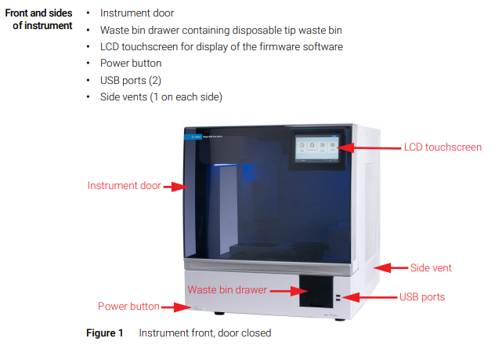
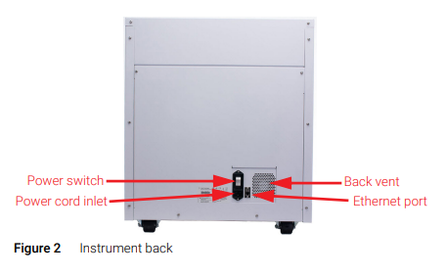
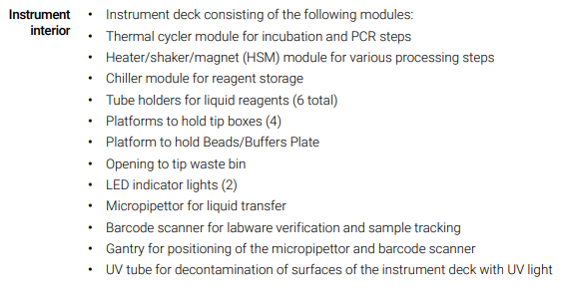
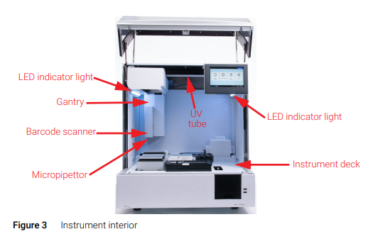
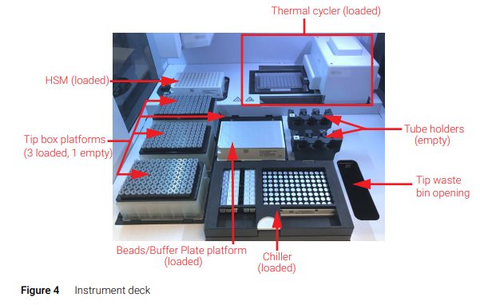
  - Indicator Lights: You can quickly and easily check the status of the instrument based on the color of the LED indicator lights that illuminate the entire plate filling area.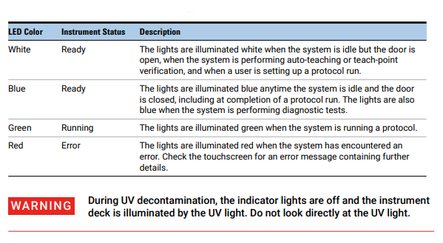
- ENVIRONMENTAL REQUIREMENTS:
  - Maintain optimal environmental requirements.
    - Ambient temperature between 15°C and 25°C
    - Humidity levels between 30% and 70% non-condensing.

- PREPARING THE MAGNIS:
  - Before starting the run, check the ambient humidity on the hygrometer. If it is less than 30%, utilize the humidifier to increase the humidity.
    - Fill both water bottles in the humidifier with DI water and set the fans to high.
  - Verify that the instrument deck is cleared of any labware from previous runs.
  - If the instrument is off, press the power button on the front lower left of the device.
    - The instrument will turn on, the LED indicator lights will illuminate, and the software will launch on the touchscreen. During hardware initialization, the system moves all motorized parts through all sensor positions. This takes approximately 15 minutes.
    - Log in to the software using the lab username “mgp” and password “1234”.
  - If the power is already on, touch “Run Protocol” on the touchscreen. The system will perform an Instrument Health Check to ensure that the hardware is functioning within specifications. This takes about 5 minutes.

- PREPARE THE SURESELECT XT HS2 DNA REAGENTS:
  - You will need:
    - An ice bucket filled with ice.
    - One new tube strip.
    - One PCR tube rack.
    - One red sharps waste bag.
  - Remove the following reagents from storage and thaw accordingly:
    - Ensure the appropriate index strip is used for the run. The provided index strips are labelled D1 through D4 to indicate the specific set of index pairs in each well.
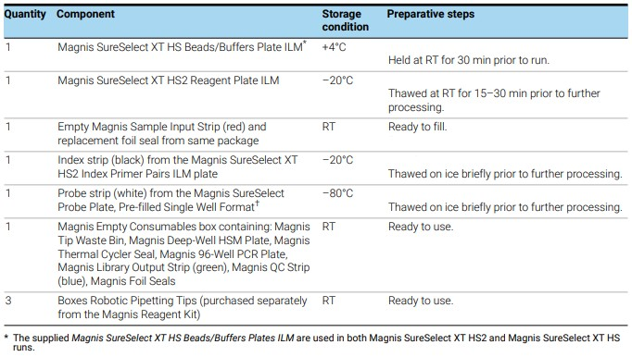
  - Familiarize yourself with the labware handling instructions below before you start the component preparation steps.
    - The adhesive seals and foils covering the kit plates and strip tubes must be left in place during run setup and execution. Avoid touching or damaging the foil and adhesive covers during run setup.
    - Filled reagent plates (both Magnis SureSelect XT HS Beads/Buffers Plates and Magnis SureSelect XT HS2 Reagent Plates) are provided in white cardboard sleeves. Leave the filled plates in the sleeves during all the preparation steps described below.
    - Vortex the filled reagent plates after thawing using the following procedure, illustrated in the pictures below.
      - Hold the sleeved plate in a vertical position (on its side) while vortexing.
      - Vortex one vertical side of the plate for 10 seconds, then rotate the plate 90° and vortex for an additional 10 seconds.
      - Continue the rotation/10 second mixing sequence until completed on all four sides of the plate.
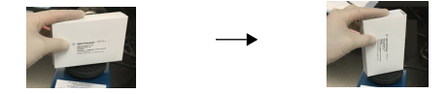
- HEME PANEL NGS PROCEDURE:
  - Log in to Soft Molecular
  - Open the Heme NGS Library Prep Test Worksheet Builder.
  - Click the “Find” button. A new worksheet will now open.
    - If applicable, double click the “New” line to open a new worksheet.
  - In the Barcode# field, scan the product label of each sample to be added to the worksheet.
  - Enter the Control Qubit Concentration for the Positive Control and NTC. NTC = 0.
  - Verify the control lot number by clicking on the sample ID field. Make changes, if necessary, by selecting the proper ID from the dropdown menu in the field.
  - Enter the Index Strip ID for each sample and control. Ex. D1-1, D1-2 etc..
  - Verify that the Test Code for the Positive Control and NTC matches at least one sample Test Code. The codes for Positive Control and NTC must match each other.
  - Verify the reagent lot numbers by clicking on the vertical Settings tab on the left side of the screen. Make changes, if necessary, by selecting the proper lot# from the dropdown menu in the Stock# field.
  - Mark the Completed checkbox and click Save. Worksheet Print Preview window will automatically open.
    - Select the correct printer and click Print. Close the preview window.
  - Exit the Test Worksheet Builder screen.
  - Exit Soft Molecular.
  - Record your Index Code assignments.
    - Open the Heme Panel Index Code Log. G:\PCR_Worksheets_Current\Heme Panel Files\
    - Record the worksheet name, MOL numbers of each specimen, and Index Strip ID for each sample. Ex. D1-1, D1-2 etc.
  - Prepare the Magnis SureSelect XT HS Beads/Buffers Plate.
    - After thawing to RT, vortex the sleeved plate on each vertical side for 10 seconds.
    - Spin the sleeved plate in a centrifuge set at 250 × g for 3 seconds to collect the liquid without pelleting the beads (begin timing once centrifuge achieves full speed). Do not exceed the recommended spin speed and duration to prevent pelleting the beads.
    - Keep the sleeved plate at RT until ready to load on the Magnis.
  - Prepare the Magnis SureSelect XT HS2 Reagent Plate.
    - Slide the plate partially out of the sleeve and confirm that the reagents are completely thawed.
    - Vortex the sleeved plate on each vertical side for 10 seconds.
    - Spin the sleeved plate in a centrifuge set at 250 × g for 1 minute (begin timing once centrifuge achieves full speed). Check bottoms of the plate wells for any bubbles. Repeat the spin step if needed to eliminate any bubbles.
    - After spinning, keep the plate on ice until ready to load on the Magnis.
  - Prepare the Magnis Sample Input Strip.
    - Label a new tube strip 1-8 and place in a rack.
    - Using low TE, dilute the patient samples according to the Library Prep Worksheet. The final diluted volume will always be 14 ul.
    - Place the Sample Input Strip in the rack so that the barcode is facing towards the right side. This orientation ensures specimens are loaded 1-8, left to right.
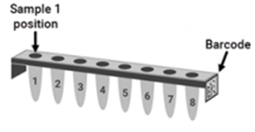
    - Using a multi-channel pipette, pierce each well in the foil strip.
    - Pipette the entire 14 μL of prepared DNA into each corresponding well 1-8.
      - If there are less than eight samples, pipette 14uL of low TE buffer into the unused wells.
    - Once all samples have been pipetted into the Magnis Sample Input Strip wells, re-seal with a fresh foil seal, taking care to avoid obscuring the barcode with the foil seal.
    - Briefly spin the Sample Input Strip to remove any bubbles that may be present.
    - Keep the sealed Sample Input Strip on ice until ready to load on the Magnis.
  - Prepare the Index Strip Tube.
    - Double check that the correct index strip has been thawed.
    - Vortex the strip for 5 seconds, then spin briefly to collect the liquid in the bottom of the wells. If bubbles are present, gently finger flick the tube and re-spin.
    - Keep the index strip on ice until ready to load on the Magnis.
  - Prepare the Probe Strip Tube.
    - Once thawed on ice, vortex the Probe Strip for 5 seconds, then spin briefly to collect the liquid at the bottom of the well. If bubbles are present, gently finger flick the tube and re-spin.
    - Keep the probe strip on ice until ready to load on the Magnis.
  - Set aside one Magnis Empty Consumables box for use during deck setup.

- RUNNING A LIBRARY PREPARATION PROTOCOL:
  - When the Magnis instrument and all reagents have been prepared for the run, follow the prompts provided on the instrument touchscreen to load the labware on the instrument and run the library preparation protocol.
  - Initiate the protocol and enter run information.
    - From the Home screen, touch Run Protocol. The system locks the door and performs an instrument health check which requires about 5 minutes. This can also be done prior to setup in the PCR room.
    - Follow the prompts on the Enter Run Info screen.
    - Set the protocol to “SSEL-DNA_XTHS2-ILM” in the protocol dropdown menu.
    - Aliquot sample for QC. Select No. Enzymatic fragmentation. Select Yes. 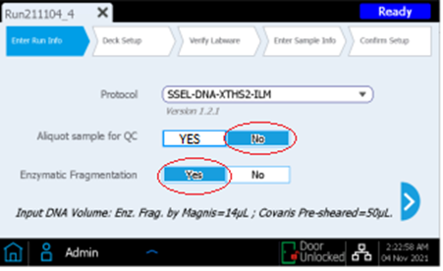
    - Press the forward arrow to advance to the next screen.
    - Set the sample type to High Quality DNA in the sample type dropdown menu.
    - Set the input amount (ng) to 200ng. Touch the forward arrow to progress to deck setup.
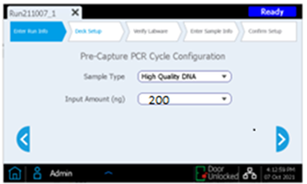
  - Set up the Deck.
    - All Consumables for the deck setup are contained in the Magnis Empty Consumables box. For each deck loading step, the deck position to be loaded will be shaded in blue on the touchscreen.
    - Install the disposable Waste Bin in the pull-out waste bin drawer, with the barcode facing you, as shown on the touchscreen. Close the waste drawer. 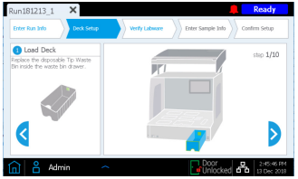
    - Install the Magnis Deep-Well HSM Plate in the deck position shown on the touchscreen, with the barcode facing you. To load the plate, first insert the left edge of the plate into the spring-loaded slot, then lower the right edge of the plate down until the plate is flat on the platform. Ensure that the plate is fully seated inside the holder.
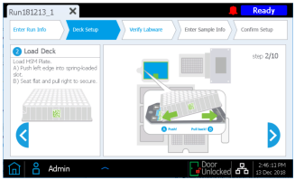
    - Install the Magnis Thermal Cycler Seal. Peel the protective film from the foam pad below the metal plate, by pulling the yellow tab. Insert the Thermal Cycler Seal into the slot at the position shown on the touchscreen, with the barcode facing up. Continue sliding the Thermal Cycler Seal into the slot until it clicks.
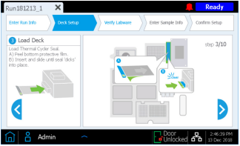
    - Install the Magnis 96-Well PCR Plate in the deck position shown on the touchscreen by inserting the plate wells into the thermal cycler block wells, with the plate barcode facing you.
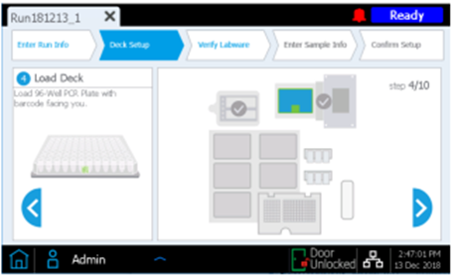
    - Load a new, full tip box, with the lid removed at each of the deck positions indicated on the touchscreen.
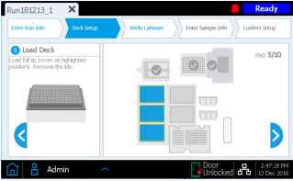
    - Install the Magnis SureSelect XT HS Beads/Buffers Plate. Remove the white cardboard sleeve, then load the plate in the deck position shown on the touchscreen, with the barcode facing you. To load the plate, first insert the left edge of the plate into the spring-loaded slot, then lower the right edge of the plate down until the plate is flat on the platform. Ensure that the plate is fully seated inside the holder.
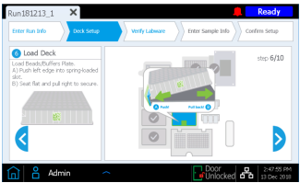
    - Load the chiller module.
      - Open the chiller door by pressing on the white button indicated with a green arrow on the touchscreen.
      - Install the Reagent Plate into the chiller as shown on the touchscreen. Remove the white cardboard sleeve and check bottoms of wells for any bubbles. If bubbles are present, spin the plate for one minute at 250g. Load the plate in the chiller module with the barcode facing you. Press down firmly, applying pressure evenly across the plate.
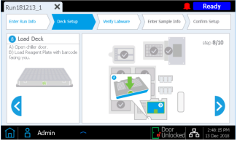
    - Load the strip tubes in the indicated positions of the chiller, in the order listed. Before loading each strip, check bottoms of wells for any bubbles. If bubbles are present, remove them by briefly spinning down the tube strip. Avoid touching or damaging the foil covers. Make sure to orient each strip tube with the barcode facing you.
      - Load the red sample strip tube containing input DNA samples into the strip tube holder position labeled with “S”. Leave the foil cover intact.
      - Load the black strip tube containing indexed primers into the strip tube holder position labeled with “IDX”. Leave the foil cover intact.
      - Load the white strip tube containing probe solution into the strip tube holder position labeled with “P” Leave the foil cover intact.
      - Load the empty green library output strip into the strip tube holder position labeled with “L”. Leave the foil cover intact.
      - The optional blue QC strip is not used for this assay and can be discarded. 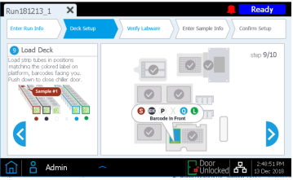
      - Once all strip tubes are loaded in their appropriate positions S, IDX, P, and L, close the chiller door.
    - Close the instrument door.
  - Verify Labware.
    - Once all Deck Setup steps are complete, verify that lids have been removed from all tip boxes and that all tip boxes are full. Once the tip box status has been verified, press OK to begin the instrument’s automated labware verification routine.
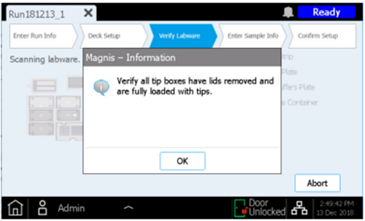
    - During the barcode scan, the instrument verifies that all components required for the run type are present, in the correct position and orientation, and are not expired. Results of the verification are displayed on the Magnis touchscreen. Press the forward arrow to proceed.
    - The identity of the probe solution is automatically conveyed to the Magnis software by the strip barcode, and the probe properties are reported for your review as shown below. Press the forward arrow to proceed.
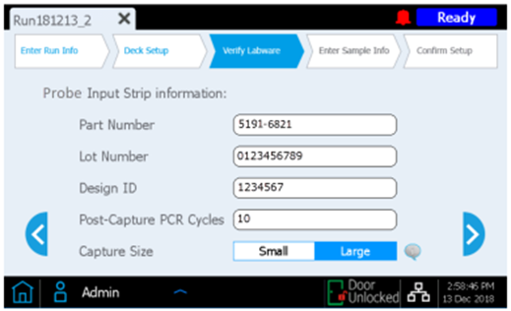
  - Enter Sample Info.
    - Use this screen to assign each well position to a specific sample in the Magnis software. Assign each sample ID in order from 1-8 with the correct Mol numbers.
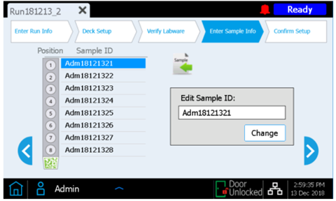
  - Confirm Setup and Start the Run.
    - Verify the run settings displayed on the first Run Setup Summary screen.
      -  Edit the fragmentation time to 15 minutes. Touch the pencil icon and change the default 25 min, to 15 min.
    - Press the forward arrow to proceed.
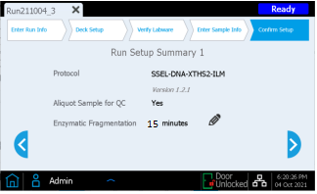
    - The second screen displays the run details relating to the quality and quantity of the samples. Pre and post capture PCR cycles are based on optimal conditions for the input DNA and probe used in the run. Verify input amount is set to 200ng.
    - Press the green start button to begin the run.
      - Once the run starts, the LED indicator lights turn green, and the touchscreen displays the status of the run. Runs with enzymatic fragmentation take approximately 10 hours to complete. Once complete, the prepared libraries are held at 12°C and can remain on the instrument for a maximum of 72 hours.
  - Process your Library Prep Worksheet:
    - Log in to Soft Molecular.
    - Open the Heme NGS Test Worksheet Processing tile.
    - Click the Worksheet# field, then scan the barcode on your Heme NGS Library Prep Worksheet.
    - Complete the Load Magnis activity by clicking the Completed checkbox, then click Save.
    - Click the Build Next Worksheets button.
      - Verify HEMNORMLD “To build”, “Select all tests”, and “Transfer Controls” are all checked.
      - Click OK.
    - Exit Soft Molecular.
  - Collect the final library samples from the Magnis.
    - When the run is complete, the instrument will prompt you to collect the samples.
    - Press OK on the touchscreen.
    - The robot transfers the prepared libraries from the PCR plate to the green Library Output Strip in the chiller.
    - Once in the output strip, the libraries can stay on the chiller for up to two hours.
After two hours, the chiller will be automatically turned off.
    - Open the instrument door and collect the final library samples in the green Library Output Strip. Place into a rack, and re-seal with a fresh foil seal strip provided in the Magnis Empty Consumables Package.
    - Close the run screen by pressing the “x” on the tab to return to the home screen.
    - Bring the library strip to the post hood to continue processing, or store at -20°C.
    - If continuing processing, label a new tube strip “Heme Libraries” and date.
Example: Heme Libraries mm/dd/yy.
    - Using a multichannel pipette, transfer the entire volume from the Magnis output strip into the new tube strip. Be sure to orient the Magnis strip so that the barcode is facing to the right side. This will orient the samples in order 1-8 from left to right.
  - Clear the instrument after the run.
    - Remove the tip waste bin and dump the tips into a sharp’s container. Dispose the empty bin in the red biohazard trash.
    - Remove all plates from the deck and dispose in the red biohazard trash.
    - Remove all reagent strip tubes from the chiller and dispose in the sharp’s container.
    - Remove all tip boxes and dispose in regular trash.
    - Wipe down all surfaces with a lint free wipe and 70% ethanol.
    - From the home screen, run the 30-minute UV decontamination.

- QUANTITATION OF THE FINAL LIBRARIES.
  - If the final libraries were stored at -20˚C overnight, remove from the freezer and allow them to completely thaw at room temperature before proceeding with Qubit Quantitation.
  - Prepare the Qubit dsDNA High Sensitivity master mix according to the chart below:
Number of Reactions (Sample and/or Standards) | Volume of Qubit® Buffer (µL) | Volume of Qubit® Reagent (µL)
1 | 398 | 2
2 | 597 | 3
3 | 796 | 4
4 | 995 | 5
5 | 1194 | 6
6 | 1393 | 7
7 | 1592 | 8
8 | 1791 | 9

    - Prepare a Qubit tube for each sample and control on the run.
    - Transfer 198uL of the Qubit dsDNA HS master mix into each Qubit tube.
    - Add 2uL of each Magnis Library sample to the appropriate Qubit tube.
    - Briefly vortex and spin each tube, to mix and collect contents.
    - Incubate the tubes at room temperature, away from the light, for 2 minutes.
    - To prevent inaccurate readings due to residue on the tube, use a clean Kim Wipe to wipe each tube before inserting into the Sample Chamber.
    - On the Qubit home screen, click dsDNA, then select the appropriate Qubit quantitation kit.
    - Click Run Samples, then verify the input volume is set to 2uL.
    - Insert the assay tube into the sample chamber, close the lid, and then touch Read Tube. The reading takes approximately 3 seconds.
    - The concentration values are displayed as:
      - The top value (in large font) is the concentration of the original sample.
      - The bottom value is the dilution concentration (the concentration of the sample in the tube inserted into the Qubit® Fluorometer).
    - To quantitate the next sample, remove the current tube and insert the next tube. Touch Read Tube. Repeat this for all applicable samples and controls.
    - To export the data, return to the Qubit Home screen using the house icon, click Data, then select Export.
    - In the Export Data Screen, mark the selection box to the left of the appropriate data set.
    - Click Export. Select .csv as the format type, and USB as the destination.
    - Once the file has been exported, open file explorer and navigate to the Qubit 4 drive.
    - Open the Internal Storage folder, then the Qubit 4 folder.
      - In the Qubit 4 folder, data is organized into separate folders according to date.
    - Open the appropriate data folder, then open the Excel .csv file.
    - Rename each sample in the “Test Name” column using the Sample ID in the HEMENORMLD worksheet. Keep in mind, Qubit lists the samples in descending order. Sample #1 is at the bottom of the list, #8 at the top.
    - Click File, then Save As and name the file using the format: [YYYYMMDD_DNA_Qubit_Heme_Libraries]
    - Save the file to the MGP_Qubit Import files folder on the RICMBLAB$ shared drive.
    - Change the file type to Excel Workbook (*.xlsx).
    - Return to the Qubit 4 folder, right click on the appropriate folder and in the dropdown that appears click Delete. This removes the folder and .csv file from the Qubit Export folder.
  - Process your HEMENORMLD Worksheet.
    - Log into Soft Molecular.
    - Open the Heme NGS Library Normalization Test Worksheet Processing tile.
    - Click the “…” button to the right of the import button.
    - Select the Excel radial button, then click the ‘…’ button next to the File Name field.
    - In the File Finder, navigate to the previously saved final Qubit Quantitation file, then click Import.
    - The final quantity of each sample will appear in the Library Qubit Concentration field. The normalization dilutions will be calculated automatically upon import.
    - Click the Print Worksheet button.
    - Select the appropriate printer, then click Print.
    - Exit Soft Molecular.

- PREPARE FOR SEQUENCING:
  - Prepare the NextSeq® 500/550 Mid Output kit components.
    - The Reagent Cartridge can be thawed overnight at 4°, or in a water bath for 1 hour on the day of sequencing. The HT1 buffer can be thawed overnight at 4° or on ice for 1 hour on the day of sequencing.
      - If thawed at 4°, remove the cartridge from the refrigerator at the start of library pool prep and place it in the NGS hood.
      - If thawed at 4° remove the HT1 buffer from the refrigerator and place on ice.
    - The flow cell can be removed from the refrigerator at the start of library pool prep and remain at room temp until ready to use.
      - For more detailed information regarding use of the sequencing kit or the NextSeq® instrument, refer to the NextSeq® 500 Instrument Procedure.
  - Remove the 10nM PhiX Control from the freezer and place on ice until ready to use.
    - The PhiX Control is derived from the bacteriophage genome (PhiX) and is provided as a ready-to-use library at a concentration of 10nM. The PhiX Control is used to monitor the quality of sequencing runs on Illumina platforms.
  - Once the HT1 is thawed, prepare to denature and dilute (DD) the library pool and PhiX Control. Obtain the following:
    - One new tube strip.
    - One fresh tube of PCR-grade water.
    - One tube of 200mMol Tris-HCL pH 7.0.
    - 1N NaOH.
    - Five, 1.5mL centrifuge tubes, placed in a rack.
  - Label the 1.5mL tubes as follows:
    - 0.2N NaOH
    - Heme Pool w/date
    - Library DD
    - PhiX DD
    - Final Load Pool
  - After quantitation, each final library is normalized to a concentration of 4nM, then pooled at equal volumes.
    - Label the new tube strip 1-8 for dilution.
    - Add the appropriate amount of PCR-grade water to each tube according to the HEMENORMLD worksheet.
    - Using a multichannel pipette, add 5uL of each final library to the corresponding tubes.
    - Once the dilutions are made, place the final libraries back on ice.
    - Vortex and briefly centrifuge the 4nM diluted libraries.
    - Into the tube labelled “Heme Pool” pipette 5 µL of each 4nM diluted library.
      - Vortex and briefly centrifuge the 4nM Heme Pool and place in the rack.
    - Discard the tube strip with the individual 4nM diluted libraries.
      - The 4nM Heme Pool is available for repeats. In rare cases, if necessary, the individual 4nM libraries can be remade from the final libraries.
  - Denature and dilute the pooled library and PhiX control.
    - In the tube labelled 0.2N NaOH, make a fresh aliquot by combining 4 µL of 1N NaOH with 16 µL of laboratory PCR-grade water.
    - Into the tube labelled “library DD”, pipette 10µL of the 4nM Heme Pool.
    - Place the 4nM Heme Pool stock on ice.
    - Finger flick and briefly spin down the thawed PhiX Control.
    - Into the tube labelled “PhiX DD”, pipette 2 µL of the 10nM PhiX Control and 3 µL of laboratory PCR-grade water. This results in a 5 µL PhiX Control at a 4nM concentration.
    - Denature the 10µL “Library DD” and the 5µL “PhiX DD” by respectively adding 10 µL and 5 µL of 0.2N NaOH to each tube.
      - Vortex both tubes briefly, then centrifuge to spin down the contents.
      - Incubate the tubes at room temperature for 5 minutes.
      - After 5 minutes, stop the denaturation by adding 10µL of 200mM Tris-HCl, pH 7.0 to the Library DD tube and 5uL of 200mM Tris-HCl, pH 7.0 to the PhiX DD tube.
      - Vortex both tubes briefly, then centrifuge to spin down the contents.
    - Dilute the Library DD tube by adding 970 µL of ice-cold HT1.
    - Dilute the PhiX DD tube by adding 985 µL of ice-cold HT1.
    - Vortex both tubes briefly, spin down, and place on ice.
      - This results in a 40pM denatured library pool and a 20pM denatured PhiX control.
  - Create the Final Load Pool.
    - Into the tube labelled “Final Load Pool”, pipette the following:
      - 1256.9 µL of ice-cold HT1.
      - 4.1 µL of the diluted 20pM PhiX DD tube.
      - 39.0µL of the diluted 40pM Library DD tube.
    - This results in a 1.3mL Loading Pool at a concentration of 1.2pM with 5% PhiX.
    - Place the Loading Pool on ice until ready to use.

- PREPARE THE NEXTSEQ FOR SEQUENCING:
  - Prepare the reagent cartridge in the NGS setup hood.
    - Inspect the NextSeq reagent cartridge to make sure it is completely thawed.
      - Allow more time if the cartridge reagents are not completely thawed.
    - Invert the cartridge 5 times to mix the reagents.
    - Gently tap the cartridge on a hard surface to remove bubbles and dislodge water from the base of the cartridge.
    - Use a dry Kimwipe and clean the foil seal covering the well designated ‘Load Library Here’ (well #10).
    - Pierce the foil seal with a clean 1 mL pipette tip.
    - Pipette the entire Final Load Pool (1.3 mL) into the Library Load well.
      - Take care to avoid introducing bubbles into the well as this could affect cluster generation and the performance of the Flow Cell.
  - Set up the run on the NextSeq as follows:
    - On the Home Screen of the NextSeq®, touch the Sequence button.
    - Click Manual in the window that appears.
    - BaseSpace Sequence Hub Settings: Leave unchecked
    - On the Run Setup screen, enter the run parameters as follows:
      - Run Name: scan the HEMENORMLD worksheet.
      - Library ID: Leave blank.
      - Read Type: Select Paired End.
      - Read Length: Enter 151 in the text fields for both Read 1 and Read 2.
      - Enter 8 in the text fields for both Index 1 and Index 2.
      - Custom Primer: Leave all options unchecked.
      - Output Folder: The default location is: \\192.168.1.16\nextseq\runs for automatic transfer of the data to the lsmplinux2 server.
      - In rare cases, local storage can be utilized. Select D:\Output to store data on the NextSeq hard drive. If using the D: drive, a manual transfer step is required after sequencing is complete. Please refer to the Data Transfer Process section of the NextSeq 500 Instrument Procedure for more information.
    - When completed, select Next.
    - Remove the used Flow Cell and discard in the sharp’s container.
    - Remove the new Flow Cell from its packaging.
    - Inspect the Flow Cell and place on the stage. Select Load.
    - Select Next once the Flow Cell loads properly.
    - When prompted, remove the used Buffer Cartridge. Discard in red trash.
    - When prompted, remove the Spent Reagents Container. Dump this waste in the satellite hazardous waste container labelled “Formamide Waste”.
    - Remove the new Buffer Cartridge from its packaging. Invert 5 times to mix.
    - Insert the new Buffer Cartridge into the instrument.
    - Insert the empty Spent Reagents Container back into the instrument.
    - Close the compartment door and select Next.
    - When prompted, open the Reagent Cartridge compartment door and insert the Reagent Cartridge.
    - Select Load and then, Next.
    - The instrument will perform pre-run System Checks for all run components, disk space, and network connections.
      - If any checklist item fails during the System Check, an error notification will appear on the screen with instruction on how to correct the error.
If an error requires technical support, leave the loaded NextSeq® kit components on the instrument and contact Illumina Technical Support. The kit components are stable at room temperature for several hours (see the NextSeq® 500 Instrument Procedure for more info on Troubleshooting).
    - When the System Check is successfully completed, the program will begin sequencing automatically. The run takes approximately 27 hours to complete.
  - Process the HEMENORMLD Worksheet:
    - Log in to Soft Mol.
    - Open the Library Normalization Worksheet using the tile on the dashboard.
    - Complete the Load NextSeq Heme NGS activity by marking the Completed checkbox and click Save.
    - Exit Soft Mol.
  - After the run is complete, perform the “quick wash”, according to the NextSeq Instrument Procedure.

- CREATE THE SAMPLE SHEET:
  - A Sample Sheet is required to process and analyze the sequencing data from the NextSeq®. The Sample Sheet must be created and saved as a ‘comma delimited values’ file (.csv file).
  - Create the sample sheet: Test worksheet processing
    - Open test worksheet processing with the tile on the dashboard. Press Find.
    - Make sure the sub-template is set to “sample sheet”
    - Select the ‘…’ button to the right of the Export button to export the Sample Sheet.
    - Change the format from XML to Excel by pressing the radial button.
    - Select the ‘…’ button next to the Directory field and navigate to the run folder.
    - Click the Export button.
      - This will export a file name MTW_[Date]-HEMENORMLD-1
    - On the RICMBLAB$ network drive, go to the \\PCR_Worksheets_Current\Heme Panel Files subfolder and open the SampleSheetTemplate file.
    - In the SampleSheetTemplate file, select File, followed by Save As.
    - Select Browse and navigate to the Heme panel run folder.
    - Name the file in the File Name field by scanning the HEMENORMLD worksheet after Sample Sheet, replacing the word “Template”.
    - Open the Sample Sheet and the exported HEMENORMLD file.
    - Copy the appropriate information from the exported HEMENORMLD file into the template file. Save the Sample Sheet Excel file and then close the HEMENORMLD file.
      - Sample ID: enter the Soft Molecular number of each sample and control.
      - Sample Name: enter the same information as the Sample ID column (e.g., control identifier and molecular numbers).
      - Index1_P7_ID: obtain this information from the HEMENORMLD file.
      - Index1_P7_Sequence: the Excel workbook will calculate this information.
      - Index2_P5_ID: obtain this information from the HEMENORMLD file.
      - Index2_P5_Sequence: the Excel workbook will calculate this information.
      - Sample Project: Enter the project name using the format [DDMMYYYY]_Heme_Panel_Fastq, where the date is the day that the instrument is loaded.
    - In Soft Molecular, complete the Sample Sheet action by marking the Completed checkbox and selecting Save.
    - When completed, inform the Bioinformatics team that the run was started, and the Sample Sheet is ready.
    - This step is to be completed by the Bioinformatics team:
      - Copy and paste the information from the Excel file appropriately into the Sample Sheet .csv file template (received from Illumina). Save in the run folder.
      - Close both the Excel and .csv files.

- POST SEQUENCING:
  - After sequencing is completed, an automatic post-run wash is performed using the wash solution provided in the Buffer Cartridge and the NaOCl provided in the Reagent Cartridge.
  - On the NextSeq® Maintenance Sheet, document the date of the post-run wash.
  - Transfer the archived (*.zip) SAV file.
  - Select the Illumina Sequencing Analysis Viewer icon located on the desktop of the NextSeq instrument.
    - Select Browse on the top left.
    - Select Computer.
    - Select the Data (D:) drive.
    - Select the Illumina folder.
    - Select the NextSeq Output folder.
    - Select the run (i.e., based on the date – example: 20220321).
    - Select OK.
    - Click on the Summary tab.
    - Select the Zip my Run button on the bottom of screen.
    - Save to the Heme NGS Panel run folder on the nextseq drive in Nextseq\Runs.
    - Save a screenshot of the completed run screen on the nextseq server.
      - Open the Snipping Tool program (Shift+Windows+S).
      - Click on the completed run screen. A screenshot of the window should open.
      - In the Snipping Tool window, click File followed by Save As.
      - In the Save As window, navigate to the Runs folder on the NextSeq server, then click Save.
  - Process Library Normalization Worksheet
    - Log into Soft Molecular on a BUH Computer.
    - Open Heme NGS Library Normalization–Test Worksheet Processing by using the tile on the dashboard.
      - Select Find.
      - Complete the Data Transfer action by marking the Completed checkbox and selecting Save.
      - Select Back in the Heme NGS Library Normalization–Test Worksheet Processing.
    - Create the Tasklist.
      - Click the tasklist button at the top of the worksheet.
      - Document SAV metrics in the Tasklist.
        - % > Q30 – SAV Summary tab, Total
        - Aligned % – SAV Summary tab, Read 1
        - Cluster Density – NCS Screenshot
        - % Cluster Passing Filter – NCS Screenshot
        - Yield Total (G) – SAV Summary tab, Total
        - Leave Reads (M) and Reads (PF) blank, as they are not used for this assay
      - Verify the Sample ID field is populated for each control. This indicates that a lot number is selected, and the Q numbers will generate appropriately.
        - If a Sample ID field is empty for any of the controls, click the dropdown arrow in the Sample ID field.
        - In the window that appears, select the correct lot number.
          - Lot numbers can be found in the Sample ID fields of the printed worksheets.
        - Repeat i-ii for each applicable control.
      - Click Select All, then Coll/Exp. Button.
      - Complete SAV Parameters QC action by marking the Completed checkbox located on the patient sample line and select Save.
        - Q numbers will generate for all controls.
      - Select Back in the Tasklist Entry window.
    - Exit Soft Molecular.
    - Document SAV metrics in the NextSeq_Run_Metrics_Heme_Panel log.
      - RICMBLAB$\NGS\NextSeq_Run_Metrics\NextSeq_Run_Metrics_Heme_Panel
  - SAV and Run Data Transfer:
    - After the completion of sequencing, the data may be transferred from the NextSeq to the BUH network shared drive using WinSCP or may have to be manually transferred using an external hard drive.
    - The Director of Clinical Bioinformatics will determine the appropriate methodology.
      - To transfer the run data using WinSCP:
        - On a BUH computer, Open WinSCP.
        - Enter 10.217.75.25 in Host name window.
        - Enter the appropriate username and password.
        - Click Login. The program will display two windows.
        - In the left window, navigate to G:\CMB_Tests\Year\Month\[Date]-hemelibprp-1 on the RICMBLAB$ drive.
        - Create a folder named [Run date]-hemenormld-1
        - Within the [Run date]-hemenormld-1 create inside another folder called MD5_Check
        - In the right window, navigate to the /nextseq/Runs folder on the nextseq server.
          - Locate the run folder with the latest date.
        - Highlight the SAV zip file and NextSeq run screenshot in the /nextseq/Runs folder and drag to [Run date]-heme2normld-1 on the RICMBLAB$ drive
        - When transfer is complete on the left window navigate on the drop-down menu to the MGPGenomicData$ drive
        - Navigate to the NextSeq_Files/ [Year] NextSeq Files folder on the MGPGenomicData$ drive
        - On the left window locate the Run Folder and drag to the Run Folder to NextSeq_Files/ [Year] NextSeq Files

- TEST PROCEDURE – BIOINFORMATICS ANALYSIS FASTQ GENERATION and TRANSFER:
  - These steps are performed by the Bioinformatics Analyst and/or Director of Bioinformatics.
  - Make the FASTQ Files on lsmplinux2(10.217.75.25).
    - Transfer the sample sheet from the BUH computer to lsmplinux2(10.217.75.25).
      - On a BUH computer, navigate to and open the run folder located in G:\CMB_Tests\Year\Month\[Date]-hemelibprp-1
      - Rename the sample sheet file to “SampleSheet.csv”
      - Open WinSCP on a BUH computer.
      - Enter 10.217.75.25 in Host name window.
      - Enter the appropriate username and password.
      - Click Login. The program will display two windows.
      - In the left window, navigate to the run folder on the RICMBLAB$ drive.
      - In the right window, navigate to the /nextseq/Runs folder on the nextseq server.
        - Locate the run folder with the latest date.
      - Highlight the sample sheet file in the G:\CMB_Tests\Year\Month\[RunID] in the left window and drag to the run folder on the /nextseq server in the right window.
      - Wait until the file transfer is completed.
      - On a BUH computer, open Putty.
      - Type 10.217.75.25 in Host name (or IP address) window.
        - This is the IP address for lsmplinux2 which will open the terminal window.
      - Open Putty on a BUH computer:
        - Enter username/password .
        - Type “cd /nextseq/Runs”
        - Locate the run folder with the latest date.
        - Type “cd [the run folder named with the latest date]”
        - Type “scp /nextseq/Runs/bcl2fastq_command_line_heme_3.sh ./” and press Enter on the keyboard.
          - This will copy the bcl2fastq_command_line_heme_3.sh file to the run folder
        - Type “sh bcl2fastq_command_line_heme_3.sh”.
          - This will make the FASTQ files for the heme run.
      - Perform MD5 Checksum on sequencer:
        - On a BUH computer, open Putty.
        - Type 10.217.75.25 in Host name (or IP address) window.
          - This is the IP address for lsmplinux2 which will open the terminal window.
        - In the Terminal window:
          - Enter username/password in the terminal.
          - Type ‘’cd /molpath”
          - Type “sh md5gen_sequencer_heme.sh /nextseq/Runs/[run directory with the latest date]/Data/Intensities/BaseCalls/Heme_NGS_Panel_Fastq/”
            - The script generates a file “MD5checksum_sequencer_heme.txt” used for the MD5 Checksum excel file
        - On a BUH computer open WinSCP.
        - Enter 10.217.75.25 in Host name window.
        - Enter the appropriate username and password.
        - Click Login. The program will display two windows.
        - In the left window, navigate to the run folder on the RICMBLAB$ drive.
        - In the right window, navigate to the /molpath on the server.
        - Highlight the MD5checksum_sequencer_heme.txt in the /molpath directory in the right window and drag the file to G:\CMB_Tests\Year\Month\[Date]-hemelibprp-1/[Run date]-hemenormld-1/MD5_Check in the RICMBLAB$ drive on the left window.
        - Wait until the file transfer is completed before proceeding to next step.
    - Transfer FASTQ files from the NextSeq to the RICMBLAB$ drive:
      - On WinSCP in the right window, navigate to /nextseq/Runs/run_number/Data/Intensities/BaseCalls
      - Highlight the directory “Heme_NGS_Panel_Fastq” in the BaseCalls folder and drag to the G:\CMB_Tests\Year\Month\[Date]-hemelibprp-1/ [Run date]-hemenormld-1 under RICMBLAB$ drive.
      - Wait until the file transfer is completed before proceeding to next step.
    - Transfer FASTQ files from the run directory to lsmplinux3 for bioinformatics analysis:
      - On a BUH computer open WinSCP.
      - Enter 10.37.28.238 in Host name window.
        - This is the IP address for lsmplinux3 server.
      - Enter the appropriate username and password.
      - Click Login. The program will display two windows.
      - In the left window, navigate to G:\CMB_Tests\Year\Month\[Date]-hemelibprp-1/ [Run date]-hemenormld-1/ Heme_NGS_Panel_Fastq on the RICMBLAB$ drive.
      - In the right window, navigate to the /nextseq/Heme_Directory/Fastq_Files folder on the lsmplinux3 server.
      - Highlight the FASTQ files in the run folder on the RICMBLAB$ drive and drag to the /nextseq/Heme_Directory/Fastq_Files.
      - Wait until the file transfer is completed before proceeding to next step.

- SOPHiA DDM ANALYSIS AND VARIANT REVIEW:
  - Download FASTQ files from RICMBLAB$ drive to a local drive on a BUH computer (i.e. C: drive)
  - Open SOPHiA-DDM-v4 software
  - Login with credentials
Figure 5. SOPHiA-DDM-v4 software login
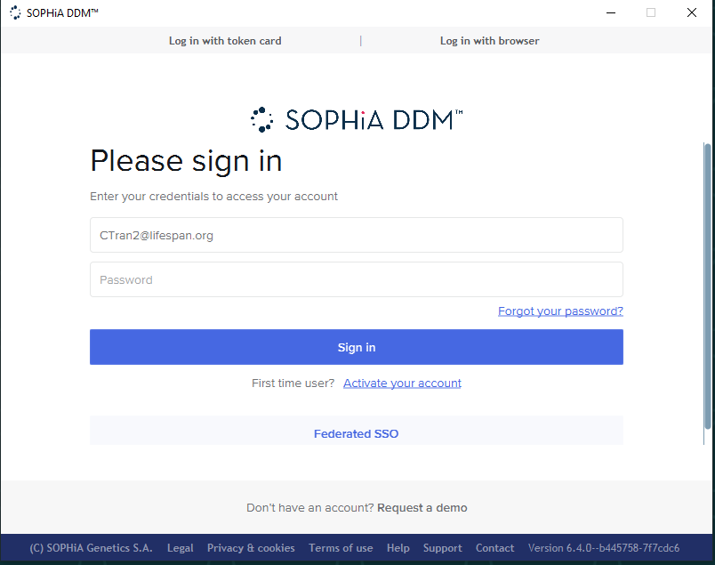

  - On top right side of the screen click on “upload” icon

Figure 6. SOPHiA-DDM-v4 upload
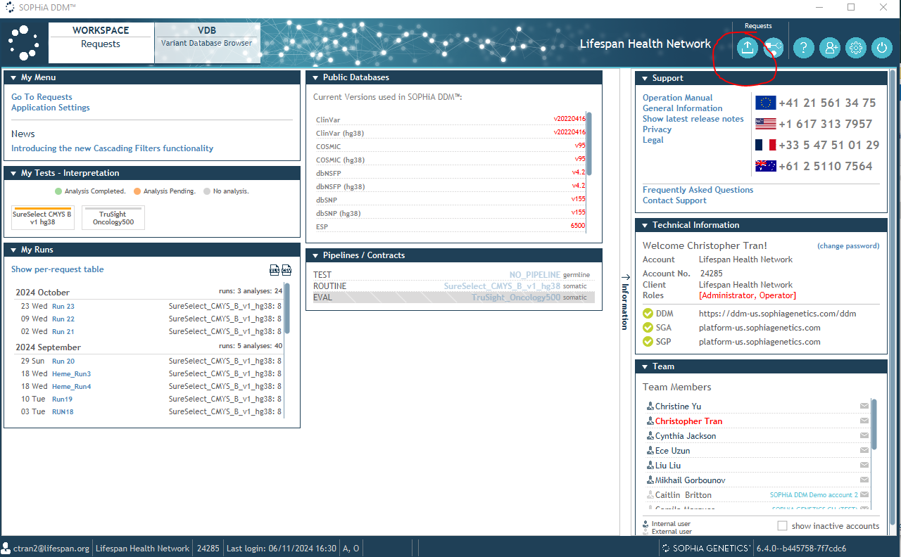
  - Copy Run ID from the run directory under G:\CMB_Tests and paste it under “Reference”
    - Run ID format is [Date]-hemelibprp-1
  - Select “Illumina NextSeq” in the Sequencer
  - Click on “Choose Sequence File”
  - Upload all FASTQ files from local drive on BUH computer.
Figure 7. SOPHiA-DDM-v4 FASTQ upload
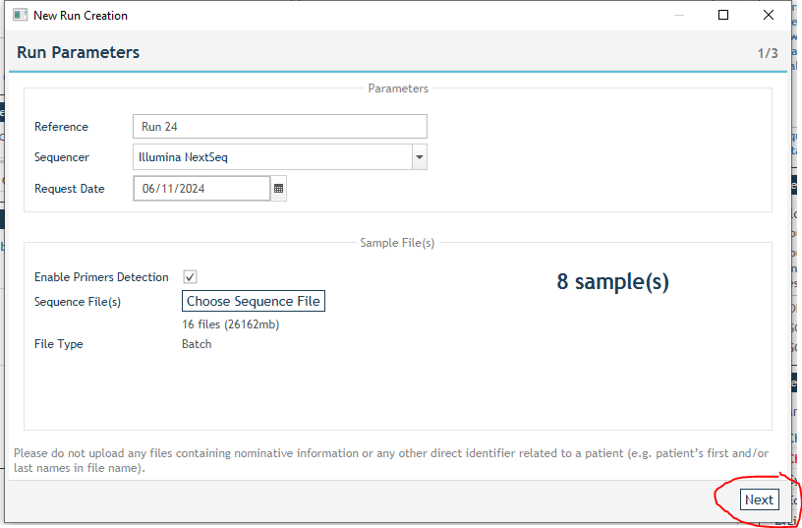
  - Click on “Next”. This will start the uploading of the FASTQ files.
  - When processing the NTC be sure to click the custom pipeline and continue to click next
  - Wait for the upload and analysis to complete. This will take 5-6 hours.
  - After SOPHiA DDM finishes the analysis, click on “Add interpretation”
  - In the popup window named “New Interpretation Project”, click “add”

Figure 8. SOPHiA-DDM-v4 Sample Interpretation addition.
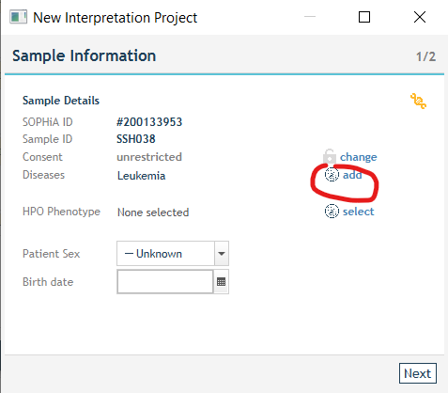

  - In the popup window named “Disease Ontology Selection” choose the appropriate disease ontology, click ok.

Figure 9. SOPHiA-DDM-v4 Disease Ontology Selection
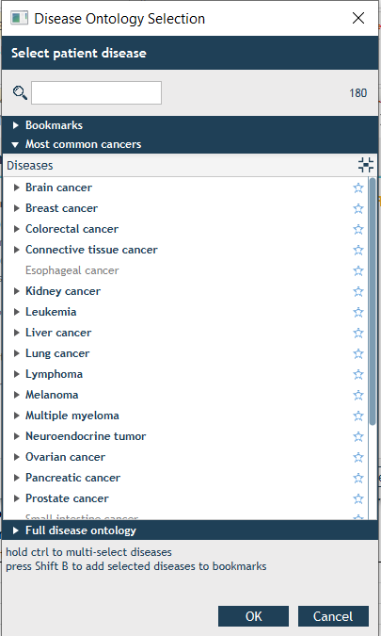
  - Click ‘Next’ in the window named “New Interpretation Project”.
  - Click ‘Finish’.
  - After the the new interpretation is loaded, click ‘ok’ on popup window.
  - Click ‘Variant’ tab to review the variants

Figure 10. SOPHiA-DDM-v4 Variant Tab selection
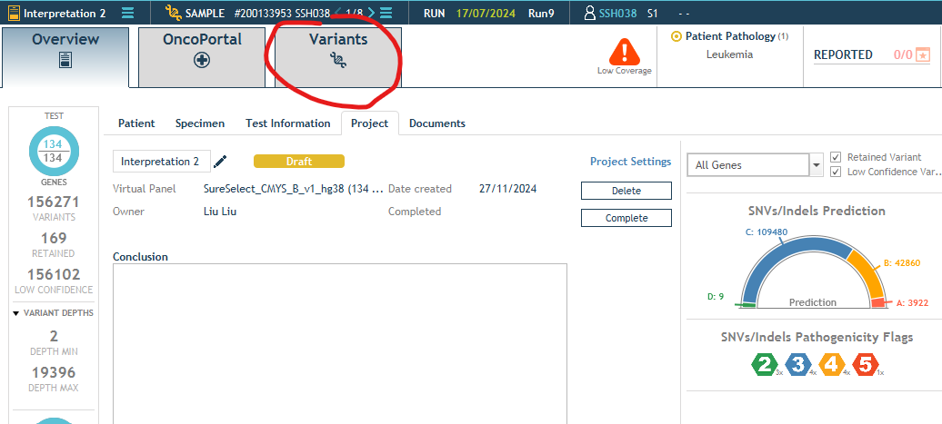

  - For variant interpretation, select the variant, check in IGV, review databases (GnomAD, ClinVar, COSMIC, OMIM), check variant prediction in overview, check similar patients list and warnings, flag the classification using 1-5 (1-benign, 2-likely benign, 3-VUS, 4-likely pathogenic, 5-pathogenic) following the AMP/ACMG guidelines.
  - For variants to be included in the final report, click ‘Add To Report’

Figure 11. SOPHiA-DDM-v4 Variant Selection
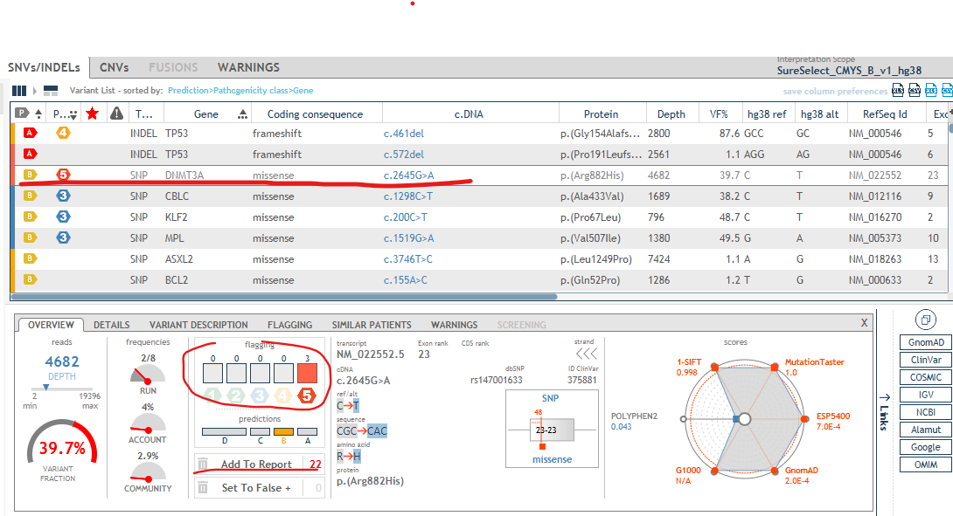
  - Repeat steps S and T for all necessary variants in a sample.

- MD5Checksum Generation:
  - MD5 Checksum for the FASTQ files in RICMBLAB$ drive:
    - Open Powershell on a BUH computer.
    - Navigate to the [Run Date]-hemelibprp-1\[Run Date]-hemenormld-1\Heme_NGS_Panel_Fastq folder on the RICMBLAB$ drive.
    - Copy the path that directs to the FASTQ files
    - Paste the path within the quotation marks below.
      - dir "G:\CMB_Tests\2025 tests\09-2025\09.22.25-hemelibprp-1\09.22.25-hemenormld-1\Heme_NGS_Panel_Fastq" -Recurse | Get-FileHash -ea 0 -Algorithm MD5 > MD5checksum_Gdrive_Heme.txt
    - Using the command above copy the command and paste it within Powershell.
      - This generates the MD5checksum_Gdrive_Heme.txt file for MD5 Checksum.
    - In a file explorer open the following path C:\Users\[your user ID]
      - MD5checksum_Gdrive_Heme.txt file should be located in that directory
    - Right click and use the cut option.
    - Paste the file into G:\CMB_Tests\Year\Month\[Date]-hemelibprp-1/[Run date]-hemenormld-1 in the RICMBLAB$ drive.
  - MD5 Checksum for the FASTQ files on lsmplinux3:
    - On a BUH computer, open Putty.
    - Type 10.37.28.238 in Host name (or IP address) window.
      - This is the IP address for lsmplinux3 server.
    - In the Terminal window:
      - Enter username/password
      - Type “cd /nextseq”
      - Type “sh md5gen.sh ./Heme_Directory/Fastq_Files/”
        - The script generates a file named MD5checksums_server.txt
      - Open WinSCP
      - Enter 10.37.28.238 and enter your credentials
      - In WinSCP, on the right window navigate to the G:\CMB_Tests\Year\Month\[Date]-hemelibprp-1/ [Run date]-hemenormld-1/MD5_Check in the RICMBLAB$ drive
      - Locate the MD5checksums_server.txt file in the /nextseq directory on lsmplinux3.
      - Click and highlight MD5checksums_server.txt file and drag it into the left window to G:\CMB_Tests\Year\Month\[Date]-hemelibprp-1/ [Run date]-hemenormld-1/MD5_Check in the RICMBLAB$ drive.
  - MD5 Checksum Result Generation:
    - In a file explorer, Navigate to G:\Bioinformatics\MD5CheckSum in the RICMBLAB$ drive.
    - Within the folder, Copy the MDchecksum_heme.xlsx file to G:\CMB_Tests\Year\Month\[Date]-hemelibprp-1/ [Run date]-hemenormld-1/MD5_Check in the RICMBLAB$ drive.
    - Open the MDchecksum_heme.xlsx.
    - Open the txt files below, Copy and pasting the information in each file to the designated tab in the excel file:
      - MD5checksum_Gdrive_Heme.txt
      - MD5checksum_sequencer_heme.txt
      - MD5checksums_server.txt
    - When data is copied, use text import wizard or text to columns function changing the delimiter from tab to space
      - This properly formats sample information into each cell.
    - Move over to the CheckPage tab to confirm all rows contain true statement.
    - If there is a false, review data, reorder if necessary, and repeat the copying process from step 4 above.
    - Save file within the run directory the RICMBLAB$ drive.

- BROWN UNIVERSITY HEALTH HEME REPORTER (BUHR):
  - Principle:
    - The Brown University Health Heme Reporter (BUHR) is a bioinformatics pipeline which combines multiple open-source programs to analyze NGS data produced by the NextSeq 500 instrument. The pipeline has been optimized to detect Single Nucleotide Variants (SNVs), as well as insertions and deletions (indels) in clinical samples.
    - Please refer to Appendix A for the source code for the pipeline.
    - Please refer to Figure 12 for a pipeline flow chart.
Figure 12. Pipeline FlowChart
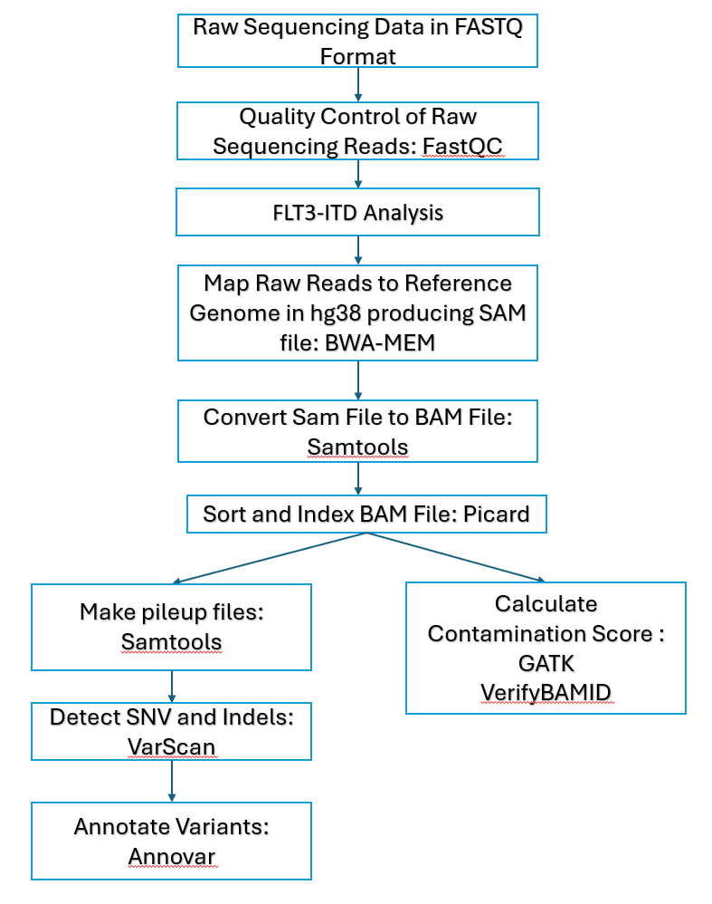

  - BUHR Data Processing:
    - Start Putty on a BUH computer to open a Terminal
    - In the Terminal window:
      - Type the IP address for the Linux server, lsmplinux3 (10.37.28.238) on the “Host Name (or IP address)” window.
      - Enter your username/password.
      - Type “cd /nextseq/Heme_Directory/”
      - Type “nohup sh Heme_Analysis.sh”
        - Heme_Analysis.sh is intended to run multiple shell scripts described below:
          - start_code_heme.sh
            - This shell script runs the ListDetect_Fusion_server3.pl script and creates designated folders for each data type (i.e. BAM files). This script also creates shell scripts for each individual Heme sample to analyze the data for each sample.
          - final_code_heme.sh
            - This script moves all designated files in the heme directory into the designated run folder
          - Heme_QC.sh
            - This script runs QC analysis on the BAM files. The script outputs two files: Avg_Coverage_Score_Samples_Heme.xlsx and Seq_QC_Metrics.xlsx in QC_Results Directory. The QC_results are transferred to the Run_Directory run folder after completion.
          - Parsing_Custom_Filtering_scripts.sh
            - This script parses the whole genome annotated files and generates a file of variants within our filtered specifications. The filtered files are automatically transferred into the run folder after completion.
  - Transfer BUHR Results to Run Directory:
    - Open WinSCP on a BUH computer.
    - Enter 10.37.28.238 in Host name window.
    - Enter the appropriate username and password.
    - Click Login. The program will display two windows.
    - In the left window, navigate to G:\CMB_Tests\Year\Month\[Date]-hemelibprp-1/ in the RICMBLAB$ drive.
    - In the right window, navigate to the /nextseq/Heme_Directory/ folder on the lsmplinux3 server.
    - Highlight the Run_Files Directory and drag to the G:\CMB_Tests\Year\Month\[Date]-hemelibprp-1/.
    - After transfer is complete, please remove Run_Files Directory from the lsmplinux3 server.
    - In G:\CMB_Tests\Year\Month\[Date]-hemelibprp-1, rename the Run_Files as [Date]-hemelibprp-1-HEME_Reporter
  - Transfer Graph and Case List Files:
    - Open WinSCP on a BUH computer.
    - Enter 10.37.28.238 in Host name window.
    - Enter credentials.
    - Click Login.
    - In the left window, navigate G:\Bioinformatics\MolDB\ Case_List_Heme.
    - On the right side, go to /nextseq/Heme_Data_Process/Comparison_Custom_Filtering/Custom_Filtering/Case_List_Heme.
    - Select all xlsx files on the right side.
    - Drag xlsx files into the G:\Bioinformatics\MolDB\Case_List_Heme
    - After Files are completed, On the left window, navigate G:\Bioinformatics\MolDB\Graph_Files_Heme.
    - On the right side, go to /nextseq/Heme_Data_Process/Comparison_Custom_Filtering/Custom_Filtering /Graph_Files_Heme.
    - Select all PNG files on the right side.
    - Drag PNG files into the G:\Bioinformatics\MolDB\ Graph_Files_Heme.
    - After Transfer is complete, Proceed to the next Step.
  - Brown University Health Variant Review Tool (BUHVRT):
    - The BUHVRT consists of several scripts to aid in variant review and combine results from Sophia DDM and the BUHR Pipeline.
      - The BUHVRT consists of 6 modules:
        - SoftMolecular Import File Module:
          - The SoftMolecular import file module contains the shell script, Soft_import_files.sh, which generates summary files containing variant, QC, and FLT3-ITD data from Sophia DDM and the BUHR pipeline.
          - Files generated in this module will be uploaded to SoftMolecular.
        - RefSeq ID Check Module:
          - This module consists of python scripts, mane_select_match_variant_list.py and mane_select_match_reporter.py, which compares RefSeq IDs for variants generated by Sophia DDM to the MANE select ID for each transcript to aid in variant reporting.
        - CNV Generation Module:
          - The CNV module consists of a single shell script, CNV_Generation.sh, which generates a CNV VCF file per sample along with a diagram and scatterplot of the CNV results.
        - Returned Patient Status Module:
          - The Returned Patients module is used to check the returning patient status of all patient samples for the current run to aid in variant reporting.
          - This module utilizes two in-house databases and requires a sample log to be filled out with sample IDs and MRN numbers
          - This module contains 4 python scripts run in two parts:
            - The traceback_variant_list.py and Return_patient.py scripts are run using the variant lists generated by Sophia DDM. The scripts generate a list of variants for returning patients as well as frequency graphs for the reported variants from each returning patient.
            - The traceback_reported_Variant.py and Combined_variant.py scripts are run after the reported variant lists from Sophia DDM are available and generates a list of reported variants for all returning patients as well as a combined list of non-reported and reported variants per returning patient.
        - Comparison File Generation Module:
          - The Comparison File module contains a shell script, Comparison_Filtering_Script_v2.sh, to compare and filter variants from Sophia DDM and BUHR pipeline.
        - Contamination Score Module:
          - Two open-source programs; GATK and VerifyBAM are used to calculate contamination score.
          - This module consists of a single shell script, Full_Contamation_Score_generation.sh, that is used to run GATK and VerifyBAM programs on the sample and control BAM files.
    - Sophia DDM file Download
      - Navigate to G:\CMB_Tests\Year\Month\[Date]-hemelibprp-1 in the RICMBLAB$ drive on a BUH computer.
      - Create folders and name “Sophia_Results” and “Soft_Import_Results”
      - In the Sophia_Results Directory, create the following sub folder listed below:
        - BAM_Files
        - QC_Reports
        - VCF_Files
        - Variant_Files
          - Reported_Variants
            - This is a sub folder which includes the variant lists marked as reported on SOPHiA DDM.
        - When Sophia Results are ready, open SOPHiA-DDM-v4 software and enter credentials.
        - Select the run under SOPHiA-DDM-v4 “My Runs”.

Figure 13. SOPHiA-DDM-v4 My Runs Section
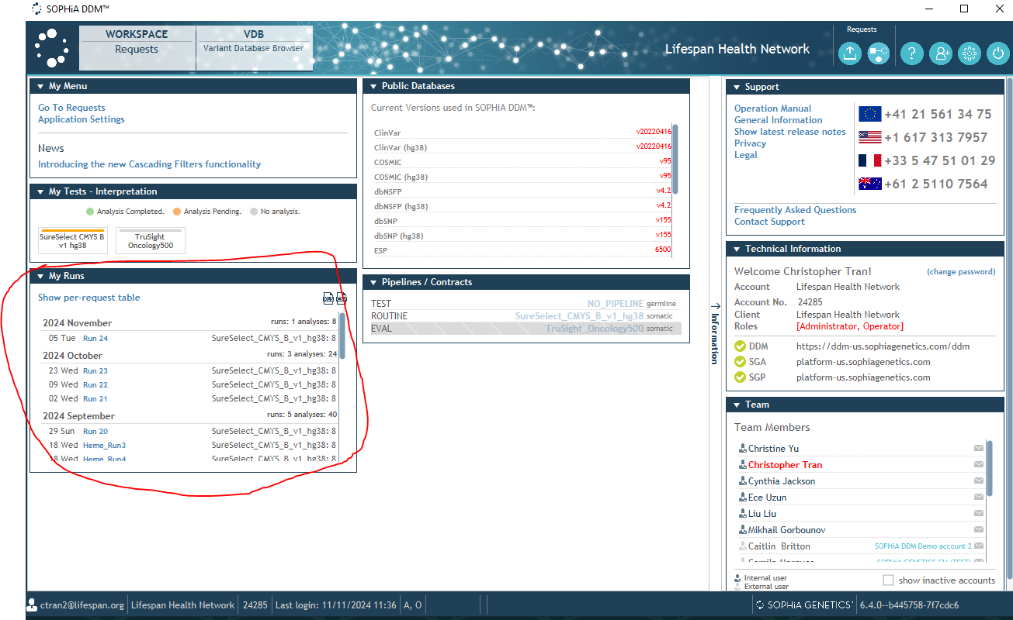
        - When inside, locate “My Files” window.
        - Select the run with the current run date

Figure 14. SOPHiA-DDM-v4 File Download location
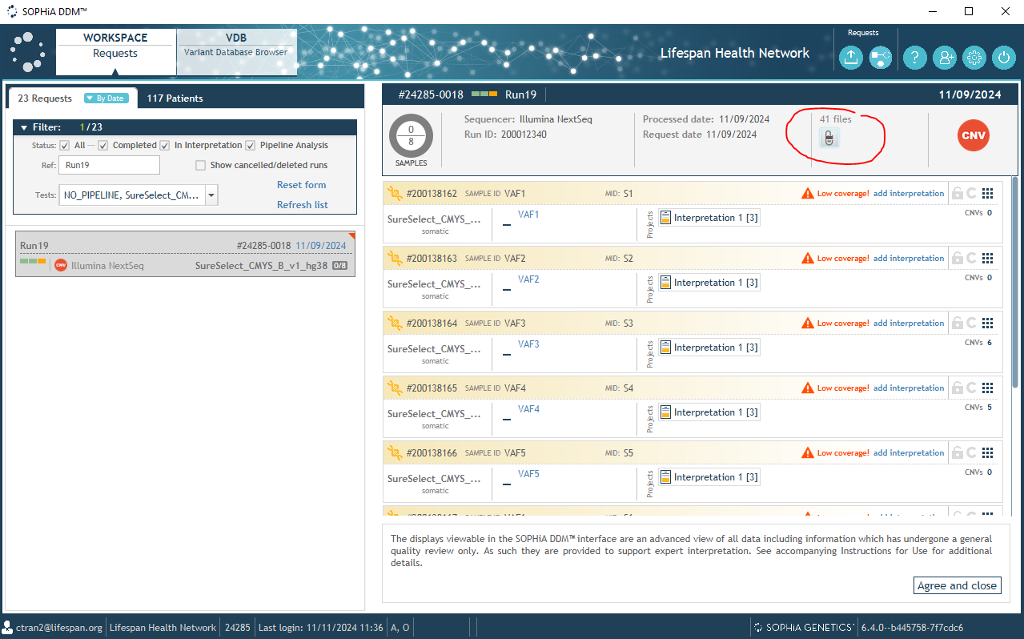
        - Clicking on the paperclip icon circled in red in figure 14 above will show a list of downloadable files

Figure 15. SOPHiA-DDM-v4 File Lists
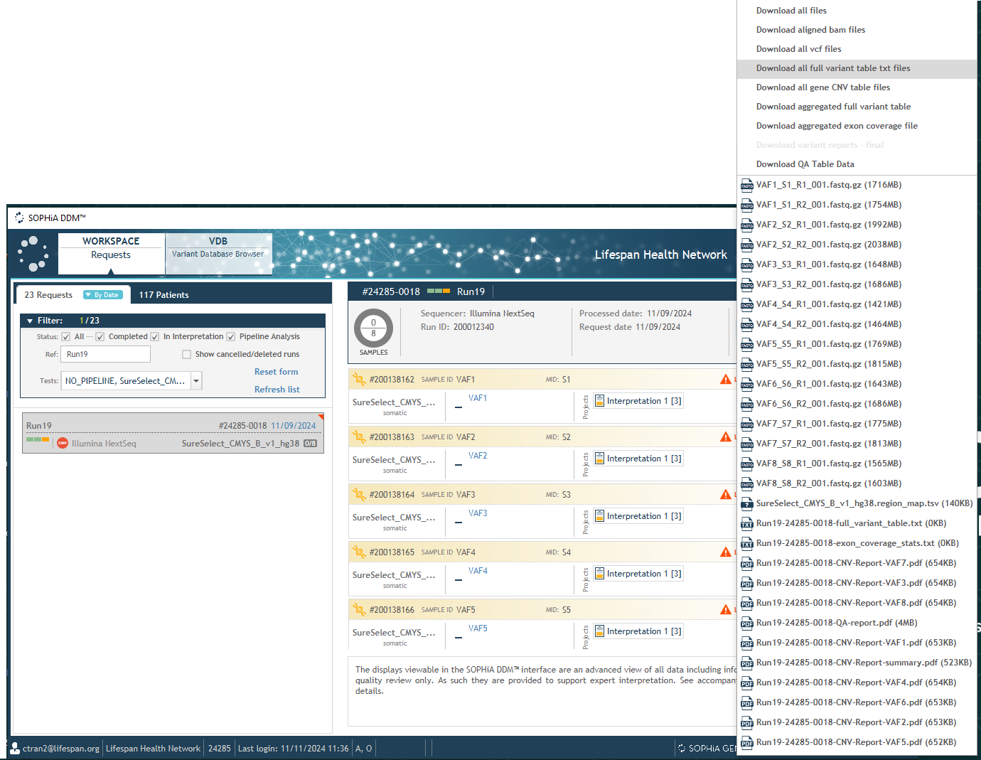
        - Download the following files into the designated [Run Date]-hemelibprp-1\Sophia_Results sub-directories below:
          - BAM_Files
            - Aligned BAM Files ([sample name].bam and .bai Files)
          - QC_Reports
            - [RunID]-Exon Coverage stat.txt
            - QA table data
            - [RunID]-QA-report.pdf
          - Variant_Files
            - [RunID] Full Variant table.txt
          - VCF_Files
            - VCF Files
        - After the download is completed, click on the interpretation tab on the first sample.

Figure 16. SOPHiA-DDM-v4 Sample Interpretation tab
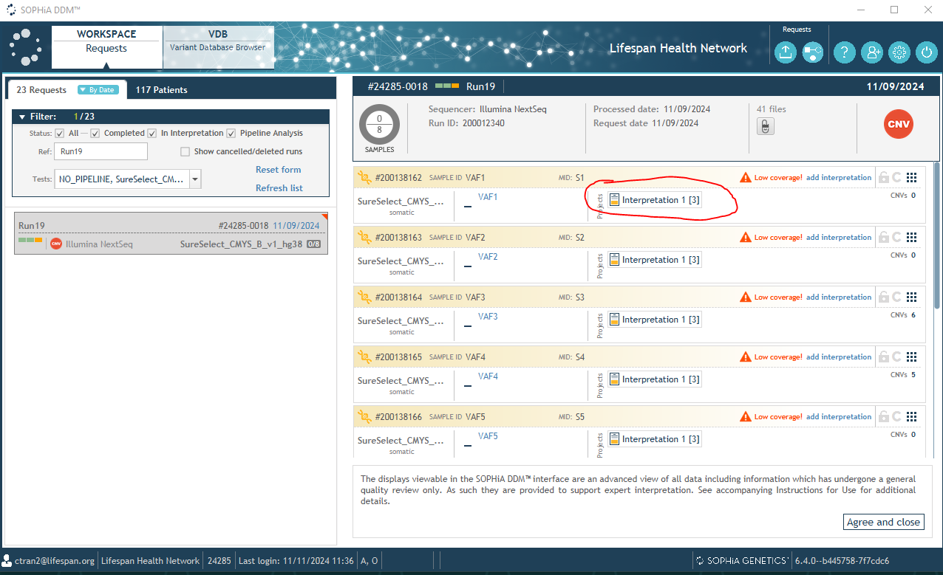
        - Click on “Variants” tab.

Figure 17. SOPHiA-DDM-v4 Variant Tab
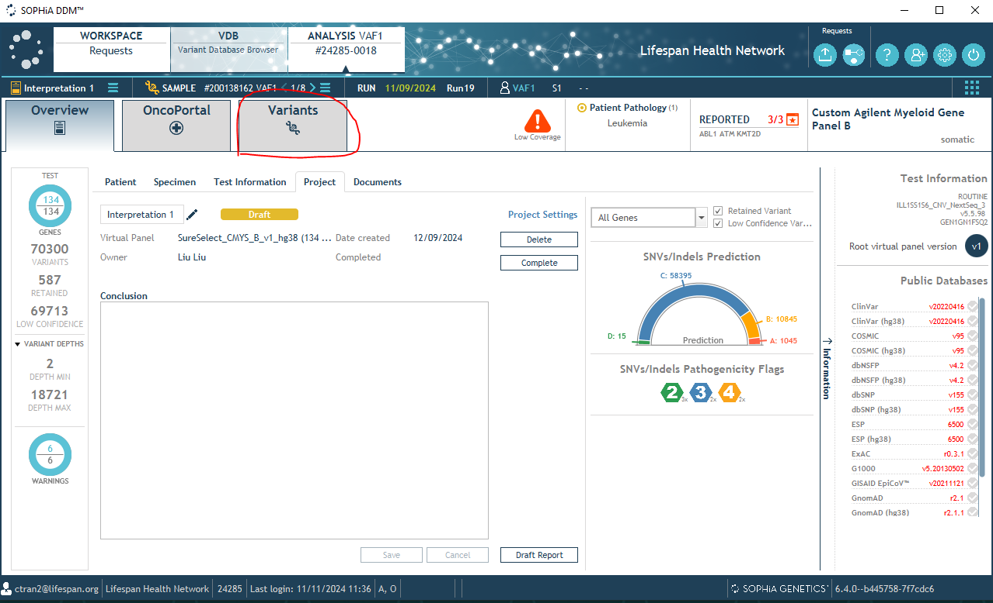
        - On the right side, click on the “csv file” icon to download [SampleID]-Variant-list.csv file
          - [SampleID]-Variant-list.csv should be downloaded on BUH computer directly as Sophia DDM gives an error if the file is directly downloaded to the network drive.
          - [SampleID]-Variant-list.csv should be copied from BUH computer to G:\CMB_Tests\[YYYY] tests\[MM-YYYY]\[MM.DD.YY]-hemelibprp-1/Sophia_Results/Variant_Files

Figure 18. SOPHiA-DDM-v4 Variant File Download
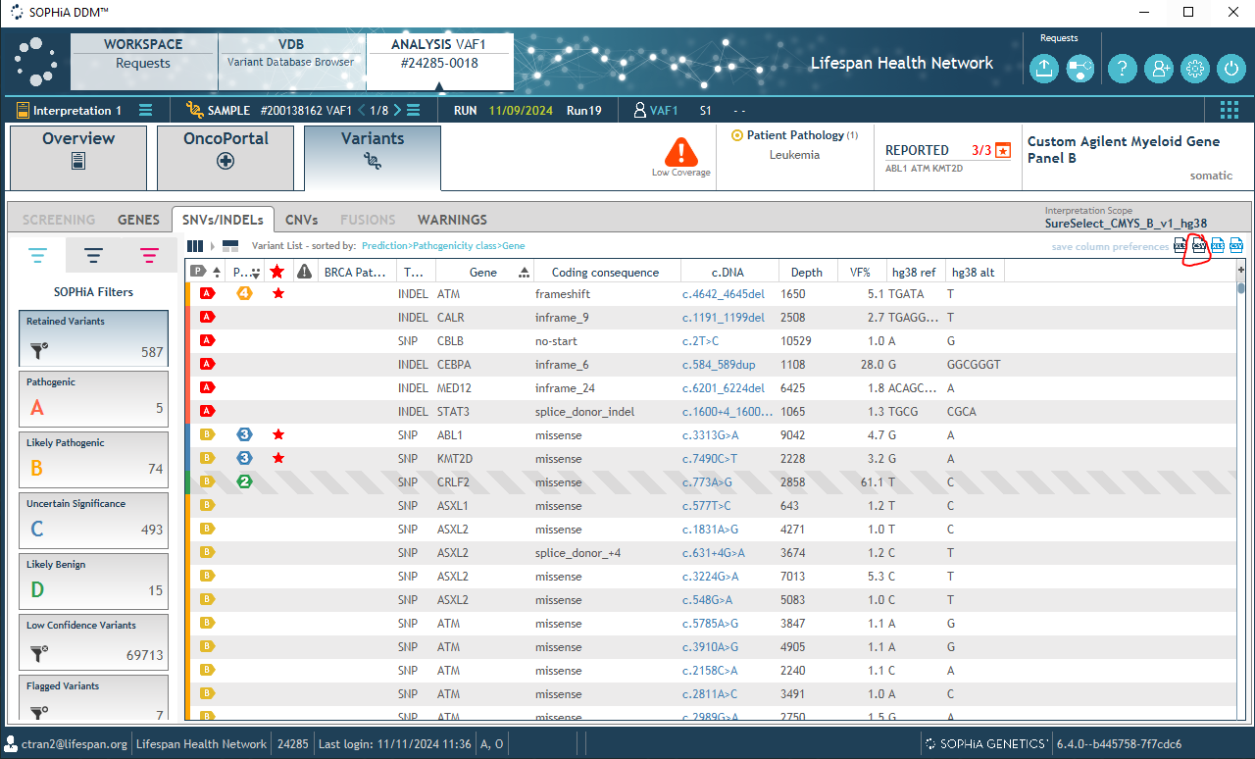
        - click on the “REPORTED” Icon.

Figure 19. SOPHiA-DDM-v4 Reported Variant
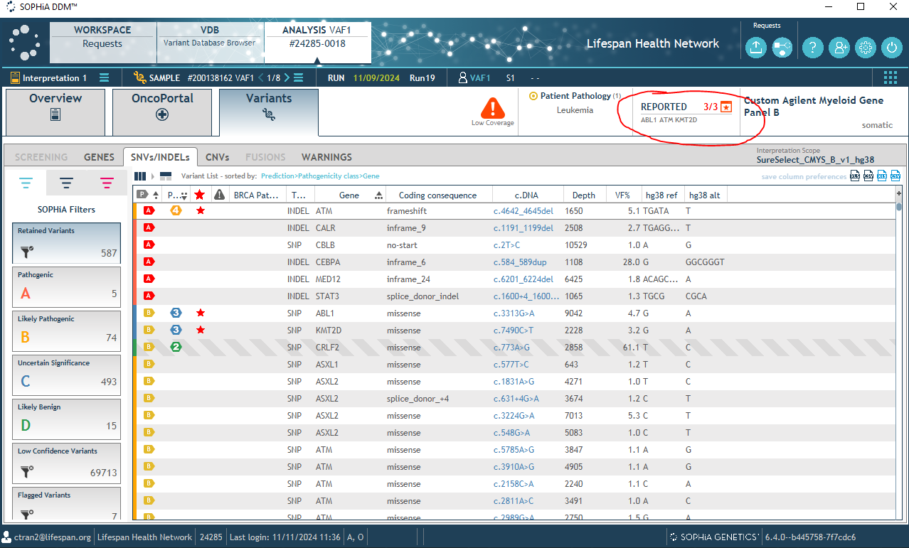
          - A Reported Variants pop up box will appear. Click on the XLS icon to download the [SampleID]-reported-variants.xlsx file to the BUH computer
          - After downloading, copy the files from the BUH computer into the /Sophia_Results/Variant_Files /Reported_Variants location.

Figure 20. SOPHiA-DDM-v4 Reported Variant Download
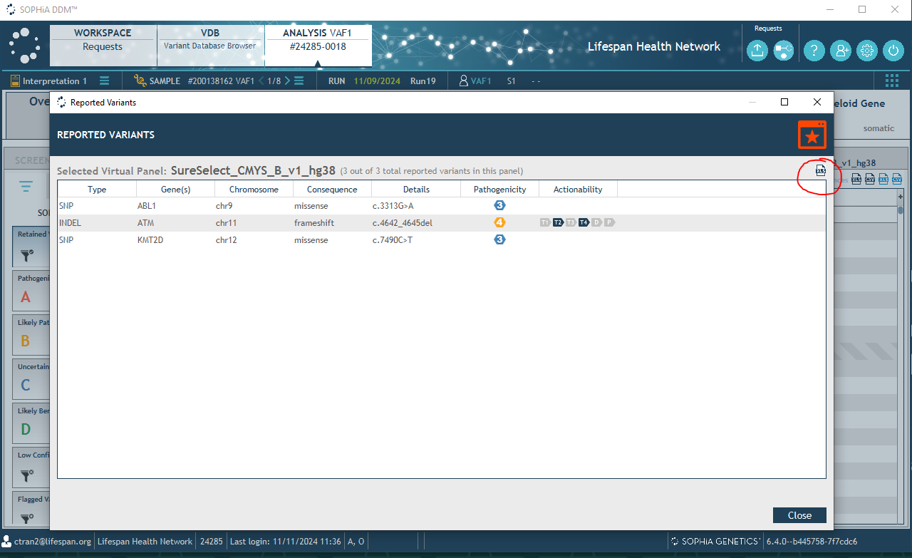
        - To move to the next sample, click on the arrow next to SAMPLE [Sample ID]
        - Repeat the steps D.xii-xiv. to download the variant list and variant report for all samples in the run.

Figure 21. SOPHiA-DDM-v4 move to next sample
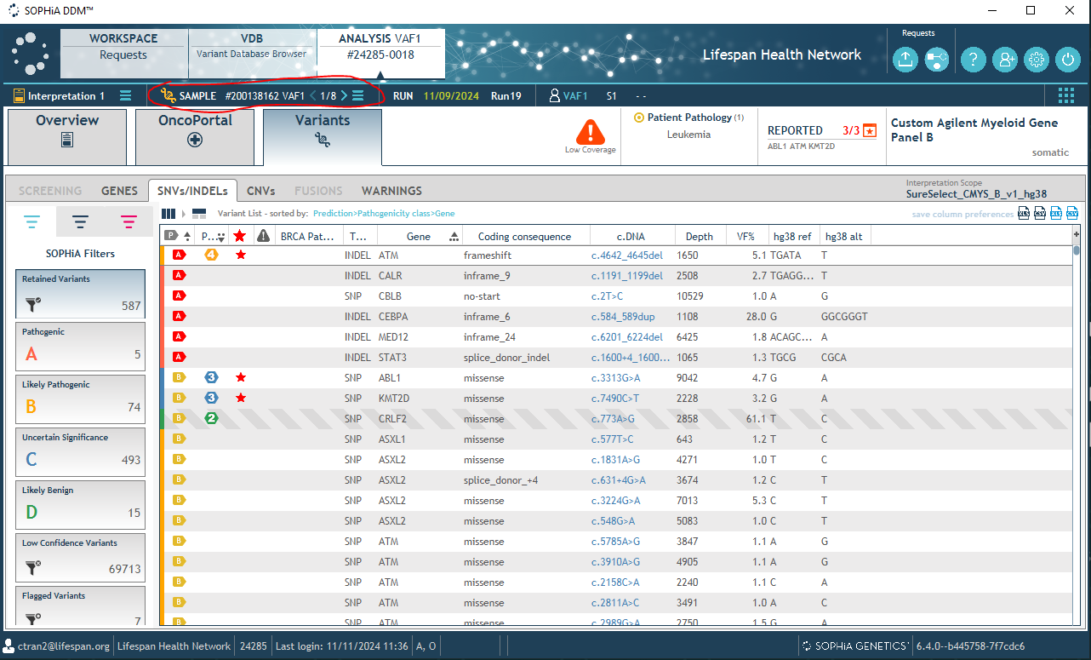

    - SoftMolecular Import File Generation on lsmplinux3 (10.37.28.238):
      - Open WinSCP on a BUH computer.
      - Enter 10.37.28.238 in Host name window.
      - Enter the appropriate username and password.
      - Click Login. The program will display two windows.
      - In the left window, navigate to the run folder on the RICMBLAB$ drive.
      - In the right window, navigate to the /nextseq/Heme_Data_Process/Soft_Import/Input_Files / folder on the lsmplinux3 server.
      - Highlight and drag the following files from [Date]-hemelibprp-1\Sophia_Results Folder to /nextseq/Heme_Data_Process/Soft_Import/Input_Files:
        - [SampleID]-reported-variants.xlsx
        - target-region-coverage-table-SureSelect_CMYS_B_v1_hg38.csv
        - read-counts-overview-table.csv
        - ontarget-mapping-statistics-table-SureSelect_CMYS_B_v1_hg38.csv
        - [RunID]-Exon Coverage stat.txt
        - FLT3-ITD files will be automatically copied from the run_directory to /nextseq/Heme_Data_Process/Soft_Import/Input_Files.
        - If the files are not in the directory, highlight and drag the following files from G:\CMB_Tests\Year\Month\[Date]-hemelibprp-1 \[Date]-hemelibprp-1_HEME_Reporter\FLT3 :
          - [SampleID]_trimmed_FLT3_ITD_none.vcf
          - [SampleID]__trimmed_FLT3_other_summary.txt
          - [SampleID]__trimmed_FLT3_ITD.vcf
          - [SampleID]__FLT3_ITD_summary.txt
      - On a BUH computer, open Putty.
      - Type 10.37.28.238 in Host name (or IP address) window.
        - This is the IP address for lsmplinux3.
      - In the Terminal:
        - Enter username/password.
        - Type “cd /nextseq/Heme_Data_Process/Soft_Import/Soft_import_Code”
          - All scripts under this directory are part of BUHVRT pipeline
        - Type “sh Soft_import_files.sh”
          - This script generates all the SoftMol input files needed to report each sample
          - Files are generated under: /nextseq/Heme_Data_Process/Soft_Import/Soft_Import_Results
      - When script is complete, transfer the following files listed below to G:\CMB_Tests\Year\Month\[Date]-hemelibprp-1\ in the designated directories on the RICMBLAB$ drive using WinSCP
        - Soft_Import_Results
          - Low_Coverage_Regions_Summary.xlsx
          - merged_FLT3_ITD_VCF.xlsx
          - QC_Summary.xlsx
          - Reported_Variants_Summary.xlsx
        - Sophia_Results
          - Low_Coverage_Regions_Summary_Extended.xlsx
        - \[Date]-hemelibprp-1_HEME_Reporter\FLT3
          - merged_FLT3_other_summary.xlsx
      - If samples review is performed in batches proceed with the following below, otherwise proceed to Step XIX.E:
        - Repeat step D.xiv to download the reported variant files for the remaining samples.
          - Open WinSCP on a BUH computer.
          - Enter 10.37.28.238 in Host name window.
          - Enter the appropriate username and password.
          - Click Login.
          - In the left window, navigate to the run folder on the RICMBLAB$ drive.
          - In the right window, navigate to the /nextseq/Heme_Data_Process/Soft_Import/Input_Files/ folder on the lsmplinux3 server.
          - Remove the previously run reported variant files from the /nextseq/Heme_Data_Process/Soft_Import/Input_Files/ folder on the lsmplinux3 server
          - Highlight and drag the following files from G:\CMB_Tests\Year\Month\[Date]-hemelibprp-1\ Sophia_Results\ Variant_Files\Reported_Variants to /nextseq/Heme_Data_Process/Soft_Import/Input_Files:
            - [SampleID]-Reported-variants
            - NOTE: ensure no previously run reported files are in the input file directory
          - On a BUH computer, open Putty.
          - Type 10.37.28.238 in Host name (or IP address) window.
            - This is the IP address for lsmplinux3.
          - In the Terminal:
            - Enter username/password.
            - Type “cd /nextseq/Heme_Data_Process/Soft_Import/Soft_import_Code/Scripts/”
              - All scripts under this directory are part of Brown University Health Variant Review Tool (BUHVRT)
            - Type “python3 Full_Reported_Variant_Summary.py”
          - When script is complete, a Reported_Variants_Summary.xlsx is generated in the /nextseq/Heme_Data_Process/Soft_Import/Soft_Import_Results.
          - In WinSCP, rename the Reported_Variants_Summary.xlsx to Reported_Variants_Summary_Additional.xlsx
          - Transfer the Reported_Variants_Summary_Additional.xlsx file from /nextseq/Heme_Data_Process/Soft_Import/Soft_Import_Results into G:\CMB_Tests\Year\Month\[Date]-hemelibprp-1\ Soft_Import_Results
  - RefSeq ID Check
    - Open WinSCP on a BUH computer.
    - Enter 10.37.28.238 in Host name window.
    - Enter the appropriate username and password.
    - Click Login.
    - In the left window, navigate to G:\CMB_Tests\Year\Month\[Date]-hemelibprp-1\Sophia_Results on the RICMBLAB$ drive.
    - In the right window, navigate to the /nextseq/Heme_Data_Process/MANE_select_comparison/Input/ folder on the lsmplinux3 server.
    - Highlight and drag the following files from G:\CMB_Tests\Year\Month\[Date]-hemelibprp-1\Sophia_Results\Variant_files into /nextseq/Heme_Data_Process/MANE_select_comparison/Input/:
      - [SampleID]-Variant-list.csv
    - Highlight and drag the following files from G:\CMB_Tests\Year\Month\[Date]-hemelibprp-1\Sophia_Results\Variant_files\Reported_Variants\ to /nextseq/Heme_Data_Process/MANE_select_comparison/Input:
      - Reported_Variants_Summary.xlsx
    - On a BUH computer, open Putty.
    - Type 10.37.28.238 in Host name (or IP address) window.
      - This is the IP address for lsmplinux3.
    - In the Terminal:
      - Enter username/password.
      - Type “/nextseq/Heme_Data_Process/MANE_select_comparison/Scripts”
      - Type “python3 mane_select_match_variant_list.py”
        - This script generates a per sample list ([Sample_Name]-variant-list_maneselect_match.csv) containing all variants with a column denoting whether the RefSeq ID reported from Sophia matches the MANE select ID for that transcript.
        - This script also generates a csv file (nonmatching_mane_refseq_ids.csv) that contains list of variants where the RefSeq ID does not match the MANE select transcript for each sample.
        - Files are generated under /nextseq/Heme_Data_Process/Mane_select_comparison/MANE_Select_Results
      - After processing the full variant list, generate the RefSeqID_Check.csv file for the reported variant lists:
        - Type “cd /nextseq/Heme_Data_Process/MANE_select_comparison/Scripts”
        - Type “python3 mane_select_match_reporter.py”
          - This script generates a single report for all samples (RefSeqID_Check.csv) containing the reported variants only with a column denoting whether the RefSeq ID reported from Sophia matches the MANE select ID.
    - Once the script is complete, transfer the MANE_Select_Results directory into G:\CMB_Tests\Year\Month\[Date]-hemelibprp-1 \ on the RICMBLAB$ drive using WinSCP.
  - Copy Number Variant (CNV) Analysis
Note: CNV results are not included in the reports. The CNV analysis is done using an open-source program, CNVKit to keep a record of potential CNVs in heme samples.
    - Open WinSCP on a BUH computer.
    - Enter 10.37.28.238 in Host name window.
    - Enter the appropriate username and password.
    - Click Login. The program will display two windows.
    - In the left window, navigate to G:\CMB_Tests\Year\Month\[Date]-hemelibprp-1\Sophia_Results on the RICMBLAB$ drive.
    - In the right window, navigate to the /nextseq/Heme_Directory/CNV/Input_Files/ folder on the lsmplinux3 server.
    - The input directory should already contain BAM files for each sample. In the event the BAM files are not transferred:
      - Highlight and drag the following files from G:\CMB_Tests\Year\Month\[Date]-hemelibprp-1\[Date]--hemelibprp-1-HEME_Reporter\BAM_Files to /nextseq/Heme_Directory/CNV/Input_Files/Input_files:
        - [SampleID]_trimmed.aligned.dedup.sorted.bam
        - [SampleID]_trimmed.aligned.dedup.sorted.bai
    - On a BUH computer, open Putty.
    - Type 10.37.28.238 in Host name (or IP address) window.
      - This is the IP address for lsmplinux3.
    - In the Terminal:
      - Enter username/password.
      - Type “cd /nextseq/Heme_Directory/CNV”
      - Type “nohup sh CNV_Generation.sh”
        - This script generates a CNV VCF file and a diagram and scatterplot of the CNV results for each sample.
    - When script is complete, transfer the CNV_Results directory into G:\CMB_Tests\Year\Month\[Date]-hemelibprp-1\[Date]-hemelibprp-1-HEME_Reporter on the RICMBLAB$ drive using WinSCP .
  - Returned Patient Samples
    - Open WinSCP on a BUH computer.
    - Enter 10.37.28.238 in Host name window.
    - Enter the appropriate username and password.
    - Click Login. The program will display two windows.
    - In the left window, navigate to G:\CMB_Tests\Year\Month\[Date]-hemelibprp-1\Sophia_Results\Variant_files on the RICMBLAB$ drive.
    - In the right window, navigate to the /nextseq/Heme_Data_Process/Returned_Patients/Input_files folder on the lsmplinux3 server.
    - Highlight and drag the following files from G:\CMB_Tests\Year\Month\[Date]-hemelibprp-1\Sophia_Results\Variant_files to /nextseq/Heme_Data_Process/Returned_Patients/Input_files:
      - [SampleID]-Variant-list.csv
    - Copy the Sample_log.xslx file from the previous run directory and place in G: drive run folder
        - The sample log needs to be filled in prior to running the returned patient scripts using the MTW_[Date]-HEMENORMLD-1 file located in G:\CMB_Tests\Year\Month\[Date]-hemelibprp-1
        - Open both Sample_log.xlsx and MTW_[Date]-HEMENORMLD-1 file.
        - Sample Log will have three columns.
        - In the MTW_[Date]-HEMENORMLD-1 file copy and paste the Sample ID and MRN column to Sample_ID and MRN_Number Column.
          - When complete, copy the Sample_log.xlsx file into /nextseq/Heme_Data_Process/Returned_Patients/Input_files
    - On a BUH computer, open Putty.
    - Type 10.37.28.238 in Host name (or IP address) window.
      - This is the IP address for lsmplinux3.
    - In the Terminal:
      - Enter username/password.
      - Type “cd /nextseq/Heme_Data_Process/Returned_Patients/Scripts/Python_Scripts”
        - Type “python3 traceback_variant_list.py”
          - This will generate the traceback variant list
        - Type “python3 Return_patient.py --search”
          - This script generates frequency graphs for reported variants for returning patients.
          - This script contains prompts that may require the user to copy previously generated reported variant lists into: /nextseq/Heme_Data_Process/Returned_Patients/Returned_Patient_Input
      - Once all variants have been reported add the [SampleID]-reported_variants.xlsx files into /nextseq/Heme_Data_Process/Returned_Patients/Input_files using winscp
      - On a BUH computer, open Putty.
      - Type 10.37.28.238 in Host name (or IP address) window.
        - This is the IP address for lsmplinux3.
      - In the Terminal:
        - Enter username/password.
        - Type “cd /nextseq/Heme_Data_Process/Returned_Patients/Scripts/Python_Scripts”
        - Type “python3 traceback_reported_Variant.py”
          - This generates a list of variants for returning patients from the list of reported variants only.
          - Type “python3 Combined_variant.py”
          - This combines the variants for returning patients from both the full variant lists and the reported variant lists.
    - When script is complete, transfer the Returned_Patients directory folder G:\CMB_Tests\Year\Month\[Date]-hemelibprp-1 \ on the RICMBLAB$ drive using WinSCP.

Compare the Returned Patient Results to SoftMol Results:
      - Once the traceback is complete, open SoftMol and select the “Query Results” tab under “Processing”
Figure 22.SoftMol Sample Query Results
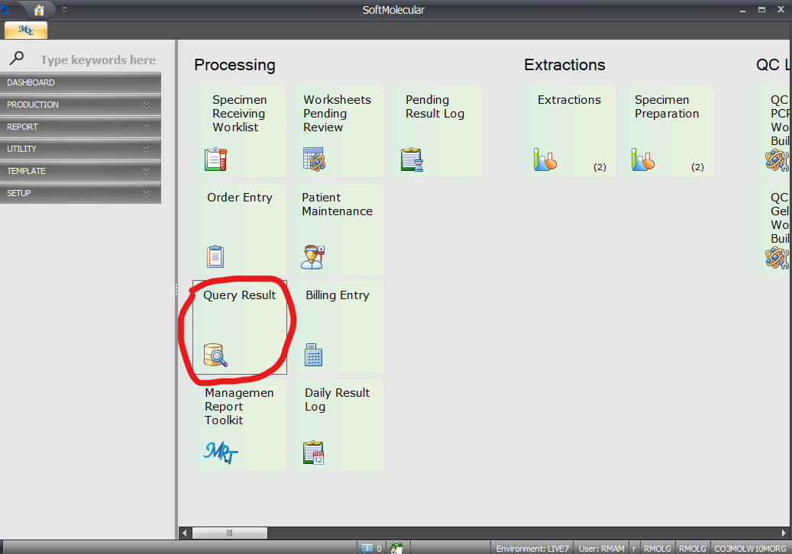

      - Select the “Simple Search” option in the Query Results tab

Figure 23. SoftMol Simple Search
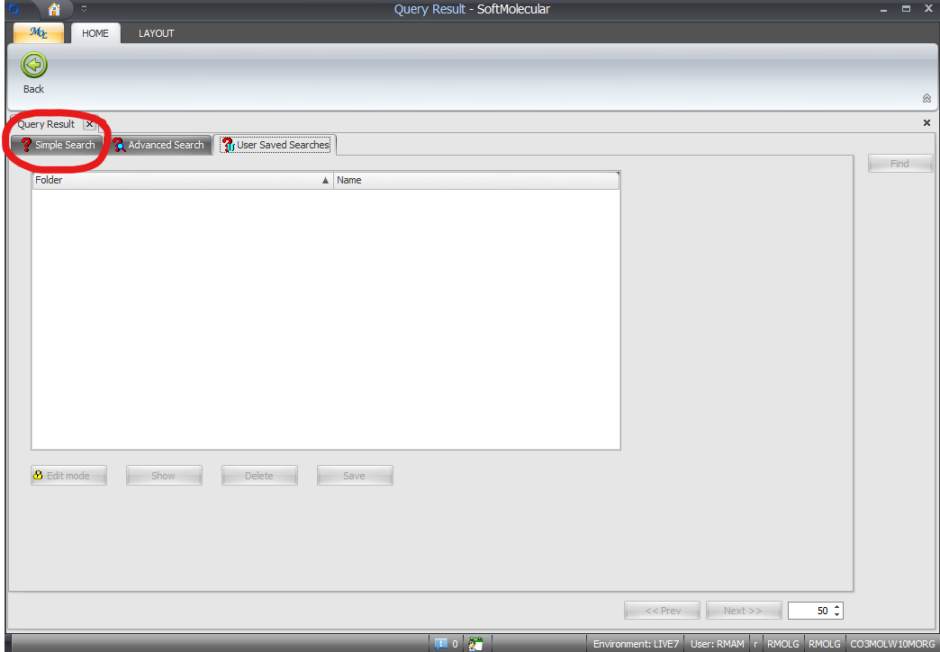
      - Open the Heme clinical log located at: G:\CMB_Database_USE THIS\NGS_CaseLogs\ Heme_clinical_log
      - Complete the following steps for all MOL samples:
        - Copy the MRN number from column B in the heme clinical log and paste into the MRN search bar in SoftMol, click “find”

Figure 24. SoftMol MRN Search
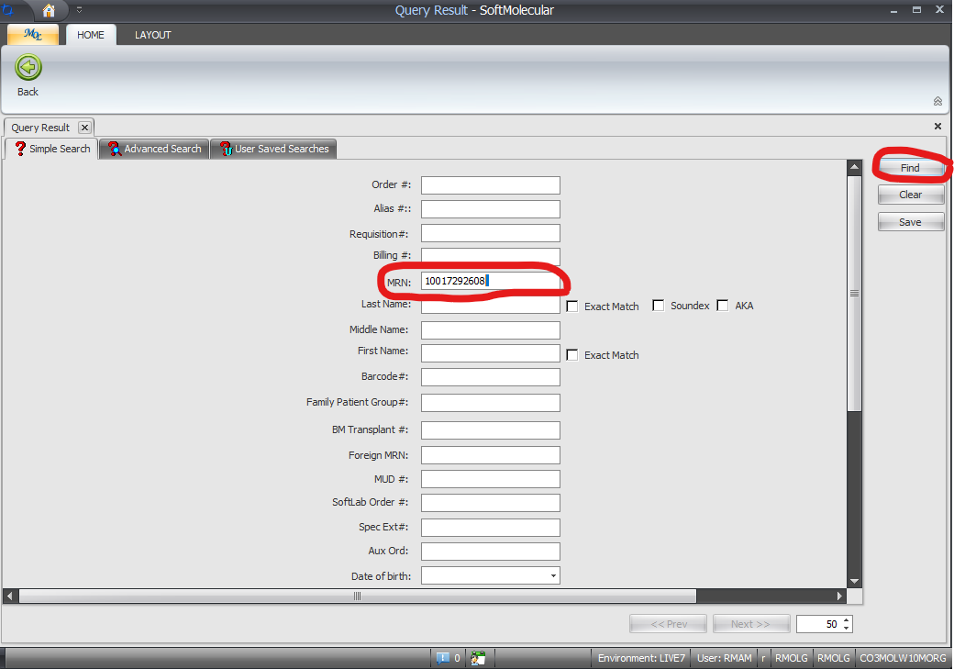
        - Any previous tests for that patient will be returned, check the column labeled “Tests” for any previous tests labeled “HEMBM/L” for that sample

Figure 25.Sample Query Results
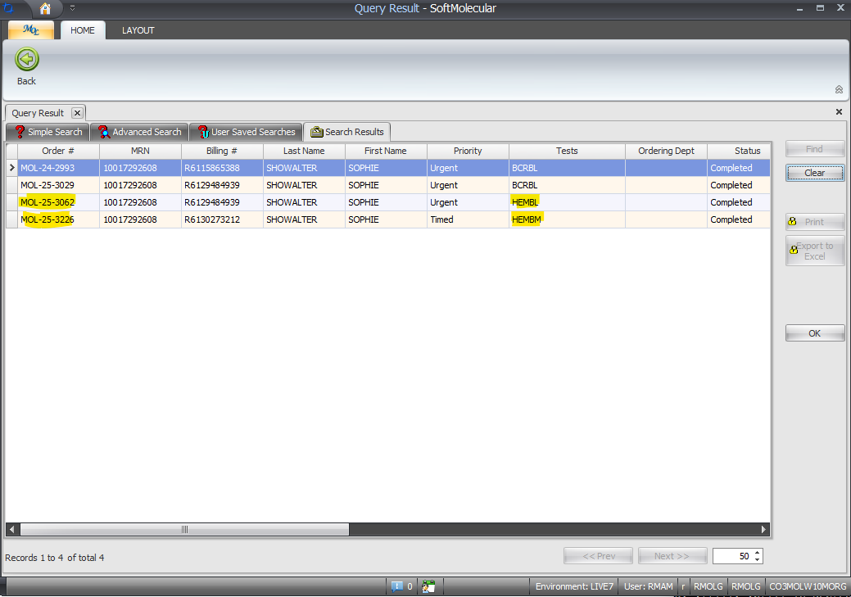
        - If previous heme tests are reported, enter the previously assigned MOL number from the “Order #” column in SoftMol in the heme clinical log in column J labeled “Returned Patient” in the format “Yes MOL-XX-XXX”
        - If no previous heme tests are reported, write “No” in column J in the heme clinical log

  - Comparison File Generation:
    - Comparison File Specifications:
      - These steps compare the custom-made pipeline results with the SOPHiA DDM results and generates filtered files based on the following criteria:
        - Variants are filtered based on the following criteria:
          - Synonymous variants
          - Variants with gnomad40 allele frequency below 1%
          - Variants which are not covered by the assay (Coverage file: 3450291_Covered_Coord_Edited.tsv).
          - Depth of coverage < 200, and an allele frequency < 5%.
    - Open WinSCP on a BUH computer.
    - Enter 10.37.28.238 in Host name window.
    - Enter the appropriate username and password.
    - Click Login. The program will display two windows.
    - In the left window, navigate to the run folder on the RICMBLAB$ drive.
    - In the right window, navigate to the /nextseq/Heme_Data_Process/Comparison_Custom_Filtering/Comparison_Filtering/input_Files
    - Highlight and drag the following files from G:\CMB_Tests\Year\Month\[Date]-hemelibprp-1 \Sophia_Results\Variant_Files to /nextseq/Heme_Data_Process/Comparison_Custom_Filtering/Comparison_Filtering/input_Files:
      - [SampleID]-Variant-list.csv
    - On a BUH computer, open Putty.
    - Type 10.37.28.238 in Host name (or IP address) window.
      - This is the IP address for lsmplinux3.
    - In the Terminal:
      - Enter username/password.
      - Type “cd /nextseq/Heme_Data_Process/Comparison_Custom_Filtering/Filtering_Code”
      - Type “nohup sh Comparison_Filtering_Script_v2.sh”
        - This script generates files that compare the custom Annotated Variant files and Sophia Variant files. The script also filters out variants under the metric specifications mentioned above. The files being compared to are listed below:
          - [SampleID]-Variant-list.csv
          - Final_Parsed_[SampleID]_SNP_INDEL_list.tsv
            - This file is generated within the pipeline and is automatically copied into: /nextseq/Heme_Data_Process/Comparison_Custom_Filtering/Comparison_Filtering/Input_Files
    - When Script is complete, transfer the Comparison_Files directory into [Run Date]-hemelibprp-1\[Run Date]-hemelibprp-1-HEME_Reporter\Filtered_Results Folder in the RICMBLAB$ drive using WinSCP.
  - Cleaning Directory After Analysis:
    - Open Putty on a BUH computer.
    - Type 10.37.28.238 in Host name (or IP address) window.
      - This is the IP address for lsmplinux3.
    - In the Terminal:
      - Enter username/password.
      - Type “cd /nextseq/Heme_Data_Process/sh_scripts”
      - Type “sh heme_clean_post_analysis.sh”
        - This script cleans the run directories after analysis is completed
  - Contamination Score Calculation:
    - Contamination score is not included in the reports, but used as part of the QC. Contamination score is reviewed by Lab Director or Pathologist. Any indication of contamination in the samples is further investigated.
    - Two open-source programs; GATK and VerifyBAM are used to calculate contamination score.
    - Open WinSCP on a BUH computer.
    - Enter 10.217.75.24 in Host name window.
    - Enter the username and password.
    - Click Login
    - In the left window, navigate to the G:\CMB_Tests\Year\Month\[Date]-hemelibprp-1\[Date]-hemelibprp-1_HEME_Reporter\BAM_Files on the RICMBLAB$ drive.
    - In the right window, navigate to the /molpath/Contamination_Summary/BamFiles Highlight and drag the BAM files from run folder/BAM_Files to /molpath/Contamination_Summary/BamFiles
    - On a BUH Windows computer, open Putty.
    - Type 10.217.75.24 in Host name (or IP address) window.
      - This is the IP address for lsmplinux1.
    - Enter username/password.
    - Type in the terminal “cd /molpath/Contamination_Summary/Scripts”
    - Type in the terminal “sh Full_Contamation_Score_generation.sh”
      - This script generates the contamination score for all samples in the run run using GATK and VerifyBAM
    - When script is complete, transfer the Contamination_Score directory in the/molpath/Contamination_Summary into the \[Date]-hemelibprp-1\[Date]-hemelibprp-1_HEME_Reporter directory folder using WinSCP
    - Open WinSCP on a BUH computer.
    - Enter 10.217.75.24 in Host name window.
    - Enter the appropriate username and password.
    - Click Login. The program will display two windows.
    - In the left window, navigate to the G:\CMB_Tests\Year\Month\[Date]-hemelibprp-1\[Date]-hemelibprp-1_HEME_Reporter on the RICMBLAB$ drive.
    - In the right window, navigate to the /molpath/Contamination_Summary.
    - Highlight and drag the Contamination_Score folder to G:\CMB_Tests\Year\Month\[Date]-hemelibprp-1\[Date]-hemelibprp-1_HEME_Reporter to transfer.
    - After Transfer is complete, in the terminal type “sh clean_post_analysis.sh”
      - This Script cleans the directory.

- HEME BIOINFORMATICS: TASKLIST
  - These steps should be performed by a bioinformatician or other approved/designated personnel.
  - In Soft Molecular, open My Orders by using the icon on the dashboard.
  - Click on the Bioinformatician tab.
    - Click two times on tasklist number.
    - Click on No button.
  - In the tasklist, review the SAV Parameters for the run.
  - Import Low_Coverage_Regions_Summary.xlsx, merged_FLT3_ITD_VCF.xlsx, QC_Summary.xlsx, and Reported_Variants_Summary.xlsx.
  - In the tasklist, click the ‘…’ button to the right of the Import button.
  - Click OK.
  - Select the Excel radial button, choose the file path (directory and file name) for the Low_Coverage_Regions_Summary file, then click Import.
  - Repeat steps F-H for the merged_FLT3_ITD_VCF, Reported_Variants_Summary, and QC_Summary files.
  - Review variant summary calls.
    - For each variant, mark the checkboxes to indicate the pipelines which detected that variant.
  - Review QC Summary data for patient samples and controls by reviewing the “MeanCoverage” field at the child level.
  - Review Low Coverage Regions for all patient samples and controls. For any given sample, amplicons with <200x depth of coverage will be listed.
    - For patient samples, make sure that the ‘Print on Report’ box is checked for all Low Coverage Regions.
  - Review FLT3-ITD for all patient samples and controls.
  - Enter FastQC R1, and FastQC R2 results.
    - Note: This should be passed by the Bioinformatics Director
    - For each patient sample and control, enter the following information at the parent-level after reviewing FastQC results for all samples:
      - FastQC R1: pass or fail.
      - FastQC R2: pass or fail.
      - Enter any relevant notes for FastQC R1 and R2 in the note columns.
  - If any additional mutations were identified by secondary analysis:
    - Create a new Variant_Summary file and save with the name “Variant_Summary_Additional”.
    - Open the file in Excel. Keep the header row but delete all other existing data. Add data from the new variant call. Save the file and close.
  - Import Variant_Summary_Additional File.
    - In the tasklist, click the ‘…’ button to the right of the Import button.
    - Click OK.
      - Select the Excel radial button, choose the file path (directory and file name) for the Variant_Summary_Additional file, and click Import.
    - In the Comment box at the top of the tasklist, enter a comment indicating your findings.
    - For all samples, review the variants again.
    - For each variant, mark the checkboxes to indicate the pipelines which detected that variant.
  - Pass Controls
    - In the tasklist, locate the HEMENTC and HEMEPOSCTL
    - Locate the Heme NGS Final Results column
      - This column will be a drop down menu
    - Under the HEMENTC and HEMEPOSCTL samples, click the drop down menu and select pass.
    - HEMENTC and HEMEPOSCTL samples should reflect the image below:
Figure 26.Control pass for HEMENTC and HEMEPOSCTL samples
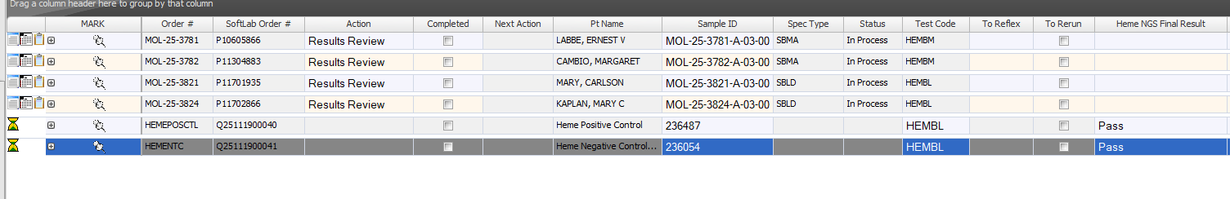
  - Once reviews are complete: for each patient sample, complete the HEME Bioinformatics action by marking the Completed checkbox.
  - When all patient samples are complete, select Save.
  - Select Back in the HEME Tasklist Entry window.
  - Exit Soft Molecular application.

- HEME PANEL RESULTS REVIEW: TASKLIST
  - These steps should be performed by a pathologist or director.
  - In Soft Molecular, open My Orders by using the icon on the dashboard.
    - Click on the Molecular Pathologist tab.
    - Click two times on tasklist number.
    - Click on No button.
  - In the tasklist, review the SAV Parameters (QC information) for the run.
    - Runs should ideally meet the following metrics. Those that do not meet the following metrics should be interpreted appropriately by the Director:
      - Q30 > 75% (percent of bases with at least Q30)
      - % Clusters PF (Passing Filter) > 80%
    - Additional metrics to review:
      - % aligned (ideally 2-7%, but may vary with run)
      - Cluster density (ideally 170-220k/mm2 per Illumina, but may vary with run)
    - If the runs fail any of these criteria, the Director/Pathologist may choose to repeat testing of all samples.
  - Review variant calls.
    - Review all variant calls for patient samples and controls by clicking the ‘+’ button to expand the child level results.
      - Variants are filtered out if they meet the following criteria:
        - Depth of coverage < 200
        - VAF < 1%
        - Synonymous variants
        - Intronic variants
      - In addition, SOPHiA provides the primary variant information, such as the genomic coordinates, VAF, etc.
      - Any variants with VAF between 1-5% should be reviewed for determination of inclusion in further steps (at the discretion of the Director/Pathologist).
      - Review the information provided for the variant to aid in annotation.
    - To request Sanger Sequencing confirmation:
      - Send an email to the NGS team requesting the confirmation including sample information, target mutation and appropriate primers.
  - Review QC Summary data for patient samples and controls by reviewing the “MeanCoverage” field at the child level.
  - Review Low Coverage Regions:
    - Review low coverage regions for all patient samples and controls. For any given sample, regions with <200x depth of coverage will be listed.
    - For patient samples, make sure that the ‘Print on Report’ box is checked for all failed amplicons.
    - For the NTC, all 133 targets should appear on this list. If there are less than 133 entries, open the SOPHiA Report Summary Excel file and review all amplicons in detail to determine the low coverage region(s).
  - Review Controls, as follows:
    - A previously tested patient sample is to be used for the weekly run control. Confirm the variants match with what was previously reported. A log of controls in use can be found on the control monitoring tab in the Index Code Log. G:\PCR_Worksheets_Current\Heme Panel Files
      - If no mutations are identified or if additional variants are identified, determine if all clinical samples should be re-tested.
    - SeraSeq Myeloid Mutation DNA control will be used to QC new shipments of library prep kits.
    - Negative Control (No Template Control, NTC): no variants should be identified.
      - If any true variants are identified, determine if all clinical samples should be re-tested.
    - In addition, potential contamination of the NTC should be evaluated by looking for the presence of the following parameters:
      - SOPHiA: mean coverage >200x
      - FastQC: low error bars of high quality
    - At the Director’s/Pathologist’s discretion, clinical samples may be re-tested if any of these criteria are identified.
  - Sample Quality Control checks
    - For each patient sample, review all low coverage regions, as described above.
      - In the SOPHiA DDM, the coverage for all covered regions in each sample may also be reviewed. Also a file named [Sample]-exon_coverage_stats with coverage information for all covered regions for all samples is available in the run directory under RICMBLAB$ shared drive .
    - For each patient sample, review sample metrics. These metrics correspond to the QC data downloaded from SOPHiA DDM :
      - Criteria for Pass state (Indicates a library result where the variant analysis will confidently report variants down to LOD):
        - Coverage for all amplicons > 200x OR
        - Minimum coverage of one or more amplicons at < 200x
      - Criteria for Failed state (Libraries in which the SOPHiA may not be able to detect even germline variants):
        - greater than 20% of the targeted bases have less than 100x coverage
      - The “Coverage_Mean” is optimally >1000x for any given sample.
    - Any samples that fail QC parameters should either have testing repeated or should receive the appropriate annotation in the Final Report.
  - Review all results.
    - Select the Analysis Images button on right hand side of the screen. This will open the window with attached documents. The window can be floated by clicking the Dual view button at the top left of the window.
    - Review the FastQC results for all samples.
      - Any sample that does not pass QC should be reviewed and reported as insufficient, repeated, or interpreted with caution at the pathologist’s discretion.
    - For each patient sample, review the variant calls:
      - Any sample with Sanger Sequencing confirmation:
        - The Sanger Sequencing run folder will be saved in the Heme Panel run folder. File path: RICMBLAB$\CMB_Tests\[YEAR] Tests\[MM-YYYY]\[Heme Panel Run Folder]
        - Upload the workbook into Soft Molecular using the steps included below.
          - Select Analysis Images button on the right side of the window.
          - On the window that opens, select the Add File tab on the left side. Then, select the add file (folder) icon.
          - Find and select the file to be added from the Windows Explorer window. Select Open.
          - Choose Instrument Documents from the Template dropdown.
          - Select the green check icon to add the files.
          - Close the window.
        - For all variants:
          - To display the variant on the report, mark the ‘Print on Report’ checkbox.
          - Click the dropdown arrow in the “Report?” field.
            - To display the variant on the report, Select a Tier level of I-III.
            - For variants that will not be reported, select “No” or “Artifact”, if appropriate.
            - Tier designation is determined during the clinical interpretation review above. The following Variant Tiering system shall be used:
              - Tier I Variants (Strong Clinical Significance)
              - Tier II Variants (Potential Clinical Significance)
              - Tier III Variants (Uncertain Clinical Significance)
            - If possible, ensure that variant nomenclature is consistent with Human Genome Variation Society (HGVS) guidelines and HUGO Gene Nomenclature Committee gene name. Reference transcript information should be included, as appropriate.
            - For indels, review of the sequencing data in IGV may help in determination of correct variant syntax.
          - For both indels and base substitutions (single and multi-nucleotide variants), the variant call thresholds are:
            - Total depth of coverage ≥200x
            - Variant allele fraction ≥5%
        - Review failed amplicons for all patient samples and controls.
          - For patient samples, make sure that the ‘Print on Report’ box is checked for all failed amplicons.
        - At the parent level, use the drop-down menu to select the Heme NGS Final Result.
  - Once reviews are complete: for each patient sample, complete the Results Review action by marking the Completed checkbox.
  - When all patient samples are complete, select Save.
  - Select Back in the Tasklist Entry window.
  - Exit Soft Molecular application.

- CLINICAL INTERPRETATION AND VARIANT ANNOTATION:
  - Pathologist/Director: Review clinical and pathology information for the specimen and enter the appropriate information into the HEME Clinical Sample Log on the RICMBLAB$ shared drive.
  - In Soft Molecular, open My Orders by using the icon on the dashboard.
    - For each clinical sample:
      - Enter the Order # and press Enter on the keyboard.
  - Pathologist: For clinical samples, determine the clinical significance of variants (Guideline for review of sequence variants in samples)
    - For each clinical sample, the associated clinical report should include interpretation of the variants with clinical implications, as appropriate.
      - Interpretation (such as determination of pathogenicity or therapeutic targetability) may be based on a variety of factors, including visualization of the sequencing data and review of public databases, the literature, and historical laboratory data.
      - Examples of relevant data include frequency of the mutation in the tumor type (e.g., as reported in the COSMIC database), gene-specific functional data, the availability of targeted therapy, patient-specific clinical/pathological factors, literature/references, and information from publicly available databases and other bioinformatics resources.
      - Public databases include but are not limited to: COSMIC (for determination of significance and frequency of variants in cancer), dbSNP (for determination of population frequencies of variants), MyCancerGenome, ClinVar, cBioPortal, clinicaltrials.gov, as well as the Genome Browsers from NCBI, Ensembl, and UCSC.
      - Variants should be classified according to clinical significance, in accordance with professional organization guidelines.
      - LVRT is a decision-support tool that can aid in this process.
      - Variants should be classified with each clinical run. However, for variants that have been identified in samples previously, a variant database may be used. See the NGS Quality Management Program policy for more details.
    - For clinically significant variants, an attempt may be made to confirm the variant by orthogonal testing, such as one of the following techniques (refer to the appropriate Procedure for additional information):
      - Sanger sequencing
    - Based on an extensive validation study and numerous variants in clinical samples that were confirmed by other clinically validated assays, most variants that meet quality control standards can be reported without confirmation. However, at the discretion of the Pathologist/Director, variants may be confirmed by alternative testing (for example: low VAF, uncommon variant, etc.) if appropriate.

- SIGN OUT ENTRY:
  - Open My Orders by using the icon on the dashboard.
  - Verify the Molecular Pathologist tab is displayed.
  - Click two times on the appropriate order.
  - Click No in the window that appears.
  - Verify whether RBS rules are triggered correctly (Result, Interpretation sections are filled appropriately.)
  - Overwrite Interpretation window may display.
    - The pop-up window will display original text.
    - Click Skip unless a new result was manually generated.
  - In the Test Result tab, review the assay results.
    - Make changes, as needed.
    - To switch subtemplates (Variant, Failed Amplicon etc.), use the Subtemplates dropdown menu at the bottom of the tab.
      - Verify the ‘Print on Report’ box is checked for all Failed Amplicons.
    - At the parent level, review the HEME Final Result. If necessary, use the dropdown to change the result.
    - In the ‘Final Result’ area, update the final result summary.
    - Review and update the ‘Print on Report’ box and ‘Report?’ field, as appropriate.
    - In the ‘Final Test Interpretation’ area:
      - Update the Final Report comments.
      - For each Tier I-III that has a variant call, enter an interpretive comment indicating the clinical significance of each variant.
        - To aid in the interpretation, review sample information (specimen type, diagnosis, tumor percentage, etc.)
        - If there are any Tiers that do not have a variant call, leave it blank. The Report will automatically indicate ‘NONE’.
    - Mark Completed checkbox.
    - Select Sign Out button.
    - Select Sign Out in the window that appears.
    - Make sure that information on the report is correct and edit as needed.
    - Complete sign out by selecting Complete Sign Out button.
    - Select Back in Sign Out Entry.
    - Exit Soft Molecular application.

- REVISIONS
  - 7/17/2025: Updated Bioinformatics steps.
  - 2/4/2026: Updated Bioinformatics steps

