Molecular Genomic Pathology Specimen Accessioning Procedure
Table of Contents
Principle 2
Acceptable specimens 2
Receiving non-tissue specimens 2
Preparing for histology delivery 3
Creating an Encounter in EPIC………………………………………………………………………………………………………………….7
Receiving CoPath Specimens 13
Looking Up Patient History in Lifechart 16
BCR-ABL Qualitative Orders……………………………………………………………………………………………………..18
Ordering test in SoftLab……………………………………………………………………………………………………………19
Ordering Cap Specimens………………………………………………………………………………………………………….22
Ordering Water Cultures………………………………………………………………………………………………………….22
Receiving RO cases…………………………………………………………………………………………………………………..22
Returning blocks and slides to histology…………………………………………………………………………………..25
Scanning requisitions into Lifechart………………………………………………………………………………………….26
Pulling pending test log……………………………………………………………………………………………………………26
Epic add-on requisition forms………………………………………………………………………………………………….26

- PRINCIPLE:
  - The laboratory utilizes several Laboratory Information Systems to acquire specimens. The purpose of this procedure is to provide step-by-step instructions on how to receive specimens that have tests already ordered, but also how to order tests on specimens that we receive in the lab. Refer to the Molecular Genomic Pathology EPIC Procedure for details.

- ACCEPTABLE SPECIMENS:
  - Refer to individual test procedures for their acceptable specimens.
  - Refer to the Quality Management Program Procedure for proper specimen labeling and transport.

- RECEIVING NON-TISSUE SPECIMENS:
  - The following steps are applicable only for each physical specimen that has been received. If we have not received a physical specimen, you should not receive them in either SoftLab or Soft Molecular.
  - Log into Soft Lab.
    - On the dashboard, click on the Specimen Tracking icon.
    - A screen will pop up for you to choose the tracking route.
    - Choose ‘R-Received’, ‘D-Testing Department’, ‘CORO Molec’
    - Choose OK.
    - Scan the SoftLab Specimen label barcode of each specimen order.
    - As you scan, you will see a list being created.
    - When you have scanned all the specimens, click Save.
    - You will be asked if you want to save the list. Answer YES.
    - You will then be asked if you want to print the list. Choose Cancel.
  - Log into Soft Molecular.
    - Click on the Specimen Receiving Worklist tile.
    - Highlight the Barcode# field.
    - Scan the SoftLab Specimen label and mark the ‘Received’ checkbox to receive the specimen in Soft Molecular.
    - Select Save.
  - If specimens were received with a Soft Lab tracking list:
    - When finished, click on ‘Specimen Tracking List’ Icon.
    - In the SCC Search Wizard window, choose “184, RIH to Coro – Sent from RIH to CORO Molec.”
    - Click Next.
    - A list of pending Soft Lab tracking lists will appear. Double click a tasklist to view the specimens included on the list.
    - Check for any outstanding orders that were not ‘Received’ at Coro and resolve any issues.
    - To return to the previous window, click the Open icon depicted as a folder.
    - To return to the SCC Search Wizard window, select Back.
    - Repeat steps 2-7 for “185, TMH to Coro – Sent from TMH to CORO Molec” and “208, NPT to Coro – Sent from NPT to CORO Molec”.

- PREPARING FOR THE HISTOLOGY DELIVERY
  - If you want to view or print the Histology Logs before 2 pm:
    - In CoPath, in the left-hand corner, click on File and choose ‘Browse Items’
    - A long list will populate on the right-hand side.
    - Choose ‘LIF Histology Stain/Process Log’
    - Click on ‘Run’
    - You will need to choose all the search criteria listed.
    - For Status Date chose the date and time that the last list printed – ex. Yesterday at 2:00 pm (14:00) to the current date and time.
    - Go right to the next criteria (do not choose OK)
    - Click on Stain/Process Status
    - Check off ‘Individual Items’.
    - On the right click on ‘Ordered’. Then click ‘Add’ to move it to the left.
    - Go back up to the criteria and click on Stain/Proc Category.
    - On the right, highlight ‘Molecular Biology’, then click ‘Add’ to move it to the left.
    - Go back up to the criteria and click on Department.
    - A drop down will populate. Choose RIH Histology or another department.
    - Review your collection criteria at the top and then click on ‘OK’.
    - You will create the log according to the criteria you listed.
    - If you want, you can print it from here using the print button at the top of the screen.
    - To look at additional reports without having to re-select the criteria, click ‘Select Criteria’.
    - In the dropdown, choose the next department you want to view.
    - Click ‘OK’.
  - At 2 pm, the Histology log will print in the MGP lab.
  - Check the ‘EPIC Orders by Director/Pathologist’ folder for any outstanding orders.
  - Prior to placing any orders, check with the Director/Pathologist to see if they have any EPIC add-on forms.
  - Match the Histology Log cases to the EPIC Add-on Requisition Forms.
  - Log into CoPath:
    - Choose the Inquiry Tile.
    - Put in the CoPath number and click Search or hit the Enter key.
    - The case you are interested in should be listed and highlighted.
    - Click OK.
    - Write the patient’s name, date of birth, medical record number (MRN), and ordering physician on the Histology log.
    - Click the Source Tab.
    - Write the Taken date and time on the Histology log.
      - Note: The taken date in CoPath is the procedure date.
    - Repeat steps 1-8 for all orders on the Histology log.
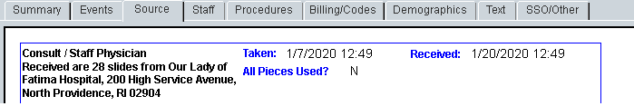

  - Log into EPIC:
    - Click the Patient Station button.
    - In the Patient Lookup window, enter the MRN in the Name/MRN field. Then, select Find Patient.
    - In the window that appears, verify that the patient’s name and date of birth match what is written on the Histology Log. Select Find.
    - Click the Chart Review tab, followed by the Encounters tab.
    - If the patient is currently an inpatient at a Lifespan site and the procedure date in CoPath falls within the visit, copy the CSN# from the encounter onto the Histology Log or EPIC Add-on Requisition. Proceed to step H.
      - If it does not, then proceed to step I.1.
    - If the patient is not an inpatient, look for an encounter that matches the date the specimen was collected (example: surgical pathology/ultrasound/CT/Interventional Radiology – VIR).
      - Many procedure, admit and/or discharge entries in EPIC are listed in red, bold text.
      - If there is no such encounter, proceed to step I.1.
      - If there is such an encounter, look at the notes in that encounter to see if a biopsy/specimen was collected.
        - If there was a specimen collected during that encounter, look to see if the date of that encounter is within 14 days of the test order being placed.
          - If it is less than or equal to 14 days, you can add the test to that encounter in Soft Lab. Proceed to step H.
          - If it is not less than 14 days, proceed to step I.1.
        - If there was no specimen collected during that encounter, proceed to step I.1.
  - Log into Soft Lab:
    - Double click the Order Entry icon.
    - In the Order Entry Search window, enter the patient MRN in the MRN field.
    - Click Next, followed by Next again.
    - The Search window will populate with test orders organized under bill numbers.
    - Highlight the bill number that matches the CSN# taken from the encounter date in EPIC and select New.
    - In the dropdown that appears, select New Order.
    - In the New Order window, change the Collect date and time to reflect the procedure date and time from CoPath.
      - For an outpatient encounter, the Collect date has to match the date of the encounter.
    - Click the arrow next to the Req. by field.
      - In the Doctor Search Screen, enter the last name of the ordering physician and click Enter.
      - When the correct doctor is located, click OK.
      - An example of the clinical provider listed in the CoPath comment section is included below.

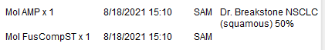

      - In this case, the Ordering Provider is Dr. Breakstone and the Approving Pathologist: Sara Maleki (SAM).
        - In Soft Lab, if possible, put Dr. Breakstone as the Ordering Provider and Dr. Maleki as the Report To provider.
        - If the order already has an Ordering Provider, add both Dr. Breakstone and Dr. Maleki as Report To providers.
    - If there are additional doctors that should be included, click the arrow next to the Report To field.
      - In the Doctor Search Screen, enter the last name of the additional physician and click Enter.
      - When the correct doctor is located, click OK.
    - Highlight the empty ID field in the Order tab. The Keypad will open.
    - In the Keypad, click the 9 Molec tab followed by Tissue, then select the test that appears on the Histology Log.
      - Note:
        - If Fusion Solid Tumor and AMP are ordered, they must always be placed under separate Soft Lab order numbers.
        - If AMP is ordered with any assay that isn’t Fusion Solid Tumor or 1p19q, they can be placed under the same Soft Lab order number.
        - If 1P19Q is ordered with any additional assays (Ex. MGMT or AMP), it must always be placed under a separate Soft Lab order number.
    - Click the Specimen tab, followed by Collect/Receive.
    - Click Save, then select Yes in the window that appears.
  - After saving the order, print the collection label. Paperclip the printed label to the Histology log and place in the Order Waiting folder for the 3:30PM delivery. For orders that fall outside the 14-day window:
    - Any CoPath orders without an EPIC Add-on Requisition will be brought to the attention of the Molecular Pathologist.
      - For these cases, the Molecular Genomic Pathology Requisition Form will need to be filled out.
      - Fill out the highlighted area (see sample form) and then have the Molecular Pathologist enter the ICD 10 code.
        - NOTE: The “Ordering Physician” usually refers to the clinical provider, which may be listed in the CoPath comment or provided elsewhere. If there is none listed, leave this blank. The “Approving Pathologist” refers to the pathologist who placed the order in CoPath. Both lines should be accurate as they determine who will receive the final report(s).
        - An example of the clinical provider listed in the CoPath comment section is included below.
          - Ordering Provider: Dr. Breakstone
          - Approving Pathologist: Sara Maleki (SAM)
    - Verify the Epic Add-On Requisition form or the Molecular Genomic Pathology Requisition form has the CoPath number and Procedure Date for the specimen written down.
    - If the procedure date is not included on the form, identify the date in CoPath and add it to the form.
- CREATING AN ENCOUNTER AND ORDERING IN EPIC
    - After 2PM give req forms to the tech so they can be ordered.
      - Log into EPIC
      - In the first window that appears for Job, use the magnifying glass to select Lab Tech then click continue
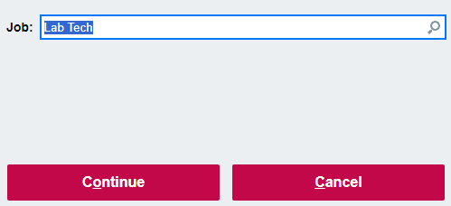
      - In the second window that appears for department, use the magnifying glass to select RIH OUT LAB PROV CUST then click continue
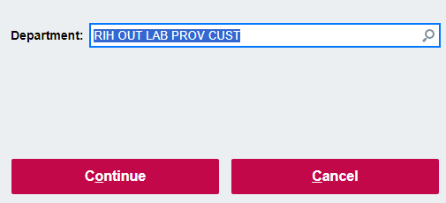
    - Creating a new encounter
      - Click on New Specimen Reg in the top left corner
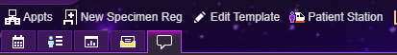
      - Enter patients MRN
      - Assure you have the correct patient and click accept
      - In the box that pops up:
        - Select the current date as the expected date
        - Under attending provider, use the magnifying glass to choose the submitting physician NOTE: the approving pathologist CANNOT be used as the attending provider unless it’s an RO case from Leslie Robinson-Bostom, Christopher Dimarco or Gladys Telang.
        - Click accept
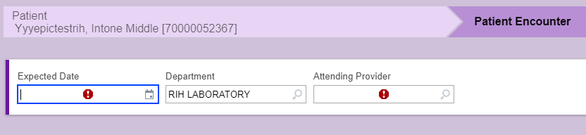
      - On the screen that appear, scroll down to Encounter Guarantor and Coverages
        - Click on the pencil to put into edit mode
        - For patient class click on the magnifying glass and select specimen
        - Click on the box that says self pay
        - Click on the gray “Create/Assign Hospital Account” box
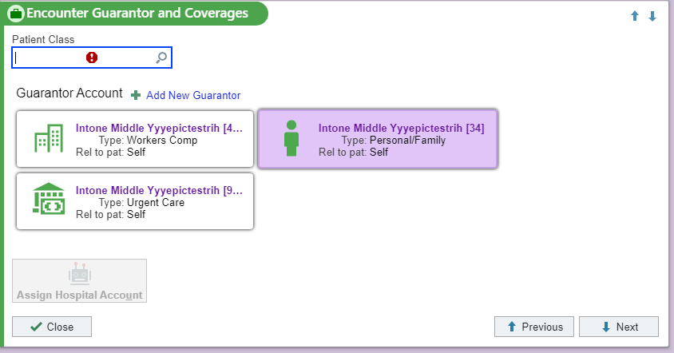
      - Scroll down to Site Code
        - Click on the pencil to put into edit mode
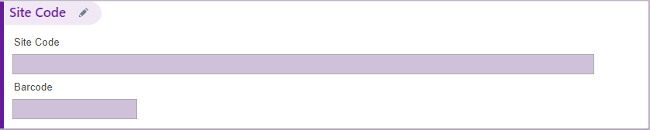
        - Under site code type in LSO
          - If the pathologist is Dr. Bostom use the site code L8P
        - Leave the barcode field blank
        - Click on close to save
      - On the right-hand side of the screen there is a checklist tab
        - Click on the box that says Encounter (this saves and verifies the encounter)
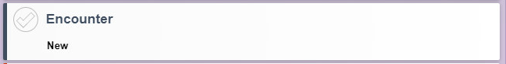
      - Click on check In
        - NOTE: A box will pop up saying ‘Ignore warnings and continue anyway’, select continue anyway
        - NOTE: The encounter is now created, and it will exit out bringing you back to the EPIC home screen
    - Creating the order
      - Click on Patient Station
      - Enter patients MRN
      - Locate the encounter just created
        - NOTE: Multiple encounters will appear, choose the one that matches the date and provider you entered 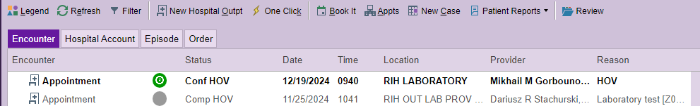
      - Click on Manage Orders
        - On the right-hand side select the +New button next to ‘place orders or order sets’
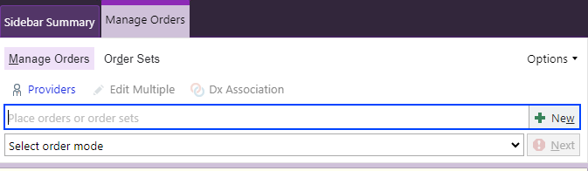
        - In the box that appears click on facility list then database
        - Type in the appropriate order then click on accept
          - The order will appear green, click on this box
          - On the screen that appears:
            - Select FUTURE for the status
            - For expected date use the current date
                - You can select the current date from the calendar dropdown or type in ‘T’ for today and it will fill in the date for you.
            - Click on the +Add Comments, in the box that appears enter the patient’s CoPath number
            - Click accept
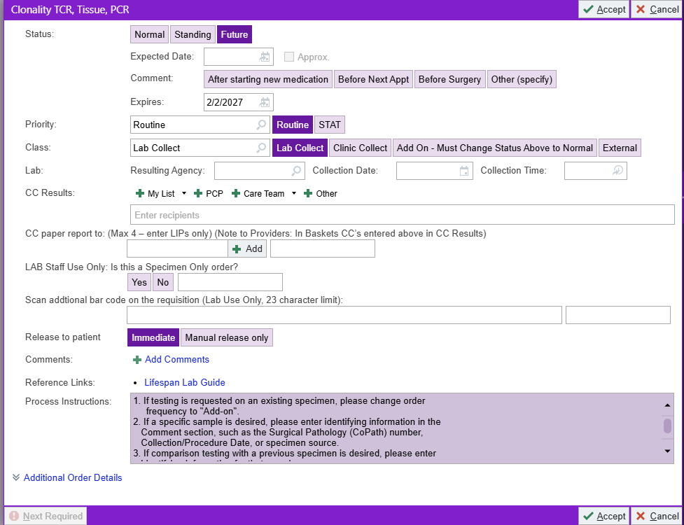

      - Click on DX Association
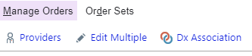
        - Click on +Add to search for the diagnosis
          - Here you would search using the ICD-10 code provided by the pathologist/director.
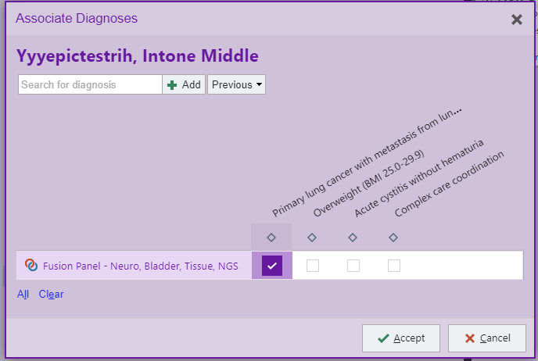
          - Use the following website The Web's Free 2025 ICD-10-CM/PCS Medical Coding Reference to confirm diagnosis with the ICD-10 code provided
          - Click accept
        - The test will appear with the patient’s diagnosis and a box, check this box off and click accept.
      - Click on Select Order Mode
        - Select ‘Transcribe from paper: no cosign required’
        - Click on ordering provider and the ordering pathologist should automatically fill in.
        - Click accept
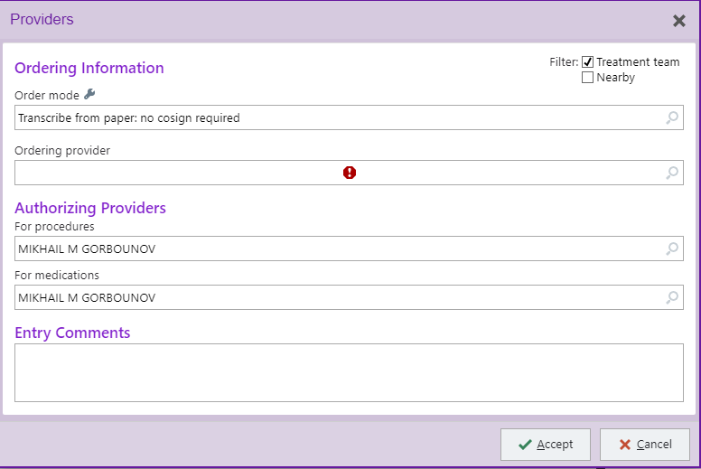
      - Click Sign in the bottom right corner
        - An order validation window will appear, click accept.
          - NOTE: Some insurance companies require prior authorization for certain tests and the following window may pop up
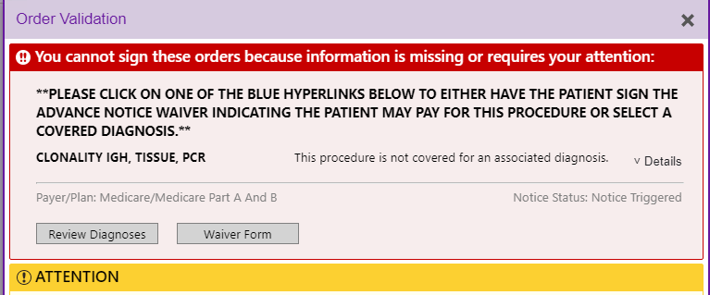
          - Click on waiver form
          - The form is going to open and on top it will say status
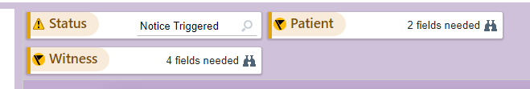
          - Click on the magnifying glass and select ON HOLD (LAB ONLY)
          - Click accept
      - Navigate to the Order Review tab
        - Select the order that was just placed, it should become highlighted in blue. Click the release button.
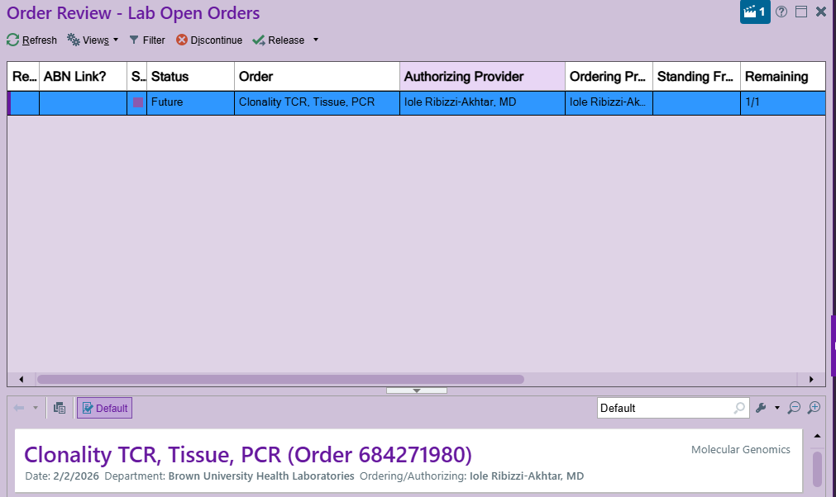
***NOTE: Please ensure you are selecting only the order you have placed***
          - Once you release the order it will automatically transfer the order to SoftLab (this may take a few seconds)
          - Once you see the order in SoftLab:
            - Add any other clinicians who may need to see the report
            - Ensure the admission date and collection date are the same.
            - Collect/receive the order and print the specimen label.
          - Proceed to the MGP Specimen Accessioning Procedure (Page 8-Part J)

- RECEIVING COPATH SURGICAL SPECIMENS FROM HISTOLOGY:
  - All tissues delivered from Histology will arrive with a Histology Log printout.
  - This log lists the tests that were ordered in CoPath.
  - On this log, Histology may make notes of specimens that will be delayed or how many slides were sent.
  - Stamp this form with the transport delivery temperature stamp. If the items were received at room temperature, check off ‘at room temperature’ and initial it.
    - If the tissue was not at room temperature, contact the Histology lab to investigate.
  - Tissue Slides:
    - Open the containers and make sure all the slides are from the correct case and part number.
    - Match them to the H&E slide using the case and part numbers.
    - We cannot process most cases without an H&E.
  - H&E slide:
    - If you do not receive the H&E slide, page the ordering pathologist (found in CoPath). If you do not hear from them by the end of your workday, email them and copy the Directors, Pathologist, and Manager on your email.
    - The H&E slide should have the tumor circled and the % tumor in the circle noted by the pathologist or they should indicate ‘scrape all’ if no microdissection is needed.
    - The % tumor may be located either on the slide or in the comment section on the Histology printed list.
    - If neither is done, please consult the Lab Director(s)/Pathologist.
    - Write the % tumor on the Requisition form.
  - Log into CoPath.
    - Click on the TASKS tile.
    - Choose Histology Functions. Then, choose Histology Data Entry/Edit.
    - Type in the Case number and hit enter.
    - Go under the Histology tab.
      - Check to make sure that what is ordered on the histology sheet is ordered in CoPath.
  - Verify your specimens off the Histology Logs.
    - Once you have determined which cases are complete and all necessary tissue has been received, you need to clear the orders off of the log.
    - Any orders that are still pending on the log will be cut again unnecessarily.
    - In CoPath, click on the TASKS icon.
    - Choose Histology Functions and then Stain Process Log Verify Print.
    - Both boxes at the top should be checked.
    - Use the Status dates that are listed on the sheets.
    - Make sure you check all departments that you received.
    - On the right side, always choose Molecular Biology.
    - Highlight each test that you want to verify by pressing CTRL on the keyboard and right clicking on the mouse.
    - Once they are highlighted, choose Verify. Double check that the ones highlighted are indeed the ones you brought into the lab.
    - If you made an error up until now, you can X out and start all over again.
    - The changes you made are not complete until you choose SAVE.
    - If your changes are OK, now choose SAVE.
  - Log into Soft Lab.
    - The following steps are applicable only for each physical specimen that has been received. If we have not received a physical specimen, you should not receive them in either SoftLab or Soft Molecular.
    - On the dashboard, click on the Specimen Tracking icon.
    - A screen will pop up for you to choose the tracking route.
    - Choose ‘R-Received’, ‘D-Testing Department’, ‘CORO Molec’.
    - Choose ‘OK’.
    - Scan the SoftLab Specimen label barcode of each specimen order.
    - As you scan, you will see a list being created.
    - When you have scanned all specimens, click Save.
    - You will be asked if you want to save the list. Answer YES.
    - You will then be asked if you want to print the list. Choose Cancel.
  - Log into Soft Molecular.
    - Click on the Specimen Receiving Worklist tile.
    - Highlight the Barcode# field.
    - Scan the SoftLab Specimen label and mark the ‘Received’ checkbox to receive the specimen in Soft Molecular.
    - Go back to the dashboard and Click on the Order Entry tile.
    - Scan the specimen label in the Barcode# field and select Enter on the keyboard.
    - Enter ’Date HE Slide received’ and/or ‘Date Block received’.
      - Note: For cases with AMP and Fusion ordered on the same tissue, record the ‘Date HE Slide received’ and/or the ‘Date Block received’ under the Fusion order in Order Entry.
    - Navigate to the Specimen Tab and on the parent level of the specimen enter:
      - CoPath number
      - Block number
      - Procedure date
      - % tumor
      - # of slides received (if applicable)
      - Type of Cyto slides received (if applicable)
      - NOTE: This information is automatically pulled onto the final report so take care to not make a spelling error.
    - If the Tissue type needs to be changed:
      - All Tissue samples will default to FFPE Block (Code: H4T) in Order Entry.
      - In the Specimen Tab, open the child level by clicking the + button in the Code field.
      - Click the dropdown menu in the Type field and select the correct specimen.
      - For Unstained Slides, change the Initial Vol to 5000.
      - Change the protocol to the correct protocol for the specimen type and test.
        - UNSLD: For non-Fusion tests change the protocol to SLDSCRAPE
          - For Fusion (FPCT, FPLT, FPST, FPNT), change the protocol to RSCSCRPSLD.
          - For FISH, leave the protocol as !ATST.
        - CYTO: change the protocol to SOAKXYLENE
    - Print Soft Molecular specimen labels.
      - Note:
        - For Fusion, print two specimen labels. Place one label on the block or slide case and the other on the Fusion Cases log.
        - If AMP and Fusion are ordered, place the AMP specimen label and one Fusion specimen label on the block or slide case. Place the second Fusion specimen label on the Fusion Cases log.
      - Select the Print tab.
      - Click Print Specimen Label.
      - Verify the correct printer is selected and the template reads SPEC LBL V1. Change the printer if necessary.
      - Click the Print button.
    - Place label on back of blocks or slide cases.
    - In pencil, write the MOL number on H&E slide sticker.
    - Scan the H&E slides into our shared scan drive.

- GENETIC (GERMLINE) OR SOMATIC TESTING – LOOKING UP PATIENT HISTORY IN LIFECHART:
  - Log into LifeChart.
  - Choose Patient Station at the top of the window.
  - In the Patient MRN field, enter the patient’s MRN and choose Find Patient.
  - A Patient Select box will appear. Double-check you have selected the correct patient by matching the name and date of birth.
  - If you have found your patient, choose Select.
  - In the patient chart, at the top, choose the Chart Review tab.
  - Right below that, choose the Labs tab.
  - Choose Results Review.
  - On the tree to the left, all testing that we perform is found under the heading of Molecular Genomics.
  - There are branches for Somatic and Germline.
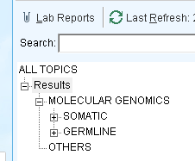
  - Open the Germline branch by clicking on the + sign.
    - JAK2 samples: Open the Somatic branch by clicking the + sign and look for the JAK2 test.
  - Look for the genetic test in question.
  - Click on the + sign to open up all occurrences of testing for that test.
  - Both the old test names and new test names can be found here.
  - Click on the report icon under the date tested to see the results.
  - Let the technologist performing the test know if testing has previously been performed:
    - For HFE, cancel a duplicate request following the Soft Molecular Billing Procedure.
    - For Thrombophilia assays:
      - If a physician orders a test that has already been performed:
        - In Soft Molecular Order Entry, Cancel the test as a duplicate order (Refer to the Soft Molecular Billing Procedure).
          - In the comment section, enter: "Test already performed. See results for specimen collected on: XX/XX/XXXX."
      - If the panel was previously performed, but a physician orders a test that was not ordered before:
        - Perform the new test on the new specimen.
    - For JAK2, if second specimen is drawn within 7 days of the first specimen:
      - Cancel the duplicate specimen by following the Soft Molecular Billing Procedure.

- BCR-ABL1 QUALITATIVE ORDERS:
  - Note: Occasionally, a BCR-ABL1 Qualitative test is ordered, but the provider really wants a Quantitative test. The following guidelines can be used for making decisions about how to proceed (for most patients).
  - If a patient has JAK2 ordered together with the BCR-ABL1, run the BCR-ABL1 Qualitative assay.
  - If no JAK2 was ordered, log into Epic and look for previous BCR-ABL1 testing.
    - BCR-ABL1 Quantitative testing results can be found in the Epic lab results tree, under Molecular Genomics.
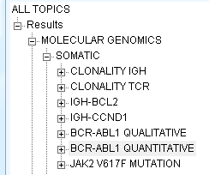
    - If there was a reported BCR-ABL1 test within the past 3 weeks, please see a Director/Pathologist.
    - If the most recent Qual was negative, run the BCR-ABL1 Qualitative test.
    - If the most recent Qual was positive, look in the Epic Media tab to see what the lab requisition looks like.
      - If the provider ordered Quant, but Qual was entered by customer service, send the specimen to the Send Outs lab with a note: ‘Physician requested Quantitative – please send out.’
        - We must cancel our order by following the Soft Molecular Billing Procedure.
      - If the provider ordered a Qual or if there is no requisition in the Media tab, please see a Director/Pathologist.
    - If the most recent Quant was negative, look in the Epic Media tab to see what the lab requisition looks like.
      - If the provider ordered Quant, but Qual was entered by customer service, send the specimen to the Send Outs lab with a note: ‘Physician requested Quantitative – please send out.’
        - We must cancel our order by following the Soft Molecular Billing Procedure.
      - If the provider ordered a Qual or if there is no requisition in the Media tab, please see a Director/Pathologist.
    - If the most recent Quant was Positive, look in the Epic Media tab to see what the lab requisition looks like.
      - If the provider ordered Quant, but Qual was entered by customer service, send the specimen to the Send Outs lab with a note: ‘Physician requested Quantitative – please send out.’
        - We must cancel our order by following the Soft Molecular Billing Procedure.
      - If the provider ordered a Qual or if there is no requisition in the Media tab, please see a Director/Pathologist.
  - If a Director/Pathologist is unavailable and if there is sufficient volume in the tube for RNA extraction with enough left over to send out (4 ml) if needed, proceed with RNA extraction.
    - Then, discuss next steps with Director/Pathologist when they are available.

- ORDERING TESTS IN SOFTLAB (INCLUDING ADD-ON THROMBOPHILIA):
  - Double click on the Order Entry icon.
    - If there is a current Soft order you want to add to, enter the current Soft order number and proceed to F below.
    - If there is a current Soft order and you want to add to that encounter but give the specimen a unique SoftLab number (ex: ALK or ROS1 added to an AMP):
      - Enter the SoftLab number.
      - At the top left of the screen, click on the order icon with the red arrow. This will transcribe all of the order information except for the collection date and time.
      - Enter the correct collection date and time in the General tab.
      - Proceed to step F below.
  - Search by MRN.
  - Double click on the desired patient.
  - Choose the correct encounter based on the hospital billing number and the specimen collection date.
  - Click on the encounter and choose NEXT.
  - Click on TEST ID.
  - Order the correct test using the Molecular Keypad.
  - On the left side, enter the correct collection date and time. Note that the collection date must match the admit date for outpatients.
  - Go to the Specimen tab.
    - If the specimen is already in the lab, then Collect and Receive the specimen, making sure the correct collection date is displayed.
    - If the specimen is coming from a different lab, only Collect the specimen, making sure the correct collection date is displayed. Do not Receive the specimen until it physically arrives.
  - If the specimen type is a Body Fluid
    - Once you collect, receive, and select save, you will get a pop up window and a body fluid keypad.
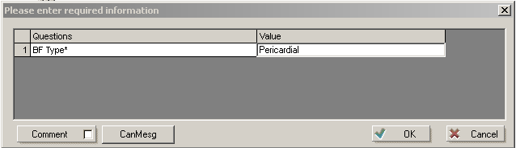
    - Choose the correct body fluid from the keypad and click OK.
      - Note: Once the order has been saved, this information can be found in Soft Molecular Order Entry under the Testing Info tab. If the Testing Info tab is populated the tab will appear as Testing Info (Y).
  - When asked if you want to save changes, click on Yes.
  - Print the specimen label and place it on the specimen or the add-on slip, depending on if the specimen is in the lab or not.
  - For testing that is added onto an existing order in Soft Lab, additional steps must be taken in Soft Molecular Order Entry.
    - First, go to the Specimens tab.
      - Click the + button to expand the child levels.
      - The first child row should be the original specimen (blood, tissue, etc.) and the second row should be the Product (DNA, RNA, etc.). There may be additional rows if additional aliquots were made.
      - Scroll to the right find the “Att Tests” column. Select the child row for the nucleic acid product and attach the appropriate tests, including the new tests, to that child. You may notice that some of the pre-existing tests have been unchecked. If so, make sure to check them again.
        - Note: See the screenshots below for an example of the nucleic acid product in the Specimen tab of Order Entry.
      - Scroll left to find the “Protocol” column. For the child level, make sure that the protocol is appropriate. For example, if extraction has already been completed, change the Protocol to ATST.
      - Then, scroll to the right and make sure that the “Next Action” column has the appropriate action for the same child row. For example, you may need to change the Next Action to !ATST for testing.
      - Alternatively, if the specimen needs to be re-extracted, follow the procedure for reruns and check that the order is pending in Specimen Preparation.
    - Next, go to the Tests tab.
      - Find the test of interest. If necessary, expand the child-level rows.
      - Check the “Next Action” column and adjust if necessary.
      - Check the other tests to make sure they are still on the appropriate action.
    - Save and then exit Order Entry.
    - Check the Test Worksheet Builder to make sure that the order is pending.

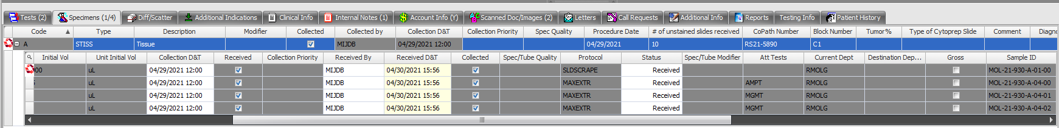

- ORDERING CAP PROFICIENCY TESTING (PT) SPECIMENS IN SOFTLAB:
  - Scan the page of the CAP paperwork that has the name of the PT and the due date.
  - Send an email to the Manager and Directors with the scan attached so they know that a CAP PT specimen has arrived and when it is due.
  - Follow the steps above using:
    - MRN = Q002011
    - Patient = CAP, Molecular
  - Order all necessary tests based on the CAP PT paperwork.
    - Remember to place the orders on each specimen that needs to be tested. CAP PT often comes with multiple specimens to be tested.
  - Place the paperwork in a folder.
  - Give the folder containing paperwork and specimens to the person performing extractions.
  - Write a note on the whiteboard in the Pre-PCR room including the CAP test names and due dates.

- ORDERING WATER CULTURES FOR QA IN SOFTLAB:
  - Follow the steps above using:
    - MRN: ZQ000119
    - Patient: Water, MolecularQC
  - Order CXENV, hit Enter.
  - Source: Water, hit OK.
  - Site: Molecular Genomic Pathology
  - Click on Add(F6) next to Collected by.
  - Save the order and print a specimen label.
  - Place label on the water container and send to Microbiology.

- RECEIVING CONSULT (RO) CASES:
  - Consult cases come from the Pathology office.
    - NOTE: All RO blocks should be returned to Histology once testing is completed. Histology will determine how to proceed with the RO blocks that are received.
  - The patients should be registered and have a RO case number.
    - If the specimen has not been registered – send the specimen and all the paperwork to the Pathology Office.
  - NOTE: When the specimen arrives in the laboratory, enter appropriate information into the Consult Cases Log in the CMB database folder on the RICMBLAB$ shared network drive.
    - Please note that cytology consult cases do not get an RO#. These cases have a C#. The pathologist/director may identify these cases from the cytology report and should enter the information into the Consult Cases Log.
  - If the consult case is sent from Dermpath:
    - Paperwork will be sent with the block(s).
    - If the paperwork and block(s) are received with the 3:30PM run, set the paperwork aside and fax the requisition form to Central Collections the next day.
    - When the order is faxed back from Central Collections, it can be received in Soft Molecular and cut.
    - Deliver the remaining paperwork to the Director and/or Pathologists.
    - For tests such as BRAF, EGFR, AMP, etc. check with the Pathologist/Director if the block has to be sent to histology for cutting unstained slides.
    - For tests such as Clonality, IGH-BCL2, etc., the block can be used for testing and should not be sent to histology unless requested specifically.
  - NOTE: When multiple blocks are received for a patient, the blocks should get separate orders so the nucleic acid extraction and testing can be performed separately.
  - If a requisition form is received from an outside provider, make a copy of the form and update each to reflect the different block numbers. If slides need to be cut, you can place the correct order in CoPath, or if you are unsure of the correct order, give the paperwork to the Pathologist to enter the order in CoPath. If no slides need to be cut, then no orders need to be placed in CoPath.
    - Choose TASK, Histology Functions, Histology Data Entry/Edit.
    - Enter the CoPath number (RO#).
    - Make sure you have the right ‘part’, such as blood, bone marrow biopsy, or bone marrow aspirate. You can use the ‘Next Part’ button to move to the correct part.
    - Click on the three small dots next to an open order box under the heading ‘Stain/Process’.
    - Type in the correct test name and hit enter on the keyboard.
    - Choose the correct test and then click on ‘Save/Close’.
    - If we have the tissue, and Histology does not need to cut it, verify the orders off of the Histology Log.
  - Order the testing in Soft Lab.
    - Collect and receive the order.
    - Print the specimen label.
  - Log into Soft Molecular
    - Click on the Specimen Receiving tile.
    - Highlight the Barcode# filed.
    - Scan the specimen label and mark the Received checkbox.
    - Save
  - Go back to the dashboard and click on the Order Entry tile.
  - Follow the steps as you normally would for updating information on tissue samples.
    - When you enter the CoPath number, add the outside hospital block number next to it in parenthesis. Ex: RO20-123 (FS20-220)
    - Be sure to use the original date of the Procedure from the Outside Hospital for the Procedure Date, not the Procedure Date for the CoPath case.
    - To determine the outside case number and Procedure Date in CoPath, go to Inquiry > Text tab > scroll down to Gross Description.
    - Example:
      - In Soft Molecular, put for CoPath Number: “RO20-211 (31049937)”
      - In Soft Molecular, put the block number, as usual.
      - In Soft Molecular, put for Procedure Date: 03/30/20
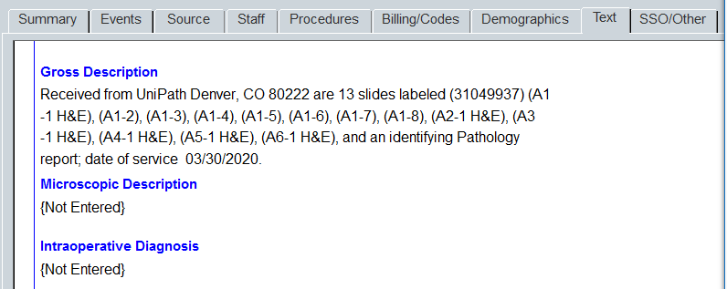

- RETURNING BLOCKS AND SLIDES TO HISTOLOGY:
  - Please note that all blocks and slides, including RO cases, should be returned to Histology.
  - In Soft Molecular, open Order Entry by using the icon on the dashboard.
    - Enter the MOL number of the slide or block to be returned.
    - Look at tests ordered and only send back blocks and slides on cases that have a status of signed out (unless requested by a pathologist).
    - Go to the Order tab at the top of the screen.
    - If the case has been signed out, you will need to click the Reactivate Order icon.
      - Enter Reason. Add a comment, if desired. Then, click OK.
    - Enter date under ‘HE Slide Returned’ or ‘Block Returned’.
      - Note: For cases with AMP and Fusion ordered on the same tissue, record the ‘HE Slide Returned’ and/or ‘Block Returned’ date under the Fusion order in Order Entry.
    - Save order.
    - Repeat for all items being returned.
    - Exit Order Entry.
  - Open Management Report Toolkit by using the icon on the dashboard.
    - Double click on List of Samples to be Returned tile.
    - Select either Block Return or H&E Return, depending on material to be returned.
    - Enter the test ordered date range then click Find.
    - The list should contain all the specimens you checked for ‘Return’.
    - Select Print icon and print 2 copies of the list.
      - One copy goes with the specimens back to Histology.
      - The other copy goes into the binder labeled “Block and Slide Return Lists”.
    - Repeat process if another material type is being returned.
    - When all lists have been printed, close Management Report Toolkit.
  - Open Order Entry by using the icon on the dashboard.
    - Enter the MOL # of the slide/block you packed for return.
    - If the test has been signed out, go to the Order tab at the top of the screen.
    - Click the Reactivate Order icon.
    - Enter Reason.
    - Mark checkbox for ‘HE Return Complete’ or ‘Block Return Complete’, depending on material being returned.
    - Repeat for all items being returned.
    - Click Save.
    - Close Order Entry.

- SCANNING REQUISITIONS INTO EPIC/LIFECHART (INLCUDING ADD ON REQUISITIONS)
  - All orders for testing need to be documented in the patient chart.
    - If we receive an Add-on request (ex: Thrombophilia test or Microbiology test), the physician needs to complete the Add-on Test form and fax it back to the lab.
    - To document the request, the Add-on Form needs to be scanned into EPIC.
  - Log into LIFECHART.
    - Click on Media Manager.
    - Search for the patient by using their Medical Record Number.
    - When you find the correct patient, click on Accept.
    - Click on +Add New Media
    - Under “Select document type” type lab requisition scan
    - Click ‘select encounter’. Choose the CSN associated with the encounter **NOTE: there is B# on the demographic label, this is the correct CSN to choose. Turn the scanner on.
    - . Click scan.
    - Double check the CSN and MR numbers. Then, put the paper in the scanner, facing away from you.
    - Click Scan 1 sided document.
    - Select Document Type.
    - In the Document Description box, use the format MGP_[Test ordered] or MolMicro_[Test ordered] and put in the specific test that was ordered on the requisition form. Example: MGP_TCR or MolMicro_GC/CT.
    - Click OK.
    - Click Upload Images.
    - Click Accept.
  - If for any reason, scanning of the requisition can not be done immediately, place the requisition in the “To be Scanned” folder at the front desk.
    - The next day, a technologist will be assigned to scan all pending requisitions into the appropriate patient chart in EPIC.
    - When a requisition is scanned into the appropriate patient chart in EPIC, place the requisition in the “To be Reviewed” folder.
    - Requisitions in the “To be Reviewed” folder will be checked for accuracy by the Lead Technologist or Lab Supervisor.
  - All reviewed requisitions will be stored in a separate binder for one month. After that time, they will be discarded in the HIPPA bin.

- PULLING TEST PENDING RESULT LOGS
  - Log into Soft Molecular
  - On the left-hand side of the screen select Report and then Management Report.
  - Choose the Pending Result Log tile.
  - Enter the Ordered From date by choosing the date that is one month prior to the current date.
  - Choose the Test that you are interested in by using the dropdown menu.
  - Click FIND.
  - The report is generated by Order number so all tests associated with that number will show up on the report.
All tests that are pending an action are listed with their last action completed, their next action expected and the worksheet number that the sample is on.

- EPIC ADD-ON REQUISITION FORMS:
  - If an EPIC add-on requisition slip prints in the lab:
    - For FFPE-based tests, place the form in the red folder by the Post-PCR room printer. The pathologists will review these cases.
    - If the form is for cancellation of any test, place the form in the red folder
  - If the form is requesting testing on a blood (this includes tests such as HFE or JAK2), take the form and investigate.
    - If testing requires a lavender tube, a tube may be available in Hematology.
      - Log into Softlab.
      - In Order Entry, search by patient MRN.
      - Look for a test, such as CBCWD, that has a specimen type of L1V.
      - Look at the tracking to see where the specimen is currently located.
      - Ask the other lab to send the tube to us on the next courier run.
        - For RIH Heme, call: 4-6160
        - For TMH Heme, call: 3-4215
    - Example:
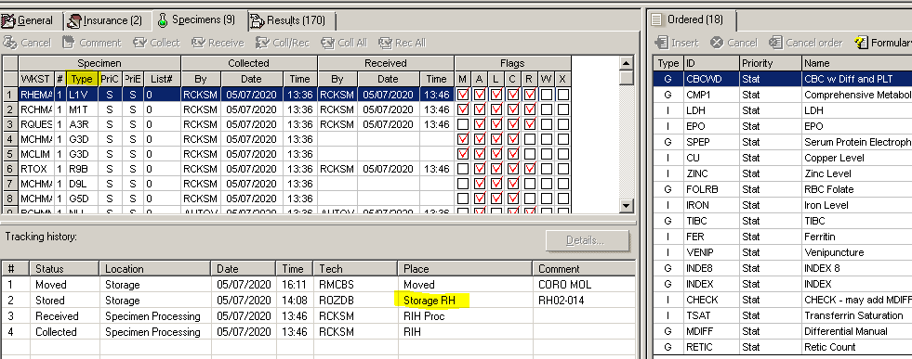
  - If the test is for a body fluid, perform an investigation and locate a specimen for testing.
  - If no specimens are available for add-on testing, inform the Director/Pathologist immediately so they can contact the ordering provider and discuss alternative options.

- REVISIONS:
  - 2/28/2020: Added steps for filling out forms, adding procedure date, RO outside lab number and pulling Pending Result Logs
  - 8/14/2020: Added steps for how to handle printed requisition slips, clarified the handling of RO cases, and included additional steps necessary when processing add on requests.
  - 12/14/2020: Updated with information for the Fusion assay as well as clarifications for add on tests.
  - 7/6/2021: Added instructions on how to attach tests in Soft Molecular Order Entry, updated the Preparing for the Histology Delivery section.
  - 9/3/2021: Additional clarifications on the ordering process including the Ordering physician and Copy to physician.
  - 11/18/2022: Updated several steps for Soft Molecular upgrade and updated RO block information.
  - 5/12/2023: Added information for printing logs prior to 2 pm.
  - 7/17/2025: Added instructions to create encounters in EPIC
  - 2/4/2026: Updated EPIC ordering steps

