PROCEDURE: Critical Results Notification (NPH)

- Principle
    - For all critical results that fall into any of the different critical categories, the Microbiology laboratory follows the notification timeframes and documents critical values established in the system-wide policy: LABADM 1.8 – Communication of Critical Values and Abnormal Lab Results.

- Procedure
    - Refer to LABADM 1.8 – Communication of Critical Values and Abnormal Lab Results, Policy Stat.
    - Documentation of communicated test results must be linked to the critical result and must include:
      - “Called to and readback by” statement
      - DATE and TIME
      - At least first name and initial of last name is required
    - Notification Algorithm:
      - Contact Provider according to the above-mentioned policy.
        - Inpatients and discharged patients and long-term care: RIH (Rhode Island Hospital), TMH (Miriam Hospital), and NH (Newport Hospital)

        - Outreach and Private MD patients:
          - Call the ordering provider’s office directly within the specified amount of time based on call category.
          - The phone number to call can be found in Order Entry:

Open the Call Box:

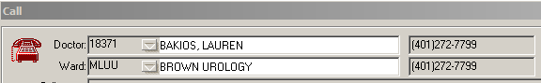

There also might be a 2nd box with Clinic instructions that pops up:
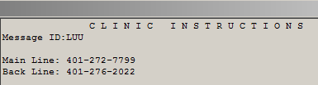

If unable to obtain correct location and/or number from the above steps refer to Outreach Clinics Contact Location for additional clinic information.

        - Bradley Patients:
          - Bradley Laboratory Services via pager 350- 6192 (07:00-15:00) or the Nursing Supervisor via hospital operator #21000 (15:00-07:00 and weekends)

        - Private MD (non-outreach) & Brown University:
          - Call MD office directly within the specified amount of time based on call Category. See Appendix VI for Brown University patients (MLBU).

- Reference
  - LABADM 1.8 – Communication of Critical Values and Abnormal Lab Results, Policy Stat.

- Revisions
  - 11/19/2019 – Added notification guidelines for Newport Hospital ED patients
  - 09/02/2020 – Updated to only call ESBL producing Klebsiella spp.
  - 04/02/2021 – Updated the Outpatient algorithm and included COVID in the RIDOH reportables
  - 08/19/2021 – Updated the outpatient algorithm and added Long Term Care Facilities
  - 05/02/2022 – Removed calling Newport Hospital Lab for critical results on discharged patients, updated call policy for positive blood cultures, updated notification algorithm for RIH ED patients
  - 08/05/2022 – Updated Pediatric Hospitalist algorithm for RIH/HCH
  - 02/17/2026 – Removed all information not specific to NPH. Reformatted for consistency between affiliated laboratories.

