PROCEDURE: Corrected and Supplemental Reports (NPH)

- Principle
  - Supplemental and/or corrected final reports on any patient record must be indicated as such. Original final reports must never be deleted regardless of how minute the addition and/or correction is to the report. Additions to final patient reports should ultimately generate a supplemental report. Edits to incorrectly reported information should ultimately generate a corrected report.
  - There are four areas in a patient report that may be altered to trigger either a supplemental or corrected report. These areas include edits to test comments, isolate comments, isolate identifications, and/or drug alterations. The following procedure outlines the correct way to update and/or correct a report based on the portion of the report being altered.

- Procedure
  - Corrected Test Comments
    - Test Comments (corrected after Final status is set and saved)
      - Edits to test comments will result in either a supplemental or corrected report ONLY if made after a report has a final status applied.
        - Edits made to test comments set with a final status will trigger an edit warning box, as well as a List of Corrections with a checkbox.
        - This box may be left checked, which will then prompt a correction reason box and corrected report banner, or it may be unchecked, generating a supplemental report instead.
    - Test Comments (corrected in Preliminary or Interim status)
      - Edits to test comments in Preliminary or Interim status may trigger an edit warning box, depending on whether information is added or removed.
        - This warning box will inform the technologist that a change is being made, but no further action must be taken.
    - Correcting Gram Stain (Test Comment)
    - Insert canned message }PREC above the original smear result.
      - Insert canned message }PREC above the original smear result.
      - Insert correct gram stain result directly beneath header THIS IS A CORRECTED REPORT.
      - Add/Remove a period at the end of the original gram stain result, this will generate a corrected report.
      - Notify appropriate personnel regarding the corrected report and document phone report.
      - Set final status and save.
      - Edit warning box will appear, Click OK.
      - List of corrections with check box will appear, leave the box CHECKED.

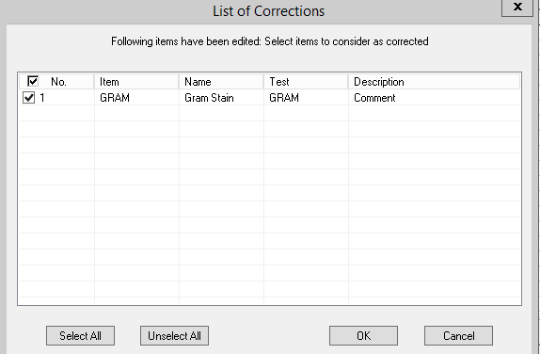
      - Correction reason box will appear, enter reason for change and click OK.
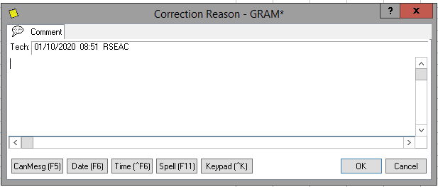
      - Review the Instant Report to verify accuracy.
The report format should resemble the example below:
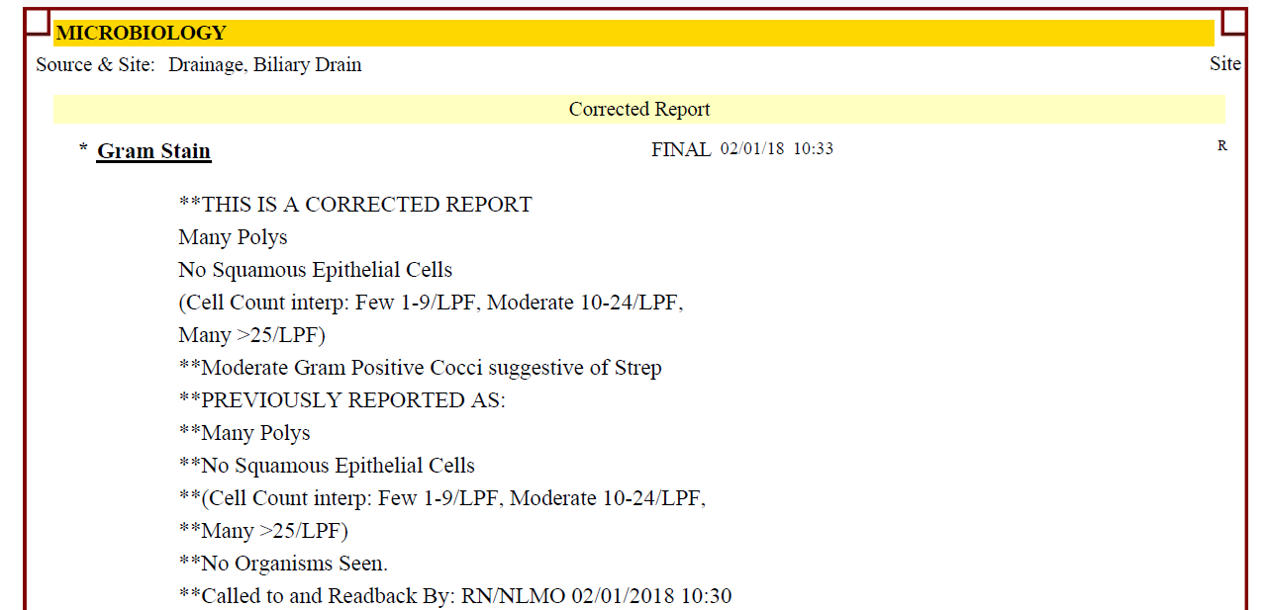

  - Correcting Results in Result Entry (SOFTLAB)
    - Simply delete what currently resides in the result field.
    - Enter the correct result.
    - Open the comment section.
      - A result that needs correction and has been verified, will autogenerate a “previously reported…” comment
      - Notify appropriate personnel regarding the corrected report and document phone report.
      - Verify.
The report format should resemble the example below:

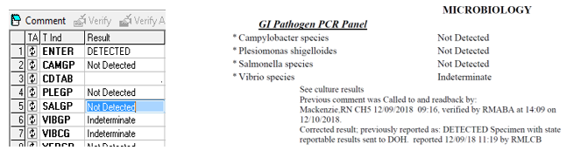
- Notification of Corrected Results
  - Refer to Lab Admin 1.8 Communication of Critical Values and Abnormal Lab Results
  - Corrected Gram stains must be called unless it is the result of a gram stain review and previously reported culture results match the reviewed gram stain.

- Revisions
  - 02/17/2026 – Removed examples and instructions for testing no longer performed at the NPH location. Reformatted for consistency between affiliated laboratories. Updated title.

