PROCEDURE: LIS Specimen Handling & Order Entry (NPH)

- Principle
  - The importance of consistent and appropriate microbiologic specimen processing is to maintain a rigorous and continuous chain of custody for every clinical sample from the moment of arrival to its final disposition. By integrating standardized receipt verification, precise order entry, and systematic tracking, the laboratory ensures that patient demographics are accurately linked to clinical requests and that the physical location of every specimen—whether in local storage or in-transit—is known at all times.
  - By standardizing the process for adding tests to existing samples, tracking physical movement via a verifiable audit trail, and resolving order discrepancies through formal cancellations and credits, the laboratory ensures clinical accountability and
  - It is the responsibility of the Microbiology laboratory to review and evaluate orders to be sure that the expected results will reflect the original requests. Processing begins at the time of orders being placed and continues through the various aspects of receiving, processing, routing, etc. Aside from assuring accurate laboratory results, the order entry process is also a vital part of the medical records and billing cascade.

- Prioritizing Specimens
  - STAT specimens, tissues, body fluids, and any surgical specimens delivered from OR should be processed as a priority.
  - Routine specimens should be logged in as they arrive in the micro department
    - All routine micro specimens are sent to planter to be processed or split.
See Appendix AP1 - Microbiology Order Entry
    - Molecular specimens are held for processing-
See Appendix AP22 – MOLECULAR TESTS
    - Sendout tests sent to reference lab:
      - Stool Ova and Parasites (OP1)
      - Worm Identification
      - Cyclospora/Isospora
      - Other Parasites

- Splitting Specimens With Other Departments
  - All specimens should be put in clear biohazard specimen bags for transport to other departments.
  - Be sure specimens are labeled correctly so planter will know specimen is shared and needs to be forwarded to another department.

- Labels
  - Collection labels should be applied to the original container
  - Be sure that source printed on label is correct.
  - Blood culture collection labels must be applied vertically on bottles

- Specimen Tracking
  - Use specimen tracking to send and receive from another site

- Procedures
  - Ordering
    - Specimens Delivered with Test Orders
      - Routine Micro Orders - Track, go to Plating List, scan barcode labels and Plate
      - Molecular Orders – Track
    - Specimens with downtime slips or paper requisitions
      - Use LIFECHART for ordering tests
      - Choose correct account number (billing date of service) to search
      - Choose correct label printer for collection label to print out
      - Enter correct collection date of specimen when placing orders
      - Apply collection label to container
      - Phlebotomy Receive in SoftLab
    - Common Issues and Exceptions
      - If discrepancy with account numbers or date of service, fax requisition to Registration for an updated account linked to date of service.
      - In Phlebotomy Receive- you may get “No orders found”, this just means that the specimen was already received at specimen receiving.
      - Confirm specimen was received by going to Soft Order Entry, on Specimen Tab and make sure the “R” box is checked off.
      - Special Requests/Pathologies – Appendix AP4
      - If a specimen that is normally run and resulted at Newport hospital is sent over to Rhode Island Hospital, it is necessary to have the specimen received at a null computer to have patient results sent to patient’s chart.

  - Canceling Tests in SOFTMIC
    - Canceling SOFTMIC Tests That Will Not Be Reordered
      - This procedure is to be used for canceling tests that WILL NOT be processed or reordered. Below are examples of reasons for cancellation.
        - Delay in Transport
        - Specimen QNS
        - Improper collection device for request.
      - In the Result Entry screen, enter the order number.

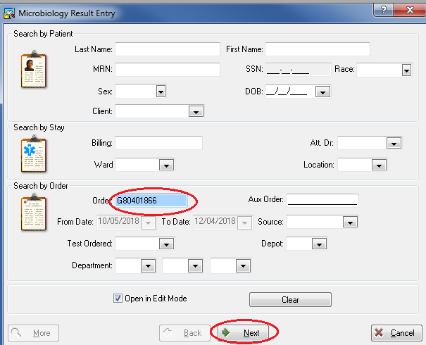

      - Hit “Next”
      - In the Micro Result Entry Screen, open the Test Comment window for the Gram stain. Use a canned comment (when possible) that best describes the clinical situation
      - Examples of canned comment include:
        - }aQNS – Specimen QNS
        - }aUNL – Unlabeled Specimen
        - }aMIS – Mislabeled Specimen
NOTE: Not every clinical situation has a canned comment that is appropriate. When there is no canned comment available, free-text to describe the reason for canceling the culture.
      - Notify and document the notification call to the provider.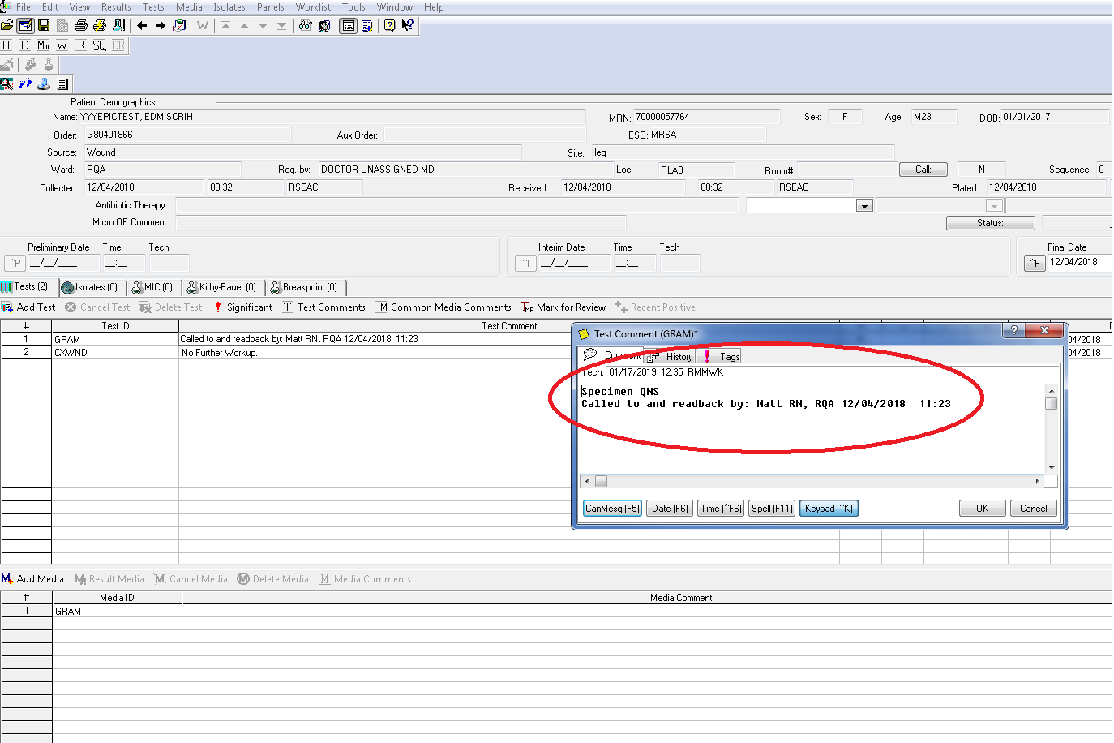

      - Hit “OK” at the bottom left of the Test Comment box and set the status of the Gram stain to FINAL.
      - Open the Test Comment box for the culture and add the canned comment }NFW (No Further Workup).
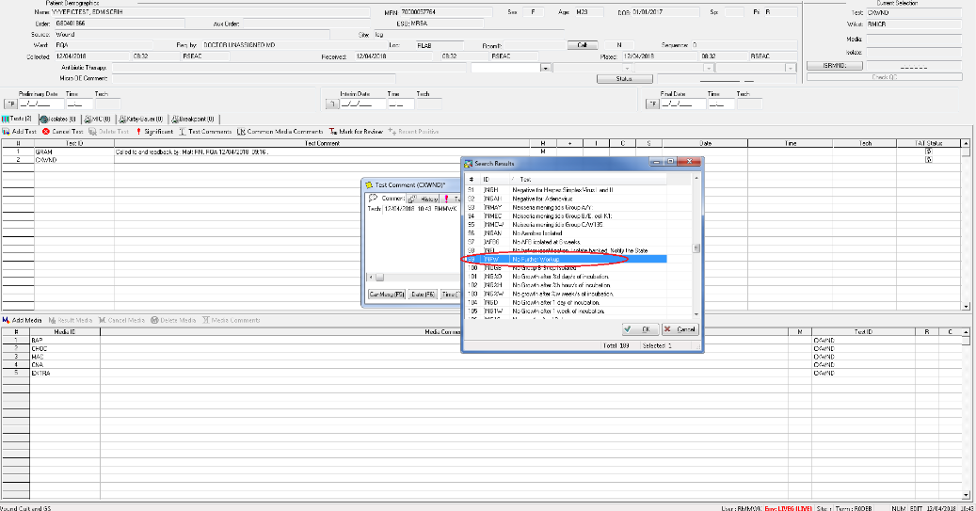

      - Hit “OK” at the bottom left of the Test Comment box and set the status of the culture to FINAL.
      - Check your instant report before moving to the next step to ensure all the information entered is accurate.
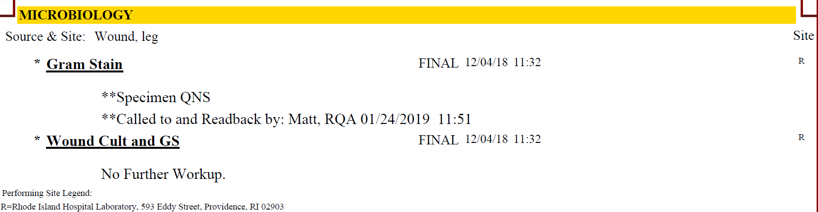

    - Cancel & Reorder in ORDER ENTRY:
      - Follow this protocol when canceling tests that will be reordered. Order Entry errors, such as a tissue specimen being ordered as a wound culture or operating room cultures ordered as CXANA, are the most common examples.
      - In Order Entry, right click on the order you want to cancel and slide the cursor over to “Test”.
(picture example on next page)

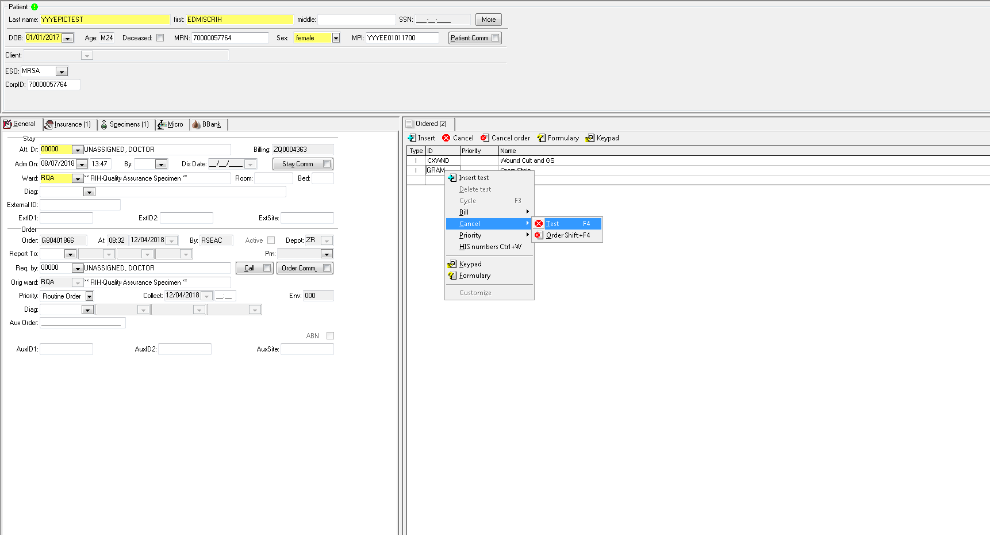

      - A text box will open, free text the Cancellation Reason (ie: “Order Entry Error. Test is inappropriate for the specimen.”)
      - Repeat these steps for every order that you will be canceling (ie: GRAM, CXAFB, CXFUN, etc…)
      - Using the collect time and date of the original order, refer the canceled culture to the new order for results.
NOTE: Notification calls do not need to be made when the culture is being reordered
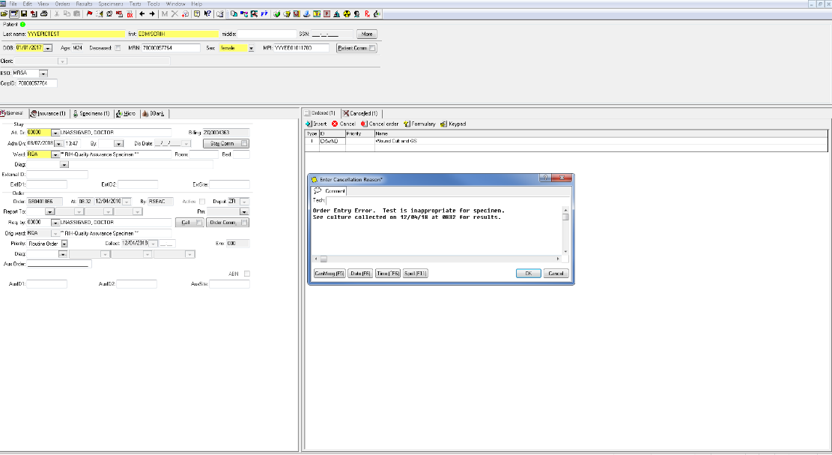
      - Hit “OK” at the bottom and save all changes and save the culture results.
      - Check your instant report prior to finalizing the culture to ensure all the information entered is correct.
(picture example on next page)

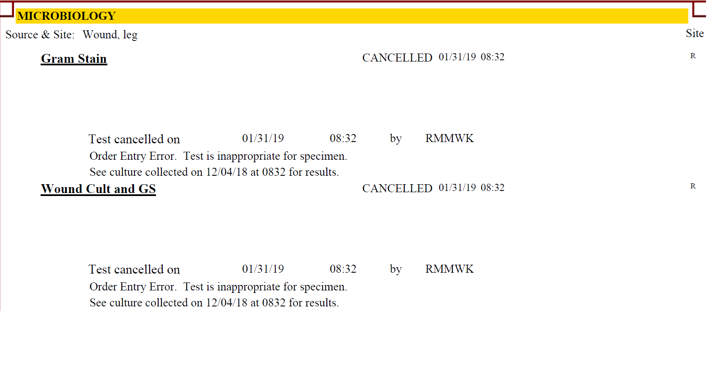
      - When reordering, do not add the test to the original order number. A new order needs to be created. At the top of the taskbar in Order Entry, click the icon of a red arrow through a piece of paper (below).
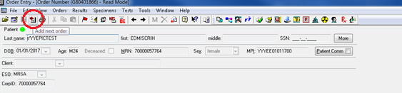
        - This will bring you to a new Order Entry screen. Enter the new test order(s) and save your results.
        - Reprint collection labels and place the new label on the collection container.

  - Crediting in SOFT MIC
    - Crediting A Test Order
      - After completing the cancellation steps outlined in section A, the charge associated with the test needs to be credited.
      - Switch from Result Entry to Order Entry for the canceled culture by selecting the Order Entry icon on the top right of the taskbar. SOFT will ask if you want to save changes. Select YES
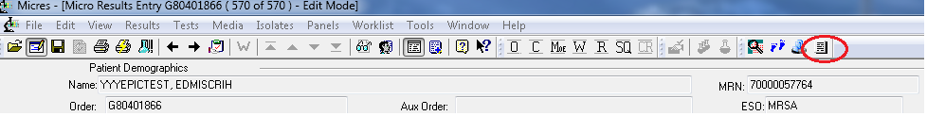
      - Right click on the order you wish to credit.
      - Move the mouse cursor down to “Bill”
      - When the drop-down menu appears, select “No charge”
(picture example on next page)
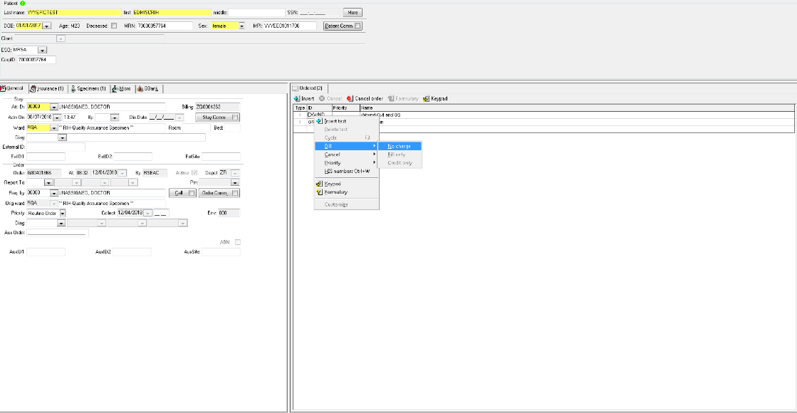
      - A text box will open, copy or free text the reason for the test cancelation. This should be the same comment that went into the results for the order.
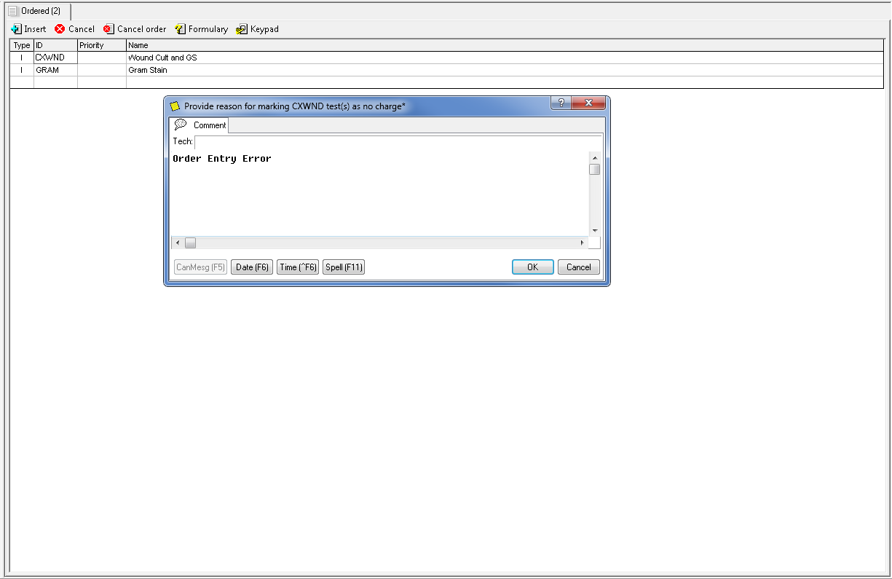
      - Click “OK” to close the text box and save the Order Entry updates.

  - Canceling Molecular Tests (SOFTLAB)
    - From Result Entry Select tests by “Tests”
    - Enter the Test ID in the Test box
    - Enter the order number in the order number box.
(picture example on next page)

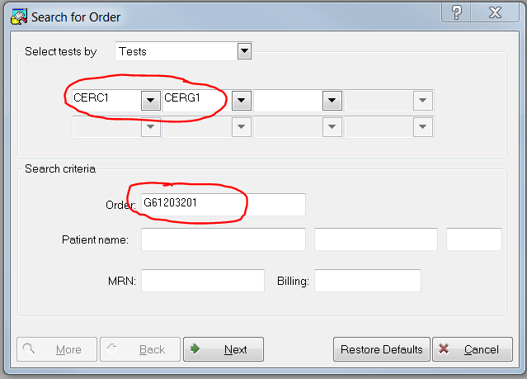
    - Hit “Next”
    - Click on the Result box for the test to be canceled
    - Choose >CANC from the resulting keypad box.
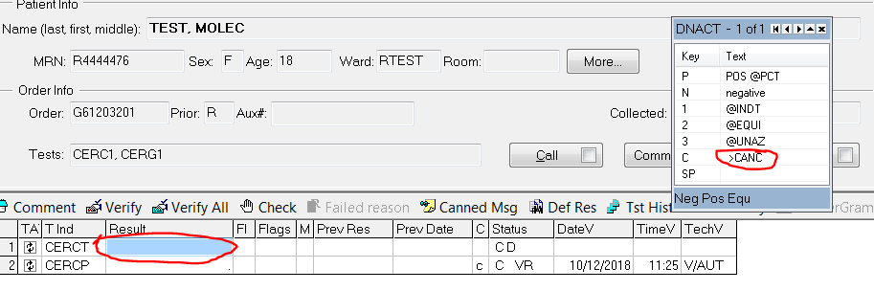
    - Click the ↓ to open the Cancel keypad
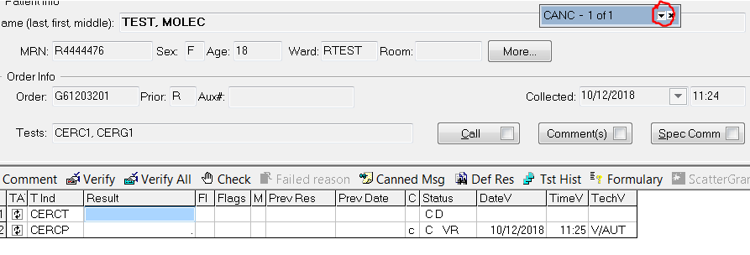
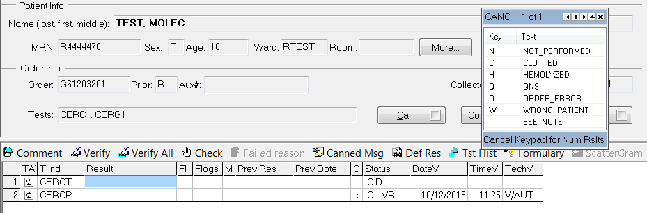
    - Choose the reason for canceling from the choices, ie. Not Performed, Order Error, QNS, etc.
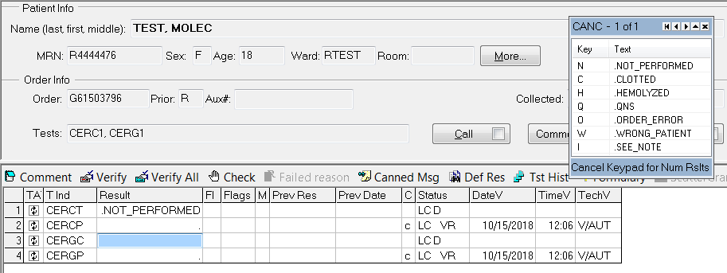
    - Repeat for additional orders if there are more than 1, ie. CERC1 and CERG1.
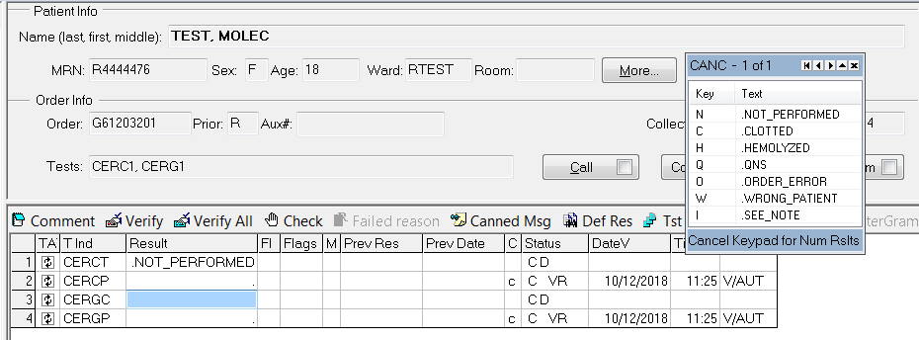
    - To add additional comments, open the comment box and add a canned comment or free text a comment, ie. Phone report.
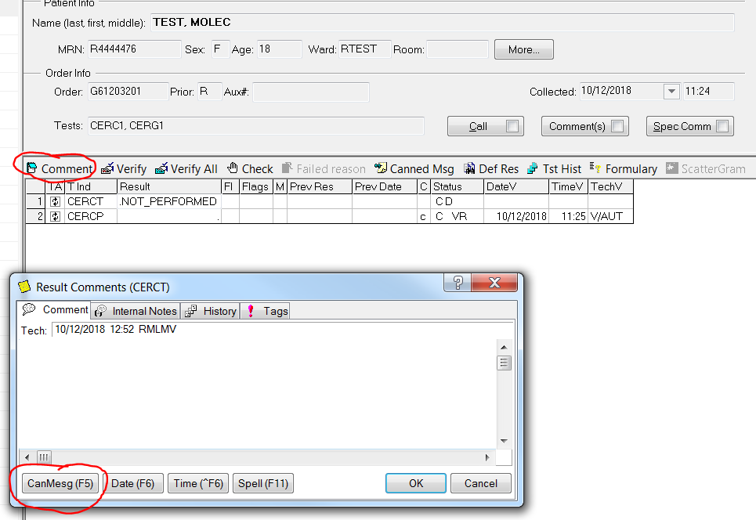
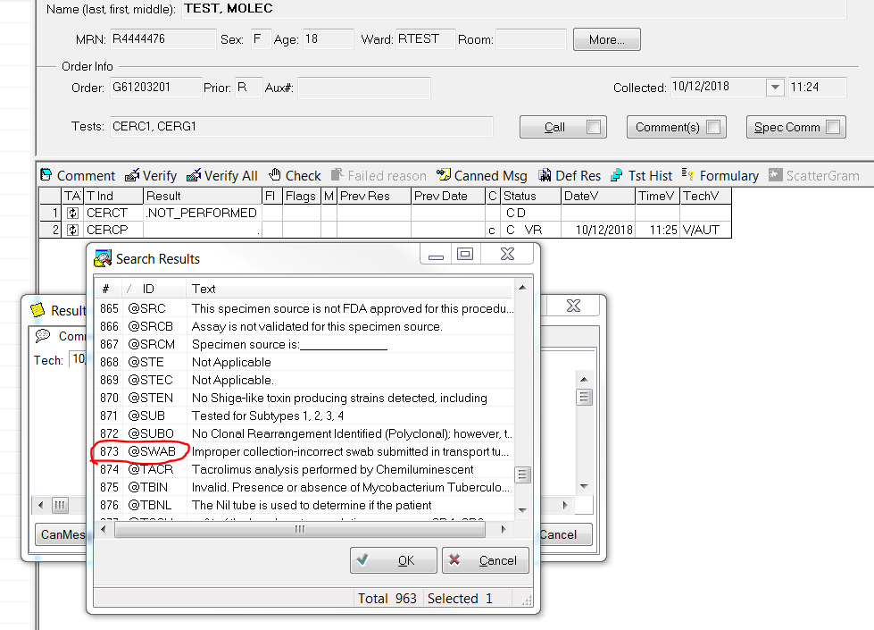

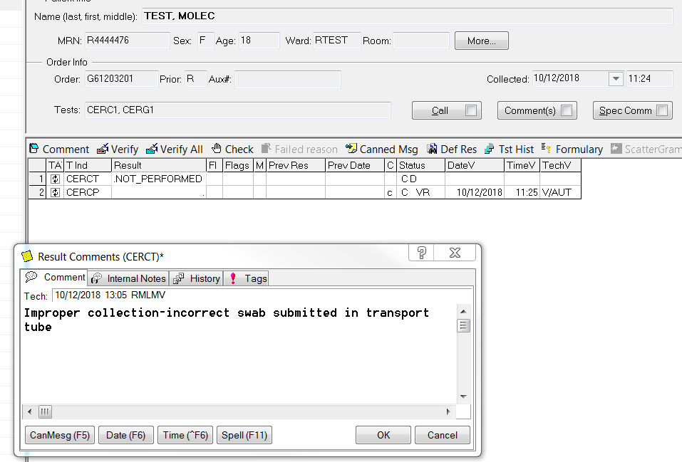
    - Frequently used cancellation codes.
Note: These codes can be typed in the comment box and hit Enter or look them up alphabetically in the canned messages.
      - @CONT- Received in wrong container
      - @OVER- Urine transport tube overfilled
      - @UNDER- Urine transport tube underfilled
      - @SWAB- Incorrect swab received in transport tube.
    - Free text as much information as available and add phone report when required.
NOTE: Notification calls do not need to be made when the culture is being reordered.
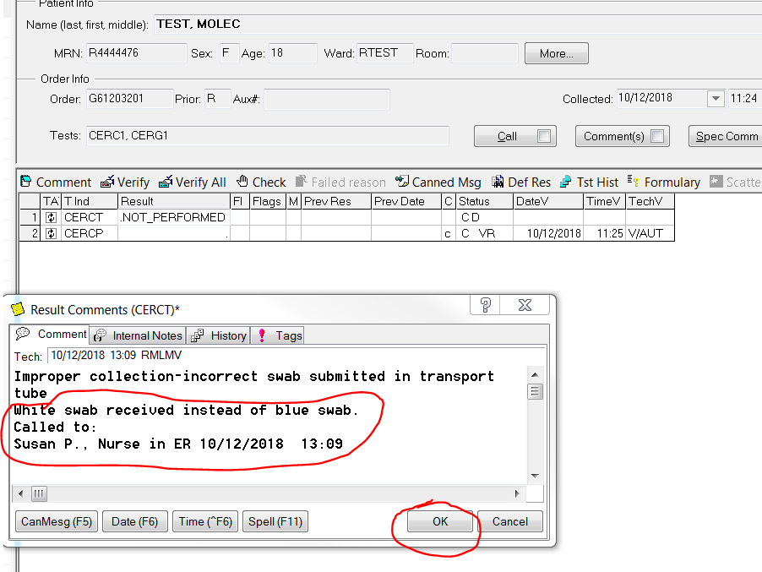

    - Click OK
    - Repeat for additional tests.
    - Cancel all additional lines corresponding to the test, ie. “Performed by” footnote or “Bill Only” lines, by choosing Cancel and Not Performed.
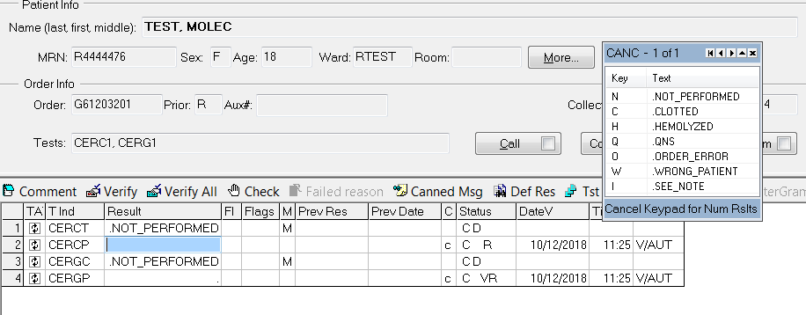
    - Verify All and Save
(picture example on next page)

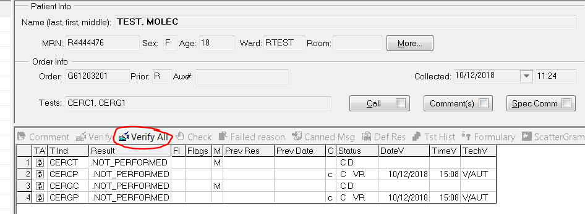
    - Check the Instant Report
