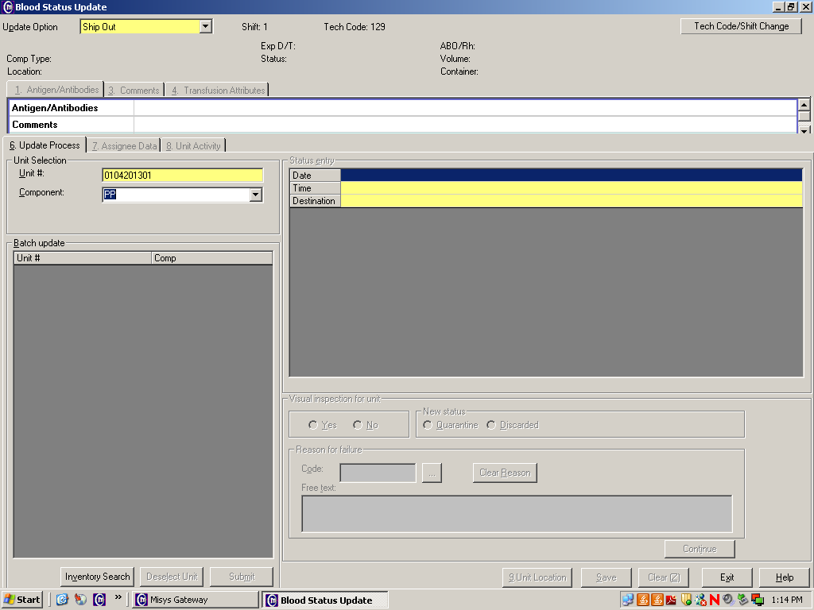

- The facility that is SENDING the blood product “Ships Out”
in the computer.

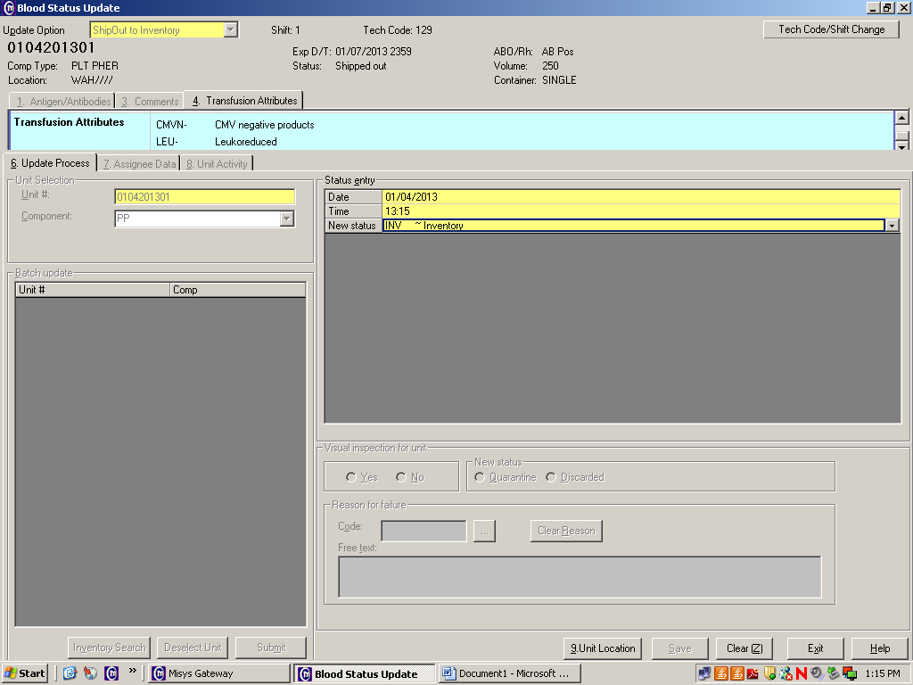

- The facility that is RECEIVING the blood product
“Ships Out to Inventory” in the computer.

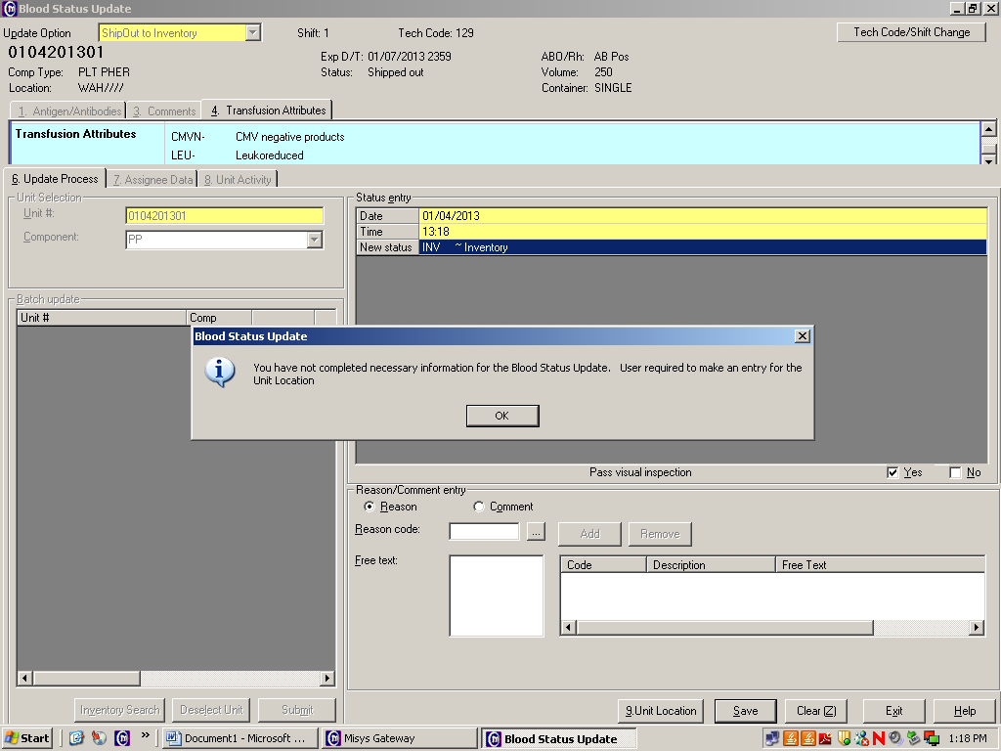

- You will receive this message if you DO NOT change the
location of the blood product. Click the “OK” box.

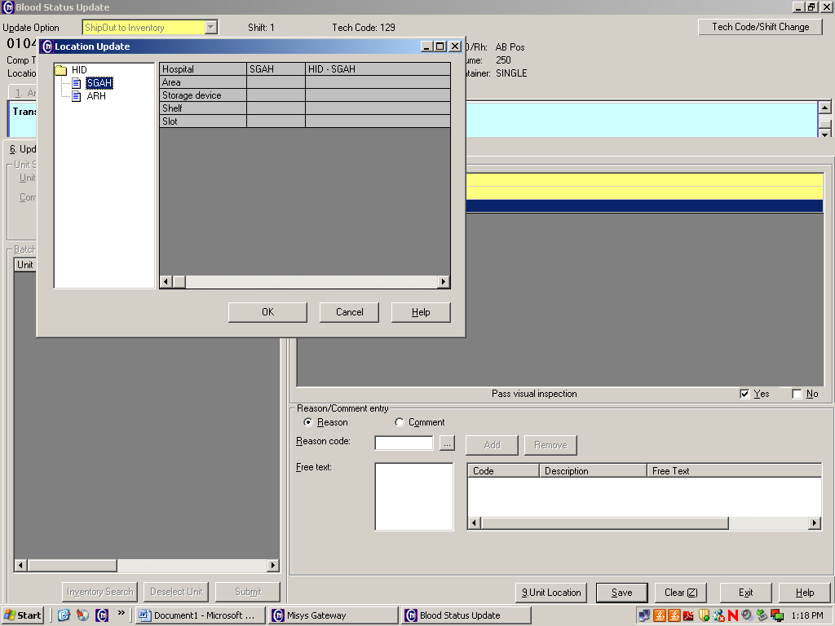

- On this screen YOU MUST choose the location where the blood product will be.
  - If a product is shipped from SGAH to WAH, select WAH here.
  - If a product is shipped from WAH to SGAH, select SGAH here.
  - If a product is shipped from SGAH to ARHM (future state), select ARHM here.

