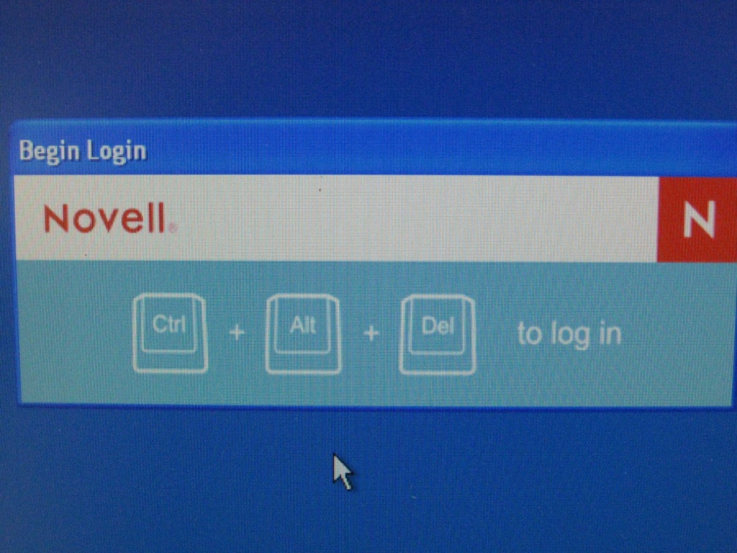

1. When you encounter a computer, you must click the Ctrl + Alt + Del buttons at the same time to log in.

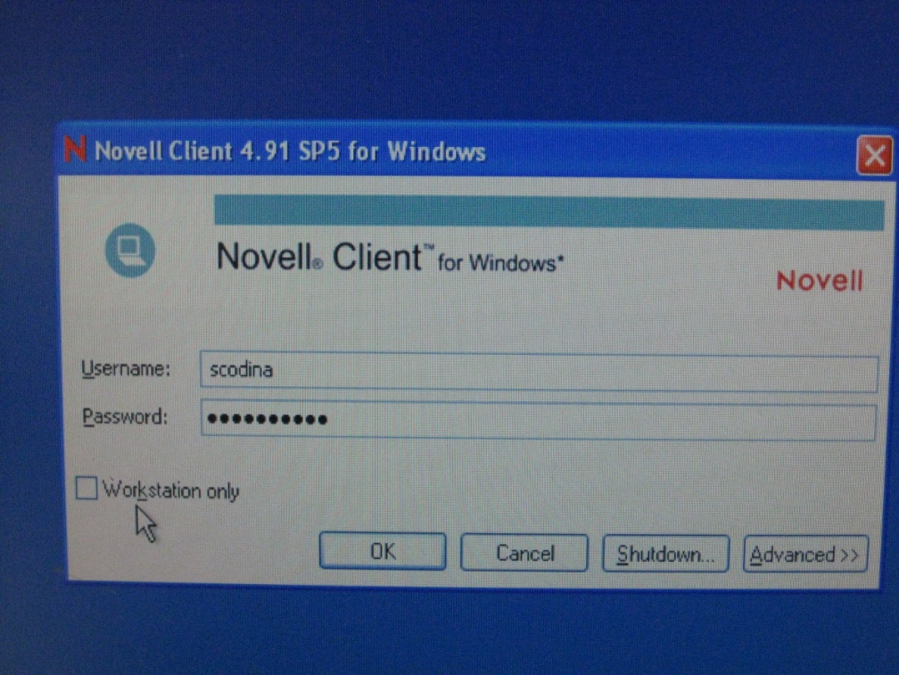

1. At the Novell login, type your username and password.

Be sure the “Workstation only” box is **NOT** checked.

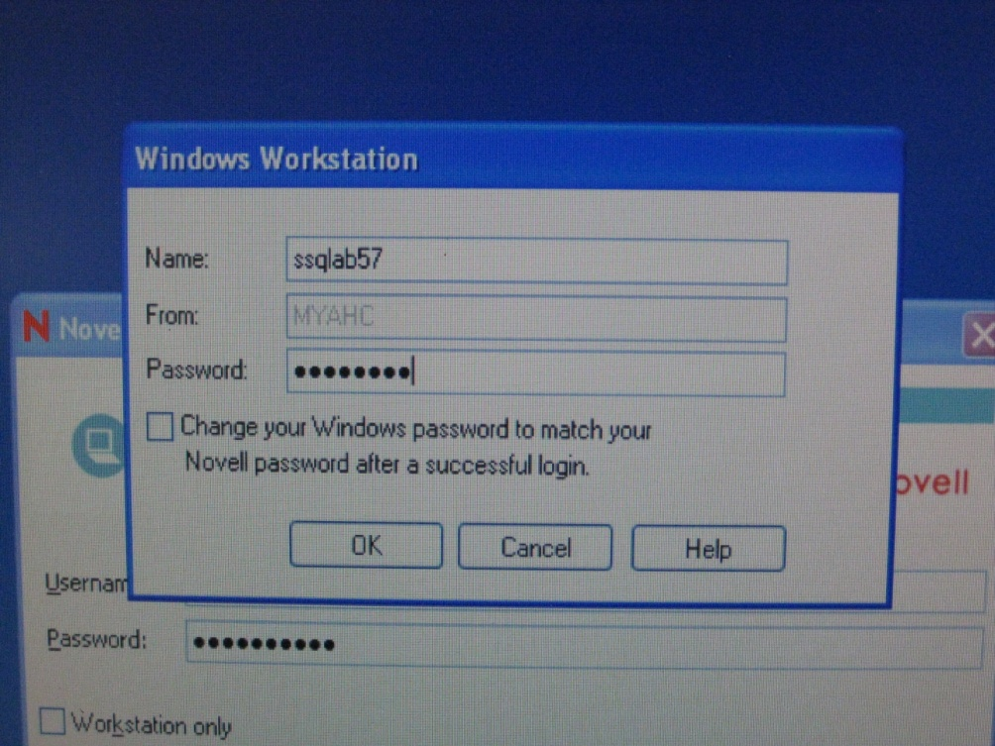

1. At the second screen, the name of the computer will default.

The password is also the name of the computer. This information can also be found on the upper, right-hand corner of all PCs in the blood bank.

Be sure the “Change your Windows password to match your Novell password after successful login” is NOT checked. If this box is checked, only you will be able to access the computer and it will create big issues for other BB staff members.

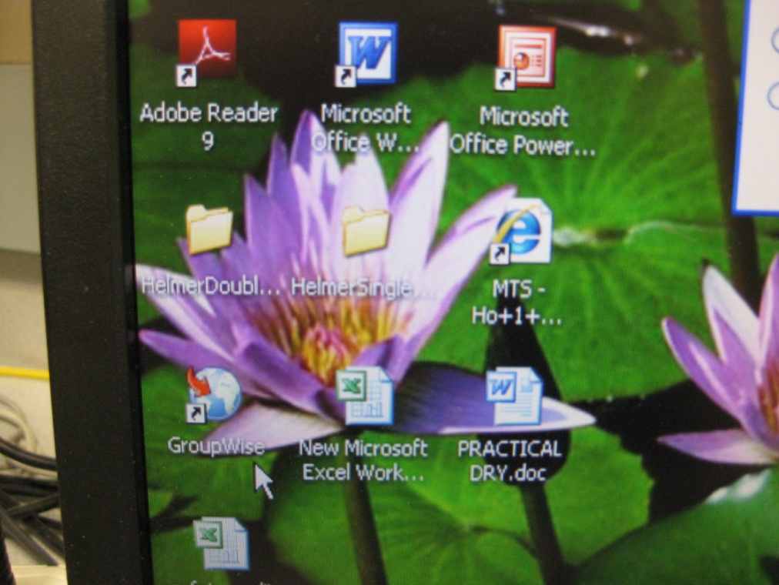

1. To access your Adventist e-mail, click on the “Groupwise” icon.

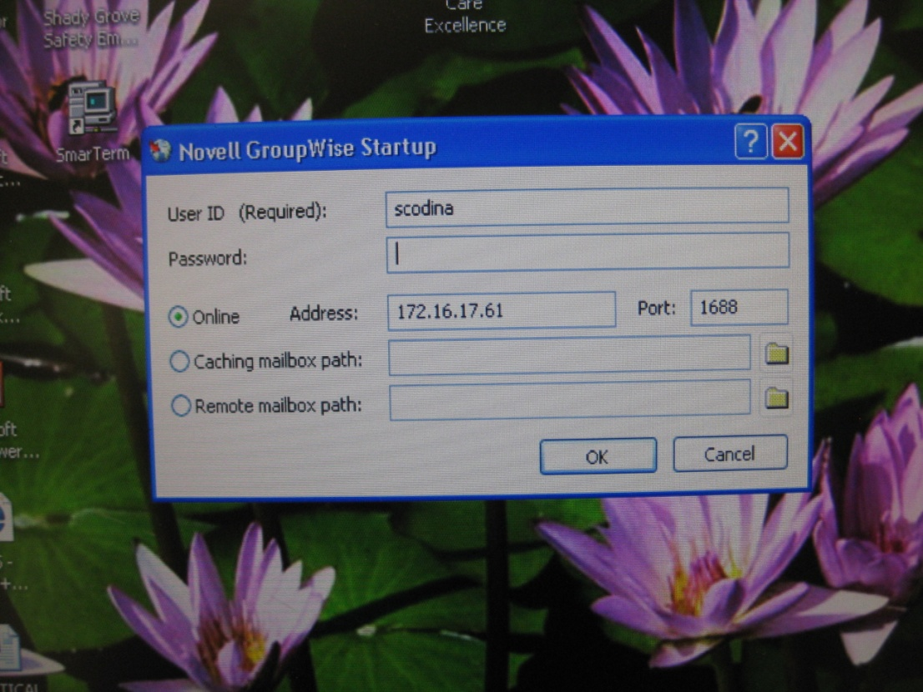

1. Type your Groupwise username and password in at the prompts. These may or may not be the same as your Novell login and password.

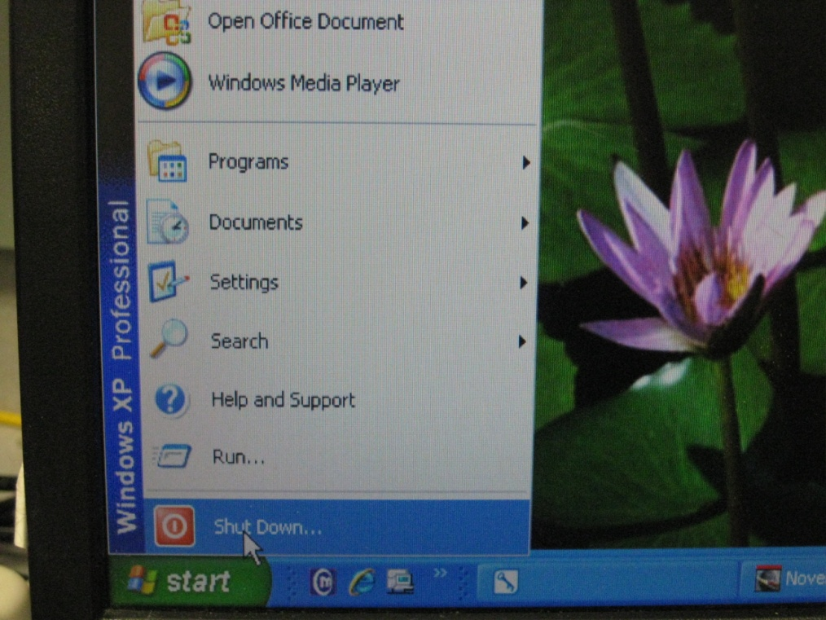

1. At the end of your shift, log off the computer.

Click the “Start” button, then select “Log off computer.”

