Non-Technical SOP
Title | Issuing Blood Products in a 930 Medical Transport Cooler
Prepared by | Stephanie Codina | Date: 1/2/2010
Owner | Stephanie Codina | Date: 1/2/2010

Laboratory Approval
Print Name and Title | Signature | Date
Refer to the electronic signature page for approval and approval dates.
Local Issue Date: | Local Effective Date:

Review:

Print Name | Signature | Date

TABLE OF CONTENTS

1. PURPOSE 2
2. SCOPE 2
3. RESPONSIBILITY 2
4. DEFINITIONS 2
5. PROCEDURE 2
6. RELATED DOCUMENTS 5
7. REFERENCES 5
8. REVISION HISTORY 5
9. ADDENDA AND APPENDICES 5

PURPOSE

The Blood Bank will issue blood products in a blood product cooler to be transported to the patient care area when requested.

SCOPE

This procedure applies to all employees who issue blood products.

RESPONSIBILITY

All blood bank staff must adhere to this procedure for storing and handling blood products in coolers.

DEFINITIONS

None

PROCEDURE

A. Issuing Blood Products in the Blood Product Cooler

Step | Action
1 | Blood products may be issued in a blood product cooler for transport to the patient care area when requested by the nurse or physician caring for the patient.
2 | Retrieve a 930 Medical Transport Cooler.
3 | Place a Polybag in the cooler as the inner liner.
4 | Retrieve 3 Hardsided Polar Pack Gel Bottles from the plasma freezer.  - Place 1 frozen gel bottle in the bottom of the cooler.  - Place 1 frozen gel bottle on the left side of the cooler.  - Place 1 frozen gel bottle on the right side of the cooler.  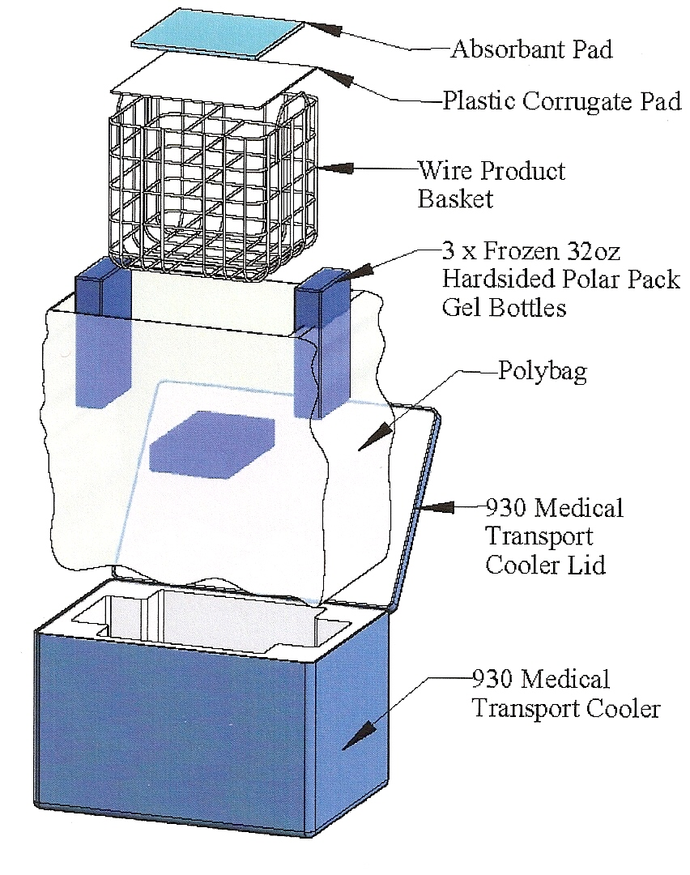
5 | Place wire basket into the cooler.
6 | Place the plastic corrugated pad and absorbent pad in the bottom of the wire basket.
7 | Issue the blood products in the LIS per procedure, “Issuing Blood Components.”
8 | Attach an activated temperature indicator to each unit (blood and/or plasma) that will be transported in the blood product cooler. Refer to procedure, “HemoTemp II Temperature Indicators.”

Step | Action
9 | Place the blood products in the wire basket located inside the cooler. Divide the blood products equally among each side of the wire basket.  - Blood products for ONE patient may be stored in a single cooler. DO NOT place blood products for more than one patient in a single cooler.  - Only red blood cell and plasma products may be transported in the cooler. Any combination of rbc’s and plasma may be stored in a single cooler provided the total number does not exceed 8 units.  - DO NOT place platelet, cryoprecipitate, or non-blood products in the cooler.  - A minimum of 1 unit may be stored in the cooler.  - A maximum of 8 units may be stored in the cooler.
10 | Retrieve 2 refrigerated 16oz. polar pack gel packs from the refrigerator. Place 1 polar pack gel on each side of the wire basket, resting on top of any blood products.  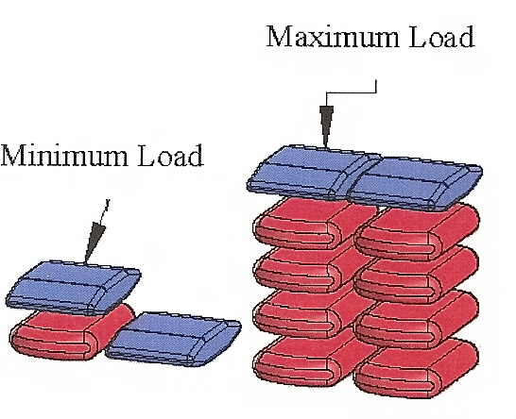
11 | Place the cooler lid on the cooler and secure shut.
12 | Record the patient’s last name and issue time next to the corresponding ice chest number on the white board.  - Blood bank personnel should contact the patient care area if the cooler has been out longer than 3½ hours.  - If the cooler is still needed after 4 hours, a second cooler should be issued and the first cooler should be returned to blood bank. NO COOLER SHOULD BE OUT OF THE BLOOD BANK LONGER THAN 4 HOURS.  - Additional coolers may be issued prior to return of the first cooler if the patient is actively bleeding.
13 | Patient care personnel will return the cooler when it is no longer needed to transport blood products.
14 | Units may be returned to inventory per procedure, “Return and Reissue of Blood Products.”

RELATED DOCUMENTS
SOP: Issuing Blood Components
SOP: HemoTemp II Temperature Indicators
SOP: Return and Reissue of Blood Products
SOP: Variance/Incident and Error/Accident Procedure and Logs

REFERENCES
- Fung, MK, Grossman, BJ, Hillyer, CD, and Westhoff, CM. 2014. AABB Technical Manual, 18th edition, 2014. AABB Publishing, Bethesda, Maryland.
- Standards for Blood Banks and Transfusion Services, 29th ed., 2014. AABB Publishing, Bethesda, Maryland
- ThermoSafe Medical Transporter Model 930 Qualification Report, Tegrant Corporation, ThermoSafe Brands, Phoenix, AZ, 2007.

REVISION HISTORY

Version | Date | Reason for Revision | Revised By | Approved By
 |  | Supersedes SOP WAB303.00
000 | 3.3.2011 | Section 5: remove sections “Returning Blood Products That Have Been Transported in a Cooler” and “Computer Entry”. Reference SOPs ‘Return and Reissue of Blood Products’ and ‘HemoTemp II Temperature Indicators.’  Section 6: add additional documents  Section 9: remove Addendum A | S.Codina | N.Cacciabeve
001 | 5.12.15 | Changed time coolers may be used from 6 hours to 4 hours; updated references; updated responsibility for clarity. | S.Codina | N.Cacciabeve

ADDENDA AND APPENDICES
N/A

