
Laboratories at Adventist Healthcare Washington Adventist Hospital, Shady Grove Medical Center and Germantown Emergency Center

Date: June 5, 2015
LABORATORY ALERT for Processing
Subject: New Chemistry Tests

The Laboratory is informing you of the following test change:
Effective date: | June 17, 2015
Test Names / Codes /  Stability:
  Test | Code | Refrigerated | Frozen
  Ferritin | FERIT | 7 days | 6 months
  Folate | FOLAC | 24 hours | 7 days
  Iron | FE | 7 days | 6 months
  TIBC | TBCP | 24 hours | 7 days
  Prealbumin | PRALB | 24 hours | 7 days
  Vitamin B12 | VTB12 | 48 hours | 7 days
  Vitamin B12 and Folate | FOLB12 | 24 hours | 7 days
  PSA Total | PSAT | 24 hours | 7 days
Specimen Requirements: | Preferred specimen is Lithium Heparin plasma (mint green top tube)  - SST and red top tubes are also acceptable  - Specimens for Vitamin B12 and Folate should be protected from light
Turn Around Time: | Within 24 hours
Additional information:
- Testing will be performed at SGMC only
- Specimens from WAH will be sent once per day via courier (Gary)
- A new aliquot label will print with collection labels. It will list tube type as “PS SG” to indicate a PST tube to be sent to SG
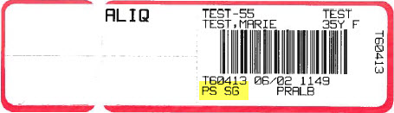
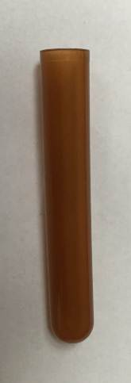

- Specimens for ALL of these tests will be aliquotted into a special amber aliquot tube. Label with the above ALIQ label
Amber aliquot tube
- Perform Tracking in LIS using template WLAB

- Place aliquot specimens into a zip-lock bag. Place that bag and Tracking list into a transport bag with an ice pack. 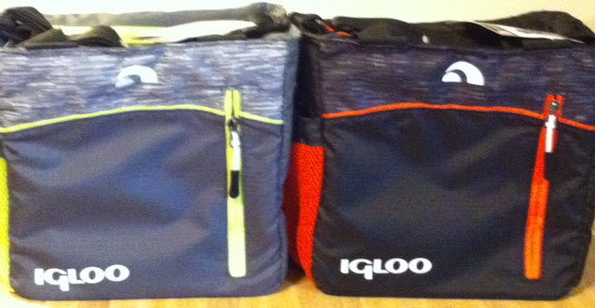
Transport bags

- Place the transport bag at the designated spot. COMPLETE the courier log.

- Send on first courier after morning run is complete

- Empty transport bag will be brought back by courier.

Contacts: | Rob SanLuis, Samson Khandagale and Neal Maskare
LBarrett/6.5.15

G:\AHC_Lab\Clinical Folders\Communication_General Lab\Lab Alerts

