
Laboratory at Washington Adventist Hospital

Date: 6/16/2015
LABORATORY ALERT
Subject: Urine Collection Tubes

The Laboratory is informing you of the following change:
Effective date: | July 6, 2015
Urinalysis Collection Tube  (Tube contains preservative) | The Urine Analysis Preservative Tube will replace the current yellow top tube UA tube in the urine collection kit. This tube will preserve the patient urine sample for up to 24 hours for Urinalysis testing.  Notes:  - The gray top tube for Culture & Sensitivity will remain the same  - Urine sample is transferred into tubes and can be sent immediately via Pneumatic Tube system. |  |  | 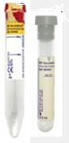
Urine Chemistry Collection Tube  (Plain Yellow Top Tube) | The following tests must be collected in the plain yellow top:  - Urine hCG / pregnancy test  - Urine Drugs of Abuse  - Urine Chemistry Tests (Na, Cl, or Creat) |  |  | 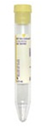
Urine Collection Kit  Obtain from Hospital Materials Management  BD Product Number: 364956 | 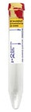  Urinalysis Tube  BD 364992 | 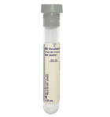  Urine Cult & Sens.  BD 364951 | 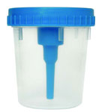  Urine Collection Cup  BD 364975 |  | 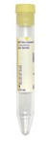  Plain Urine Tube  BD 364980  Not in kit, obtain separately
Additional Information: | The Lab will accept properly labeled urine samples for urinalysis received in plain yellow tubes until the older kit supply has been exhausted.
Lab Contacts: | Neal Maskare WAH 301-891-6126  Robert SanLuis, WAH 301-891-6238 or SGMC 240-826-6095

G:\AHC_Lab\Clinical Folders\Communication_General Lab\Lab Alerts

