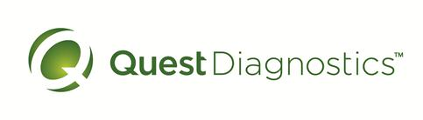
Laboratories at Adventist Healthcare Washington Adventist Hospital, Shady Grove Medical Center and Germantown Emergency Center

Date: Sept 29, 2015
INTERNAL LABORATORY ALERT
Subject: Lactic Acid

The Laboratory is informing you of the following test change:
Effective date: | October 1, 2015
Lactic Acid | Cerner is implementing a new Sepsis Protocol.  All Lactic Acid values > 1.9 will be called.  Sunquest and DI will automatically tag these values to be called with -CALL  Note: There is NO change to our critical value of >4.0
Marie Sabonis/ 092915

G:\AHC_Lab\Clinical Folders\Communication_General Lab\Lab Alerts

