
Laboratories at Adventist Healthcare Washington Adventist Hospital, Shady Grove Medical Center and Germantown Emergency Center

Date: May 5, 2016
LABORATORY ALERT
Subject: New QC for PT, APTT, Fibrinogen & Thrombin Time

The Laboratory is informing you of the following test change:
Effective date: | SGMC  May 5, 2016 | WAH  May 9, 2016 | GEC  May 10, 2016
Test Name: | PT, APTT, Fibrinogen & Thrombin Time (WAH)
QC Information | Bio – Rad Lyphochek Coagulation Control, Levels 1, 2 and 3  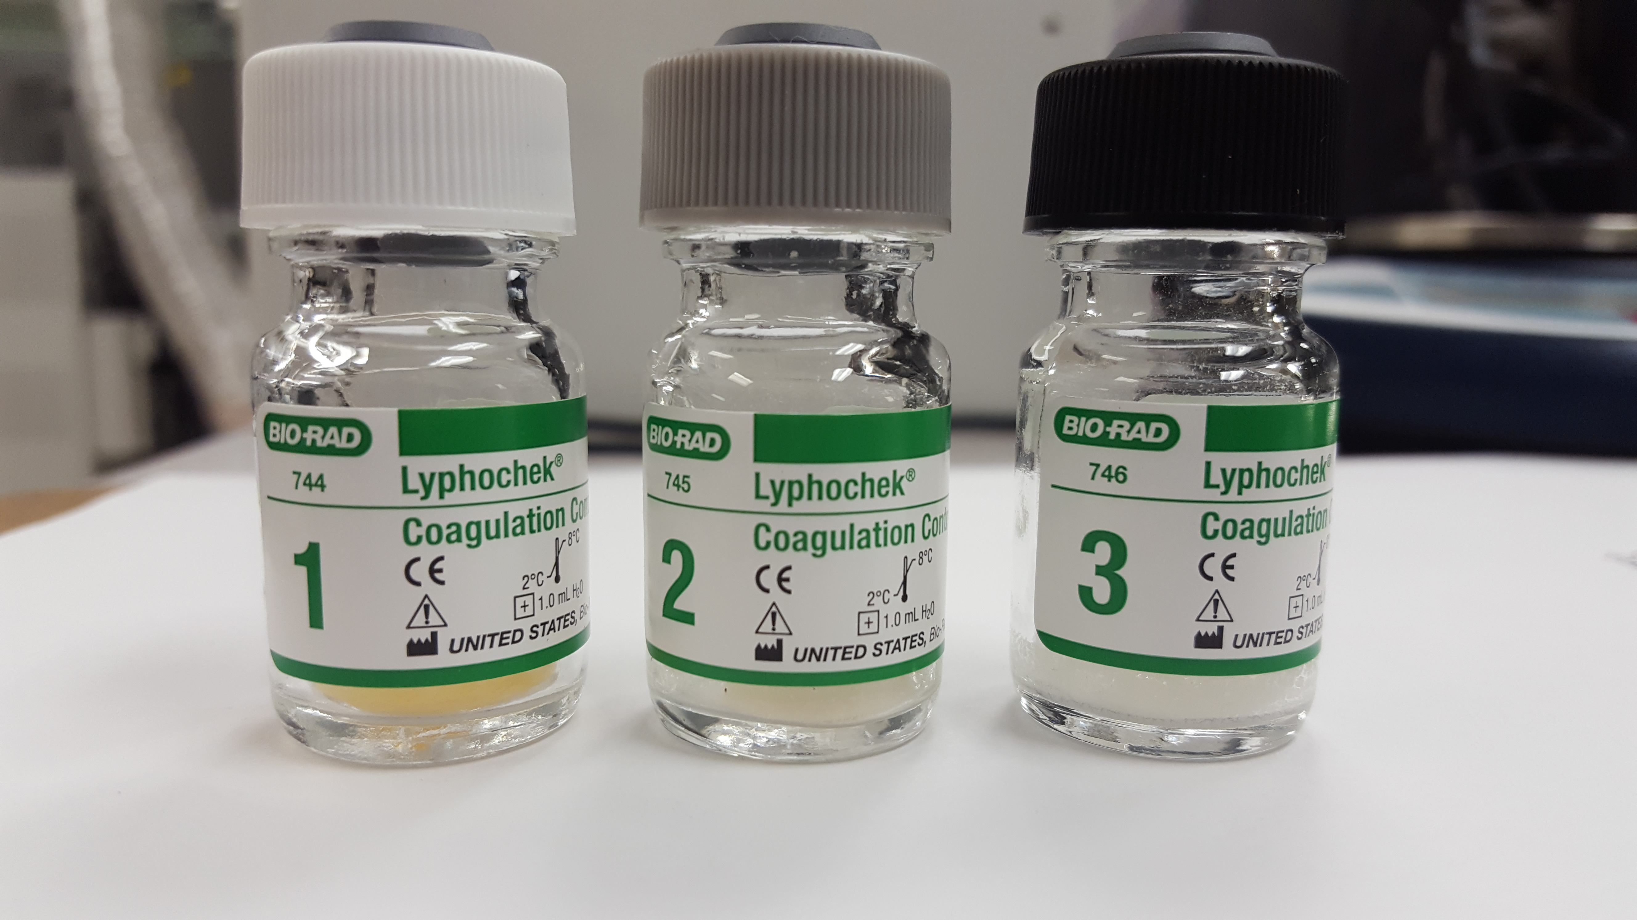
QC Stability: | Stable until expiration date when stored unopened at 2 - 8° C.  After reconstitution, this product will be stable for 48 hours when stored onboard Stagos or at 2 - 8° C.
QC Preparation: | Reconstitute each vial with exactly 1 mL of Reagent Grade water. Replace the stopper and allow this product to stand for 10 – 15 minutes swirling occasionally. Before sampling, gently swirl the vials several times to ensure homogeneity.
QC frequency: | All three levels are run at the beginning of each shift and every 4 hours after and with the change of any reagent used in test performance. All three levels are run after maintenance also.
Contacts: | Zanetta Morrow, Julie Negado & Rob SanLuis
ZMorrow /5.5.16

G:\AHC_Lab\Clinical Folders\Communication_General Lab\Lab Alerts

