TRAINING UPDATE

Lab Location: | SGMC and WOMC | Date Implemented: | 10/2/2020
Department: | Field Ops | Due Date: | 10/18/2020

DESCRIPTION OF PROCEDURE REVISION

Name of procedure:
Specimen Receipt and Processing

Description of change(s):
We made changes to the way samples will be received in processing. These changes were made, because staff were not receiving all lab orders that applied to the specimens.

- Patients should be searched using MRN and not accession number.
- Change the “Order Status” radial button from “All” to “Unreceived.”
- Review all orders and receive the appropriate orders.

Non-Technical SOP
Title | Specimen Receipt and Processing
Prepared by | Samson Khandagale | Date: 3/20/2015
Owner | Stephanie Codina | Date: 10/19/2017

Laboratory Approval
Print Name and Title | Signature | Date
Refer to the electronic signature page for approval and approval dates.
Local Issue Date: | Local Effective Date:

TABLE OF CONTENTS

1. PURPOSE 1
2. SCOPE 1
3. RESPONSIBILITY 1
4. DEFINITIONS 1
5. PROCEDURE 2
6. RELATED DOCUMENTS 7
7. REFERENCES 7
8. REVISION HISTORY 7
9. ADDENDA AND APPENDICES 8

PURPOSE
This procedure describes the process for receiving specimens in the laboratory.

SCOPE
All specimens that arrive in the laboratory will be received and processed for testing.

RESPONSIBILITY
All laboratory staff members must understand and adhere to this procedure when receiving and processing specimens for testing.

DEFINITIONS
Irreplaceable specimen – a specimen obtained by invasive means that is not easily obtained or replaced, i.e. CSF, body cavity fluids, fine needle aspirations, surgical biopsies, etc.

PROCEDURE

Step |  | Action
1 |  | Specimens will be transported to the laboratory in person (lab/hospital staff) or via pneumatic tube station. Specimens dropped off in the laboratory by non-laboratory personnel must be properly recorded on the specimen receipt log.
2 |  | Specimens will be processed in the order in which they arrive (specimens delivered first will be processed first) and they will be prioritized as follows:  - Specimens on ice  - Irreplaceable specimens (such as body fluids)  - Green biohazard bags  - Purple biohazard bags  - Red or orange bags  - Stat and timed specimens  - Routine specimens
3 |  | Verify the specimen is labeled properly. Each specimen must include the following:  - Patient’s full name  - Patient’s medical record number  - FIN may be used during periods of computer downtime for registered patients  - Birthdate may be used for patients whose specimens were collected at outside locations such as Mercy Health, MobileMed, etc.  - Date and time of collection  - Collector’s initials or identification  Forward all blood bank specimens to blood bank for review. Blood bank staff will check labeling and adequacy.  The specimen will be rejected if the name and/or medical record number is incorrect or absent. The collector may come to the laboratory to fix specimens with missing or incorrect collection date/time and/or collector’s initials.  The laboratory will not return any specimens to the floor for any reason once received. All edits to specimen labels must be completed in the confines of the laboratory.
4 |  | Verify that the specimen submitted meets the requirements for testing. Characteristics that should be considered when evaluating the adequacy of a specimen include, but are not limited to, the following.  - Specimen container is within the manufacturer’s expiration date. Verify only if visible; do not remove labels to verify expiration date.  - Correct specimen container  - Correct anticoagulant for blood tubes  - Adequate specimen volume  - Timely specimen delivery (as outlined by the stability standards for the requested test(s).  - Accurate blood-to-anticoagulant ratio as indicated by the collection tube and test requirements  - Adequate visual inspection of the tube/container.  - Specimen does not appear to be contaminated.  - Specimen is not leaking.  - Visual clots are not seen.  - Gross hemolysis is not seen.  - Accurate correlation of specimen collection time when timed specimens are collected.  - The test code ordered should match the specimen type. Edit orders that correspond to the incorrect specimen type.  - During periods of computer downtime, paper requisitions must be completely and accurately filled out. Information on the requisition must match information on the specimen label.  Cancel a specimen that is not adequate for testing per procedure.
5 | Receive specimens in Sunquest per one of the below procedures. Keep in mind the following:  - Each accession number should contain only one specimen type (blood, urine, stool, etc.).  - Miscellaneous tests require extra handling. Refer to the procedure.  - Specimens received without orders should be documented per procedure. Extra tube orders should be placed for EVERY specimen received without orders.  - Each microbiology specimen should be on its own accession number. Edit specimens that overlap accession numbers by receiving one specimen then cancelling and reordering the other tests on new accession numbers.  - Microbiology specimens cannot have the same collect time or results will not post to Cerner. Separate the collect times by 1 minute in Sunquest if more than one specimen is received with the same collect time.
6 | Relabel tubes with laboratory labels as needed per procedure.
7 | Separate and deliver specimens to the appropriate section of the laboratory.  - Specimens that require centrifugation should be placed into the centrifuge.  - Chemistry, send out, and extra specimens are placed in the centrifuges between processing and chemistry.  - Coagulation specimens are centrifuged in the coag area.  - Blood bank armbands should be delivered to blood bank with specimens.  - If aliquot labels print during receipt, bring the aliquot label to the bench with the specimens.

Receiving Specimens in Sunquest
Step | Action
1 | Access Sunquest GUI.
2 | Select function “General Laboratory.”  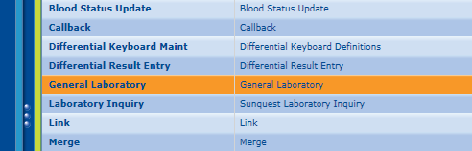
3 | Select “Order Receipt/Modify” from the dropdown menu in the upper, left-hand corner of the screen.  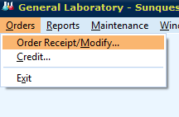
4 | If the specimen is not labeled with a lab label,  - Select “Patient ID” from the Access Option dropdown menu.  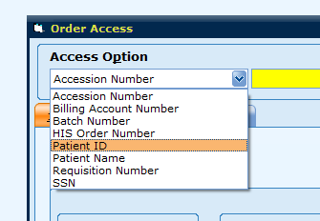  - In the yellow box, enter the medical record number from the tube then click the “Get Orders” box. You may also scan the MRN from the Cerner patient label.  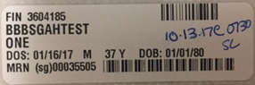  This barcode contains the MRN
5 | In the “Order Status” area, click the “Unreceived” radial button.  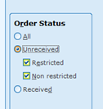
6 | Click the “Display Orders” button.  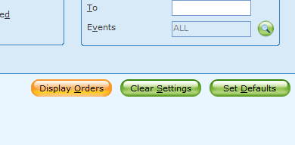
7 | The order codes pending for the patient will appear at the top of the screen. Click on the accession that corresponds to the specimen you would like to receive.  - You can only receive one accession at a time.  - Ensure you have received all tubes required to complete testing on the accession number. If you are missing a tube or cannot complete the testing, cancel that particular test and reorder per procedure.  - Do not receive testing for which you do not have a specimen.  - Do not reschedule a test in processing.  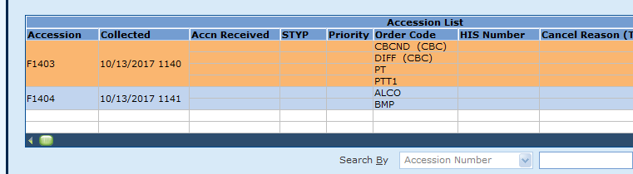
8 | Print a lab label if indicated. Print the label prior to receiving the specimen.  - Click the “Reprint Labels” button.  - All orders on the accession will display.  - Highlight the orders for which you need a label or click “select all.”  - Click the “Print” button.  - The labels will print.  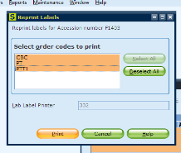
9 | At the “Collection date” prompt, type the date the specimen was collected from the tube. Pay special attention to this field if the sample was collected around midnight. If a sample was ordered before midnight and collected after midnight, the date will be incorrect and nursing/provider staff will not be able to see results.  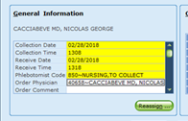
10 | At the “Collection time” prompt, type the time the specimen was collected from the tube.  Note: If more than one microbiology sample is received with the same collect date and time, separate the collect times by 1 minute. Microbiology results will not cross into the patient’s electronic medical record if we duplicate collection date and time.
11 | At the “Received date” press the “tab” key to default the current date or type a date in the field.
12 | At the “Received time” press the “tab” key to default the current time or type a time in the field.
13 | At the “Phlebotomist’s code” prompt, enter one of the following.  - Type the tech ID if a phlebotomist collected the specimen.  - Enter “850” for nurse collect.  - Enter “855” for Mobile Med collect.  - Enter “860” for ED collect.  - Enter “865” for Mercy Health collect.  - Enter “870” for physician collect.  - Enter “880” for patient collect (such as urine).  - Enter “905” for autotransfusion samples.
14 | If extra tubes are received, order barcodes for them by entering the mnemonic in the “Order code” area.  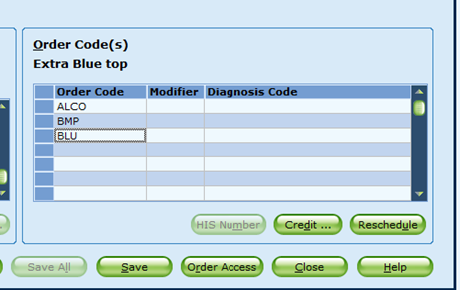
15 | Review the accuracy of the information and correct as necessary. Then, press the “Save” button.
16 | Additional information is required for some tests. A pop-up screen will appear with prompts. The mnemonic will appear in yellow and the test definition will appear in the “Test” area below. Answer the prompts per procedure. Then, click the “Save” button.  - Microbiology specimens will require that a source is entered.  - Sunquest will prompt, “SDES.” At the “SDES” prompt, verify that the source listed in the LIS matches the source listed on the specimen.  - If the source matches, proceed with receiving the order.  - If the source does not match, modify the source in the LIS to match the source on the specimen.  - Acceptable source codes may be found by typing a left bracket "[" followed by a few letters that describe the source. Example: "[nasal" will give the source code "NP"  - Use a hyphen to add further descriptions Example: FOOT-RT for right foot  - Sunquest may also prompt the “SREQ” special request field. This field will autofill as “HIDE.” Do not use this field.  - Blood bank type and screen specimens require that an armband number is entered. Sunquest will prompt, “RN.” Enter through this prompt; blood bank staff will enter the armband number.  Note: Predefined English text codes (ETC) should be entered directly into the field and free-text results require a semi-colon “;” before the entry. Do not enter a semi-colon before an ETC.  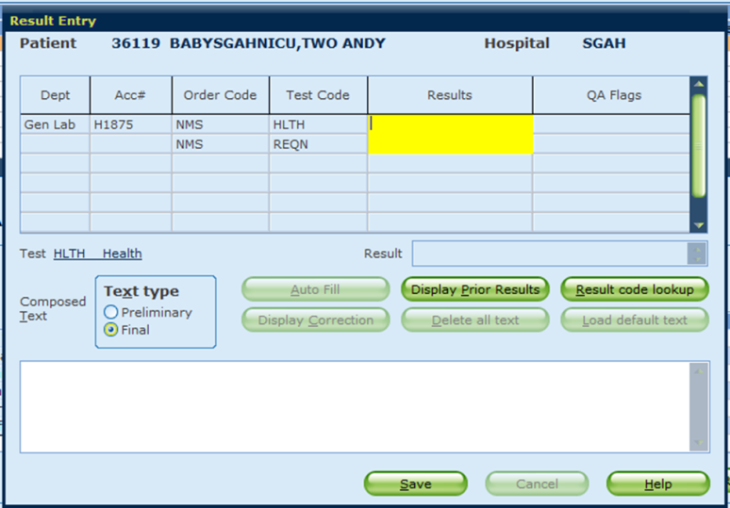

RELATED DOCUMENTS
Specimen Acceptability Requirements
Cancelling Tests or Orders
Miscellaneous Test Ordering
Specimens without Orders
Specimens without Orders Log (AG.F318)
Laboratory Specimen Receipt Log (AG.F323)
Specimen Labeling (Secondary)

REFERENCES
Laboratory for Windows User’s Guide for Sunquest Laboratory, Software Version 7.1

REVISION HISTORY

Version | Date | Reason for Revision | Revised By | Approved By
0 | 6/8/15 | Section 4: add SDES and SREQ  Section 5: Add detail to microbiology (step B.5), change clear tube to plain yellow top for other urine tests and stability for preservative tube (step C.5)  Section 6: Remove Microbiology Processing SOP | L Barrett | S Khandagale
1 | 10/19/17 | Updated owner  Header: add other sites  Sections 1 & 2: Updated to reflect content  Section 3: Edited to include all staff  Section 5: Updated formatting and wording for clarity; added steps to receive specimens in the LIS (primary and alternate methods)  Section 6: Removed LIS SOPs, added secondary labeling | SCodina | NCacciabeve
2 | 2/28/18 | Section 5: Added process for aliquot labels; added process for scanning lab labels; deleted requirement to enter workload codes; updated pictures | SCodina | NCacciabeve
3 | 9/25/20 | Header: Changed WAH to WOMC  Section 5: Removed alternate receiving procedure (staff are missing orders when using this method). Added instructions to look at “unreceived” specimens. Added mobile med/mercy health collect. Added statement telling staff never to reschedule samples in processing. | SCodina | NCacciabeve

ADDENDA AND APPENDICES
None

