## TRAINING UPDATE

|  |  |  |  |
| --- | --- | --- | --- |
| **Lab Location:** | SGMC and WOMC | **Date Implemented:** | 10/2/2020 |
| **Department:** | Field Ops | **Due Date:** | 10/18/2020 |

### DESCRIPTION OF PROCEDURE REVISION

|  |
| --- |
| **Name of procedure:** |
| Specimen Processing Sendouts |
| **Description of change(s):** |
| Several changes were made to this procedure. When doing ROB,   1. Staff will pull a pending log.    1. Use the pending log to ensure all of the required questions have been answered. **Do not send the test until we can result the prompts required for the test.**    2. Aliquot the specimens and sort by storage condition (refrigerated, room temp, frozen). 2. Manually create an ROB batch list by storage condition. We will no longer let the system create automatic batches, because too many staff members were not verifying that all samples were sent. 3. Queue the ROB batch for transmission. 4. Pull a new pending log to ensure all specimens are accounted for. |

Non-Technical SOP

|  |  |  |
| --- | --- | --- |
| Title | **Specimen Processing Sendouts** | |
| Prepared by | Lori Loffredo | Date: 12/14/2010 |
| Owner | Stephanie Codina | Date: 5/24/2018 |

|  |  |  |
| --- | --- | --- |
| Laboratory Approval | | |
| **Print Name and Title** | **Signature** | **Date** |
| *Refer to the electronic signature page for approval and approval dates.* |  |  |
| Local Issue Date: | Local Effective Date: | |

**TABLE OF CONTENTS**

1. PURPOSE 1

2. SCOPE 1

3. RESPONSIBILITY 1

4. DEFINITIONS 1

5. PROCEDURE 2

6. RELATED DOCUMENTS 9

7. REFERENCES 9

8. REVISION HISTORY 9

9. ADDENDA AND APPENDICES 11

# PURPOSE

This procedure describes the preparation of specimens for sending to reference laboratories for testing.

# SCOPE

This procedure applies to any specimen that will be sent to Quest reference laboratory for testing or referral to another laboratory.

# RESPONSIBILITY

All staff assigned to Specimen Processing must understand and perform these duties when referring specimens to Quest for testing.

# DEFINITIONS

**Irreplaceable specimen:** A specimen that has been obtained by invasive means that is not easily obtained or replaced, i.e. CSF, body cavity fluids, fine needle aspirations, surgical biopsies, tissue, etc.

# PROCEDURE

**Print Pending Log**

| **Step** | **Action** |
| --- | --- |
| 1 | All tests must be received in Sunquest before beginning this process. |
| 2 | Print a pending log for each batch of specimens being referred to Quest Diagnostics for testing. The pending log will provide additional information required for test submission such as specimen source, specimen volume, and other information required for specific tests. |
| 3 | Access Sunquest SmarTerm. |
| 4 | At the “Function” prompt, type “PL” for pending log. |
| 5 | At the “Printer” prompt, type the number of the printer to which you would like to print the report. |
| 6 | The following screen will appear. Answer the following prompts:   1. At the “Start Date” prompt, type “T-3” and press enter. 2. At the “Start Time” prompt, type “0001” and press enter. 3. Press enter at the following prompts to accept the default responses.    1. Cut-off date    2. Cut-off time    3. Include preliminary results    4. Include AD comments    5. Print rack numbers    6. Print expanded comments 4. At the “All, Received, Unreceived” prompt, type “R” and enter for received specimens. 5. At the “Hospital ID” prompt, type the hospital for which you are pulling the report. A new report must be generated for each location.    1. SGAH = Shady Grove Medical Center    2. WAH = White Oak Medical Center    3. ARHT = Adventist Rehabilitation Hospital at Takoma Park    4. ARHR = Adventist Rehabilitation Hospital at Rockville 6. At the “Worksheet(s)” prompt, type “REFOE” for “Result at order entry.” 7. At the “Lab location(s)” prompt, press enter to default “all lab locations.” 8. At the “Accept, Modify, Reject” prompt, type “A” for accept and press enter. 9. The pending log will print.     Default is “ALL” for Hospitals and Worksheets  Default is current date. Change to T-3. |
| 7 | Review the pending log to determine if there are any missing results/responses for “result at order entry.” Resolve pending tests as required. There are no pending tests if the report is blank. Orders with missing results will not transmit to Quest.   1. Access Sunquest GUI function, “Order Entry.” 2. At the “Lookup by” prompt, select “Accession Number” from the dropdown menu. 3. At the “Value” prompt, type in the accession number to be edited. 4. Click the “Search” button. 5. Click the “Results” button at the bottom of the screen. 6. Follow the prompts and result any missing information. |
| 8 | Attach this list to the sendout ROB for documentation that this step was completed. |

**Aliquot Specimens**

| **Step** | **Action** |
| --- | --- |
| 1 | Aliquot non-micro specimens in plastic transport vials and label per procedure aliquoting specimens.   1. Access test information using Sunquest function MIQ or contact Chantilly client service as needed to verify you have the correct specimen type and sufficient volume. DO NOT send out specimens that do not meet the test requirements.   Note: If the specimen was drawn from a neonate and it does not meet volume requirements, notify the patient care area that the specimen is less than the minimum volume for the test. If the provider insists, send the specimen to Quest to see if testing can be completed but document the name of the person that was notified the specimen volume may be insufficient. |
| 1  Cont | 1. Write the client number on any specimen going to Quest.    1. 25224 WOMC non-micro    2. 23494 WOMC micro    3. 25225 SGMC non-micro    4. 23495 SGMC micro    5. 25225 ARH non-micro    6. 23495 ARH micro 2. Write the storage conditions on the tube if the specimen must be stored refrigerated or frozen. |
| 2 | Separate irreplaceable specimens from replaceable ones.   1. Immediately place each irreplaceable specimen in a designated **purple bag** (one specimen per bag). 2. Mark the appropriate storage condition (refrigerated, frozen, room temperature) on each bag. Refer to MIQ for test details. 3. Irreplaceable specimens will remain and be shipped in the purple bags. 4. Purple bags are placed in a bin labeled, “IRREPLACEABLE SPECIMENS” until send out processing begins. |

**Create a pending ROB**

| **Step** | **Action** |
| --- | --- |
| 1 | Create a pending ROB (Reference Order Batch) list to ensure that every order is addressed. This step must be completed prior to creating an ROB batch list. |
| 2 | Access Sunquest SmarTerm. |
| 3 | At the “Function” prompt, type “ROB” and press enter. |
| 4 | At the “Tech” prompt, press enter to default your tech code and name. |
| 5 | At the “Interface number” prompt, type one of the following and press enter.   1. Type “601” for non-microbiology tests 2. Type “602” for microbiology tests   These numbers are associated with our sites (SGAH, WOMC, and ARH). |
| 6 | A menu will appear. Select option “6” for “Reports” and press enter. |
| 7 | At the next menu, select option “1” for “Pending List” and press enter. |
| 8 | At the “Hospital ID” prompt, type one of the following and press enter. A new report must be generated for each location.   1. WAH for White Oak Medical Center. 2. SGAH for Shady Grove Medical Center. 3. ARHT for Adventist Rehabilitation Hospital at Takoma Park. 4. ARHR for Adventist Rehabilitation Hospital at Rockville.   Notes:   1. Do not pull for location ARH. ARH will list specimens for both   ARHT and ARHR.   1. Do not pull automatic batches. Create a different batch for each site. |
| 9 | At the “Patient event type(s)” prompt, type one of the following:   1. For NON-MICRO specimens, type “A” to default “All.” 2. For MICRO specimens, type “MC” for “Microbiology.” |
| 10 | At the “Cutoff Collect Date” prompt, press enter to default the current date. |
| 11 | At the “Cutoff Collect Time” prompt, press enter to default the current time. |
| 12 | At the “Include unreceived specimen” prompt, press enter to default no. |
| 13 | At the “Accept, Modify, Reject” prompt, type “A” for accept and press enter. |
| 14 | At the “Printer” prompt, type the number of the printer to which you want the report to print and press enter. |
| 15 | Review the ROB pending log and obtain all specimens. **Check each one to ensure you can account for every specimen.** |

**Create a Batch List**

| **Step** | **Action** |
| --- | --- |
| 1 | Access Sunquest SmarTerm. |
| 2 | At the “Function” prompt, type “ROB” and press enter. |
| 3 | At the “Tech” prompt, press enter to default your tech code and name. |
| 4 | At the “Interface number” prompt,   1. Type “601” for non-microbiology tests and press enter. 2. Type “602” for microbiology tests and press enter.   These numbers are associated with our sites (SGAH, WAH, and ARH). |
| 5 | A menu will appear. Select option “1” for “Create Batch” and press enter. |
| 6 | At the “Hospital ID” prompt, type one of the following and press enter. A new report must be generated for each location.   1. WAH for White Oak Medical Center. 2. SGAH for Shady Grove Medical Center. 3. ARHT for Adventist Rehabilitation Hospital at Takoma Park (WAH). 4. ARHR for Adventist Rehabilitation Hospital at Rockville (SGMC). |
| 7 | At the “Automatic or Manual Create” prompt, select the default value “M” for manual and press enter. |
| 8 | At the “Department, Worksheet, Lab Location, or All” prompt, press “enter” to default “department.” |
| 9 | For NON-MICRO processing, enter ALL of the following at the “Department(s)” prompt. Note, these must be entered individually, so specimens append to the correct shipping temperature.   1. Department (s): **RLR** for “reference lab refrigerated” and press enter. 2. Department (s): **RLT** for “reference lab room temp” and press enter. 3. Department (s): **RLZ** for “reference lab frozen” and press enter. 4. Department (s): **RLO** for “reference lab other” (this is used for miscellaneous tests) and press enter.   For MICRO processing, at the “Department (s):” prompt, enter **MC** for “microbiology” and press enter. |
| 10 | At the “Accept, Modify, Reject” prompt, type “A” for accept and press enter. |
| 11 | At the “Manual Create Batch (worksheet)” prompt,   1. Scan each specimen and press enter. 2. For micro, scan one specimen from each bag and press enter. Remove specimens from a single bag and return them to the bag; do not remove specimens from more than one bag at a time. 3. Repeat step A until all “bags” have been entered. |
| 12 | At the “Print Batch List” prompt, type “Y” for yes and press enter. |
| 13 | At the “Printer” prompt, type the number of the printer to which you want the report to print and press enter. |
| 14 | Compare the accession numbers, patient names, and patient medical record numbers on the specimen tubes to the accession numbers, patient names, and patient medical record numbers listed on the batch list. Ensure all specimens are accounted for. Review one specimen at a time. Only remove plates for one microbiology specimen at a time from the bag. |
| 15 | Modify the batch to remove specimens if any of the following occur:   1. You are unable to locate a specimen. 2. The provider cancelled a test. 3. An inappropriate test is ordered.   Note: Removing a test from the batch does not cancel the test. You must cancel the test per procedure.  **Modify a batch:**   1. Access Sunquest SmarTerm. 2. At the “Function” prompt, type “ROB” and press enter. 3. At the “Tech” prompt, press enter to default your tech code and name. 4. At the “Interface number” prompt, type one of the following and press “enter.” This number is associated with our sites (SGAH, WAH, and ARH).    1. Type “601” for non-microbiology tests.    2. Type “602” for microbiology tests. 5. A menu will appear. Select option “2” for “Modify Batch” and press enter. 6. At the “Batch date” prompt, type the date on which the batch was created and press enter. 7. At the “Batch number” prompt, type the batch number that is located on the Order Batch Listing and press enter. 8. At the “Automatic or Manual Modify” type “M” for manual and press enter. 9. At the “Accept, Modify, Reject” prompt, type “M” for modify and press enter. 10. At the “Accession #” prompt, type the accession number to be modified and press enter. 11. At the “Order code” prompt, type the order code to be removed. Note: the order codes will display in step J above. 12. The test name will display. 13. Under the test name, type a hyphen “-” and press the enter key. 14. The comment, “Order removed from batch” will display. 15. At the “Put into a pending pool” prompt, type “Y” and press enter.   Note: If you say “N” at this prompt, the test will not qualify for a subsequent order batch when created.   1. Repeat steps J-N for any additional accessions that need to be modified. 2. At the “Print batch list” prompt, type “Y” for yes and press enter. 3. At the “Printer” prompt, type the number of the printer to which you want the report to print and press enter. |

**Queue Batch for Transmission**

| **Step** | **Action** |
| --- | --- |
| 1 | When you queue the batch for transmission,   1. The orders in the batch will electronically transmit to Quest Diagnostics Chantilly. 2. The packing list that is used to ship specimens will print. |
| 2 | Access Sunquest SmarTerm. |
| 3 | At the “Function” prompt, type “ROB” and press enter. |
| 4 | At the “Tech” prompt, press enter to default your tech code and name. |
| 5 | At the “Interface number” prompt, type one of the following and press enter.   1. Type “601” for non-microbiology tests. 2. Type “602” for microbiology tests.   This number is associated with our sites (SGAH, WAH, and ARH). |
| 6 | A menu will appear. Select option “3” for “Queue Batch” and press enter. |
| 7 | At the “Batch date” prompt, type the date on which the batch was created and press enter. |
| 8 | At the “Batch number” prompt, type the batch number that is located on the Order Batch Listing and press enter. |
| 9 | At the “Accept, Modify, Reject” prompt, type “M” for modify and press enter. |
| 10 | At the “Print Packing List?” prompt, type “Y” for yes and press enter. |
| 11 | At the “Number of copies” prompt, type “2” and press enter.   1. One copy is sent with the specimens. 2. The second copy is saved on site in the designated area for 2 weeks. |
| 12 | At the “Printer” prompt, type the number of the printer to which you want the report to print and press enter. |
| 13 | **For Microbiology Specimens only: Perform FES per procedure.** |
| 14 | Package the specimens and the packing list in the appropriately colored bag.   1. Irreplaceable specimens are segregated in a purple bag and the appropriate storage conditions are checked on the front of the bag. **Never** place a purple bag inside another bag. 2. Refrigerated specimens (RLR) go in a blue bag in the designated refrigerator. 3. Room temperature specimens (RLT) go in an orange bag at the designated room temperature location. 4. Frozen specimens (RLZ) go in a yellow bag in the designated freezer. 5. Microbiology specimens (MC) go in a regular, biohazard bag in the incubator. |
| 15 | Reprint the pending log per instructions above to ensure all specimens were properly ROB’d and none were missed. Please note that specimens received since the ROB list was created will be added to the pending log. |

# RELATED DOCUMENTS

Specimen Receipt and Processing

Aliquoting Specimens

MIQ 1 – Maintenance Inquiry, Test Code Lookup

Cancelling Tests or Orders

FES, Processing Microbiology Orders

# REFERENCES

None

# REVISION HISTORY

| Version | Date | Reason for Revision | Revised By | Approved By |
| --- | --- | --- | --- | --- |
|  |  | Supersedes SOPs - SGAH/WAH.S04.000, SGAH/WAH.S05.000, WAH.S18.000, SGAH.S19.000, SGWAH.S017.001 |  |  |
| 000 | 12/5/2013 | Section 4: added facility codes  Section 5: Item A.3 added location ARH  Item C - added instructions for ROB pending logs and handling of ARH samples  C.I - added steps to pull pending log in ROB  C.II, step 11 - use manual batch creation  Item D - Deleted TIBC, FERTN & Prometheus samples from Tracking List for Send Out Tests, Non-Quest or Between Sites.  Footer: version # leading zero’s dropped due to new EDCS in use as of 10/7/13 | N Maskare,  S Khandagale | S Khandagale |
| 1 | 4/7/16 | Section 4: add irreplaceable and replaceable  Section 5:  Item A & C.V: add purple bag process  Item D.II – update tracking template codes  Section 9: add purple bag | L Barrett  S Khandagale | S Khandagale |
| 2 | 5/24/18 | Updated owner  Header: Added WAH  Section 5: Moved tracking to its own procedure. Moved overdue log to its own procedure. Updated format and wording for clarity.  Section 6: Updated SOP titles | SCodina | NCacciabeve |
| 3 | 12/14/18 | Section 5: Clarified procedure for manually entering micro specimens. | SCodina | NCacciabeve |
| 4 | 12.19.19 | Header: Changed WAH to WOMC  Section 5: Added requirement to add the PL to the sendout ROB to document that this step was done. Moved Faxback Log to a separate procedure. | SCodina | NCacciabeve |
| 5 | 9.25.20 | Section 5: Changed non-micro to “manual” batch. Added the requirement to pull pending log at the end to verify all specimens were ROB’d | SCodina | NCacciabeve |

# ADDENDA AND APPENDICES

A. Purple Bag for Irreplaceable Specimen

**Purple Bag for Irreplaceable Specimen**

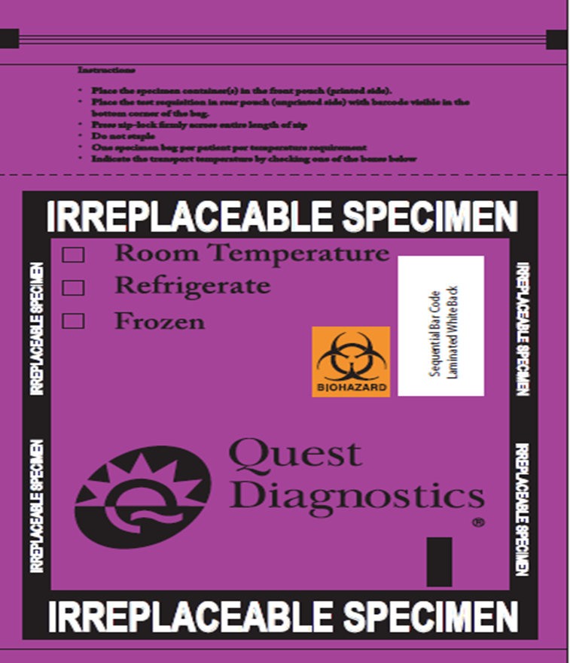

**Examples of irreplaceable specimens**:

Tissue biopsy or bone marrows

Fine needle biopsies/aspirations

Body cavity fluids (synovial, pleural, peritoneal, ascites)

Products of Conception (for chromosome analysis)

Lavages, washings, or brushings

Cerebrospinal Fluid (CSF)

Cord blood

Stones

Meconium (for drug screening)