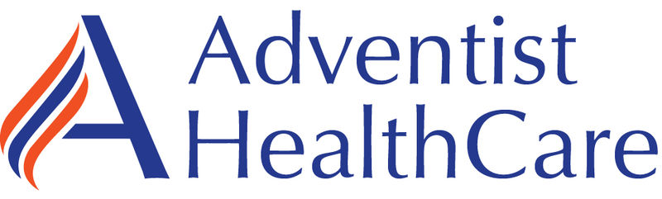

Laboratories at Adventist Healthcare White Oak Medical Center, Shady Grove Medical Center, Fort Washington Medical Center and Germantown Emergency Center

Date: January 21, 2022
LABORATORY ALERT
Subject: New Sani-Cloth Prime Wipes for 2022

The Laboratory is informing you of the following test change:
Effective date: | January 2022--When current hydrogen peroxide wipes (green top) supply is depleted
Product Name: | Sani-Cloth Prime wipes (purple top)
Additional information: | - AHC has switched from the Chlorox Hydrogen Peroxide wipes to the Sani-Cloth Prime wipes  - AHC has been using Chlorox hydrogen peroxide wipes (green top) for routine cleaning of equipment and surfaces in its facilities. The wet-time for these wipes was 1 minute.  - AHC will now use the Sani-Cloth Prime wipes (purple top) for routine cleaning of equipment and surfaces  - The wet-time is the same – 1 minute. This means the surface must remain wet for 1 minute to assure germs and viruses are killed.  - AHC will continue to use the Chlorox Bleach wipes for biohazardous cleaning (blue top).
- This does NOT replace the Bleach wipes (blue top) for bio-hazard cleaning!!
- Once all of the hydrogen peroxide wipes are used you will see the Sani-Cloth wipes in your supply rooms – early in the week of January 24.

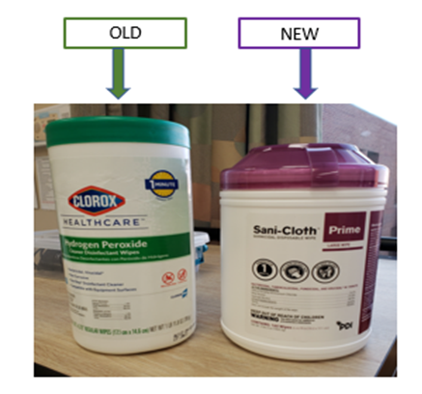

Contacts: | Stephanie Codina, Lab Manager 240-826- 6689  Hollie Genser, SGMC Lab Supervisor 240-826-6432  Zanetta Morrow, WOMC Lab Supervisor 240-637-5681  Derrick Wallace, SGMC Field Ops Supervisor, 240-826-6642  Cadara Baker, WOMC Field Ops Supervisor 240-637-6126
D. Collier/1.21.2022

G:\AHC_Lab\Clinical Folders\Communication_General Lab\Lab Alerts

