TRAINING UPDATE

Lab Location: | All Sites | Date Distributed: | 7/1/22
Department: | Core Lab | Due Date: | 7/14/22
 | Hematology

DESCRIPTION OF PROCEDURE REVISION

CAP Survey FH9-B Slide BCP-18 Educational Slide Review
Slide BCP-18 was an educational slide.

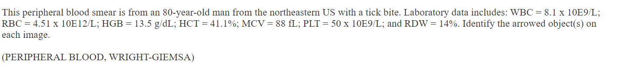
The arrowed cells on the slide were incorrectly identified as neutrophils with hypersegmented nucleus by us and 68% of participants.

Per CAP: “Although one of these cells depicted shows more than six nuclear lobes, both demonstrate cytoplasmic morulae and thus, the more specific and correct response is “leukocyte with intracellular Anaplasma/Ehrichia”

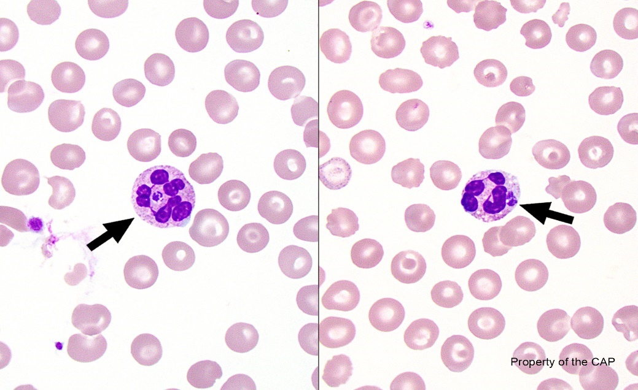

For educational review:
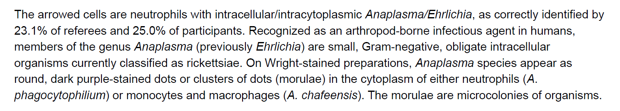

Reminder: When reviewing CAP slides, the images on the CAP website are of higher quality than the paper images. Consult the images on the website when in doubt.

