

ALL AHC Managed Laboratories

January Monthly Meeting

Minutes

(1/17/2023)

Present: 6 meetings in-person and on teams.

Distribution: All Lab Staff via MTS

Meeting commenced: 1/10/2023, 1/17/2023, 1/24/2023

Item | Discussion | Action | Follow-up
Approval of Minutes | Lab ADM Team | Approved | RS
AHC Monthly Topics
Devotional | Dr. Martin Luther King Jr. said, “Whatever your life’s work is, do it well.”  Our Mission expresses our work: who we are, why we exist, and the purpose behind what we do. It serves as a “north star” to guide our decision making and shape our organization. Let us strive each day to do it well. | AHC
Mission | We extend God’s care through the ministry of physical, mental, and spiritual healing. | COE
RISES Values | Respect, Integrity, Service, Excellence, Stewardship | COE
Pillars | Big, Better, Beyond  Better- People, Quality & Safety, Experience, Finance | COE
Finance Discussion | 70% of Hospitals nationwide lost money in 2022. AHC hospitals are all struggling financially and are running at a loss. Maryland is on a global reimbursement model, meaning they get paid based on average daily census. Example: If a hospital Average daily census is 100 patients and they run 125 patients they do not get paid for the extra 25 patients. Both FWMC and WOMC have been running over their reimbursed average daily census for months, causing the hospitals to run at a loss.  To make matters worse, Maryland is reducing reimbursements which started January 1, 2023. Thus, all sites are carefully monitoring overtime and have implemented hiring freezes in certain areas to get costs under control  The AHC LAB contract ran in the “RED” at a loss for 2021 ($91K Loss) & 2022 ($214K Loss). Why are we running at a loss: Salary increases, Training Costs, Employee Turnover, Supply line disruptions, Increased Over Time utilization due to callouts.  We are also watching overtime very closely and only approving OT for required patient care needs. What does that mean for everyone, we are evaluating if we need to activate on-call or can we get by with reduced staffing based on patient care needs. We need to ensure everyone is clocking in and out on-time as much as possible, and everyone needs to clock in/out for meal breaks.
Supervisor Promotions | Rob sent mailboxes updating staff. Jenny Dhall was on the WOMC morning meeting and provided an update regarding the approval process so we can move forward.  Jenny expects to get approval to move forward shortly. We are working on how to fund these changes and implement plans to reduce overtime costs. |  | Rob & Jenny
Glint Survey | We really need every staff member to take the GLINT (Employee) Survey. Let your voices be heard, bring up concerns you want the company to address. The survey speaks directly to Quest Leadership at a Regional and Corporate Level.
Maryland Blood Bank Inspection | The State of Maryland inspected the FWMC blood bank in November. They had some suggestions for how we can improve service that we will implement. All technical staff should log into MTS and complete the 3 mandatory assignments before January 30. This is a firm date, and the State will be verifying all staff met the training goal.  - Referral of Blood Bank Workups from FWMC to WOMC  - Blood Bank Turnaround Time  - Labeling Antigen Typing of Units at FWMC  Highlights:  - When FWMC has a positive Antibody Screen, they will immediately pull segments from 4 ABO/Rh compatible units on their shelf.  - The segments will be labeled with the unit numbers.  - One segment from each unit is kept at FWMC for crossmatch testing.  - Two segments from each unit are sent to WOMC with the patient specimen.  - The patient specimen and segments will be sent to WOMC via STAT courier.  - FWMC staff will then immediately perform a screening crossmatch on the segments and document the results on the referral form. The form will be faxed to WOMC as soon as the crossmatch testing is complete.  - WOMC will start the workup within 30 minutes and notify the FWMC BB if it will not be complete within 2 hours.  - FWMC BB staff will be responsible for communicating delays with the patient care team. All notifications must be documented on the back of the referral form and must include date, time, tech code, and full name of the person notified.  - WOMC will antigen type the segments sent when Antibody Identification is complete. Results will be entered into Sunquest. FWMC will view the results using “Blood Bank Inquiry” and entering the unit number. We will add a tie tag with the antigen typing results to each unit tested. | Complete MTS assignments | Impacted Staff
Metrics | Graph formats are changing for 2023 for our metrics. World Class will be 30 MIN and Target will be 35 MIN.  This is a benefit and more accurately reflects national bench marking.
TROP TAT | For EXL and Vista’s where TROP reagent may require hydration. Staff brought up to achieve this goal technical staff need to be proactive and ensure they have a flex load and pre-hydrated to ensure tests are ready. If you load a flex as needed the hydration delay will cause TAT delays. | This is a great point and team members are expected to keep the instrument ready.
Malaria | Malaria order must be accompanied by the Malaria History Form (AG.F175). | GEC & FWMC send the LAV tube and do not collect slides on site.
Urine Orders | Urines submitted to the lab should be delivered in the appropriate transport tubes to ensure stability. Technical staff pointed out that when the UA reflexes to culture sometimes they do not have a gray top tube. | Send SBAR to nursing.
Staff Question WOMC | Blood bank staff member requested blood bank related information be presented at the monthly staff meeting. | The BB GL lead provides updates at the monthly meetings during the departmental round table. Information to be provided as needed. | Stephanie & GL’s.
ADDON Process | This came up at FWMC, tech said the ADDON process needs to be reviewed with staff and providers. There is confusion about the process and what can be added on. We discuss the process and will review with staff. |  | Steph
Supplies | Staff at WOMC and FWMC have brought up concerns about excess supplies. I informed staff that I have communicated the excess supply to Inventory Control Team. Ryan should be rounding at FWMC and WOMC the week of 1/16/2023 to review this concern. | Lab ADM has a weekly meeting setup with the supply team every Friday at 0900. Please send any and all supply concerns via email to Rob he they will be addressed. | Rob
AM LAB Metrics | AM Lab samples are to be collected and received in lab before 0700AM. The AM Lab goal is to have all labs results before 0800AM.  Issues:  - Collecting samples then carrying them for an extended period.  - High volume as well as receiving some late orders.  - Staff callouts.  Night staff should begin collections as early as possible but no later than 0400AM. 0400AM staff need to collect first sample by 0410AM. 0430AM staff first sample should be collected by 0440AM.  Samples should be sent to the lab timely and not carried. Samples should be sent every 3 or 4 patients.
Dress Code | Quest Staff must follow the AHC Dress Code.  Clothing Not Permitted:  - Jeans, bib overalls, and Denim material of any kind.  - Unapproved hair coverings  - Casual Capri or cropped pants, jogging or sweatpants, spandex, leggings, or other exercise/sports clothing  - No opened toed shoes, or shoes with holes on tops.  Nails – AHC policy states fingernail length cannot be longer than 1/8 inch and artificial nails are not permitted for infection control and the safety of patients.  Fragrance allergies – Many patients are allergic to perfume, cologne, lotion and/or powders. This can be a very serious health concern for patients as well as coworkers. Either do not wear fragrances or keep it extremely light. All complaints are taken very seriously and investigated.  Badges must be worn at all times above the waist with photo displayed. | Dark Blue Scrubs are mandatory at FWMC.  Dark Blue Scrubs are the recommended color for all lab staff.
Phone Use in the Lab | Mobile phone use in the lab should be extremely limited.  Please do not take personal calls at the bench, if you receive an emergency call please, notify the tech-in-charge, and momentarily leave the work area. If the call takes more than a few minutes this will be considered your break.
Bereavement Policy | Staff have questions about the Bereavement Policy. | Rob to send the Policy to all staff.
Specimen Stability Requirements | When adding any test (add-on) it is important to determine if the sample is still acceptable for testing. How long is the sample stable?  How do you determine if the sample is still acceptable? MIQ lookup, SOP, or Lab Test Directory. Should the sample be removed from cells? Room Temp or Frozen?
Restocking Carts | Keeping the carts stocked. The carts should be in a constant state of readiness.
Keeping Receiving Area Clean and organized | Each shift should ensure a tidy work environment to pass to the next shift.
Send-out | What is the process for getting send-outs complete before leaving? As each shift leaves, they need to ensure all samples are accounted for.
Holiday List | Can we identify the list of Holiday’s team will work? Staff would like to know so they can make holiday plans.
Career Ladder | FWMC phlebotomists asking about the Career Ladder Promotions.
AHC Leadership System

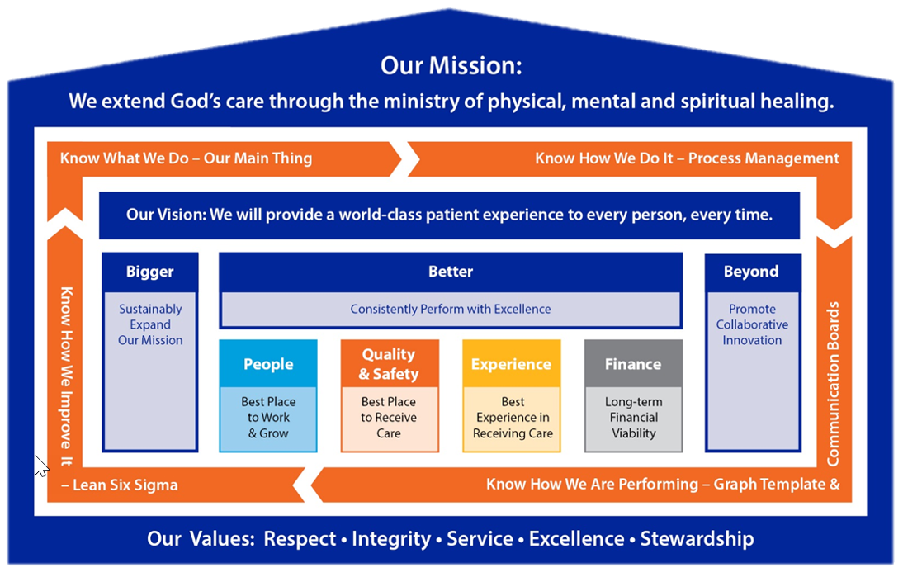

Behavioral Health | Critical Calls – Need numbers. Very difficult to reach nurses. | Follow-up | Derrick
ED Boarders | ED Boarders- growing issue everywhere.
POCT | Outpatient FINS timing out. The Women’s Center (Number One), Wound Care, Cardiac Rehad | Follow-up | Rob
Meeting adjourned
Next meeting

Recording Secretary

