Non-Technical SOP
Title | Medical Training Solutions (MTS)
Prepared by | Leslie Barrett | Date: 8/24/2010
Owner | Robert SanLuis, Jean Buss | Date: 5/21/2012

Laboratory Approval
Print Name and Title | Signature | Date
Refer to the electronic signature page for approval and approval dates.
Local Issue Date: | Local Effective Date:

12 month (or new) management review and approval:
Signature acknowledges SOP version remains in effect with NO revisions.
Print Name | Signature | Date

TABLE OF CONTENTS

1. PURPOSE 2
2. SCOPE 2
3. RESPONSIBILITY 2
4. DEFINITIONS 2
5. PROCEDURE 2
6. RELATED DOCUMENTS 5
7. REFERENCES 5
8. REVISION HISTORY 5
9. ADDENDA AND APPENDICES 5

PURPOSE

This procedure describes the use of Medical Training Solutions (MTS) for administering and tracking competency and training.

SCOPE

This procedure applies to all Laboratory staff.

RESPONSIBILITY

All employees must understand and utilize MTS in accordance with this procedure.

Supervisors and managers write and revise custom competency tests, and must ensure staff complies with this procedure.

Quality Assurance personnel may facilitate process by editing and loading custom competency tests, assigning tests, and providing compliance reports.

DEFINITIONS

MTS – Medical Training Solutions, web based training and competency system accessed via www.medtraining.org.

PROCEDURE

- General Description and Information

  - The system is used for both competency and training.

  - Custom competency tests are added to the system. Other portions of competency assessment (direct observation, record review, test performance) will be administered on paper documents.
Note: Assignments for job specific competencies are based on Job Authorization Grids

  - Training updates are placed on the system in quiz format.
- A copy of the revised SOP will be uploaded onto MTS. Click on ‘Download Document’ to view the SOP.
- MTS will prompt for acknowledgement that the document has been read. Click to ‘check’ the box to certify the revised SOP has been read or reviewed.
- Click ‘Take Test’ to proceed to the quiz. Questions will encompass major revisions to the SOP.
- In some situations, a copy of an SOP may also be placed in the training update binders. For management or QA staff, the SOP may be posted in the Outlook Public folder.

  - MTS contains a training library with modules that cover technical, nontechnical and safety areas of the Laboratory. Applicable training may be assigned at the supervisor’s discretion, and will appear in red. Unassigned training modules may also be taken by clicking on the ‘Training Library’ button and then click the module title.

  - Notification of new assignments may be communicated via LIS mailbox or staff meetings. All employees are expected to log onto the system frequently (a minimum to every 2 weeks) to check for new assignments.

  - After logging into MTS, the Home screen will display ‘My Assignments’.
  - Custom assignments will display under ‘QDx at AHC Content’
  - MTS system assignments will display under ‘Lab Training Library’ or ‘Lab Competency Assessment’ as appropriate
  - Click on the title of an assignment to complete it

- Login instructions

    - The website is accessed via Adventist Healthcare PCs within the Laboratory. It may be available as an icon, saved as a ‘favorite’ on Internet Explorer, or accessed by entering www.medtraining.org in the browser.
Note: The website may also be accessed from an employee’s home computer.

    - Employees are initially setup on the system with
- User ID is their employee number
- Password is their location (WAH, SGAH, GEC)

    - To change password
- click your UserID shown in the upper right of the screen
- type new password in ‘Password’ field
- click ‘Save’ at the bottom of the screen

    - If you have forgotten your password, notify your supervisor who can reset it. Once reset, you can log on and change it as described above.

    - User ID can be changed to an email address (personal or work) by typing it in the ‘Email/Username’ field and clicking ‘Save’.

- Test Grading for Competencies

- Passing score is 80% or greater unless otherwise specified, but any score <100% requires additional action.

- If the score is 80 – 99%, the employee must notify their supervisor.
      - The supervisor must review all incorrect answers with the employee.
      - The supervisor will create an electronic record of the quiz, document the review and save the record to the shared drive. Refer to addendum B for instructions on one method to create an electronic record.

- If the score <80%, follow step 2 above to document review. Re-set the test and instruct employee to re-take.
  - If the re-take score is 100%, no further action is required
  - If the re-take is <100%, create an electronic record of the quiz. Conduct remedial training and review the employee’s previous work to determine whether patient results were affected. Additional corrective action is indicated if patient results were affected. Note: all remedial training must be documented on a Previously Trained training verification form.

- Test Grading and Failures for Training Updates

- Passing score is 80% or greater unless otherwise specified.

- If an employee fails an update quiz (score <80%), the employee must notify their supervisor. The supervisor must review and document as described in step C.2 above. Re-set the test and instruct employee to re-take.

- System Administrators

  - To manage users, assignments, content and create reports refer to addenda C ‘MTS Administrative Instructions’.

  - Use the browser arrows at the top of your screen to move back to previous screens.

  - Track Progress
- View Status by Program
  - Click ‘Content’ button
  - Select Group, Program and Date (MTS utilizes a 6 month time frame) from the drop down.
  - Titles listed to the right have been assigned for the time period. System displays the number of employees assigned, number that have completed and average score.
  - Click on a Title to see list of employees who have completed and their scores.
- View Status by User
  - Click ‘User’ button
  - Select Group, Program and Date (MTS utilizes a 6 month time frame) from the drop down
  - Employees listed have assignments for the time period. System displays the number of assigned, number that have completed and average score.
  - Click on an employee to see list of assignment titles. Those that have been completed will display their score and date. Click the test title to display a list of questions; any that were incorrectly answered will be designated as such. Click on the question to display it.

- Record Retention
  - User test history is maintained online for the life of the system.
  - Upon resignation, a transcript is printed for the employee and retained in their competency file.

RELATED DOCUMENTS
Competency Assessment, QA procedure
Training Verification, QA procedure

REFERENCES
None

REVISION HISTORY

Version | Date | Reason for Revision | Revised By | Approved By
000 | 5/21/2012 | Update owners  Section 5: Item C added, subsequent items re-numbered, Item E detail removed and reference to addendum C added  Section 9: add addendum B & C | L. Barrett | L. Loffredo

ADDENDA AND APPENDICES
A. Example of Failed Quiz screen
B. Creating electronic documentation
C. MTS Administrative Instructions (see Attachment Tab of Infocard)

Addenda A

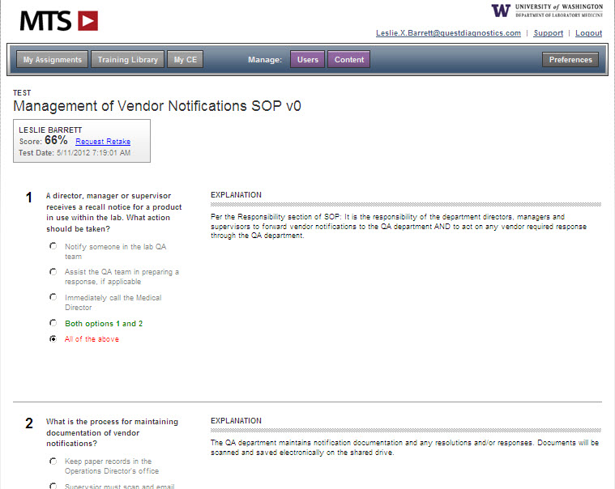

Addenda B

Creating Electronic Documentation

- Access the employee’s MTS records as described in the SOP in item E.3.b. Access the particular competency quiz.

- Click the ‘File’, then ‘Print’
  - When the printer dialog box opens, select Adobe PDF as the printer and click ‘Print’.
  - When the file save dialog box opens, name the file in the using the following format
Employee first initial last name_title of competency or document_date taken.pdf

Example: ASmith_Hema1_040512.pdf

  - Save the file under the following pathway

G:\AHC_Lab\Quality Assurance\Competency\MTS Resets and Failures

- To document the review and discussion with the employee
- Open the Adobe document
- On the tool bar, select Tools. Select Typewriter.
- Type the discussion and items reviewed, include your name and date.
- Save the changes to the document before closing.

Example of documentation
