

ALL AHC Managed Laboratories

February Monthly Meeting

Minutes

(2/21/2023)

Present: Minutes on MTS.

Distribution: All Lab Staff via MTS

Meeting commenced: 2/14/2023, 2/21/23

Item | Discussion | Action | Follow-up
Approval of Minutes | Lab ADM Team | Approved | RS
AHC Monthly Topics
Devotional | Respect means, we recognize the infinite worth of each individual.  When we encounter people who are unkind or disrespectful to us, we have a choice. Respond in the same manner or rise above. It’s not easy to meet unkindness with kindness and disrespect with respect. But kindness and respect always mins. | AHC
Mission | We extend God’s care through the ministry of physical, mental, and spiritual healing. | COE
RISES Values | Respect, Integrity, Service, Excellence, Stewardship  RISES Value of the Month – Respect  At Adventist HealthCare, our RISES value of respect means we recognize the infinite worth of each individual. | COE
Pillars | Big, Better, Beyond  Better- People, Quality & Safety, Experience, Finance | COE
Finance Discussion | Reduction of Over-time is a critical financial goal for everyone for 2023. We need to make major changes to drive OT utilization down.  Every week I track overtime by person, all call-outs, FML, Paid Time Off, and total hours. | 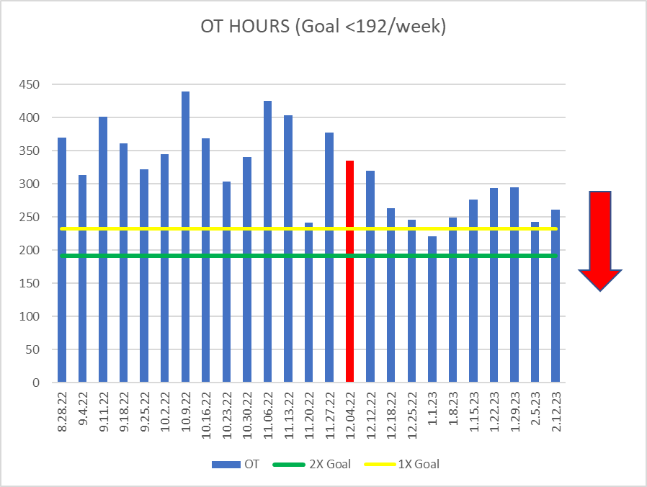
Supervisor Promotions | We finally have the approval to move froward with all Supervisor promotions. | Rob will move forward with offers. | Rob & Jenny
Glint Survey | We really need every staff member to take the GLINT (Employee) Survey. Let your voices be heard.  Results are back. Our participation was lower than last time but scores have improved. | I reviewed results with HR and we are formulating a plan that we will roll out next month.
Metrics | Graph formats are changing for 2023 for our metrics. World Class will be 30 MIN and Target will be 35 MIN.  This is a benefit and more accurately reflects national bench marking.
New Metric 2023 | Lactic Acid (Lactate) <35 MIN
Timed Collections | Timed Collection results are required to make treatment adjustments.
Incident Review | Tourniquet Safety – I put a mailbox out regarding tourniquet safety, also please review the article and take the MTS quiz.
Supplies | Donald is now covering supplies at FWMC & WOMC.  FWMC on Tuesday & Thursday.  WOMC on Monday, Wednesday, Friday. |  | Rob
AM LAB Metrics | AM Lab samples are to be collected and received in lab before 0700AM. The AM Lab goal is to have all labs results before 0800AM.  Issues:  No carrying samples, please. Carry samples cause major delays.  Night staff should begin AM collections no later than 0400AM.  Morning shifts should collect first sample with 10 minutes of their start time.  Samples are single bagged.  NEXTAM Samples should be sent every 3 or 4 patients.  TIMED Samples are collected first and sent or delivered IMMEDIATELY.
Authorized Footwear | We are still seeing a lot of people still wearing crocs with holes in them. These are prohibited per OSHA, because if you spill blood or body fluids on your shoe it will hit your foot. We will have to start disciplining staff that continue to disregard this policy.
QNS Samples | If a specimen looks QNS, the processors must receive the specimen. Generally, we will let technical staff determine if something is QNS. However, the patient care area must be notified, and we have to cancel the specimen in the computer if we can’t run it. I have gotten a couple of RLs lately about this. The processors are not receiving specimens that appear to be QNS, and no one is notifying the patient care area. This makes it look like we lost the samples. When I discuss with the processors, they say that technical staff yell at them when they receive things that are QNS.  In one case, we received a green tube that had a CMP and Vancomycin. The processor received the CMP but not the vanco stating it was QNS. When I asked about this, he said technical staff told him not to receive. I don’t necessarily believe this, but the vanco was the time-sensitive test and should have been run before everything else. I think we should have tried to run the entire thing and cancel what couldn’t be done.  In another case, it was a tissue for cultures. The processor only received one test. When the nurse called to ask why the other test has not been received, the processor told them it was QNS. They were angry that we did not notify them. Also, I suspect we could have done both from the tissue which is why techs needs to make the call about whether something is QNS.
Personal Item Storage | I realize in areas and at some labs this is challenging but personal items need to keep in lockers or left in vehicles.
AHC Leadership System

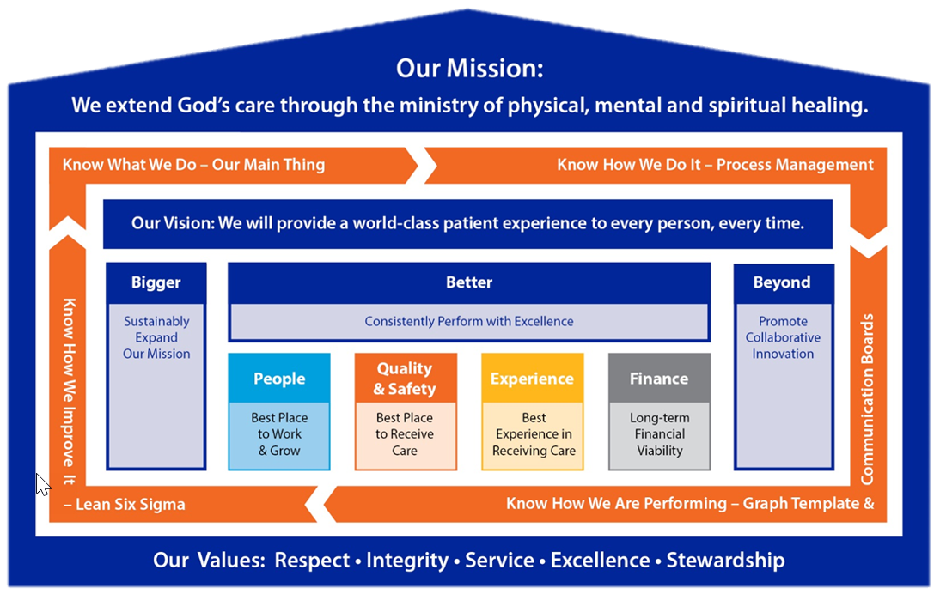

Knowing the management structure (above), Mission, Vision, Values, Pillars, Standard MGT Approach, Lab Main Thing.

Meeting adjourned
Next meeting

Recording Secretary

