TRAINING UPDATE

Lab Location: | WOMC, SGMC | Date Distributed: | 4/21/23
Department: | Core Lab -Micro PCR | Due Date: | 5/30/23

DESCRIPTION OF PROCEDURE REVISION

Name of procedure:
Title:
Update reminder is in response to a CAP failure.
Description of change(s):
- We recently had a CAP failure at one of our sites on the IDR-A survey, sample # IDR-05. The root cause of the non-conformance (failure) is believed to be, that although the samples were initially well mixed, sample number 5 settled as it was waiting to be run.

Since there are only 4 modules on the BioFire, the contents of sample #5 could have settled during the time that samples 1, 2, 3 and 4 were tested on the first batch.

- The purpose of this update is to remind staff that CAP samples should be immediately mixed before use by inverting several times, followed by vortexing the tube for 3-5 seconds. The tube should be tapped several times on the bench to remove any liquid caught in the cap before opening the tube.

Because the CAP samples are vials that look exactly like the QC vials, the techs should be following the same process as we have for QC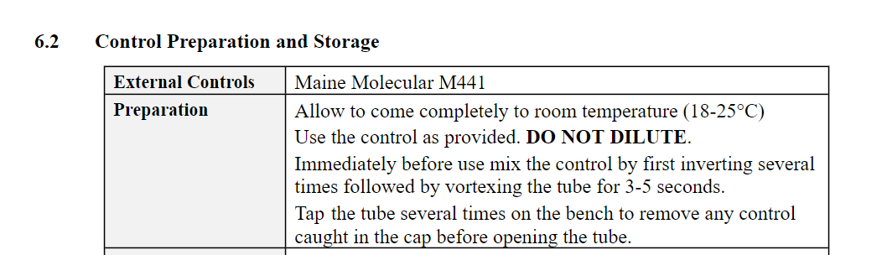
We have run pos QC before where there is material still left in the vial cap and we don’t recover all positive targets, so this step is important.

- We have decided, that going forward, both sites will always run the IDR survey on the Biofire. (NEW).

Document your compliance with this training update by taking the quiz in the MTS system.

