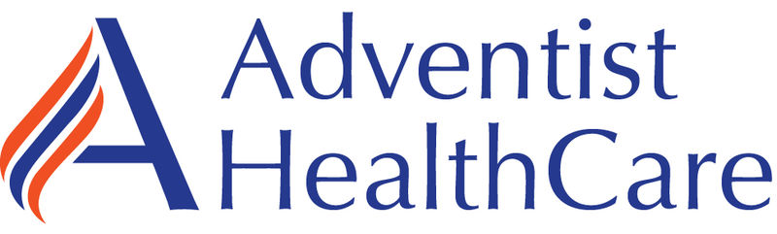

ALL AHC Managed Laboratories

March Monthly Meeting

Minutes

(3/28/2023)

Present: Minutes on MTS.

Distribution: All Lab Staff via MTS

Meeting commenced: 3/14/2023, 3/21/23, 3/28/2023

Item | Discussion | Action | Follow-up
Approval of Minutes | Lab ADM Team | Approved | RS
AHC Monthly Topics
Devotional | At Adventist HealthCare, we define integrity as being conscientious and trustworthy in everything we do. That means being true to who we are and embodying authenticity in every aspect of our life.  The ability to be ourselves at work is central to our identity as an organization committed to equity, diversity, and inclusion. We foster a diverse and inclusive workplace through awareness of our own identities and respect and understanding of the identities of others. | AHC
Mission | We extend God’s care through the ministry of physical, mental, and spiritual healing. | COE
RISES Values | Respect, Integrity, Service, Excellence, Stewardship  RISES Value of the Month – Integrity | COE
Pillars | Big, Better, Beyond  Better- People, Quality & Safety, Experience, Finance | COE
Finance Discussion | Reduction of Over-time is a critical financial goal for everyone for 2023. We need to make major changes to drive OT utilization down.  Every week I track overtime by person, all call-outs, FML, Paid Time Off, and total hours.  We are seeing OT reduction and much less use of ON-CALL, many fewer call-outs.  Our biggest budget concern is training costs.
Supervisor Promotions | We finally have the approval to move froward with all Supervisor promotions.  Rob spoke to all the candidates and they have verbally accepted the positions. Working with HR to create and implement. |  | Rob & Jenny
Glint Survey | We really need every staff member to take the GLINT (Employee) Survey. Let your voices be heard.  Results are back. Our participation was lower than last time but scores have improved.  Review results from the survey and they are attached below, at the end of the minutes. | I reviewed results with HR and we are formulating a plan that we will roll out next month.
Metrics | Graph formats are changing for 2023 for our metrics. World Class will be 30 MIN and Target will be 35 MIN.  This is a benefit and more accurately reflects national bench marking.  Looking pretty good overall.
New Metric 2023 | Lactic Acid (Lactate) <35 MIN  Needs some work. | Everyone needs to focus on Lactate (Lactic Acid)
Lab Collections | Timed Collection results are required to make treatment adjustments.  Collect STAT & Timed within 30 minutes.  We must pull pending logs multiple times each shift at T-24. (Required – Any collection on your list must be collected or passed to the next shift)  Priorities:  STAT  TIMED  ASAP  Routine | Phlebotomists must pull pendings T-24.  If someone leaves a pending collection it becomes the next shifts responsibility. If needed write a QV to document issues.
Incident Review | Tourniquet Safety – I put a mailbox out regarding tourniquet safety, also please review the article and take the MTS quiz. | Always check for Tourniquet before leaving the patient. WOMC is piloting a system to ensure this is completed.
Supplies | Donald is now covering supplies at FWMC & WOMC.  FWMC on Tuesday & Thursday.  WOMC on Monday, Wednesday, Friday. |  | Rob
AM LAB Metrics | AM Lab samples are to be collected and received in lab before 0700AM. The AM Lab goal is to have all labs results before 0800AM.  Issues:  No carrying samples, please. Carry samples cause major delays.  Night staff should begin AM collections no later than 0400AM.  Morning shifts should collect first sample with 10 minutes of their start time.  Samples are single bagged.  NEXTAM Samples should be sent every 3 or 4 patients.  TIMED Samples are collected first and sent or delivered IMMEDIATELY. | Critical Goal.  NIGHT Shifts phlebs are critical to ensure we achieve this goal.  Rob tracks collections by phlebotomist daily.
Glint Survey Results

Overall our scores are very similar to the Company overall. We have some areas I think we can make focused improvements. We really need to focus on staff retention. I listed some thoughts and comments I have below and there is an overview of the results. I think we need to take some quick action steps. I will schedule a meeting for this Friday to review and discuss.

Things I’d like to work on are:
- Reducing the impact of the on-call on the staff.
- Implementing a monthly recognition ceremony at the monthly meetings. Call people out and provide a simply low cost gifts.
- Have every leader do weekly rounding on staff and turn it in. AHC is using a similar rounding process.
- Have a discuss with staff at the monthly meetings and review our Glint correct action plans.
- I like posting the immediate action step.
- I will be speaking to Jenny & Sarah about Non-technical staff wages as they are at highest risk of leaving for money.

We had a drop in participation but a 2 point improvement in score overall.
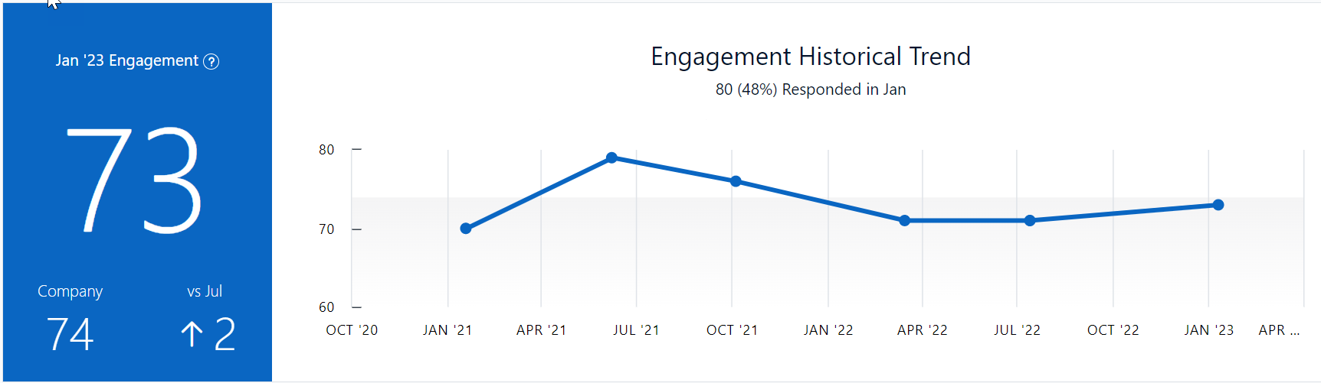

I feel good about our TOP strengths. We worked really hard on recognition yet we aren’t seeing the needle move. We need to continue to utilize recognition Quest and we need to take time to thank staff in person. I’m thinking we should consider recognizing staff in the monthly meeting and giving out small prizes, let me know your thoughts on this. Intent to stay should improve as staffing improves and we have trained staff start to step up and relieve more of the burden. Also, if we can get the on-call utilization under control that will help with intent to stay and care.
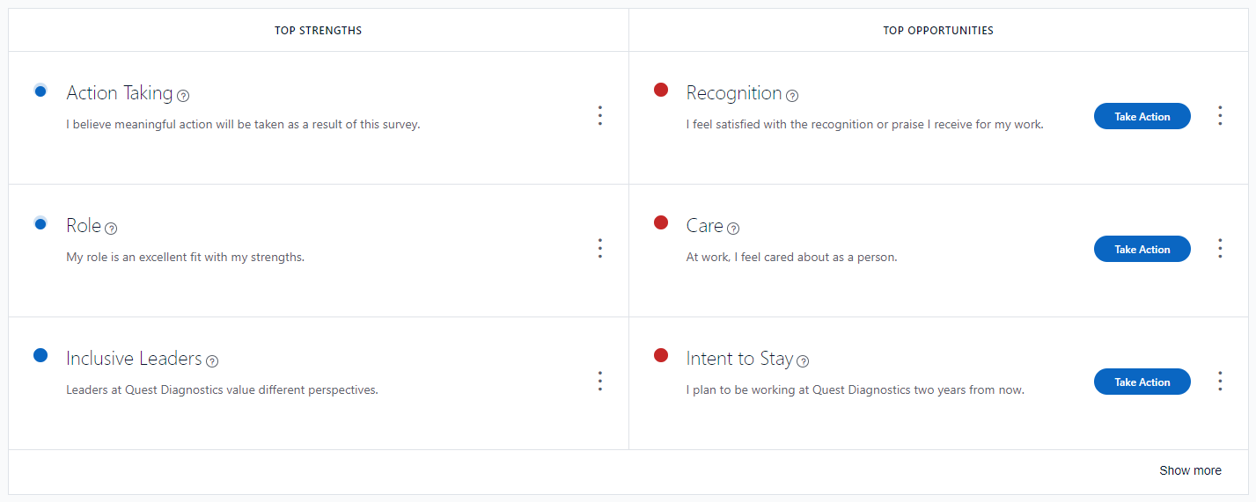

Overall these questions improved. Comments under engagement identified work-life balance as an issue. Intent to stay listed pay increases and we have retirements pending.
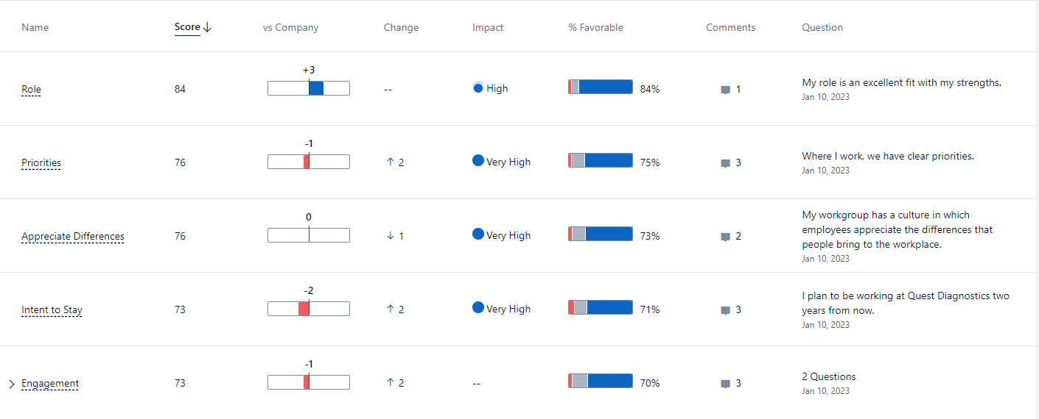

The following scores are interesting… Inclusive leaders we score +2 above Company and Taking Action we score +8 above Company. The comment under recognition is about “Low Pay” and I hear that a lot. Staff correlate recognition and pay! The Question about Care has comments about the On-Call policy. I recently had a few staff members discuss the oncall requirement and they feel we don’t care how it impacts their lives. I asked them for suggestions and alternatives and they could not provide a different method, they said we don’t have enough staff. Change Communication our score stayed the same and we are 2 points better than the Company.
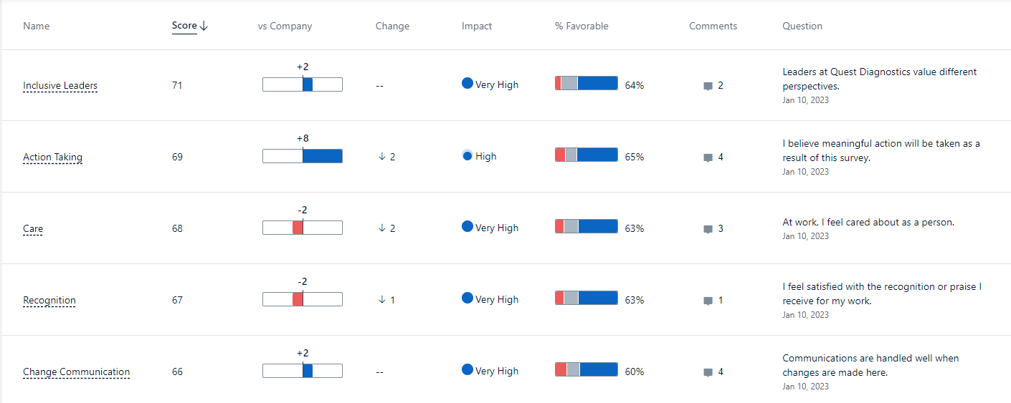

More Action Planning to follow – Our staff is our most value resource & strength!

AHC Leadership System – All staff must know this information.

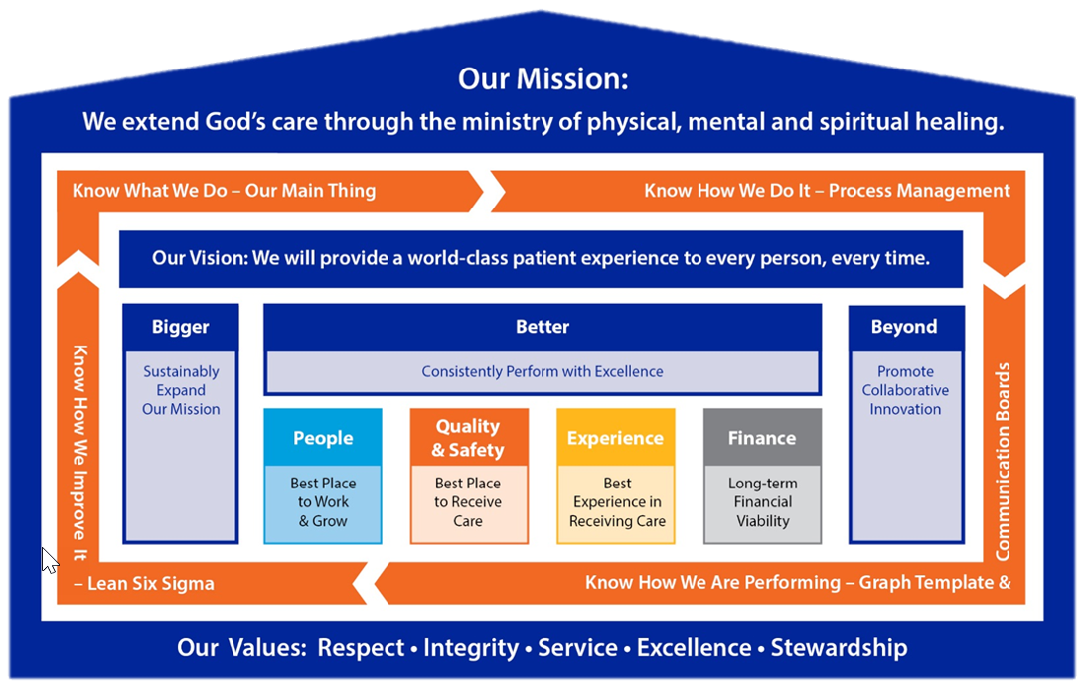

Knowing the management structure (above), Mission, Vision, Values, Pillars, Standard MGT Approach, Lab Main Thing.

Meeting adjourned
Next meeting

Rob SanLuis
Recording Secretary

