

ALL AHC Managed Laboratories

Monthly Meeting

Minutes

(5/23/2023)

Present: Minutes on MTS.

Distribution: All Lab Staff via MTS

Meeting commenced: 5/9/2023, 5/16/23, 5/23/2023

Item | Discussion | Action | Follow-up
Approval of Minutes | Lab ADM Team | Approved | RS
AHC Monthly Topics
Devotional | EXCELLENCE  We do our best every day to exceed expectations.  At Adventist HealthCare, whatever we do, we strive to do it well. Whatever we commit ourselves to, we commit completely. Whether our task is great or small, we do it with careful diligence. | AHC
Mission | We extend God’s care through the ministry of physical, mental, and spiritual healing. | COE
RISES Values | Respect, Integrity, Service, Excellence, Stewardship  RISES Value of the Month – Excellence | COE
Pillars | Big, Better, Beyond  Better- People, Quality & Safety, Experience, Finance  Spotlight: Get Better: Long Term Financial Viability. Reduce reliance on contract labor. AHC is making great progress.  This is the same for Quest. We are also struggling to break even on the contract. The cost of OT, Training, and supplies has gone up significantly and reimbursement has not. This is especially true for us as we are on a set contract with AHC, no price increases even tough everything costs more. | COE
Finance Discussion | OT Reduction Project Continues. We are doing well almost hitting the 2X goal for hours, we are at the 1X currently.  Lab Budget – April Tests Counts were down by 7,000 tests, May is doing a little better, Negative OM = $351K YTD, doing better with OT & on-call utilization  We are looking to consolidate more testing to a single location or center of excellence in the system. This is to reduce operational and training cost. SGMC has the Attelica’s which has the lowest cost per test because it is the Quest standard large instrument. In addition, the capacity and speed is the greatest.  Consolidating testing where we can: At FWMC we are going to stop testing VALP and DIG onsite very soon.
Supervisor Promotions | Same Update – In progress.  Getting the new supervisors in place will take some time. I think we should be on track for June for everyone to have official titles in place. |  | Rob
Glint Survey | New Survey is out – Please take it. It means a lot to our team and it really makes a difference we our voices are heard.
Metrics | Graph formats are changing for 2023 for our metrics. World Class will be 30 MIN and Target will be 35 MIN.  This is a benefit and more accurately reflects national bench marking.  Looking pretty good overall.
New Metric 2023 | All sites looking good, getting better! | Everyone needs to focus on Lactate (Lactic Acid)
Lab Collections | Morning run is the biggest challenge.
Incident Review | None discussed.
Supplies | We are still working on some supply issues. We have a weekly meeting on Fridays with the supply team. |  | Rob
AM LAB Metrics | AM Lab samples are to be collected and received in lab before 0700AM. The AM Lab goal is to have all labs results before 0800AM.  Issues:  Staffing is our major issue with AM labs currently. We are working on it. Please focus on getting the samples to the lab fast.
Discussion:
- Bleach cannot be stored in the flammable cabinet. It keeps finding its way back in there. Oxidizers and flammables cannot be stored together.
- When a T&S specimen is referred to WOMC for Antibody ID, FWMC staff must send at least 2 segments with the workup and perform a screening crossmatch at FWMC. The screening crossmatch is generated when the antibody screen is positive NOT when they place a transfuse order.
- When a sample is referred to WOMC for Antibody ID or antigen typing (as in for sickle patients), we need a complete history of the patient documented on the referral form. The referral form must be filled out per procedure.
- Post Holiday Schedules
- FWMC evening shift asked about the lab meeting schedule. We posted meetings for evening shift but no one attended. We have 5 meetings a month that evening shift can call into. We will look at rotating the schedule for 2024.

AHC Leadership System – All staff must know this information.

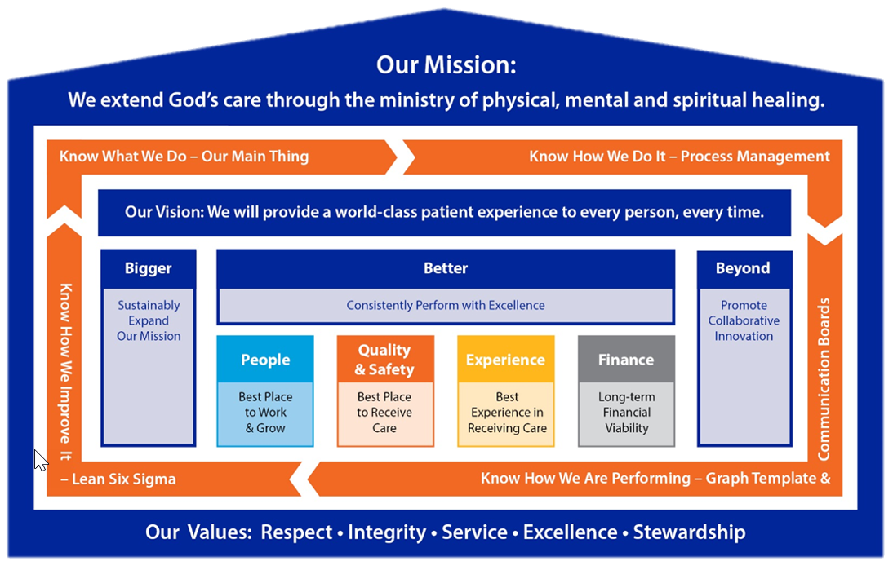

Knowing the management structure (above), Mission, Vision, Values, Pillars, Standard MGT Approach, Lab Main Thing.

Meeting adjourned
Next meeting

Rob SanLuis
Recording Secretary

