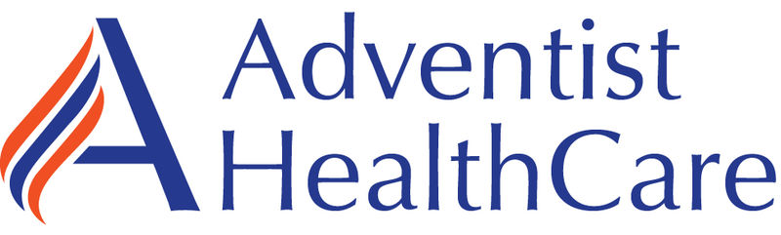

ALL AHC Managed Laboratories

Monthly Meeting

Minutes

(6/27/2023)

Present: Minutes on MTS.

Distribution: All Lab Staff via MTS

Meeting commenced: 6/13/2023, 6/20/23, 6/27/2023

Item | Discussion | Action | Follow-up
Approval of Minutes | Lab ADM Team | Approved | RS
AHC Monthly Topics
Devotional | STEWARDSHIP  We take ownership to efficiently and effectively extend God’s care.  In practical terms, stewardship means to take careful and responsible management of something, or someone entrusted into our care. Author Paul Washer said that we are stewards “of every moment, of every talent, of every gift, of every resource that God has given. Choose wisely what you do today.” | AHC
Mission | We extend God’s care through the ministry of physical, mental, and spiritual healing. | COE
RISES Values | Respect, Integrity, Service, Excellence, Stewardship  RISES Value of the Month – Stewardship | COE
Pillars | Big, Better, Beyond  Better- People, Quality & Safety, Experience, Finance  Spotlight: Go Beyond  How AHC is Promoting Collaborative Innovation  Physician Enterprise: Partnership with Howard University Faculty Practice Plan  To create a more accessible and comprehensive care network for our patients, Adventist HealthCare has entered into a two-year management agreement with the Howard University Faculty Practice Plan. The Faculty Practice Plan is the employed physician practice of Howard University that supports the medical school, hospital and the community.  Strategic Initiatives:  - Partner with 170+ providers across 30+ specialty areas to support our patients’ growing needs  - Provide patient-centered health and wellness services to all, including high-risk and underserved communities  - Hardwire AHC’s referral process & build deeper connections in Washington D.C  AHC Collaborates and partners with Quest Diagnostics to provide their lab services. Why? Because Quest can provide the service more efficiently and effectively. Quest is the largest reference lab company and we have ~49,000 team members worldwide. The relationship between AHC and Quest is synergistic, both organizations benefits.  Excellence in Motion Highlight:  On May 16th AHC held its 3rd Sharing Days celebration to highlight success stories achieved by following our Standard Management Approach.  Congratulations to our amazing presenters!  The Lab’s current Project is rolling out the COVID only testing systemwide and it is now complete. We are tracking progress: implementation and financial benefit. | COE
Finance Discussion | OT Reduction Project Continues. We are doing well almost hitting the 2X goal for hours, we are at the 1X currently.  Lab Budget – May Tests Counts were better but still down as expected for this time of year. Unfortunately, we are in the “RED” YTD (Our bills are more than we are making on the contract), we are over $500,000 in the negative. As discussed at previous meeting this is because of higher salary costs, increase supply costs, and increased training costs.  Still in-progress- Not Completed yet!  We are looking to consolidate more testing to a single location or center of excellence in the system. This is to reduce operational and training cost. SGMC has the Attelica’s which has the lowest cost per test because it is the Quest standard large instrument. In addition, the capacity and speed is the greatest.  Consolidating testing where we can: At FWMC we are going to stop testing VALP and DIG onsite very soon.
Supervisor Promotions | Supervisor promotions are finally complete.  Congratulations!  SGMC/GEC  Technical: Meaza & Jonathan  Non-Technical: Kathy & Maria  WOMC/FWMC  Technical: Daniel & Bryana  Non-Technical: Derrick (Move) & Paulette  Derrick has done an excellent job at SGMC. He wants a better commute which will help his work life balance.  In addition, Both Hollie & Zanetta were promoted to Lab Managers with the Technical and Non-Technical Supervisors reporting to them.  Reason for the ReOrg:  We are growing and with the addition of FWMC Stephanie & I are being pulled in many directions. We are turning over some daily lab operations duties to Hollie and Zanetta as we prepare for additional growth, potential Howard in the future.  This reorganization also provides more opportunities for many of our team members. We prefer to grow and promote internally. Also, we are trying to create a much lower Supervisor to Team Member ratio and provide a more connected approach to leadership. This also creates a succession strategy that is critical to future success, we must train our future leaders.  We are implementing a training plan for our new leaders and the plan will span a fairly long period, the initial training takes about 12 months but supervisors are really learning for the first few years, so please be patient with them. Also, they can really use everyone’s support. |  | Rob
Glint Survey | New Survey Results are back. Scores went up everywhere. My only disappointment was we only had 49% participation. Everyone I asked said they took the survey. We really need everyone to be heard. We have a lot of team members and when we all speak we are heard. Next time let’s hit >70%.  We scored in the 74th percentile which is the same as all of Quest and 1 point better than the national benchmark.  We are working on pretty much the same topics as previously identified:  Recognition, Appreciation, Care, Reducing On-Call, Staffing & Retention, and Pay.  We are working on all of the above, more to come. Currently, my main focus is getting out non-technical phlebotomy staff increases. This will have to be a multi-phases approach. We are working on some salary adjustments. We need to mentor staff and for those that want to move up the career ladder and provide that path. We will be looking at improving and clarifying the Career Ladder Paths. Also, we will be creating a new path call Float which will mirror the Float Positions in the Quest PSCs. More to come in future meetings.
Metrics | May was good month. Most Metrics were achieved or very close to on target.  AM Labs Collected by 0700 and Resulted by 0800 are still challenges at WOMC & SGMC. FWMC hit the metric!
Incident Review | None discussed.
Supplies | We are still working on some supply issues. We have a weekly meeting on Fridays with the supply team. |  | Rob
What’s New and Coming:

THE QUEST WAY
Leaders need to embed The Quest Wayin all we do –from huddles, team meetings, recognition, etc.
Three elements of The Quest Way: (1) Purpose –why we exist; (2) Strategy –how we grow; and (3) Culture –how we work.

STRATEGY: HOW WE GROW
Our Strategy: collaborating to leverage our broad access; offering the most extensive test and services menu; leveraging our data assets and services to improve population health; and continuously improve our quality and efficiency by embracing AI and automation.
We have the right strategy to accelerate growth with physician lab services, hospital lab services & consumer health.
CULTURE: HOW WE WORK
The 5C’s guide behavior: Customer first, Care, Collaboration, Continuous improvement and Curiosity
Leaders must find opportunities to identify and name when employees live the 5C’s in both personal conversations and huddles. Use this worksheetto identify examples for your team
New RecognitionQuestcategories support our Culture
Reminder: Quest celebrates Years of Service Milestone employees in June. Visit RecognitionQuesttoday to recognize someone on your team!

MAY 2023 EMPLOYEE ENGAGEMENT SURVEY RESULTS
Quest Company overall response rate great at 69% (-1 vs. January ‘23), representative of Quest overall
Overall Engagement index (74) stable since January; 1 point above the healthcare benchmark
Relative strengths to maintain: Manager/Supervisor support and meaningful work
Suggestions for leader improvement: visibility and responsiveness to questions/concerns; better change communications; more 1:1 time to discuss job and career.

JUNE OBSERVANCES: PRIDE & JUNETEENTH
Upcoming Pride celebrations: Gender affirming care -facts vs mython June 15 and Pride EBN networking event, featuring Cecilia McKenney and Quest leaders, on June 19. Check out Pride EBN pagefor more.
Juneteenth: African-American Business Leaders (ABL) EBNcelebrating across the Regional chapters
Still time to register forvirtual Juneteenth Marchon June 19 -email questions to DiversityInclusion@questdiagnostics.com

MID-YEAR CHECK-INS
Employee self-evaluation July 11-31 and Manager feedback July 11 – August 31.

Discussion:
- Reviewed ON CALL (its not optional if you are designated)
- Calling Out (staff must call Admin on Call and TIC in lab)
- Give Admin on Call your name, location you work at, and shift you are not working.
- Staff concern about lockers – WOMC specific.
- Introduced New Supervisors
- Advised staff that New Supervisors will be looking closely at time & attendance.
- Staff still struggling to make critical calls to nursing, the struggle continues.

AHC Leadership System – All staff must know this information.

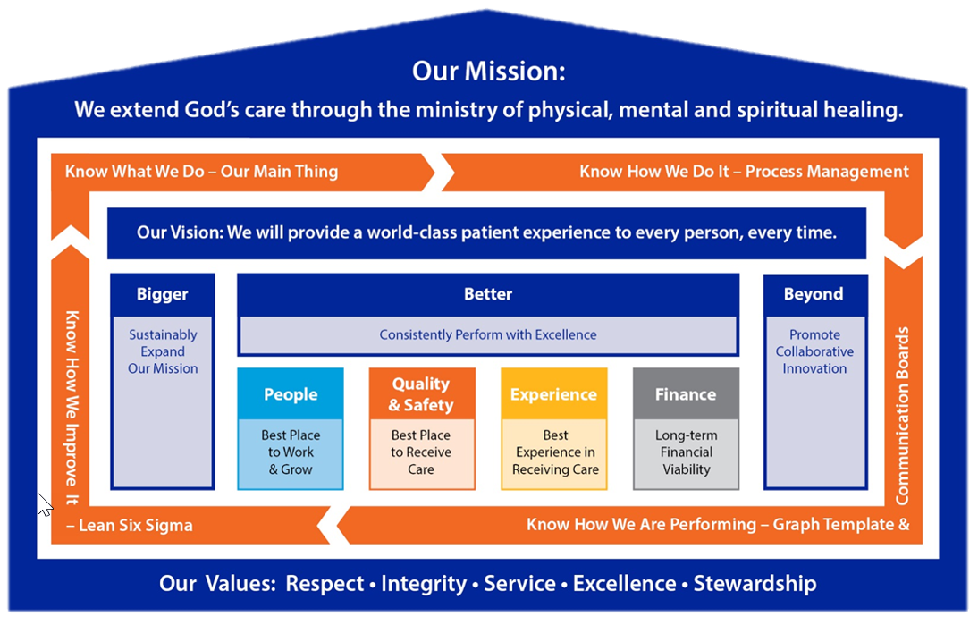

Knowing the management structure (above), Mission, Vision, Values, Pillars, Standard MGT Approach, Lab Main Thing.

Meeting adjourned
Next meeting

Rob SanLuis
Recording Secretary

