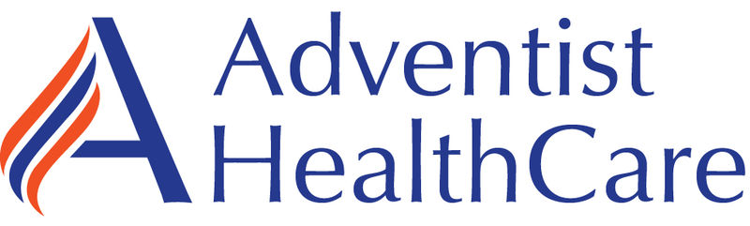

WOMC & FWMC

Non-Technical Employee Expectations

Minutes

7/26/23

Present: Zanetta, Derrick, Paulette, Victoria, Vinitha, Binta, Chamekia, Khalim, Talayah, Abidemi, Decoda, Mouniratou, Orlando, Yvonne, Collin, Daniel, Bryana, Stephanie, & Rob

Distribution: ALL WOMC and FWMC NON TECHNICAL STAFF

Meeting commenced:

Item | Discussion | Action | Follow-up
Time & Attendance | - All staff need to read and make sure they understand the Attendance Policy  - Review of On Call expectations  - Clocking in/out for breaks and TIC approval for no break | - Reminder to call the Admin on Call and Tech in Charge when calling out  - MUST CLOCK IN AND OUT FOR BREAKS  - Workforce central logs are used as supplements, you do not use this as the only way to keep time  - You are late if you clock in 8 minutes after your start time (for example shift is at 430am, and you clock in at 438am)
New Employee Transition | - Supervisors will assign new staff to a person to orient them  - ALL STAFF need to create a welcoming environment for new employees | - Will be down with new employees moving forwward
Staffing Updates | - Zanetta will provide | - All WOMC openings are filled and the staff are training
Competency | - Must be completed by the assigned due date | - ongoing
Vacations | - Supervisors will approve/deny vacations timely  - Vacation approvals/denials go to the email you used to sign up for humanity  - If vacation is denied and you call out, it is automatic discipline (refer to attendance policy)  - You must find coverage for your weekend if your request includes your weekend
Vocera Usage | - Supervisors are working on a process to get more voceras | - ongoing
Rep in Charge | - Will work with the Tech in Charge to ensure operations  - Expected to enforce procedures as it pertains to day to day operations  - Responsible for filling out communication log on shift | - Supervisors will go over these duties with anyone that is Rep in Charge
Communication Logs | - Will be put in use to communicate operational issues  - Rep in charge is responsible for communicating issues
Patient Experience | - Supervisors are arranging training for all staff as asked by Mabel Ankrah
Items Mentioned During the Meeting | - Weekend coverage will be resolved once new trainees are done  - Derrick/IT Team working on RN to collect samples and orders to prevent orders from being changed  - WOMC PHLEBOTOMISTS are expected to draw all patients (some Phlebs avoid COVID patients or hard sticks)  - COMMUNICATION IS EVERYONE’S RESPONSIBILITY  - All WOMC staff must park on the 4th floor or above in the parking garage. You will need your badge to enter.
Meeting adjourned
Next meeting

Recording Secretary

