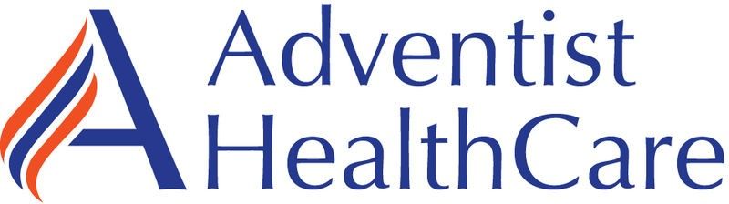

Laboratories at Adventist Healthcare White Oak Medical Center, Shady Grove Medical Center, Fort Washington Medical Center and Germantown Emergency Center

***Date:***

LABORATORY ALERT

*Subject:*

*The Laboratory is informing you of the following change:*

|  |  |
| --- | --- |
| **Effective date:** | July 2023 |
| **Change:** | Bio Rad Liquichek Pediatric Control (catalog numbers 177 and 355)  Stability update: The thawed/open vial stability of this QC has changed from 14 days to 7 days. |
| **Additional information:** |  |
| **Contacts:** | Hollie Genser (SGMC & GEC) 240-826-6432  Zanetta Morrow (WOMC & FWMC) 240-637- 5681 |

**G**:\AHC_Lab\Clinical Folders\Communication_General Lab\Lab Alerts