**

Shady Grove and White Oak Medical Centers

|  |
| --- |
| **Blood Bank Team Meeting** **Minutes**  **November 7, 2023** |

**Present:**

|  |  |  |  |  |  |
| --- | --- | --- | --- | --- | --- |
| √ | Mary-Dale Abellano | √ | Bilen Gebresenbet | √ | George Li |
| √ | Kelvin Addo | √ | Isaias Gebreweldi | √ | Arlene Mencias |
| √ | Malak Antar | √ | Hojat Goudarzi |  | Tsegaye Negash |
| √ | Arianna Clatterbuck | √ | Natasha Hall |  | Yvonne Ngwa |
|  | Lesley Crowder | √ | Jessica Jenkins |  | Boris Njeambosay |
|  | Bech Ebini |  | Larissa Kukapa | √ | Rocio Vergara Torres |
| √ | Uchama Eni | √ | Milka Lenarz |  |  |

**Distribution:** Blood Bank Team

**Meeting commenced:** 0630 and 1600 via TEAMS

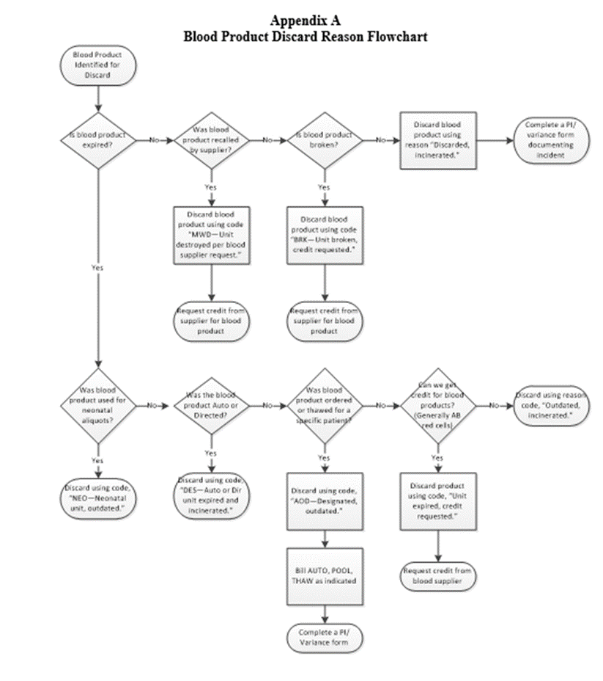

| **Item** | **Discussion** | **Action** | **Follow-up** |
| --- | --- | --- | --- |
| **BB Standing Orders** | SGMC now has a standing order for a neonatal unit to arrive every 2 weeks on Monday, beginning November 6.  We also established standing orders for red cells from Inova to be delivered twice a week on Monday and Thursday.   * Staff need to be aware of the standing orders and ensure we are accounting for them when we place new orders. * Whenever practical, please place orders for Monday and Thursday delivery with our standing order.   Do we need to establish standing orders for frozen products? The group said no.  How are the standing orders working? They are working well for SGMC, but WOMC needs the orders earlier in the day due to platelets for OH surgery. | F/U with Inova to see if we can get our standing orders earlier in the day | Stephanie |
| **MMRN on Cord Hold Orders** | If mom’s MRN is entered incorrectly in a cord hold order, we DO NOT edit it.   1. Notify the RN 2. Cancel the order 3. Ask them to place a new order 4. Specimen is still good and does not need to be redrawn unless there are other reason to cancel such as labeling. | Informational | None |
| **Disposition of Units** | We reviewed the flowchart for dispositioning units in BSU. Please follow the flow chart when disposing of units (posted at the end of the minutes). We track wastage versus expiration very closely.   1. Plasma and cryo that are thawed for a specific patient and not used before expiration are discarded as “AOD” for designated, outdated. The unit would not have expired if we had not thawed it for the patient. 2. Units used for neonatal aliquots get discarded as “NEO” for Neonatal unit, outdated. These do not count against the blood bank, because we used them for neonatal aliquots. 3. Red cells and platelets get discarded as “Outdated, incinerated.” These are part of our inventory, and we need to manage the expiration. The only time we will use “AOD” for red cells and platelets is if we ordered specific units in for a patient order such as washed red cells, HLA-matched platelets, etc.   If we discard a unit because it was wasted, we need a PI/Variance. These reasons include things like….   * RN spiked bag * RN returned outside of temp range (this also requires the reason for return per policy) * Thawed plasma/cryo but not used   Reminders:   * The date on the PI/variance should be the date of order * We charge THAW for each unit of plasma or cryo thawed and wasted * We charge POOL for each unit of cryo wasted | Informational | None |
| **Emergency Release Blood Products** | Reminder that we NEVER withhold blood for a signature on an emergency release form. If they request blood without a signature, we follow our process….   1. Issue the blood requested. 2. Print the name of the ordering provider on the form. 3. Print the name of the person picking up the blood on the form. 4. Make a copy of the form. 5. Give the original to the person picking up the blood and ask them to obtain provider signature. 6. Keep the copy, so we know to follow up.   Question was posed: Can we give Emer Rel units before a patient is registered?  Answer: Yes, an example of this happened recently at SGMC. A patient was having surgery at a nearby surgery center and started bleeding. They transferred her to SGMC. The doctor called ahead and told our ED she was bleeding. ED came to get units. In this case, we issue and obtain the name of the person picking up. We issue in the computer after we receive the patient name and MRN. | Infomational | None |
| **OIC T&S** | At the October meeting, staff expressed concern that we are delaying transfusion for first time OIC patients, because we have to get history and we need to recall them for additional sample. We are working on a new order for this. More information once approved. | Informational | None |
| **Documentation Technique** | Reminder that we must all follow our documentation technique policy. This is something CAP/AABB will cite us for.   1. If you need to change information, place a single line through the incorrect information. Write the correct information next to it with your tech code/initials and date. 2. If you add information after the fact, you must list the reason why the information was late and the date added. For example, you forgot to document centrifuge QC for a particular day, but you know you did it. If you document late, you will need to initial the box, add the date it was added and the reason it was added late. | Informational | None |
| **Good Laboratory Practices** | When pipetting using an MLA pipette, you must primer your pipette before measuring. A certain amount of the liquid you are pipetting will be retained in the pipette tip. This is no accounted for in the measurement. When pipetting, you must aspirate and discard the first amount of liquid to prime the pipette before using it to measure.  When reading for agglutination, all staff MUST use the mirror with the light as designed. DO NOT remove the mirror or attempt to read without the mirror. You should hold the specimen straight up and down, button facing towards you, and shake gently while watching the cells come off the button. | Informational | None |
| **On-Call** | We reviewed the draft on-call policy for blood bank. A request was made to allow staff to revote on the options. We agreed that we would revote on the top two options: using the same on call system as core lab and using the system where your name gets added to a list if you call out.  Voting occurred and the majority of BB staff requested to use the on-call policy the rest of the lab is using. This will be implemented immediately. | Informational | None |