1. When placing a new reagent into use, you must QC the reagent before any patient testing is performed. If QC has already been done for the day, you must enter “Y” for yes at the “Retest” prompt.

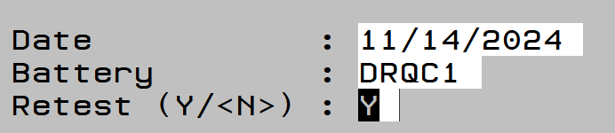

1. Add the new lot and enter in the lot/expiration grid.

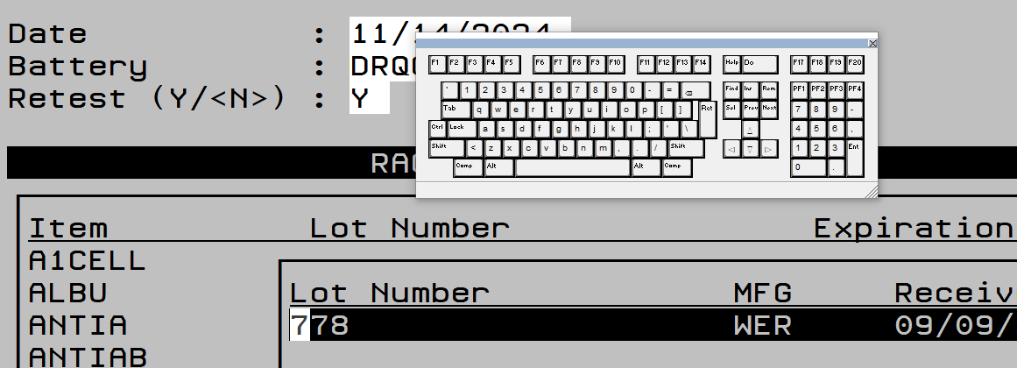

1. When you place a new reagent into use, you MUST enter a comment.

After you enter the QC results, you will see the “Modify Accept Reject Comment” screen. Select “Comment.”

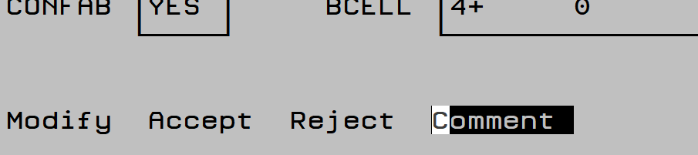

1. Type your comment.

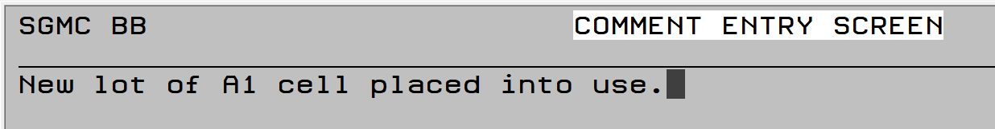

1. After you type your comment, press the “F1” key at the top of your keyboard. The Command prompt will appear. Type “e” and enter to save the comment.

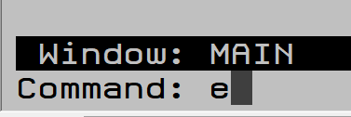

1. Sunquest will prompt, “Save and Exit: Are you sure?” Select Y and press enter. This will save your comment.

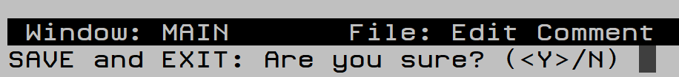

1. The screen will return to the previous “Modify Accept Reject Comment” screen. Select “A” for accept and press enter.

