
Laboratories at Adventist Healthcare
Date: September 18th, 2025
Laboratory Alert
Subject: BD Vacutainer 3.2% Sodium Citrate (blue top) tubes
Effective Date: | 9/18/25
Process: | BD vacutainer blue top tubes with 3.2% sodium citrate must be filled to the fill line with specimen to achieve a 9:1 ratio (blood: anticoagulant).  The score line / fill indicator on the tube indicates volume requirements.
Background Information: | Recently, lab samples collected in the BD Vacutainer blue top tube with 3.2% sodium citrate were cancelled as overfilled due to the sample exceeding the fill indicator.  The manufacturer provided clarified information regarding minimum and maximum fill lines.  (see supporting information)  Samples which do not meet adequate volume requirements (meniscus must fall between the minimum and maximum fill) must be cancelled and redrawn.
Supporting information: | 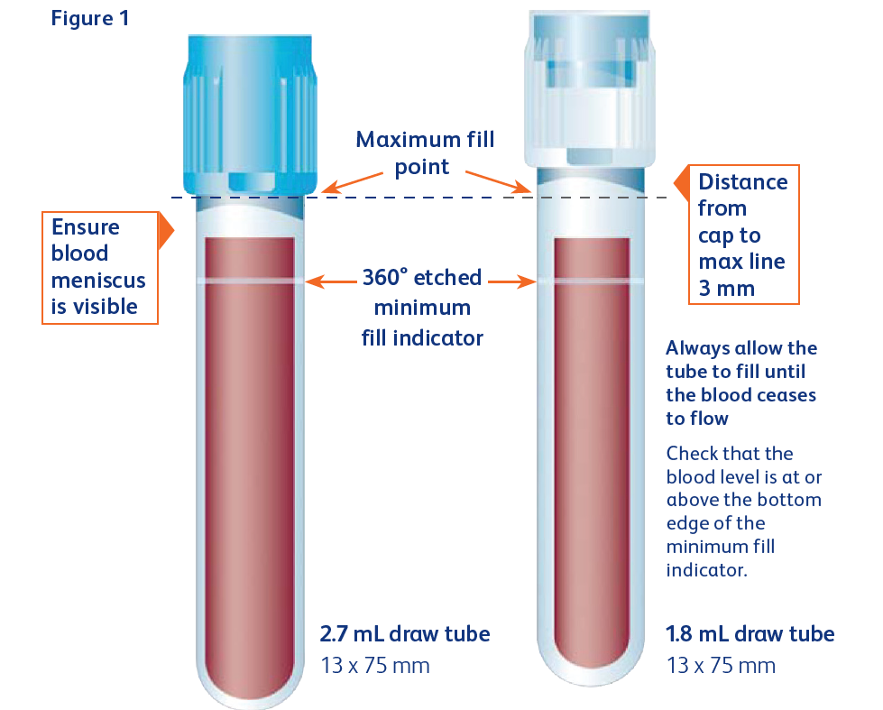
Contacts | Rob SanLuis, System Lab Director 240-620-3413  Stephanie Codina, System Lab Manager 240-826-6689 (SG) or 240-637-6015 (WOMC)  Zanetta Morrow, WOMC & FWMC Lab Manager 240-637-5681  Hollie Genser, GEC & SGMC Lab Manager 240-826-6432

