
Shady Grove and White Oak Medical Centers

Blood Bank Team Meeting

Minutes

Oct 7, 2025

Present:
 | Mary-Dale Abellano | √ | Isaias Gebreweldi | √ | Arlene Mencias
√ | Kelvin Addo |  | Blen Getaneh |  | Tsegaye Negash
√ | Malak Antar | √ | Hojat Goudarzi |  | Boris Njeambosay
√ | Lesley Crowder | √ | Chizobam Igweh | √ | Henry Nvule
√ | Bech Ebini | √ | Jessica Jenkins | √ | Natasha Quashie
√ | Uchama Eni | √ | Larissa Kukapa | √ | Rocio Vergara Torres
 |  | √ | George Li

Distribution: Blood Bank Team

Meeting commenced: 0630 and 1600 via TEAMS

ITEM | DISCUSSION | ACTION | FOLLOW UP
Recognition | This area is for staff members to recognize their peers. | Informational | None
FDA Reportable | We had an FDA-reportable event.  Patient testing performed on 9/15:  O-negative, AbS positive, ADRH identified  On 9/16 a transfuse order was entered for 2 RBCs. The tech allocated 2 O-negative units and performed immediate spin crossmatches.  Unit 1 issued 9/16 @ 1949  Unit 2 issued 9/16 @ 2051  What is the issue?  The patient has ADRH demonstrating and we did not perform IgG crossmatched  Why didn’t the computer alert us?  The computer will not identify what type of crossmatch is needed. It will alert if a patient has a clinically-significant antibody and the units are not negative for the corresponding antigen  What process do we have in place to catch this type of error?  We check the patient history and verify the correct crossmatch testing has been performed at the time of issue  What steps should be taken to remedy?  Pull segments from the units and crossmatch retroactively; notify the manager immediately to alert of possible RQI/FDA-reportable event  We attempted to pull segments to retroactively perform IgG crossmatched. One segment was available. The other was not. Please be VERY careful when bringing in units and ensure all segments are pulled and stored. Segments must be stored for 7 days post transfusion (regulatory requirement). We store all segments for 90 days. | Informational | None
Mislabeled Specimens | Blood bank performed T&S testing on a patient specimen.  TS Results: A-negative, AbS neg  A retype was needed. The patient had a CBC collected at a different time. The CBC was pulled for retype testing.  Retype Results: O-positive  A new ABO retype specimen was obtained.  2nd Retype Results: A-negative  It was determined that the original CBC/retype specimen was mislabeled.  What steps would you take in this situation?  We must notify core laboratory that they have a mislabeled specimen so they can amend the results with a “wrong patient tested” comment. | Informational | None
Empty Box Pickups from ARC | When requesting box pickups from ARC, please use the following process in Blood Hub:  - Select the tri-bar  - Open the Inventory tab  - Select Pickups  - Choose + New Pickup (Do not use SAMPLE Pickup)  If you do not get this option, so are on the AHC group account. You must be in a hospital account.  - Put the details in the User Comments field.  Transactions can be viewed on the bottom of the dashboard.  This is in our procedure. Please utilize the procedure as needed. | Informational | None
Blood Inventory | We have had some issues lately where staff use up our inventory of a specific product (cryo, platelets, etc) and do not reorder. All staff members are responsible for ensuring we have adequate number of blood products. Failure to do this puts our patients in danger.  It is mandatory that staff are aware of a product that has low inventory and replace that product. All staff should be placing ad hoc orders if inventory goes below critical levels on their shift. All staff should be looking that the inventory at the beginning of their shift to ensure there are adequate number of blood products and ordering as needed.  If we are low on a blood product and cannot get replacement (O-neg red cells, platelets, etc) you are required to notify the manager and medical director AND document that communication. | Informational | None
Reagents and Supplies | Reagents and supplies need to be QC’d before being placed into use. We are still seeing issues with people not completing this. Example: WOMC used an entire box of HemoTemp devices. The box contained a red circle sticker.  - We place red/yellow stickers on the boxes when they arrive.  - When QC is performed, the sticker is changed to green. The green sticker is placed directly on top of the red/yellow sticker.  - All staff members must look for the green sticker prior to using that reagent.  People MUST put green stickers on all boxes from the lot and shipment when QC is performed.  Different lots and shipments must be sequestered from each other. We utilize rubber bands to do this. | Informational | None
QC and Discarding Reagents | Our Daily Reagent QC procedure states  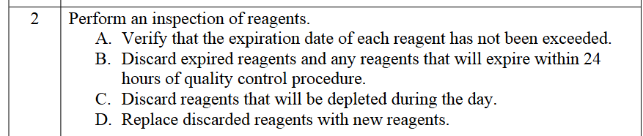  The purpose of this statement is to ensure reagents are not used past their expiration date. All reagents expire at 2359 on the printed expiration date. The 24 hours in the procedure refers to the day on which a reagent expires 0001-2359 on the day of expiration.  I am getting a lot of unnecessary IQE events when day or evening shift QC a reagent more than 24 hours before expiration. For example, Reagent 1 expires on 10/9 at 2359. We would stop using this at 0001 on 10/9.  If day or evening shift perform QC on 10/8, it is acceptable to use reagents with a 10/7 expiration. These will be QC’d again and taken out of use on 10/8 before midnight and before they reach the manufacturer’s expiration.  Night shift performs QC after midnight. They must ensure the reagents are discarded one day prior to QC, because a reagent that expires at 2359 on the 7th won’t get replaced and reQC’d until the 8th. | Informational | None
Saline/DI Water | Please ensure each shift fills the saline and DI water on the Vision before leaving. This is part of the shift change requirement of stocking reagents and supplies. | Informational | None
Antigen Typing | New process for ordering/resulting antigen typing for UNITS in Sunquest when they are run on the Vision. This was demonstrated during the meeting. | Informational | None
Reviewing QC | When performing QC verification each shift, please review on the screen and do not print. This was demonstrated during the meeting. | Informational | None
Open Forum | We must document when standing orders are modified. This should also be included in the verbal exchange at shift change.  All staff should start testing that comes in on their shift. This includes crossmatches for future transfusions in OIC, etc. It is understandable if workload does not complete finishing workups, but they should be started.
To Do List | - The 2025 Blood Bank Competencies are past due. You must complete and turn in as soon as possible.  - Boris  - Jessica  - Empower mandatory courses  - Uchama  - Hojat  - Tsegaye  - Boris  - Natasha  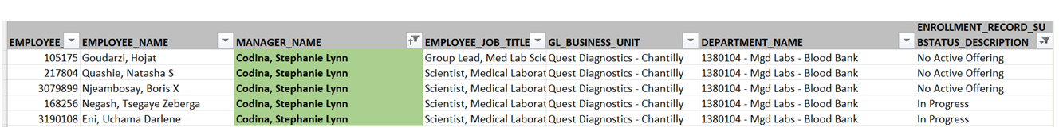  - TB testing due 10/15/25.  - Malak  - Lesley  - Uchama  - Hojat  - Natasha  - Flu shots due Monday, November 10 at noon  - 6-month competency for gel/Vision due November 14. | Complete mandatory training assignments by the deadline | All Staff

