
Shady Grove and White Oak Medical Centers

Blood Bank Team Meeting

Minutes

Nov 3, 2025

Present:
√ | Mary-Dale Abellano | √ | Isaias Gebreweldi | √ | Arlene Mencias
√ | Kelvin Addo |  | Blen Getaneh |  | Tsegaye Negash
√ | Malak Antar | √ | Hojat Goudarzi | √ | Boris Njeambosay
√ | Lesley Crowder | √ | Chizobam Igweh | √ | Henry Nvule
√ | Bech Ebini | √ | Jessica Jenkins | √ | Natasha Quashie
√ | Uchama Eni |  | Larissa Kukapa | √ | Rocio Vergara Torres
 |  | √ | George Li

Distribution: Blood Bank Team

Meeting commenced: 0630 and 1600 via TEAMS

ITEM | DISCUSSION | ACTION | FOLLOW UP
Recognition | This area is for staff members to recognize their peers.  Hojat recognized Kelvin and Uchama for doing a great job preparing reconstituted whole blood. | Informational | None
ADRH vs ASAR | There seems to be a lot of variation when calling ADRH on a specimen that does not fit the anti-D pattern.  Generally speaking, if a patient has a clinically-significant antibodies, we need a minimum of three cells to rule the antibody in the first time and only one cell to rule the antibody in for subsequent workups.  For RhIG, we really want to ensure it is still demonstrating and providing protection. RhIG is only in the patient’s system for a short time. We should be ensuring RhIG is present and looking for Three positive cells each time we encounter a positive screen. When fewer than three positives are present, please continue workup to rule other antibodies out and call ASAR as applicable.  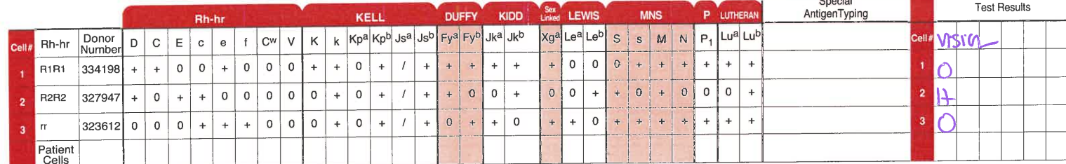  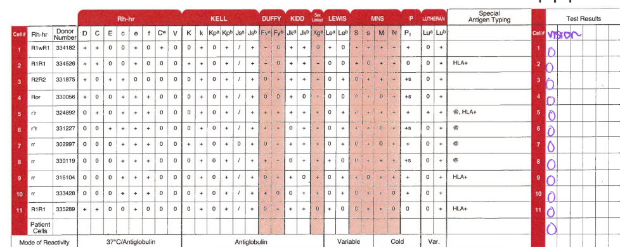  For a pattern like this, we would go to PeG and call ASAR and not ADRH. | Informational | None
Editing Results on the Vision | We recently performed an audit of all edited results on the Vision. We saw some patterns where staff are editing results that should not be edited.  Examples:  - If the Vision grades a reaction, we should not be editing the grade.  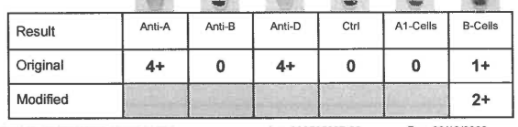  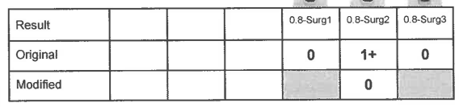  - If the Vision calls something MF on an ABO/Rh, we need to move to ABO discrepancy. We should not edit the result to positive.  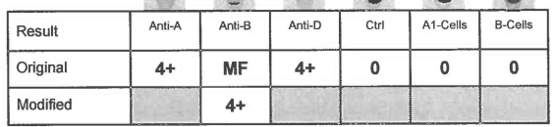  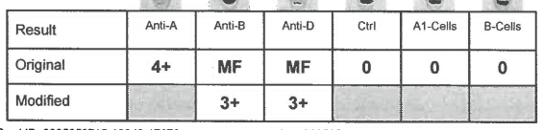  - If the Vision calls TMC or TFC, we must repeat per SOP. You cannot edit the result.  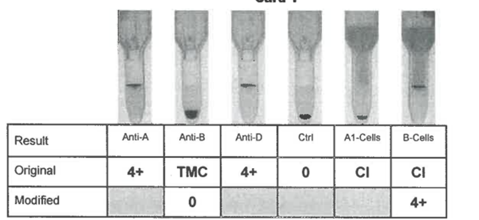  When is it acceptable to edit a result???  - When the SOP says it is OK to manually interpret. For example, when we get the CNF or CI error code, the procedure allows you to pull the card and manually interpret.  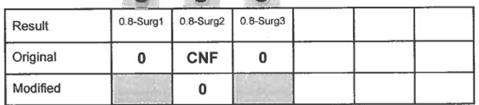  - When you get a questionable result, the procedure allows you to pull the card and manually interpret.  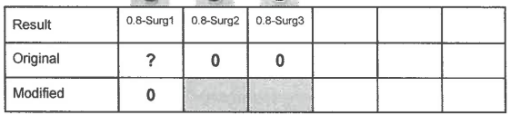  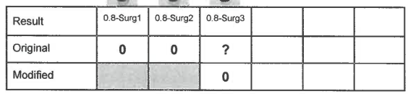 | Informational | None
Fibrin | When you get the FIB error code, it means the instrument is detecting fibrin in the specimen. Fibrin generally occurs when the sample is not properly mixed at the time of collection.  To avoid: Check the specimen for microclots and remove prior to centrifugation just like we do for all cord bloods.  If you encounter, use sticks in the specimen, recentrifuged, and repeat testing. DO NOT BILL THE PATIENT FOR SELECT CELLS FOR THE REPEATED TESTING.  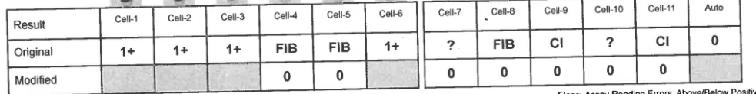 | Informational | None
Change of Shift | We need to make change of shift more efficient for all staff. Here are some guidelines:  - Outgoing shift should vacate the bench as soon as possible when the incoming shift arrives. Do not stay at the bench until the end of your shift when you are leaving.  - All workups should be brought to a transition state and passed to the incoming shift. Examples:  - PeG screen incubating  - Eluate prepared and ready for testing  - Screen cells selected and pulled  The incoming staff member that takes over will enter both tech codes in the computer when resulting.  DO NOT tell the outgoing shift that they must finish a workup before leaving  - All pending samples must be accounted for. Newly received specimens (not started) will be passed off. All samples that are in process (ie workups) must be documented on the shift-to-shift log.  - Outgoing shift should use the transition time to tie up loose ends:  - Check the ARC website for BBREF workups  - Pull and verify pending logs  - Enter any IQE events from your shift that haven’t been completed  - Fill the saline and DI water on the Vision(s) | Informational | None
KBT and Blood Type | If we refer a specimen for KBT, please ensure the patient has a blood type on file. If the patient does not have a blood type on file, please REFLEX and perform the ABO. Please note that must be done on a different specimen than the KBT, since the KBT requires whole blood and we centrifuge for ABO/Rh. | Informational | None
A1 negative units | Reminder: We issue O or A1-negative units for patients with Anti-A1. However, we only honor the antibody when it is currently demonstrating. This is not required if the antibody is historical only. | Informational | None
Professional Responsibility | Assignment maintenance tasks including blood administration audits must be completed on time. If maintenance tasks are returned for rework, you must complete them during the next shift. | Informational | None
Open Shifts | We have a number of open shifts for which I am looking for volunteers. Please let me know if you are able to pick up any of the open shifts. | Informational | None
Racks | A request was made by staff to please fill current racks before creating new racks in DI. We don’t have enough refrigerator room to store partially-filled racks. | Informational | None
Diluent/  Dilution Trays on Vision Maintenance Form | When performing Vision maintenance, the daily requirement to change diluent refers to the process of putting the diluent in the refrigerator each day and replacing it with the bottle that has been refrigerated. Per manufacturer’s instructions, the diluent can only be at room temperature for 24 consecutive hours and then must be returned to the refrigerator for 24 hours. We can use the bottles until the manufacturer’s expiration.  Also, we should be pulling used dilution trays off and replacing them with blank dilution trays each night when we perform maintenance. We must check for used dilution trays nightly and sign off that this was done even if we don’t need to change them. | Informational | None
Cross Training | A question was posed about cross training. The management team is currently working on defining a process for crosstraining. There are a number of factors that will be included.  - Staff on disciplinary action will not be eligible for crosstraining.  - Crosstraining must be arranged so that it does not impact the blood bank schedule. It is unlikely that we will crosstrain more than one person crosstraining at a time.  - Staff who are willing to work in areas of greater need will be given priority. For example, we need additional staff at FWMC, so staff willing to pick up shifts at FWMC will be given priority.  - We must consider budget, because blood bank employees get paid out of the BB budget even when they are working in core lab. We have to control this expense also. | Informational | None
To Do List | - Flu shots due Monday, November 10 at noon  - Blen  - Boris  - 6-month competency for gel/Vision due November 14. That is next week. Please ensure you complete and return by that date. | Complete mandatory training assignments by the deadline | All Staff

