
Shady Grove and White Oak Medical Centers

Blood Bank Team Meeting

Minutes

Dec 2, 2025

Present:
 | Mary-Dale Abellano | √ | Isaias Gebreweldi |  | Arlene Mencias
√ | Kelvin Addo |  | Blen Getaneh |  | Tsegaye Negash
√ | Malak Antar | √ | Hojat Goudarzi |  | Boris Njeambosay
√ | Lesley Crowder | √ | Chizobam Igweh | √ | Henry Nvule
 | Bech Ebini | √ | Jessica Jenkins | √ | Natasha Quashie
√ | Uchama Eni | √ | Larissa Kukapa | √ | Rocio Vergara Torres
 |  | √ | George Li

Distribution: Blood Bank Team

Meeting commenced: 0630 and 1600 via TEAMS

ITEM | DISCUSSION | ACTION | FOLLOW UP
Recognition | This area is for staff members to recognize their peers. | Informational | None
Rejected Specimens | All specimens that are rejected must be cancelled and reordered in Sunquest. We are required to maintain this documentation. If you cancel a specimen that has not been received, you must receive it before cancelling.  If you receive a mislabeled specimen that does not have any orders associated with it, please place the “Extra Tube” order and then cancel, so the nursing units know it cannot be used for T&S. | Informational | None
Transfusion Reaction and Whole Blood Storage | Please do not store transfusion reactions and whole blood units in the large red, biohazard bags. These take up too much room in the refrigerator and are difficult to manage.  Instead, place the unit, tubing, and saline in a plastic ziplock bag. Mark the front with the date received and a description of what is inside. For example: Txn Rxn 12/02/25 or Whole blood 12/02/25. This will make it much easier to determine when they can be discarded.  Transfusion reactions are retained for 10 days post reaction.  Whole blood units are retained for 90 days post transfusion.  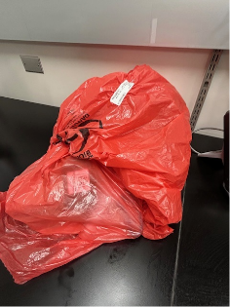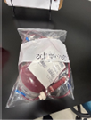 | Informational | None
NIST Thermometer | Prior to using the NIST thermometer, please ensure you are verifying the calibration information by viewing the sticker on the thermometer. New thermometers have the original (manufacturer) sticker. Older thermometers have the Scientific Calibration sticker.  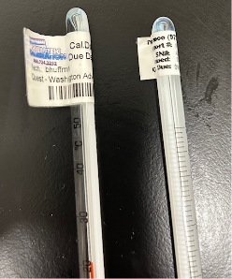 | Informational | None
Vision Backup | All results (QC and patient) are stored in the Vision for 1 year and can be accessed.  The Vision backup does not work like the Echo backup. The backup is ONLY used to restore the instrument to a previous version of software. If you “Restore from backup” you are actually deleting all current settings and results from the system. This creates HUGE problems. | Informational | None
Name | When documenting your name on paperwork, you must document both first and last names per policy. We do not document only our first name on technical documents. It is acceptable to use initials and/or tech code where allowed. | Informational | None
BBREF Eluate Results | When entering BBREF results, do not order ELUATES to result eluate results. This attaches billing for testing we did not do.  If you have eluate results that need to be entered, freetext them into the field and let me know, so I can add them to the BAD file. | Informational | None
K-Neg Units and DARA | You are performing an antibody ID workup in house. The Vision reports Weak/1+ for all panel cells. PeG screen is negative on all cells. You call the antibody ASAR. The patient has a history of taking DARA.  Question: Do you have K-negative units to this patient?  Answer: No  Anti-CD38 interferes with blood bank testing. When we send workups to Red Cross, they treat the cells. The treatment they use alters or destroys the Kell antigen, so they cannot rule out anti-K. They recommend giving K-negative cells in case the patient has an anti-K they did not detect.  In this case, we ruled out anti-K with the PeG screen. Therefore, it is not necessary to give K-negative red cells. We do not need to give K-negative red cells if we rule out anti-K in house. | Informational | None
Attendance | Attendance Reminders:  - All staff are expected to be at their workstations at the start of their shift. Please do not clock in, go to the breakroom, talk to people, etc and then arrive late. You should walk directly to the work area after clocking in.  - You will be allowed a 7-minute grace period for attendance discipline, but you are still expected to be at your workstation at your shift start time. Use of the 7-minute grace period should be an infrequent occurrence.  - All staff should be clocking in and out for their work shifts and lunches. Failure to clock is counted as 0.5 attendance occurrences and will be treated as such. | Informational | None
Open Forum | - Please pay attention to the surgery type and not just the surgery location when reviewing the surgery schedule. We have had a number of situations lately in which blood was not set up for open hearts that were preformed outside of the open heart rooms (ie Cath Lab or Flex Room).  - Please ensure you are checking for retypes when doing the surgery schedule and the T&S. We received 4 complaints last month because we failed to order retypes on a pre-surgical patient.  - Reminder to ensure you are completing your assigned maintenance tasks on time.  - Daily = Every Day  - Weekly = 7 + 1 Day  - Monthly = 30 + 7 Days  - Question was asked regarding how items are counted for the monthly inventory that is returned to the supply staff.  Per Todd, we only count items on the list, and we only count unopened packages.  - Question was asked regarding method comparisons for antigen typing.  We do not need to perform method comparisons for antigen typing unless we are performing the antigen typing both in tube and on the Vision.  SGMC has transitioned to all Vision typing, so we do not need to do method comparisons for antigen typing.  WOMC is still using tube for some of the Rh antigens, so method comparisons will need to be done.  - Staff brought up concerns that phlebotomy is cutting off valid BB/TS armbands without checking with BB staff. I forwarded this concern to the phlebotomy supervisors/managers. | Informational | None
To Do List | - Ensure MTS is complete by the end of the month (Due 12/31)  - Clean out mailboxes (Due 12/12)  - Complete Self Evaluation in Employee Self Service (Due 1/5)  - From Self Service, click on “Career and Performance”    - Click on “Employee Self Evaluation”  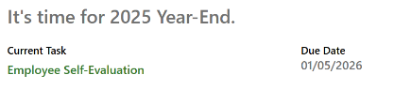  - Click the “Evaluate” button next to “Year End Review.”  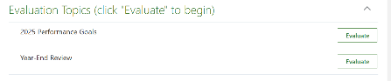  - Answer the 3 questions listed.  -   - 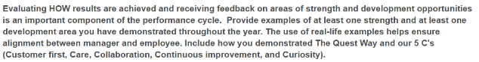 | Complete mandatory training assignments by the deadline | All Staff

