
Shady Grove and White Oak Medical Centers

Blood Bank Team Meeting

Minutes

Jan 6, 2026

Present:
√ | Mary-Dale Abellano | √ | Isaias Gebreweldi | √ | Arlene Mencias
√ | Kelvin Addo | √ | Blen Getaneh |  | Tsegaye Negash
√ | Malak Antar | √ | Hojat Goudarzi |  | Boris Njeambosay
√ | Lesley Crowder | √ | Chizobam Igweh | √ | Henry Nvule
√ | Bech Ebini | √ | Jessica Jenkins | √ | Natasha Quashie
 | Uchama Eni | √ | Larissa Kukapa | √ | Rocio Vergara Torres
 |  | √ | George Li

Distribution: Blood Bank Team

Meeting commenced: 0630 and 1600 via TEAMS

ITEM | DISCUSSION |  | ACTION | FOLLOW UP
Recognition | This area is for staff members to recognize their peers. |  | Informational | None
STAT Ab Screen TAT Metrics | Review 2025 STAT/ASAP Ab Screen turnaround time. Metrics at end of presentation.  GOAL: Effective 8/1/25, 95% of STAT/ASAP AbS will be resulted within 60 minutes of receipt.  - What factors impede our ability to meet the 60-min TAT?  - What initiatives will we put in place to improve/meet TAT?  - Additional centrifuges added Dec 2025  - Review metrics monthly at the BB staff meeting  Risk—metrics are not available until the 5th of the month; BB staff meetings are the 1st Tuesday  - Timers  - Processors bringing received samples in a timely manner  - Fibrin  - Instrument aborting testing—Please ensure you complete an equipment failure form when this occurs |  | Informational | None
2nd Tech Review of AbID Panels | December 2025  - SGMC = 98% (42/43)  - 1 missed because reviewing tech determined additional work needed to be done  - WOMC = 79% (27/34)  - 1 missed due to workload  - 6 missed due to failure to check the ARC site for BBREF results  FWMC Referred Workups  - 100% (1/1) started within 30 minutes of receipt  - 100% (1/1) resulted within 2 hours of receipt  - NA (0/0) FWBB notifications required |  | Informational | None
Updated Daily Tasks Form | I added the following reminders to the daily tasks form for each shift:  - Verify adequate inventories of blood products at the beginning of each shift—Goal for 2026. Will track the number of customer complaints due to inadequate blood product inventories when the cause is determined to be blood bank ordering  - Check ARC for BBREF results at the middle and end of each shift  - Refill liquids and empty liquid waste on Vision at end of shift  - Print and clear pending log |  | Informational | None
Fetal Screen | We failed both samples of the fetal screen survey. The suspected root cause of this failure is samples were switched. Direct observation noted the following issues:  - We must follow the procedure as written. The procedure states we add 1 drop of 2-4% patient red cell suspension to 1 drop of anti-D reagent and incubate. We must use 1 drop of each to achieve the desired serum to cell ratio for the test. Failure to use the proper serum to cell ratio can result in decreased sensitivity and specificity.  - Staff must document results of each tube in real time. This means all tubes and slides are labeled and results are documented on the fetal screen log when they are read. You must bring the worksheet to the microscope and document results.  We also had an incident where a staff member performed a fetal screen on an Rh-positive specimen and obtained a negative result.  Principle of the fetal screen:  - Anti-D is added to a Rh-negative specimen (mom’s specimen)  - The anti-D attaches to any Rh-positive cells in the specimen (baby’s Rh-positive cells)  - The tube is washed to remove all unbound antibody  - A weak suspension of D-positive cells is added and centrifuged  - Since the anti-D is coating any D-positive cells, the indicator cells will form rosettes around the D-positive cells  All staff will be required to complete fetal screen competency in January 2026 as a result of the CAP survey failure. |  | Informational | None
Expired Reagents | We discard all expired reagents with the exception of the following:  - Antibody panels are kept for 3 months to use as selected cells.  - A1 and A2 cells are kept for 3 months to remedy ABO discrepancies due to anti-A1.  - Rare antisera may be kept for training purposes only. |  | Informational | None
Manufacturer/Reagent Issues | We recently had a situation where staff noted a new lot of check cells received from Werfen were discolored and contained clots. When reagent issues are identified, the following must take place.  - Remove the reagent from inventory immediately  - Notify the manager  - Notify the manufacturer of the issue—Contact tech support to report issues  - Document in IQE |  | Informational | None
Blood Bank Cleanliness | 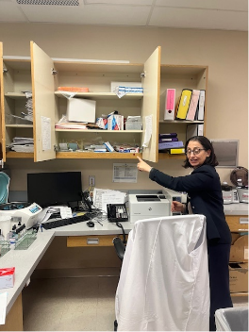 | Dr Beltaifa will be doing routine inspections of the blood banks. She is expecting everything to be clean and organized.  I cleaned out all of the cabinets at SGMC and labeled where items should be placed.  - Please ensure you are putting things in the correct locations.  - Surplus items should be placed in the BB area of the store room  - Please do not tape papers inside cabinets | Informational | None
Crosstraining SOP | We have created a lab procedure for crosstraining. All staff members have an MTS assignment for this new procedure.  - Employees who have been placed on disciplinary action within 4 months are not eligible for crosstraining.  - Employees must submit a written request for crosstraining in writing to their direct supervisor. The request must include the departments/sites in which crosstraining is requested and the requestor’s availability to fill extra shifts on different shifts, weekends, and holidays.  - The leadership team will determine if crosstraining can be accomplished for that employee and the order in which staff will be crosstrained.  - Crosstrained employees must commit to picking up at least 2 shifts per month in the crosstrained department for a minimum of 2 years. |  | Informational | None
Eluate Validation | We are still working on the eluate validation. Please ensure you are testing all eluates in manual gel and on the Vision(s). |  | Informational | None
Career Ladder | We discussed the career ladder procedure. This is available to all staff in MediaLab. |  | Informational | None
Humidity Measurements | We added humidity measurements to the daily temperature log. Hygrometers have been placed in both the SGMC and the WOMC blood banks. Procedure to follow. |  | Informational | None
Neonatal MTP | The Neonatal Emergency Transfusion procedure was updated to add instructions for ordering blood products on newborns that have not been registered. To do this,  - An emergency release form is required.  - Mom’s identifiers will be placed and the words “Baby of” will be added.  - Blood bank will issue to the baby when the baby is registered.  - If the baby is not registered (fetal demise), we will issue on the mom and add a comment that the blood was for the infant. |  | Informational | None
Methodology for Ab Panels | We are required to write the testing methodology used on the top of each antigram. The approved methods are:  - PEG  - Manual Gel  - Vision  I have been seeing a lot of “Ortho” and “gel” lately. Please ensure you are using the correct methods. |  | Informational | None
QC Equipment Failure Form | Please don’t forget to initiate a QC/Equipment Failure form when you experience issues with QC or equipment maintenance or performance. All attempts to fix the problem must be documented on the form. |  | Informational | None
Cord Blood Method Comparisons | We need to perform cord blood method comparisons. These are not in the procedure yet. SGMC is done, but WOMC is still in progress. |  | Informational | None
Antigen Typing | A question was posed:  Do we bill antigen typing performed as part of a delayed transfusion reaction investigation?  Answer: Yes. We bill all testing that we perform. |  | Informational | None
Employee Survey | 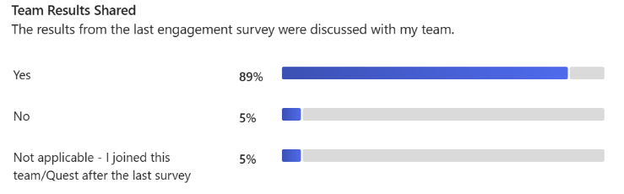  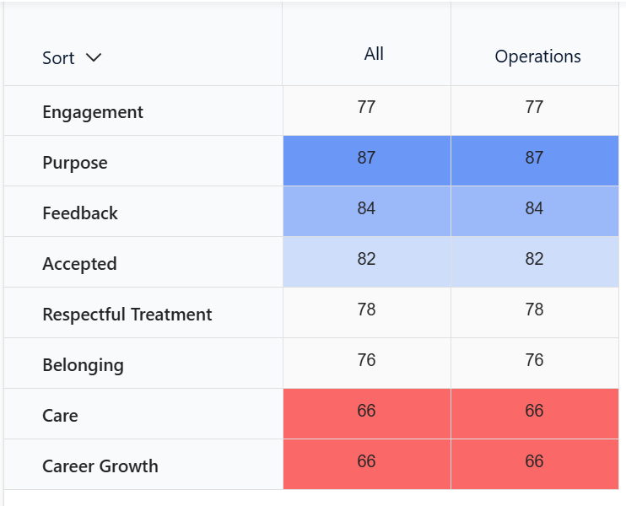  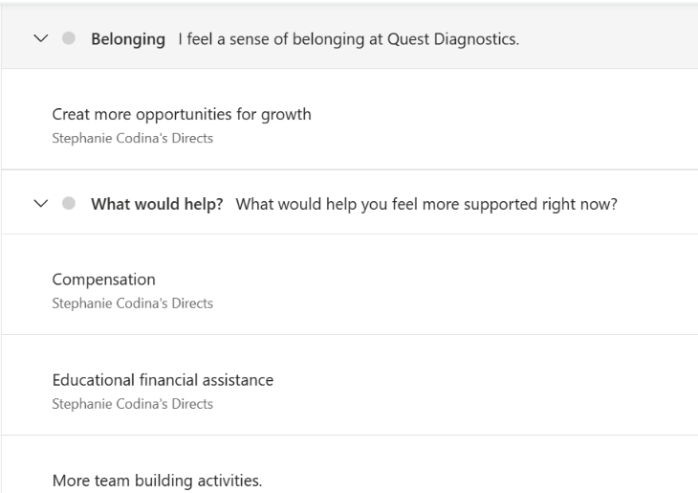  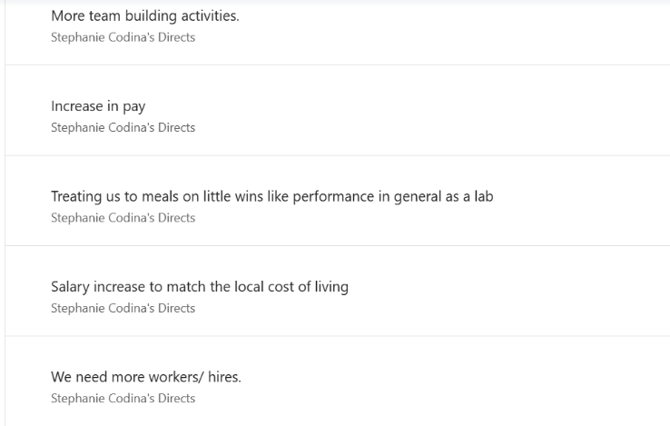  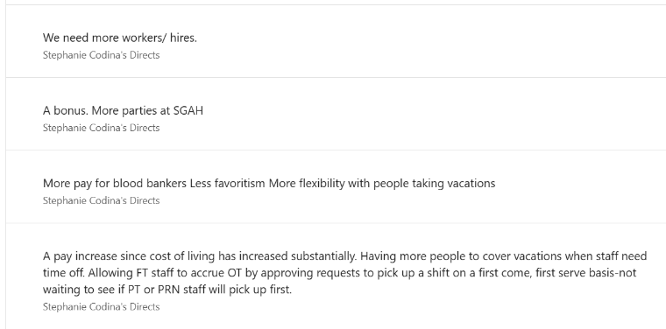 |  | Informational | None
To Do List | - Come up with a minimum of 2-3 possible personal goals for 2026 and submit by January 31, 2026.  - Complete the fetal screen competency by the deadline once assigned. |  | Complete mandatory training assignments by the deadline | All Staff

