Procedure
Dignity Health Central Coast Service Area

SUBJECT: Dispensing Blood Products in Cerner
ORIGIN: Laboratory – Transfusion Service
NUMBER: 7540.BB.CC.511

Applies to:
☒ Santa Maria Campus,  Marian Regional Medical Center | ☒ Arroyo Grande Campus,  Marian Regional Medical Center | ☒ French Hospital Medical Center
☐ St. John’s Pleasant Valley Hospital | ☐ St. John’s Regional Medical Center

PURPOSE:
To provide guidance for dispensing products in the laboratory information system (LIS), Cerner.

clinical Complexity:
High Complexity

Principle:
According to the Standards of Blood Banks and Transfusion Services each critical step in the process of transportation of blood products must be trackable and traceable and include the identity of whom and when each step was performed. Dispensing blood products in the LIS provides documentation of this critical step and provides traceability in accordance with standards and regulations.

Procedure:

Routine Transfusion – Current specimen and all testing complete
Step | Action | Related Documents
1 | On the Cerner app bar select the Dispense and Assign Products icon.  
2 | Select the correct location.  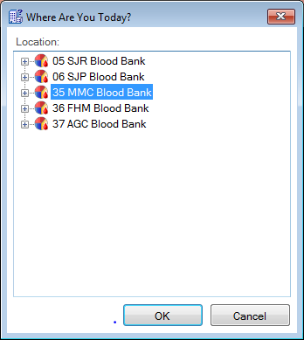  Note: The location will default to the last location selected. If the wrong location is selected, then select View on the menu bar and then Location Selection or on the toolbar select the Location Selection icon.
3 | Click on the dispense button or icon on the toolbar.  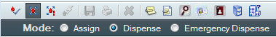
4 | Scan the M# (medical record number) barcode from the patient label. Select the current admission or place the cursor in the financial number (FIN NBR) box and barcode the FIN from the patient label and select OK.
5 | Click in the Product List grid and barcode the donor identification number (DIN) of the blood product to be dispensed.  If multiple products are received in inventory with the same DIN, a Select Blood Product window will appear. Barcode the standard product code (SPC) of the unit to select the correct product type or container.  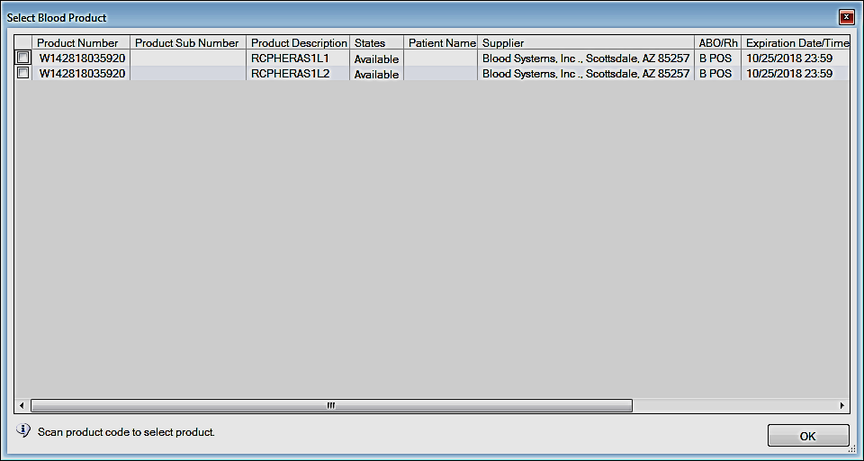  Note: If this is a product that has been modified by thawing or division, ensure the product is correctly relabeled with an ISBT label. If the product is labeled with the original expiration date and time or original ISBT label, then do not continue the dispense process until the product has been correctly labeled and component label verified, if indicated.
6 | Barcode additional products if necessary.
7 | Perform a visual inspection and verification of all information | 7540.BB.CC.312 Visual Inspection of Blood Components and RhIg  7540.BB.CC.316 Issuing Blood Products – 2 Person Check  7540.BB.CC.317 Issuing Blood Products via Pneumatic Tube System  7540.BB.CC.319 Issuing Blood Products – Single Person Check
8 | If all information is accurate and without discrepancy click on the save icon on the toolbar or use the keyboard shortcut of Ctrl + S.
9 | Document the following:  Physician ordering the transfusion  Reason  Visual inspection  Courier  Location  Cooler (if indicated)  Blood bank id  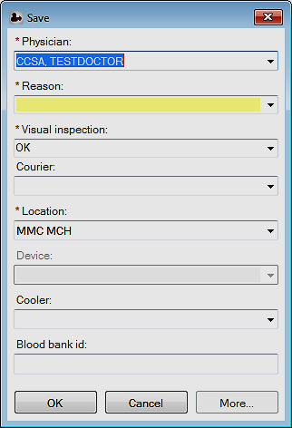  Select the OK button.

Emergency Release- Patient assigned a medical record number (MRN)
Step | Action | Related Documents
1 | On the Cerner app bar select the Dispense and Assign Products icon
2 | Select the correct location.  Note: The location will default to the last location selected. If the wrong location is selected, then select View on the menu bar and then Location Selection or on the toolbar select the Location Selection icon.
3 | Click on the dispense button or icon on the toolbar.
4 | Scan the M# (medical record number) barcode from the patient label. Select the current admission or place the cursor in the financial number (FIN NBR) box and barcode the FIN from the patient label and select OK.
5 | Click in the Product List grid and barcode the donor identification number (DIN) of the blood product to be dispensed.  If multiple products are received in inventory with the same DIN, a Select Blood Product window will appear. Barcode the standard product code (SPC) of the unit to select the correct product type or container.  Note: If this is a product that has been modified by thawing or division, ensure the product is correctly relabeled with an ISBT label. If the product is labeled with the original expiration date and time or original ISBT label, then do not continue the dispense process until the product has been correctly labeled and component label verified, if indicated.
6 | A Blood Bank Exception window will appear.  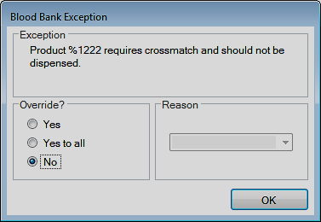  Read the Blood Bank Exception carefully prior to selecting a response.
7 | If the Exception is that the “Product requires a crossmatch and should not be dispensed” and the product is needed for an emergency transfusion, then select the option for Yes to Override?  Use the drop down box for the reason and select the appropriate response (Emergency, MTP). A reason must be selected before the OK button can be selected.  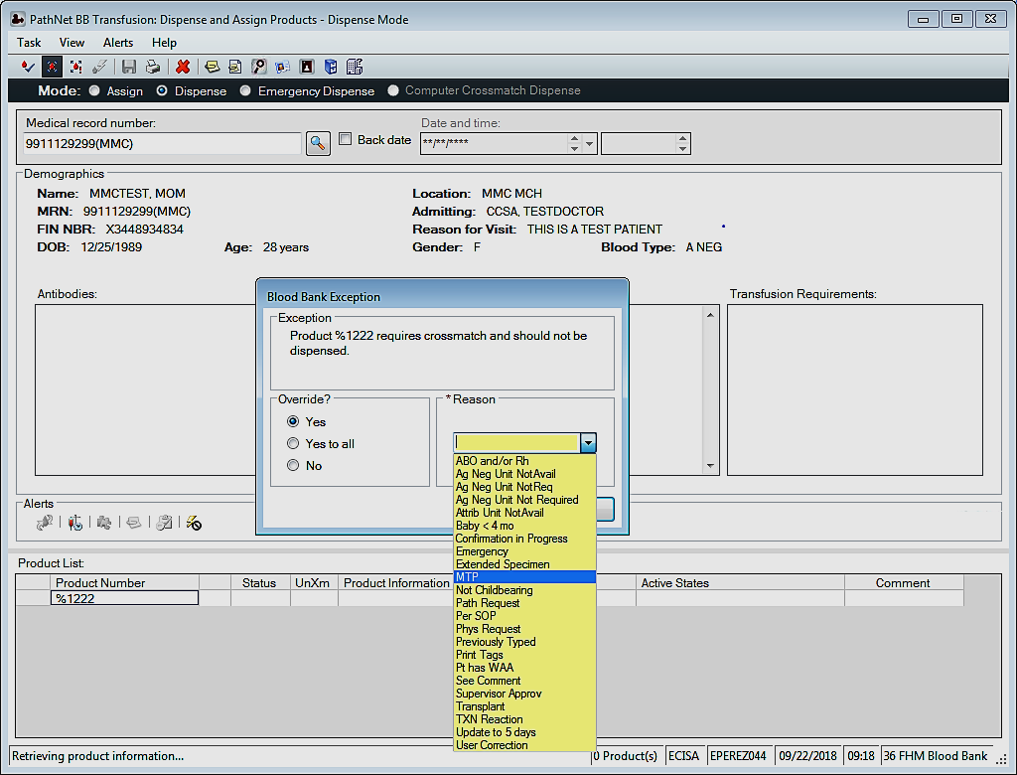
8 | If the blood type is unknown, a second Blood Bank Exception window will appear.  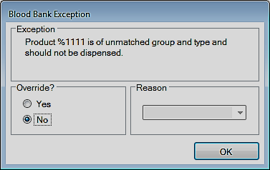  Ensure the blood product type is acceptable for transfusion for the recipient.  If Then  RBC Group O Males – Group O, D- positive Females ≤ 50 years old – Group O, D-negative Females > 50 years old – Group O, D-positive Children (>4 months – 16 years old) – CMV safe, Group O, D-negative Neonates (<4 months) – CMV safe, irradiated, Hgb S negative, Group O, D-negative (If unavailable contact the ordering physician and on call pathologist for approval and guidance).  Plasma Group AB  Platelet pheresis (PLP) 1st Expiring If the patient is found to be D-negative and a female ≤ 50 years old and a D-positive PLP was administered, then prophylactically administer one vial of RhIg per 7 PLP.  Cryoprecipitate 1st Expiring | 7540.BB.CC.007 Code Crimson – Massive Hemorrhage Event  7540.BB.CC.320 Emergency Release of Products
9 | If the blood component is acceptable for transfusion, then select Yes to Override and use the drop down box to select the Reason and select OK.
10 | If any other Blood Bank Exception appears, then read the exception carefully and do not override any exceptions that include an expired product, unconfirmed products, antigen/antibody validation, patient/product compatibility, and/or transfusion requirements, unless approved by the medical director or pathologist and the ordering physician.
11 | Barcode additional products if necessary and override acceptable emergency release blood bank exceptions.
12 | Review the products barcoded in the product list grid. If there was an exception, then an exception warning will be in the Status box. The exception and the override reason will be visible when the mouse cursor is hovered over the exception warning icon.  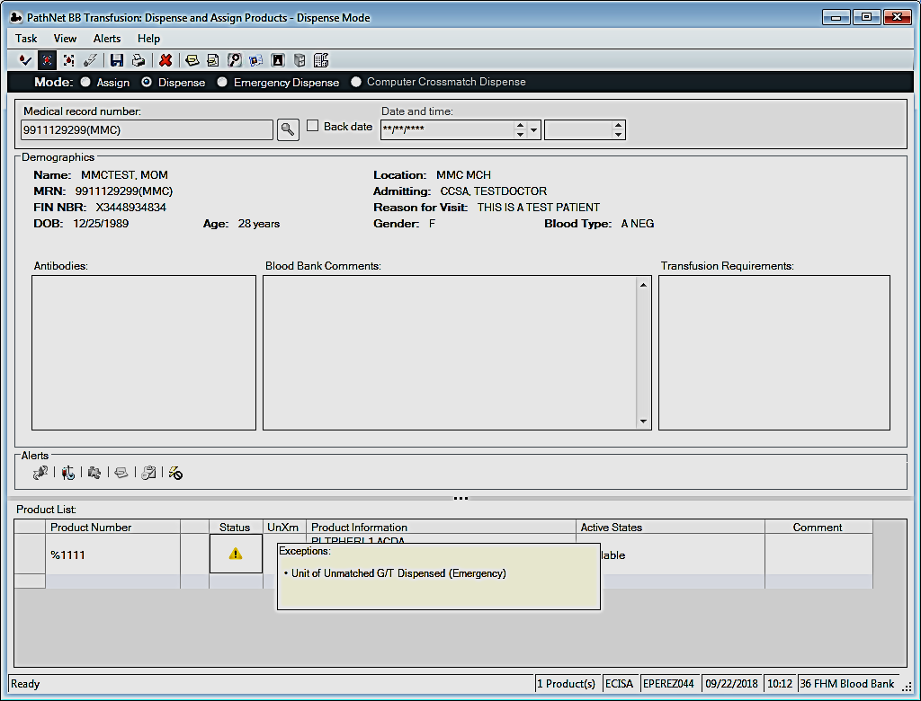
13 | Perform a visual inspection and verification of all information. | 7540.BB.CC.312 Visual Inspection of Blood Components and RhIg  7540.BB.CC.316 Issuing Blood Products – 2 Person Check  7540.BB.CC.317 Issuing Blood Products via Pneumatic Tube System  7540.BB.CC.319 Issuing Blood Products – Single Person Check
13 | If all information is accurate and without discrepancy click on the save icon on the toolbar or use the keyboard shortcut of Ctrl + S.
14 | Document the following:  Physician ordering the transfusion  Reason (Emergency, MTP, OB-MTP)  Visual inspection  Courier  Location  Cooler (if indicated)  Blood bank id (if indicated)  Select the OK button.
15 | Press Enter or the OK button twice (first for the emergency dispense packing list and second for the emergency dispense product ID tag).

Emergency Release – Patient not assigned a medical record number (MRN)
Step | Action | Related Documents
1 | On the Cerner app bar select the Dispense and Assign Products icon
2 | Select the correct location.  Note: The location will default to the last location selected. If the wrong location is selected, then select View on the menu bar and then Location Selection or on the toolbar select the Location Selection icon.
3 | Click on the emergency dispense button or icon on the toolbar  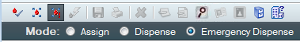
4 | In the Emergency Patient box, type in a description of the patient as an identifier.  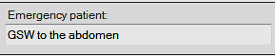
5 | Click in the Product List grid and barcode the donor identification number (DIN) of the blood product to be dispensed.  If multiple products are received in inventory with the same DIN, a Select Blood Product window will appear. Barcode the standard product code (SPC) of the unit to select the correct product type or container.  Note: If this is a product that has been modified by thawing or division, ensure the product is correctly relabeled with an ISBT label. If the product is labeled with the original expiration date and time or original ISBT label, then do not continue the dispense process until the product has been correctly labeled and component label verified, if indicated.
6 | A Blood Bank Exception window will appear due to the unknown group and type of the recipient. Read the Blood Bank Exception window carefully before selecting an Override response.  Ensure the blood product type is acceptable for emergent transfusion.  If Then  RBC Group O Males – Group O, D- positive Females (age unknown) – Group O, D-negative Females ≤ 50 years old – Group O, D-negative Females > 50 years old – Group O, D-positive Children (>4 months – 16 years old) – CMV safe, Group O, D-negative Neonates (<4 months) – CMV safe, irradiated, Hgb S negative, Group O, D-negative (If unavailable contact the ordering physician and on call pathologist for approval and guidance).  Plasma Group AB  Platelet pheresis (PLP) 1st Expiring If the patient is found to be D-negative and a female ≤ 50 years old and a D-positive PLP was administered, then prophylactically administer one vial of RhIg per 7 PLP.  Cryoprecipitate 1st Expiring | 7540.BB.CC.320 Emergency Release of Products  7540.BB.CC.007 Code Crimson – Massive Hemorrhage Event
7 | If the blood component is acceptable for transfusion, then select Yes to Override and use the drop down box for the Reason and select OK.
8 | If any other Blood Bank Exception appears, then read the exception carefully and do not override any exceptions that include an expired product, unconfirmed products, antigen/antibody validation, patient/product compatibility, and/or transfusion requirements, unless approved by the medical director or pathologist and the ordering physician.
9 | Barcode additional products if necessary and override acceptable emergency release blood bank exceptions.
10 | Review the products barcoded in the product list grid. If there was an exception, then an exception warning will be in the Status box. The exception and the override reason will be visible when the mouse cursor is hovered over the exception warning icon.
11 | Perform a visual inspection and verification of all information. | 7540.BB.CC.312 Visual Inspection of Blood Components and RhIg  7540.BB.CC.316 Issuing Blood Products – 2 Person Check  7540.BB.CC.317 Issuing Blood Products via Pneumatic Tube System  7540.BB.CC.319 Issuing Blood Products – Single Person Check
12 | If all information is accurate and without discrepancy click on the save icon on the toolbar or use the keyboard shortcut of Ctrl + S.
13 | Document the following:  Physician ordering the transfusion  Reason (Emergency, MTP, OB-MTP)  Visual inspection  Courier  Location  Cooler (if indicated)  Select the OK button.
14 | Press Enter or the OK button twice (first for the emergency dispense packing list and second for the emergency dispense product ID tag).

Interpretation of Results:

Compatible: Crossmatch compatible red blood cells should be dispensed whenever possible.

Least Incompatible: Least incompatible red blood cells should only be dispensed when approved by the medical director or pathologist and the ordering physician.

OK to Issue: Neonates that are < 4 months of age will have a crossmatch interpretation of OK to Issue due to compatibility testing not being indicated [7540.BB.CC.360 Pretransfusion Testing: Neonate under Four Months (120 days) of Age]. Massive transfusion patients that have received >10 RBC units in an adult recipient in <24 hours do not need to be crossmatched during the massive hemorrhage event and may have a crossmatch interpretation of OK to Issue.

Incompatible: Incompatible crossmatched red blood cells should not be dispensed,

Limitation of Procedure:

The transfusion service is responsible for confirming the recipient identifying information, transfusion request, testing, compatibility, and blood component labeling are accurate and in agreement. However, the final identification of the recipient and the blood component is the responsibility of the transfusionist(s).

Definitions:

LIS: Laboratory information system

MRN: Medical record number

DIN: Donor identification number is the unique identification that can be traced to the blood donor. The DIN is found in the first quadrant of the ISBT label.

ISBT: International Society of Blood Transfusion

SPC: Standard Product Code is the barcode in the third quadrant of the ISBT label and is determined by the standard product description.

Emergent Transfusion: The recipient’s physician deems the clinical situation sufficiently urgent and requires the release of blood before completion of compatibility testing.

References:

Fung, M. K. (Current Edition). Technical Manual. Bethesda, MD: AABB.

Standards for Blood Banks and Transfusion Services (Current Edition). Bethesda, MD: AABB.

associated Documents:

7540.BB.CC.007 Code Crimson – Massive Hemorrhage Event

7540.BB.CC.312 Visual Inspection of Blood Components and RhIg

7540.BB.CC.316 Issuing Blood Products – 2 Person Check

7540.BB.CC.317 Issuing Blood Products via Pneumatic Tube System

7540.BB.CC.319 Issuing Blood Products – Single Person Check

7540.BB.CC.320 Emergency Release of Products

7540.BB.CC.360 Pretransfusion Testing: Neonate under Four Months (120 days) of Age

