Policy   
Dignity Health Central Coast Service Area

**SUBJECT**: Selection of Type of Crossmatch

**ORIGIN**: Laboratory-Transfusion Service

**NUMBER**: 7540.BB.CC.142

|  |  |  |
| --- | --- | --- |
| **Applies to:** | | |
| Santa Maria Campus,  Marian Regional Medical Center | Arroyo Grande Campus,  Marian Regional Medical Center | French Hospital Medical Center |
| St. John’s Pleasant Valley Hospital | St. John’s Regional Medical Center | |

# PURPOSE:

This policy provides instructions for the selection of the appropriate red cell crossmatch method.

# DEFINITIONS:

1. Immediate Spin (IS) Crossmatch: Serological method used to determine ABO incompatibility between donor red cells and recipient plasma.
2. Antiglobulin Crossmatch: Procedure that uses the indirect antiglobulin test (IAT), which includes incubation at 37°C and the addition of antihuman globulin to determine the compatibility between donor red cells and recipient plasma. The IAT methodology is utilized when the recipient has been previously or is currently immunized.
3. Alloantibody: Individual produces an antibody to an antigen that the individual lacks.
4. Autoantibody: Individual produces an antibody to an antigen that the individual possesses.
5. Clinically significant red cell antibodies: antibodies that are frequently associated with hemolytic disease of the fetus and newborn, hemolytic transfusion reactions, or a decreased survival of transfused red cells.

Examples: Anti-D, Anti-C, Anti-E, Anti-c, Anti-e, Anti-K, Anti-Fya, Anti-Fyb, Anti-Jka, Anti-Jkb, Anti-S, Anti-s

1. Clinically insignificant red cell antibodies: antibodies that are not frequently associated with hemolytic disease of the fetus and newborn, hemolytic transfusion reactions, or a decreased survival of transfused red cells.

Examples: Anti-Lea, Anti-Leb, Anti-M, Anti-N, Anti-P1, Anti-I, Anti-i

# POLICY:

1. Ensure the recipient has a current blood bank identification band and the ABORh, antibody screen, and antibody identification (if indicated) has been performed.
2. Review the recipient’s history for the following:
   * 1. ABO/Rh (At least two determinations of a recipient’s ABO/Rh are required before transfusion of type specific (non-group “O”) red blood cells or whole blood.
     2. Antibody screen
     3. Antibody identification (if indicated)
     4. Special transfusion requirements
     5. Transfusion reactions
     6. Blood bank comments, which may indicate a history of difficulty in blood typing.
3. Review the PRBC Requisition order for the number of units requested along with any special transfusion requirements.

|  |  |  |
| --- | --- | --- |
| **If the recipient’s current antibody screen is** | **And there is a history of** | **Then crossmatch red cells by any of the methods listed below:** |
| Negative | No previous antibodies  *Passive Anti-D | Immediate Spin crossmatch |
| Negative | †Clinically significant alloantibody  ‡Clinically insignificant alloantibody  Cold autoantibody  Warm autoantibody  Nonspecific antibody  Positive antibody screen with “No clinically significant antibodies” | **⊥**Tube Indirect Antiglobulin Test (IAT)  **⊥**Gel Indirect Antiglobulin Test (IAT)  Note: IAT crossmatches must be performed using the same methodology as the antibody screen. Gel IAT crossmatches must include an immediate spin phase to detect ABO incompatibility. |
| Positive | **†**Clinically significant antibody  Warm autoantibody  Refer to Appendix A to determine the requirement for antigen negative RBC’s. | **⊥**Tube Indirect Antiglobulin Test  **⊥**Gel Indirect Antiglobulin Test  Note: IAT crossmatches must be performed using the same methodology as the antibody screen. Gel IAT crossmatches must include an immediate spin phase to detect ABO incompatibility. |
| Positive | ‡Clinically insignificant antibody  Cold autoantibody  Positive antibody screen with “No clinically significant antibodies”  Refer to Appendix A to determine the requirement for antigen negative RBC’s. | **⊥**Tube Indirect Antiglobulin Test  **⊥**Gel Indirect Antiglobulin Test  Note: IAT crossmatches must be performed using the same methodology as the antibody screen. Gel IAT crossmatches must include an immediate spin phase to detect ABO incompatibility. |
| Positive | Nonspecific antibody | **⊥**Tube Indirect Antiglobulin Test  **⊥**Gel Indirect Antiglobulin Test  Note: IAT crossmatches must be performed using the same methodology as the antibody screen. Gel IAT crossmatches must include an immediate spin phase to detect ABO incompatibility. |
| Negative | Anti-CD38 treatment (Daratumumab; DARA) with no underlying alloantibodies detected using DTT treated antibody screening cells. | Immediate spin crossmatch that is ABO/D compatible and phenotypically matched for the Rh (C, E, c, e) and Kell antigens.  Refer to the AABB Bulletin #16-02. |
| Negative | Anti-CD38 treatment with underlying clinically significant alloantibody(ies) | ABO/D compatible and phenotypically matched for the Rh (C, E, c, e), Kell antigens, and antigen negative for the detected clinically significant alloantibody(ies).  **⊥**Tube Indirect Antiglobulin Test  **⊥**Gel Indirect Antiglobulin Test  Note: IAT crossmatches must be performed using the same methodology as the antibody screen. Gel IAT crossmatches must include an immediate spin phase to detect ABO incompatibility. |
| Negative | Anti-CD38 treatment with underlying clinically insignificant alloantibody(ies) | ABO/D compatible and phenotypically matched for the Rh (C, E, c, e), and Kell antigens  **⊥**Tube Indirect Antiglobulin Test  **⊥**Gel Indirect Antiglobulin Test  Note: IAT crossmatches must be performed using the same methodology as the antibody screen. Gel IAT crossmatches must include an immediate spin phase to detect ABO incompatibility. |
| Positive | Anti-CD38 treatment with no underlying alloantibodies detected using DTT treated antibody screening cells.  Testing performed by the immunohematology reference laboratory. | Immediate spin crossmatch that is ABO/D compatible and phenotypically matched for the Rh (C, E, c, e) and Kell antigens.  Refer to the AABB Bulletin #16-02. |
| Positive | Anti-CD38 treatment with underlying clinically significant alloantibodies detected using DTT treated antibody screening cells.  Testing performed by the immunohematology reference laboratory.  Refer to Appendix A to determine the requirement for antigen negative RBC’s. | ABO/D compatible and phenotypically matched for the Rh (C, E, c, e), Kell antigens and antigen negative for the detected clinically significant alloantibody(ies).  **⊥**Tube Indirect Antiglobulin Test  **⊥**Gel Indirect Antiglobulin Test  Note: IAT crossmatches must be performed using the same methodology as the antibody screen. Gel IAT crossmatches must include an immediate spin phase to detect ABO incompatibility. |
| Positive | Anti-CD38 treatment with underlying clinically insignificant alloantibodies detected using DTT treated antibody screening cells. Testing performed by the immunohematology reference laboratory.  Refer to Appendix A to determine the requirement for antigen negative RBC’s. | ABO/D compatible and phenotypically matched for the Rh (C, E, c, e) and Kell antigens.  **⊥**Tube Indirect Antiglobulin Test  **⊥**Gel Indirect Antiglobulin Test  Note: IAT crossmatches must be performed using the same methodology as the antibody screen. Gel IAT crossmatches must include an immediate spin phase to detect ABO incompatibility. |

*Rh Immune Globulin is administered to Rh negative females during pregnancy or after the administration of Rh positive blood products to a Rh negative recipient.

If the current antibody screen is negative, then remove the Passive Anti-D by:

* Selecting the Transfusion Requirements, Antibodies, and Antigens icon

 in Result Entry or Patient Product Inquiry.

* Select the Antibodies button



* Select the red X to remove the Passive Anti-D and then select the Apply Button.

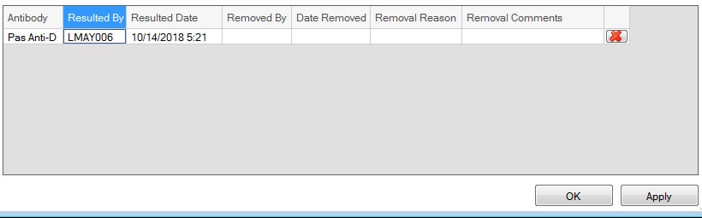

* Select the OK button to exit the window.
* Select the 
* Add a Blood Bank comment that includes “Passive Anti-D due to (antenatal/postpartum) RhIg received on (Date).”

† Recipient’s with a history or the current identification of clinically significant antibodies must receive red blood cells that are lacking the antigen corresponding to the clinically significant antibody. Refer to Appendix A for further instruction.

‡ Recipient’s with a history or the current identification of clinically insignificant antibodies do not require red blood cells that are lacking the antigen corresponding to the clinically insignificant antibody. Refer to Appendix A for further instruction.

**⊥**If an IAT crossmatch is required, then cancel the XMIS that is automatically ordered in Cerner and add an ALT XM to the sample using the Department Order Entry> Accession Add on function in the LIS.

# REFERENCES:

## Blackall, D.P. (2007). *Transfusion Service Manual of Standard Operating Procedures, Training Guides and Competence Assessment Tools.* Bethesda, MD: AABB.

## Fung, M.K. (Current Edition). *Technical Manual*. Bethesda, MD: AABB.

## Judd, W.J., Johnson, S.T., & Storry, J.R. (2008). *Judd’s Methods in Immunohematology.* Bethesda, MD: AABB.

## *Standards for Blood Banks and Transfusion Services* (Current Edition). Bethesda, MD: AABB.

# ASSOCIATED DOCUMENTS:

1. 7540.BB.CC.010 Collection of Specimens for Transfusion Testing
2. 7540.BB.CC.121 Evaluating Patient Samples and Request Forms
3. 7540.BB.CC.145 Tube Indirect Antiglobulin (IAT) Crossmatch Procedure
4. 7540.BB.CC.146 Manual Gel Indirect Antiglobulin (IAT) Crossmatch Procedure
5. 7540.BB.CC.502 PRBC Requisition
6. Appendix A: Clinical Significance of Alloantibodies and Provision of Red Cells
7. Appendix B: AABB Association Bulletin #16-02 Mitigating the Anti-CD38 Interference with Serological Testing

Appendix A: Clinical Significance of Alloantibodies and Provision of Red Cells

|  |  |  |  |
| --- | --- | --- | --- |
|  | **Antibodies to the Following:** | **Is Antigen Negative Blood Required** | **Is a Full Serologic Crossmatch Required?** |
| Clinically significant antibodies | D, C, E, c, e, f*, K, k, S, s, M*, Jka, Jkb, Fya, Fyb,  *f – give c negative units | Yes | Yes |
| Clinically insignificant antibodies | M*, N, P1, Lea, Leb, Lua, Lub, A1, H, HI, Hi, I,i, | No  (IAT crossmatch compatible only) | Yes |
| Potentially clinically significant antibodies | Kpa, Kpb, Wra, Jsa, Jsb, Dia, Dib, Yta, Doa, Dob, Coa, Cob, Cw, V, Bg, Vel, PP1Pk, Lan | No  (crossmatch compatible only) | Yes |
| Antibody to the above antigens plus pan-reactive warm autoantibody | Yes, if antisera available | Yes |
| *Anti-M | Anti-M only | No  (IAT crossmatch compatible only) | Yes |
| Anti-M plus pan-reactive warm autoantibody | Yes | Yes |
| Passive anti-D  *Note: Recent injection of Rh Immune Globulin must be documented* | D | Yes | Yes  Only while antibody screen is positive |
| Warm autoantibodies |  | Yes, phenotypically matched to recipient for Rh (C, E, c, e), Kell antigens and antigen negative for underlying clinically significant antibodies. | Yes |
| Unidentified or inconclusive antibody(ies) | All major blood group systems excluded | Not applicable | Yes |

Appendix B: AABB Association Bulletin #16-02 Mitigating the Anti-CD38 Interference with Serological Testing

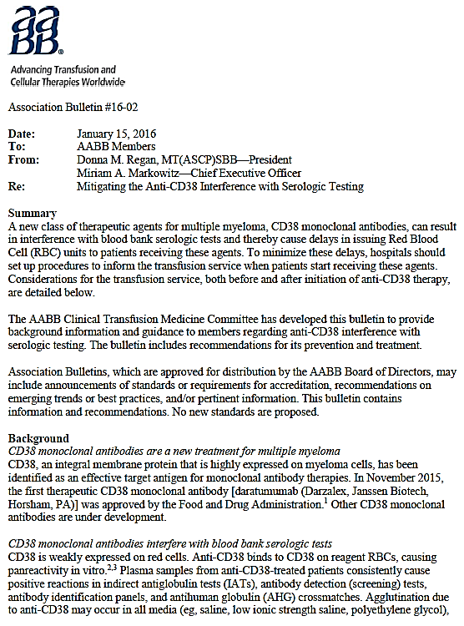

Appendix B: AABB Association Bulletin #16-02 Mitigating the Anti-CD38 Interference with Serological Testing continued.

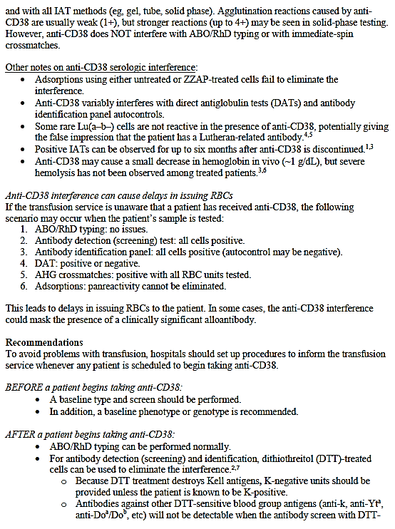

Appendix B: AABB Association Bulletin #16-02 Mitigating the Anti-CD38 Interference with Serological Testing continued.

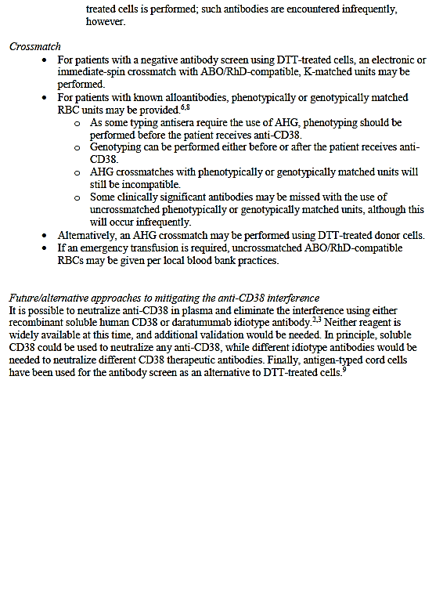

Appendix B: AABB Association Bulletin #16-02 Mitigating the Anti-CD38 Interference with Serological Testing continued.

