Dignity Health Central Coast Service Area

**SUBJECT**: VerifyNow - Aspirin and PRUTest Assays

**ORIGIN:** Clinical Laboratory/Coagulation

| **Document Category:** | | | |
| --- | --- | --- | --- |
| ☒ Policy | ☒Procedure | ☐Standardized Procedure | ☐Other: |

| **Applies to:** | | |
| --- | --- | --- |
| ☐ Santa Maria Campus,  Marian Regional Medical Center | ☐Arroyo Grande Campus,  Marian Regional Medical Center | ☒French Hospital Medical Center |
| ☐St. John’s Pleasant Valley Hospital | ☐St. John’s Regional Medical Center | |

1. **PURPOSE**

The VerifyNow system is a turbidimetric based optical detection system which measures platelet induced aggregation. The VerifyNow Aspirin Test is a qualitative test to aid in the detection of platelet dysfunction due to aspirin ingestion in citrated whole blood. The VerifyNow PRUTest is designed to measure platelet P2Y12 receptor blockade.

1. **PRINCIPLE**

Aspirin affects platelet function by irreversibly inhibiting the cyclooxygenase-1 (COX-1) enzyme involved in the conversion of arachidonic acid to thromboxane A2, which ultimately activates GP IIb/IIIa receptors involved in platelet aggregation. If aspirin has produced the expected anti-platelet effect, such aggregation will not occur. The VerifyNow Aspirin test incorporates the agonist arachidonic acid to activate platelets. The Aspirin Test is designed to measure platelet function based upon the ability of activated platelets to bind fibrinogen. Fibrinogen-coated microparticles aggregate in whole blood in proportion to the number of unblocked platelet GP IIb/IIIa receptors. Light transmittance increases as activated platelets bind and aggregate fibrinogen-coated beads. The instrument measures this change in optical signal caused by aggregation.

Substances known to specifically block the P2Y12 receptor include the thienopyridine class of drugs, including clopidogrel. The test is based upon the ability of activated platelets to bind fibrinogen. Fibrinogen-coated microparticles aggregate in whole blood in proportion to the number of expressed platelet GP IIb/IIIa receptors. The rate of microbead aggregation is more rapid and reproducible if platelets are activated; therefore the reagents adenosine-5-diphosphate and prostaglandin E1 (ADP/PGE1) are incorporated into the test channel to induce platelet activation without fibrin formation. The reagent is formulated to specifically measure P2Y12-mediated platelet aggregation. Light transmittance increases as activated platelets bind and aggregate fibrinogen-coated beads. The instrument measures this change in optical signal and reports results in P2Y12 Reaction Units (PRU).

1. **SPECIMEN REQUIREMENTS**
   1. Two (2) Greiner Bio-One 2.0 mL partial fill 3.2% citrate vacuum blue top tubes filled to black line. Do not underfill or overfill
      1. Direct venipuncture
         1. Whole blood may be collected from venous sites using a 21 gauge or larger needle
         2. Collect approximately 2 mL of blood in a discard tube (eg, no additive, sodium citrate) before collecting sample tube
         3. Gently invert sample tube 5 times to ensure complete mixing
      2. Indwelling catheter
         1. Whole blood sample obtained from an indwelling catheter should be collected after sufficient discard (approximately 5 mL) has been drawn to clear the line
         2. When using a syringe, transfer blood to sample collection tube immediately after collection
         3. If blood is transferred using a needle, needle size must be 21 gauge or larger
         4. Gently invert sample tube 5 times to ensure complete mixing
      3. Collection of the blood specimen should be performed with care to avoid hemolysis or contamination by tissue fluids. Samples with evidence of clotting must not be used
         1. It is important to minimize the amount of time that the tourniquet is applied prior to filling the tube in order to avoid activating the platelets while obtaining the sample
         2. Perform the phlebotomy and obtain the appropriate volume of blood in the sample tube following a discard tube of at least 2 mL of whole blood. DO NOT DRAW A SAMPLE FOR ANY PLATELET FUNCTION ASSAY AFTER A TUBE THAT CONTAINS EDTA (PURPLE TOP). Always draw the sample tube(s) for the VerifyNow test first
         3. Gently invert the citrated tube containing whole blood 5 times immediately after collection to mix the blood with the anticoagulant and prevent clotting
         4. Samples must be kept at room temperature. Do not refrigerate, freeze or centrifuge the samples to be used for the VerifyNow Test
         5. Samples that are difficult to obtain may hemolyze or clot. Samples that are hemolyzed or clotted should be recollected
   2. Blood must equilibrate at room temperature (18 °C to 25 °C) for a minimum period of time depending on assay type, but no longer than 4 hours
      1. Aspirin assay: wait 30 minutes before testing
      2. PRU assay: wait 10 minutes before testing
   3. **Do not centrifuge, separate, freeze, or refrigerate samples. Do not place samples in a water bath or on a rocker plate.**
   4. For VerifyNow Aspirin Test, samples should be collected between 2 and 30 hours after ingestion of aspirin
2. **MATERIALS**
   1. Equipment and Supplies
      1. VerifyNow Instrument with Electronic Quality Control (EQC) device
      2. Greiner Bio-One 2 mL blood collection tubes containing 3.2% sodium citrate
   2. Reagents
      1. VerifyNow Aspirin Test Device kit
         1. Kit contains individually sealed foil pouches each with a test device containing lyophilized fibrinogen-coated beads, platelet agonist, peptide, bovine serum albumin, stabilizer, and buffer
         2. Store test devices at 2 °C to 25 °C. If refrigerated, allow test devices to reach room temperature (18 °C to 25 °C) prior to use
         3. Test device should remain sealed in the foil pouch until ready to use to prevent damage by humidity.
         4. Each kit has a temperature indicator on the outside of the packaging which is to be inspected upon receipt of the kit. The indicator detects errors due to adverse environmental conditions
         5. If indicator has changed color, indicating kit has been exposed to elevated temperature, a Wet Quality Control (WQC) Level 2 must be run to ensure reagents are performing properly
      2. VerifyNow PRUTest Device kit
         1. Kit contains individually sealed foil pouches each with a test device containing lyophilized fibrinogen-coated beads, ADP, bovine serum albumin, PGE1, and buffer
         2. Store test devices at 15 °C to 25 °C. PRUTest product is stable under these conditions until the date indicated on the pouch and box
         3. Test device should remain sealed in the foil pouch until ready to use to prevent damage by humidity
      3. VerifyNow AssayWet Quality Control (WQC) kit
         1. Level 1/Level 2 WQC Diluent tubes containing 2 mL of optically absorbent suspension with bovine serum albumin and preservative
         2. Level 1/Level 2 WQC Diluent is used as Level 1 Control
            * Gently invert diluent 4-5 times to mix reagents prior to use
         3. Level 2 WQC pellets containing peptide in buffered solution and colored pink
            * Immediately prior to use, open vial containing Level 2 WQC pellet. Remove stopper from Level 1/Level 2 WQC Diluent tube
            * Hold diluent tube vertically and insert the pellet into the diluent
            * Replace stopper on diluent tube then gently invert 4-5 times to mix reagents
         4. Control material should be stored at 15 °C to 25 °C
         5. Unopened controls are stable until expiration date indicated on label
         6. Open/reconstituted controls should be used within 15 minutes
         7. Do not freeze
         8. Each kit contains material for six Level 1 or six Level 2 controls
3. **CALIBRATION**
   1. The VerifyNow Aspirin Test and PRUTest Devices are calibrated by the manufacturer at the factory. This calibration information is contained in the barcode on the pouch of each Test Device
   2. The barcode must be scanned whenever a new lot of Test Devices is to be tested. The system will not allow a Test Device to proceed without the lot number calibration information entered into the system. If a new lot of Test Devices is being used, the instrument will prompt the user by displaying a barcode icon after the Test Device is inserted
   3. At prompt, place the Test Device pouch approximately one inch in front of the barcode reader found on the left side of the instrument, so that the light shines on the center of the barcode reader
   4. An audible beep will be heard when the instrument receives the required information
   5. The user needs only to perform this action once per lot. No additional calibration is performed by the user
   6. Calibration Verification is performed by the use of WQC materials with every new lot of reagent and at specified time intervals, with periodic review of QC results by the laboratory technical supervisor. Tests of platelet reactivity are non-linear, and no additional calibration verification is required
4. **QUALITY CONTROL**
   1. Electronic Quality Control
      1. Electronic Quality Control (EQC) is a procedure during which the software will verify proper functioning of instrument optics, reagent mixing, and instrument pneumatics. It also confirms correct calibration parameters and simulates testing at two levels of results to check correct data acquisition and calculations
      2. EQC is performed using the reusable EQC device supplied with the VerifyNow instrument and takes up to 2 minutes
      3. EQC is to be run once a day to confirm instrument integrity. It is also recommended to run after resetting the date and time on the instrument
      4. If a fault is detected in any of its systems, the instrument cannot perform patient testing until the fault is corrected
      5. Performing EQC
         1. From the Main Menu, press the QC key. Wait for the image of the EQC device to display

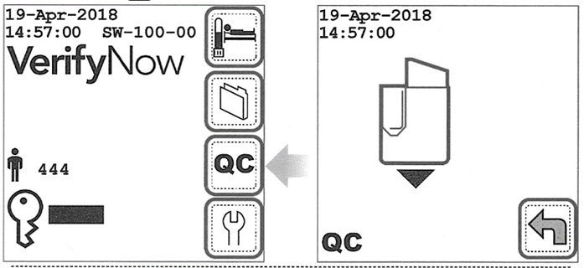

* + - 1. Remove the EQC Device from the storage bay.
      2. Open the instrument cover. Using the finger grip, insert the EQC Device into the test device port until it clicks. The instrument will produce two audible beeps. Close cover to test port

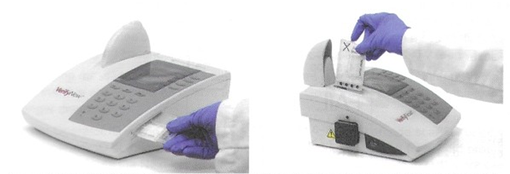

* + - 1. The instrument will automatically proceed with the EQC test. A countdown screen will display while EQC is in progress
      2. When EQC is complete, the instrument will prompt to completely remove the EQC device from the test port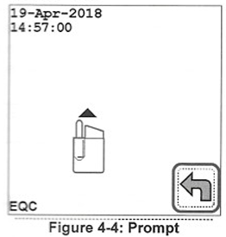
      3. Open the instrument cover and remove the EQC Device and return it to the storage bay. Close instrument cover
      4. A result of PASS or FAIL will be displayed. In addition, numeric values will be reported for the diagnostics, along with the acceptable range for each parameter.

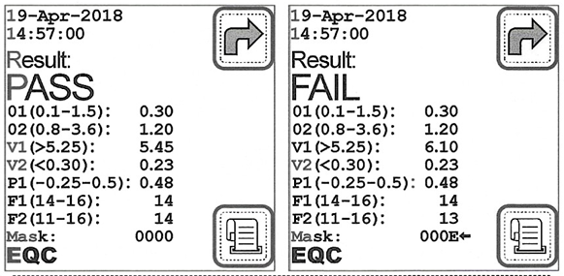

* + - 1. If the instrument is operating within its specifications, PASS will display.
      2. If there is a problem detected during the EQC process and the instrument is not operating within its specifications, a FAIL message will display. The failed parameter will be indicated by an arrow **⬅** to the right of the measured value(s).
      3. Press the Nextkey and perform the corrective action described
      4. When the corrective action is complete, repeat the EQC
      5. If diagnostic failure displays a second time, record the name of the parameter(s) indicated by an arrow **⬅** and contact Technical Support
      6. When EQC is complete, press the Nextkey to return to the Main Menu
  1. Wet Quality Control
     1. Wet Quality Control (WQC) is intended to be used with a diluent and a test device as a basis for quantitative quality control
     2. WQC measures two levels of turbidimetric signal that verify the dynamic range of the instrument
     3. One of these signals is at the level that would be observed in a patient with a minimal amount of platelet aggregation (negative control), and the other represents a patient who demonstrates a significant amount of aggregation (positive control)
     4. WQC Level 1 is formulated at a clinically relevant level and is representative of a sample with platelet inhibition
     5. WQC Level 2 is formulated at a clinically relevant level and is representative of a sample with minimal platelet inhibition
     6. Performing WQC (Level 1 and Level 2)
        1. From the Main Menu, press the QC key. Wait for image of device to display
        2. Just before use, open foil pouch and remove test device using finger grip
           + NOTE: Each test device has a finger grip. Avoid handling other surfaces of the test device
        3. Remove the needle’s protective sheath by twisting clockwise until resistance is met. While continuing to twist clockwise, pull up on the sheath

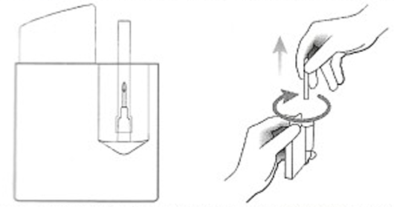

NOTE: Do not try to re-attach any test device needles that may inadvertently be removed. If this occurs, discard the device and use a new one

* + - 1. Open the cover. Using the finger grip, insert the test device into the test port until it clicks

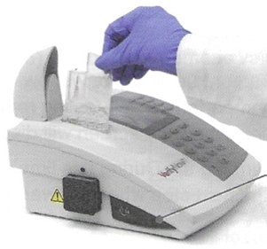

* + - 1. Level 1 WQC
         * **Gently** invert the diluent tube 5 times to mix the reagents immediately before use

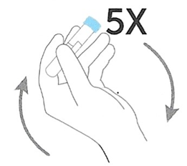

* + - 1. Level 2 WQC
         * Immediately before use, open the vial containing the pellet and inspect. Pellet should appear pink. If pellet appears smaller, red, or is stuck to the vial, discard and use a new pellet.
         * Remove cap from diluent tube. Hold the tube vertically while inverting vial containing pellet so that the pellet falls into the diluent tube. Ensure pellet does not stick to side of diluent tube

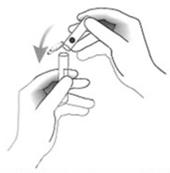

* + - * + Replace cap on diluent tube and gently invert 5 times to mix reagents
        + Control material should be used within 15 minutes of reconstitution
        + If reconstituted control is not used immediately, gently invert tube 5 times to mix reagents again just before use
      1. Wait for the image of the tube to display then insert the WQC sample into the sample well of the test device with the rubber stopper facing downwards so that the needle fully pierces the stopper. The instrument will produce two audible beeps when the tube has been fully inserted.

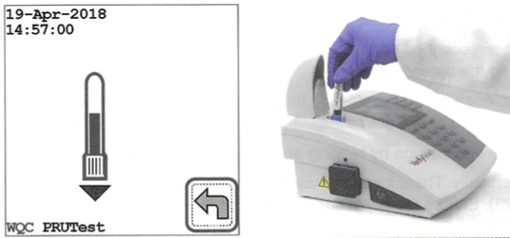

* + - 1. Close the cover to the test device port

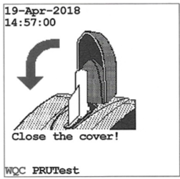

* + - 1. The instrument automatically draws the sample for the vacuum collection tube into the test device, heats the sample, and proceeds with analysis. During this time the screen will flash the test device icon, indicating that the sample is processing. Do not open the cover until the test has completed and a result displays. A calculator will display when the test is near completion.

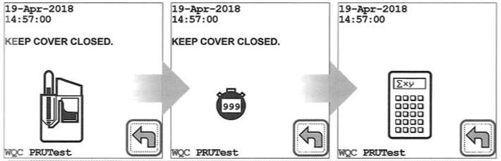

* + - * + CAUTION: The sample is pressurized during parts of the test. Never remove the sample tube or test device during the test. To abort a test, press the Backkey. Wait for the prompt before removing the test device and tube.
      1. When the results display, record or print the results
      2. Open cover. Remove test device and tube together in one piece by grasping the finger grip of the test device and pulling straight up. Never separate the tube from the test device.

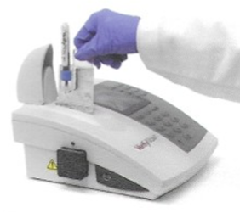

* + - 1. Close cover and discard test device and tube in biohazard waste
      2. Compare WQC results with expected values printed on the test device pouch for Control Level 1 and Control Level 2

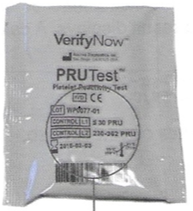

* + - 1. If the results fall within expected ranges, the instrument has passed WQC
      2. If control material does not produce a result within the expected ranges, perform an EQC to ensure the instrument is working properly. If EQC displays PASS, prepare a new WQC sample and repeat WQC procedure with a new test device. If EQC displays FAIL, follow instructions in the *Troubleshooting* chapter of manual.
      3. If WQC result fails on the second attempt, contact Technical Support
      4. Press the Nextkey to return to the Main Menu
  1. Internal System Internal Quality Control
     1. The instrument automatically verifies sample filling, correct fluid transfer, and proper mixing. It also monitors electronic and mechanical components
     2. Each test device incorporates two levels of quality control to identify invalid test runs caused by random errors, reagent degradation, or inappropriate blood samples
        1. Before platelet activation and fibrinogen binding begin, the negative internal control performs a test for non-specific aggregation. A failure of this test will result in an Attention message (Attention 24) or “error” message and no results will be reported
        2. During the active phase of the test, the positive internal control channel monitors the reaction and calculates Control Units which must fall within specified limits. Failure of the positive control will give no results
     3. The system controls prevent the operator from running an expired Test Device.
     4. The system also detects certain other operator errors, such as placing the Test Device or the sample in the instrument at the wrong time, or removing the Test Device before the test is complete. These controls prevent reporting of an inaccurate test result.
     5. The Test Device internal controls in the Verify*Now* Aspirin Test Device can detect failures of the reagent system due to improper storage or handling conditions.
     6. The internal controls will flag an improperly collected or mishandled blood sample, or a blood sample with certain types of interfering substances.
     7. The Test Device internal controls detect errors from the reagent system, adverse environmental conditions, and additional types of operator errors.

1. **PROCEDURE**
   1. Performing Patient Testing
      1. Procure a test device and the sample tube. If test device is refrigerated, allow it to reach room temperature (18 °C to 25 °C) prior to use. Do not remove test device from foil pouch.
      2. Power on instrument using power switch on back panel. The instrument will power on and perform a self-testing routine lasting approximately 30 seconds. After self-testing is complete, the Start screen will display.
      3. Enter Operator ID and Password if required. Press the Next key to advance to the Main Menu.
      4. The instrument should be allowed to warm up for at least 15 minutes prior to use
      5. If sufficient time has elapsed, the instrument will prompt you to perform an EQC. After a PASS has been achieved on EQC, the instrument will be ready to perform testing.
      6. When the initial screen displays, press the Test key. If the Patient ID is required, the Patient ID prompt will display. If not, the instrument will prompt you to insert the test device
         1. A series of question marks will signify the required length of the Patient ID. Use the handheld barcode scanner of the instrument keypad to input an alphanumeric Patient ID and then press the Nextkey

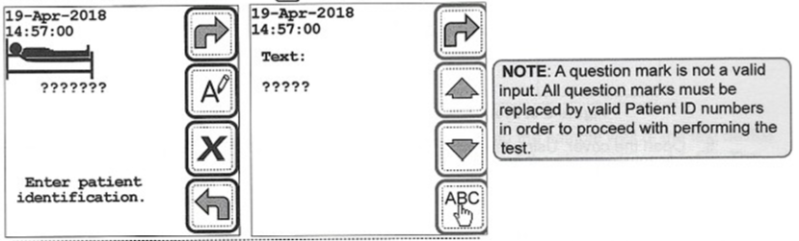

* + 1. Open the foil pouch and remove the test device, holding the test device by the finger grip
    2. Remove the needle’s protective sheath by twisting clockwise until resistance is met. While continuing to twist clockwise, pull up on the sheath



* + 1. Open the cover. Using the finger grip, insert the test device into the test device port until it clicks
    2. If the test device is the first from a new lot, the instrument will display a barcode screen as soon as the device is inserted into the port and the spot code is read. Use the barcode scanner to scan the barcode on the test device pouch. An audible beep will be heard when the instrument reads the information

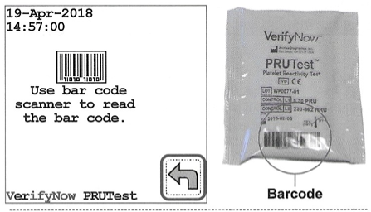

* + 1. After the barcode has been scanned once, the instrument will accept all remaining test devices from that lot without displaying the barcode screen
    2. Gently invert the sample tube 5 times to mix immediately before use
    3. Wait for the Insert Tube icon to display then insert the sample into the sample well of the test device with the rubber stopper facing downwards so that the needle pierces the stopper. The instrument will produce two audible beeps when the tube has been fully inserted



* + 1. Close the cover to the test port
    2. The instrument automatically draws the sample for the vacuum collection tube into the test device, heats the sample, and proceeds with analysis. During this time the screen will flash the test device icon, indicating that the sample is processing. Do not open the cover until the test has completed and a result displays. A calculator will display when the test is near completion.



* + - 1. CAUTION: The sample is pressurized during parts of the test. Never remove the sample tube or test device during the test. To abort a test, press the Backkey. Wait for the prompt before removing the test device and tube.
    1. When the results display, record or print the results
    2. Open cover. Remove test device and tube together in one piece by grasping the finger grip of the test device and pulling straight up. Never separate the tube from the test device.



* + 1. Close cover and discard test device and tube in biohazard waste
    2. Press the Nextkey to return to the Main Menu

1. **RESULTS REPORTING**
   1. Aspirin Test Results and Interpretation
      1. Reference Range (pre-aspirin): 620-672 ARU
      2. The sample result for the Aspirin Test is based on the rate of platelet aggregation measured and is reported in Aspirin Reaction Units (ARU)
      3. Interpretation of results are based on the following cutoffs:
         1. ≥550 ARU: platelet dysfunction consistent with aspirin has not been detected
         2. <550 ARU: platelet dysfunction consistent with aspirin has been detected
      4. Results should be interpreted in conjunction with other laboratory and clinical data available to the clinician
      5. The reportable range includes a numerical value within the range of 350 – 999. Any result that is outside of the reportable range will be displayed as an error, and no numerical value will be reported.
   2. PRUTest Results and Interpretation
      1. Reference Range (pre-drug): 194-418 PRU
      2. The PRUTest reference range describes a reference range that was calculated at the 95% confidence level for the baseline (pre-clopidogrel) dataset, using CLSI Guideline C28-A2
      3. P2Y12 Reaction Units (PRU) report the amount of P2Y12 receptor mediated aggregation specific to the platelet and are calculated as a function of the rate and extent of platelet aggregation in the ADP channel
      4. The percentage of platelet aggregation inhibition (percent reduction from baseline) can be manually calculated for a given patient receiving treatment with a P2Y12 receptor inhibitor
         1. A baseline PRUTest measurement must be done prior to initiating drug therapy
         2. Percent (%) inhibition = Baseline PRU - Post-treatment PRU x 100

Baseline PRU

1. **LIMITATIONS**
   1. To minimize problems during specimen handling, test performance and reporting of test results, the area where testing is performed must contain the proper workbench space, ventilation, utilities, and supplies necessary for conducting the type and volume of testing performed.
   2. Place the VerifyNow instrument on a clean, firm, level bench top, which is free of excessive vibration from equipment such as a centrifuge. Provide adequate space around the instrument to access instrument components and be sure the area is free from exposure to unusual temperature fluctuations.
   3. Do not locate the VerifyNow instrument in an area next to a source of heat, air conditioning or in direct sunlight. Do not place the instrument under an incandescent light source.
   4. The VerifyNow instrument operates at ambient temperature (18-32°C or 64-90°F) and up to 85% humidity without condensation.
   5. The lyophilized agent is hygroscopic and can degrade after prolonged exposure to room air. Therefore, the test device should be used shortly after removal from the foil pouch.
   6. Store reagents and quality control material according to the package directions. The test devices can be stored either at room temperature or in the refrigerator.
   7. Delays in testing or difficulty of specimen collection may result in spurious values. Do not test any sample that is clotted, too old, hemolyzed or that has been mishandled or mislabeled.
   8. When results are not within the expected limits, the possibility of improper sample collection or handling should be investigated. Repeat the test using a new test device and sample.
   9. VerifyNow Aspirin and VerifyNow PRUTest results should be interpreted in conjunction with other clinical and laboratory data available to the clinician.
   10. VerifyNow Aspirin Test
       1. Interfering Substances: The following medications may cause a change in platelet function. The following information should be considered for patients who are to be tested with the VerifyNow Aspirin Test.
          1. **P2Y12 Inhibitors:** Plavix®, Ticlid ®, and Effient® are commonly prescribed in conjunction with aspirin. While infrequent, these agents may cause a reduction of ARU in some patients. However, the effect of the P2Y12 inhibitors did not affect the categorization of patients taking aspirin as having platelet dysfunction (i.e. ARU < 550) due to aspirin ingestion. The duration of inhibitory effects varies among these P2Y12 inhibitors. Average durations are listed below:
             * Plavix (up to 5 Days)
             * Ticlid (up to 5 Days)
             * Effient (up to 10 days)
          2. **Other** **Anti-Platelet Agents:** These agents can all inhibit platelet function and may result in a decreased ARU value independent of the effects of aspirin. The duration of inhibitory effects varies among drugs. Average duration times are listed for each drug.
             * Aggrenox (10 days)
             * Persantine (12 hours)
             * Pletal/Cilostazol (12 hours).
          3. **NSAIDs**: Like aspirin (ASA), NSAIDs have been documented to inhibit platelet function. Unlike ASA, NSAIDs do not irreversibly inhibit platelet function. This may lead to less platelet inhibition by ASA if the NSAID and ASA are taken at the same time. Average duration times for these inhibitory effects are given for each drug.
             * Ibuprofen (Motrin, Advil) (8 hours)
             * Naproxen (Aleve, Anaprox, Naprelan, Naprosyn) (24 hours)
             * Diclofenac (Voltaren, Cataflam) (24 hours)
             * Indocin (24 hours)
             * Feldene (50 hours)
          4. **GP IIb/IIIa Inhibitors:** Patients who have been administered tirofiban (Aggrastat®) or eptifibatide (Integrilin®) within two days, or abciximab (ReoPro®) within two weeks should not be tested.
          5. Other classes of commonly used drugs were tested with no significant effect on VerifyNow Aspirin Test performance (antioxidants, ACE inhibitors, antiarrhythmics, anticoagulants, antidepressants, insulin, allopurinol, alcohol, beta blockers, bronchodilators, calcium channel blockers, gastrointestinal medications, betamethasone, lovastatin, and the thyroid hormone L-thyroxine). The thrombolytic agent streptokinase showed a measurable inhibition of platelet function, as measured by the VerifyNow Aspirin Test.
       2. Laboratory and clinical testing was performed to assess the effect of the levels of several blood constituents. Test performance was not affected by
          1. Hematocrit values between 29-56%
          2. Platelet count values of ≥92,000 platelets per microliter
          3. Moderate to extensive blood hemolysis induced by physical manipulation. The degree of hemolysis was determined by visual examination of plasma from centrifuged samples collected concurrently with VerifyNow Aspirin Test samples
          4. No significant interference was observed on samples studied with triglyceride concentrations up to 577 mg/dL
          5. Fibrinogen levels between 164-529 mg/dL were tested with the VerifyNow Aspirin Test. No known relationship exists between performance of VerifyNow Aspirin Test and fibrinogen levels.
       3. Patients with inherited platelet disorders such as von Willebrand Factor Deficiency, Glanzmann Thrombasthenia and Bernard-Soulier Syndrome have not been studied with the VerifyNow Aspirin Test.
       4. Patients receiving the following anti-platelet agents may not be tested with VerifyNow Aspirin Test, based on documented interference testing results: GPIIb/IIIa inhibitors, dipyridamole, clopidogrel, non-steroidal anti-inflammatory drugs (NSAIDS) which inhibit COX-1 and/or COX-1, COX-2 enzymes (ibuprofen, naproxen, diclofenac, indomethacin, and piroxicam)
       5. The performance of VerifyNow Aspirin Test on patients with acquired non-drug induced platelet abnormalities is not known
       6. The performance of VerifyNow Aspirin Test on patients with acquired non-drug induced platelet abnormalities is not known.
       7. Patients who have been treated with Glycoprotein IIb/IIIa inhibitor drugs should not be tested until platelet function has recovered. This time period is approximately 14 days after discontinuation of drug administration for abciximab (ReoPro) and up to 48 hours for eptifibatide (Integrilin) and tirofiban (Aggrastat). The platelet function recovery time varies among individuals and is longer for patients with renal dysfunction
   11. VerifyNow PRUTest
       1. Interfering Substances
          1. Cilostazol may affect VerifyNow PRUTest results. The average duration of its platelet inhibitory effect is 12 hours
          2. Drugs that affect platelet function may be detected up to 14 days after ingestion.
          3. Other classes of commonly used drugs were tested with no significant effect on VerifyNow PRUTest performance, including: antioxidants, ACE inhibitor, antiarrhythmics, anticoagulants, aspirin, antidepressants, insulin, allopurinol, alcohol, beta blockers, bronchodilators, calcium channel blockers, gastrointestinal medications, betamethasone, lovastatin, NSAIDs (including COX-1 and COX-2 enzyme inhibitors), and the thyroid hormone L-thyroxine. The thrombolytic agent streptokinase showed no significant inhibition of platelet function, as measured by the VerifyNow PRUTest.
          4. Laboratory and clinical testing was performed to assess the effect of the levels of several blood constituents. Test performance was not affected by:
             * Hematocrit values between 33-52%
             * Platelet count values between 119,000 -502,000/µL
             * No significant interference was observed on samples studied with triglyceride concentrations between 41-824 mg/dL
             * No significant interference was observed on samples studied with cholesterol concentrations between 98-316 mg/dL
             * No test interference was observed when samples with fibrinogen levels between 171 and 599 mg/dL were tested with the VerifyNow PRUTest.
       2. Patients with inherited platelet disorders such as von Willebrand Factor Deficiency, Glanzmann Thrombasthenia and Bernard-Soulier Syndrome have not been studied with the VerifyNow PRUTest. The VerifyNow PRUTest is not intended for use with these types of platelet disorders.
       3. Patients with a known history of platelet counts <100 x109/L have not been studied.
       4. Patients who have been treated with Glycoprotein IIb/IIIa inhibitor drugs should not be tested until platelet function has recovered. This time period is approximately 14 days after discontinuation of drug administration for abciximab (ReoPro) and up to 48 hours for eptifibatide (Integrilin) and tirofiban (Aggrastat). The platelet function recovery time varies among individuals and is longer for patients with renal dysfunction
2. **REFERENCES**

VerifyNow User Manual, P/N VN5006, Rev 01, 11/2018

VerifyNow Test Wet QC Package Insert, P/N VN1018WEU, Rev 01, 03/2021

VerifyNow Aspirin Test Package Insert, P/N VN1011WEU, Rev 04, 03/2021

VerifyNow PruTest Package Insert, P/N VN1016WEU, Rev 02, 06/2019