Dignity Health Central Coast Service Area

**SUBJECT**: iQ200 Dilutions

**ORIGIN:** Clinical Laboratory/Urinalysis

| **Document Category:** | | | |
| --- | --- | --- | --- |
| ☒ Policy | ☒Procedure | ☐Standardized Procedure | ☐Other: |

| **Applies to:** | | |
| --- | --- | --- |
| ☐ Santa Maria Campus,  Marian Regional Medical Center | ☐Arroyo Grande Campus,  Marian Regional Medical Center | ☒French Hospital Medical Center |
| ☐St. John’s Pleasant Valley Hospital | ☐St. John’s Regional Medical Center | |

# purpose:

To explain how to dilute grossly bloody or heavy amorphous specimens on the iQ200 for microscopic analysis.

# REAGENTS/SUPPLIES:

Iris 16x100 round bottom tubes

Dilution barcoded labels

Patient barcoded label

Dilution Rack #23

Patient Racks

# QUALITY CONTROL:

Quality Control is performed every 24 hours using iQ200 Focus, iQ Positive Control and iQ Negative Control.

# SPECIMEN REQUIREMENTS:

### Fresh “clean catch” urine specimens are the specimen of choice. Fresh urine samples should be delivered to the laboratory for analysis within 1 hour or be refrigerated at 2-8°C. Refrigerated specimens must be brought to room temperature before analysis. All primary urine containers and urine tubes submitted to the laboratory for testing are properly labeled at the time of collection with a minimum of the patient’s first and last names as well as the patient’s date of birth. The collection date/time, receipt date/time, and collector’s information are documented in the laboratory information system.

### Stability:

###### Unpreserved urine samples for urinalysis or urine culture are stable for 2 hours at 18-25 °C (room temperature) and up to 24 hours refrigerated at 2-8 °C.

###### The stability of unpreserved urine for other laboratory testing varies. Refer to individual procedures/reference manuals for stability requirements of testing other than urinalysis or culture.

###### Red/Yellow UA preservative tubes are stable for 72 hours at temperatures of 2-25 °C.

### Volume:

###### For chemistry and microscopic analysis, the minimum volume is 4mL. For chemistry analysis only, the minimum is 2mL and for microscopic analysis only, the minimum is 3mL.

### Specimen rejection criteria:

###### Grossly hemolyzed or turbid specimens must not be run on the iQ Workcell. Turbid specimens may be diluted and run on iQ200 for microscopic analysis. See dilution procedure.

###### Do not run gray top tubes on the iQ Workcell.

###### All improperly labeled specimens other than suprapubic taps and surgically collected samples are rejected.

###### Samples submitted to the laboratory which have not been properly preserved, stored, transported, or are outside stated stability are rejected and recollected if possible.

###### Underfilled/overfilled preservative tubes, samples submitted in improper preservative, specimens collected in non-sterile containers, and specimens submitted with inadequate volume will be rejected and recollected.

###### 

# procedure:

### Ascertain the specimen meets the criteria for dilution. If the specimen contains heavy amorphous, rewarm the sample under warm running water.

***Note: Dilutions are only run on the iQ200 analyzer ONLY. Do not perform dilutions***

***on the AX-4030 Analyzer.***

2. If you have a barcoded specimen:

###### Obtain a Dilution (YELLOW) rack for the AX-4030.

###### Print identical patient barcodes and place them on two tubes. One for yellow rack (AX-4030) and one for the dilution to run on the iQ200.

###### Pour 3mL urine into the first tube and run on the YELLOW rack on AX-4030.

###### ***Note:  The rack will proceed to the iQ200 but will not sample.***

###### Remove the rack from the AX-4030.

###### Label matching second tube with the appropriate secondary barcode dilution label (fix label below the patient barcode leaving a small space between the two labels so each barcode can be read by the analyzer). See picture below:

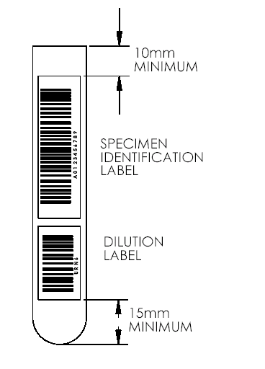

Select the Dilution label from the following:

URN1     1:2 Dilution

URN2 1:3

URN3     1:5

URN4     1:10

URN5    1:20

URN6    1:50

URN7    1:100

URN8    1:500

URN9    1:1000

###### Prepare dilution in this tube, using Iris Diluent according to the information found in SETTINGS and the Dilutions Binder. Each label is assigned a specific dilution. The analyzer makes its calculations based on how that label is read.

###### Replace the undiluted sample that was used for the Chemistry analyzer with the diluted tube and place the specimen into a patient (GRAY) rack.

###### Put the rack on the iQ200 analyzer and press START to run the sample.

###### Results will consolidate with the chemistry results.

###### If auto-release has been enabled, results will auto-release as the user has defined, unless flagged.

###### Verify results only for samples that did not auto-release (refer to previous sections of this document).

3. If you are not using barcodes:

* 1. Obtain a Dilution (YELLOW) rack.
  2. Click on Manual Orders and choose the patient rack and position number that will be used to run the assay.
  3. Identify the specimen ID, select URN, Dilution code and Work order = run.
  4. Put the sample into the correct position in Dilution (YELLOW) rack number 23.
  5. Pour 3 ml urine into the corresponding unlabeled tube.
  6. Place the rack on the right hand side of the Chemistry analyzer and run.

***Note: the Dilution rack will not be aspirated by the iQ200.***

1. The Chemistry Result will be displayed as ID_ERROR.
2. After Chemistry has completed, remove the rack.
3. Perform appropriate dilution according to the dilution protocol in SETTINGS and Dilution Binder.
4. Place the diluted sample in the patient rack and position number that was programmed manually.
5. Place the rack on the iQ200 analyzer and press START to run the sample.
6. Consolidate results with Chemistry manually by following prompts.
7. If auto-release has been enabled, results will auto-release, as the user has defined, unless flagged.
8. Verify results only for samples that did not auto-release (refer to previous sections of this document).

# LIMITATIONS:

Never try to run a diluted specimen on the AX-4030. The diluted sample will not provide accurate patient chemistry results.

# references:

Iris Operator’s Manual 301-4760. Sample Preparation 3.