**Dignity Health Central Coast Service Area**

**SUBJECT**: ROTEM® *delta* - Whole Blood Haemostasis System using Thromboelastometry

**ORIGIN:** Clinical Laboratory/Coagulation

| **Document Category:** | | | |
| --- | --- | --- | --- |
| ☒ Policy | ☒Procedure | ☐Standardized Procedure | ☐Other: |

| **Applies to:** | | |
| --- | --- | --- |
| ☐ Santa Maria Campus,  Marian Regional Medical Center | ☐Arroyo Grande Campus,  Marian Regional Medical Center | ☒French Hospital Medical Center |
| ☐St. John’s Pleasant Valley Hospital | ☐St. John’s Regional Medical Center | |

1. **PURPOSE**

The ROTEM® *delta* is designed for in vitro diagnostic use to provide a qualitative and quantitative indication of the coagulation state of a blood sample in order to assist in the assessment of patient clinical hemostasis conditions. Clotting characteristics are described by the functional parameters Clotting Time (CT), Speed of Clot Formation (CFT and alpha angle), Clot Firmness (A20/MCF) and Clot Lysis (LOT, ML, LI(x)). The indication for ROTEM® *delta* use is with adult patients where an evaluation of their blood coagulation properties is desired. Coagulation evaluations with the ROTEM® *delta* are commonly used to assess clinical conditions in organ transplantation, cardiovascular surgery, cardiology procedures, and trauma to assess postoperative hemorrhage and/or thrombosis.

1. **PRINCIPLE**

The patented ROTEM technology is based on a fixed cylindrical cup and a permanently oscillating vertical axis (Figure 4-1). The axis is supported by a high precision ball bearing and oscillates to the left and to the right through an angle of 4.75°. The rotation of the axis is driven by a motor that is connected to the axis via an elastic spring. For the measurement, a disposable plastic pin with 6 mm diameter is placed firmly on the axis and the blood sample is filled into a disposable 8 mm diameter cup and is then lifted onto the measurement channel. Hence, the plastic pin is immersed into the blood sample. The rotation is detected optically via a mirror plate at the upper end of the axis, a diode as a light source and a light sensitive sensor (CCD Chip). If no clotting takes place, the movement is not obstructed. When a clot is formed and attaches itself between pin and cup surfaces, the movement is obstructed. The result is a balance between the spring tension and the tension of the clot. As the clot becomes firmer, the rotational amplitude of the axis is reduced. The results of the measurement are interpreted with special software.

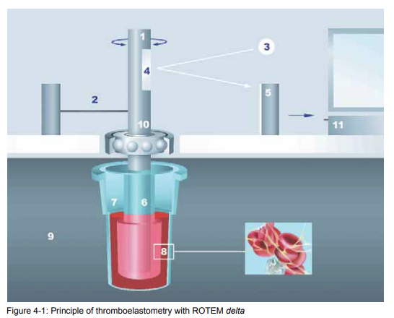

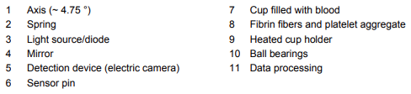

1. **DEFINITIONS**

The ROTEM software utilizes a highly developed curve smoothing algorithm and noise filter which prevents potential errors due to mechanical or electronic noise. The parameters are determined in real time during the tests. They are then calculated and represented graphically in TEMograms. The rotational amplitude of the pin is converted into a graphical amplitude, thus the following definitions apply for the ROTEM system: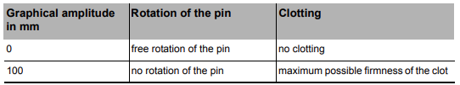

Generally, the measurement results are interpreted with routine parameters. The figure below shows the most commonly used parameters. The y-axis depicts the amplitude in mm, whereas the x-axis shows the time in minutes.

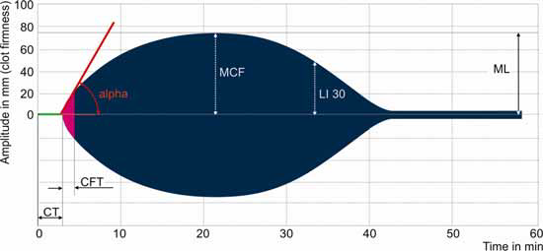

CT: Clotting Time (sec). The time from the beginning of the test, when the clotting activator is added, until the time when an amplitude of 2 mm is achieved. The CT describes how fast the formation of fibrin starts. This parameter is analogous to the clotting time in a classical clotting test performed in a laboratory. However, they are not identical, as more fibrin is created and has to be stabilized in order to achieve a certain firmness of the clot that is sufficient to connect the two moving parts of the measuring cell. Clotting factors and anticoagulants are the main influencing factors. The CT parameter facilitates the decision to substitute clotting factors or to reverse anticoagulation.

CFT: Clot formation time (sec). The CFT is the time between 2 mm amplitude and 20 mm amplitude of the clotting signal. It describes the next phase of the clotting: the kinetics of the formation of a stable clot through both activated platelets and fibrin. The amount of platelets and their contribution to the clot firmness, as well as fibrinogen level and its ability to polymerize are the main influencing factors for this parameter.The CFT facilitates the decision to substitute with platelets, fibrinogen, or both. A shortened CFT is indicative of hypercoagulation (as well as increased MCF parameter and alpha angle). For samples with very low clot formation, the clot formation time may not be achieved and therefore not indicated.

Alpha Angle (𝝰, [°]): The alpha angle is defined as the angle between the middle axis and the tangent to the clotting curve through the 2 mm amplitude point. It describes the kinetic of clotting. The diagnostic information of this parameter is similar to CFT. A reduced alpha angle indicates a hypocoagulable state (refer to CFT).

MCF: Maximum Clot Firmness (mm). The MCF is the measure for the firmness of the clot and therefore the clot quality. It is the maximum amplitude that is reached before the clot is dissolved by fibrinolysis and the clot firmness falls again. Main influencing factors include platelets, fibrinogen (concentration and the ability to polymerize), Factor XIII, and the presence of fibrinolysis. A low MCF indicates a low clot firmness. The MCF value is used to facilitate the decision for substitution therapy with platelets or fibrinogen. A high MCF value may indicate a hypercoagulable state.

A20 (mm): Amplitude measured 20 minutes after CT and represents clot firmness. Platelets, fibrinogen (concentration, ability to polymerize), and Factor XIII mainly influence the A20 parameter.

LI30: Lysis Index at 30 min and related parameter (%). The LI30 value represents the fibrinolysis 30 min after CT. It is the relation of the amplitude to the maximum clot firmness (% remaining clot firmness). The LI60 parameter describes the according remaining clot firmness 60 min after CT. Due to the high concentration of fibrinolysis inhibitors, almost no fibrinolysis can be observed in samples from healthy persons . An abnormal LI30 value mostly indicates hyperfibrinolysis. In certain cases, hyperfibrinolysis may develop relatively late. In such cases, LI60 may also be used for a decision.

ML: Maximum Lysis (%). The parameter of maximum lysis (ML) describes the degree of fibrinolysis relative to maximum clot firmness (MCF) achieved during the measurement (% clot firmness lost). A ML of 5% means that, at the period of observation, the MCF has decreased by 5%. As the maximum lysis is not calculated at a fixed time point, but is defined as % lysis at the end of the measurement, the total runtime and the time after maximum clot formation should always be considered.

The ROTEM whole blood haemostasis analysis with the specific system reagents enables extensive diagnostics as help for therapeutic decisions. The ROTEM analysis extends the resulting diagnostic power by a number of additional tests and parameters, which:

• shorten the reaction time,

• increase the precision,

• inhibit certain factors (e.g. heparin)

• allow differentiation between fibrin and platelet contributions to the overall clot

NATEM: The NATEM assay is a semi-quantitative in vitro diagnostic assay used on the ROTEM *delta* Thromboelastometry System to monitor the coagulation process, contact-activated by the surface of the measurement cell, in citrated whole blood specimens.

INTEM: The in-tem assay is a semi-quantitative assay used to monitor the coagulation process via the intrinsic pathway in citrated whole blood specimens. in-tem® reagent contains an optimized concentration of ellagic acid, which leads to a standardized mild activation of the contact phase through the negatively loaded surface. The sample is recalcified with star-tem® reagent.

HEPTEM: The hep-tem assay is a semi-quantitative assay used to monitor the coagulation process, via the intrinsic pathway in the presence of unfractionated heparin, in citrated whole blood specimens. The hep-tem reagent is used to inactivate heparin in patients receiving unfractionated heparin. In addition, it contains an optimized calcium ion concentration in a buffer to start the coagulation reaction. By adding heparinase* to a heparinized blood sample, the heparin in the sample is degraded and the anticoagulant activity is removed. This enables blood coagulation to be evaluated without the effect of heparin. The test is usually compared with an INTEM test (without addition of hep-tem® reagent).

EXTEM: The EXTEM assay is a semi-quantitative assay to monitor the coagulation process via the extrinsic pathway in citrated whole blood specimens. ex-tem® contains an optimized concentration of tissue factor and phospholipids which is used for a mild extrinsic activation of the coagulation system. By adding ex-tem® to the sample a standardized activation of extrinsic clotting cascade is triggered by the added tissue factor. The sample is recalcified with star-tem®.

FIBTEM: The FIBTEM assay is a semi-quantitative assay to monitor the clot firmness of citrated whole blood specimens after blocking platelet contribution to the clot firmness. The fib-tem reagent is always used in conjunction with ex-tem reagent. The fib-tem® reagent contains cytochalasin D as a thrombocyte inhibitor (inhibiting the actin/myosin-system) and CaCl2 as a recalcification reagent. Therefore only the fibrin clot is measured on ROTEM® in an extrinsic activated test using ex-tem®. The platelets are inactivated (2). Using the FIBTEM test the quality of fibrin polymerisation or the fibrinogen concentration can be estimated quickly. A weak fibrin coagulation with fib-tem® indicates fibrinogen deficiency or a disturbance in fibrin polymerisation. By means of a parallel test using only ex-tem® the contribution of thrombocytes to coagulation is also recorded. The difference in clot firmness between FIBTEM and the EXTEM test is an indirect measure of the thrombocyte function. For the assessment of clot formation in the FIBTEM test, reference is made chiefly to firmness parameters such as A10, A20, MCF. CT, CFT and alpha angle are not evaluated.

APTEM: The APTEM assay is a semi-quantitative assay to monitor the clot firmness of citrated whole blood specimens after blocking hyperfibrinolysis by aprotinin. The ap-tem reagent is always used in conjunction with ex-tem reagent. In the APTEM test activation is caused by ex-tem® using the extrinsic system. The plasmin-antagonist Aprotinin prevents a fibrinolysis in vitro; CaCl2 in the ap-tem® recalcifies the sample. The APTEM test provides information regarding coagulation without fibrinolysis effects (EXTEM includes such effects). Evidence of fibrinolytic activity is obtained by comparing the results from the EXTEM and APTEM test. A significant normalization of the parameters (CT), CFT and MCF in the APTEM test by comparison with the EXTEM test confirms hyperfibrinolysis seen in the EXTEM assay.

1. **SPECIMEN REQUIREMENTS**
   1. Citrated whole blood in 9:1 ratio of blood to 3.2% sodium citrate anticoagulant
      1. Do not refrigerate or put on ice
      2. Do not spin, shake samples, or roll the sample container
      3. Specimen is stable for up to 4 hours at room temperature
      4. Before analysis, bring citrated blood to 37° C and immediately mix carefully and thoroughly to eliminate storage sedimentation. Avoid formation of foam
2. **MATERIALS**
   1. Equipment and Supplies
      1. ROTEM *delta* Instrument complete with touchscreen monitor with mounted barcode scanner, keyboard, and electronic system pipet
      2. ROTEM *delta* software
      3. ROTEM Cup & Pin pro
      4. Pipet tips and filters
   2. Reagents
      1. ROTROL N + ROTROL P
         1. Quality control material for monitoring the accuracy and precision of testing carried out on the ROTEM *delta* Thromboelastography System
         2. Each kit consists of 5 vials ROTROL Lyo and 5 vials ROTROL Dil
         3. ROTROL Lyo is a lyophilized human plasma collected using 3.2% sodium citrate as an anticoagulant. Stabilizers and buffers were added prior to lyophilization
            * ROTROL N Lyo plasma was adjusted to yield coagulation values in the normal range of whole blood
            * ROTROL P Lyo plasma was adjusted to yield coagulation values in the abnormal range of whole blood
         4. Unopened reagent is stable until expiration date indicated on label when stored at 2 to 8 °C
         5. Allow ROTROL Dil and Lyo reach room temperature before reconstitution. Dissolve contents of ROTROL Lyo by pouring contents of ROTROL Dil into the lyophilisate. Do not transfer diluent with a pipet
         6. Swirl gently to mix, do not shake. Ensure powder is completely dissolved
         7. Let ROTROL N stand 15 minutes at room temperature to fully reconstitute
         8. Let ROTROL P stand 30 minutes at room temperature to fully reconstitute
         9. Before use, bring ROTROL N and ROTROL P to 37 °C on a temperature controlled work surface for 5 minutes. Mix again by gentle swirling
         10. Reconstituted ROTROL N is stable for 8 hours at 2 to 8 °C Reconstituted ROTROL P is stable for 4 hours at 2 to 8 °C
         11. Freezing and thawing is not recommended
         12. After reconstitution, each vial is sufficient for 4 assays
         13. Avoid contamination and always close the vials after each use
      2. Star-tem®
         1. Intended for use as a recalcification reagent in the NATEM, EXTEM, and INTEM assays
         2. Consists of 0.2 mol/l CaCl2 in HEPES buffer pH 7.4 and 0.1% sodium azide. Ready to use after mixing thoroughly
         3. Unopened reagent is stable until expiration date indicated on label when stored at 2 to 8 °C
         4. Opened vials must be used within 8 days after opening. Always enter the expiration date of the opened reagent. Store at 2 to 8 °C.
         5. Avoid contamination and always close the vials after each use to avoid evaporation
      3. Ex-tem®
         1. Used for a mild extrinsic activation of the coagulation system
         2. Contains recombinant tissue factor, phospholipids, preservatives, heparin inhibitor, buffer. Ready to use after mixing thoroughly
         3. Unopened reagent is stable until expiration date indicated on label when stored at 2 to 8 °C
         4. Opened vials must be used within 8 days after opening. Always enter the expiration date of the opened reagent. Store at 2 to 8 °C
         5. Avoid contamination and always close the vials after each use to avoid evaporation
      4. In-tem®
         1. Used for standardized mild activation of the contact phase through the negatively loaded surface
         2. Contains partial thromboplastin phospholipid from rabbit brain (chloroform extract), ellagic acid, buffer, preservatives. Ready to use after mixing thoroughly
         3. Unopened reagent is stable until expiration date indicated on label when stored at 2 to 8 °C
         4. Opened vials must be used within 8 days after opening. Always enter the expiration date of the opened reagent. Store at 2 to 8 °C
         5. Avoid contamination and always close the vials after each use to avoid evaporation
      5. Fib-tem®
         1. Used to monitor the clot firmness of citrated whole blood specimen after blocking platelet contribution to clot firmness
         2. Contains cytochalasin D/DMSO solution as thrombocyte inhibitor (inhibiting the actin/myosin-system) and 0.2 mol/l CaCl2 as recalcification reagent in HEPES buffer pH 7.4, preservative
         3. Unopened reagent is stable until expiration date indicated on label when stored at 2 to 8 °C
         4. Opened vials must be used within 14 days after opening. Always enter the expiration date of the opened reagent. Store at 2 to 8 °C
         5. Avoid contamination and always close the vials after each use to avoid evaporation
      6. Hep-tem®
         1. Used to inactivate heparin in patients receiving unfractionated heparin to monitor the coagulation process via the intrinsic pathway
         2. hep-tem® Lyo: Heparinase I from flavobacteria*, preservatives and buffer, lyophilized
         3. hep-tem® Dil: Calcium-containing diluent and start reagent with sodium azide (NaN3 <0.1%) and preservatives
         4. Unopened reagent is stable until expiration date indicated on label when stored at 2 to 8 °C
         5. Dissolve the contents of one vial hep-tem® Lyo with 200 μl hep-tem® Dil and allow to reconstitute for 10 minutes in the closed container. Mix again by swirling carefully before use
            * Reconstitution may be performed using the system pipet and the menu item Liquitrans (refer to the User Manual) or using a manual pipet
         6. Reconstituted reagent is stable for 30 days at 2 to 8 °C
         7. Avoid contamination and always close the vials again (stopper and screw cap) after each use
         8. Open hep-tem® Dil is stable to the expiration date indicated on the label when stored at 2 to 8 °C
         9. Avoid contamination and close the vials again thoroughly after each removal of diluent
         10. Any turbidity in the reagent should be considered microbial contamination and the reagent should then be discarded
      7. Ap-tem®
         1. Used to prevent fibrinolysis in vitro to provide information regarding coagulation without fibrinolysis effects usually included in EXTEM testing
         2. Contains Aprotinin, 0.2 mol/l CaCl2 in HEPES buffer pH 7.4 and 0.1% sodium azide (NaN3). Ready to use after mixing thoroughly
         3. Unopened reagent is stable until expiration date indicated on label when stored at 2 to 8 °C
         4. Opened vials must be used within 14 days after opening. Always enter the expiration date of the opened reagent. Store at 2 to 8 °C
         5. Avoid contamination and always close the vials after each use to avoid evaporation
3. **QUALITY CONTROL**
   1. Internal Quality Control
      1. The internal quality control consists of a continuous self-monitoring procedure when the system is powered on, as well as automatic monitoring and information during routine measurement operation of the system
      2. The ROTEM system contains a continuous self-monitoring system that monitors the performance of the axis movement, sensors, and temperatures
         1. From main screen, access the SERVICE menu and select SETTINGS tab
         2. Evaluate the following values per channel

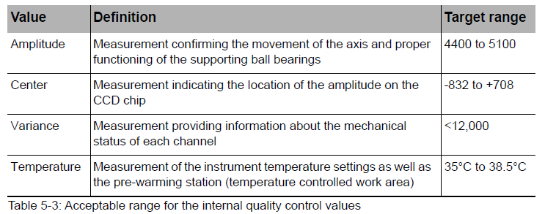

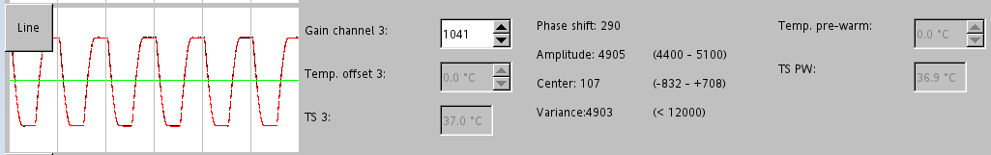

* + 1. The internal monitoring also validates the proper functioning of the axis on each channel and the performance of the instrument optics
       1. Black curve depicts the actual light beam from the CCD
       2. Red curve depicts the calculated light beam from the CCD

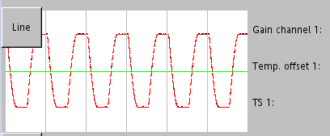

* + 1. The proper function of the measuring mechanism and of the electronics is continuously monitored through the equipment's self control during routine measurement operation
       1. Channel status information and warnings are displayed automatically as soon as a self-test failure is detected

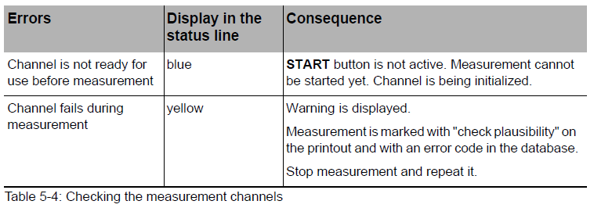

* 1. External Quality Control
     1. Prepare ROTROL N and ROTROL P controls as detailed in the Reagents section
     2. The control is usually performed as a QC combination on all 4 channels (2 channels INTEM and 2 EXTEM). INTEM and EXTEM are the most commonly performed tests and are the base activators for FIBTEM, APTEM, and HEPTEM
     3. For each channel, select a QC test by touching the test bar
        1. QCinN: ROTROL N, intem test
        2. QCexN: ROTROL N, extem test
        3. QCinP: ROTROL P, intem test
        4. QCexP: ROTROL P, extem test
     4. Select the correct ROTROL N or P lot number for each channel
     5. Select a channel and touch START
     6. Follow the pipetting sequence shown on the screen
     7. Repeat Steps 5 and 6 for remaining channels

1. **PROCEDURE**
   1. Switching on ROTEM system
      1. Check there are no cup holders present on any of the four measurement channels
      2. Press once and release the blue on/off button on the right hand side of the instrument
      3. The ROTEM system software starts automatically and checks the system
      4. The connection between the ROTEM system, the connected pipet, and the optional printer is established
      5. The login screen is loaded
      6. Log in to the system
         1. Touch the screen if the screen saver is active
         2. Select user and enter password
      7. The system displays QC and maintenance reminders in the measurement module according to the preset QC and maintenance schemes
      8. Perform maintenance as prompted by the reminder
      9. Perform QC measurements as prompted by the reminder
      10. The system now displays the reagent lot confirmation box
      11. Check the lots of the reagents to be used with the ones on the screen
          1. Change any reagent lots if required
          2. Confirm with **All lots have been checked**
      12. Heating up the device to operating temperature. This procedure may take several minutes. The color of the 5 temperature indicators down to the right of the screen (1) changes from dark blue (very cold) over light blue (less cold) to white (target temperature)

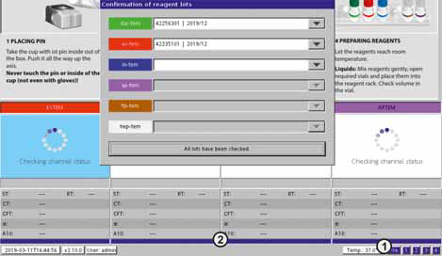

The color of the status line (2) indicates the status of the measurement for each channel (see figure above)

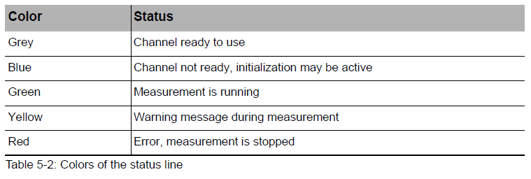

* 1. Reagent and Supplies Preparation
     1. Take reagent rack with reagents already in use out of the refrigerator
     2. Withdraw additional fresh reagents for the work day from the packages in the refrigerator
     3. Write the open date on any new bottle
     4. Refill the reagent rack
     5. Place the reagent rack to its position in the front of the ROTEM *delta*
     6. Allow reagents to reach room temperature before use
        1. During the workday, reagents may be kept at room temperature but vials must be closed tightly immediately after each use
     7. Before performing a HEPTEM test, dissolve the lyophilized reagent
        1. Withdraw one small bottle hep-tem Lyo and a big bottle diluent hep-tem Dil from the package. Open both bottles
        2. Quit measurement module and confirm with Yes to exit
        3. Select LIQUITRANS module
        4. Enter 200 μl in the entry field
        5. Confirm with Start
        6. Take new pipet tip and immerse the pipet into the bottle with hep-tem Dil
        7. Push blue start button of the pipet. 200μl liquid is aspirated
        8. Hold pipet tip over the target vial (hep-tem Lyo)
        9. Push blue start button of the pipet. 200μl liquid is dispensed again
        10. Choose Done
        11. Exit LIQUITRANS module with Quit
        12. Close both bottles with their caps
        13. Place the hep-tem Dil in its package into the refrigerator
        14. Gently swirl the dissolved hep-tem Lyo
        15. Before first use of the hep-tem reagent, let it rest for 10 minutes
        16. Write the date of preparation onto the new bottle. The reagent may be used for a period of 30 days
        17. One bottle contains reagents for seven tests

Note: It is also possible to reconstitute these reagents directly from the pipetting sequence in the MEASUREMENT menu.

* + 1. Refill tips and measurement cells (cups & pins) in the accessories box if necessary
  1. Measuring Cell Preparation
     1. Take the cup with the pin in it from the storage box
     2. Slide the cup (with the pin in it) until it stops onto the axis of the channel chosen for the measurement

Note: The status line under the channel is grey when the channel is ready. In case the axis has been moved heavily when attaching the pin, the channel becomes inactive and the status line turns blue during the time of initialization

* + 1. Place the cup with its opening facing upwards into the appropriate preheated cup holder
    2. Place the cup holder onto the temperature controlled work area again
    3. Push and fix the cup in the cup holder using the MC Rod

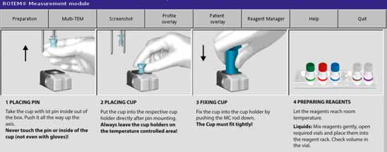

* 1. Select Channel and Test
     1. Each of the four channels can be selected to start a measurement by touching the screen on the corresponding channel
     2. For each channel, a test is preset in the menu SETUP. These presets may be overwritten and another test may be chosen

Note: This choice cannot be changed during a running measurement

* + 1. Touch the test name on top of the selected channel
    2. A list with all possible tests pops up. Select required test by touching it
    3. The new test name above the channel is highlighted in the color code of the ROTEM reagent bottle
    4. The color coded reagent(s) necessary for this test are displayed in the Reagent lots in use / Reagents field under the patient data
  1. Enter Patient Data
     1. Touch one of the four channels
     2. In the upper part of the screen entry fields for patient data are displayed
     3. Touch the respective entry field
     4. Enter patient information
        1. Alternatively patient data may be read in, using a barcode scanner
        2. Mandatory fields are displayed in blue
     5. Choose a normal range profile for the patient
        1. The normal values from this profile are used for this patient
        2. The profile overlay TEMogram is formed with these normal values
     6. Patient data can be copied from one channel to another by **Copy** and **Paste** or **Copy to all**
     7. All patient data of a channel can be deleted with the **<Esc>** key or with the **Reset data** button

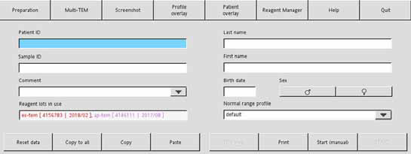

* 1. Performing Measurements
     1. Start Measurement
        1. Mix reagents gently and thoroughly
        2. Measure blood sample immediately after collection
           + If unable to test immediately, preheat specimen for 5-10 minutes in the sample preheating station. Do not leave specimen for more than 30 minutes in preheating station
        3. Mix the blood sample by repeated slow tilting of the sample
        4. Start the pipetting sequence for the selected channel by using the **START** button on the screen
        5. The instructions (including. pictogram) for the next step to be performed are displayed on the screen

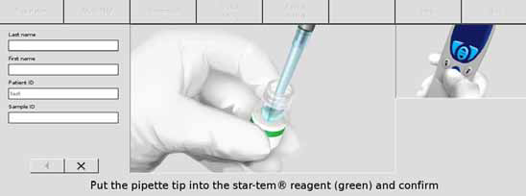

* + - 1. Follow the menu navigation of the pipetting program and confirm each step by pressing the blue start button of the pipet
         * If reconstitution of the hep-tem reagent is required, press **Reconstitute**
         * If the pipetting sequence requires a pipet tip change, the blue start (confirm) button stays inactive until the pipet tip is ejected by using the eject button
      2. The pipetting steps can be restarted in the event of pipetting failure
         * Always hold the pipet tip above the waste container before you select **Step back** (). The pipet will automatically empty the liquids in the pipet tip when performing this step back
         * Press **Step back** () button (arrow to the left)
         * Confirm on the screen
         * The pipetting program blows out the liquids in the pipet tip
         * The previous pipetting step is shown
         * Follow the pipetting sequence again
         * After the last step of the pipetting sequence, the reaction starts
      3. Place the cup holder onto the measuring position using the guiding rods.
         * The cup holder is held in the measuring position with magnets. In case that the cup holder is not positioned in time, the measurement is aborted.
         * If required, press **<Enter>** or touch the screen to confirm that the cup holder is in place
    1. Stop Measurement
       1. A measurement can be stopped automatically or manually
       2. The measurement is stopped automatically when the maximum measurement time determined in the module SETUP is reached
       3. Select **Stop channel x** to stop the measurement manually
    2. Save and Clear Measurement
       1. When a channel is cleared, the data is transmitted to the database and only remains available for printing or exporting
       2. Carefully check the patient ID and the sample ID before transmitting the measurement to the database. For safety reasons, data cannot be changed after a measurement has been finished and transmitted to the database
       3. Select Save/Clear channel
       4. The measurement is cleared from the screen and is saved in the database
    3. Remove Measuring Cells
       1. The cup holder is equipped with an integrated blue pin remover. The cup and the pin are removed together with the cup holder from the measuring position
       2. Hold the cup holder with one hand and push, with the thumb of the other hand, the blue pin remover up towards the device
       3. The pin is held into the cup
       4. While holding in the pin remover, pull down the cup holder
       5. Cup holder, pin, and cup are removed together

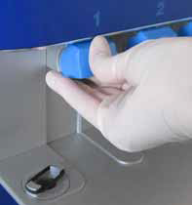

* + 1. Remove Cup and Pin
       1. Insert metal pin at the right edge of the work area into the bottom of the cup holder
       2. Push the cup holder down the metal pin to release and lift the cup
       3. Dispose of cup and pin according to the effective regulations for biohazardous material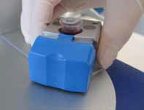
  1. Graphics of Measurement Results
     1. During measurement, the large TEMogram is shown at the left upper side of the screen
     2. In the upper right part of the screen, the current measurement results of the test parameters are shown
     3. Some of the coagulation parameters are shown as “preliminary values” in the display while a clot is developing
        1. These values are based on a limited amount of data and are replaced by the final values as soon as the appropriate amount of data points are available
        2. Preliminary results are marked with an asterisk (*)

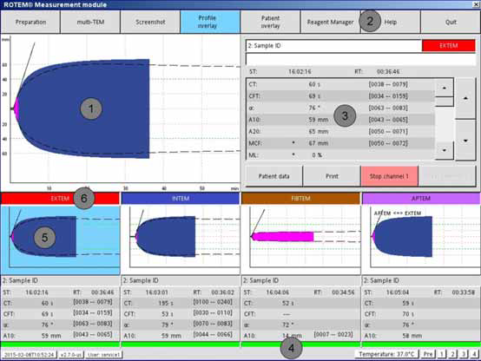

* + 1. By pressing the Multi-TEM button, an overview of all four channels is displayed
    2. For measurements run > 60 minutes, it is possible to scroll through the graph up to 180 minutes after double-touching the graph
       1. Screenshots (to the FILE MANAGER) can be taken or printed out directly with Print Screenshot.

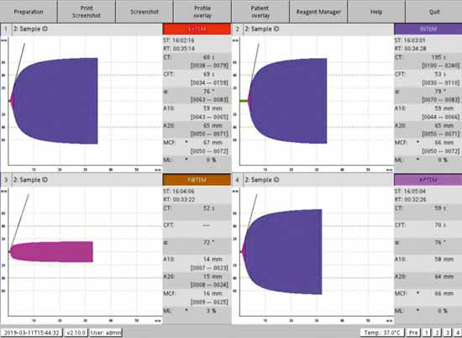

1. **RESULTS REPORTING**
   1. Reference Ranges
      1. EXTEM
         1. CT: 43-82 sec
         2. CFT: 48-127 sec
         3. ⍺-angle: 65-80 degrees
         4. A20: 50-70 mm
         5. MCF 52-70 mm
      2. INTEM
         1. CT: 122-208 sec
         2. CFT: 45-110 sec
         3. ⍺-angle: 70-81 degrees
         4. A20: 51-72 mm
         5. MCF 51-72 mm
      3. FIBTEM
         1. A20: 7-24 mm
         2. MCF: 7-24 mm
      4. HEPTEM: See INTEM ranges
         1. HEPTEM is INTEM test with the addition of heparinase
      5. APTEM: See EXTEM ranges
         1. APTEM is EXTEM test with the addition of plasmin-antagonist Aprotinin
   2. Preoperative Testing
      1. EXTEM, INTEM, and FIBTEM tests are performed for preoperative testing
      2. Allow tests to run until completion of MCF parameter of each test
      3. Enter result values in Cerner
   3. Intraoperative Testing
      1. EXTEM, INTEM, FIBTEM, and HEPTEM tests are performed
      2. Two intraoperative testing points
         1. Prior to off-pump (patient still on heparin)
         2. Post administration of protamine to reverse heparin
      3. Report results to the operating room when EXTEM A10 parameter completes
      4. Allow tests to run until next specimen arrives or completion of MCF parameter of each test
      5. Enter result values in Cerner
2. **LIMITATIONS**
   1. Only blood samples collected in 3.2% sodium citrate tubes may be used for testing
   2. ROTROL controls are subjected to the limitation of the test system. Variables such as temperature, reagent stability, instrument properties, and individual techniques may affect the final result
   3. ROTEM reagents should be stored at 2 to 8 °C when not in use
   4. Reagents should not be used after the expiration date printed on the label
   5. ex-tem®, in-tem®, fib-tem®, hep-tem®, and ap-tem® assays are not intended for use on patients under 21 years of age
   6. hep-tem® Lyo and hep-tem® Dil are only suitable for use together with in-tem®
   7. Patients with hypofibrinogenemia have not been fully evaluated for ex-tem®, fib-tem®, and ap-tem® assays
   8. Patients with dysfibrinogenemia were not tested for fib-tem® assay
   9. The temperature of the sample may influence the measurement results and/or reproducibility
      1. Measure the blood sample directly after sampling.
      2. If this is not possible, preheat the blood sample for 5–10 minutes before measurement in the sample preheating station of the ROTEM *delta*
      3. Do not leave the sample for more than 30 minutes in the preheating station
   10. Results from the the ROTEM® *delta* should not be the sole basis for a patient diagnosis; the ROTEM® *delta* results should be considered along with a clinical assessment of the patient's condition and other coagulation laboratory tests

**REFERENCES**

ROTEM® *delta* Whole Blood Haemostasis System Using Thromboelastometry Operating Manual, Instrumentation Laboratory, Munich, Germany. June 2019.

ROTEM *delta* ROTROL N Product Insert, Instrumentation Laboratory, Munich, Germany. Nov 2022.

ROTEM *delta* ROTROL P Product Insert, Instrumentation Laboratory, Munich, Germany. Nov 2022.

ROTEM *delta* star-tem® Product Insert, Instrumentation Laboratory, Munich, Germany. Oct 2015.

ROTEM *delta* ex-tem® Product Insert, Instrumentation Laboratory, Munich, Germany. Oct 2015.

ROTEM *delta* in-tem® Product Insert, Instrumentation Laboratory, Munich, Germany. Oct 2015.

ROTEM *delta* fib-tem® Product Insert, Instrumentation Laboratory, Munich, Germany. Oct 2015.

ROTEM *delta* hep-tem® Product Insert, Instrumentation Laboratory, Munich, Germany. Sept 2016.

ROTEM *delta* ap-tem® Product Insert, Instrumentation Laboratory, Munich, Germany. Oct 2015.