Carbapenem Resistance

For all gram negative rods that are Meropenem resistant, add organism code **CRE** as the last isolate. This is to trigger the physician to check the susceptibility.

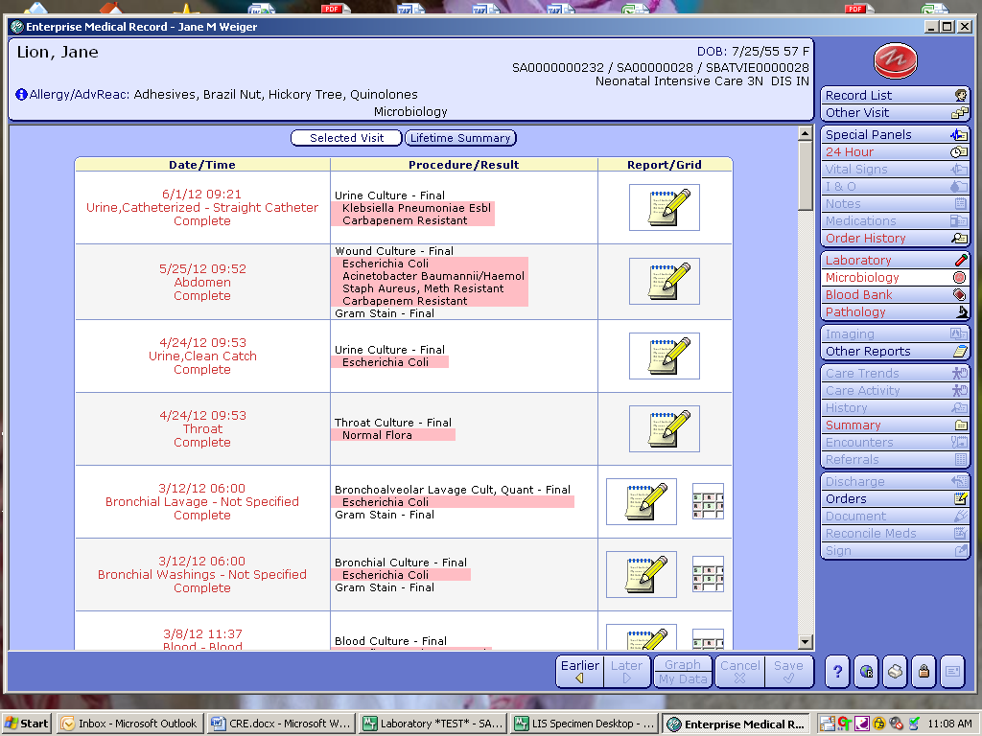

If you receive the “Possible KPC carbapenemase” alert: Unusual resistance (MICs >1 to a carbapenems are >1 and R to 3GCEPH (3rd generationcephalosporins)):

* Repeat the panel
* If the panel repeats with the same results; check the results for the carbapenems results - Ertapenem (Etp), and Meropenem (Mer)
  + If both the Etp and Mer are I or R; report MIC.
  + If one is S and one is I or R
  + Send the isolate to ARUP for the Modified Hodge Test (**MAKPC)**
  + Enter the comment **CRE** = “This isolate of [organism name] is a possible Carbapenem-Resistant Enterobacteriaceae (CRE). Isolate sent for further testing.”
  + Suppress the Meropenem result – **DO NOT** report results electronically or verbally.

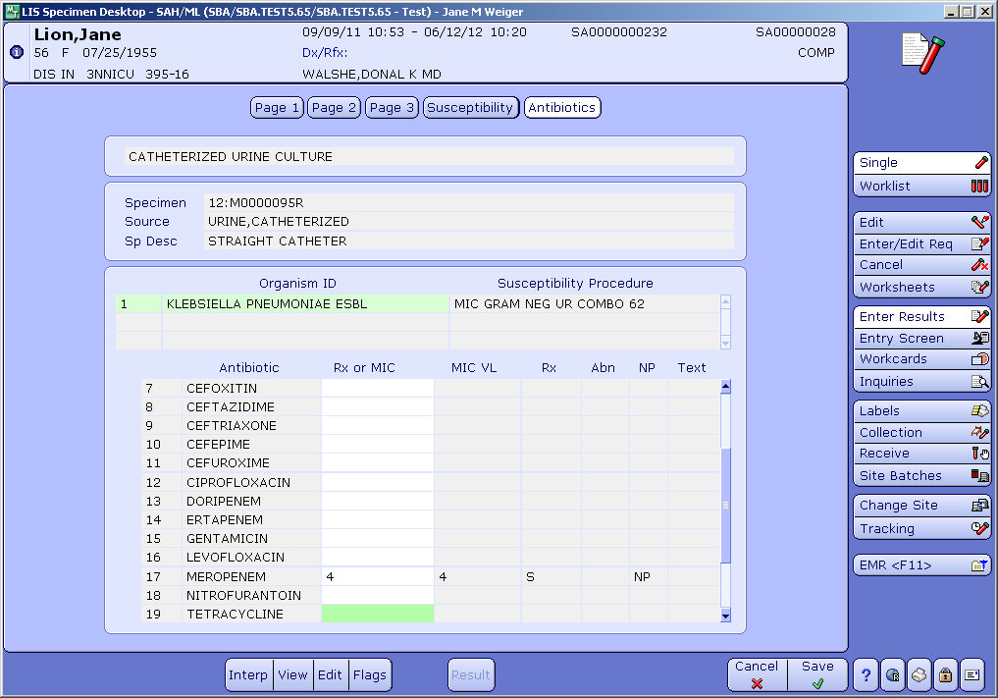

* + When the MHT results are back from ARUP:
    - * If negative –
    - Enter the comment: **MHTNEG** = This isolate of [organism name] is Modified Hodge Test NEGATIVE.
      * + Release the Mer as is

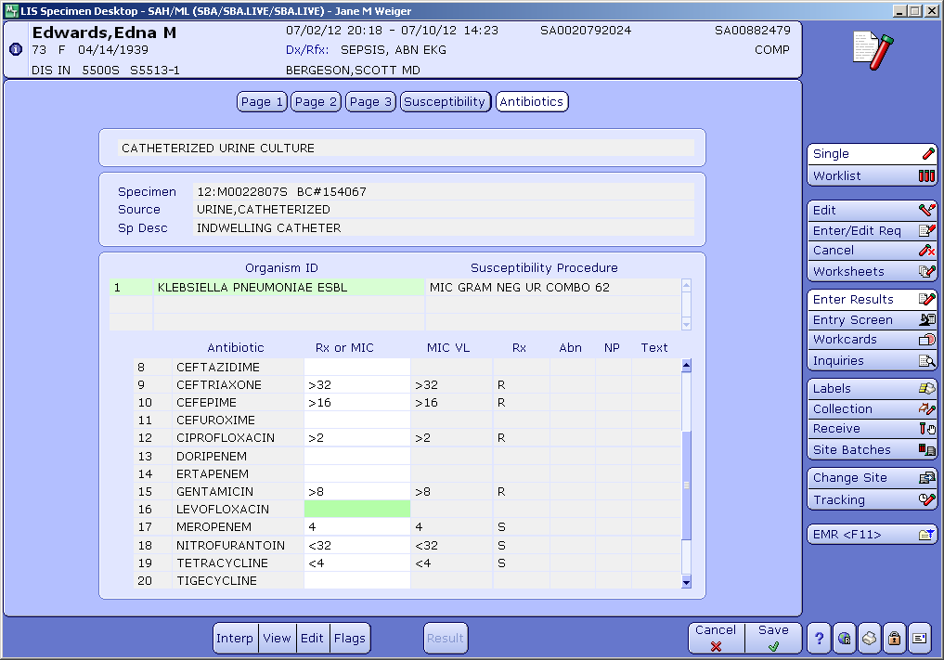

* + - * If positive –
        + Enter the comment: **MHTPOS** = This isolate of [organism name] is Modified Hodge Test POSITIVE. Confirmed CRE - Carbapenem-Resistant Enterobacteriaceae
        + Change the Meropenem interpretation to ***resistant*** by removing the MIC result and entering R

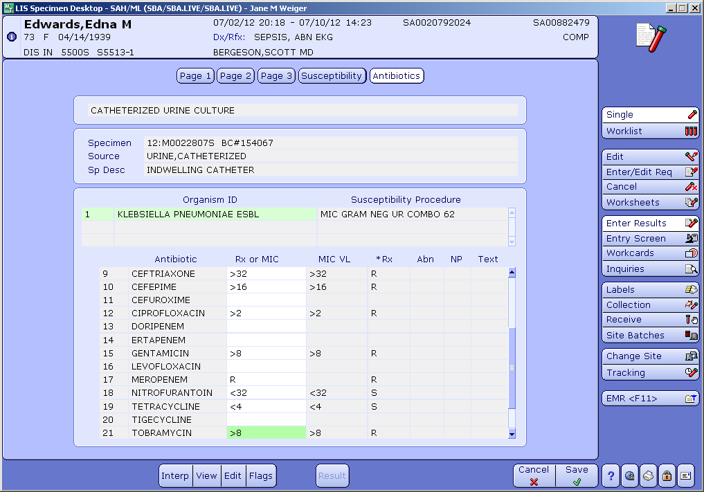

* + - Notify Infection Prevention and Control.