Policy Statement | The Department of Pathology has a standardized policy, process, and procedure for corrections, modifications and additions to laboratory results.
Purpose | This policy provides the approved format and guidelines for changes to Microbiology Laboratory results. This includes corrections and additional information.
Scope | This process applies to testing personnel. This group includes, but is not limited to Laboratory Technologists as well as leads and supervisory personnel.
Responsibility | All testing personnel are also responsible for evaluating the results and taking proper remedial action.
Corrected Reports MIC Module | When a report is corrected in the MIC Module the original results are overwritten. However, the final report must clearly state the original results as well as the corrected result. To achieve this, complete the following steps on the comment page:  - Enter the comment “THIS IS A CORRECTED REPORT”  - Enter the correct results  - Enter the comment “Previous Report”  - Enter the previous results  - Notify the physician or nurse of the corrected report and the reason.  - Document who you notified, date and time of notification and that the corrected report was read back to you.  - Leave the Corrected Report Box as is appears.  - An Occurrence Report Form (ORF) is to be completed.  - Example:  THIS IS A CORRECTED REPORT:  ACINETOBACTER BAUMANNII Moderate Growth  NORMAL FLORA Moderate Growth  PREVIOUS REPORT:  PSEUDOMONAS AERUGINOSA Moderate Growth  NORMAL FLORA Moderate Growth  CORRECTED REPORT CALLED BY [user] ON [today] AT [now] TO [0000]. RESULTS READ BACK  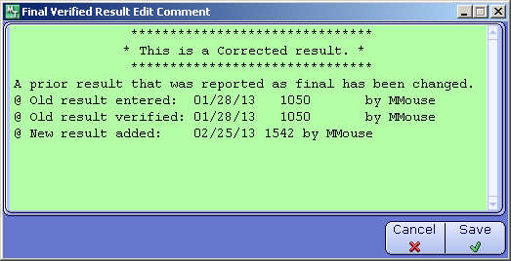
Corrected Reports LAB Module | When a report is corrected in the LAB Module, complete the following steps:  - Replace the incorrect result with the correct result.  - A “pop-up” message will appear stating the following:  [TEST] previously reported as: [RESULT]  @Edited by: [Name of tech currently logged in]  @Reason:  - Enter the reason for the corrected result.  - Notify the physician or nurse of the corrected report/results and the reason.  - Document who you notified, date and time of notification and that the corrected result was read back to you.  - An Occurrence Report Form (ORF) is to be completed.  - Example:  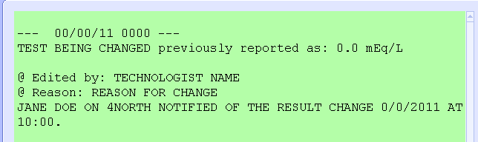
Supplemental Reports | When a physician requests additional information after the reported has been finalized, replace the “Corrected” with “Supplemental” in Final Verified Result Edit Comment box. Include a comment stating the reason for the additional information.  Example:  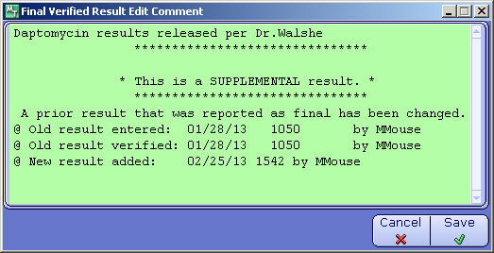  Supplemental reports do not require an Occurrence Report Form (ORF) is to be completed.
Preliminary Reports – Testing updates | If the culture is still preliminary and the updated results change during the normal testing process use the UFT comment (UPON FURTHER TESTING THE PREVIOUSLY REPORTED [ ] HAS BEEN IDENTIFIED AS [ ] ) to document the reason for the change.  Example: PBP2 was reported as MSSA. The next day the Microscan panel reports the Staph as MRSA. It is determined the Staph had inadequate growth to perform the PBP2 the previous day. Enter the UFT comment: UPON FURTHER TESTING THE PREVIOUSLY REPORTED MSSA HAS BEEN IDENTIFIED AS MRSA.
Review of Corrections | All results are reviewed daily. See MICR 6005 R Daily Report Review
Related Documents | LADM 2200 Q Corrected Reports Policy  MICR 6005 R Daily Report Review  MICR 0000 QP Core Laboratory Quality Plan

